22th October 2020

To Editor in Chief,

Thank you very much for your kind message dated at 2020-07-03. We made the necessary amendments in the manuscript, and attached our corrections as written in red color. Here are the responses to the comments of reviewers.

Thank you so much for your consideration.
With the best wishes.
Yours sincerely,

Faruk Berat AKÇEŞME

E-mail: farukberat.akcesme@sbu.edu.tr
University of Health Sciences, Medical Faculty, Department of Biostatistics and Medical Informatics, P.O. Box: 34668, Istanbul, Turkey

Reviewer D:
Comments for the authors:
Major comments
1. Title
I would suggest title to be Assessment of Interaction of Human OCT 1-3 Proteins and Metformin using Silico Analyses.
Answer: -Thank you. We agree with your assessment. We did the changes needed in the title.
The updated title is as following:
“Assessment of Interaction of Human OCT 1-3 Proteins and Metformin using Silico Analyses.”
2. Abstract- I suggest abstract should be more informative with technical data for good readership.
Answer: More information about technical data is given in the abstract.

3. Introduction: needs some rephrasing as sentences as listed below are not clear.
Answer: We agree with your assessment. We did the changes needed in the introduction.
Line 57- Plasma membranes are associated with…..
Membrane proteins are associated with prominent functions in the cell, approximately responsible for 30% genes in the human genome ¹ and currently possessing 50% of pharmaceutical drug discovery.²
Line 60- They are structurally….
We thought this sentence was unnecessary after the rephrased first sentence and discarded it.

Line 72- I would suggest “including the pharmacokinetics of a drug in metabolism as absorption…” to be “including drug metabolism as absorption…”
Human body constitutes more than 400 important SLC transporters for a broad range of tasks including drug metabolism as absorption, distribution, and excretion.

Line 75- I would suggest “is introduced into the cell from SLC22A1-3 (also named OCT1-3) transporters from SLC proteins” to be “is uptaken by cell via SLC transporter proteins encoded by SLC22A1-3 (also named OCT1-3) genes”
Answer: Thank you. We agree with your assessment. We rephrased the sentence by “is uptaken by cell via SLC transporter proteins encoded by SLC22A1-3 (also named OCT1-3) genes”.
Line 90-92- The manuscript is about diabetes and authors are mentioning about cancer. I would suggest an in-depth insight about molecular mechanism related to uptake of metformin be introduced here.
Answer: We agree with your assessment. We have included the general mechanisms required for metformin as follows.
Following metformin enters into the cell via HOCT1-3, it exhibits its anti-diabetic properties in several ways. It is broadly believed that the blood glucose-lowering impact of metformin is mediated chiefly through the repression of hepatic glucose production by decreasing gluconeogenesis and blocking glucagon-mediated signaling in the liver.¹¹⁻¹² Furthermore, some mechanisms have been suggested that metformin can activate AMPK (AMP-activated protein kinase) by the upstream liver kinase B1 ¹³, enhanced AMP/ATP rate hereby the restraint of mitochondrial respiratory chain complex I.14 Metformin improves the activity of the insulin receptor and of IRS‑2 (insulin receptor substrate 2) and boosts glucose uptake via enhanced translocation of glucose transporters, such as GLUT‑1, to the plasma membrane.¹⁵

Line 107-110- Here authors presented the importance of their study but nothing strong has been presented- I would suggest importance of the study be presented more technically and relevantly.
We included the following statements:
In the present study, we have reported and defined ligand-dependent interactions of hOCT1-3 with metformin and the other ligands utilizing the computational some approaches and explored the found interactions through comparative analysis, homology modeling, and molecular dynamic studies. This study is first attempt to demonstrate OCT1-3 interaction with metformin. This interaction has characterized by docking analysis and results were validated with MD simulations. This is important study that use predicted structure of OCT proteins to stimulate the interaction which stays highly stable throughout the MD analysis. This study is first attempt to demonstrate OCT1-3 interaction with metformin. This interaction has characterized by docking analysis and results were validated with MD simulations. This is important study that use predicted structure of OCT proteins to stimulate the interaction which stays highly stable throughout the MD analysis.
4. Materials & Methods- As per my literature search, I found that the three dimensional models of hOCTs (1-7 etc) are already predicted by Dakal TC et al., 2007. The energy minimization of structures modeled has not been done or missing in the text. Good part is that authors have used blind docking servers and all authenticated/trusted bioinformatics tools that are used in such studies.
Answer: Thank you. We agree with your assessment. We have already cited to Dakal TC et al. in the discussion part. They used only one tool to predict the model proteins.
For the energy minimization of 3D model protein structure was subjected to minimization method in chimera 1.14 (Pettersen et al. 2004) as default the steepest descent:100 with 0.02 step sizes, without fixing any atoms, after that 10 steps of conjugate gradient steps with 0.02 step size (Å) minimization (please see part 2.1.4)

5. The involvement of human Organic Cation Transporters in uptake/transport of metformin is already know since 2009 - (Tzvetkov et al, 2009, Clin Pharmacol Ther. 2009 Sep;86(3):299-306.). Authors must highlight clearly the novelty element of their research without which the research is simply not significant or would not be beneficial for scientific community.
Even though the involvement of human OCT in uptake/transport of metformin is already mentioned in the literature, this study is demonstrating the hOCTs-metformin interaction at atomic level as the first time. This study describes how and where biding occurs. Mimicking this binding with the absence of the structural information of the protein was possible with the unique approach that was described in the pipeline in figure I.
(this statements was included in the conclusion part as well)

6. Conclusion- It needs extensive modifications and high attention. It’s with very superficial information and without any future prospects.
Conclusion was modified as it is suggested but we tried to avoid repeating the results. Future prospects were included.
7. Most of the important works have not been cited. After page no. 19 there is not work cited in the manuscript. Authors should cite others work and discuss their work wrt to what others have done. This is really missing.
Answer: Thank you for your kind suggestion and comment. We discussed the studies in the discussion part.

Reviewer E:.
1) Computational work should never be used to validate experimental facts – an inappropriate goal of the present work, as stated in the Abstract. Also, on p.5, the authors have written: “This in silico analysis will confirm the in vitro and in vivo studies …” Any computational work is associated with one of the two possible goals: i) providing information that is inaccessible by other methods or suggesting new experimental procedures and ii) dissecting and rationalizing experimental indications. I would suggest the authors to stick with i). In other words, the goal of this work should be to predict the structures of molecular models, displaying such functional features that are essential for mimicking the cellular uptake of metformin by way of OCT1-3 proteins.
Answer: We did the changes needed in abstracts.

2) The appropriately defined goal of this work (item 1) means that the experimental structures of the apo (ligand-free) and liganded OCT1-3 proteins do not exist at present. Is that correct? The answer must be clear - yes or no. On p.5, the authors have written: “The three-dimensional atomic structure of human OCT 1-3 and molecular docking of metformin with these proteins hasnot been visualized before.” This is not a clear answer to the precise question, taking into account the previous work of Boxberger et al. (10.1016/j.bcp.2018.08.028) that has been overlooked by the authors. If the answer is yes, please proceed with the item 3).

3) The docking structures reported in the manuscript are the physically meaningless - static structures, as their dynamic features for mimicking the cellular uptake of metformin via OCT1-3 proteins have not been investigated at all. This has, in a sloppy manner, been mentioned in the Conclusion as a future prospect; however, the key point must be part of this study. Thus, the docking structures only are a starting point for performing molecular dynamics (MD) simulations. The authors are suggested to continue with classic MD simulations aimed at establishing the stable regime of MD for consecutive analyses. Steering MD may be considered as a useful approach as well.
MD simulation was performed as it is suggested. Now, our results indicate protein and ligand dynamic features for mimicking cellular uptake of metformin via OCT1-3. Each of the RMD results and protein-ligand contact interaction result was given in figures. (Please check part 3.3.)

4) In the Methodology section, nothing was told about how the docking jobs had been prepared and run. All technical details must be given. Docking protocol, in general, predicts the binding conformations between the receptor and the ligand, providing that the ligand fits in the binding site in terms of both shape and charge. The authors need to start with elaborating the idea of empirical scoring, indicating that the total binding free energy (BFE) can be separated into physically distinct contributions, which sum up to estimate the overall binding quantitatively. Afterwards, please give an expression, showing and explaining all additive contributions to the total BFE, as implemented in the Autodock Vina. Even though a simultaneous interplay between these separate contributions occurs in reality, the idea of empirical scoring is useful for applications in the area of drug design and discovery where efficient and quick estimates of the BFEs are needed, without relying on formal and strict statistical mechanics procedures.
Answer: Thank you for your kind suggestion and comment.
For the preparation of docking process, hOct1-3 proteins were downloaded from Robetta server in PDB format. All ligands (Metformin, Phenformin, Norepinephrine ) of hOct1-3 were retrieved as in SDF format from PubChem.³⁴ We removed the water, added the polar hydrogen to the model proteins. Then, we charged the model proteins and the ligands by the computation of Gasteiger before converting to pdbqt format using AutoDock Vina.³⁵

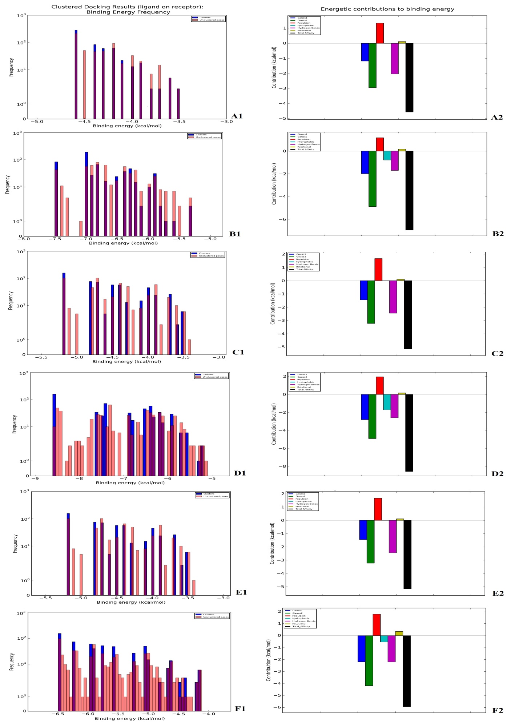
Supplementary Figure 1.

5) Scientific presentation
The Introduction should not be presented as a review article. Only key results from the literature influencing the current research should be included. Presentations of the homology modeling and molecular docking results should be shortened by about 50%, respectively, as the procedures will not be of vital importance. I would suggest new MD results (item 3) to be the main objectives that will be elaborated to a greatest extent instead.
Answer: Thank you for your kind suggestion and comment. We edited the introduction part as appropriate as possible.
In the current study, we aimed to predict the three-dimensional structure of human OCT1-3 by using various computational approaches by considering the current authenticated/trusted bioinformatics tools. The molecular docking was also performed under the inspiration of the in vitro and in vivo founding. We also performed Molecular dynamics (MD) simulation of docking of Metformin and hOCT1-3 at the atomic level for validation. The computational approaches to OCT1-3 proteins, particularly structural prediction of proteins and simulations by MD, have been broadly implemented for investigating their dynamic actions.

6) A thorough English editing is needed. The use of past tense is, very often, in conflict with using the future tense (and vice versa) throughout the manuscript. A concise and careful rewrite up should get quickly and clearly to the main points.
The text of the paper completely was revised and edited. We rewrote some sentences of the paper.
Thank you for letting us improve our manuscript.

