Assessment of Human OCT 1-3 Proteins and Metformin Interaction by in Silico Analysis
Running Title: Investigation of Human OCT1-3 and Metformin

Faruk Berat AKÇEŞME PhD¹*, Nail BEŞLİ, MSc²

¹ Department of Biostatistics and Medical Informatics, Faculty of Medicine, University of Health Sciences, Istanbul, Turkey
² Department of Medical Biology, Faculty of Medicine, University of Health Sciences, Istanbul, Turkey.

Nail BEŞLİ: http://orcid.org/0000-0002-6174-915X
e-mail:beslinail@gmail.com

*Corresponding author: Faruk Berat AKÇEŞME
Address: University of Health Sciences, Medical Faculty, Department of Biostatistics and Medical Informatics, P.O. Box:34668, Istanbul, Turkey
Tel: +090-537- 502 2634
E-mail: farukberat.akcesme@sbu.edu.tr

ABSTRACT
Organic cation transporters (OCT 1-3) proteins termed as SLC22A1-3 proteins as well, expressed in varied tissues of the human body. Metformin, a drug frequently used diabetic patients the first-line treatment worldwide, is positively charged and is transported into the cell through these transporters. We aimed to evaluate the 3D structure prediction of hOCT1-3 proteins and docking with Metformin by bioinformatics tools. Obtained homolog proteins used as a template to demonstrate the 3D structure of OCT1-3 by considering the structures and function of these proteins. We predicted functional regions (active and ligand binding site) of OCT1-3 and performed comparative bioinformatics analysis. Predicted structure of hOCT1-3 was then analyzed in Blind Docking server and the results were confirmed with predicted binding site residues and conserved domain regions. As the last step, we simulated the OCT1-3 and metformin docking and also validated the docking procedure with other substrates of HOCT-1-3 proteins. We selected the best poses of metformin docking simulations according to binding energy (-5.27 to -4.60kcal/mol). Our results validated in vitro and in vivo studies that claimed the uptake of metformin into the cells by OCT1-3 proteins.
KEYWORDS: Organic cation transporters, Metformin, Protein structure prediction, Model Validation, Docking
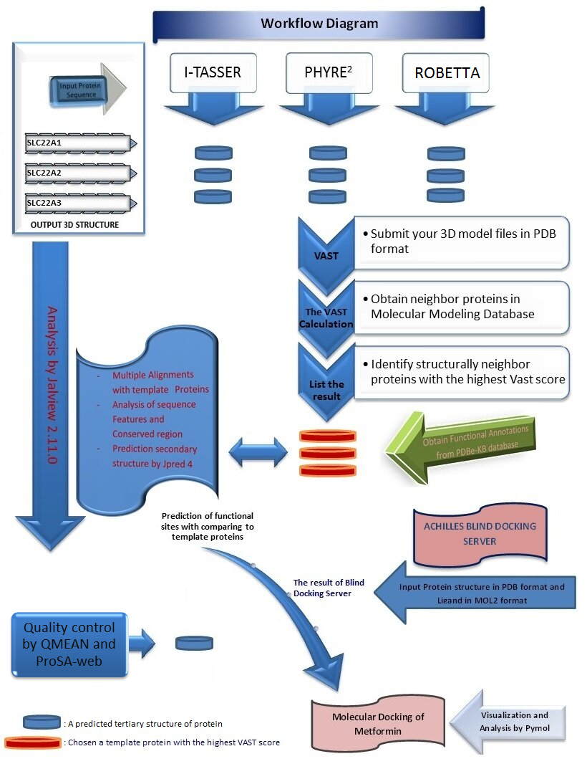
Figure 1. Identification of molecular modeling of OCT1-3 and metformin. There are four main steps in the workflow. First, prediction of the 3D structure of OCT1-3 proteins and quality control of the model protein structures. Second, identification of template proteins with the VAST. Third, Analysis of sequence data by Jalview 2.11.0. Fourth, Molecular docking by Achilles Blind Docking Server.
- Introduction
Plasma membranes are associated with prominent functions in the cell, approximately responsible for 25% genes in the human genome¹ and currently possessing 50% of pharmaceutical drug discovery.² In eukaryotic cells, they provide separation of the cell with the extracellular environment and compartmentalization for the organelles within the cell. They are structurally hydrophilic and hydrophobic bilayer phospholipids where integral proteins studded. Embedded membrane proteins perform a broad variety of particular roles during cellular events.³ Due to its structural and physicochemical properties, plasma membrane has a selective permeability for organic and inorganic substances including cation and anion compounds. Hence, it assists to sustain the unique content both inside and outside of the cell.
One of the protein families that provide translocation of cationic organic and inorganic compounds that localized in the cell membrane is SLC (Solute carrier) family from the MFS superfamily. The SLC family is a 22-membered cell membrane transporter. A subfamily of the SLC family is SLC22A1,2 and 3 (cd17379: MFS_SLC22A1_2_3).⁴ Beside many essential cation molecules for the cell, the SLC transporters are the target of drugs with high pharmacological value. Human body constitutes more than 400 important SLC transporters for a broad range of tasks including the pharmacokinetics of a drug in metabolism as absorption, distribution, and excretion. Hence, there is a growing interest in the effects of the drug on the development and progression of interacting with these transporters.⁵
Metformin, categorized as antidiabetic medication, is introduced into the cell from SLC22A1-3 (also named OCT1-3) transporters from SLC proteins.⁶ OCT1-3 membrane proteins are expressed at different levels in several tissues including OCT-2 in the level of renal expression is high, OCT-3 is most commonly expressed in skeletal muscle,⁷ whereas OCT-1 is the primary characterized expressed in hepatocytes.⁸ Metformin hydrophilic (logD -6.13 pH 6.0) and pKa (physiological pH) is 12.4.⁹ Functional elimination of OCT-1 in primary mouse hepatocyte culture and OCT-1 has been demonstrated to play an important role in metformin response in in vivo mouse model.¹⁰ Moreover, OCT-1 highly expressed in cancer cells and involved in the uptake of metformin into the cell.¹¹
In another study, OCT expression levels in breast cancers were demonstrated to correlate with the anti-proliferative and antitumor effect of metformin. Metformin uptake and anti-proliferative activity were compared with the human breast cancer cell line BT-20 and OCT-3 modified BT-20 cell line. Consequently, metformin uptake in BT-20 cells was minimal, while Oct3-BT20 cells increased 13-fold and anti-proliferative potency more than 4-fold compared to BT-20 cells.¹²
Metformin possesses a relative safety profile and an inexpensive price unlike the other cancer treatment drugs and therefore it may be sustained to appealing to research throughout most cancer therapies without knowing drug interactions. ^{13,14} In a very recent study, Besli et al. have demonstrated that anti-proliferative effect of metformin on MCF-7 breast cancer cell line.¹⁵
The visualization of the full atomic structure of proteins is mostly implemented by experimental methods such as X-ray crystallography and NMR spectroscopy. Due to the technical challenges and taking long duration of these methods, the accumulation of protein sequences are much more than the number of 3D protein structures. For that reason, in order to diminish the blank between the number of protein sequences and the number of protein structures, it has been developed countless algorithms for comparative modeling, which is also termed homology modeling, over the last 25 years. The aim of homology modeling is to identify structure templates from the PDB to compare with a target protein based on sequence similarity.^{16,17}
The three-dimensional atomic structure of human OCT 1-3 and molecular docking of metformin with these proteins has not been visualized before. Considering the main roles of integral membrane proteins, it is essential to focus on its physicochemical features at the atomic structure level. Given the pharmacological importance of SLC22A1,2 and 3 proteins in humans, determination of the structure of these proteins, estimation of their active sites and definition of how the transport mechanism works have aroused great interest. This in silico analysis will confirm the in vitro and in vivo studies that explain the role of transmembrane proteins in the uptake of metformin into the cell. The predicted structure of OCT proteins was used to stimulate this molecular mechanism.

- Materials and Methods
  - Computational structural modeling of OCT1-3
    - Prediction of Secondary and Tertiary Structure of OCT1-3 Proteins
We retrieved OCT1,2,3 (Accession no:AAI26365.1, NP_003049.2, NP_068812.1 respectively) from GenBank in FASTA format, predicted the secondary structure of the proteins by using JPred4,¹⁸ which is the latest version of the JPred online prediction server supplying by the JNet algorithm.
Each of OCT1-3 protein structures was predicted on PHYRE²,¹⁹ Robetta^{20,21} AND I-TASSER^{22,24} (protein structure prediction servers). In these prediction tools, homology modeling (or comparative modeling) were used by comparing the experimentally determined proteins as templates. To quality control of model proteins, we performed to the tool of the local structural quality of transmembrane protein models using statistical potentials (QMEANBrane)²⁵ and ProSAweb.²⁶
We compared each obtained model to all PDB proteins in MMDB (Molecular Modeling Database) in order to find 3D similar structures in VAST (Vector Alignment Search Tool).²⁷ Vast found the following proteins with the highest scores, PDB Id: 4zw9_A, 4zwc_A, 5c65_A. Each of OCT1-3 protein structures obtained from Robetta server were then selected as a model since its neighbor proteins have the highest VAST score and %Id, compared to the other prediction tools (Fig1).
The Computed Atlas of Surface Topography of proteins (CASTp) ²⁸ 3.0 was utilized to predict the surface of the binding pocket of the model proteins to interacting with their substrates.
    - Sequence Analysis
We performed pairwise in BLASTP ²⁹ and multiple sequence alignment in Clustal OMEGA³⁰ for each of the OCT1,2,3 proteins with the selected template proteins (4zw9, 4zwc, 5c65) obtained from VAST. Parameters for alignment with Clustal OMEGA were set as –GAPEXT :0.1, ENDGAPS: 0.5, GAPDİST: 1, GAPOPEN:10 and MATRIX: BLOSUM62. We analyzed and interpreted the results in Jalview 2.11.³¹
For analyzing sequence features, functional annotations of template proteins were retrieved from PDBe-KB database.³² Then, we compared these proteins with the model proteins to identify conserved regions and to predict sequence features. In this way, we assigned Predicted Functional sites, Predicted PTM sites, Predicted Ligand binding sites, Ligand binding sites, and Interaction interfaces for our model proteins.
    - Visualization
Visualization of primary and secondary structures of the proteins was performed in the Jalview 2.11. The PyMOL ³³ software was utilized for representing and analyzing the atomic structure of proteins.
    - Molecular docking simulations
The final step in this study is the molecular simulation as given in the workflow in Fig1. The docking study was carried out under ACHILLES BLIND DOCKING SERVER ³⁴ protocol, "Calculations were carried out with Blind Docking Server, available at: http://bio-hpc.eu/software/blind-docking-server/". We prepared figures by using PyMOL.
Results and Discussion
  - Alignments
We aligned a range of 146-445 aa of OCT-1 with of 85-397 aa of 4ZW9 and 4ZWC as explained previously. The OCT-1 sequence demonstrated the 22.77% sequence identity with 4zw9 and 4zwc. Alignment of a range of 146-540 aa of OCT-1 with of 63-477aa of 5c65 is as 22.51% identity.
Alignment of a range of 24-546 aa of OCT-2 with of 93-510 aa of 4ZW9, 4ZWC, and 71-438 aa of 5c65 shows the same identity as 26.57% with 4zw9, 4zwc, and 5c65.
As for OCT-3, Alignment of a range 60-353 aa of OCT-3 with of 86-513 aa of 4zw9 and 4zwc is a 24.53% Identity. Alignment of a range 84-353 aa of OCT-3 with of 64-473 aa of 5c65 is the 24.53% Identity.

  - Analysis of Conserved Domain and Sequence Features of OCT1-3
After multiple alignments of the sequence of OCT1-3 and template proteins, we detected the conserved region of these proteins by comparative analysis in Jalview 2.11.0(Fig2). We summarized the results of comparative analysis as a list in Table1.
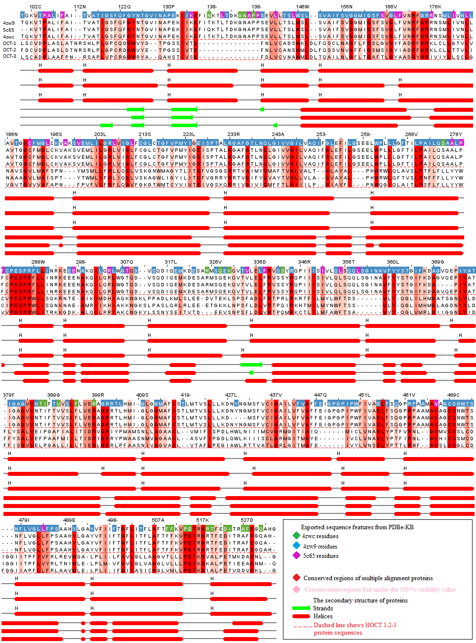
Figure 2. Representation of primary and secondary structure of 4zw9, 5c65, 4zwc, and OCT1-3 proteins. Visualization of sequence features and Conserved Domain of the protein residues are colored by analysis in Jalview 2.11.0. The probability of conserved regions decreases from dark red to pink. After multiple alignments, OCT-1 protein was set as a reference for sequence numbering. As a result of multiple sequencing, solely the overlapping regions of the proteins were exhibited.

 |  | Fig 6.Exported Functional Annotations of the templates proteins from PDBe-KB
OCT-1
Metformin | GLU¹³⁷ |  | Conserved Domain
Metformin | PRO⁴⁸¹ |  | 4zw9;Predicted Ligand binding sites, 5c65; Ligand binding sites
Metformin | ARG⁴⁸⁸
Phenformin | GLN¹⁵² |  | 4zw9;Predicted Ligand binding and functional sites, Ligand binding sites
Phenformin | ASN¹⁵⁶ |  | 4zw9;Ligand binding sites, Conserved Domain
Phenformin | LYS²¹⁴ |  | 4zw9;Predicted Ligand binding and functional sites
Phenformin | TRP³⁵⁴ |  | 4zw9;Predicted Ligand binding sites, Conserved Domain
Phenformin | ASP³⁵⁷ |  | 4zw9;Predicted Ligand binding and functional sites, Ligand binding sites
Phenformin | GLN³⁶² |  | 4zw9;Predicted Ligand binding and functional sites, Conserved Domain
Phenformin | ILE⁴⁴⁶
OCT-2
Metformin | ASN¹⁵⁷ |  | 4zw9;Predicted Ligand binding sites, Ligand binding sites, Conserved Domain
Metformin | CYS⁴⁷⁴ |  | 4zw9;Predicted Ligand binding sites, 4zwc; Predicted PTM sites,  5c65; Ligand binding sites, Conserved Domain
Metformin | ASP⁴⁷⁵ |  | 4zw9;Predicted Ligand binding sites
Phenformin | TYR³⁷
Phenformin | ASN¹⁵⁷ |  | 4zw9;Predicted Ligand binding sites, Ligand binding sites, Conserved Domain
Phenformin | LYS²¹⁵ |  | 4zw9;Predicted Ligand binding and functional sites
Phenformin | TYR²⁴⁵ |  | 4zw9;Predicted Ligand binding and functional sites, Ligand binding sites
Phenformin | TYR³⁶² |  | 4zw9;Predicted Ligand binding sites, Ligand binding sites, Predicted funtional sites,  5c65; Predicted PTM sites, Conserved Domain
Phenformin | CYS⁴⁷⁴ |  | 4zw9;Predicted Ligand binding sites, 4zwc; Predicted PTM sites,  5c65; Ligand binding sites, Conserved Domain
Phenformin | ASP⁴⁷⁵ |  | 4zw9;Predicted Ligand binding sites
OCT-3
Metformin | VAL³⁷
Metformin | ASN¹⁶² |  | 4zw9;Predicted Ligand binding sites, Ligand binding sites, Conserved Domain
Metformin | ARG²¹² |  | 4zw9;Predicted Ligand binding sites, Ligand binding sites, Conserved Domain
Metformin | GLN³⁶⁶ |  | 4zw9;Predicted Ligand binding sites, Ligand binding sites, Conserved Domain
Norepinephrine | PHE³⁶
Norepinephrine | VAL³⁹
Norepinephrine | GLN¹⁵⁸ |  | 4zw9;Predicted Ligand binding and functional sites, Ligand binding sites
Norepinephrine | ASN¹⁶² |  | 4zw9;Predicted Ligand binding sites, Ligand binding sites, Conserved Domain
Norepinephrine | ARG²¹² |  | 4zw9;Predicted Ligand binding sites, Ligand binding sites, Conserved Domain

Table 1. A list of a result of sequence features by analysis multiple alignments. The residues of OCT 1-3 proteins that interact with Metformin, Phenformin and Norepinephrine and functional annotations of template proteins from PDBe-KB.

Cluster Populations
The highest binding energy (kcal/mol)
 | Metformin |  | Phenformin
OCT-1 | -4.60 |  | -7.00
OCT-2 | -5.20 |  | -8.60
OCT-3 | Metformin |  | Norepinephrine
OCT-3 | -5.27 |  | -5.93

Table 2. A list of the Autodock Vina binding energy of best pose of metformin, Phenformin, Norepinephrine and hOCT1-3 proteins.
Figure 3. Representation of molecular modeling of OCT-1 and metformin, phenformin. A: OCT-1 transmembrane protein embedded in the plasma membrane model was predicted by QMEANBrane. B: Structure validation of modeled OCT-1 with regard to membrane insertion energy and local quality estimate of the residues of the model OCT-1. C: The surface of the binding pocket of the model OCT-1 as computed using CASTp 3.0. Molecular simulation of the best pose of the interaction of OCT1 and metformin(C.1), phenformin(C.2) with the highest docking score.
Figure 4. Representation of molecular modeling of OCT-2 and metformin, phenformin. A: OCT-2 transmembrane protein embedded in the plasma membrane model was predicted by QMEANBrane. B: Structure validation of modeled OCT-1 with regard to membrane insertion energy and local quality estimate of the residues of the model OCT-2. C: The surface of the binding pocket of the model OCT-2 as computed using CASTp 3.0. Molecular simulation of the best pose of the interaction of OCT-2 and metformin(C.1), phenformin(C.2) with the highest docking score.
Figure 5. Representation of molecular modeling of OCT-3 and metformin, norepinephrine. A: OCT-3 transmembrane protein embedded in the plasma membrane model was predicted by QMEANBrane. B: Structure validation of modeled OCT-1 with regard to membrane insertion energy and local quality estimate of the residues of the model OCT-3. C: The surface of the binding pocket of the model OCT-3 as computed using CASTp 3.0. Molecular simulation of the best pose of the interaction of OCT-3 and metformin(C.1), norepinephrine (C.2) with the highest docking score.

The cellular and biological function of a protein is highly related to its 3D structure. The pharmacodynamics of the drug on the cell decreases or has no effect when the functional parts of these proteins are mutated in the genome. On the other hand, defining protein-ligand binding sites and explaining functional parts of the protein is a critical approach for drug discovery.³⁵ Regarding the pharmacodynamics of metformin, the 3D prediction of OCT1-3 proteins and the determination of ligand binding sites in the functional sites are critical for investigating their effects on the cell.
Recent studies and meta-analyses have shown that patients with T2DM have a lower incidence of tumor development than healthy controls and cancer patient that use metformin has a lower risk of mortality.³⁶ Metformin takes more attention after its role in cancer prevention and treatment has revealed. Improving or managing cellular uptake of therapeutic entities is mostly related to an understanding of the molecular mechanism of interaction with components of the cell membrane and therapeutic entities. This paper aimed to predict the 3D structure of OCT1-3 Proteins and identify their role in the uptake of metformin into the cells that have been studied by in vitro and in vivo studies before.^{37,38}
Sequence and structure analysis of proteins of unknown function with those of proteins of known function enables us to discover and deduce the function of unknown proteins. Characterization of protein function by in vivo and in vitro studies is time and labor-consuming. Furthermore, for some proteins, especially membrane proteins are exceedingly difficult to crystallize by experimental tools. In the modern genomic and proteomic era, a protein is mostly identified before its function is determined therefore the role of in silico studies in structural analyses of proteins become more important in recent years.
The structure of OCT1-3 proteins has not been solved yet by any experimental tools although some of the protein`s structures have already known in the same protein family. This paper is important as a first attempt to study and predict the 3D structure of OCTs to reveal the information about how these proteins facilitate the uptake of metformin into the cells. Even though our analysis indicates no significant similarity between OCTs and the proteins of the database at a sequence level, the predicted OCTs have been found to be similar with its conservative regions to some carrier proteins that share a similar function.
It is known that 30 percent of all sequences are membrane proteins. Unlike globular proteins, a 3D model for membrane proteins can hardly be computed. Another important aspect of this paper is presenting a new pipeline to stimulate the docking of protein molecules in the absence of a similar sequence in the database. The recent algorithms in 3D structure prediction of proteins enable us to predict the structure of proteins in high accuracy even in the absence of sequence similarity and this paper is using the benefits of these tools. In silico analyses helped us to stimulate this biological process and propose the uptake of metformin by OCTs as it is shown in Fig 3-5.
Dakal et al. modeled the 3D structures of hOCTs by only one tool using I-TASSER in 2017.³⁹ In Fig 1, four key steps of this pipeline have shown as a workflow. One of the very critical points, the prediction of the 3D structure of the protein, was performed by three different tools; Iterative Threading ASSEmbly Refinement, Phyre2 that uses protein homology and Robetta. The output model proteins were then exposed to all proteins in the PDB by calculation in the VAST. This approach is reflected in our results in increasing accuracy in protein structure prediction. It is aimed to increase the accuracy of the prediction by validation of these structures to use experimentally determined proteins as templates. After obtaining a structure of OCTs, the orientation of these molecules in the plasma membrane was predicted by using QMEANBrane scoring function.
Transmembrane proteins play vital roles in a diverse range of essentially biological processes. To know about the protein position within the lipid bilayer is important and requires a computational approach because identifying the correct orientation is possible by defining the relationship between sequence, structure and the lipid environment. One of the commonly used tools to localize the structure of proteins within the lipid player by knowledge-based statistical potential, QMEANBrane was used and the predicted position as exhibited in Fig 3-5. As a result, all model proteins are within the expected range of transmembrane structures.
Models obtained from the other tools were determined to be inapplicable for the docking process. Robetta is continuously evaluated with CAMEO(Continuous Automated Model EvaluatiOn), which constantly assesses the accuracy and reliability of the prediction. Among other prediction tools at CAMEO, Robetta and QMEANBrane are the first-line by time-based statistical confidence and show reliable performance. We also used the ProSAweb to verify structurally the quality of the model proteins. The Z-score designates the entire model-quality for OCT1-3 respectively (Z-score:-8.59, -7.04, -5.95) in figure 6.
Figure 6. ProSA-web service analysis of human OCT1-3 proteins. The black points represent that model hOCT1-3 proteins are in the range of Z-score values of experimental structures according to a number of residues. The other graph shows the local quality with regard to a number of sequence position (A;OCT-1, B;OCT-2, C;OCT-3). respectively (Z-score:-8.59, -7.04, -5.95).
For analyzing sequence features, functional annotations of template proteins were retrieved from PDBe-KB database. Recently released database, PDBe-KB, give us a great opportunity to analyze and visualize sequence features of similar proteins that are used as a template to assign a novel function to our sequence in interest. Even though the sequence similarity is low, as the results indicate, there are significantly conserved regions. In this way, we assigned Predicted Functional sites, Predicted PTM sites, Predicted Ligand binding sites, Ligand binding sites, and interaction interfaces to OCTs.
Representation of Molecular modeling of OCTs and metformin was performed by using Blind Docking server. The server mainly utilizes a customized version of Autodock Vina for the blind docking calculations. We obtained binding energy plots, and, in this way, the most energetically favorable docking has been selected the first best pose according to binding energy frequency. Due to obtaining by predicting the proteins, taking into account the model protein uncertainty as well as the small size of the metformin molecule, it is not surprising that many different ligand poses with similar scores were obtained. To cope with this, we used the CASTp bioinformatics tool and compared the prediction active sites of model poteins with the first best poses as docking results. Interestingly, both output results from two servers are similar. In addition, for the obtained results to be more meaningful, the pharmacologically important Phenformin from metformin analogs was validated by the docking study of OCT-1 and OCT-2, while OCT-3 by Norepinephrine compound. We also combined these outputs with outcomes from exported functional annotations of the templates proteins from PDBe-KB. We visualized the interaction of metformin, Phenformin, Norepinephrine and OCTs in PyMOL to better examine the poses and extract our images. As listed in Table 1, OCT-2 interacted with both metformin and phenformin from ASN¹⁵⁷ CYS⁴⁷⁴ ASP⁴⁷⁵ residues with noncovalent interactions such as hydrogen bond, salt bridge and hydrophobic interaction see in Figure 4. One of the residues that OCT-1 interacts with Phenformin is GLN¹⁵² but OCT-3 interacts with Norepinephrine in GLN¹⁵⁸ as a same residue. The difference in number residue is because of setting as a sequenced reference. Our results suggest that, just as human OCT proteins are predominantly expressed in different tissues of the human body, the active binding sites of the proteins also vary.
Although the methodology, including template definition, comparative protein modeling, structure analysis, and molecular docking, seems pretty standard and employed in hundreds of research projects in our workflow, there is validation such as the quality control of the model proteins using Web services at almost every stage to increase reliability in achieving and evaluating meaningful results. Thus, the described pipeline is highly useful due to its ability to integrate the ligand-binding site and interaction interfaces information that is obtained from PDBe-KB database to the information that is derived from similarity analysis and prediction tools. This pipeline is promising to assign a function to the predicted 3D structure even in the absence of sequence similarity.
CONCLUSION
The three-dimensional structure of a protein is direct to associate with its comprehensive cellular and biological function. To investigate of identifying the tertiary atomic structure of OCT1-3 proteins and their localization in the cell membrane, it is significant to evaluate the pharmacodynamics of metformin, frequently preferred in Type 2 Diabetes Mellitus medication, by determination of the residues that interact with metformin to the cell translocation of these proteins. To determine therapeutic effect of Metformin or other life-saving drugs into the cells, further studies are needed to examine genetic variants of human OCTs in specific patient populations. Analyzing insertions, deletions, and other genetic variants effects on hOCTs in structure level is important to explore the role of these proteins in metformin pharmacokinetics and response. Since molecular dynamic (MD) simulation study is missing, it is recommended to simulate both the dynamic form of the model proteins in the lipid bilayer and their chemical bonds they form with their substrates as a powerful computational approach. Application of the MD simulation is to validate this study and to increase its reliability. Our study could be a front preparation and inspiration for future positively charged drug discoveries and development by examining the atomic level of OCT proteins.
CONFLICT OF INTEREST
The authors declare that they do not have any conflict of interest.
ACKNOWLEDGEMENTS
We are really thankful to Mungo Carstairs and his coworkers from the Barton group for their support in our study in the Jalview 2.11.

REFERENCE
1. T. M. Bakheet, A. J. Doig, Bioinformatics. 2009, 25, 451-457. DOI 10.1093/bioinformatics/btp002.
2. L. Fagerberg, K. Jonasson, G. Von Heijne, M. Uhlén, L. Berglund, Proteomics. 2010, 10, 1141-1149. DOI 10.1002/pmic.200900258.
3. S. Tan, T. T. Hwee, M. C. M. Chung, Proteomics. 2008, 8, 3924-3932. DOI 10.1002/pmic.200800597.
4. A. Marchler-Bauer, Y. Bo, L. Han, J. He, C. J. Lanczycki, S. Lu, F. Chitsaz, M. K. Derbyshire, R. C. Geer, N. R. Gonzales, et al., Nucleic Acids Res. 2016, 45, D200-D203.
5. C. Colas, P. M. U. Ung, A. Schlessinger, Medchemcomm. 2016, 7, 1069-1081. DOI 10.1039/c6md00005c.
6. I. Pernicova, M. Korbonits, Nat. Rev. Endocrinol. 2014, 10, 143.
7. L. Chen, B. Pawlikowski, A. Schlessinger, S. S. More, D. Stryke, S. J. Johns, M. A. Portman, E. Chen, T. E. Ferrin, A. Sali, et al., Pharmacogenet. Genomics. 2010, 20), 687. DOI 10.1097/FPC.0b013e32833fe789.
8. A. T. Nies, H. Koepsell, K. Damme, M. Schwab, Handb. Exp. Pharmacol. 2011, 105-167. DOI 10.1007/978-3-642-14541-4_3.
9. R. Saitoh, K. Sugano, N. Takata, T. Tachibana, A. Higashida, Y. Nabuchi, Y. Aso, Pharm. Res. 2004, 21, 749–755.
10. D.-S. Wang, J. W. Jonker, Y. Kato, H. Kusuhara, A. H. Schinkel, Y. Sugiyama, J. Pharmacol. Exp. Ther. 2002, 302, 510–515.
11. B. Salani, A. Del Rio, C. Marini, G. Sambuceti, R. Cordera, D. Maggi, Endocr. Relat. Cancer. 2014, 21, R461-R471.
12. H. Cai, Y. Zhang, T. Han, R. S. Everett, D. R. Thakker, Int. J. cancer. 2016, 138, 2281–2292.
13. Y. K. Chae, A. Arya, M.-K. Malecek, D. S. Shin, B. Carneiro, S. Chandra, J. Kaplan, A. Kalyan, J. K. Altman, L. Platanias, et al., Oncotarget. 2016, 7, 40767.
14. C. Coyle, F. H. Cafferty, C. Vale, R. E. Langley, Ann. Oncol. 2016, 27, 2184–2195.
15. N. Besli, G. Yenmis, M. Tunçdemir, E. Y. Sarac, S. Do\ugan, S. Solako\uglu, G. K. Sultuybek, Turkish J. Biochem. 2020, 45.
16. S. Wu, Y. Zhang, in Bioinformatics, Springer. 2009, pp. 225–242.
17. C. A. Floudas, H. K. Fung, S. R. McAllister, M. Mönnigmann, R. Rajgaria, Chem. Eng. Sci. 2006, 61, 966–988.
18. A. Drozdetskiy, C. Cole, J. Procter, G. J. Barton, Nucleic Acids Res. 2015, 43, W389–W394.
19. L. A. Kelley, S. Mezulis, C. M. Yates, M. N. Wass, M. J. E. Sternberg, Nat. Protoc. 2015, 10, 845.
20. Y. Song, F. DiMaio, R. Y.-R. Wang, D. Kim, C. Miles, T. J. Brunette, J. Thompson, D. Baker, Structure 2013, 21, 1735–1742.
21. S. Raman, R. Vernon, J. Thompson, M. Tyka, R. Sadreyev, J. Pei, D. Kim, E. Kellogg, F. DiMaio, O. Lange, et al., Proteins Struct. Funct. Bioinforma. 2009, 77, 89–99.
22. A. Roy, A. Kucukural, Y. Zhang, Nat. Protoc. 2010, 5, 725.
23. J. Yang, R. Yan, A. Roy, D. Xu, J. Poisson, Y. Zhang, Nat. Methods 2015, 12, 7.
24. J. Yang, Y. Zhang, Nucleic Acids Res. 2015, 43, W174-W181.
25. G. Studer, M. Biasini, T. Schwede, Bioinformatics 2014, 30, i505-i511.
26. M. Wiederstein, M. J. Sippl, Nucleic Acids Res. 2007, 35, W407-W410.
27. J.-F. Gibrat, T. Madej, S. H. Bryant, Curr. Opin. Struct. Biol. 1996, 6, 377–385.
28. W. Tian, C. Chen, X. Lei, J. Zhao, J. Liang, Nucleic Acids Res. 2018, 46, W363–W367.
29. S. F. Altschul, W. Gish, W. Miller, E. W. Myers, D. J. Lipman, J. Mol. Biol. 1990, 215, 403–410.
30. H. McWilliam, W. Li, M. Uludag, S. Squizzato, Y. M. Park, N. Buso, A. P. Cowley, R. Lopez, Nucleic Acids Res. 2013, 41, W597-W600.
31. A. M. Waterhouse, J. B. Procter, D. M. A. Martin, M. Clamp, G. J. Barton, Bioinformatics 2009, 25, 1189–1191.
32. Pdb.-K. consortium, Nucleic Acids Res. 2019. DOI 10.1093/nar/gkz853.
33. Schrödinger, LLC, The {PyMOL} Molecular Graphics System, Version~1.8, 2015.
34. I. Sánchez-Linares, H. Pérez-Sánchez, J. M. Cecilia, J. M. García, BMC Bioinformatics 2012, 13, S13.
35. Q. Wu, Z. Peng, Y. Zhang, J. Yang, Nucleic Acids Res. 2018, 46, W438-W442.
36. F. Zi, H. Zi, Y. Li, J. He, Q. Shi, Z. Cai, Oncol. Lett. 2018, 15, 683–690.
37. A. T. Nies, U. Hofmann, C. Resch, E. Schaeffeler, M. Rius, M. Schwab, PLoS One 2011, 6, e22163.
38. M. Foretz, B. Guigas, L. Bertrand, M. Pollak, B. Viollet, Cell Metab. 2014, 20, 953–966.
39. T. C. Dakal, R. Kumar, D. Ramotar, Comput. Biol. Chem. 2017, 68, 153–163.

