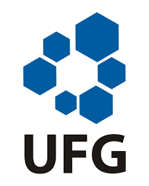
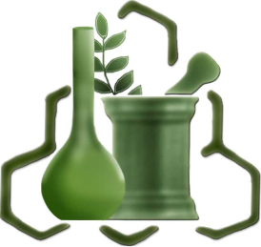
SCHOOL OF PHARMACY
FEDERAL UNIVERSITY OF GOIÁS - UFG
Rua 240, s/n, 74605-170, Goiânia - GO, Brazil
Phone: +55 (62) 3209-6470

May 12th, 2020

Dear Editor,

We are submitting the paper “A new and ecological method to quantify vancomycin in pharmaceutical product by infrared” for consideration of publication in the “Acta Chimica Slovenica”. We confirm that all authors have read and approved this version of the article, and no part of this paper has been published or submitted for publication elsewhere, nor will it be submitted elsewhere. Moreover, the authors have no financial or non-financial interests that represent a conflict of interest.

We can highlight:
- Vancomycin is an antimicrobial for parenteral use
- This work shows a new, ecological and green method by infrared for quantification of vancomycin in pharmaceutical product
- The method adds advantages to existing ones
- It is fast, low cost, easy to handle, does not use organic solvents, does not need sample pre-treatment and the waste generation is minimal
- It is an eco-friendly and sustainable alternative to the routine analyzes of quality control of this product.

If there are any questions regarding this manuscript or its content, please let us know.
Sincerely,

Ana Carolina Kogawa (corresponding author).

