Article
Study of Select Morphologic, Structural and Optical Effects of Silver Coating CBD-CdS Thin Films
Angel Roberto Torres-Duarte¹, Horacio Antolín Pineda-Leon^{1,2}, Aned de Leon³∗, Ramón Ochoa-Landín⁴, Santos Jesús Castillo¹
¹Departamento de Investigación en Física, Universidad de Sonora, Apdo. Postal 5-088, CP. 83000, Hermosillo, Sonora, México
²Departamento de Matemáticas, Universidad de Sonora, CP. 83000, Hermosillo, Sonora, México
³Departamento de Ciencias Químico Biológicas, Universidad de Sonora, C.P. 83000, Hermosillo, Sonora, México.
⁴Departamento de Física, Universidad de Sonora, CP. 83000, Hermosillo, Sonora, México

Abstract
This work focused on growing cadmium sulphide (CdS) thin films through chemical bath deposition and depositing silver aggregates as a coating (CdS:Ag). Absorption and transmission responses were found. Calculated direct band gap energies yielded values of 2.50 (CdS) and 2.49 eV (CdS:Ag). Our scanning electron microscope characterization at different magnifications, visualized cluster formations with granular shapes. The highest magnification of 50,000x showed silver clusters as shiny granulates, which were confirmed by microprobe elemental mapping at a magnification 18,000x. Energy Dispersive Spectroscopy revealed that the light composition of the silver clusters was the unique difference from the CdS thin film. X-Ray Diffraction results only detected the hexagonal CdS pattern, but no silver. The crystallite size was of around 13 nm. A Surface-Enhanced Ramman Scattering effect was observed upon the silver coating of the CdS thin film at 293.3 cm⁻¹.
Keywords: CdS thin films, Ag coated film, CBD, characterization

Introduction
Cadmium sulphide has been applied in some optoelectronical devices and used as window layer in solar cell thin films.^{1,2} However, upon direct contact is a hazardous material living beings.³ It has been reported that silver (Ag) has no negative effect on humans.⁴ Thus, this work focuses on coating CdS thin films with silver and characterize them to compare them to pure CdS thin films.
The synthesis methods of CdS are pulsed laser deposition (PLD),⁵ molecular beam epitaxy (MBE),⁶ thermal evaporation, sputtering, chemical vapor deposition (CVD),⁷ chemical bath deposition (CBD),⁸ among others. In 2000, SJ Castillo et al. diffused metallic indium on a CdS thin film.⁹
In 2010, A. de Leon et al. theoretically studied the interactions between CdS and glycine.¹⁰ In 2011, A. Apolinar-Iribe et al. synthesized hexagonal CdS thin films with acetylacetone as complexing agent through CBD.¹¹ In 2017, M. Ruiz-Preciado et al. developed criteria to adjust the growth of both, CdS and CdTe Thin Films elaborated by the PLD technique.¹² In 2011, S. Rengaraj et al. developed a solution phase synthesis method for cubic CdS hollow microspheres of around 2.5 μm in diameter, with photocatalytic activity.¹³ In 2019, Chao Xu et al. predicted the formation of clusters of combined elements including cadmium, silver, sulfur and oxygen with promising semiconducting and photocatalytic activity.¹⁴ T. Zhai et al. have synthesized CdS micro/nanowires, nanorods, nanotubes and other nanostructures for applications in electronic and optoelectronic devices.¹⁵
J. Kaur et al. synthesized CdSe thin films doped with Ag and analyzed some morphological, optical and structural properties.¹⁶ Furthermore, CdS thin films were prepared via thermal evaporation and then immersed on a silver nitrate (AgNO₃).¹⁷

Experimental
In this section, we explain the CdS thin film and the silver coated CdS thin film recipes. The cadmium source for the CdS thin film, was 10 mL of a 0.1M solution of cadmium nitrate, Cd(NO₃)₂. 20 mL of a 0.5 M solution of the complexing agent, sodium citrate, Na₃C₆H5O₇, were added. To control the pH of the reaction, we used 10 mL of a 0.3 M solution of potassium hydroxide (KOH). Afterwards, we poured 10 mL of a 0.5M solution of thiourea, CS(NH₂)₂, as the sulfur source. Next, 5 mL of a pH 11 buffer, NH₄OH/NH₄Cl were included. Finally, we afforated to a volume of 95 mL with the aid of deionized water. Furthermore, 4 Corning brand soda lime glass substrates were vertically immersed in the reactor at 70°C for 30 min. After this, we obtained 4 CdS thin films deposited on the glass substrate. Two of these samples were used for characterization. The other two were reimmersed on a colloidal silver suspension at 24°C for 20 min. The colloidal silver suspension was prepared with 2.5 mL of Microdyn brand commercial colloidal silver (0.082% volume of colloidal silver). Two silver coated CdS thin films were obtained.
The CdS and silver coated CdS thin films were characterized through different devices. Transmission and adsorption characterizations were performed with a UV-Vis Nanodrop 2000 ThermoScientific brand spectrophotometer. SEM and EDS characterizations were carried on with a JEOL JSM-7800F equipment. The XRD characterization was realized with a RIGAKU Dmax2100 equipment. The Raman characterization was done with a Dilor Labram II equipment with an excitation line of 632.8 nm.

Results and Discussion
As it can be observed on Fig. 1, this thin film has a low absorption between 553 and 1100 nm. While it has an absorption edge at wavelengths lower than 496 nm. On the other hand, the transmission graph for this thin film shows a transmission higher than 70% for wavelengths higher than 553 nm.
Figure 1. Absorption and transmission responses for CdS thin film.
Fig. 2 shows that his thin film has a low absorption between 615 and 1100 nm. It has an absorption edge at wavelengths lower than 498 nm. On the other hand, the transmission graph for this thin film shows a transmission higher than 70% for wavelengths higher than 615 nm.
Figure 2. Absorption and transmission responses for a silver coated CdS thin film.
In order to be explicit about the transmission difference between the two films, we display Figure 3. The transmission curves differ from 492 to 894 nm, where the CdS layer coated with silver decreases its transmission mildly. It should be noted that CdS films are yellowish, while the resulting CdS films coated with silver change to an amber-like color.
Figure 3. Transmission responses for the CdS thin film (solid line) and the silver coated CdS thin film (dashed line).
We processed the optical absorption data generated on Figs. 1 and 2 in order to obtain Fig. 4 where we evaluated the direct band gaps through the Tauc method.¹⁸ As it can be seen for the CdS thin film, the direct band gap was of 2.50 eV, while for the silver coated CdS thin film, there was a slight reduction to 2.49 eV. This reduction can be interpreted as a very localized doping on the surface. These energy band gap values correspond to 496 and 498 nm for the CdS and silver coated CdS thin film, respectively. On the study performed by Shah et al.,¹⁷ the CdS thin film reached to a maximum transmission value of 80%, while on our graphs, after 589 nm the transmission values are higher than 80% up to 92% on the visible region.
Figure 4. Direct band gaps obtained via the Tauc method.

The morphologic studies performed by the SEM technique show differences on the surfaces of the films. Figure 5 depicts a scale of 1 μm at a magnification of 10,000x. Part a) corresponds to the CdS thin film where a flat background is observed with some imperfections. Part b) corresponds to the silver coated CdS thin film, where additional isolated spheres appear, which we expect to be silver since the CdS thin films were immersed in a colloidal silver suspension.
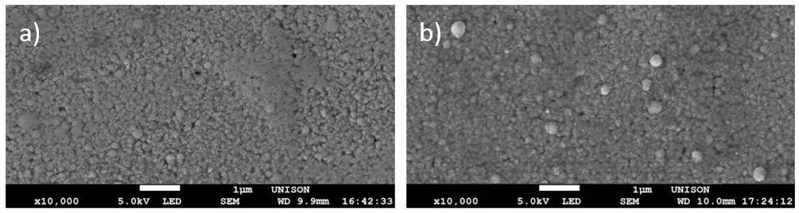
Figure 5. SEM 1μm images at a magnification of 10,000x of a) CdS thin film, b) silver coated thin film.
Figure 6 displays the films of Figure 5 indicating a scale of 100 nm and a magnification of 50,000x. Part a) corresponds to the CdS thin film where the flat background is has granular formations (CdS clusters). In part b) corresponding to the silver coated CdS thin film, small shiny grains have been formed. These are presumed to be Ag incorporated to CdS.
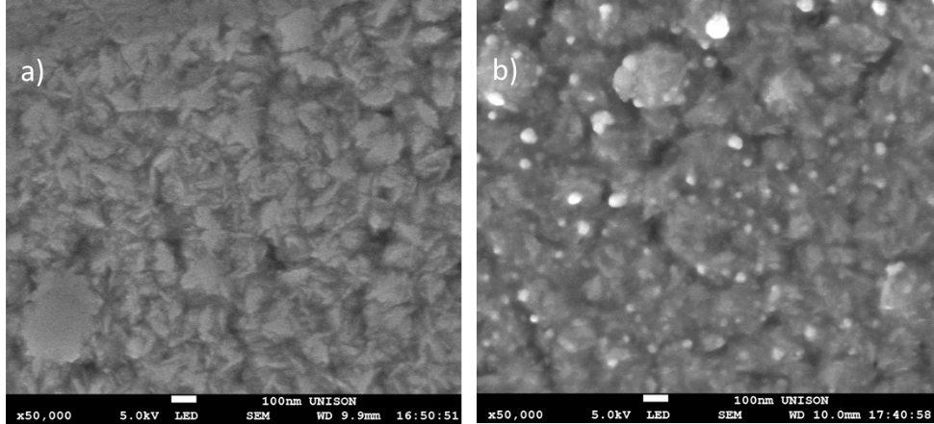
Figure 6. SEM 100 nm images at a magnification of 50,000x of a) CdS thin film, b) silver coated thin film.
An elemental mapping was carried on the bilayer of the silver coated CdS thin film where the distributions of the elements sulphur, cadmium and silver. Part a) corresponds to a morphologic image on a gray scale formed by secondary electrons. In contrast, part b) is formed by a EDS energy detector coupled to the SEM generating a surface mapping of the indicated element distribution. As it can be seen, the bright spots have a high composition of silver as indicated on part b) of Figure 7. Related theoretical research can be found with this configuration of materials on the scientific literature by Chao Xu et al.¹⁴ The research made by Shah et al. obtained noticeably different morphology and did not present the formation of silver aggregates.¹⁷
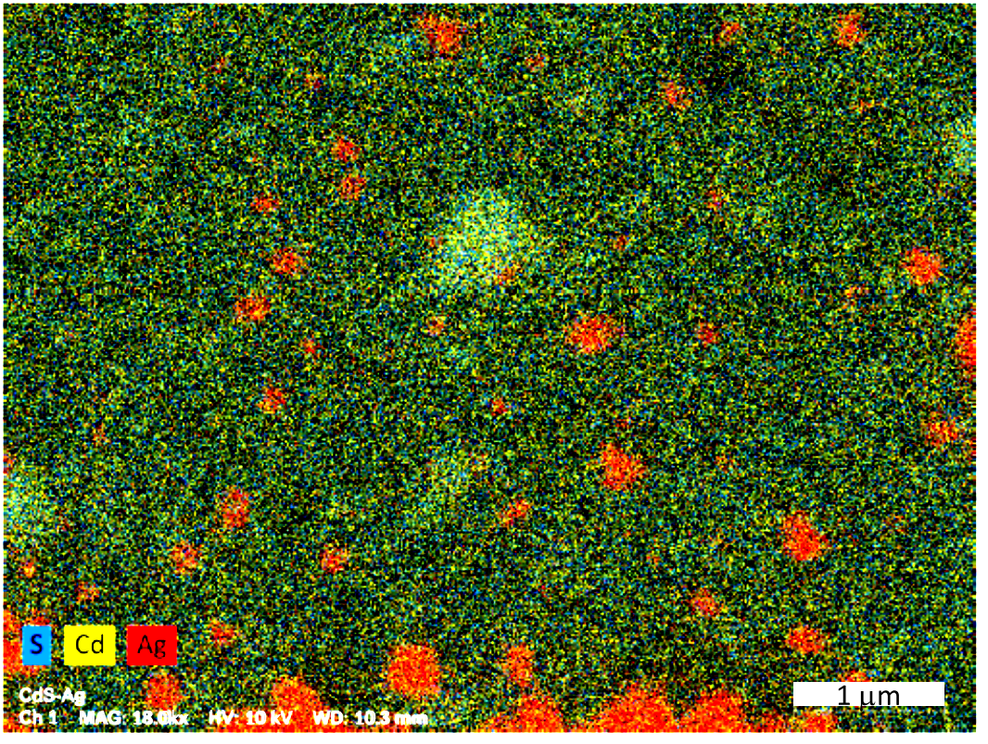
a)
b)
Figure 7. Silver coated thin film images: a) SEM 1μm at a magnification of 18,000x, b) EDS coupled to SEM surface mapping.
EDS measurements were performed to both films. The distribution of elements was portrayed on Figure 8, where the curves of both films are superposed. The CdS thin film curve has well-defined signals for oxygen, sodium, silicon, sulphur, cadmium and other elements. Cadmium and Sulphur signals are due to the film, yet the rest of them are originated from the substrate.
Figure 8. EDS measurements of CdS (gray solid line) and silver coated CdS (black solid line) thin films.
In the case of the silver coated CdS thin film, signals corresponding to the elements aforementioned are present. In addition, a signal corresponding to the energy of silver at 2.98 KeV arose. This characterization enhances the slight difference between both systems of thin films. This justifies a surface difference in chemical composition.
Table I lists EDS measurements (mass %) and the calculated atomic percentages of the elements labeled on Figure 8. The study focused on the next elements: carbon, oxygen, sodium, silicon, sulphur, cadmium and silver. Sulphur and cadmium percentages almost remained constant on both films. However, in the thin film immersed in a colloidal silver suspension, an atomic percentage of silver of 1.90 % emerged. In comparison to the work of Shah et al. a similar trend in composition for the EDS was observed.
Table I. EDS measurements: mass and atomic percentages.
 | CdS |  | CdS:Ag
Element | Mass (%) | Atoms (%) | Mass (%) | Atoms (%)
C | 3.93 | 11.25 | 4.50 | 13.44
O | 12.8 | 27.53 | 10.44 | 23.39
Na | 4.07 | 6.09 | 4.09 | 6.37
Si | 21.68 | 26.56 | 20.72 | 26.45
S | 9.89 | 10.61 | 9.79 | 10.94
Cd | 42.76 | 13.09 | 40.39 | 12.88
Ag | ---- | ---- | 5.71 | 1.90
Others | 4.87 | 4.87 | 4.36 | 4.63

The next characterization is XRD. Figure 9 compiles the XRD patterns for CdS and CdS:Ag. The identified planes indicated on the figure are: (002), (101), (103) and (112). These correspond to hexagonal CdS (PDF# 41-1049). As it can be appreciated, the pattern for the silver coated CdS film is mildly more defined. This enhancement could be due to the silver clusters deposited on CdS. From the CdS pattern we calculated the crystallite size ($c_{s}$) by using the Debye-Scherrer equation.
$c_{s}=\frac{0.9λ}{βcosθ}$ (1)
Where $λ$ is the used X-ray wavelength=1.5418 Å; $β$ is the full width at half maximum (FWHM) of the main peak, 0.0108 rad and $θ$ is half of angular value at the peak location in the diffraction pattern, $2θ=26.72°$.
$$c_{s}=\frac{0.9(1.5418Å)}{0.0108(cos13.36°)}=132.057Å=13.2057 nm$$
This crystallite size was obtained utilizing the XRD for the CdS film.
Figure 9. XRD patterns for CdS (lower) and silver coated CdS (upper) thin films.
Finally, Figure 10 presents the comparison of the Raman dispersion spectra. The black curve shows sequential disperson bands of low amplitude, without well defined peaks. On the other hand, when the CdS layer was coated with silver, the Raman dispersion spectrum was modified significantly at 293.3 cm⁻¹ (1LO) as it is displayed on the gray curve. This corresponds to values reported on the literature.¹³ The fundamental modification consists on an extreme magnification on the dispersion 1LO due to the SERS (surface-enhanced Raman scattering) effect. Similar results were obtained in.¹⁷
Figure 10. Raman dispersion spectra of Cds (gray solid line) and silver coated CdS (black solid line) thin films.

Conclusions
On the comparative study of CdS and silver coated CdS thin films slight differences on their properties were observed. The most important differences were the formation of silver discrete aggregates and the SERS effect on the Raman characterization. In addition, the absorption and transmission properties varied slightly from 492 to 894 nm, causing the band gap to a decrease in only 0.01 eV. XRD studies did not detect the presence of silver.

References
1. M. Isshiki, J. Wang, II-IV Semiconductors for Optoelectronics: CdS, CdSe, CdTe. In: S. Kasap, P. Capper (Ed.) Springer, Cham. 2017, 853-865.
2. M.M. Ristova, M. Ristov, Solar Energy Materials and Solar Cells 1998, 53, 95-102.
3. A. Pramanik, A.K. Datta, S. Gupta, B. Ghosh, D. Das, D.V. Kumbhakar, Int. J. Res. Pharm. Sci. 2017, 8, 741-753.
4. S. Sarkar, A.D. Jana, S.K. Samanta, G. Mostafa, Polyhedron 2007, 26, 4419-4426.
5. H. Pengchen, L. Bing, F. Lianghuan, W. Judy, J. Haibo, Y. Huimin, X. Xinju, Surf. & Coat. Technol. 2012, 213, 84-89.
6. W.P. Mc Cray, Nature Nanotech 2007, 2, 259-261.

7. M.A. Buckingham, A.L. Catherall, M.S. Hill, A.L. Johnson, J.D. Parish, Cryst. Growth Des. 2017, 17, 907-912.
8. K. Mokurala, L.L. Baranowski, F.W. de Souza-Lucas, S. Siol, F.A. Maikel, M. van Hest, S. Mallick, P. Bhargava, A. Zakutayev, ACS Combinatorial Sci. 2016, 18, 583-589.
9. S.J. Castillo, A. Mendoza-Galvan, R. Ramirez-Bon, F.J. Espinoza-Beltrán, M. Sotelo-Lerma, J. González-Hernández, G. Martínez, Thin Solid Films, 2000, 373, 10-14.
10. A. de Leon, M.C. Acosta-Enriquez, S.J. Castillo, D. Berman-Mendoza, A.F. Jalbout, J. Molec. Struct.: THEOCHEM, 2010, 951, 34-36.
11. A. Apolinar-Iribe, M.C. Acosta-Enriquez, M.A. Quevedo-Lopez, R. Ramirez-Bon, S.J. Castillo, Chalc. Lett. 2011 8, 77-82.
12. M. Ruiz-Preciado, M.A. Quevedo-Lopez, A.G. Rojas-Hernandez, A. de Leon, A. Apolinar-Iribe, R. Ochoa-Landin, G. Valencia-Palomo, S.J. Castillo, Digest J. Nanomater. and Biostruct. 2017, 12, 1057-1067.
13. S. Rengaraj, S.H. Jee, S. Venkataraj, Y. Kim, S. Vijayalakshmi, E. Repo, A. Koistinen, M. Sillanpää, J. Nanosci. Nanotechnol. 2011,11, 2090-2099.
14. X. Chao, S. Ming-Ming, S. Hua-Tian, M. Strømme, Z. Qian-Feng, Dalton Trans. 2019, 48, 5505-5510.
15. T. Zhai, X. Fang, L. Li, Y. Bando, D. Golberg, Nanoscale 2010, 2, 168-187.
16. J. Kaur, R. Kaur, S.K. Tripathi, Acta Metallurgica Sinica (Eng. Lett.) 2019, 32, 541-549.
17. N.A. Shah, A. Nazir, W. Mahmood, W.A.A. Syed, S. Butt, Z. Ali, A. Maqsood, J. Alloys and Compounds 2012, 512, 27-32.
18. J. Tauc, Mater. Research Bull. 1968, 3, 37-46.

∗ corresponding author email: aned.deleon@unison.mx

