Supporting Information
Elaboration of lamellar and nanostructured materials based on manganese: Efficient adsorbents for removing heavy metals
Amina Amarray,¹ Sanae El Ghachtouli,^{1*} Mohammed Ait Himi,¹ Mohamed Aqil,² Khaoula Khaless,³ Younes Brahmi,² Mouad Dahbi,² Mohammed Azzi¹
¹ Laboratoire Interface Matériaux – Environnement, Faculté des Sciences Ain-Chock, Université Hassan II de Casablanca, B.P 5366 Maarif, Casablanca, Maroc.
² Materials Science and Nano-engineering Department, Mohammed VI Polytechnic University (UM6P), Ben Guerir, Morocco.
³ Department of Chemical and Biochemical Sciences, Green Process Engineering CBS. Mohammed VI Polytechnic University, Ben Guerir, Morocco.
* Corresponding author: E-mail address: s.elghachtouli@gmail.com.

Supporting Figures
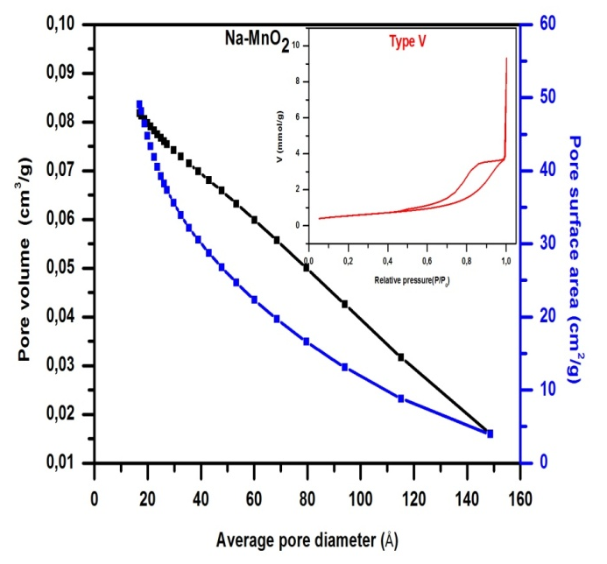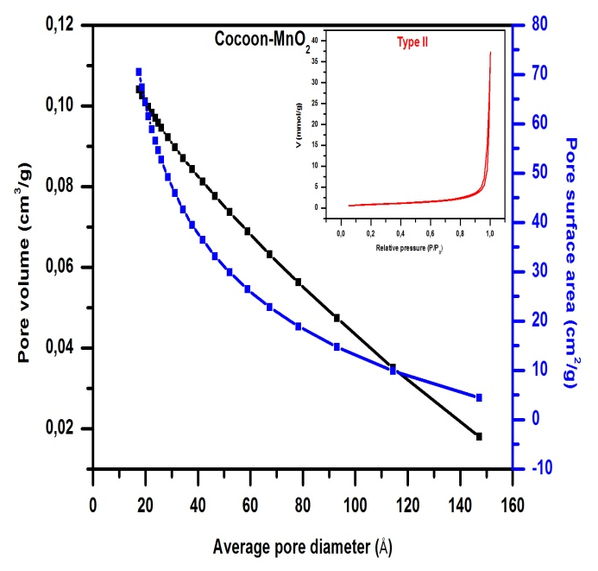
- (b)
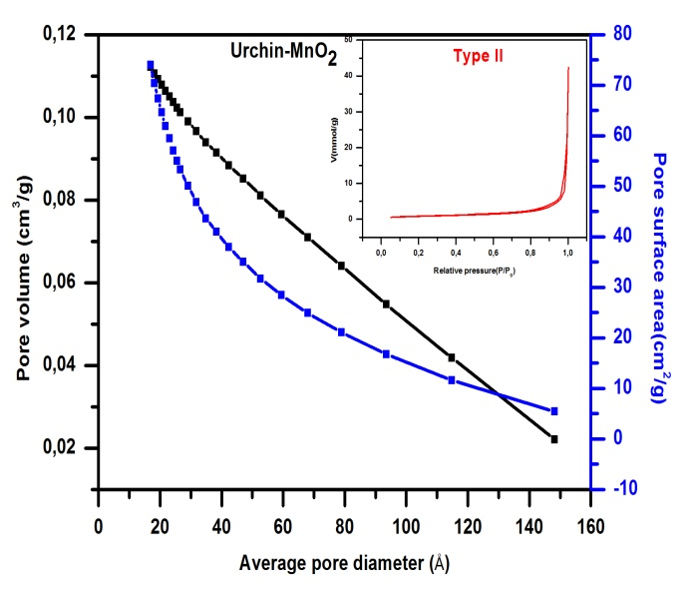
(c)
Figure S1. N₂ adsorption-desorption isotherms of (a) Na-MnO₂, (b) Cocoon-MnO₂ and (c) Urchin-MnO₂

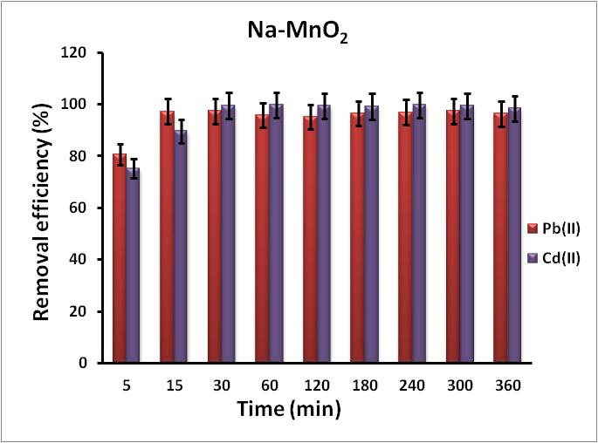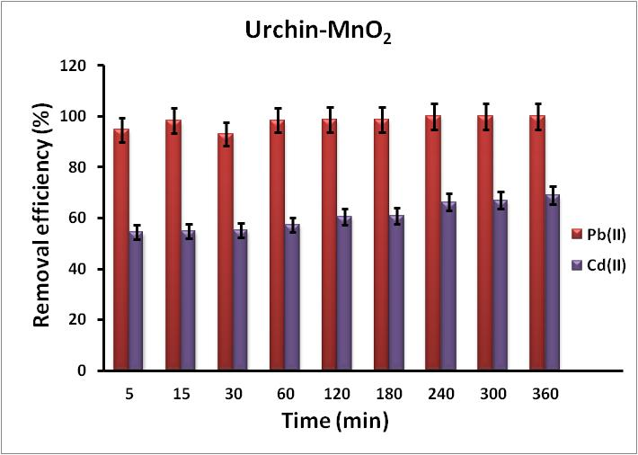

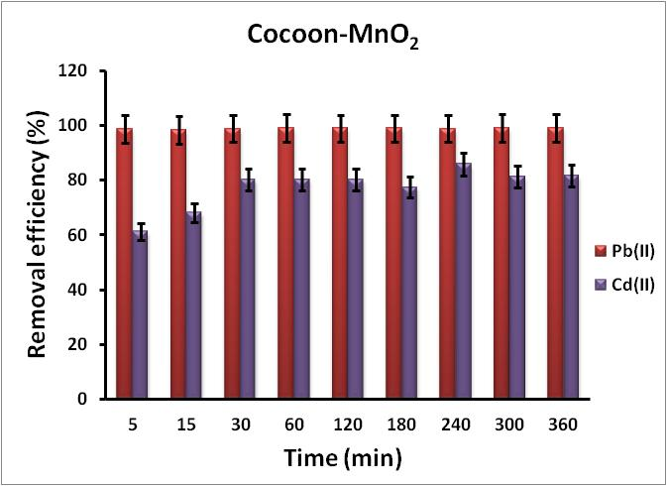
Figure S2. Comparative study of Cd(II) and Pb(II) removal efficiencies by Na-MnO₂, Urchin-MnO₂ and Cocoon-MnO₂
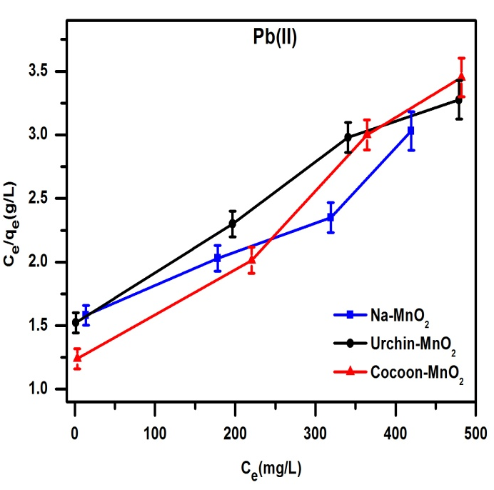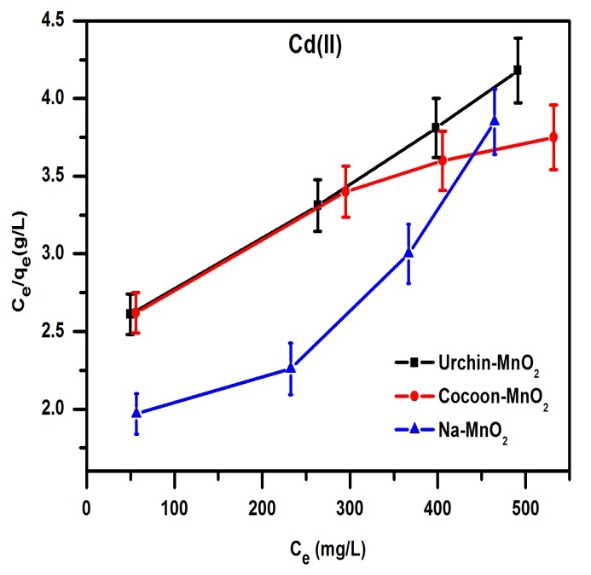
Figure S3. Langmuir isotherm plot for Pb(II) and Cd(II) adsorption onto Na-MnO₂, Urchin-MnO₂ and Cocoon-MnO₂

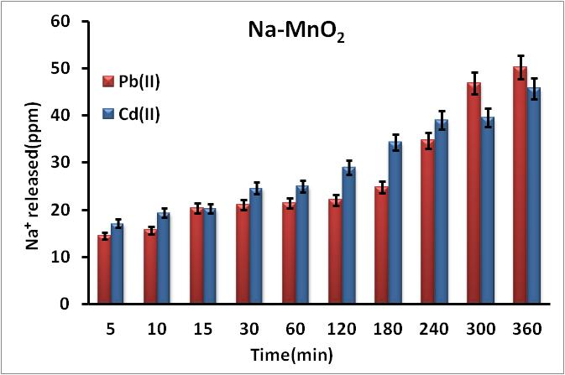
Figure S4. Amount of Na⁺ released during the removal of Pb(II) and Cd(II) ions by Na- MnO₂ material
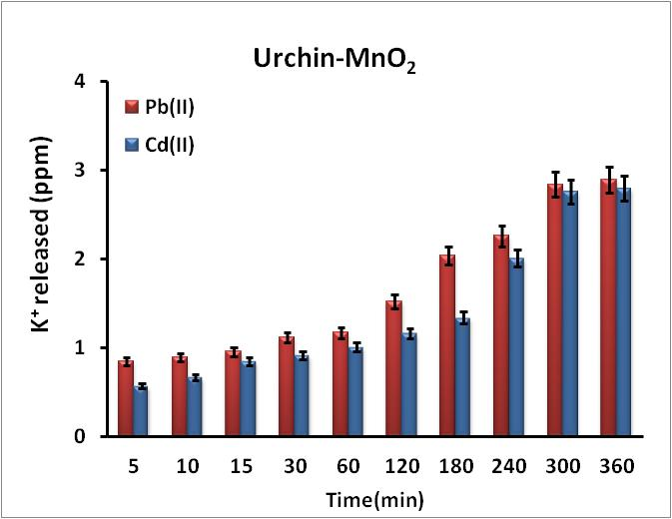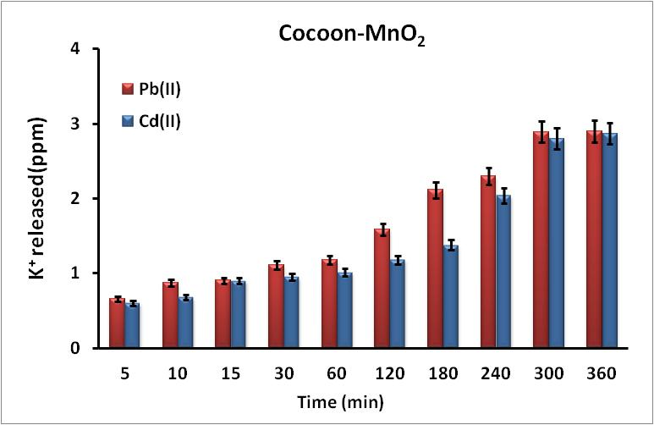
Figure S5. Amount of K⁺ released during the removal of Pb(II) and Cd(II) ions by Urchin-MnO₂ and Cocoon-MnO₂

Supporting Tables

Table S1: Porous structure parameters of the Na-MnO₂, Urchin-MnO₂ and Cocoon-MnO₂
 | Analysis of pore distribution (BJH) (%) | Average pore diameter of adsorption/desorption  (Å) (BJH) | Cumulative volume of adsorption/desorption (BJH) (cm³/g)  17Å<d< 3000Å
Na-MnO₂ | Micropores: 17.39  Mesopores: 52.17  Macropores: 30.44 | 66.630/75.844 | 0.0817/0.1232
Urchin-MnO₂ | Micropores: 13.63  Mesopores: 54.54  Macropores: 31.82 | 60.657/64.581 | 0.1121/0.1327
Cocoon-MnO₂ | Micropores: 14.29  Mesopores: 52.38  Macropores: 33.33 | 59.014/59.290 | 0.1040/0.1189

Table S2: Kinetic parameters for adsorption of Pb(II) and Cd(II) on manganese oxides materials
Pb(II)
Na-MnO₂  q_{exp}= 15.76mg/g | Urchin-MnO₂  q_{exp}= 12.04mg/g |  | Cocoon-MnO₂  q_{exp}= 14.85mg/g
Pseudo-first order
q_{e}= 1.33 mg/g | q_{e}= 1.0087 mg/g |  | q_{e}= 3.752 mg/g
K_{t}= 0.0184 min⁻¹×g/mg | K_{t}= 0.0101min⁻¹×g/mg |  | K_{t}= 0.0239 min⁻¹×g/mg
R²= 0.9996 | R²= 0.8821 |  | R²= 0.8787
Pseudo-second order
q_{e}= 14.81 mg/g | q_{e}= 12.06 mg/g |  | q_{e}= 14.92 mg/g
K= 0.058 min⁻¹×g/mg | K= 0.0846 min⁻¹×g/mg |  | K= 0.0478min⁻¹×g/mg
R²= 0.9998 | R²= 0.9999 |  | R²= 0.9997
Cd(II)
Na-MnO₂  q_{exp}= 15.13 mg/g |  | Urchin-MnO₂  q_{exp}= 10.44 mg/g |  | Cocoon-MnO₂  q_{exp}= 12.57 mg/g
Pseudo-first-order
q_{e}= 2.029 mg/g |  | q_{e}= 2.110 mg/g |  | q_{e}= 8.230 mg/g
K_{t}= 0.0177 min⁻¹×g/mg |  | K_{t}= 0.0026 min⁻¹×g/mg |  | K_{t}= 0.1308 min⁻¹×g/mg
R²= 0.8960 |  | R² = 0.9881 |  | R²= 0.9204
Pseudo-second-order
q_{e} = 15.25 mg/g |  | q_{e}= 10.58 mg/g |  | q_{e}= 12.75 mg/g
K= 0.0192 min⁻¹×g/mg |  | K= 0.0133min⁻¹×g/mg |  | K= 0.043 min⁻¹×g/mg
R²= 0.9990 |  | R²= 0.9969 |  | R² = 0.9985

Table S3: Isotherm parameters for Langmuir, Freundlich and Temkin models
 | Langmuir isotherm |  |  | Freundlich isotherm |  |  | Temkin isotherm
 | R² | q_{m}  (mg/g) | b | R² | K_{F} | n | RT/b_{T} | K_{TKKK} K_{T} | R²
 | Pb(II)
Urchin-MnO₂ | 0.9844 | 263.85 | 2.435×10⁻³ | 0.9476 | 45.760 | 4.88 | 19.120 | 205.250 | 0.9825
Cocoon-MnO₂ | 0.9820 | 209.64 | 4.146×10⁻³ | 0.6992 | 34.300 | 6.378 | 10.734 | 909.730 | 0.5783
Na-MnO₂ | 0.9409 | 297.62 | 2.290 ×10⁻³ | 0.8882 | 35.930 | 3 | 26.635 | 0.087 | 0.6829
Cd(II)
Urchin-MnO₂ | 0.9981 | 191 | 3.032×10⁻³ | 0.8029 | 0.8366 | 1.185 | 26.661 | 0.442 | 0.5607
Cocoon-MnO₂ | 0.9499 | 171.53 | 5.322×10⁻³ | 0.7745 | 0.650 | 1.291 | 13.178 | 3.027×10⁻³ | 0.7975
Na-MnO₂ | 0.9655 | 199 | 4.635×10⁻³ | 0.9087 | 2.085 | 1.598 | 31.972 | 8.168×10⁻⁴ | 0.7482

