Elaboration of Lamellar and Nanostructured Materials Based on Manganese: Efficient Adsorbents for Removing Heavy Metals
Amina Amarray,^{1*} Sanae El Ghachtouli,^{1*} Mohammed Ait Himi,¹ Mohamed Aqil,² Khaoula Khaless,³ Younes Brahmi,² Mouad Dahbi,² Mohammed Azzi¹
¹ Laboratoire Interface Matériaux – Environnement, Faculté des Sciences Ain-Chock, Université Hassan II de Casablanca, B.P 5366 Maarif, Casablanca, Maroc.
² Materials Science and Nano-engineering Department, Mohammed VI Polytechnic University (UM6P), Ben Guerir, Morocco.
³ Department of Chemical and Biochemical Sciences, Green Process Engineering CBS. Mohammed VI Polytechnic University, Ben Guerir, Morocco.
* Corresponding author: E-mail address: s.elghachtouli@gmail.com.

Abstract
The lamellar and nanostructured manganese oxide materials were chemically synthesized by soft, non-toxic methods. The materials showed a monophasic character, symptomatic morphologies, as well as the predominance of a mesoporous structure. The removal of heavy metals Cd(II) and Pb(II) by the synthesized materials Na-MnO₂, Urchin-MnO₂ and Cocoon-MnO₂ according to the mineral structure and nature of the sites were also studied. Kinetically, the lamellar manganese oxide material Na-MnO₂ was the most efficient of the three materials which had more vacancies in the MnO₆ layers as well as in the space between the layers. The nanomaterials Urchin-MnO₂ and Cocoon-MnO₂ could exchange with the metal cations in their tunnels and cavities, respectively. The maximum adsorbed quantities followed the order (Pb(II): Na-MnO₂ (297 mg/g)˃Urchin-MnO₂ (264 mg/g)˃Cocoon-MnO₂ (209 mg/g), Cd(II): Na-MnO₂ (199 mg/g)˃Urchin-MnO₂ (191 mg/g) ˃ Cocoon-MnO₂ (172 mg/g)). The best stability among the different structures was recorded in the case of the Na-MnO₂, which presented a very low amount of the manganese released. The results obtained showed the potential of lamellar manganese oxides (Na-MnO₂) and nanostructures (Urchin-MnO₂ and Cocoon-MnO₂) as selective, economical, and stable materials for the removal of toxic metals in an aqueous medium.
Keywords: Cadmium; Lead; Waste Water; Manganese oxide; Kinetic; Mesoporous structure.
1. Introduction
The depletion of drinking water resources had been a global problem in recent years, due to water pollution by heavy metals mainly from intensive human activities. These pollutants were not biodegradable and toxic.¹ Moreover, all along the food chain, some of them were concentrated in living organisms, which posed major risks to the environment and human health.^{2–4} This contamination was certainly the most serious case among the problems posed by environmental pollution.^{5–7} Metal ions were more precisely cadmium and lead were generally released without appropriate treatment during industrial processes^{8,9} such as in metal factories, paint industries, battery production as well in the combustion of motor gasoline (lead), etc... Lead and cadmium were persistent metals in the subsoil. Consequently, lead contamination of soil and groundwater was a serious problem.¹⁰ Exposure to Pb(II) and as it was known worldwide could damage the nervous system and be carcinogenic to humans.^{11–14} It could also damage the kidneys, cellular processes and the reproductive system.¹⁵ Toxic symptoms could occur in several ways such as anemia, insomnia, headaches, muscle weakness, hallucinations and kidney damage.¹⁶ The United States Environmental Protection Agency had classified cadmium as a probable human carcinogen.¹⁷ Chronic exposure to cadmium posed serious risks, including kidney dysfunction and high levels of exposure leading to death.¹⁸ Environmental requirements were becoming increasingly stringent in the paint industry, as for all industrial activities.
Intensive research and development efforts were being used worldwide to develop effective processes to reduce or eliminate toxic metal ions in aqueous solutions using precipitation of several metals such as lead,¹⁹ cadmium²⁰ and magnesium,²¹ but provided that this process was carried out at a pH between 8 and 11.^{18,22} Others have used polyamide membranes to remove in particular Cd(II)²³ and Cu(II)²⁴ cations by reverse osmosis. Other processes had adopted elaborate materials such as zeolite,^{25,26} which had been used as an adsorbent to remove some heavy metals, but with adequate pretreatment systems for the removal of suspended solids before ion exchange was applied. However, the application of these methods was limited due to their high energy costs, their complex operation and equipment, their secondary pollution and the problem of regeneration. The adsorption technique had proven to be the most efficient process due to its simplicity, ease of implementation and high efficiency over a wide range of concentrations.²⁷ Additionally, it was a cost-effective method for treating large quantities of wastewater containing low levels of pollutants.²⁸ Unlike many techniques based on oxidation/reduction reactions or photocatalytic reactions, adsorption remained a method that does not lead to the formation of products/by-products that may be more or less toxic, or that subsequently caused secondary contamination. For this purpose, several types of adsorbents had been used, either synthetic^{29,30} or natural such as calcium hydroxyapatite (CaHAP)³¹ and barium hydroxyapatite (BaHAP),³² perlite which has been used to remove cadmium and nickel ions in aqueous medium.³³ Peat,³⁴ carbon nanotubes,³⁵ alumina,³⁶ mesoporous silica,³⁷ and clays^{38,39} had also been applied to remove or reduce some heavy metals at different concentrations. However, these adsorbents had several disadvantages. They were characterized by their low adsorption capacity and reactivity to certain metal cations, as well as the equilibrium time which was long enough to remove heavy metals.
The manganese oxides materials existed widely in a wide variety of forms in the upper crust. They were very important minerals because of their abundance and high reactivity. They were the strongest oxides in soils and were characterized by high sorption power.⁴⁰ They had a high capacity to remove several organic pollutants from soils and sediments.⁴¹ In general, manganese oxides materials were characterized by a low PZC,⁴² a relatively large surface area, and strong acid sites, which gave them a high adsorption capacity and excellent oxidation and catalysis activity.⁴³ Moreover, the layered manganese oxide structure (lamellar structure) was used as an effective adsorbent to remove several heavy metals.⁴⁴ These materials had a variable number of octahedral cationic vacancies within the MnO₆ layers, which were important and significant adsorption sites for metal cation.⁴⁵ The MnO₆ layers in this type of structure were assembled in the form of sandwiches separated from each other to form empty spaces of 7Å (birnessite) or 10Å (buserite), this generateed a large part of the sorption sites.⁴⁶ Tunnel structures were generally made up of single, double or triple chains that were connected by their vertices to form tunnels of square or rectangular cross-section with inserted cations (H⁺ or K⁺).⁴⁷
The use of this type of material to remove metal cations was favorable and generally carried out by ion charge equilibrium exchange with cations inserted in tunnels that were characterized by a space of 4.6Å.⁴⁸ The removal of several metals, including arsenic (III) and (V) in aqueous media, had been studied using materials based on manganese with a compact structure (hausmannite).⁴⁹ Various studies had been carried out to remove several metals such as copper,⁵⁰ nickel,^{51,52} lead,^{53,54} cadmium²⁷ and zinc⁵⁵ ions using iron and modified manganese oxides as adsorbents. A research study reported that despite the high reactivity of iron oxides, the manganese oxides had shown an efficiency 40 times higher than iron oxides in the case of Pb(II) ions.⁵⁶
In this work, we investigated the possibility of removing Pb(II) and Cd(II) ions from the aqueous medium by three manganese oxide materials (marked as Na-MnO₂, Urchin-MnO_{2,} and Cocoon-MnO₂) with different structures lamellar and nanostructures. The composition, morphology, and distribution of the sites of each material were determined by different spectroscopic techniques. To better understand the removal process of Pb(II) and Cd(II) by manganese oxides materials the performing kinetic and adsorption studies were examined. Finally, these materials will be characterized after the interaction by X-ray diffraction. To study the stability of the materials, the total amount of manganese released, and the amount of heavy metal removed will be elucidated.

2. Experimental section
2.1. Chemical compounds
All chemicals used in this study were purchased from Sigma Aldrich and were used without further purification. Solutions were prepared with demineralized water from the Adrona crystal water system (quality ≤ 0.05 µS/cm).

2.2. Synthesis of Na-MnO₂
Manganese oxide Na-MnO₂ was obtained by precipitation at room temperature. During stirring, 10 ml of hydrogen peroxide mixed with 2.16 g of sodium hydroxide dissolved in 90 ml of water was added dropwise to the manganese sulfate (MnSO₄. H₂O) (2.535 g, 50mL). The mixture remained agitated overnight at room temperature. The deep brown precipitate obtained after filtration was washed with water and ethanol. The product was recovered by filtration and dried at 50°C.⁵⁷
2.3. Synthesis of Urchin-MnO₂ Nanostructure
Urchin manganese oxide MnO₂ nanostructure was synthesized by the reflux method under acidic conditions.⁵⁸ 2 g of manganese sulfate (MnSO₄. H₂O) was dissolved in 100 ml of distilled water. In a water bath and under vigorous stirring, 1 ml of sulfuric acid was added by dripping. After stirring a solution of potassium permanganate (0.1M, 66 ml) was added to the mixture. Stirring was maintained at 80°C for 24 hours. The resulting black colored product was isolated and washed several times with water and absolute ethanol. Finally, the product obtained was dried at 60 °C.

2.4. Synthesis of Cocoon-MnO₂ Nanostructures
Synthesis of manganese oxide type cocoon was based on the reduction of Mn(VII) and Mn(II) under ambient temperature conditions. ⁵⁸ 2.54 g of manganese sulfate was dissolved in 150 ml of deionized water after vigorous stirring 100 ml of potassium permanganate KMnO₄ (0.1M) was added by dripping. The resulting mixture was stirred for 6 hours. The resulting black colored product was isolated, washed several times with water and absolute ethanol, and dried at 60 °C.
2.5. Chemical analysis
The chemical composition of the three materials was determined by dissolving 0.1 g of sample with 1g of hydroxylamine hydrochloride in 250 ml of the distilled water.⁵⁹ The resulting Mn, K, and Na content in the solution was determined by atomic absorption spectrometry device (SHIMADZU AA-7000).
Mn average oxidation state (AOS) was determined by potentiometric determination using sodium pyrophosphate. This method avoids errors related to mass and reagent concentration measurements, and the only parameters to be determined are equivalent volumes.⁶⁰ All chemical analysis was repeated three times, and the average was determined.
2.6. Characterization
X-ray diffraction patterns were recorded on a Bruker D8 Advance diffractometer equipped with a graphite monochromator, a Lynx-Eye detector, and parallel beam optics using Cu Kα radiation (λ = 1.54184 Å). Phase identification and material structures were determined by the High Score software (XRD data processing software).
The morphology of the particles of the various samples synthesized was studied by scanning electron microscopy (SEM) with a FEG Gemini 15-25 from LEO.
The specific surface area analysis was performed using the Brunauer-Emmett-Teller (BET) method and the pore size distribution was determined using the Barrett−Joyner−Halenda (BJH) method from N₂ adsorption and desorption isotherms using Micromeritics Gemini VII system. 0.1 g of the sample was degassed before measurement at 110 °C for 3 hours under vacuum equilibrium.
2.7. Batch experiment of Cd(II) and Pb(II) removal
The Cd(II) and Pb(II) ion removal experiments were performed by mixing 100 mg of synthesized material in a 50 ml volume of an aqueous solution containing 30 ppm of the Cd(II) or Pb(II) respectively as Cd(NO₃)₂ or Pb(NO₃)₂. The content was agitated (500 rpm) throughout the interaction. The metal cation removal experiments were performed under ambient conditions at the free pH of the solution (pH = 6.5). The solution was filtered through a 0.45 µm membrane, and the residual concentration of the metal cation Cd(II) concentration in the solution was analyzed using an atomic absorption spectrophotometer (AAS). This allowed us to evaluate the removal efficiency of heavy metal (R%) using Eq. (1) and the adsorbed amount q(t) in mg/g using Eq. (2). The metal removal measurement under the same conditions was proceeded three times.

$$R\left(\%\right)=\left(1-\frac{C_{r}}{C_{0}}\right)*100 (1)$$

$$q\left(t\right)=\frac{\left(C_{0}-C_{r}\right)*V}{m} (2)$$
Where: m: mass of manganese oxide material (100 mg).
V: Volume of the solution used (50 mL).
C₀ and C_{r} were the initial and residual concentrations of metal (cadmium or lead).

3. Results and discussion

3.1. XRD of MnO₂ nanostructures
The diffractograms (Figure 1) of manganese oxides synthesized, namely: Na-MnO₂, Cocoon-MnO₂, and Urchin-MnO_{2,} showed that materials were different and therefore, they don't had the same crystalline structure.
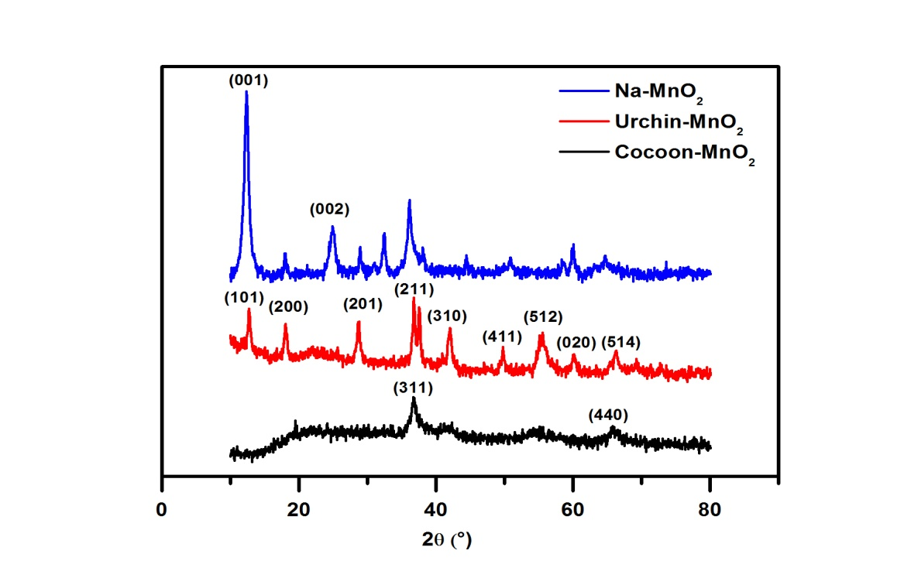
Figure 1. X-ray diffractograms of synthesis manganese oxides materials
The diffractogram of the Cocoon-MnO₂ material (Figure 1) had a very low-intensity signal. This could be explained by the low crystallinity of the material. The poor crystallinity of the material was due to its synthesis at room temperature. The increase in temperature of the reaction not only maked it possible to improve the crystallinity but also to generates different morphologies. Nevertheless, the diffractogram reveals the presence of two diffraction peaks at 2θ = 37° (311) and 65° (440), which had been indexed for the MnO₂ type structure. It was deduced that the sample was in a weakly crystalline state with α-MnO₂ crystallographic forms.⁶¹ This material was characterized by a crystalline structure that had a formula K₂Mn₄O₉ (Table 1).
For the Urchin-MnO₂ material, the diffractogram showed several well-defined and symmetrical peaks indicating that the material was well crystallized. The peaks observed, at 2θ =12.8° (101), 17.8° (200), 28.6° (201), 37.4° (211), 41.6° (310), 49.5° (411), 59.9° (512), 65° (020) and 69.7° (514), could easily be indexed with cryptomelane (KMn₈O₁₆) with a space group (I₂/m(12) (JCPDS sheet No 44-1386).⁵⁸ This material had a tunnel structure whose cation K⁺ was present in these cavities.⁶²
The last diffractogram of Na-MnO₂ material, as shown in (Figure 1) had well-defined with symmetrical diffraction peaks (001) and (002) (JCPDS card #01-073-9669).⁶³ They indicated that material was single-phase mineral and well crystallized. This phase corresponds to the family of birnessite type sodium manganese, which has a layered structure with crystal water and Na⁺ between the MnO₆ octahedral sheets.⁶⁴ This oxide had a basal spacing of 0.714 nm along the c-axis with a single crystal water sheet between the MnO₆ octahedral sheets. The diffraction peaks could be easily indexed as a monoclinic structure (space group: C2/m).⁶⁵ From the diffractograms of the different synthesized oxides had more or less broad peaks. These materials had slightly different surface areas. The chemical formulae, structures, the Mn (AOS) of each material were illustrated in Table 1. The spacing between layers for Na-MnO₂ and the size of the tunnels for Urchin-MnO₂ was calculated from the 2θ values of the peaks using a value of 1.541Å (copper anticathode wavelength).
Table 1: Crystalline parameters and composition of manganese oxide materials (Na-MnO₂, Cocoon-MnO_{2,} and Urchin-MnO₂)
Material | Chemical formula* | d (Å) | Mesh parameters (Å)* | Structure* | Composition in element (ppm)** | (AOS) of Mn
Na-MnO₂ | Na_{0.55}Mn₂O₄.(H₂O)_{1.5}  (Birnessite) | 7.14 | a = 5.1750  b = 2.8490  c = 7.3380 | Monoclinic | [Mn] = 388.87  [Na] = 75 | 3.580
Cocoon-MnO₂ | K₂Mn₄O₉ | ___ | a =b = 11.2950  c = 21.870 | Hexagonal | [Mn] = 704. 16  [K] = 34.79 | 3.650
Urchin- MnO₂ | KMn₈O₁₆  (Cryptomelane) | 4.85 | a = b = 9.840  c = 2.850 | Tetragonal | [Mn] = 637.86  [K] = 33.765 | 3.730
* determined by HighScore software.
** determined by atomic absorption spectroscopy (AAS).

3.2. SEM of MnO₂ Nanostructures
Scanning electron microscopy (SEM) was used to study the detailed surface morphology of the different synthesized materials. As seen in (Figure 2), the morphology of the materials was different.
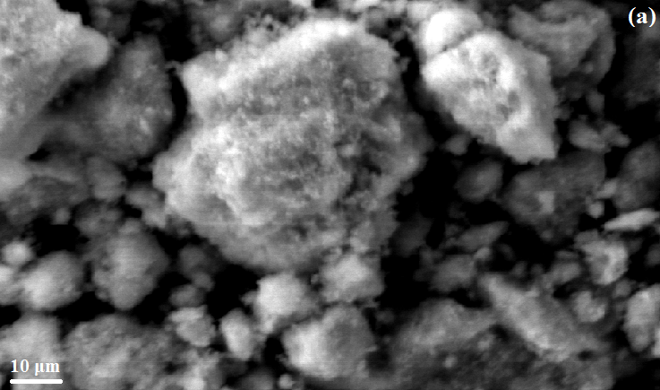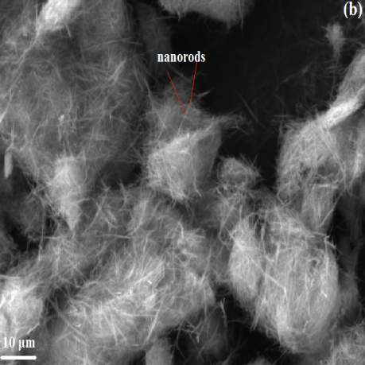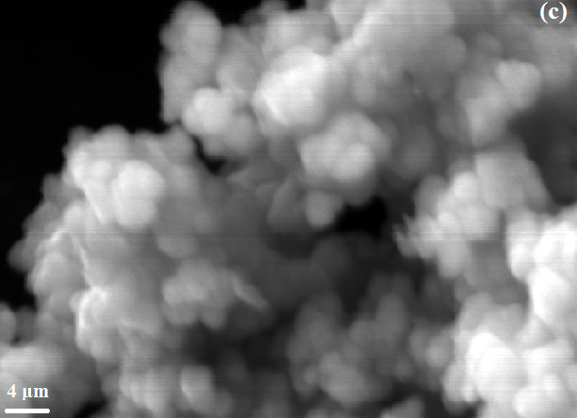
Figure 2. SEM images of (a) Na-MnO₂, (b) Urchin-MnO₂, and (c) Cocoon-MnO₂
The different SEM images showed that the surface morphology of these different materials was highly dependent on the preparation technique. Figure 2 showed that the Na-MnO₂ material (Figure 2a) was composed of thin sheets which were agglomerated together to form particles several micrometers in size. The nanostructured material (Urchin-MnO₂) obtained at 80°C (Figure 2b) had an urchin morphology and composed of a large number of nanorods with different sizes intertwining each other while the material obtained at room temperature (Figure 2c) had a cocoon-shaped morphology composed of microspheres.⁵⁸

3.3. Isotherm BET
All the characteristics of each material, including pore volume, pore size, and specific surface area were determined using conventional nitrogen isothermal analysis. From Eq. (3) we could determine the specific surface area of each material.
$$\frac{1}{Q[\left(\frac{P_{0}}{P}\right)-1]}=\frac{C-1}{C*Q_{m}}*\frac{P}{P_{0}}+\frac{1}{C*Q_{m}} (3)$$
where: P/P₀ was the relative pressure in the cell, Q_{m} was the amount adsorbed, and C was a constant related to the interaction energy between the adsorbent and the adsorbate. The evolution of $\frac{1}{Q[\left(\frac{P0}{P}\right)-1]}$$\frac{1}{Q[\left(\frac{P_{0}}{P}\right)-1]}$ with of $\frac{P}{P_{0}}$ was linear (Figure 3).
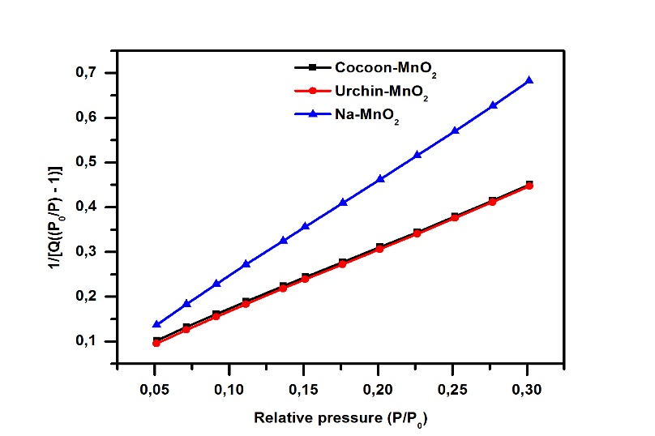
Figure 3. BET isotherm of materials Na-MnO₂, Cocoon-MnO₂, and Urchin-MnO₂

Table 2: Isotherm parameters for BET models
 | Constant C | S_{BET} (m²/g) | Q_{m} | R²
Na-MnO₂ | 75.1 | 30.5 ± 1.7 | 0.457 | 0.9999
Urchin-MnO₂ | 52.9 | 44.3 ± 3.0 | 0.705 | 0.9998
Cocoon-MnO₂ | 41.1 | 43.9 ± 3.3 | 0.709 | 0.9998

Figure 3 showed the BET isothermal models for the three materials. The results of this study showed a high correlation between relative pressures $\frac{P}{P_{0}}$ and $\frac{1}{Q[\left(\frac{P_{0}}{P}\right)-1]}$ that allowed us to determine the specific surface area of each material. According to Table 2, the three materials were characterized by a large specific surface area ranging from 30 to 44 m²/g. These results showed that a large specific BET surface area provided an effective adsorbent. The BET surface of the Na-MnO₂ material was the lowest of the three materials analyzed; this weakness may be attributed to sodium insertion into the material.
Adsorption/desorption studies of N₂ were performed to characterize the pore size distribution of the three materials, the resulting isotherms and BJH diagrams were presented in Figure S1. The adsorption isotherms of three materials exhibited a progressive increase in the amount of gas adsorbed as a function of the relative equilibrium pressure (Figure 3). According to the International Union of Pure and Applied Chemistry classification (IUPAC),⁶⁶ the curve corresponding to the Na-MnO₂ material had a type V shape with a type H3 hysteresis loop associated with mesoporous solids, while the two materials Urchin-MnO₂ and Cocoon-MnO₂ their curves had a type II shape which corresponded to non-porous rather than macroporous solids.
Barrett-Joyner-Hanlenda (BJH) method was used to determine the pore size distribution. We had adopted a pore size classification suggested by the (IUPAC).⁶⁷ Analysis of the BJH pore distribution of the Na-MnO₂ material showed that macrospores (d >50 Å) had about 30.44% of the total porous surface area. Mesopores represented approximately 52%, while micropores had 17.39% of the total surface area. These results showed the predominance of mesopores in the Na-MnO₂ material. This parameter would be a factor and an essential element for the removal of metal ions. The two materials urchin-MnO₂ and Cocoon-MnO₂, mesoporous, had 52% to 54% of the total area (Table S1). The cumulative adsorption/desorption volume for Urchin-MnO₂ was 0.112196/0.132717 cm³/g while for Cocoon-MnO₂ was 0.104038/0.118948. The average pore diameters for these two materials were slightly small compared to Na-MnO₂ (Table S1). It was also noted from Figure S1 that the pore volume was distributed according to all pore sizes studied. All these parameters allowed having the materials with a high affinity of adsorption of heavy metals. During this study, we also surveyed the average diameters of the adsorption and desorption pores of the BJH model, as well as the cumulative volume of adsorption/desorption, the results obtained were illustrated in Table S1.

4. Pb(II) and Cd(II) removal by manganese oxides materials

4.1. Effect of contact time on the removal efficiency of heavy metals
The thermodynamic equilibrium between the adsorbate (liquid phase) and the adsorbent (solid) was achieved with a speed that depends not only on the rate at which the components diffused into the adsorbent and the fluid but also on the adsorbent-adsorbate interaction. The time-dependent study of the adsorption of a compound on an adsorbent allowed us to examine the influence of contact time on its retention. The effect of contact time for the interaction studies between Pb(II), Cd(II) and the synthesized materials in an aqueous medium under ambient temperature conditions were given in Figure 4.
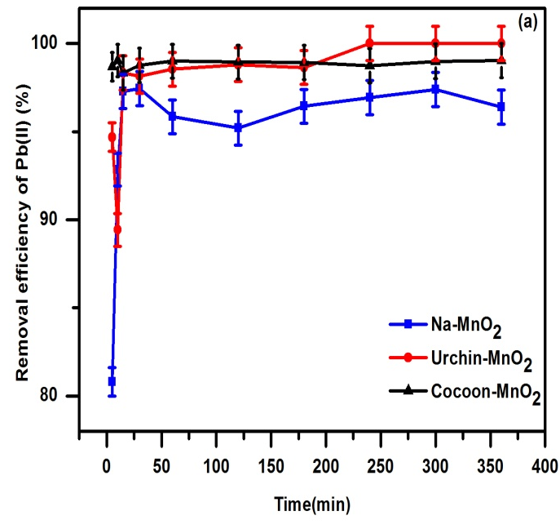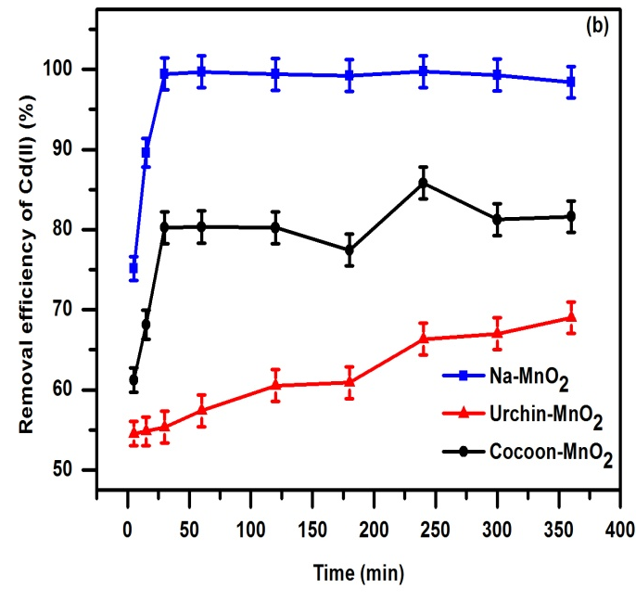
Figure 4. Effect of contact time on (a) Pb(II) and (b) Cd(II) removal by Na-MnO₂, Urchin-MnO₂ and Cocoon-MnO₂ ([Pb(II)]_{initial}=[Cd(II)]_{initial} =30ppm)

Figure 4 demonstrated that the prepared materials gave very high removal efficiency. The removal of lead ion could quickly reach the equilibrium within 15 min allowed to have a removal efficiency of 97.44, 93.15, and 98.77% for Na-MnO₂, Urchin-MnO₂, and Cocoon-MnO₂ respectively. In the case of Cd(II) ions, the materials also showed high reactivity to this metal cation during contact. The highest yield was up to 99% for Na-MnO₂ material during 30 minutes of interaction, while in the case of Urchin-MnO₂ and Cocoon-MnO_{2,} the yields were 55.33% and 80.26% respectively. Several parameters could be used to explain the behavior of Pb(II) and Cd(II) ions during interaction with synthesized materials such as the specific surface area, the acid-base properties of the materials, and certainly their composition and Mn (AOS). In this work, we determined the Mn (AOS) for each material using a specific dosage. The results showed that the materials had an oxidation degree average about 3.5. Therefore, the manganese oxide material was a mixture of Mn(III) and Mn(IV) with Mn(IV) dominated (Table 1). Studies had been done to examine the effect of oxidation degree on the removal efficiency of heavy metals.⁴⁶ The results showed that adsorption capacity increased with increasing oxidation degree. This significant correlation may indicate that samples with a high degree of oxidation contained more octahedral cationic vacancy sites, which were primarily responsible for heavy metals sorption. According to the BET isotherm performed for the three synthesized materials, we had found that these oxides had high specific surfaces (Table 2). This parameter was an essential factor in the properties of an adsorbent. The pore diameter could make possible to enhance metal ions elimination. Also, as noticed previously that the Na-MnO₂ material was characterized by the largest pore diameter (d=66.63Å) compared to the other two kinds of manganese oxides (Table S1). Higher yields recorded for the two metal ions were also enhanced at high pH which was attributed to the formation of a greater number of MOH⁺ (M = metal cation) species with the increase in pH. Therefore, the formation of MOH⁺ species leaded to higher adsorption.
The comparative study on the performance obtained during the interaction of oxides with Pb(II) and Cd(II) (Figure S2) showed that the Na-MnO₂ material had a significant affinity for (Cd(II) and Pb(II)) removal in an aqueous medium. On the other hand, the Urchin-MnO₂ and Cocoon-MnO₂ materials had more affinity for Pb(II) than Cd(II). Several parameters can explain the difference between the yields recorded for Cd(II) and Pb(II). When the lamellar materials (Na-MnO₂) interacted with the Pb(II) and Cd(II) ions, the Pb(II) ions occupied the interlayer MnO₆ and surface sites.⁶⁸ While the Cd(II) mainly occupied the sites above and below the octahedrons of MnO₆.^{59,69} The removal efficiency for each metal depended strongly on its hydrolysis constant. Indeed, this elimination capacity increased with the hydrolysis constants⁷⁰ of Pb(II) and Cd(II), which were respectively 10^{-7.7} and 10^{-10.1}. The cationic exchange was better at low pK value.⁷¹ The pH of the medium studied (pH=6.5) was less than the pK of heavy metals (7.7 and 10.1), indicating that the hydroxylation cations were formed by hydrolysis induced by the surfaces of the manganese oxide.⁷² The metal valency, as well as it's a hydrated radius (r_{hydrated} = r ion + 2r_{H2O} with r_{H2O} = 0.138nm) was also an important parameter in adsorption phenomenon.⁵⁶ Indeed, the higher the valency of the cation, the higher the affinity of the material towards this cation. For equal valence, the cations with a high volume that will be fixed as a priority (Pb(II) (1.19 Å) > Cd(II) (0.95 Å).
4.2. Adsorption Kinetics
The sorption kinetics of Pb(II) and Cd(II) on manganese oxide materials was evaluated, and the results were shown in Figure 5. The adsorption equilibrium was reached within 30 min. The kinetics data were fitted according to pseudo-first order (Eq.(4)) and pseudo-second order (Eq. (5)) kinetics equations. The adsorbed quantities q_{exp}, the order of the constants K and regression coefficients R² were shown in Table S2.

$$\ln\left(q_{e}-q_{t}\right)=-Kt+\ln\left(q_{e}\right) (4)$$
$$\frac{t}{q_{t}}=\frac{1}{( k*q_{e }^{2 })}+\left(\frac{1}{q_{e}}\right)t (5)$$

With:
q_{e}(mg/g) and q_{t}(mg/g) are the adsorbed quantities of Pb(II) or Cd(II) at equilibrium and time t(min).
K: rate constant of the pseudo-first order model (min⁻¹).
k: rate constant of the pseudo-second order model (mg.g⁻¹.min⁻¹).
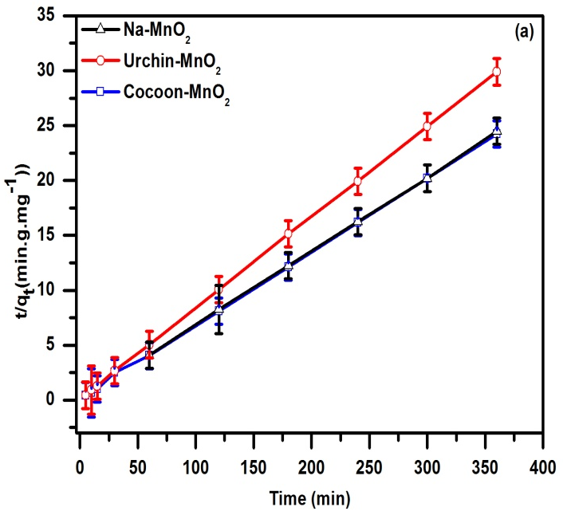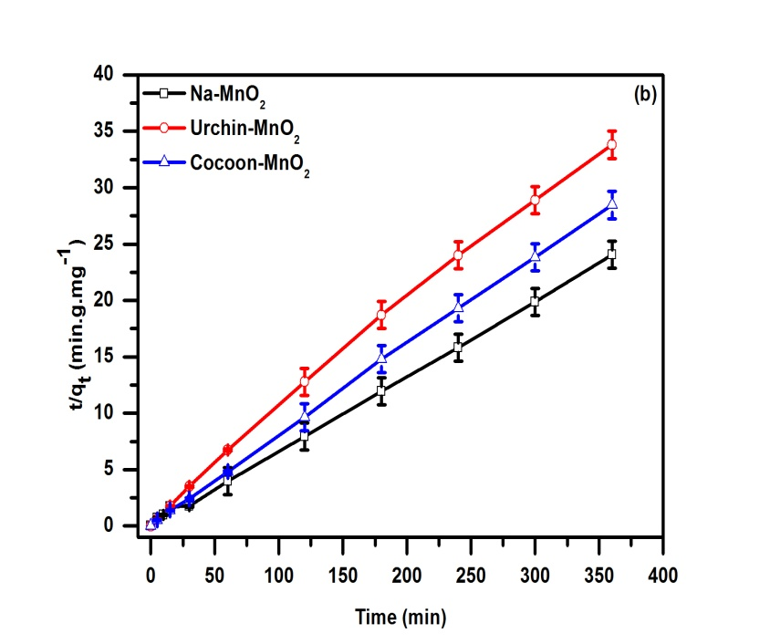Figure 5. Adsorption Kinetic diagram of (a) Pb(II) and (b) Cd(II) on Na-MnO₂, Urchin-MnO₂ and Cocoon-MnO₂
Figure 5 and Table S2 showed that the second-order R² values are very high and were all higher than those obtained with the pseudo-first-order model. The quantities fixed at equilibrium q_{e} were closed to the values obtained experimentally for the two metals. The adsorption process of (Pb(II) and Cd(II)) followed the pseudo-second-order model. This model suggested the existence of chemisorption with the formation of a monomolecular layer.⁷³
4.3. Influence of the initial concentration of metal ions on the removal efficiency of manganese oxides
The influence of the initial concentration of metal ions on manganese oxide removal efficiencies was carried out with different metal ion concentrations ranging from 30 to 800 ppm for 30 minutes of interaction. The results obtained were shown in Figure 6.
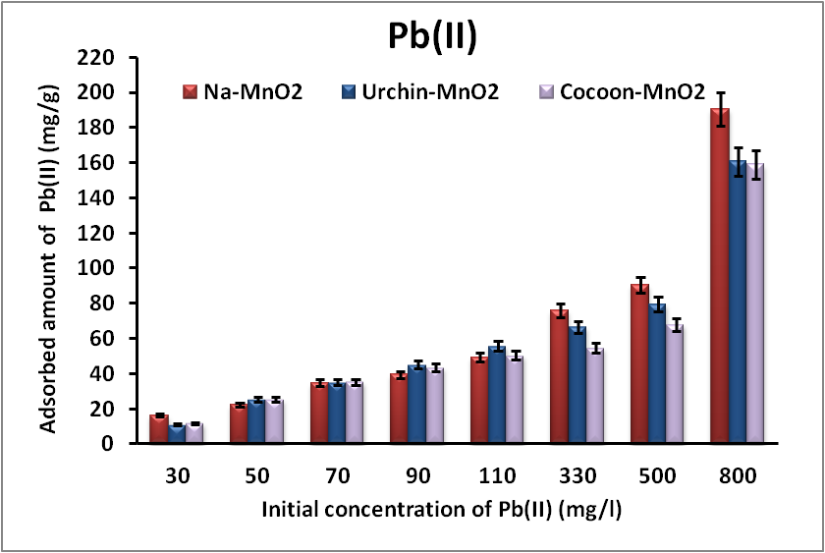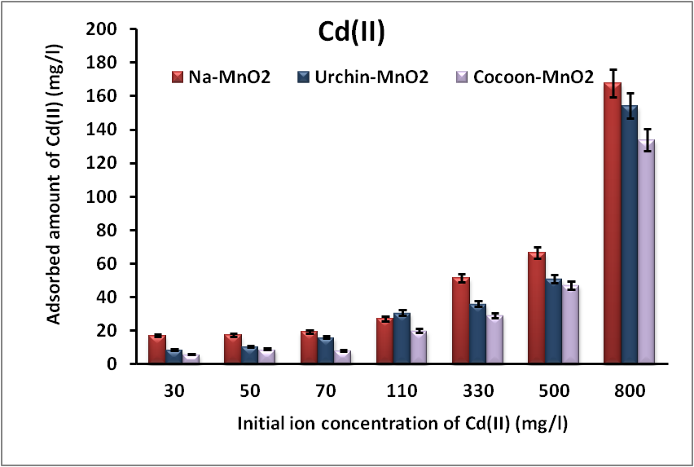
Figure 6. Influence of the initial concentration of metal ions on the removal efficiencies of Pb(II) and Cd(II) by manganese oxides
The examination of Figure 6 showed an increase in the removal efficiency of metal cations with increasing concentration. High removal capacities were recorded for Pb(II) for all three materials due to their high affinity toward this metal. For an initial concentration of 800 ppm of Pb(II), Urchin-MnO₂ and Cocoon-MnO₂ materials were able to absorb 160 mg/g, while Na-MnO₂ adsorbed a larger amount of 190 mg/g. For the same initial concentration of Cd(II), the three materials removed an amount ranging from 140 to 160 mg/g with the highest amount recorded for Na-MnO₂.

4.4. Isotherm models
In this study, the adsorption equilibrium was modeled using three mathematical laws Langmuir, Freundlich, and Temkin, which represented the equilibrium relationship between the amount of metal cation in the liquid phase (Ce) and that adsorbed on the material (Qe).
Adsorption studies were conducted for 30 minutes at different initial concentrations of Pb (II) and Cd (II) metal ions and a mass of 100 mg of the material. The isotherms were given in Figure S3. The following equations represented the models of each isotherm applied in this study:
$$Langmuir isotherm: \frac{C_{e}}{q_{e}}=\left(\frac{1}{b*q_{m}}\right)+C_{e}\left(\frac{1}{q_{m}}\right) (6)$$
$$Freundlich isotherm:log q_{e}=logK_{F}+\frac{1}{n}\left(logC_{e}\right) (7)$$
$$Temkin isotherm : q_{e}=\left(\frac{RT}{b_{T}}\right)lnK_{T}+\left(\frac{RT}{b_{T}}\right)lnC_{e} (8)$$
For the Langmuir isotherm, another parameter could also be expressed in terms of a dimensionless constant called the separation factor and defined by Eq. (9).
$$R_{L}=\frac{1}{1+b*C_{0}} (9)$$
A separation factor R_{L}>1 indicated that the adsorption was unfavorable if R_{L}=1 the adsorption was said to be linear, the adsorption was said to be favorable when 0<R_{L}<1 and a zero separation factor (R_{L}= 0) indicated that the adsorption was irreversible.⁷⁴
With:
Ce : the equilibrium concentration of substrates in the solution (mg/L).
q_{e} : the adsorption capacity at equilibrium (mg/g).
q_{m} : the maximum amount of adsorption (mg/ g).
b : the adsorption equilibrium constant (L/mg).
K_{F} : a constant representing the adsorption capacity.
n : the constant showing the adsorption intensity.
R= 8.314 J mol ⁻¹ K⁻¹.
T: absolute temperature in (K), K_{T}: Temkin constant in (L mg ⁻¹).
C₀ : the initial concentration of the adsorbate (mg/L).
Figure S3 showed the most appropriate isotherms for the three materials Na-MnO₂, Urchin-MnO₂, and Cocoon-MnO₂. In table S3 all parameters of the isotherms for the two metals were given. After studying the isothermal adsorption of Pb(II) and Cd(II) ions by manganese oxides, it could be seen that the best description of the adsorption phenomenon was obtained with the Langmuir model with a high correlation coefficient R² (Table S3). This applied model allowed us to determine the maximum adsorption quantity q_{m} (mg/g) for all materials interacting with the two metal cations (Table S3). The description of the adsorption of Pb(II) and Cd(II) by this model assumed that the adsorption of these ions by the materials was done by the formation of a monolayer on the external surface of the adsorbent. Thus, this concordance could be explained by the homogeneity of the adsorption sites on the surface of these materials. Indeed, during the interaction, there would be a direct contact of metal ions on the surface of the materials up to the coverage of the monolayer. Based on the calculated R_{L} values, all values were between 0 and 1, indicating favorable adsorption. In the structure of synthesized manganese oxides of the birnessite type (A_{x}MnO₂,zH₂O) (with A = Na⁺ (case: Na-MnO₂)), either Na⁺ and H⁺ ⁷⁵ or Mn²⁺, two proton or (Mn(III)OH)²⁺ were located on each side of a vacant cationic site to obtain local charge balance of material.⁴⁴ The Na analysis confirmed this hypothesis in solution during Cd(II) and Pb(II) removal. The result indicated that Na-MnO₂ material released the Na⁺ ions during removal processes (Figure S4).

As shown in X-ray diffractogram, the two materials Urchin-MnO₂ (KMn₈O₁₆) and Cocoon-MnO₂ (K₂Mn₄O₉) have two different structures, with K⁺ ions inserted into their cavities. The removal of Cd(II) and Pb(II) occurred by exchanging K⁺ from the tunnel site and also on the external surface of the materials.⁷⁶ The exchange between the metal ions and the K⁺ caused it to be released into the solution during the metal removal process (Figure S5).

5. Study of manganese oxides stability during interaction with metal cations
As mentioned previously, when different materials remove metal ions, manganese ions can be released. Figure 7 shows the released manganese rate with the Pb(II) and Cd(II) ion removal efficiencies recorded for each material elaborated.
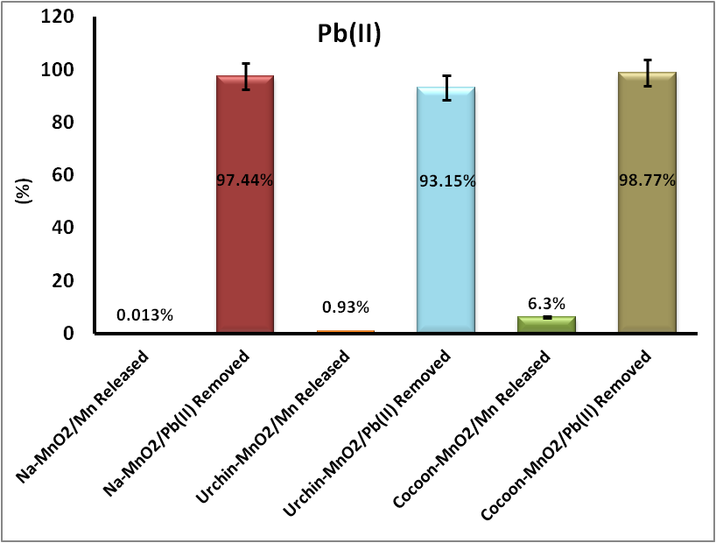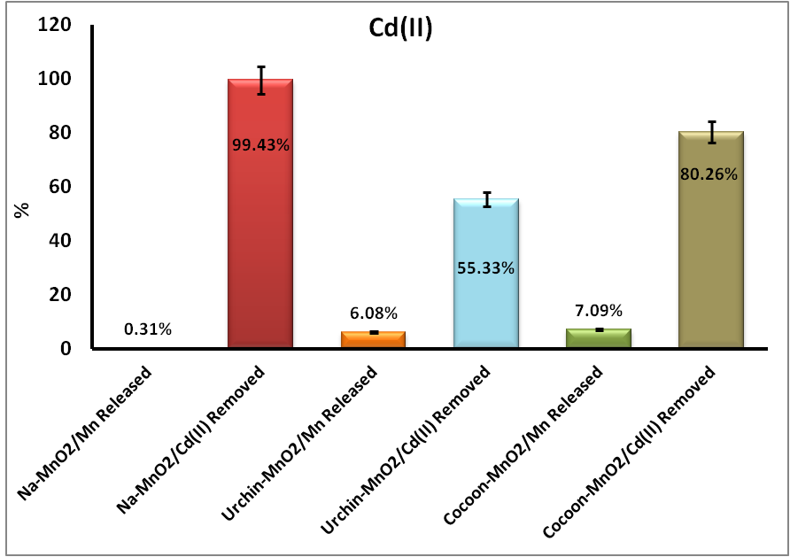
Figure 7. Evolution of the manganese released by manganese oxides during interaction with Pb(II) and Cd(II)
As displayed in Figure 7, the manganese released by materials during interaction with Pb(II) and Cd(II) was low or even negligible. In the case of the Na-MnO₂ lamellar material, the removal efficiency of metal cations was extremely high above 99%, and the release rates of manganese was lower than 1% (0.013% (0.123 mmol/Kg) and 0.31 % (2.822 mmol/Kg) during Pb (II) and Cd(II) adsorption respectively). The Urchin-MnO₂ material releases a very small amount of 0.93% (4.034 mmol/Kg) of the total manganese during Pb(II) removal, whereas in the case of cadmium, a release rate of 6% (26.422 mmol/Kg) was recorded. The highest amount of released manganese was obtained in the case of the Cocoon-MnO₂ material (6 % (66.787 mmol/Kg) during the removal of Pb(II) and 7 % (75.22 mmol/Kg) during the removal of Cd(II)). The results obtained showed that for the two nanostructures Urchin-MnO₂ and Cocoon-MnO₂ that the maximum amount of total manganese released decreased with increasing Mn AOS⁴⁴ (Mn AOS: Urchin-MnO₂ (3.730)˃Cocoon-MnO₂ (3.650).

This study indicates that manganese oxide materials present high stability. The high stability of these materials was strongly due to the stabilizing power and binding strength of the Na⁺ and K⁺ cations present in the structure of the three materials.⁷⁷ The best stability among the different structures was recorded in the case of the lamellar structure (Na-MnO₂), which presented a very low amount of the manganese release. This result confirmed that the use of Na-MnO₂ material with a lamellar structure compared to nanostructures meeted several requirements such as fast elimination kinetics and high reactivity to both heavy metals and also the factors of stability. This parameter is an essential factor in the use of materials in the form of the adsorbent. Na-MnO₂ material can be used in more advanced applications and more precisely in the industrial sector for the treatment of heavy metal contaminated waste.

6. Analysis of the adsorption mechanism

6.1. X-ray diffraction
The characterization by X-ray diffraction of the materials after interaction with metallic cations was important to determine the set of structures formed. The diffractograms before and after interaction with Pb(II) and Cd(II) were illustrated in Figure 8.
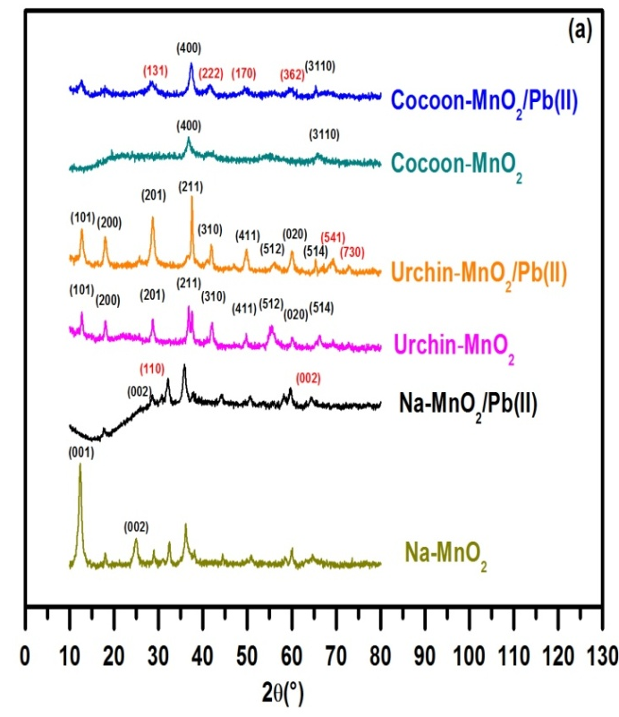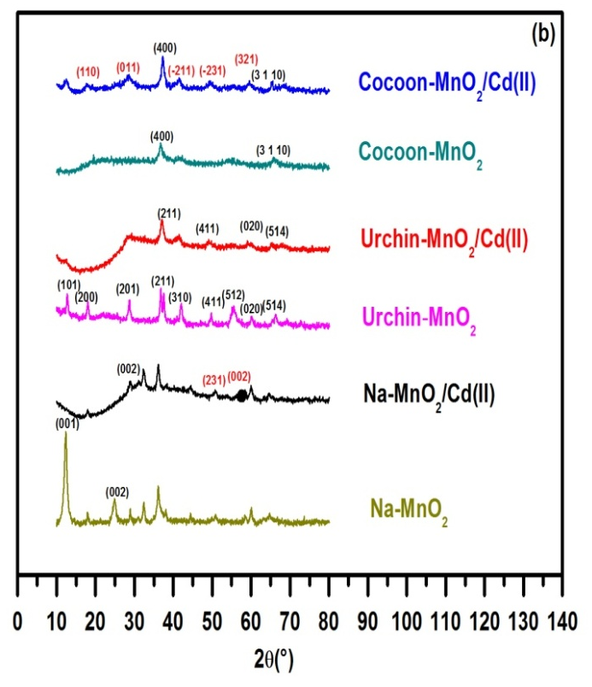
Figure 8. X-ray diffractograms of manganese oxides before and after interaction with (a) Pb(II) and (b) Cd(II)
After the interaction of the manganese oxide materials with Pb(II) and Cd(II), the diffractograms of each material were not similar. The peaks obtained from each material were analyzed to determine the phases formed. The crystallographic parameters of each phase were grouped in Table 3.
Table 3: Crystallographic parameters of the structures formed after interaction of the Pb(II) and Cd(II) ions with the materials
 | Phases formed | Mesh parameter (Å) | Crystal system
Na-MnO₂  (Before interaction) | Na_{0.55}Mn₂O₄.(H₂O)_{1.5}  (Birnessite) | a = 5.1750  b = 2.8490  c = 7.3380 | Monoclinic
Na-MnO₂  (After interaction: Pb(II)) | PbO | a = 3.9744  b = 3.9744  c = 5.0220 | Tetragonal
Na-MnO₂  (After interaction: Pb(II)) | Na_{0.55}Mn₂O₄.(H₂O)_{1.5}  (Birnessite) | a = 5.1750  b = 2.8490  c = 7.3380 | Monoclinic
Na-MnO₂  (After interaction: Cd(II)) | Cd(OH)₂ | a = 5.6700  b = 10.2500  c = 3.4100 | Monoclinic
Na-MnO₂  (After interaction: Cd(II)) | Na_{0.55}Mn₂O₄.(H₂O)_{1.5}  (Birnessite) | a = 5.1750  b = 2.8490  c = 7.3380 | Monoclinic
Urchin-MnO₂  (Before interaction) | KMn₈O₁₆  (Cryptomelane) | a =b = 9.840  c = 2.850 | Tetragonal
Urchin-MnO₂  (After interaction: Pb(II)) | Pb₂Mn₈O₁₆ | a = b = 9.8900  c = 2.8620 | Tetragonal
Urchin-MnO₂  (After interaction: Pb(II)) | KMn₈O₁₆  (Cryptomelane) | a=b= 9.840  c = 2.850 | Tetragonal
Urchin-MnO₂  (After interaction: Cd(II)) | Cd(OH)₂ | a = 5.6700  b = 10.2500  c = 3.4100 | Monoclinic
Urchin-MnO₂  (After interaction: Cd(II)) | KMn₈O₁₆  (Cryptomelane) | a = b = 9.840  c = 2.850 | Tetragonal
Cocoon-MnO₂  (Before interaction) | K₂Mn₄O₉ | a=b= 11.2950  c = 21.870 | Hexagonal
Cocoon-MnO₂  (After interaction: Pb(II)) | Pb₂MnO₄ | a = b = 12.7700  c = 5.1300 | Tetragonal
Cocoon-MnO₂  (After interaction: Pb(II)) | K₂Mn₄O₉ | a = b = 11.2950  c= 21.870 | Hexagonal
Cocoon-MnO₂  (After interaction: Cd(II)) | Cd(OH)₂ | a = 5.6700  b = 10.2500  c = 3.4100 | Monoclinic
Cocoon-MnO₂  (After interaction: Cd(II)) | K₂Mn₄O₉ | a = b = 11.2950  c = 21.870 | Hexagonal

In the case of Na-MnO₂, after interaction with Pb(II) and Cd(II), a slight decrease in the intensity of some peaks occurred. The identification of the phases formed made it possible to determine the MnO₂ manganese oxide phase and the appearance of new PbO phases observed at 2θ=30.66° (110), 64.40° (002) and for the Cd(OH)₂ phase was indexed in two peaks located at 2θ=50° (231), 53.64° (002) indicating that the Pb(II) and Cd(II) ions had been inserted into the material. The identification of the phases formed for the nanostructured material Urchin-MnO₂ after interaction with Pb(II) ions (Figure 8a) and Cd(II) ions (Figure 8b), showed the existence of the characteristic phase (KMn₈O₁₆) of Urchin-MnO₂ with the occurrence of Pb₂Mn₈O₁₆ and Cd(OH)₂ (Table 3). For Cocoon-MnO₂, the characteristic phase of this material still existed with the formation of the Pb₂MnO₄ phase (Table 3) in the case of interaction with Pb(II) ions (Figure 8a) and Cd(OH)₂ in the case of Cd(II) (Figure 8b). All diffractograms of the materials after interaction showed that the intensity of some peaks decreased while others disappeared. This deformation was due to the insertion of metal cations in the vacant octahedral sites and in the interlayer space between the MnO₆ layers (case of Na-MnO₂) or in the cavities (case of Urchin-MnO₂ and Cocoon-MnO₂) which created a disorder in the materials.²⁷ Based on the results obtained, it could be said that the removal of metal ions after interaction with the materials taked place either by insertion as MO oxide (PbO) or by adsorption as M(OH)₂ hydroxide (Cd(OH)₂) or by the formation of new phases such as Pb₂MnO₄ and Pb₂Mn₈O₁₆. As it had be shown, subsequent studies reported that the analysis of materials after interaction with Cd(II) ions by X-ray photoelectron spectroscopy (XPS) showed that Cd(II) was adsorbed on MnO₂ as CdO and Cd(OH)₂. ²⁷
7. Conclusions
XRD and SEM analysis showed that the prepared manganese oxides: Na-MnO₂, Urchin-MnO₂, and Cocoon-MnO₂ were composed of a monophase characteristic of each structure elaborated, these oxides also had particular morphologies. Studies of adsorption/desorption of N₂ of the materials showed that their structures were composed of a mixture of pores with a predominance of mesopores of more than 53% of the total porous surface. This study showed that structure and morphology had a direct effect on the elimination of metal cations Pb(II) and Cd(II). All materials (lamellar: Na-MnO₂) and (nanostructures: Urchin-MnO₂ and Cocoon-MnO₂) showed a high reactivity towards both metals with a high yield of more than 90% for a very short duration (less than 15 minutes). These materials also demonstrated high stability during the removal process. In the case of the Na-MnO₂ lamellar material, the removal efficiency of metal cations was very high above 99%, and the release rates of manganese were lower than 0.4%, which meaned that it was not only efficient and inexpensive but also very stable during the removal process. These studies carried out, and the very promising results encouraged us to extend this material for application in larger reactors and industrial-scale applications for the treatment of industrial waste contaminated by heavy metals.
Supporting Information
The pore size distributions of three MnO₂ (lamellar and nanostructures), comparative study of Cd(II) and Pb(II) removal efficiencies, Langmuir isotherm plot for Pb(II) and Cd(II) adsorption, Amount of Na⁺ released during the removal of Pb(II), and Cd(II) ions by Na-MnO₂, Amount of K⁺ released during the removal of Pb(II) and Cd(II) ions by Urchin-MnO₂ and Cocoon-MnO₂, Porous structure parameters of each material, Adsorption coefficients of Pb(II) and Cd(II) of the pseudo-first-order and pseudo-second-order models, Isotherm parameters for Langmuir, Freundlich, and Temkin models.
Acknowledgments
The authors warmly thank the OCP (Office Chérifien des Phosphates), R&D Foundation (Research and Development) for the financial support of this project National Centre for Scientific and Technical Research (CNRST), Ministry of Higher Education Scientific Research.

8. References
1. A. S. Ertürk, M. U. Gürbüz, M. Tülü, A.E. Bozdoğan, J. Acta Chim. Slov. 2018, 65, 65–74.
DOI: 10.17344/acsi.2017.3485
2. S. Sharma, A. K. Nagpal, I. Kaur, J. Chemosphere. 2019, 227, 179–190.
DOI: 10.1016/j.chemosphere.2019.04.009
3. A. Karimi, A. Naghizadeh, H. Biglari, R. Peirovi, A. Ghasemi, A. Zarei, J. Environ. Sci. Pollut. Res. 2020, 27, 10317–10327.
DOI: 10.1007/s11356-020-07642-6
4. D. Humelnicu, L.V. Soroaga, C. Arsene, I. Humelnicu, R.I. Olariu, J. Acta Chim. Slov. 2019, 66, 326–336.
DOI: 10.17344/acsi.2018.4821
5. S. Z. Ahmad Nurain, W. N. Wan Salleh, A. Fauzi Ismail, N. Yusof, M. Z. M. Yusop, F. Aziz, J. Chemosphere. 2020, 248, 1–16.
DOI: 10.1016/j.chemosphere.2020.126008
6. F. Alshahri, J. Environ. Sci. Pollut. Res. 2016, 24, 1821–1831.
DOI: 10.1007/s11356-016-7961-x
7. S.M. Mousavi, S.A. Hashemi, H. Esmaeili, A.M. Amani, F. Mojoudi, J. Acta Chim. Slov. 2018, 65, 750–756.
DOI: 10.17344/acsi.2018.4536
8. X. Xu, Y. Yang, G. Wang, S. Zhang, Z. Cheng, T. Li, Z. Yang, J. Xian, Y. Yang, W. Zhou, J. Chemosphere. 2020, 246, 125816.
DOI: 10.1016/j.chemosphere.2020.125816
9. J. Xue, Y. Zhi, L. Y. Wu, J. Shi, L. Zeng, L. Wu, J. Env. Sci Pollut Res. 2014, 21, 7698–7707.
DOI: 10.1007/s11356-014-2726-x
10. C. Lee, T. Kim, S. Komarneni, S. Han,Y. Cho, J. Appl. Clay Sci. 2013, 83–84, 263–269.
DOI: 10.1016/j.clay.2013.08.035
11. G. Zheng, L. Tian, Y. Liang, K. Broberg, L. Lei, W. Guo, J. Nilsson, I. A. Bergdahl, S. Skerfving , T. Jin, J. Neurotoxicology. 2011. 32, 374–382.
DOI: 10.1016/j.neuro.2011.03.006
12. P. Aendo, S. Thongyuan, T. Songserm, P. Tulayakul, J. Sci. Total Environ. 2019, 689, 215–222.
DOI: 10.1016/j.scitotenv.2019.06.414
13. T. Shah, F. Munsif, D. Roberto, L. Nie, J. Chemosphere. 2019, 246, 125766.
DOI: 10.1016/j.chemosphere.2019.125766
14. B. Nunes, R. C. Capela, T. Sérgio, C. Caldeira, F. Gonçalves, A. T. Correia, J. Env. Sci Pollut Res. 2014, 21, 5689–5700.
DOI: 10.1007/s11356-013-2485-0
15. C. M. Liu, J.-Q. Ma, Y.-Z. Sun, J. Environ. Toxicol. Pharmacol. 2010, 30, 264–271.
DOI: 10.1016/j.etap.2010.07.002
16. N. D. Bustamante, W. L. Macias-konstantopoulos, J. Emerg. Med. 2016, 51, 45–49.
DOI: 10.1016/j.jemermed.2016.02.025
17. P. Chen, X. Duan, M. Li, C. Huang, J. Li, R. Chu, H. Ying, H. Song, X. Jia, Q. Ba, H. Wang, J. Toxicol. Appl. Pharmacol. 2016, 310, 150–158.
DOI: 10.1016/j.taap.2016.09.006
18. F. Fu, Q. Wang, J. Environ. Manage. 2011, 92, 407–418.
DOI: 10.1016/j.jenvman.2010.11.011
19. P. Zhang, S. Ouyang, P. Li, Z. Sun, N. Ding, Y. Huang, J. Clean. Prod. 2019, 246, 118728.
DOI: 10.1016/j.jclepro.2019.118728
20. S. Hu, F. Lian, J. Wang, J. Sci. Total Environ. 2019, 666, 956–963.
DOI: 10.1016/j.scitotenv.2019.02.285
21. P. Caecilia, S. Ketut, N. Yustina, H. Prasetyo, J. Matec Web Conf. 2016, 58, 10–13.
DOI: 10.1051/matec conf/20165801022
22. F. Scholz, H. Kahlert, J. ChemTexts, 2015, 7, 1–9.
DOI: 10.1007/s40828-015-0006-0
23. J. Kheriji, D. Tabassi, B. Hamrouni, J. Water Sci. Technol. 2015, 7, 1206–1216.
DOI: 10.2166/wst.2015.326
24. A. El-Gendi, S. Ali, H. Abdalla, M. Saied, J. Memb.Wat. Tre. 2016, 7, 55–70.
DOI: 10.12989/mwt.2016.7.1.055
25. S. M. Shaheen, A. S. Derbalah and F. S. Moghanm, J. Environ. Sci. Dev. 2012, 3, 362–367.
DOI: 10.7763 / IJESD.2012.V3.248
26. M. Araissi, I. Ayed, E. Elaloui, Y. Moussaoui, J. Water Sci. Technol. 2016, 73, 1628–1636.
DOI: 10.2166/wst.2015.640
27. L. Peng, Q. Zeng, B. Tie, M. Lei, J. Yang, S. Luo, Z. Song, J. Colloid interface Sci., 2015, 456, 108–115.
DOI: 10.1016/j.jcis.2015.06.017
28. Y. Cho, S. Jang, Y. Kim, S. Komarneni, S. Kim, J. Porous Mater. 2011, 18, 125–131.
DOI: 10.1007/s10934-010-9430-0
29. N. N. Nassar, J. Hazard. Mater. 2010, 184, 538–546.
DOI: 10.1016/j.jhazmat.2010.08.069
30. H. N. Trana, D. T. Nguyenb, G. T. Le, F. Tomul, E. C. Lima, S. H. Woo, A. K. Sarmah, H. Q. Nguyen, P. T. Nguyen, D. D. Nguyen, T. V. N. S. Vigneswaran, N. V. Dai-Viet, H.-P. Chaol, J. Hazard. Mater. 2019, 373, 258–270.
DOI: 10.1016/j.jhazmat.2019.03.018
31. A. Avram, T. Frentiu, O. Horovitz, A. Mocanu, F. Goga, M. Tomoaia-cotisel, J. Stud. Ubb Chem. 2017, 4, 93–104.
DOI: 10.24193/subbchem.2017.4.08
32. A. A. Hanna, M. A. Sherief, R. M. Aboelenin, S. M. Mousa, Can. J. Pure Appl. Sci. 2010, 4, 1087–1093.
DOI: 10.1.1.302.5349
33. M. Torab-Mostaedi, H. Ghassabzadeh, M. Ghannadi-Maragheh, S. J. Ahmadi, H. Taheri, Brazilian J. Chem. Eng. 2010, 27, 299–308.
DOI: 10.1590/s0104-66322010000200008
34. N. Mohamad, I. Abustan, M. Mohamad, K. Samuding, J. Mater. Today Proc. 2018, 5, 21832–21840.
DOI: 10.1016/j.matpr.2018.07.039
35. S. Deng, X. Liu, J. Liao, H. Lin, F. Liu, J. Chem. Eng. 2019, 375, 122086.
DOI: 10.1016/j.cej.2019.122086
36. M. Hojamberdiev, S. S. Daminova, Z. C. Kadirova, K. T. Sharipov, F. Mtalo, M. Hasegawa, J. Environ. Chem. Eng. 2018, 6, 4623–4633.
DOI: 10.1016/j.jece.2018.06.070
37. H. Vojoudi, A. Badiei, S. Bahar, G. M. Ziarani, F. Faridbod, M. R. Ganjali, J. Magn. Magn. Mater. 2017, 441, 193–203.
DOI: 10.1016/j.jmmm.2017.05.065
38. S. Mnasri-ghnimi, N. Frini-srasra, J. Appl. Clay Sci. 2019, 179, 1–17.
DOI: 10.1016/j.clay.2019.105151
39. A. Djukic, U. Jovanovic, T. Tuvic, V. Andric, J. Novakovic Grbovic, N. Ivanovic, L. Matovic, J. Ceram. Int. 2013, 39, 7173–7178.
DOI: 10.1016/j.ceramint.2013.02.061
40. D. Sofronov, A. Krasnopyorova, N. Efimova, A. Oreshina, E. Bryleva, G. Yuhno, S. Lavrynenko, M. Rucki, J. Process Saf. Environ. Prot. 2019, 125, 157–163.
DOI: 10.1016/j.psep.2019.03.013
41. S. Hoseini, N. Rahemi, S. Allahyari, M. Tasbihi, J. Clean. Prod. 2019, 232, 1134–1147.
DOI: 10.1016/j.jclepro.2019.05.227
42. A. M. Muliwa, M. S. Onyango, A. Maity, A. Ochieng, Int. J. Environ. Sci. Technol. 2018, 16, 2895–2904.
DOI: 10.1007/s13762-018-1817-5
43. L. Liu, Q. Peng, G. Qiu, J. Zhu, W. Tan, C. Liu, L. Zheng, Z. Dang, J. Environ. Pollut. 2019, 244, 783–791.
DOI: 10.1016/j.envpol.2018.10.062
44. W. Zhao, X. Feng, W. Tan, F. Liu, S. Ding, J. Environ. Sci. 2009, 21, 520–526.
DOI: 10.1016/S1001-0742(10)60438-X
45. P. Yang, E. Post, Q. Wang, W. Xu, R. Geiss, P. R. Mccurdy, M. Zhu, J. Environ. Sci. Technol. 2019, 53, 7453–7462.
DOI: 10.1021/acs.est.9b01242
46. Y. Wang, X. Feng, M. Villalobos, W. Tan, F. Liu, J. Chem. Geol. 2012, 292–293, 25–34.
DOI: 10.1016/j.chemgeo.2011.11.001
47. H. Antoni, D. M. Morales, J. Bitzer, Q. Fu, Y. Chen, J. Masa, W. Kleist, W. Schuhmann, M. Muhler, J. Catalysis. 2019, 374, 335–344.
DOI: 10.1016/j.jcat.2019.05.010
48. H. M. Abuzeid, S. A. Elsherif, N. A. Abdelghany, A. M. Hashem, J. Energy Storage. 2019, 21, 156–162.
DOI: 10.1016/j.est.2018.11.021
49. S. Garcia, S. Sardar, S. Maldonado, V. Garcia, C. Tamez, J. G. Parsons, J. Microchemical. 2014, 117, 52–60.
DOI: 10.1016/j.microc.2014.06.008
50. M. H. Salmani, M. Vakili, M. H. Ehrampoush, J. Toxicol. Environ. Health Sci. 2013, 5, 150–155.
DOI: 10.5897/JTEHS2013.0275
51. N. N. Nassar, Can. J. Chem. Eng. 2012, 90, 1231–1238.
DOI: 10.1002/cjce.20613
52. D. C. Ong, S. M. B. Pingul-ong, C. Kan, M. Daniel, G. De Luna, J. Clean. Prod. 2018, 190, 443–451.
DOI: 10.1016/j.jclepro.2018.04.175
53. S. Rahimi, R. M. Moattari, L. Rajabi, A. Ashraf, M. Keyhani, J. Ind. Eng. Chem. 2015, 23, 33–43.
DOI: 10.1016/j.jiec.2014.07.039
54. G. Tan, Y. Liu, D. Xiao, Carbohydr. Polym. 2019, 219, 306–315.
DOI: 10.1016/j.carbpol.2019.04.058
55. Q. Su, B. Pan, S. Wan, W. Zhang, L. Lv, J. Colloid Interface Sci. 2010, 349, 607–612.
DOI: 10.1016/j.jcis.2010.05.052
56. R. M. Mckenzie, Aust. J. Soil Res. 1980, 18, 61–73.
DOI: 10.1071/SR9800061
57. Q. Nan, C. Hong, Y. Zhaoming, S. Sen, W. Yuan, J. Electrochim. Acta. 2018, 272, 154–160.
DOI: 10.1016/j.electacta.2018.04.012
58. X. Yu, J. He, D. Wang, Y. Hu, H. Tian, Z. He, J. Phys. Chem. C. 2012, 116, 851–860.
DOI: 10.1021/jp208947e
59. Q. Peng, L. Liu, Y. Luo, Y. Zhang, W. Tan, F. Liu, S. L. Suib, G. Qiu, J. Appl. Matererials Interfaces. 2016, 50, 34405–34413.
DOI: 10.1021/acsami.6b12224
60. H. Boumaiza, A. Renard, M. R. Robinson, L. Vidal, C. Ruby, L. Bergaoui, R. Coustel, Solid State Chem. 2019, 272, 234–243.
DOI: 10.1016/j.jssc.2019.02.017
61. H. Lin, D. Chen, H. Liu, X. Zou, T. Chen, J. Aerosol Air Qual. Res. 2017, 17, 1011–1020.
DOI: 10.4209/aaqr.2017.01.0013
62. A. S. Poyraz, J. Huang, C. J. Pelliccione, X. Tong, S. Cheng, L. Wu, Y. Zhu, A. C. Marschilok, K. J. Takeuchi, E. S. Takeuchi, J. Mater. Chem. A. 2017, 5, 16914–16928.
DOI: 10.1039/C7TA03476H
63. Y. R. Li, A. C. Marschilok, E. S. Takeuchi, K. J. Takeuchi, J. Electrochem. Soc. 2016, 163, A281–A285.
DOI: 10.1149/2.0501602jes
64. H. Gao, I. D. Seymour, S. Xin, L. Xue, G. Henkelman, J. B. Goodenough, J. Am. Chem. Soc. 2018, 140, 18192–18199.
DOI: 10.1021/jacs.8b11388
65. G. Zoua, B. Gea, H. Zhanga, Q. Zhangb, C. Fernandezc, W. Lid, J. Huanga, Q. Peng, J. Mater. Chem. A. 2019, 6, 3091–3101.
DOI: 10.1039/C9TA00744J
66. C. Yuan, B. Gao, L. Su, X. Zhang, J. Colloid Interface Sci. 2008, 322, 545–550.
DOI: 10.1016/j.jcis.2008.02.055
67. T. Mathialagan, T. Viraraghavan, J. Hazard. Mater. 2006, B134, 257–267.
DOI: 10.1016/j.jhazmat.2005.11.052
68. K. D. Kwon, K. Refson, G. Sposito, J. Geochim. Cosmochim. Acta. 2010, 23, 6731–6740.
DOI: 10.1016/j.gca.2010.09.002
69. L. Della Puppa, F. Bordas, M. Komárek, J. Bollinger, E. Joussein, J. Colloid Interface Sci. 2013, 399, 99–106.
DOI: 10.1016/j.jcis.2013.02.029
70. X. H. Feng, L. M. Zhai, W. F. Tan, F. Liu, J. Z. He, J. Environ. Pollut. 2007, 147, 366–373.
DOI: 10.1016/j.envpol.2006.05.028
71. K. Parida, P. K. Satapathy, N. DAS, J. Colloid Interface Sci. 1996, 181, 456–462.
DOI: 10.1006/jcis.1996.0402
72. L. Liu, G. Qiu, S. L. Suib, F. Liu, L. Zhen, W. Tan, L. Qin, J. Chem. Eng. 2017, 328, 464–473.
DOI: 10.1016/j.cej.2017.07.066.
73. D. Robati, J. Nanostructure Chem. 2013, 3, 55–60.
DOI: 10.1186/2193-8865-3-55
74. D. Sidiras, F. Batzias, E. Schroeder, R. Ranjan, M. Tsapatsis, J. Chem. Eng. 2011, 171, 883–896.
DOI: 10.1016/j.cej.2011.04.029
75. M. J. Young, A. M. Holder, S. M. George, C. B. Musgrave, J. Chem. Mater. 2015, 27, 1172–1180.
DOI: 10.1021/cm503544e
76. H. Li, F. Liu, M. Zhu, X. Feng, J. Zhang, H. Yin, J. Environ. Sci. 2015, 34, 77–85.
DOI: 10.1016/j.jes.2015.02.006
77. Q. Kang, L. Vernisse, R. C. Remsing, A. C. Thenuwara, S. L. Shumlas, I. G. McKendry, M. L. Klein, E. Borguet, M. J. Zdilla, D. R. Strongin, J. Am. Chem. Soc. 2017, 139, 1863–1870.
DOI: 10.1021/jacs.6b09184

