Scientific paper

Cu(I) Arylsulfonate π-Complexes with 3-Allyl-2-thiohydantoin:
The Role of the Weak Interactions in Structural Organization

Andrii Fedorchukª, Evgeny Goreshnik^{b*}, Yurii Slyvka^{c}, Marian Mys’kivc

ª Institute of Nuclear Physics Polish Academy of Sciences,
Radzikowskiego 152, PL-31342 Krakow, Poland
^{b} Department of Inorganic Chemistry and Technology, Jožef Stefan Institute, Jamova 39,
SI-1000 Ljubljana, Slovenia
^{c} Department of Inorganic Chemistry, Ivan Franko National University of Lviv,
Kyryla i Mefodiya 6, 79005 Lviv, Ukraine
* Corresponding author: e-mail: evgeny.goreshnik@ijs.si Phone: +386 1 477 36 45

Received
Abstract
The present work is directed toward preparation and structural characterization of two novel Cu(I) arylsulfonate π-complexes with 3-allyl-2-thiohydantoin, namely [Cu₂(Hath)₄](C₆H₅SO₃)₂ (1) and [Cu₂(Hath)₄](p-CH₃C₆H₄SO₃)₂·2H₂O (2) (Hath = 3-allyl-2-thiohydantoin), obtained by the means of alternating current electrochemical synthesis and studied with X-ray diffraction method. In both structures, the inner coordination sphere is represented by the cationic dimer [Cu₂(Hath)₄]²⁺ with one crystallographically independent copper(I) atom which has a trigonal pyramidal coordination environment formed by three Hath thiogroup S atoms and double C=C bond of its allyl group. [Cu₂(Hath)₄]²⁺ fragments in both coordination compounds are very similar, despite some divergences such as a big difference in Cu−S distance to the apical S atom (3.0374(8) Å in 1 and 2.7205(9) Å in 2). This difference was explained by the impact of the system of weak interactions, which are quite different.

Keywords: copper(I) arylsulfonate, π-complex, thiohydantoin, weak interaction, crystal structure.

1. Introduction
In the last years both 2-thiohydantoin (2-thioxoimidazolidin-4-ones) and hydantoin core fragments were studied as useful scaffolds in medicinal chemistry due to their synthetic feasibility and versatility of substituents. ¹⁻⁵ Moreover, their derivatives are already used in commercially available drugs such as Phenytoin, Dantrolene and Allantoin. The presence of several active chemical groups, as well as simple synthetic route advantages, could make them interesting not only as biologically active compounds but also as compounds of great interest in the chemistry of coordination compounds too. Although, due to the presence of capable for complex compound formation functional groups, 2-thiohydantoin based compounds were found to have an application in the analytical chemistry as reagents for the determination of several d-metals (including Cu and Ag). ^{6, 7} Despite the small number of such representatives (according to the Cambridge Crystallographic Database only 12 copper coordination compounds with 2-thiohydantoin still known), ⁸ it was already investigated that they could have a potential interest as optical materials due to their fluorescence sensing properties and luminescence towards Cu⁺ and Cu²⁺ as well as the possibility of successful usage in crystal engineering of organometallics. ^{9, 10} Moreover, previously, we have shown, that Cu(I) π-complexes with allyl derivatives of heterocycles can possess noticeable non-linear optical properties. ¹¹⁻¹⁵
This work is the continuation of our previous studies, in which we have studied the coordination behavior of 3-allyl-2-thiohydantoin (Hath) regarding Ag(I), where obtained coordination compounds have already shown interesting structural peculiarities, confirming the status of 2-thiohydantoin-based molecules as the potential ligands in the structural engineering. ^{16, 17}
2. Experimental
2.1 General consideration
Unless otherwise mentioned, all chemicals were obtained from a commercial source (Sigma Aldrich) and used without further purification. The NMR experiments: ¹H NMR (500 MHz), ¹³C{¹H} NMR (125 MHz) spectra for Hath were recorded on a Bruker Avance 500 MHz NMR spectrometer. The chemical shifts are reported in ppm relative to the residual peak of the deuterated CD₃OD for the ¹H and ¹³C{¹H} NMR spectra. The infrared (IR) spectrum for Hath was recorded on the Bruker IFS-88 spectrometer as nujol mulls. Diffraction data for 1 and 2 were collected on a Gemini+ diffractometer with Mo K_{a} radiation (λ = 0.71073 Å) and Atlas CCD detector.

2. 2. Preparation of 3-allyl-2-thioxoimidazolidin-4-one (Hath)
Ligand Hath was synthesized from allylisothiocyanate and glycine at the presence of triethylamine and pyridine, in accordance with the reported method. ¹⁶
¹H NMR (500 MHz, CD₃OD) δ, 5.84 p.p.m. (ddt, J = 17.1, 10.4, 5.6 1H, =CH), 5.18 p.p.m. (ddd, J = 17.1, 2.9, 1.5 Hz, 1H, CH₂=), 5.14 p.p.m. (ddd, J = 10.5, 2.5, 1.0 Hz, 1H, -CH₂=), 4.38 p.p.m. (dt, J = 5.6 Hz, 1.5 2H, CH₂), 4.14 (s, 2H, CH₂).
¹³C{¹H} NMR (125 MHz, CD₃OD) δ, p.p.m. 185.74 p.p.m. (-C=S), 174.17 p.p.m. (-C=O), 132.62 p.p.m. (=CH), 117.94 p.p.m. (CH₂=), 49.48 p.p.m. (CH₂), 43.80 p.p.m. (CH₂).
IR (nujol, cm⁻¹): 3488 (w), 3225 (s), 3091 (w), 3011 (vw), 1864 (vw), 1751 (vs), 1650 (m), 1524 (vs), 1431 (vs), 1367 (w), 1344 (vs), 1306 (s), 1289 (w), 1260 (s), 1176 (vs), 1106 (m), 1048 (m), 1029 (m), 994 (m), 977 (w), 930 (s), 893 (m), 755 (vw), 719 (w), 700 (vs), 610 (m), 581 (m), 563 (m), 541 (m), 515 (m), 474 (m), 440 (vw).

2. 3. Preparation of complexes

2. 3. 1. Preparation of [Cu₂(Hath)₄](C₆H₅SO₃)₂ (1)
To the solution of Cu(C₆H₅SO₃)₂·6H₂O (0.157 g, 0.4 mmol) in 4.5 ml of n-propanol 0.156 g (1 mmol) of 3-allyl-2-thiohydanthoine (Hath) was added and obtained mixture was stirred. The resulting orange-brown solution was placed into a 5 mL test tube and then copper-wire electrodes in cork were inserted. The inner mixture in the obtained cell was subjected to alternating-current electrochemical recovery (0.6 V, 50 Hz) for 5 days. ¹⁸ Crystals 1, suitable for X-ray diffraction studies, were formed on copper wires while maintaining this reactor for 2 weeks at -3°C.

2. 3. 2. Preparation of [Cu₂(Hath)₄](p-CH₃C₆H₄SO₃)₂ ·2H₂O (2)
To 5 ml of a solution of 0.198 g (0.4 mmol) of Cu(p-CH₃C₆H₄SO₃)₂·6H₂O in n-propanol was added 0.156 g (1 mmol) of 3-allyl-2-thiohydanthine (Hath) and stirred. The resulting orange-brown solution was placed into a 5 mL test tube and then copper-wire electrodes in cork were inserted. The inner mixture in the obtained cell was subjected to alternating-current electrochemical recovery (0.6 V, 50 Hz) during 2 days. Crystals 2, suitable for X-ray diffraction studies, were formed on copper wires.

2. 4. X–Ray crystal structure determination
The collected data for 1 & 2 were processed with CrysAlis Pro program. ¹⁹ The structures were solved by dual-space algorithm using SHELXT and refined by least squares method on F² by SHELXL-2014 with the following graphical user interfaces of OLEX². ²⁰⁻²² Atomic displacements for non-hydrogen atoms were refined using an anisotropic model. Hydrogen atoms were placed in ideal positions and refined as riding atoms with relative isotropic displacement parameters. The figures were prepared using DIAMOND 3.1 software. Crystal parameters, data collection and the refinement parameters are summarized in Table 1.

Table 1. Selected crystal data and structure refinement parameters of 1 and 2.
 | [Cu₂(Hath)₄](С₆H₅SO₃ )₂ (1) | [Cu₂(Hath)₄](CH₃C₆H₄SO₃)₂××2H₂O (2)
Formula weight (g·mol⁻¹) | 533.11 | 565.15
Crystal system and space group | Triclinic, P‾1 | Triclinic, P‾1
a(Å) | 9.1664(6) | 9.4494(3)
b(Å) | 10.7387(6) | 10.3035(4)
c(Å) | 12.4008(6) | 14.4419(6)
α(º) | 93.096(4) | 94.228(3)
β(º) | 95.581(5) | 94.821(3)
γ(º) | 114.254(6) | 116.983(4)
V(Å³) | 1101.71(12) | 1238.64(9)
Z | 2 | 2
D (g/cm³) | 1.607 | 1.515
µ (mm⁻¹) | 1.31 | 1.18
F(000) | 548 | 584
Crystal size (mm) | 0.53×0.42×0.34 | 0.60×0.36×0.25
θ range for data collection (º) | 3.7 – 28.9 | 3.5–28.8
Index ranges | −12≤ h ≤9  −14 ≤ k ≤ 13  −16≤ l ≤ 16 | −11≤ h ≤ 11  −13 ≤ k ≤ 13  −19≤ l ≤ 18
Measured reflections | 7786 | 8562
Independent reflections | 4534 | 5143
Reflections with I > 2σ(I) | 3954 | 4274
Refined parameters | 288 | 302
R_{int} | 0.022 | 0.024
R[F² > 2σ(F² )] | 0.038 | 0.047
wR(F² ) | 0.091 | 0.132
Δρ_{max}/Δρ_{min}(e/Å³ ) | 1.11, −0.65 | 1.04, −0.78

3. Results and Discussion
π-Complex [Cu₂(Hath)₄](C₆H₅SO₃)₂ (1) forms triclinic crystals in the centrosymmetric space group P‾1. This compound is composed of the centrosymmetric cationic [Cu₂(Hath)₄]²⁺ dimers (Fig. 1) with one crystallographically independent Cu atom and outer coordination sphere represented by benzenesulfonate anions. Cu(I) atom in 1 has a trigonal pyramidal coordination environment (geometric index τ₄ = 0.80). ²³ Sulfur atom and C5A=C6A olefine group from one Hath moiety and S centre from another ligand unit form basal plane of the metal ion coordination sphere, and sulfur atom from one more Hath molecule is located at the apical position. The distance to the apical sulfur atom Cu1–S1^{i} is equal to 3.0374(8) Å and is significantly greater than Cu–S distances to the equatorial S1 and S2 atoms (Table 2).
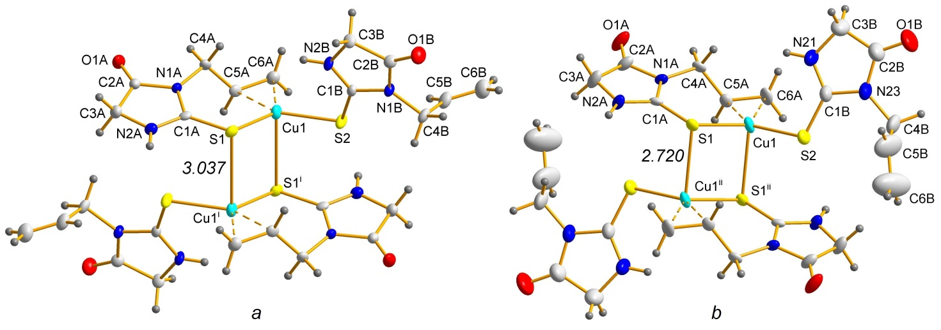
Figure. 1. Cationic fragment [Cu₂(hath)₄]²⁺ in the structures 1 (a) and 2 (b).
Symmetry codes: (i) 1−x, 2−y, 1−z; (ii) 2−x, 1−y, 1−z.

In the mentioned cationic fragment [Cu₂(Hath)₄]²⁺ there are two crystallographically independent molecules of organic ligand Hath. One of them is coordinated to the Cu atom by the thiogroup S1 atom and double C=C bond of the allyl group. Thus, the first ligand molecule possesses a bidentate chelate function, forming a seven-membered {C₄NSCu} cycle. The aforementioned S1 atom of the first ligand is also coordinated to the Cu1^{i} atom, and, due to the cetrosymmetricity of the structure, a flat four-membered {Cu₂S₂} cycle with a S1–Cu1–S1^{i} angle of 97.04(3)° is formed. Second ligand molecule is coordinated to the Cu1 atom only through its S2 atom, complementing copper’s coordination number to four. Accordingly – allyl group of the second ligand molecule doesn’t participate in the metal bonding and is freely located in the crystal structure with anticlinal conformation (119.8(3)º) relative to the C4B–C5B bond.
The structure of the complex [Cu₂(Hath)₄](p-CH₃C₆H₄SO₃)₂·2H₂O (2) is quite similar to the structure 1. It has similar cationic [Cu₂(Hath)₄]²⁺ fragments, but the outer coordination sphere is filled with p-toluenesulfonate anions and water molecules (Fig. 3). Regarding the cationic fragment, the main differences are in the noticeable shortening of the Cu−S distance to the apical atom (2.7205(9) Å in 2 compared to 3.0374(8) Å in 1) (Table 2) and a slightly different conformation of the uncoordinated ligand molecule, in particular, the torsion angle N23−C4B−C5B−C6B is equal to 142.6(7)º (in contrast to 119.8(3)º in 1). These differences can be explained, taking into account some features of the differences in the outer coordination sphere (Fig 2).

Table 2. Selected bond lengths (Å) and angle values (º) in 1 and 2.
 | 1 | 2
Bond | d, Å
Cu1–S1 | 2.2573(8) | 2.2785(8)
Cu1–S2 | 2.2556(7) | 2.2644(9)
Cu1–S1^{X} | 3.0374(8) | 2.7205(9)
Cu1–m* | 1.978(3) | 1.994(3)
C5A–C6A | 1.361(4) | 1.363(5)
Angles | ω, °
S2–Cu1–S1 | 112.97(3) | 112.06(3)
S1–Cu1–S1^{X**} | 97.04(3) | 97.21(3)
m–Cu1–S1 | 117.03(8) | 116.37(3)
m–Cu1–S2 | 129.53(8) | 128.32(3)
*m – middle point of C5A–C6A bond; **S1^{X} – S1^{i} atom for 1 and S1^{ii} atom for 2
Symmetry codes: (i) 1−x, 2−y, 1−z; (ii) 2−x, 1−y, 1−z.

Benzenesulfonate anions are located in the outer coordination sphere and take part in the formation of weak bonding in the structure 1. Two out of three oxygen atoms of the same anion (O13 and O33) participate in N–H···O bonding (Table 3, Fig. 2) with N–H groups of different cationic fragments, connecting them into infinite H-bonded chain (Fig 3). Also, one of the oxygen atoms of C₆H₅SO₃– anion (O13) forms a weak Cu–O contact with a bond length of 3.409(5) Å. Nevertheless, this distance is noticeably longer than the sum of van der Waals radii of Cu and O by Bondi (2.92 Å), ^{24, 25} it is still less than the corresponding value according to both Batsanov and Alvarez studies - namely 3.55 Å and 3.88 Å respectively. ^{26, 27}
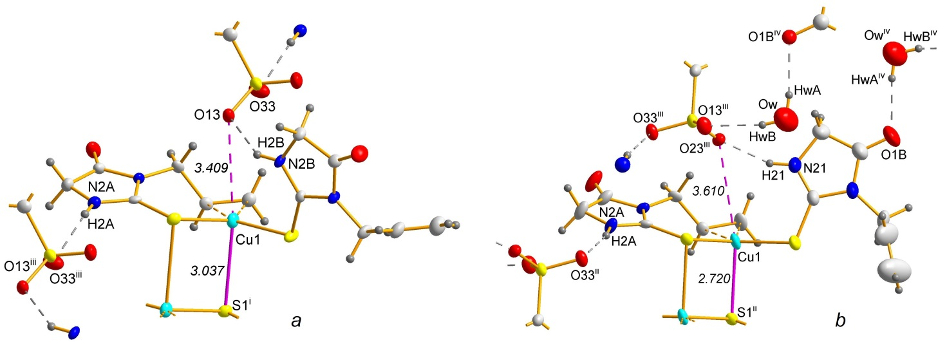
Figure. 2. Systems of weak bonding in the structure 1 (a) and 2 (b).
Symmetry codes: (i) 1−x, 2−y, 1−z; (ii) 2−x, 1−y, 1−z; (iii) x−1, y, z; (iv) 1− x, −y, −z.

Table 3. Geometry of selected hydrogen bonds in 1.
Atoms involved  D−H···A | Distances, Å |  |  | Angle, deg  D−H···A
Atoms involved  D−H···A | D···H | H···A | D···A | Angle, deg  D−H···A
N2A–H2A···O33^{iii} | 0.86 | 1.99 | 2.743(3) | 146
N2B–H2B···O13 | 0.86 | 2.01 | 2.774(3) | 148
Symmetry code: (iii) x−1, y, z.

The system of hydrogen bonding in 2 is much more complicated than in 1 due to the presence of the water molecule (Table 4, Fig 3). As one of the results of its presentence in 2 all three anion’s O atoms participate in a formation of hydrogen bonding – two of them (O23 and O33) form N–H···O bonding, like in 1, and the third one (O13) is connected with water molecule HwB atom. Second water hydrogen HwA atom is involved in Ow–HwA···O1B^{iv} H-bonding with carbonyl C=O Hath group. As a result of all bonding, 2D H-bonded net is formed (Fig 3). Also, like in 1, there is a weak Cu–O bonding but in structure 2, the corresponding distance is noticeably greater and is equal to 3.610(3) Å, which is still less than the sum of van der Waals radii by Alvarez (3.88 Å).

Table 4. Geometry of selected hydrogen bonds in 2.
Atoms involved  D−H···A | Distances, Å |  |  | Angle, deg  D−H···A
Atoms involved  D−H···A | D···H | H···A | D···A | Angle, deg  D−H···A
N21–H21···O23^{iii} | 0.88 | 1.93 | 2.761(4) | 156
N2A–H2A···O33^{ii} | 0.88 | 1.91 | 2.764(3) | 164
Ow–HwA···O1B^{iv} | 0.85 | 2.00 | 2.841(6) | 173
Ow–HwB···O13^{iii} | 0.85 | 2.08 | 2.914(5) | 168
Symmetry codes: (ii) 2−x, 1−y, 1−z; (iii) x−1, y, z; (iv) 1−x, −y, −z.

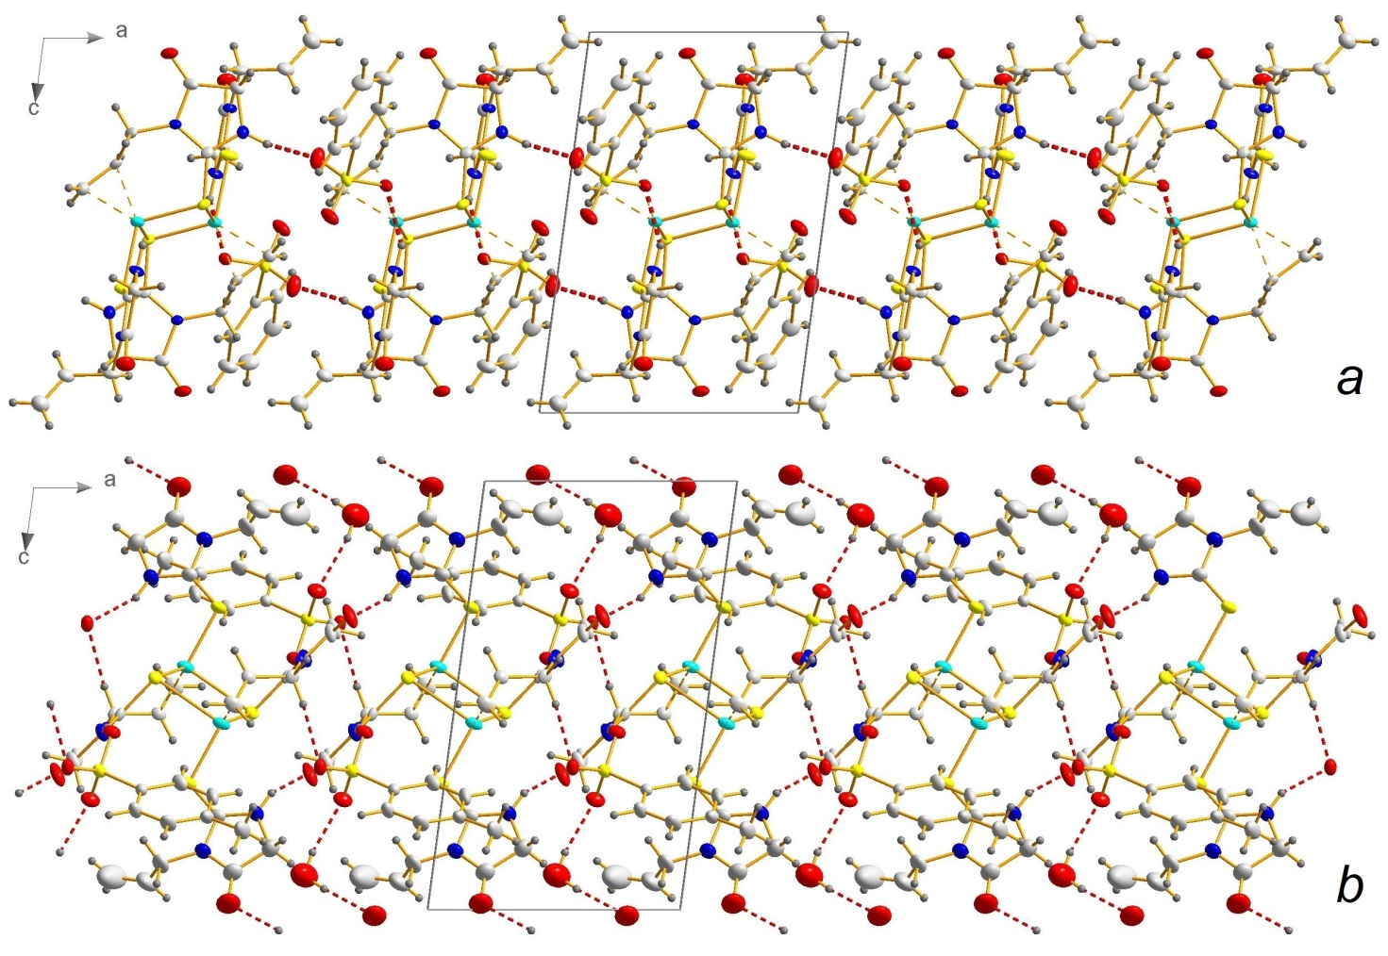
Figure. 3. 1D H-bonded chain in 1 (a) and 2D H-bonded net in 2 (b).

As it was shown before, Cu1–S1^{X} distance to the apical S1^{X} atom (X = i in 1 and ii in 2) is noticeably different in these two structures. Moreover, since all other distances and angles within the coordination environment of Cu atom are almost the same (Table 2) as well as a composition of the cationic fragment, it can be concluded that the cause of these differences should be found in the outer coordination sphere. As a possible reason, we would like to introduce the confrontation of Cu–S bonding and Cu–O weak interaction. One can notice that in 1, where Cu–S interaction is comparably weaker (3.0374(8) Å) Cu–O interaction is stronger (3.409(3) Å) and wise versa – in 2 Cu–S is stronger (2.7205(9) Å), but Cu–O interaction is weaker (3.610(3) Å) (Fig 2). In our previous works we have shown an impact of a weak interactions, including hydrogen bonding, on the structural organization in π-complex compounds. ²⁸⁻³⁰ The weakening of the Cu–O interaction in 2 (and the strengthening of Cu–S as a result) can be explained by the fact, that the anion in 2 is involved in a bigger number of the H-bonding, due to the presence of the water molecule, all of which competes with the Cu–O interaction. Finally, since the water was presented in both reaction mixtures, but co-crystallized only in 2, its presentence in its crystal structure should be explained by the different character of benzene- and p-toluenesulfonate anions.

4. Conclusions
Two novel copper(I) π-complexes [Cu₂(Hath)₄](C₆H₅SO₃)₂ (1) and [Cu₂(Hath)₄]·2CH₃C₆H₄SO₃·2H₂O (2) (Hath = 3-allyl-2-thiohydantoine) were synthesized and characterized by the X-ray diffraction method. Both structures contain centrosymmetric cationic dimmer [Cu₂(Hath)₄]²⁺ in which Cu(I) atom has a trigonal pyramidal coordination environment. Nevertheless, both [Cu₂(Hath)₄]²⁺ are very similar, there are some differences, including the difference in the Cu1−S1^{X} distance (3.0374(8) Å in 1 and 2.7205(9) Å in 2). As a possible explanation, the confrontation of Cu–S and Cu–O weak interaction was proposed. Due to this model this difference is explained by the fact, that the anion in 2 is involved in a bigger number of the H-bonding, due to the presence of the water molecule in it, and act on Cu(I) atom weaker than in 1.

5. Supplementary material
CCDC numbers 1997084 (1) and 1997085 (2) contains the supplementary crystallographic data for this paper. Copies of the data can be obtained free of charge on applications to the Director, CCDC, 12 Union Road, Cambridge CB2 1EZ, UK (Fax: int. code +(1223)336–033; e-mail for inquiry: fileserv@ccdc.cam.ac.uk).
6. References
- Seo Hyun Choa, Seok-Ho Kim, Dongyun Shin, Eur. J. Med.Chem. 2019, 164, 517–545.
- S. Suzen, E. Buyukbingol, Il Farmaco. 2000, 55, 246–248.
- M.E. Jung, S. Ouk, D. Yoo, C.L. Sawyers, C. Chen, C. Tran, J. Wongvipat, J. Med. Chem. 2010, 53, 2779–2796.
- Y.S. Bae, S. Choi, J.J. Park, J.H. Joo, M. Cui, H. Cho, W.J. Lee, S.H. Lee, Bioorg. Med. Chem. 2016, 24, 4144–4151.
- R. Raj, V. Mehra, J. Gut, P.J. Rosenthal, K.J. Wicht, T.J. Egan, M. Hopper, L.A. Wrischnik, K.M. Land, V. Kumar, Eur. J. Med. Chem. 2014, 84, 425–432.
- M. T. M. González, J. L. G. Ariza, F. Pino, R. G. Villanova, Talanta 1978, 25, 331–337.
- M. T. M. González, J. L. G. Ariza, Talanta 1980, 27, 613–614.
- C. R. Groom, I. J. Bruno, M. P. Lightfoot, S. C. Ward, Acta Cryst. B 2016, 72, 171–179.
- Weifeng Zeng, Xiaodong Yang, Xiuli Chen, Yichen Yan, Xinwei Lu, Jinqing Qu, Ruiyuan Liu, Eur. Polym. J. 2014, 61, 309–315.
- P. Aslanidis, S. Kyritsis, M. Lalia-Kantouri, B. Wicher, M. Gdaniec, Polyhedron 2012, 48, 140–145
- Yu.I. Slyvka, A.A. Fedorchuk, N.T. Pokhodylo, T. Lis, I.V. Kityk, M.G. Mys'kiv, Polyhedron 2018, 147, 86–93.
- A.A. Fedorchuk, Yu.I. Slyvka, E.A. Goreshnik, I.V. Kityk, P. Czaja, M.G. Mys’kiv, J. Mol. Struct. 2018, 1171, 644–649.
- Yu. Slyvka, A.A. Fedorchuk, E. Goreshnik, G. Lakshminarayana, I.V. Kityk, P. Czaja, M. Mys'kiv, Chem. Phys. Lett. 2018, 694, 112–119.
- Yu. Slyvka, E. Goreshnik, G. Veryasov, D. Morozov, A.A. Fedorchuk, N. Pokhodylo, I. Kityk, M. Mys’kiv, J. Coord. Chem. 2019, 72, 1049–1063.
- A.A. Fedorchuk, Yu. Slyvka, V. Kinzhybalo, I. Kityk, J. Jędryka, K. Ozga, M. Mys`kiv, J. Coord. Chem. 2019, 72, 3222–3236.
- A.A.Fedorchuk, Yu.I. Slyvka, V. Kinzhybalo, T. Lis, M.G. Mys'kiv, Inorg. Chim. Acta 2019, 481, 79–86.
- A.A. Fedorchuk, Yu.I. Slyvka, M.G. Mys’kiv, Voprosy khimii i khimicheskoi tekhnologii 2019, 4, 172–178.
- B. M. Mykhalichko, M. G. Mys’kiv. Ukraine Patent UA 25450A, Bull. № 6, 1998.
- Agilent Technologies, CrysAlis PRO, Agilent Technologies, Yarnton, England, 2011.
- G. M. Sheldrick, Acta Cryst. Sect. A. 2015, A71, 3–8.
- G. M. Sheldrick, Acta Cryst. Sect. C. 2015, C71, 3–8.
- O. V. Dolomanov, L. J. Bourhis, R. J. Gildea, J. A. K. Howard, H. Puschmann, J. Appl. Cryst. 2009, 42, 339–341.
- L.Yang, D. R. Powell, R. P. Houser, Dalton Trans. 2007, 9, 955–964.
- Bondi, J. Phys. Chem. 1964, 68, 441–451.
- Bondi, J. Phys. Chem. 1966, 70, 3006–3007.
- S. S. Batsanov, Inorg. Mater. 2001, 37, 871–885.
- S. A. Alvarez, Dalton Trans. 2013, 42, 8617–8636.
- Yu. Slyvka, E. Goreshnik, N. Pokhodylo, O. Pavlyuk, M. Mys’kiv, Acta. Chim. Slov. 2016, 63, 399-405.
- B. Ardan, V. Kinzhybalo, Yu. Slyvka, O. Shyyka, M. Luk’yanov, T. Lis, M. Mys’kiv, Acta. Cryst. Sect. C. 2017, C73, 36–46.
- E. A. Goreshnik, G. Veryasov, Yu. I. Slyvka, B. R. Ardan, M. G. Mys’kiv, J. Organomet. Chem. 2016, 810, 1–11.

