Supplementary data

A simple and effective synthesis of 4- and 3-((phenylcarbamoyl)oxy)benzoic acids
Urban Košakª, Stanislav Gobecª*

ªFaculty of Pharmacy, University of Ljubljana, Aškerčeva 7, 1000 Ljubljana, Slovenia

Table of contents

¹H NMR spectra of compounds 6, 8 and 10–22 and ¹³C NMR spectra of compounds 10–22. 2
UPLC chromatograms of compounds 16–22. 29

¹H NMR spectra of compounds 6, 8 and 10–22 and ¹³C NMR spectra of compounds 10–22.
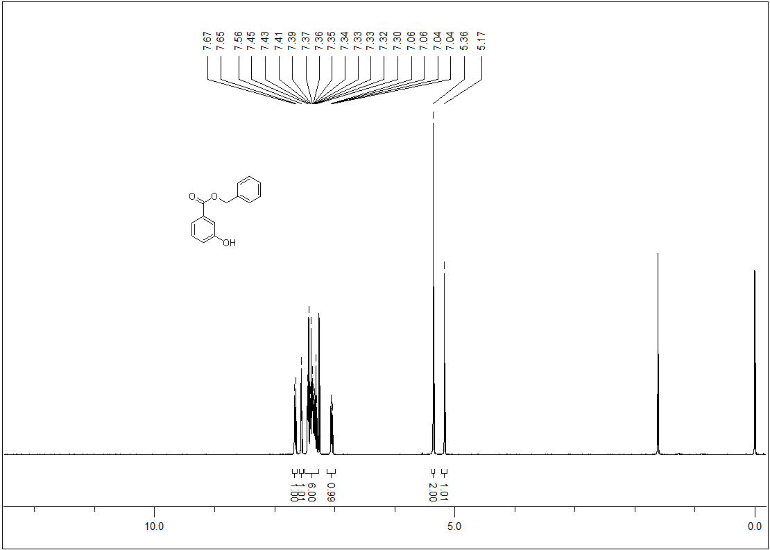
Figure 1. ¹H-NMR spectrum of compound 6.

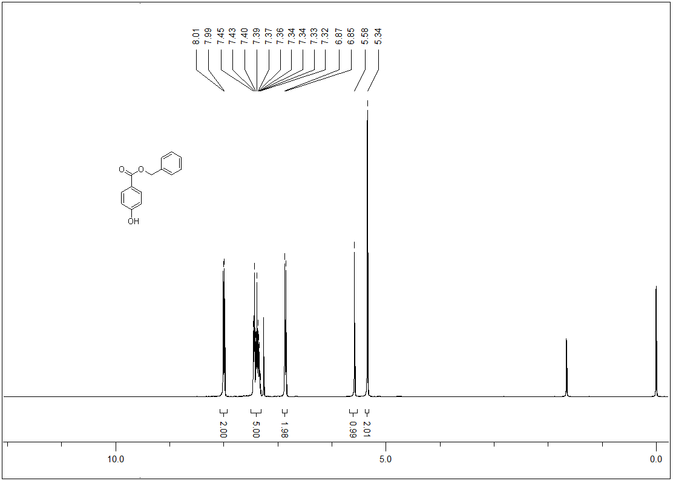
Figure 2. ¹H-NMR spectrum of compound 8.

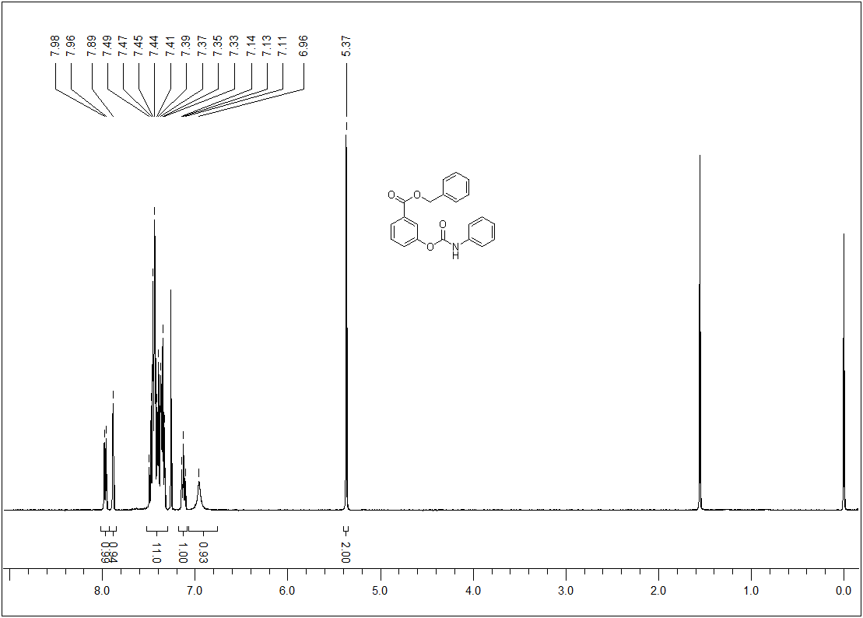
Figure 3. ¹H-NMR spectrum of compound 10.

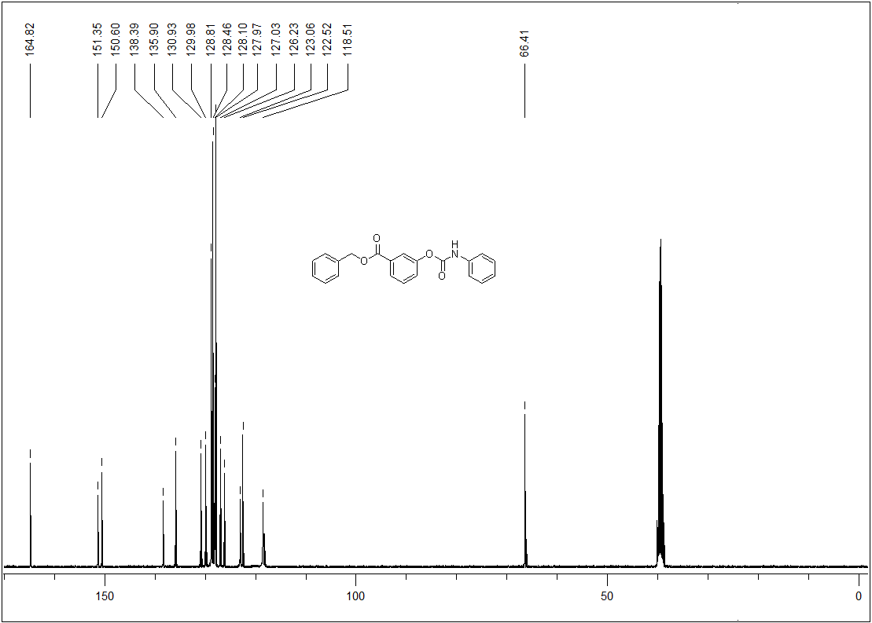
Figure 4. ¹³C-NMR spectrum of compound 10.

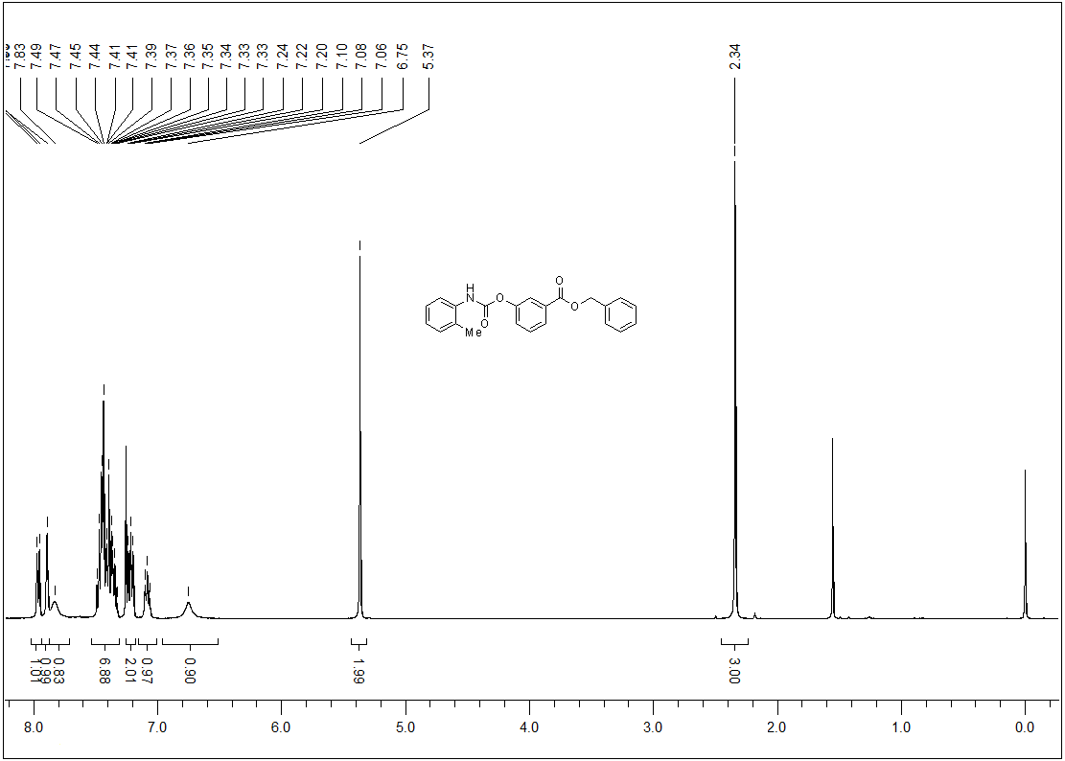
Figure 5. ¹H-NMR spectrum of compound 11.

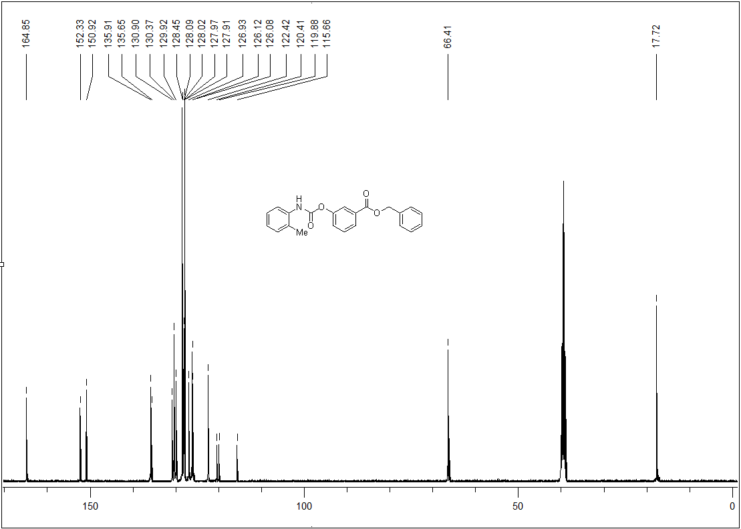
Figure 6. ¹³C-NMR spectrum of compound 11.

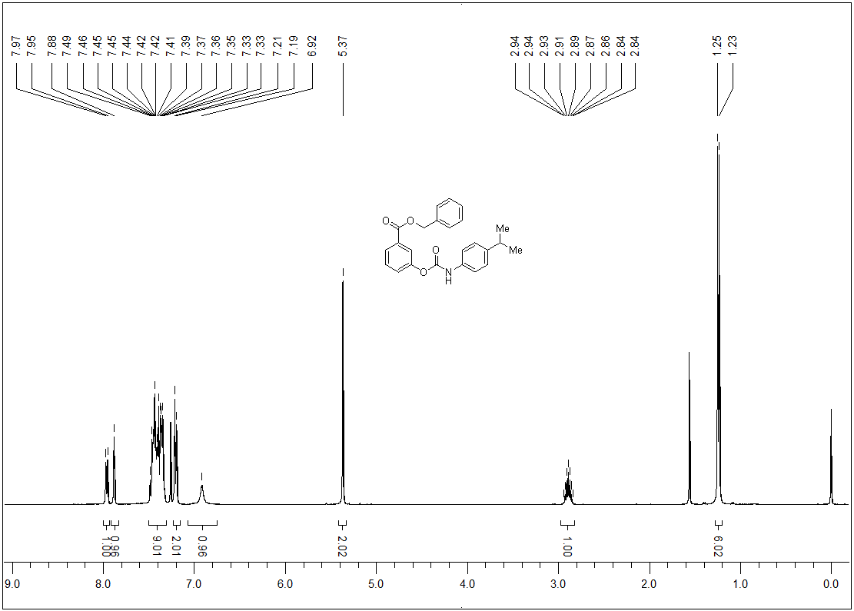
Figure 7. ¹H-NMR spectrum of compound 12.

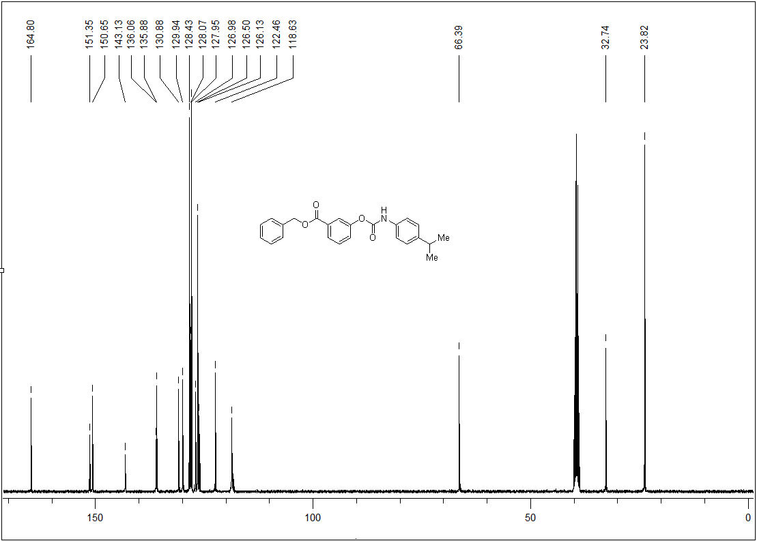
Figure 8. ¹³C-NMR spectrum of compound 12.

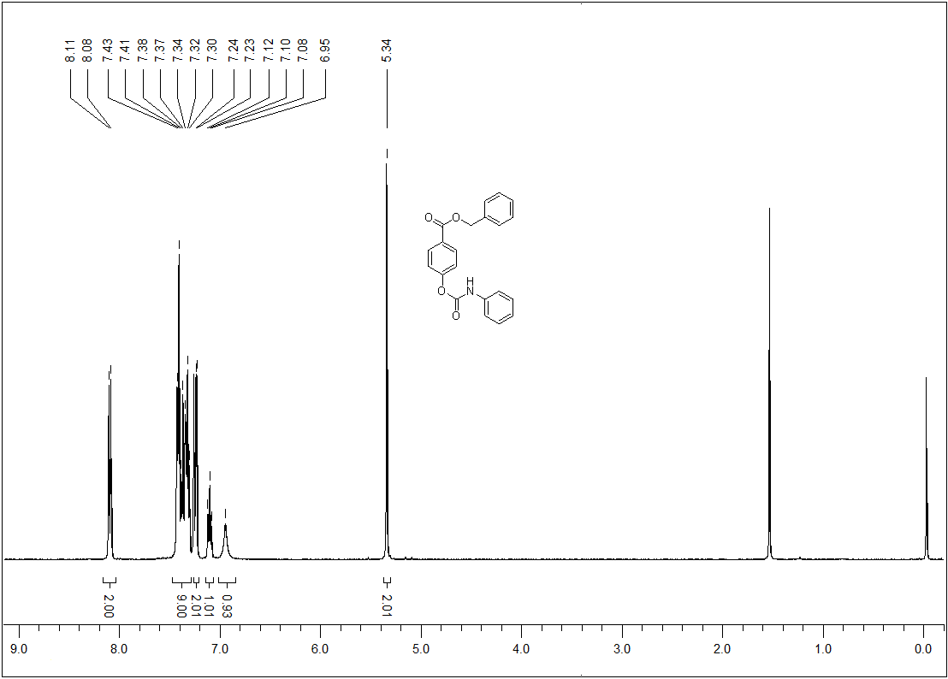
Figure 9. ¹H-NMR spectrum of compound 13.

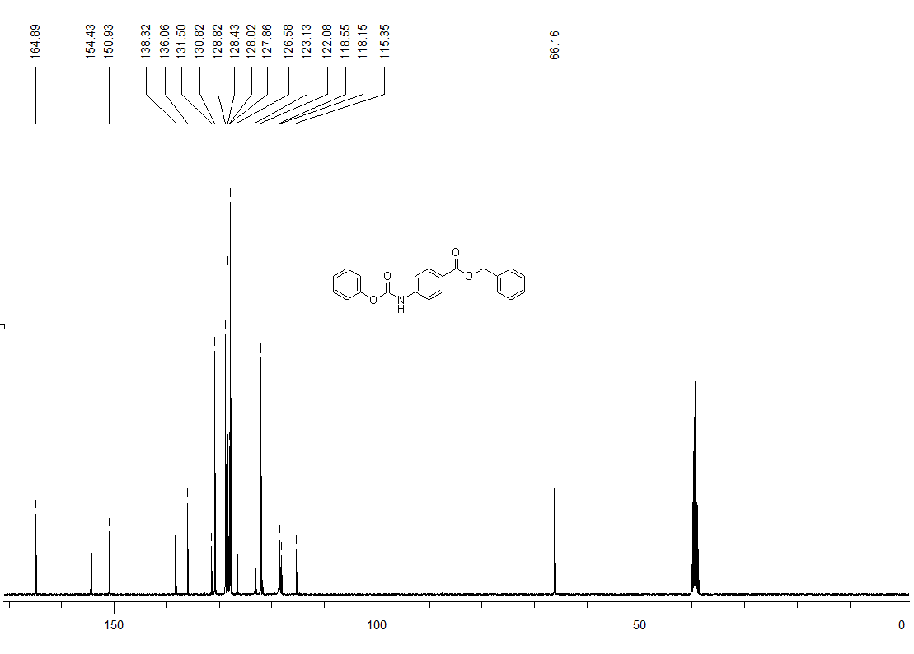
Figure 10. ¹³C-NMR spectrum of compound 13.

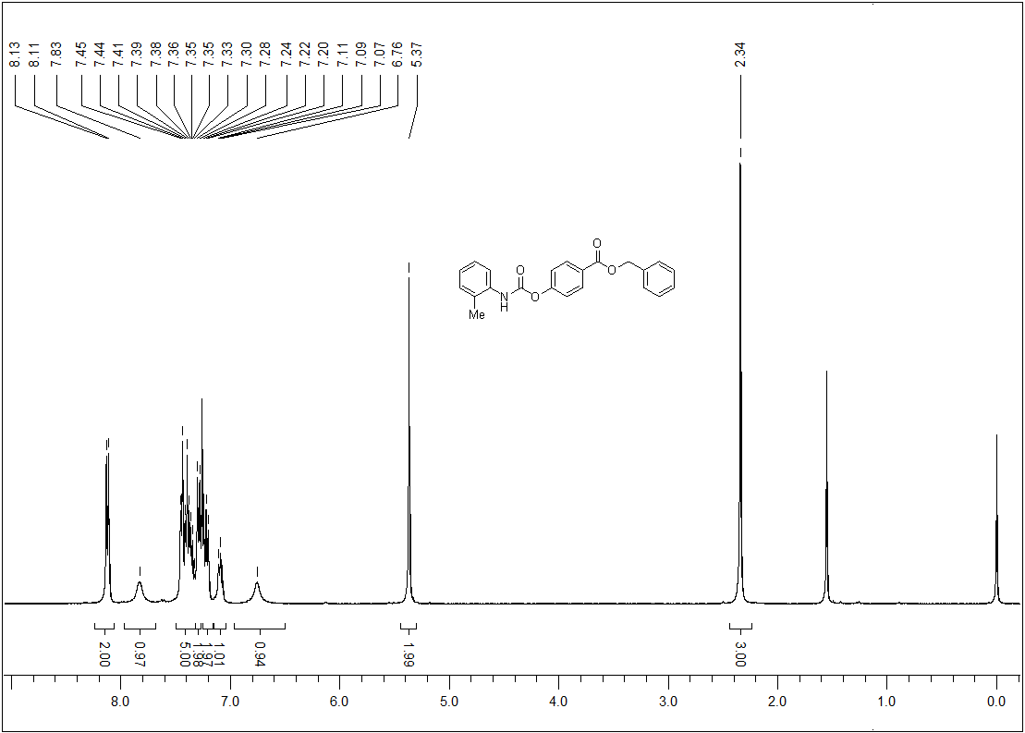
Figure 11. ¹H-NMR spectrum of compound 14.

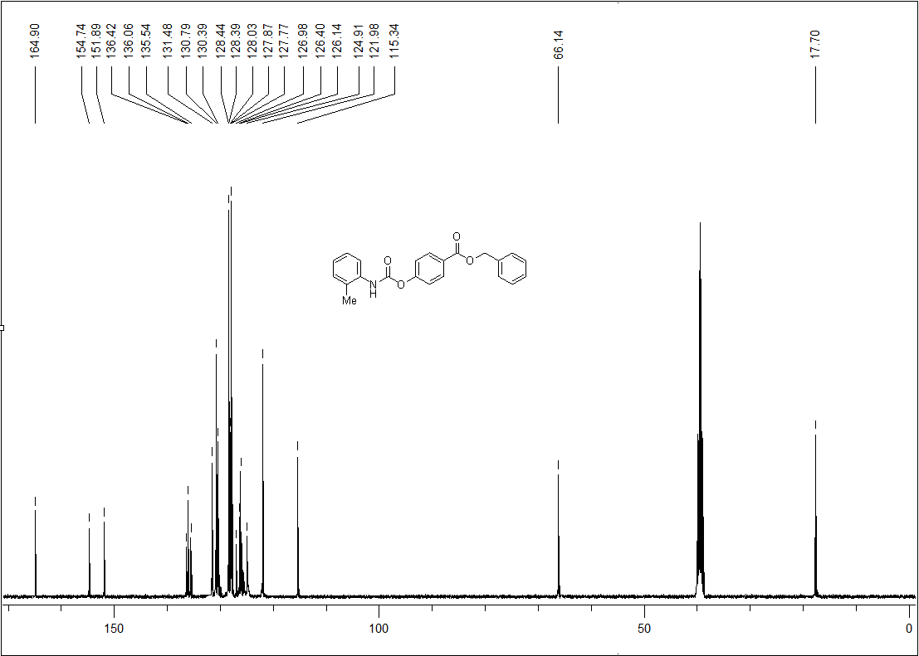
Figure 12. ¹³C-NMR spectrum of compound 14.

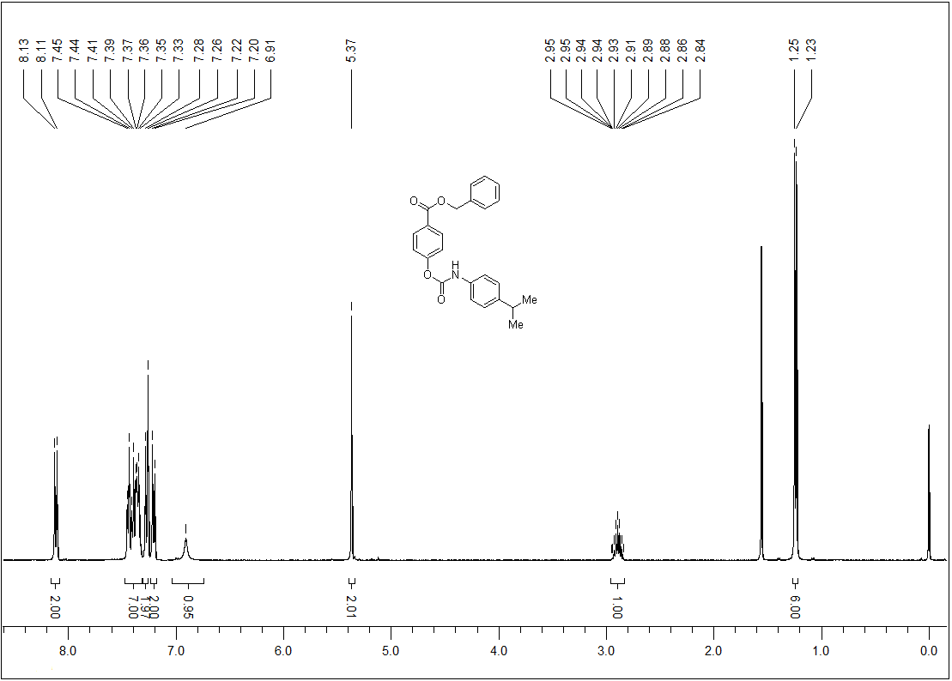
Figure 13. ¹H-NMR spectrum of compound 15.

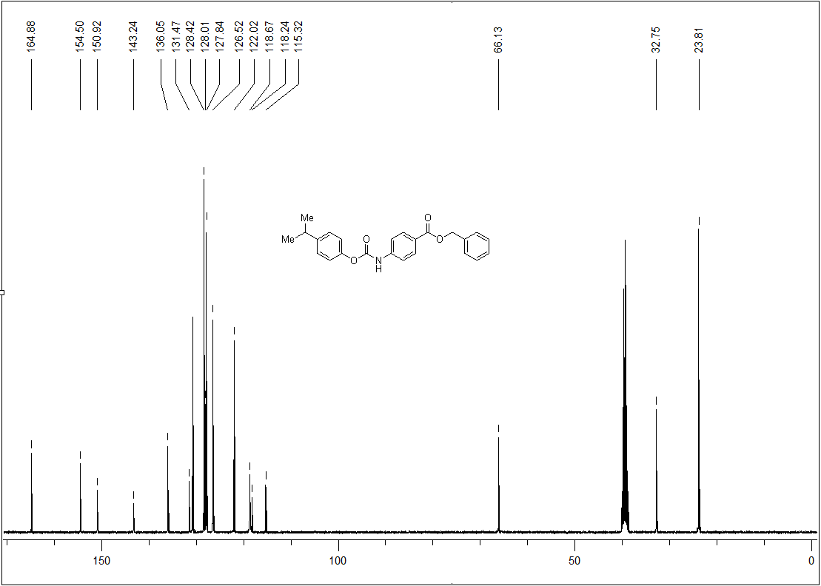
Figure 14. ¹³C-NMR spectrum of compound 15.

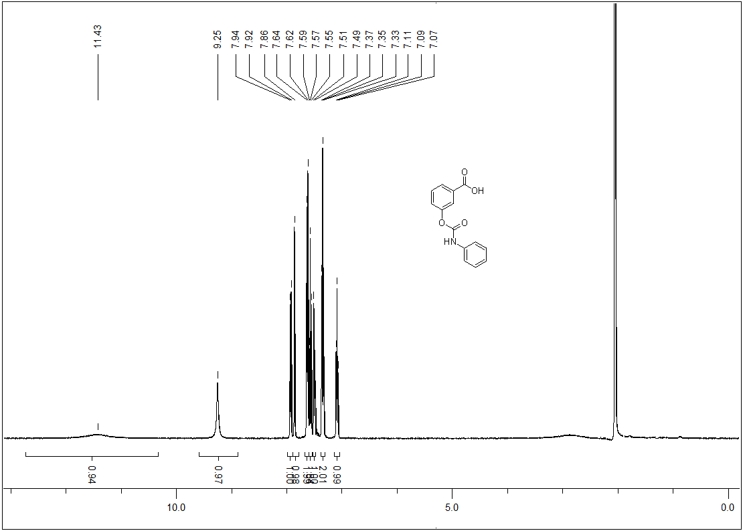
Figure 15. ¹H-NMR spectrum of compound 16.

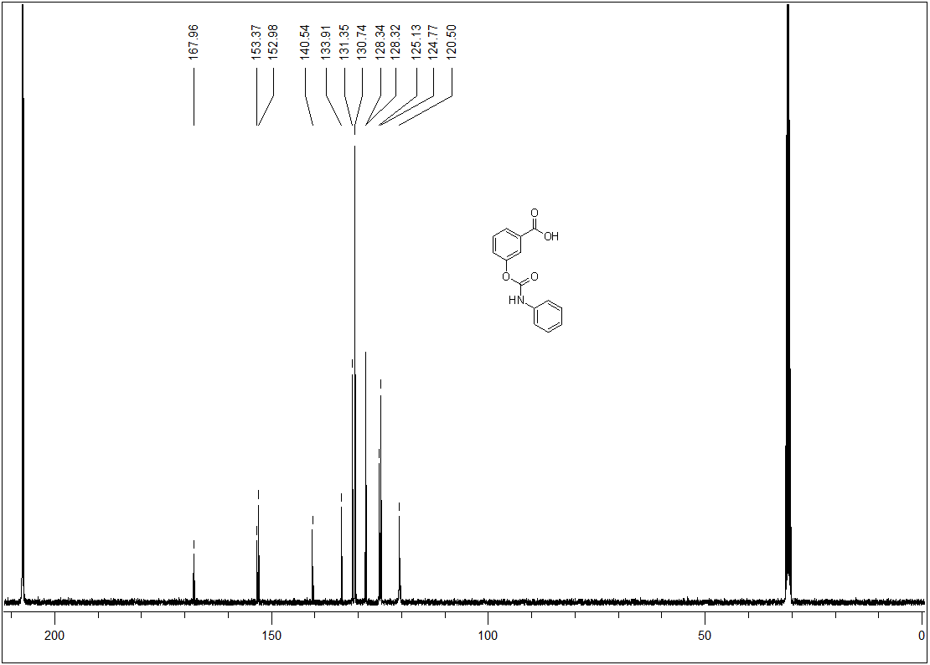
Figure 16. ¹³C-NMR spectrum of compound 16.

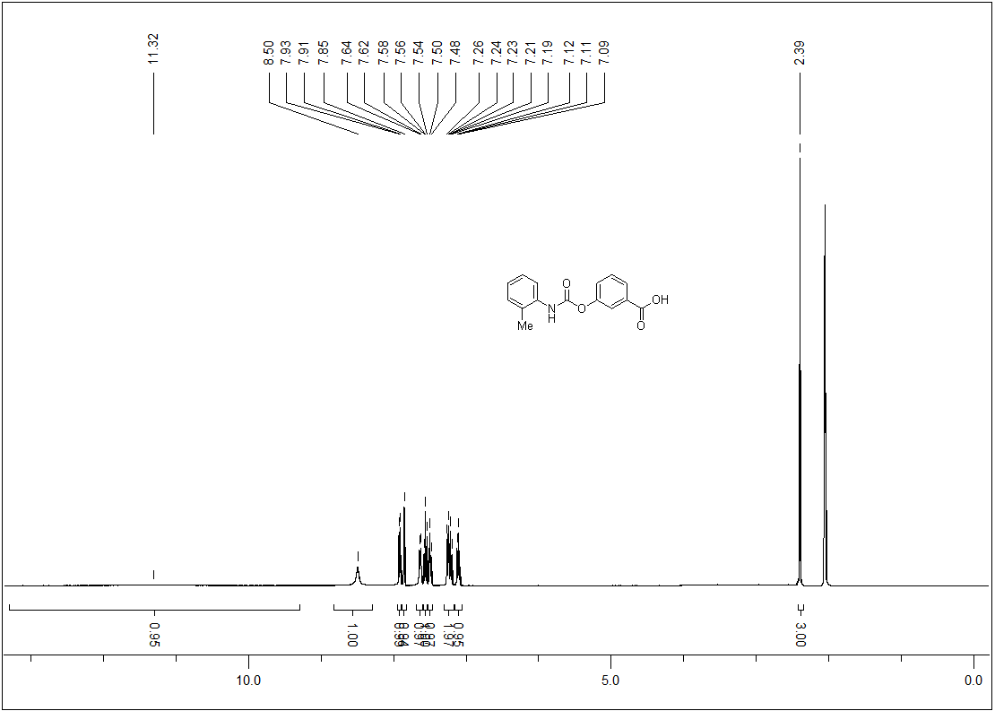
Figure 17. ¹H-NMR spectrum of compound 17.

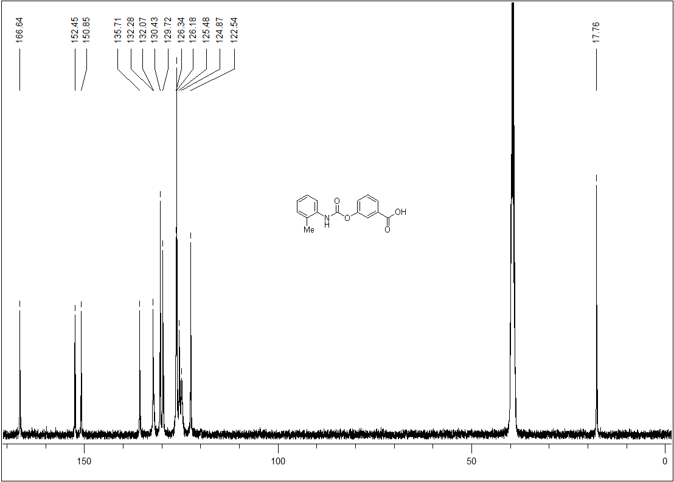
Figure 18. ¹³C-NMR spectrum of compound 17.

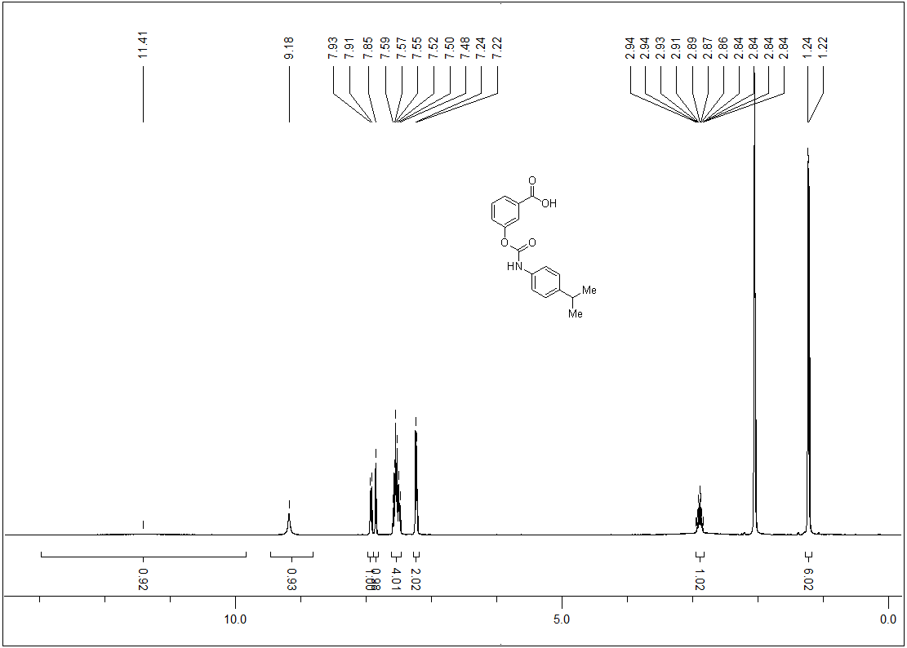
Figure 19. ¹H-NMR spectrum of compound 18.

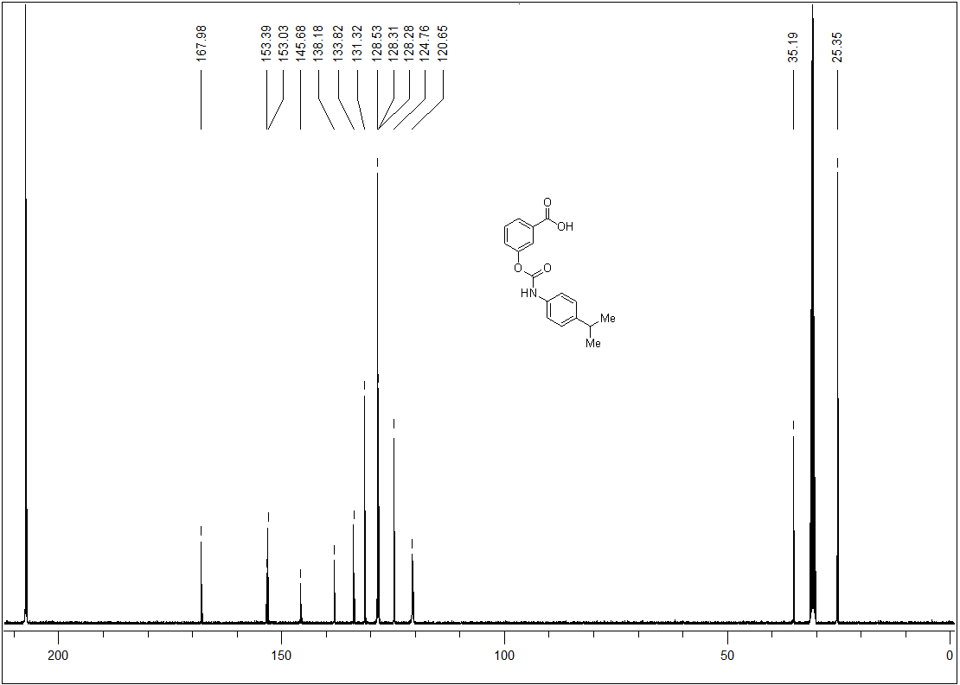
Figure 20. ¹³C-NMR spectrum of compound 18.

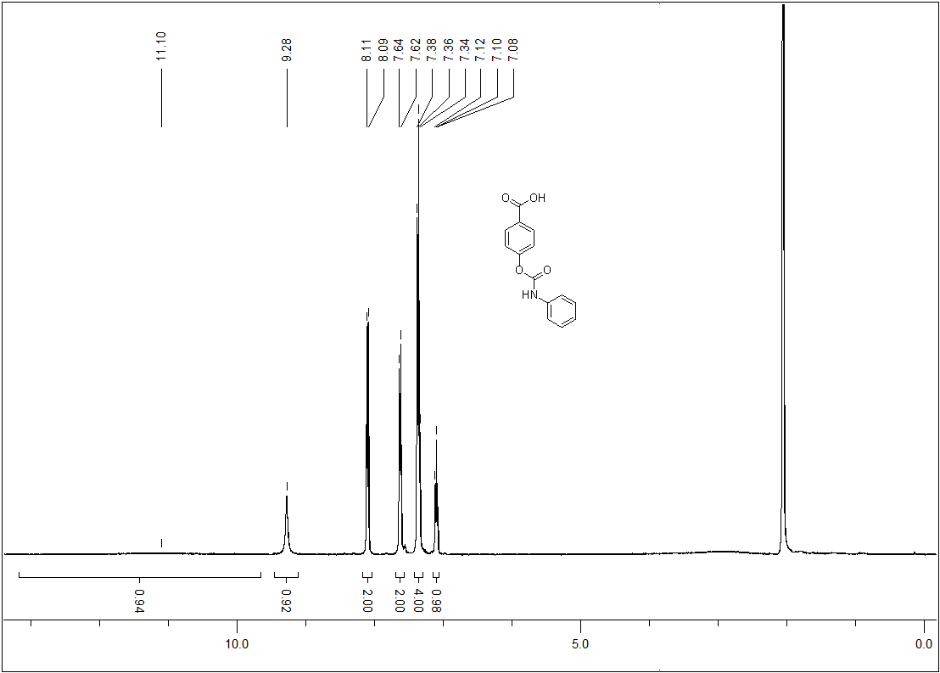
Figure 21. ¹H-NMR spectrum of compound 19.

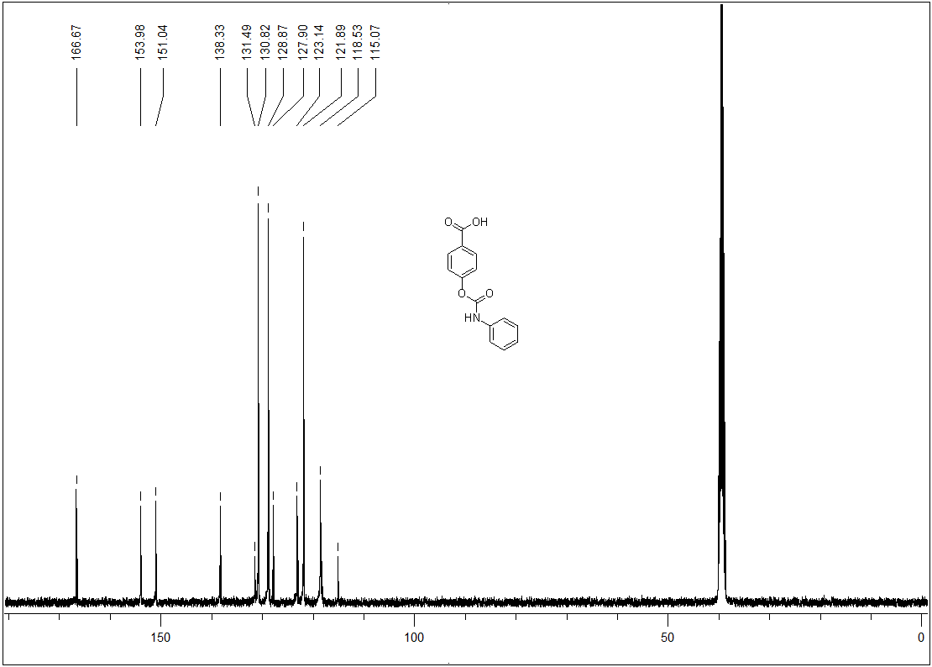
Figure 22. ¹³C-NMR spectrum of compound 19.

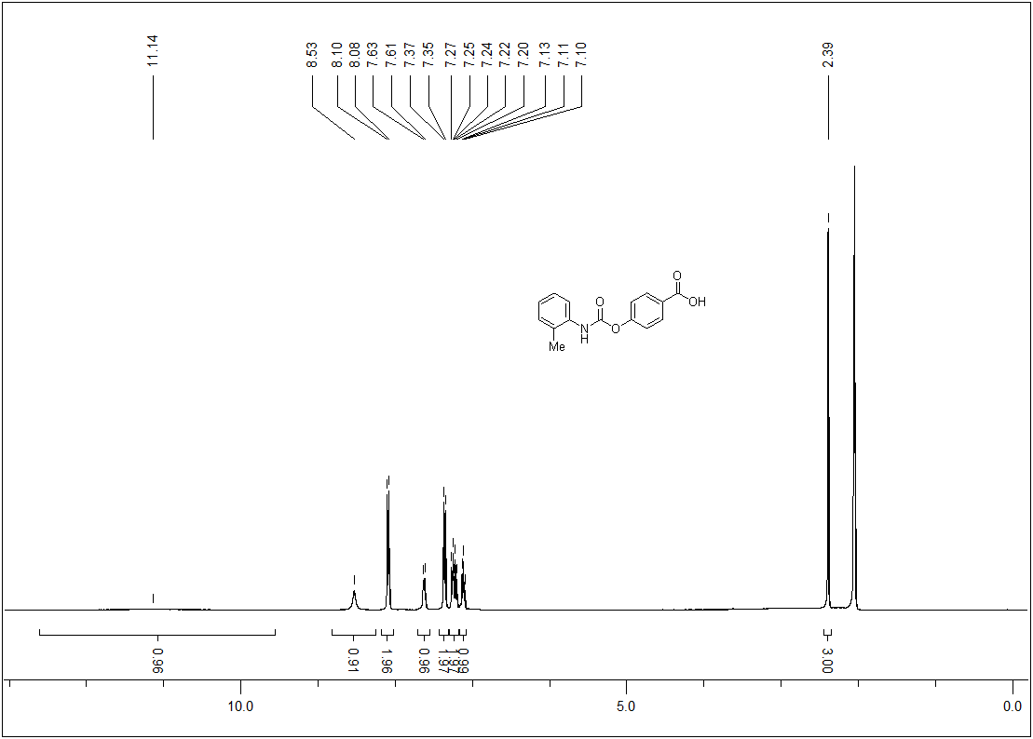
Figure 23. ¹H-NMR spectrum of compound 20.

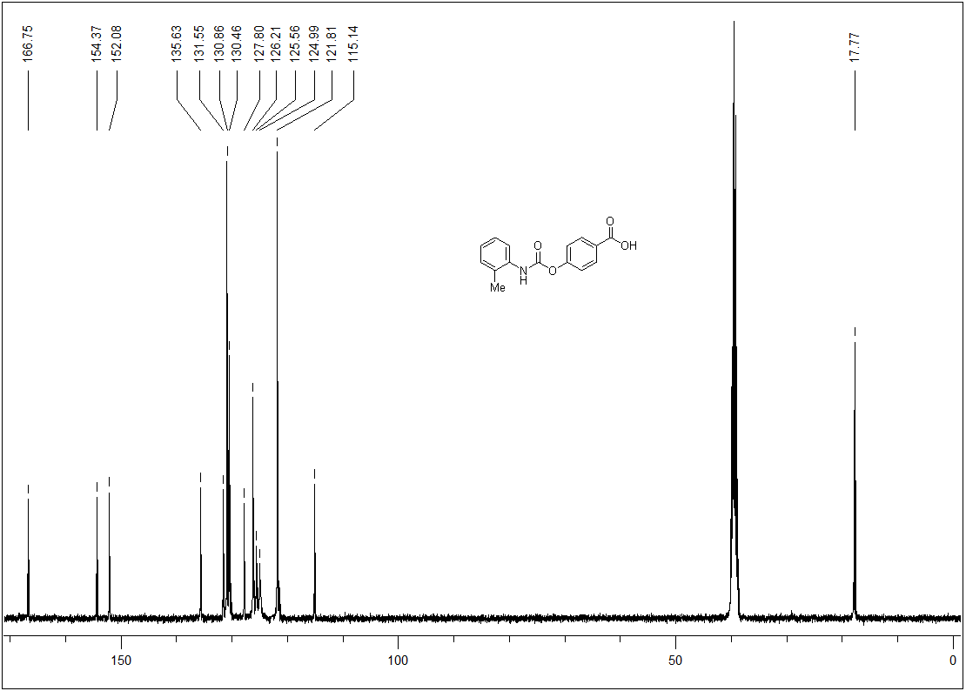
Figure 24. ¹³C-NMR spectrum of compound 20.

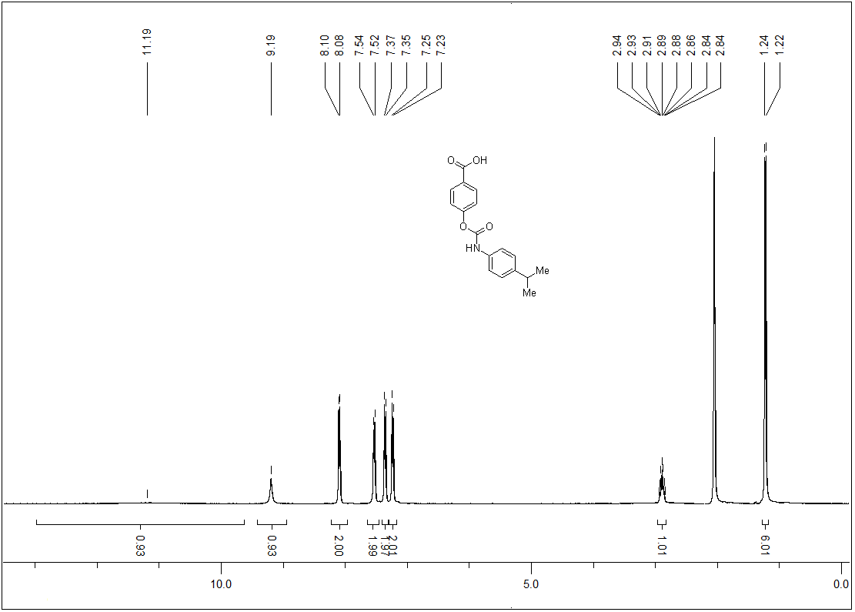
Figure 25. ¹H-NMR spectrum of compound 21.

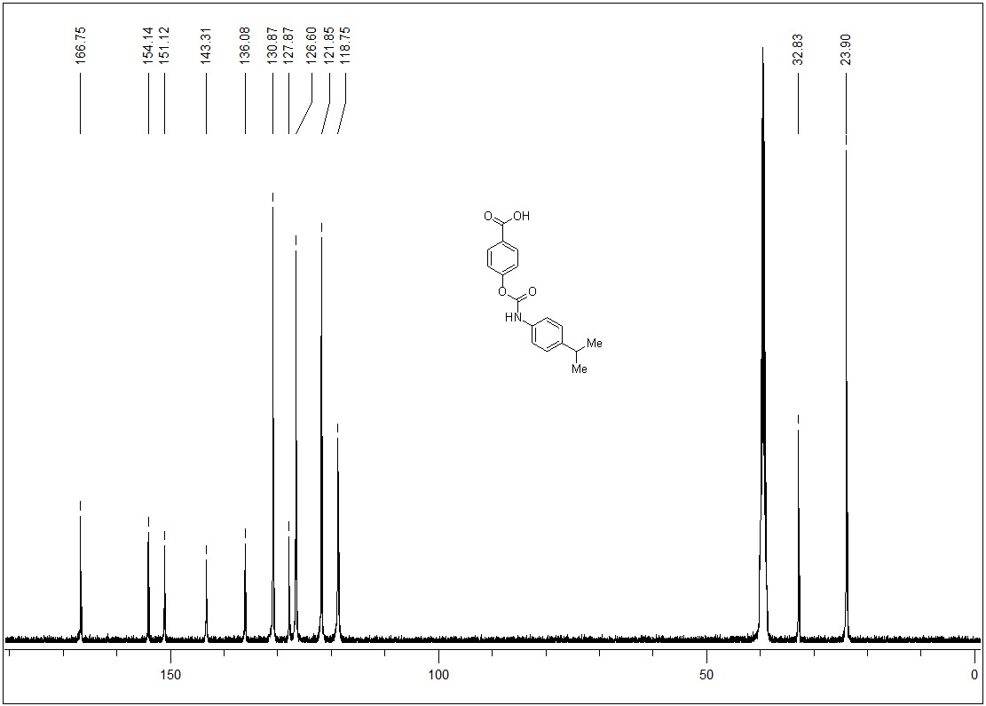
Figure 26. ¹³C-NMR spectrum of compound 21.

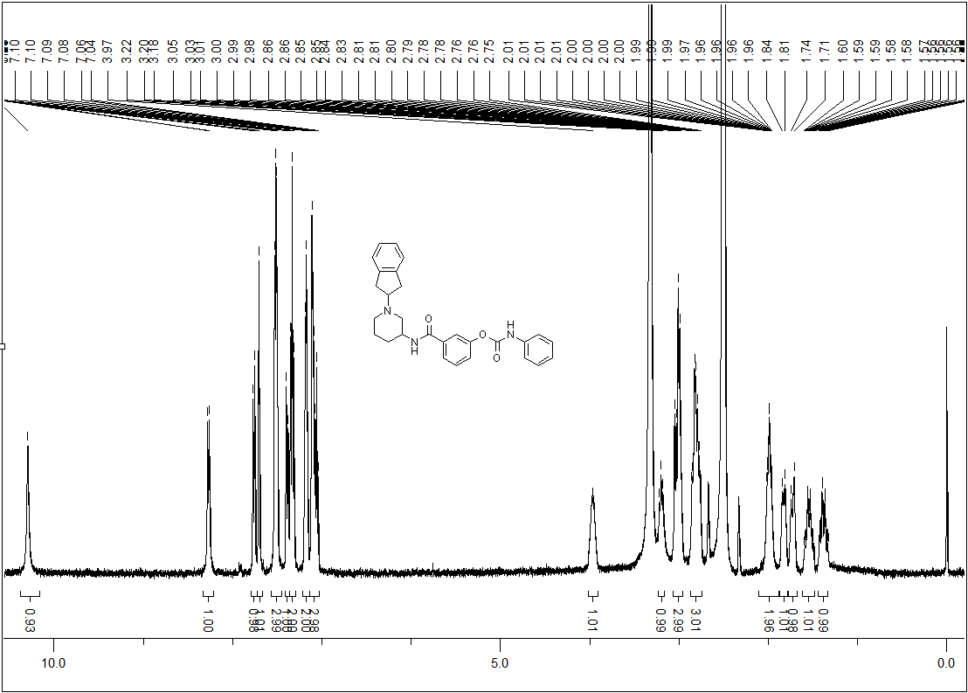
Figure 27. ¹H-NMR spectrum of compound 22.

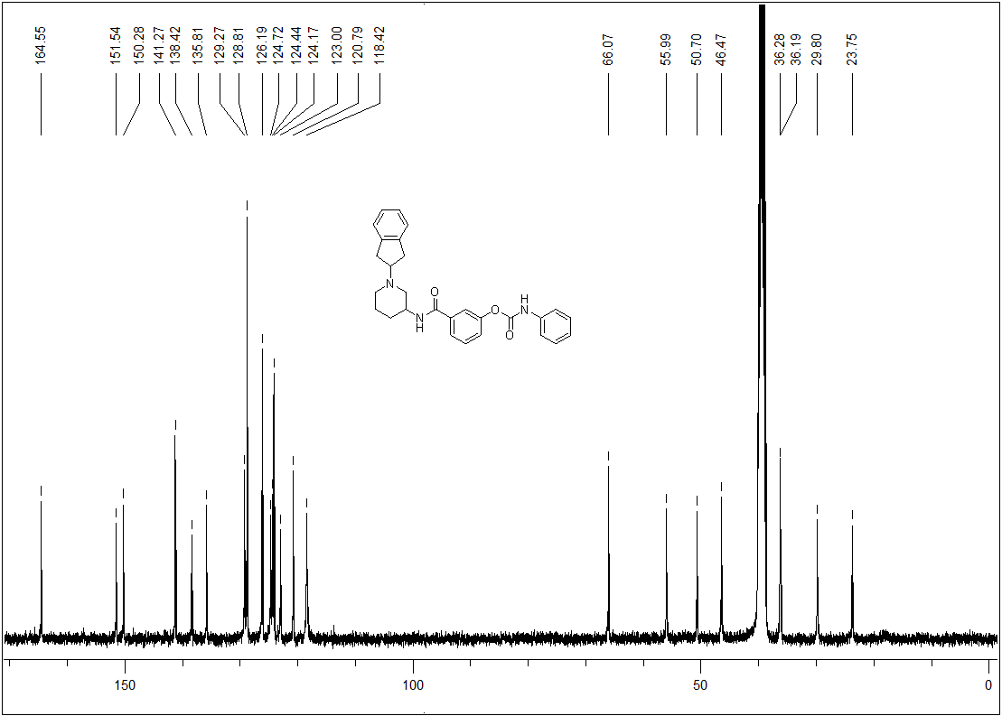
Figure 28. ¹³C-NMR spectrum of compound 22.

UPLC chromatograms of compounds 16–22.
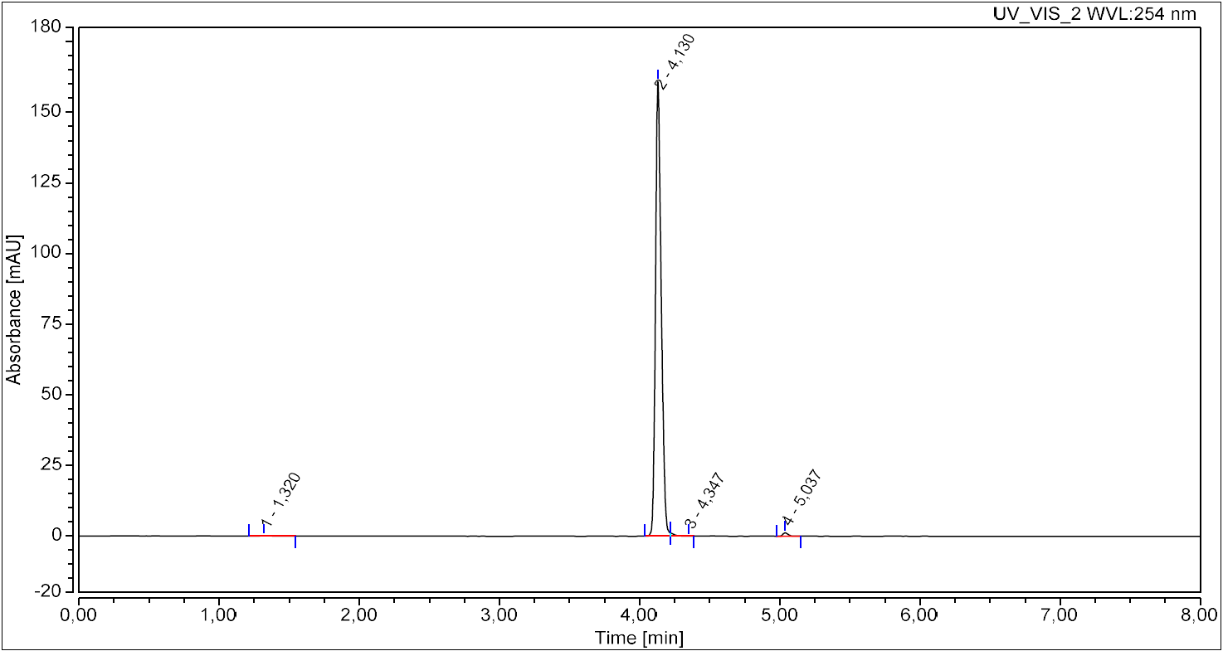
Figure 29. UPLC chromatogram of compound 16.

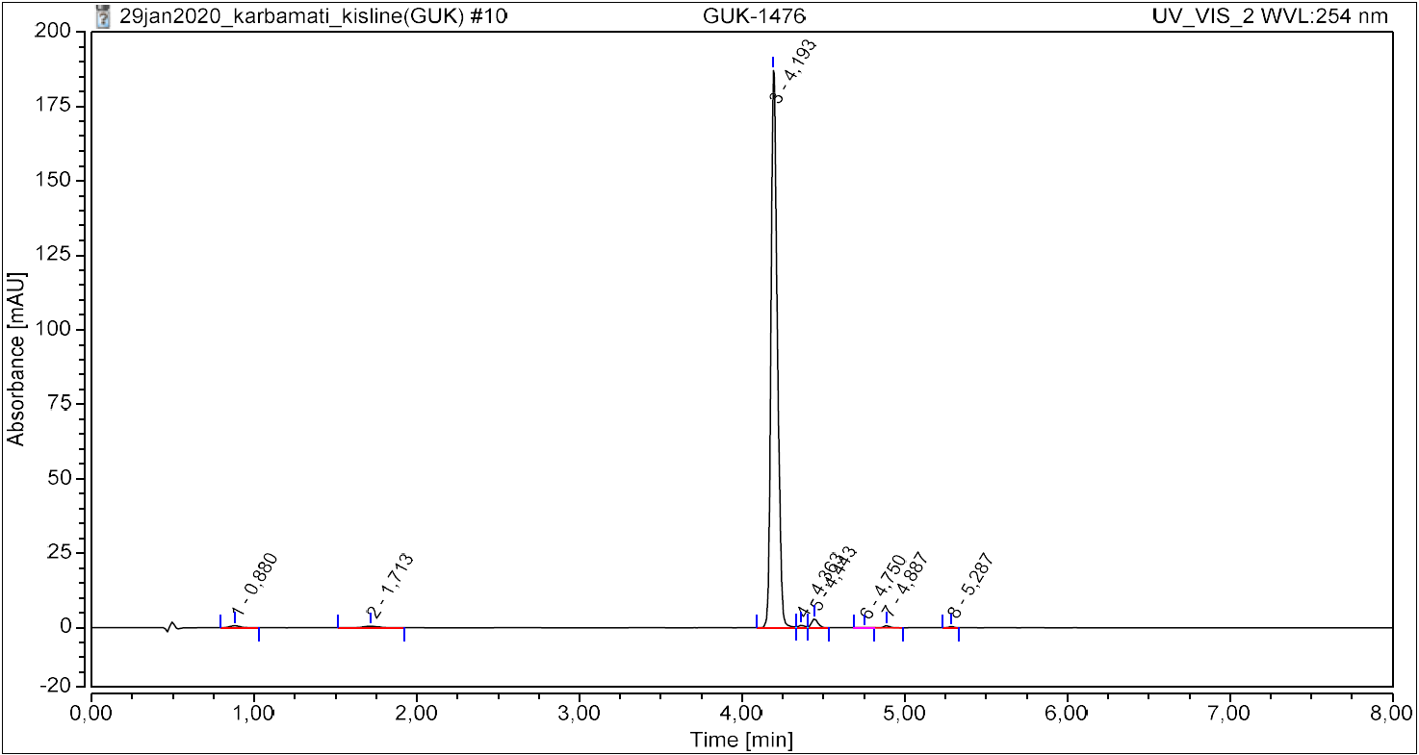
Figure 30. UPLC chromatogram of compound 17.

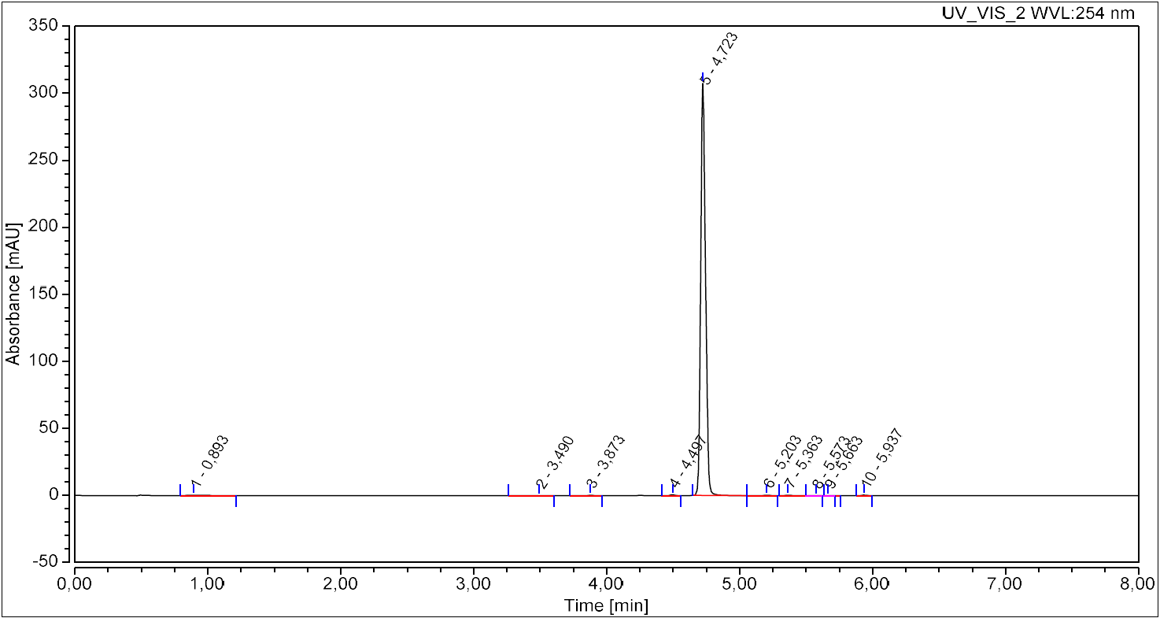
Figure 31. UPLC chromatogram of compound 18.

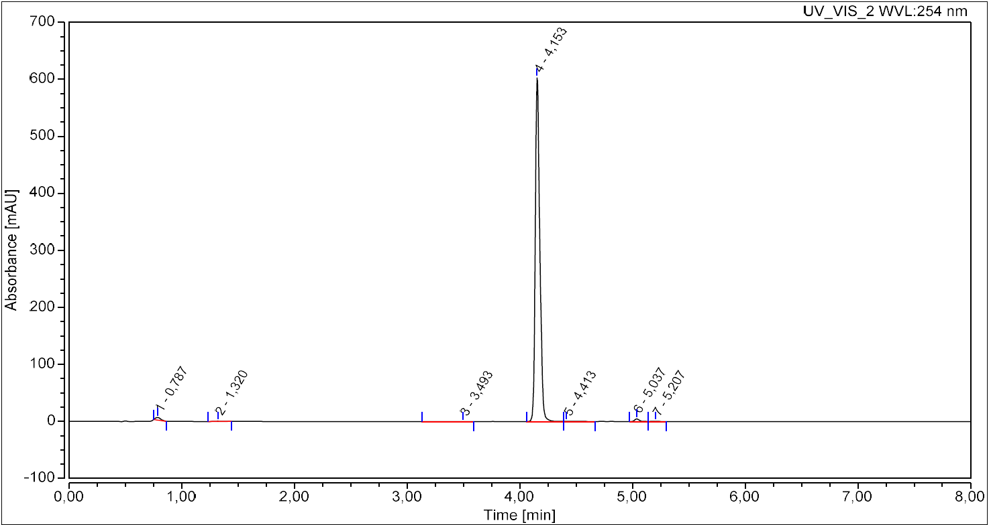
Figure 32. UPLC chromatogram of compound 19.

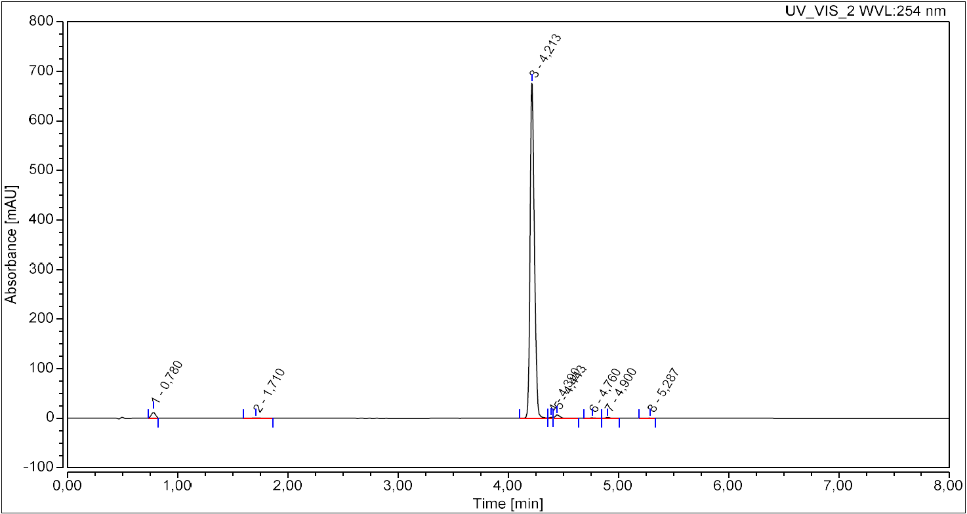
Figure 33. UPLC chromatogram of compound 20.

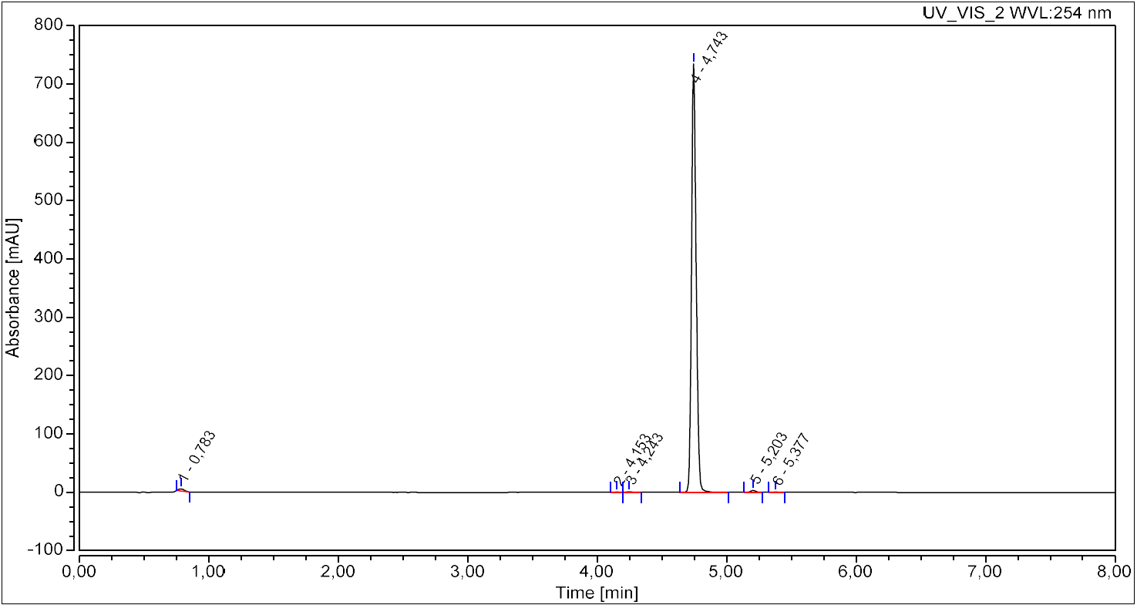
Figure 34. UPLC chromatogram of compound 21.

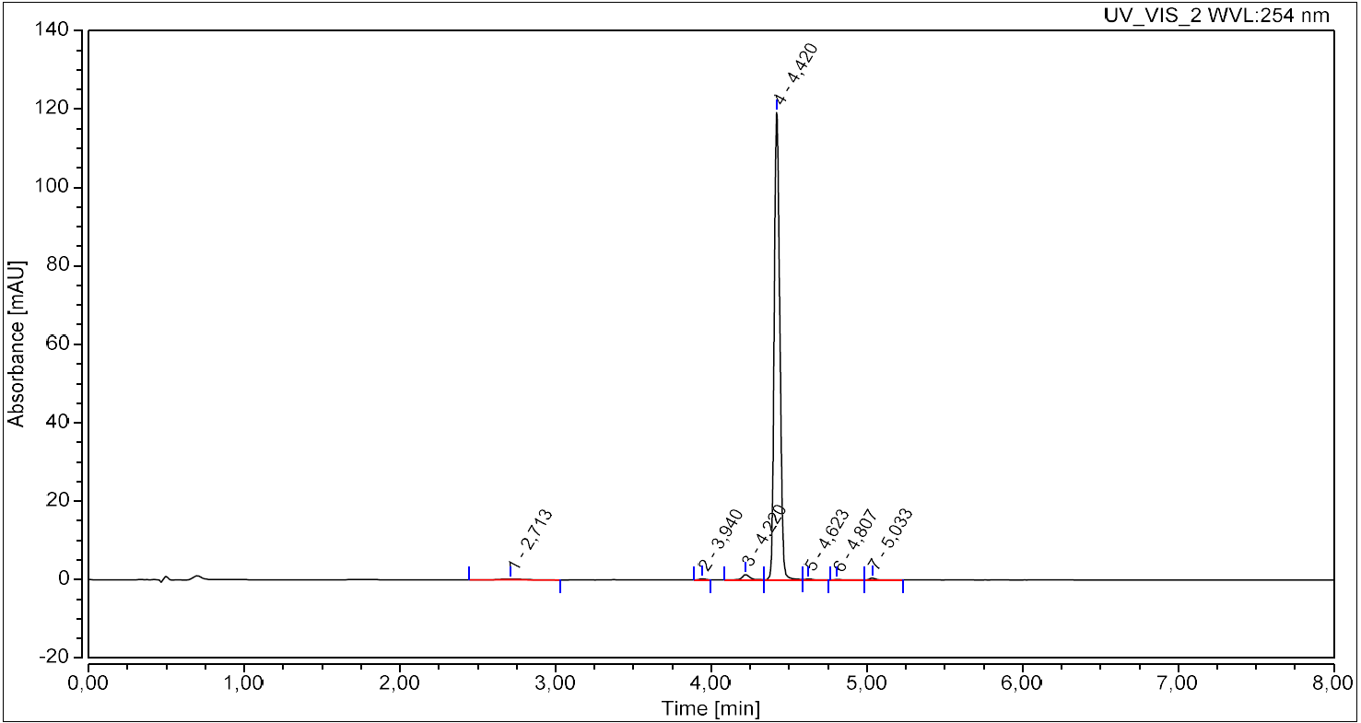
Figure 35. UPLC chromatogram of compound 22.

