Study of Electrical Discharge Machining Parameters on Stainless Steel 316L Using Copper Tool Electrode and Its Effect on the Structure and Electrochemical Properties

Mozhgan Karimi, Sayyed Ahmad Nabavi-Amri* and Ahmad Soleymanpour
School of Chemistry, Damghan University, Damghan 3671641167, Iran
*Corresponding author: E-mail address: nabavi@du.ac.ir
Tel/Fax: +982335220095
Abstract
In this work, the effect of the presence and the diffusion of the Copper from the tool electrode onto the EDMed stainless steel 316L (316L SS) surface were investigated by electrochemical impedance spectroscopy (EIS), X-ray diffraction (XRD), Quantometer analysis and Optical microscopic observations. We used the Taguchi method to study the effects of Pulse-On time (t_{on}), Pulse-off time (t_{off}), discharge current (I) and overall machining time (τ) on chemical composition, microstructures, micro-cracks and electrochemical corrosion of EDMed 316L SS samples. The results show that when the machining parameters vary, the change in chemical composition is different. By increasing the discharge current and low values of the t_{on}, the copper and carbon diffused onto the surface and chemical composition varies; this contributed to corrosion resistance increasing. The XRD showed the formation of Fe₂C, Cr₃C₂, CuNi. At higher values of I and t_{on}/t_{off} ratio, it propagates the micro-crack.

Keyword: Electrical discharge machining; Stainless steel 316L; Electrochemical impedance spectroscopy; Electrochemical corrosion; Copper diffusion

- Introduction
Electrical discharge machining (EDM) is one of the most effective processes that can produce high-quality materials precisely with a wide range of strength, hardness, and shapes. The tolerance of the shape complexity of products has been reported about the percentage of micron fractions.¹ EDM process creates a discharge current by applying electrical potential between the workpiece and the tool electrode immersed in a dielectric solution. Then discharge current overcomes with the solution resistance and continues to shape the discharging sparks on the workpiece surfaces. Each of these sparks can act as a heat source. So, the local temperature can be raised (more than 3000°C) at the micro-second time intervals.^{2, 3} Consequently, the temperature gradient developed on the surface that leads to melting and changing in material constituents,⁴ diffusing of very small particles to the surface of the tool electrode⁵ and the mechanical,^{6, 7} structural⁸ and electrochemical⁹ properties of the workpiece can be changed. These variabilities are related to some machining parameters such as electrical discharge current (I), the type of modulation of applying voltage (V), the time which modulated voltage is been pulse-on time (t_{on}) and pulse-off time (t_{off}), machining time (τ), and the type of tool electrode and work-piece.¹⁰ Whereas changing in the chemical composition of surface influences on its corrosion behavior,¹¹ it is worthwhile to study corrosion resistance of the workpiece which is made by EDM. The common methods for studying electrochemical corrosion consist of open circuit potential, potentiodynamic polarization, and electrochemical impedance spectrometry. In this work, because of the forming protecting layer on the surface of stainless steel (316L SS) during corrosion tests, the electrochemical impedance spectrometry method was used.
In this research, the EDM method was carried out on 316L SS with the copper electrode. Stainless steel was used as workpiece due to its proper mechanical properties,¹² high corrosion resistance in the corrosive medium¹³ and it is most applicable alloy¹⁴ for use in different industries such as medicine,⁵ military,¹⁵ aerospace¹⁶ and so on. There are a few studies in which, they evaluate the corrosion behavior of the samples made by EDM. The results show that the tool electrodes significantly affect the amount of workpiece corrosion.^{5, 9, 17-20}
Yan et al showed that Al–Zn–Mg alloy machined by copper electrode has greater corrosion resistance tested by weight loss method.¹⁷ Tsai et al developed a sintered electrode tools made in Cu–Cr (80–20%) composite to improve the uniform corrosion resistance of the AISI 1045 EDM surfaces.¹⁸ Sidoham et al determined the corrosion resistance of stainless steel using potentiometeric test that machined by graphite electrode in the various EDM currents.¹⁹ They indicated that by increasing the discharge current, the amounts of diffused carbon into the surface of stainless steel and also the corrosion rate increased. Saravanan et al using open circuit potential (OCP) and linear polarization measurements, showed that the corrosion has occurred in EDMed Al alloys by the brass electrode, due to the localized transfer of Cu of brass on the workpiece surface.²⁰
In this research, the presence and diffusion of Cu on the 316L SS workpiece and the effect of EDM parameters such as I, t_{on}, t_{off} and τ were investigated. At the next, the electrochemical corrosion rate of the 316L SS workpiece would assess by the electrochemical impedance spectrometry (EIS) method. The Taguchi experimental design method used to reduce cost and time of the study.

- Experimental
  - Material
The selected workpiece material was Stainless steel 316L (316L SS) in dimension 30×20×5 mm³ and the electrode tool that used in this work was made of a copper rod with a 10 mm diameter. The chemical composition of stainless steel and copper reported in table 1 and table 2 respectively. The EDM machining operations carried out due to Chmer A6040L on workpieces. The paraffin oil used as dielectric fluid. The raw and EDMed workpiece and electrode tool are shown in Figure 1. Experiments have been conducted by control parameters variations such as I, t_{on}, t_{off}, τ with each has five levels as shown in the Table 3. The design of experiments has been performing by using L25 mixed levels of orthogonal arrays according to Taguchi method that listed in Table 4.
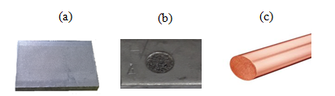
Figure1. The image of (a) raw workpiece (b) EDMed workpiece (c) tool electrode

Table1. Chemical composition of raw workpiece (wt %)
Fe | C | Si | Mn | P | S | Cr | Mo
70.2 | 0.0548 | 0.235 | 1.15 | 0.0325 | 0.005 | 19 | 0.22
Ni | Al | Co | Cu | Nb | Ti | V | W
8.36 | 0.001 | 0.122 | 0.432 | 0.0185 | 0.0078 | 0.0616 | 0.02

Table2. Chemical composition of tool electrode (wt %)
Cu | Zn | Pb | Sn | P | Mn | Fe | Ni
99.7 | 0.1 | 0.005 | 0.005 | 0.003 | 0.0054 | 0.05 | 0.005
Si | Al | Cr | Mg | S | As | Co | Ag
0.0183 | 0.0095 | 0.001 | 0.002 | 0.0113 | 0.0041 | 0.023 | 0.0082

Table3. EDM design factors
Design factor | Level
Design factor | 1 | 2 | 3 | 4 | 5
I (A) | 5 | 10 | 15 | 20 | 25
t_{on} (µs) | 50 | 75 | 100 | 125 | 150
t_{off} (µs) | 5 | 10 | 15 | 20 | 25
τ (min) | 1 | 2 | 4 | 8 | 16

Table4. The results of experimental design by using L25 orthogonal arrays
Input parameters
S. N. | I (A) | t_{on} (μs) | t_{off} (μs) | τ(min)
1 | 5 | 50 | 5 | 1
2 | 5 | 75 | 10 | 2
3 | 5 | 100 | 15 | 4
4 | 5 | 125 | 20 | 8
5 | 5 | 150 | 25 | 16
6 | 10 | 50 | 10 | 4
7 | 10 | 75 | 15 | 8
8 | 10 | 100 | 20 | 16
9 | 10 | 125 | 25 | 1
10 | 10 | 150 | 5 | 2
11 | 15 | 50 | 15 | 16
12 | 15 | 75 | 20 | 1
13 | 15 | 100 | 25 | 2
14 | 15 | 125 | 5 | 4
15 | 15 | 150 | 10 | 8
16 | 20 | 50 | 20 | 2
17 | 20 | 75 | 25 | 4
18 | 20 | 100 | 5 | 8
19 | 20 | 125 | 10 | 6
20 | 20 | 150 | 15 | 1
21 | 25 | 50 | 25 | 8
22 | 25 | 75 | 5 | 16
23 | 25 | 100 | 10 | 1
24 | 25 | 125 | 15 | 2
25 | 25 | 150 | 20 | 4
S. N. The number of EDMed samples.

  - Quantometer Analysis
The chemical elements of the EDMed samples performed by foundry master instrument. The results of the quantometer analysis presented in Table 5.
Table 5.Chemical composition (wt %) of Workpiece after EDM
S.N. | Fe | C | Si | Mn | P | S | Cr | Mo | Ni | Al | Co | Cu | Nb | Ti | V | W
1 | 69.8 | 1.06 | 0.207 | 1.11 | 0.0204 | 0.005 | 18.3 | 0.198 | 8.51 | 0.001 | 0.130 | 0.489 | 0.0114 | 0.0063 | 0.0558 | 0.02
2 | 69.8 | 1.10 | 0.199 | 1.12 | 0.0067 | 0.005 | 18.2 | 0.206 | 8.60 | 0.001 | 0.118 | 0.474 | 0.0129 | 0.0064 | 0.0611 | 0.0278
3 | 69.7 | 1.23 | 0.195 | 1.10 | 0.0072 | 0.005 | 18.0 | 0.204 | 8.71 | 0.001 | 0.117 | 0.457 | 0.0134 | 0.0059 | 0.0612 | 0.0230
4 | 69.4 | 1.23 | 0.226 | 1.14 | 0.003 | 0.0050 | 18.4 | 0.191 | 8.47 | 0.0015 | 0.115 | 0.432 | 0.0088 | 0.0087 | 0.0611 | 0.124
5 | 69.1 | 1.49 | 0.191 | 1.16 | 0.003 | 0.005 | 18.2 | 0.185 | 8.74 | 0.001 | 0.123 | 0.448 | 0.0093 | 0.0074 | 0.0649 | 0.144
6 | 69.5 | 0.808 | 0.217 | 1.14 | 0.003 | 0.005 | 18.7 | 0.191 | 8.49 | 0.0013 | 0.12 | 0.561 | 0.0082 | 0.0079 | 0.0609 | 0.128
7 | 69.1 | 1.41 | 0.210 | 1.13 | 0.003 | 0.005 | 18.3 | 0.183 | 8.59 | 0.001 | 0.112 | 0.638 | 0.0075 | 0.0071 | 0.0596 | 0.120
9 | 69.5 | 0.983 | 0.184 | 1.16 | 0.0041 | 0.005 | 15.5 | 0.190 | 8.64 | 0.001 | 0.121 | 0.492 | 0.0099 | 0.0059 | 0.0646 | 0.0389
10 | 69.6 | 0.909 | 0.169 | 1.15 | 0.003 | 0.005 | 18.4 | 0.189 | 8.82 | 0.001 | 0.119 | 0.453 | 0.0107 | 0.0053 | 0.0651 | 0.0395
12 | 69.5 | 1.04 | 0.178 | 1.14 | 0.0035 | 0.005 | 18.2 | 0.190 | 8.61 | 0.001 | 0.126 | 0.72 | 0.0109 | 0.005 | 0.0645 | 0.0245
13 | 69.1 | 1.45 | 0.183 | 1.16 | 0.003 | 0.005 | 18.3 | 0.182 | 8.62 | 0.001 | 0.123 | 0.614 | 0.0087 | 0.006 | 0.0634 | 0.118
14 | 69.8 | 0.638 | 0.213 | 1.16 | 0.003 | 0.005 | 18.6 | 0.187 | 8.55 | 0.001 | 0.0988 | 0.486 | 0.0082 | 0.0072 | 0.0624 | 0.0933
15 | 69.4 | 1.28 | 0.190 | 1.119 | 0.003 | 0.005 | 18.1 | 0.183 | 8.58 | 0.001 | 0.124 | 0.528 | 0.0086 | 0.0073 | 0.0662 | 0.168
16 | 69.6 | 0.562 | 0.236 | 1.14 | 0.003 | 0.005 | 18.8 | 0.196 | 8.45 | 0.001 | 0.105 | 0.629 | 0.0098 | 0.0091 | 0.0611 | 0.125
17 | 69.2 | 1.44 | 0.225 | 1.11 | 0.003 | 0.005 | 18 | 0.196 | 8.61 | 0.0015 | 0.126 | 0.771 | 0.0125 | 0.0089 | 0.0601 | 0.143
18 | 67.2 | 2.6 | 0.212 | 1.10 | 0.003 | 0.005 | 17.1 | 0.190 | 8.52 | 0.0019 | 0.12 | 0.62 | 0.012 | 0.0088 | 0.0584 | 0.171
20 | 69.3 | 1.37 | 0.175 | 1.15 | 0.003 | 0.005 | 18.1 | 0.186 | 8.81 | 0.001 | 0.101 | 0.594 | 0.0112 | 0.0054 | 0.0646 | 0.0582
23 | 68.9 | 1.68 | 0.195 | 1.12 | 0.003 | 0.005 | 18.1 | 0.183 | 8.65 | 0.001 | 0.0997 | 0.757 | 0.0083 | 0.007 | 0.0597 | 0.111
24 | 67.7 | 2.6 | 0.165 | 1.11 | 0.003 | 0.005 | 17.3 | 0.192 | 8.87 | 0.001 | 0.117 | 0.833 | 0.0109 | 0.0059 | 0.0676 | 0.0913
25 | 67.1 | 2.6 | 0.201 | 1.11 | 0.003 | 0.005 | 17 | 0.179 | 8.72 | 0.0018 | 0.122 | 0.763 | 0.0094 | 0.008 | 0.0572 | 0.178

  - Optical Microscopy
The micrograph observation performed by an Olympus BX51M optical microscope (OM) in a fixed magnification of 1000.

  - XRD Analysis
The phases of materials in the sample’s surface studied via XRD analysis. Analyses performed by X-ray diffraction (XRD) (Bruker D8 advance) at a wavelength of 0.15406 nm using the copper kα1 radiation.

  - Electrochemical Corrosion Test
The electrochemical behavior of EDMed samples studied with the electrochemical impedance spectroscopy (EIS) using AUTOLAB model PGSTAT 30 equipped with frequency response analyzer (FRA) software. The three electrode cell used for the electrochemical measurements. We used workpiece with an exposed area of 0.65 cm² as the working electrode. A saturated calomel electrode (SCE) and platinum tip electrode used as the reference and the counter, respectively. Each specimen subjected to three replicated measurements, each using fresh wt/wt 3.5% NaCl solutions without aeration at room temperature. The impedance studies performed at frequency range from 0.01 Hz to 1 MHz sine wave with 5 mV perturbation amplitude. All of the measurements were done in potentiostatic mode at room temperature. The EIS data were calculated by Nyquist plots. The boukamp equivalent circuit utility as a part of FRA program mentioned the most reliable simulated electrical circuit based on the impedance data.
- Results and Discussion
  - Microstructural Changes
Thermal energy generated by EDM leads to workpiece surface changes. EDMed workpiece Surface phases identified by X-ray diffraction as shown in Figure 2. Which revealed several different phases: copper (Cu₄) with cubic crystal structure, carbon (C₁₆) with cubic crystal structure, carbides (FeC with hexagonal crystal structure, Cr₃C₂ with Orthorhombic crystal structure). Lattice parameters of these phases reported in Table 6. Figure 3 shows the XRD obtained for sample-16. Sputtered Cu, during the spark ignition, diffused to the workpiece and in combination with presented Ni made the stable Cu_{x}Ni_{y} crystal lattice. Cu and Ni are both similar to each other in elemental and lattice sizes. Lattice parameters of these phases as Cu_{0.8}Ni_{0.19} with cubic crystal structure reported in Table 7.

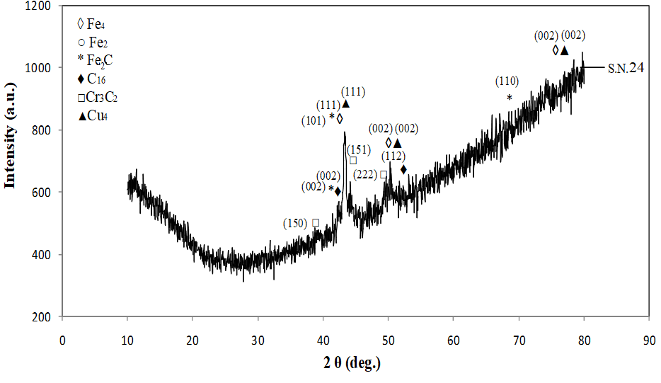
Figure2. X-ray spectrum of the surface workpiece-24

Table6. Lattice parameters of workpiece surface phases, workpiece-24
Chemical formula | Lattice parameters
Fe₄ | Cubic  a=b=c=0.362 nm  α=β=γ=90°
Fe₂ | Cubic  a=b=c=0.362 nm  α=β=γ=90°
Cu₄ | Cubic  a=b=c=0.362 nm  α=β=γ=90°
Fe₂C | Hexagonal  a=b=c=0.275 nm  α=β=90,γ=120°
Cr₃C₂ | Orthorhombic  a=b=c=0.701 nm  α=β=γ=90°
C₁₆ | Cubic  a=b=c=0.429 nm  α=β=γ=90°

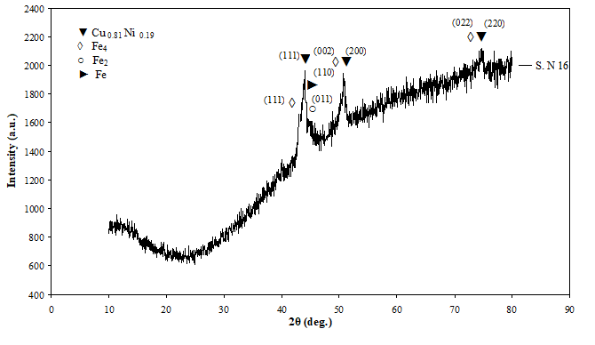
Figure3. X-ray spectrum of the surface workpiece-16

Table7. Lattice parameters of workpiece surface phases, workpiece-16
Chemical formula | Lattice parameters
Fe₄ | Cubic  a=b=c=0.362 nm  α=β=γ=90°
Fe₂ | Cubic  a=b=c=0.362 nm  α=β=γ=90°
Fe | Cubic  a=b=c=0.2853 nm  α=β=γ=90°
Cu_{0.8} Ni_{0.19} | Cubic  a=b=c=0.35934 nm  α=β=γ=90°

Carbon and copper were provided from dielectric liquid and copper electrode, respectively and these particles diffusion on workpiece surface as it has been demonstrated by Torres,²¹ Sidhom¹⁹ and Cusanelli.²²² Carbons diffuse on the melted workpiece material leading to the carbide zoon. The mechanism of copper diffusion in the machining process discussed below.

  - Effect of Copper Diffusion on EDMed Surface
During the EDM process, by closing the tool electrode to the surface of the workpiece, the schematic illustration of the diffusion mechanism showed in Figure 4.
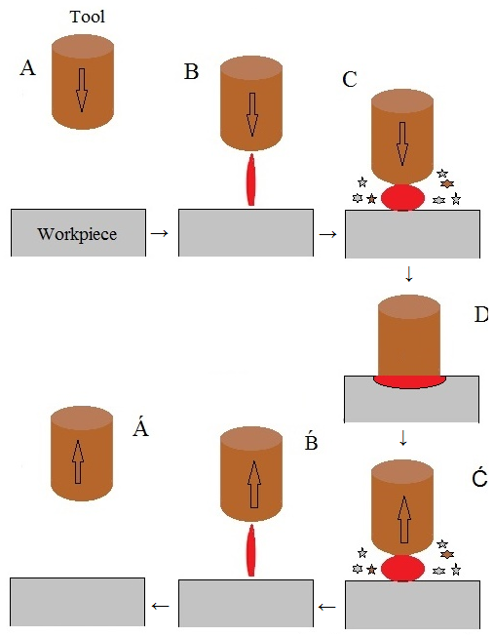
Figure4. Schematic of the copper diffusion mechanism during EDM

At stage A, the tool electrode is coming close to the workpiece surface. Then, in the next step (B), the discharge current is set between the tool electrode and workpiece by deionizing the dielectric materials and the creation of the plasma channel. When the discharge current is increased, the thermal energy produced by sparks can warm up the electrodes. It causes the debris melted materials to be sputtered into the dielectric liquid. Some of these particles do not exit the dielectric solution and, consequently, they fell on the workpiece (or tool electrode) surface (C). Finally, as the tool electrode is get closer to the workpiece; its surface will connect to workpiece (D). In this case, passing of electric current produces heat due to joule effect. The result of this phenomenon is that the tool electrode materials diffusion onto the surface of the substrate. At the next step, the tool electrode is removed from the workpiece surface and during the raising of distance, the spark length and width reduced. Flushing of dielectric liquid leads to a decrease in the temperature. We have no spark made in step A. The above procedure repeated alternatively. So, it can be said that step D can be introduced as the main stage in which the Cu diffused onto the sample. In other stages, there is also diffusion onto the surface that it is not comparable to this value of step D. whereas the linear movement of the electrode tool axle²³, its velocity will be constant in the whole steps from A to Á, the diffusion values can be described as a function of pulse-on time.

  - Effect of I on Cu Diffusion
The results of the quantometer analysis show the different amounts of copper and carbon on surface of the workpiece (Table 5). In order to investigate the overall effects of the copper and carbon amounts in different discharge currents, the mean values of the diffused copper and carbon, reported in Table 8.
Table8. The mean values of copper and carbon of SS 316L
Discharge Current (A) | Mean copper (wt %) | Mean carbon (wt %)
5 | 0.46 | 1.22
10 | 0.54 | 1.03
15 | 0.59 | 1.10
20 | 0.66 | 1.49
25 | 0.78 | 2.29

The effect of current on the mean values of the diffusion of Cu showed in Figure 5. The diffusion of Cu on the 316L SS surface was increased by raising the current values. This can be attributed to the lower melting point of Cu than the 316L SS and the fact that EDM develops a high-temperature zone on the surface²⁴. As a resultant, this increasing is by additively.

Figure5. Effect of I on diffusion mean of copper in workpiece

The change in the weight percent of other elements as well as the Cu can occur in the machining process. Table 8 shows that by increasing I, the weight percent (wt %) of carbon changed from 0.0548% (without EDM) to 2.29% (I=25 A) that this change also is raised. This is due to the diffusion of the dielectric particles into the surface when the flashing occurred. This result is in agreed to the Torres²¹ and Kumar²⁵ and John²⁶. Our results from quantometer analysis agreed to the XRD analysis.

  - Effect of t_{on} and t_{off} on Cu Diffusion
The diffusion of Cu on the surface of workpiece, was observed, more in low t_{on} values. This phenomena was increased in a high amounts of I. The diffused Cu content in high (125, 150μs) and low (50, 70, 100μs) t_{on} values vs. I sketched in Figure 6.

Figure6. Diagram of diffused copper wt % vs. I at high and low t_{on}

In the machining process, the greatest value of copper on the workpiece surface observed at t_{off} =15 and 20 μs. Figure 7 illustrates the copper values introduced by t_{off}.

Figure7. Diagram of diffused copper wt % vs. t_{off}

The results obtained from the optical microscopy show that, the microscopic images of machined samples at the high I, high t_{on} and low t_{off} have long and branched cracks on the surface. The presence of crack and micro-crack on the surface maybe attributed to the retention of the dielectric fluid during the cooling of the surface²⁷. Ultimately, Stress Corrosion Cracking (SCC) in aggressive environments occurs in this case. In Figure 8-a shows the microscopic images obtained sample 24 with high values of I and t_{on}.

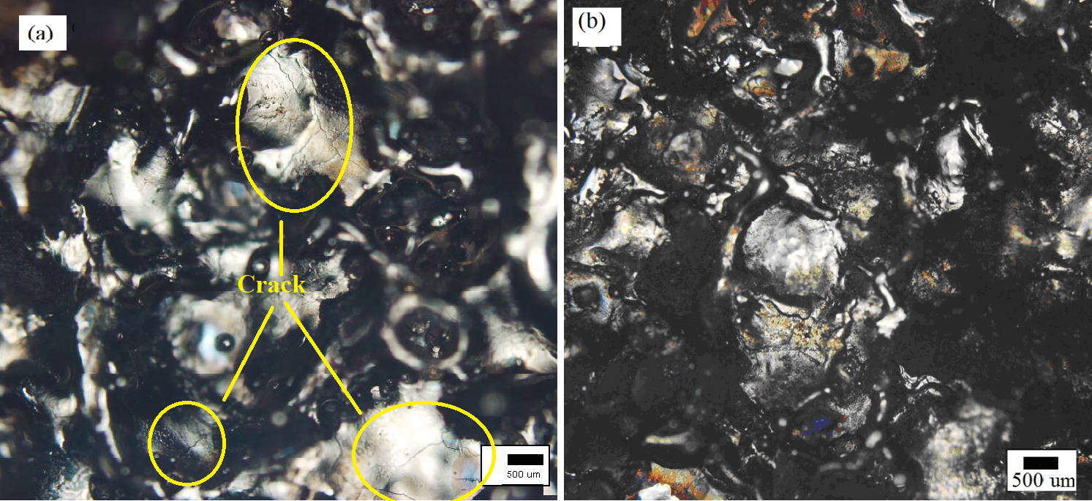
Figure8. Optical micrograph of 316L SS EDMed through copper electrode at high I and (a) high t_{on}, (b) low t_{on} by magnification of 1000

In sample 16, there is a suitable ratio of t_{on}/t_{off} (Figure 8-b). The most values of Cu diffusion and the surface without any crack or micro-crack have been observed in the condition of the higher amounts of I, lower t_{on}, higher t_{off} and the much shorter τ. The value of diffused Cu is high (0.629 %) that reported in Table 5. These conditions prevent the workpiece from the forming of cracks, micro-crack or branching them.

  - Electrochemical Corrosion
In order to investigate the effect of copper on the corrosion resistance of SS 316L, the mean values of the diffused copper, obtained by quantometer analysis, and the mean values of the corrosion resistance (R_{CT}) and electrical double layer capacitance (C_{EDL}), obtained by EIS analysis, in various currents presented in Table 9.
Table9.The mean values of the diffused copper, R_{CT} and C_{EDL} in various discharge currents
Discharge Current (A) | Mean copper (wt %) | Mean R_{CT} (Ω) | Mean C_{EDL} (μF)
5 | 0.46 | 385 | 7.6
10 | 0.536 | 453 | 12
15 | 0.587 | 495 | 14
20 | 0.66 | 590 | 21
25 | 0.78 | 456 | 18

The effect of the upcoming of the discharge currents on the mean values of the diffused Cu and corrosion resistance (Table 9) of SS 316L shown in Figure 9. By increasing the discharge current (I=20 A), the corrosion resistance also rises (R_{CT}=590 Ω). In this situation, the XRD analysis show that the Cu_{0.81}Ni_{0.19} stable phase produced and also optical microscopy show no crack or micro-crack (Figure 8-b). If the discharge current will be too high (I=25 A), the R_{CT} will significantly reduced (R_{CT}=456 Ω) and the cracks develop on the workpiece (Figure 8-a). These observations corresponds to Sidoham et al¹⁹.

Figure9. Effect of the I on the mean value of R_{CT} and Cu (wt %)

As it shown in Figure 9, the Cu diffusion on the surface grown by increasing the I and subsequently the corrosion rate decreased. Many researchers²⁸⁻³² reported that Cu diffusion plays an important role in corrosion resistance. Copper maybe stable either as metallic copper, soluble CuCl₂¯complex, insoluble CuCl salt film or as Cu²⁺ ions on the workpiece surface in corrosive environment by following mechanisms:
Ionization of Cu atom produces Cu²⁺ ions according to Eq.1^{30, 31}.
Cu²⁺ + 2e¯ Cu E₀ = +0.337 V (1)
The anodic reaction of Cu by the production of CuCl salt and CuCl₂¯complex occurs in chloride. The reaction is Eq.2 and Eq.3^{30, 33}.
CuCl ₊ e¯ Cu + Cl¯ E₀ = +0.137 V (2)
CuCl₂¯ + e¯ Cu + 2Cl¯ E₀ = +0.208 V (3)
The protective layer protects the 316L SS from corrosion. The corrosion resistance effect related to the creation of an electrical double layer of metal/ electrolyte in this case. Whereas the protection of the copper chloride layer is severely unstable, by continuing the EDM process, the workpiece corroded electrochemically by pitting corrosion mechanism. In contrast, in high t_{on}, samples have not sufficient time for cooling; this situation provides the conditions for growing of cracks on the surface (Figure 8-a). At high values of the I and t_{on} (S. N-24), the branched long cracks can be formed and the corrosion resistance of these workpieces is extremely low (R_{CT}=456 Ω). X-ray results at too high the I and high t_{on} (Figure 2) indicate the presence of heterogeneous phases such as iron-phase with cubic structure, iron-carbide phase with hexagonal structure, chromium carbide with orthorhombic structure on the workpiece surface. Decrease in kind of sample stability due to varies in sample lattice structure (cubic, hexagonal and orthorhombic) and different thermodynamic stability makes the cracking workpiece and increasing corrosion rates. The order of decreasing enthalpy formation of this sample is given in Table 10.
Table 10.Formation enthalpies of crystal observed in samples 16 and 24
S.N | Component | ΔH_{f}, KJ mol⁻¹ | Reference
24 | Fe | 13.79 | ³⁴
24 | Fe₂C | 2.57 | ³⁵
24 | Cr₃C₂ | -111.95 | ³⁶
16 | Fe | 13.79 | ³⁴
16 | CuNi | 3.7 | ³⁷

In EDMed samples with a high I and t_{off} and low t_{on} and τ (S. N-16), the workpiece has enough time for being cooled without any cracks formation (Figure 8-b). XRD analysis (Figure 3) show that, in this sample, all the phases grow up in the same cubic crystal lattice (Table 7) that have the low formation enthalpy and are stable (Table 10). In these conditions, the R_{CT} extremely increases (R_{CT}=590 Ω).
Due to sample-16 Results, it can be found that the corrosion rate is much low. In this sample, high discharge current, a large amount of heat is developed on the surface. Also, it can be seen from Figure 8-b that the metal is cooled sufficiently and accordingly the cracks are not formed because the value of t_{on} is low in this case. The quantometer analysis results (Table 4) show that during the machining process, the Cu and C diffused values to the 316L SS’s surface are 0.629 and 0.5072 respectively. By-increasing of diffused Cu, the amount of carbon diffused is lower than other samples. The resultant is the good corrosion resistance properties. The amount of C_{EDL} of this sample is the highest than the others (C_{EDL}=21 μF).

- Conclusion
The corrosion resistance of the 316L SS is an important issue because of its application in many industries. One of the methods of production and manufacturing of industrial high usage 316L SS is the EDM technique. EDM by locally arising temperature causes the surface chemical composition changes and diffusion of the tool electrode constituents onto the surface of SS 316L. The electrochemical properties of 316L SS also changed, which is differ to machining parameters. The results show that by increasing of I and t_{on}, the copper of tool electrode and carbon of dielectric liquid, diffused to workpiece surface and formation of some such phases as Fe₂C, Cr₃C₂, CuNi occurred. At higher values of I and high t_{on}/t_{off} ratio, it propagates the micro-crack. By increasing of I and appropriate t_{on}/t_{off} ratio, the amount of diffusion of Cu onto the surface arises and then the electrochemical corrosion reduced. It should be noted that sample in this optimal conditions (I=20A, t_{on}=50μs, t_{off}=25μs, τ=2min) due to the formation of the copper-nickel phase and any crack or micro-crack on its surface, showed high corrosion resistance.

Reference
1. R. P. Zeilmann, T. Vacaro, F. M. Zanotto and M. Czarnobay, Matéria, 2013, 18, 1541-1548. DOI:10.1590/S1517-70762013000400014
2. L. Tang and Y. Guo, Int. J. Adv. Manuf. Technol, 2014, 70, 1369-1376. DOI:10.1007/s00170-013-5380-4
3. D. N. Mishra, A. Bhatia and V. Rana, Int. J. Eng. Sci, 2014, 3, 24-35.
4. S. Arooj, M. Shah, S. Sadiq, S. H. I. Jaffery and S. Khushnood, Arab. J. Sci. Eng, 2014, 39, 4187-4199. DOI:10.1007/s13369-014-1020-z
5. A. Ntasi, W. D. Mueller, G. Eliades and S. Zinelis, Dent. Mater, 2010, 26, e237-e245. DOI:10.1016/j.dental.2010.08.001
6. Z. Karastojkovic and Z. Janjusevic, 2003.
7. S. Gopalakannan and T. Senthilvelan, J. Miner. Mater. Char. Eng, 2012, 11, 685. DOI:10.4236/jmmce.2012.117053
8. A. K. Tiwari, Int. J. Eng. Res. Appl, 2014, 4, 91-95.
9. X. Yan, S. Zhang, J. Li and G. Wang, Int. Manuf. Sci. Eng. Conf, 2015. DOI:10.1115/MSEC2015-9261
10. D. Thesiya, J. Dave and A. Rajurkar, Adv. Manuf. Sci. Technol, 2014, 38, 39-5. DOI:10.2478/amst-2014-0023
11. A. Pardo, M. Merino, A. Coy, F. Viejo, R. Arrabal and E. Matykina, Corros. Sci, 2008, 50, 1796-1806. DOI:10.1016/j.corsci.2008.04.005
12. Y. Guo, J. Hu, J. Li, L. Jiang, T. Liu and Y. Wu, Material, 2014, 7, 6604-6619. DOI:10.3390/ma7096604
13. C. Loto, O. Fayomi and R. Loto, In. J. Electrochem. Sci, 2012, 7, 3787-3797. DOI:10.1007/s00170-012-4156-6
14. K. H. Lo, C. H. Shek and J. Lai, Mater. Sci. Eng, 2009, 65, 39-104. DOI:10.1016/j.mser.2009.03.001
15. J. Tian, W. Wang, M. Babar Shahzad, W. Yan, Y. Shan, Z. Jiang and K. Yang, Materials, 2017, 10, 1293. DOI:10.3390/ma10111293
16. W. Garrison, JOM, 1990, 42, 20-24. DOI:10.1007/BF03220942.
17. B. Yan, Y. Lin and F. Huang, Int. J. Mach. Tools. Manuf, 2002, 42, 925-934. DOI:10.1016/S0890-6955(02)00026-3
18. H. Tsai, B. Yan and F. Huang, Int. J. Mach. Tools. Manuf, 2003, 43, 245-252. DOI:10.1016/S0890-6955(02)00238-9
19. H. Sidhom, F. Ghanem, T. Amadou, G. Gonzalez and C. Braham, Int. J. Adv. Tools. Manuf. Technol, 2013, 65, 141-153. DOI:10.1007/s00170-012-4156-6
20. S. R. Arunachalam, S. E. G. Dorman, R. T. Buckley, N. A. Conrad and S. A. Fawaz, Int. J. Fatigue, 2018, 111, 44-53. DOI:10.1016/j.ijfatigue.2018.02.005
21. A. Torres, C. Luis and I. Puertas, J. Alloys. Compounds, 2017, 690, 337-347. DOI: 10.1016/j.jallcom.2016.08.110
22. G. Cusanelli, A. Hessler-Wyser, F. Bobard, R. Demellayer, R. Perez and R. Flükiger, J. Mater. Process. Technol , 2004, 149, 289-295. DOI: 10.1016/j.jmatprotec.2003.11.047
23. K. Abrol, 2018.
24. S. Lee and X. Li, J. Mater. process. Technol, 2001, 115, 344-358. DOI: 10.1016/S0924-0136(01)00992-X
25. A. Kumar, V. Kumar and J. Kumar, Mach. Sci. Technol, 2014, 18, 47-77. DOI: 10.1080/10910344.2014.863632.
26. J. E. Fuller, EG and G Rocky Flats, Inc., Golden, CO (United States), 1991.
27. H. T. Lee and T. Y. Tai, J. Mater. Process. Technol, 2003, 142, 676-683. DOI:10.1016/S0924-0136(03)00688-5
28. T. Xi, M. B. Shahzad, D. Xu, Z. Sun, J. Zhao, C. Yang, M. Qi and K. Yang, Mater. Sci. Eng, 2017, 71, 1079-1085. DOI: 10.1016/j.msec.2016.11.022
29. Y. Jiangnan, W. Lichang and S. Wenhao, Corros. sci, 1992, 33, 851-859. DOI: 10.1016/0010-938X(92)90049-9
30. E. E. Oguzie, J. Li, Y. Liu, D. Chen, Y. Li, K. Yang and F. Wang, Electrochim. Acta, 2010, 55, 5028-5035. DOI:10.1016/j.electacta.2010.04.015
31. T. Ujiro, S. Satoh, R. W. Staehle and W. H. Smyrl, Corros. Sci, 2001, 43, 2185-2200. DOI:10.1016/S0010-938X(01)00008-7
32. E. E. Oguzie, J. Li, Y. Liu, D. Chen, Y. Li, K. Yang and F. Wang, J. Mater. Sci, 2010, 45, 5902-5909. DOI: 10.1007/s10853-010-4669-z
33. T. Sourisseau, E. Chauveau and B. Baroux, Corros. Sci, 2005, 47, 1097-1117. DOI: 10.1016/j.corsci.2004.05.024
34. G. Grimvall, Book Thermophysical properties of materials, Elsevier, 1999, 470-471. DOI:10.1361/asmhba0005240
35. C. Fang and M. van Huis, Heliyon, 2017, 3, e00408. DOI: 10.1016/j.heliyon.2017. e00408
36. W. Dawson and F. Sale, Metal. Trans. A, 1977, 8, 15-18. DOI: 10.1007/BF02677258258
37. I. Nikolaenko and M. Turchanin, Metall. Mater. Trans. B, 1997, 28, 1119-1130. DOI: 10.1007/s11663-997-0068-5

