Synthesis and evaluation on anticonvulsant and antidepressant activities of naphthoquinone derivatives containing pyrazole and pyrimidine fragments
Nataliia Polishª, Mariia Nesterkina^{b,*}, Nataliia Marintsovaª, Andriy Karkhutª, Iryna Kravchenko^{b}, Volodymyr Novikovª, Andrei Khairulin^{c}
ªDepartment of Technology Biologically Compounds, Pharmacy and Biotechnology, Lviv Polytechnic National University, Lviv 79013, Ukraine
^{b}Department of Organic and Pharmaceutical Technology, Odessa National Polytechnic University, Odessa 65044, Ukraine
^{c}Laboratory of Condensed Heterocyclic Compounds, Department of Sulfur Chemistry, Institute of Organic Chemistry NAS of Ukraine, Kyiv 02660, Ukraine
*Correspondence: Mariia Nesterkina, mashaneutron@gmail.com; ORCID 0000-0002-3201-7961

Abstract
Novel heterocyclic dichloronaphthoquinone derivatives have been synthesized by chlorine atom substitution in 2,3-dichloro-1,4-naphthoquinone to pyrazole or pyrimidine fragments. The structures of these compounds have been confirmed by FT-IR, ESI-MS, ¹H‐NMR and elementary analysis. Synthesized compounds were evaluated for their anticonvulsant action in a pentylenetetrazole (PTZ)-convulsion model and antidepressant activity in the forced swimming test (FST). All naphthoquinone derivatives at a dose 100 mg/kg were found to be protective against PTZ-induced seizure and showed the anticonvulsant effect at 3 h and 24 h after oral administration. In addition, these compounds possessed prolonged antidepressant properties significantly reducing the duration of immobility time when compared to the reference drug amitriptyline.

Key words: 2,3-dichloro-1,4-naphthoquinone, pyrazole and pyrimidine fragments, anticonvulsant activity, antidepressant action

1. Introduction
The development of novel compounds possessing combined action on central nervous system (CNS) and, thus, capable of being used simultaneously in treatment of various CNS disorders, still remains an active field in drug discovery. Such CNS disease state as depression is concomitant pathology in patients with epilepsy while some antidepressants were found to increase the risk of seizures (bupropion) or exhibit both the anticonvulsant and proconvulsant effect in experimental study (venlafaxine).¹ In this context, synthesis of compounds contemporaneously demonstrating antidepressant and anticonvulsant activity is feasible approach to reduce aforementioned side effects.
In this context, significant interest is attracted by naphthoquinones and their derivatives as building blocks for rational drug design. A considerable amount of these compounds have already been reported as antifungal, anti-inflammatory, anticancer and antibacterial agents.²⁻⁶ Surprisingly, only a limited number of publications are devoted to investigation of naphthoquinones influence on CNS. For example, amide derivatives of 4-amino-1,2-naphthoquinone were examined for anticonvulsant activity by the maximal electroshock (MES) and subcutaneous pentylenetetrazole (sc. PTZ) tests.⁷ The antidepressant potential of plumbagin, a medicinal plant-derived naphthoquinone, was explored in unstressed and stressed mice and explained by inhibition of brain monoamine oxidase A (MAO-A) activity.⁸ Naphthoquinones derived from Lithospermum erythrorhizon (acetylshikonin and shikonin) were isolated and proven as inhibitors of MAO-A and MAO-B in a competitive manner that might be further used in the treatment of depression.⁹ Obviously, the nature and position of substituents in naphthoquinone core are the crucial factors affecting the pharmacological evaluation of the structures. Bearing in mind that five- and six-membered heterocycles, pyrazole and pyrimidine, are important scaffold for CNS-active compounds,¹⁰⁻¹³ our attention was paid to the naphthoquinones containing these moieties. Thus, here we report the synthesis of aminopyrazole- and aminopyrimidine derivatives of 2,3-dichloro-1,4-naphthoquinone and their anticonvulsant and antidepressant activity determined by pentylenetetrazole (PTZ) and forced swim test (FST), accordingly.

2. Experimental
2.1. Chemistry
IR spectrum was measured with a Thermo Scientific Nicolet iS10 FT-IR Spectrometer using Nicolet iZ10 module (Thermo Fisher Scientific, Madison, WI, USA) equipped with a diamond window in a range of 4000-525 cm⁻¹. ¹Н NMR spectra were recorded on Varian Mercury-400 (Varian Inc., Palo Alto, CA) 300 MHz spectrometer with DMSO-d₆ or CDCl₃ as solvents and TMS as an internal standard; the coupling constants are given in Hz. The elemental analysis was performed on a Euro Vector EA-3000 (Eurovector SPA, Redavalle, Italy) microanalyzer. Elemental analyses were within ±0.4% of the theoretical values. Electrospray ionization mass spectrometry (ESI-MS) was measured by Agilent 1100 Series (LC/MSD Trap) Spectrometer applying isocratic elution of acetonitrile : 0.01% formic acid aqueous solution (70:30).
2.1.1. General procedure for the synthesis of aminopyrazole derivatives of naphthoquinone (3a–d)
To a magnetically stirred solution of 2,3-dichloro-1,4-naphthoquinone (1) (0.68 g, 0.3 mmol) in ethanol (50 mL) was added a solution of aminopyrazole 2a-d (0.3 mmol) in ethanol (20 mL). The reaction was carried out at 78 °C in the presence of an equivalent amount of Na₂CO₃ with constant stirring for 3 h. After reaction completion the obtained precipitate was filtered, washed several times with water and dried to afford compounds 3a-c as red and 3d as orange colored crystals.
2-Chloro-3-((1-(difluoromethyl)-1-H-pyrazol-3-yl)-amino)-naphthalene-1,4-dione (3a)
Yield 42%, red crystals, m.p. = 123-125 °С. IR (KBr, cm⁻¹): 3642 (N-H), 2968, 2895 (CH_{aliphatic}), 1681 (C=O), 1059, 1083 (C-F). ¹H NMR (300 MHz, DMSO-d₆): δ 9.01 (s, 1H, NH), 7.93-8.05 (m, 2H, quinone). MS (ESI), m/z (%): 323 [M+H]⁺ (100); С₁₄Н₁₀ClN₃O₂. Calcd: C 58.45; H 3.50; Cl 12.32; N 14.61; О 11.12. Found: C 58.32; Н 3.40; Cl 12.24; N 14.50. HPLC: t_{r} = 0.879 min.
2-Chloro-3-((1-methyl-1H-pyrazol-3-yl)amino)naphthalene-1,4-dione (3b)
Yield 78%, red crystals, m.p. = 215-217 °С. IR (KBr, cm⁻¹): 3200 (N-H); 1680, 1652 (С=О), 2967, 2894 (CH_{aliphatic}), 717 (С-Cl). ¹H NMR (300 MHz, CDCl₃): δ 9.03 (s, 1H, NH), 7.96‒8.07 (m, 2H, Ar-H), 7.71‒7.91 (m, 2H, Ar-H), 7.60 (d, J = 2.2 Hz, 1H, СН-pyraz.), 6.04 (d, J = 2.2 Hz, 1H, CH-pyraz.), 3.76 (s, 3H, СН₃). MS (ESI), m/z (%): 315 [M+H]⁺ (100); С₁₄Н₁₀ClN₃O₂. Calcd: C 58.45; H 3.50; Cl 12.32; N 14.61; О 11.12. Found: C 58.30; Н 3.42; Cl 12.21; N 14.50. HPLC: t_{r} = 0.961 min.
2-Chloro-3-((3-(p-tolyl)-1H-pyrazol-5-yl)amino)naphthalene-1,4-dione (3c)
Yield 56%, red crystals, m.p. = 238-240 °С. IR (KBr, cm⁻¹): 3500 (N-H), 1672 (С=О), 1600-1572 (С=C), 720 (С-Cl). ¹H NMR (300 MHz, DMSO-d₆): δ 12.95 (s, 1H, NH), 9.07 (s, 1H, NH), 7.97-8.06 (m, 2H, Ar-H), 7.86 (t, 1H,Ar-H), 7.79 (t, 1H, Ar-H), 7.63 (d, J = 7.8 Hz, 2H, Ar-H), 7.26 (d, J = 7.9 Hz, 2H, Ar-H), 6.49 (s, 1H, CH-pyraz.), 2.33 (s, 3H, СН₃). MS (ESI), m/z (%): 363 [M+H]⁺ (100); С₂₀Н₁₄ClN₃O₂. Calcd: C 66.03; H 3.88; Cl 9.74; N 11.55; О 8.80. Found: C 65.62; Н 3.77; Cl 9.63; N 11.25. HPLC: t_{r} = 1.389 min.
Ethyl-4-((3-chloro-1,4-dioxo-1,4-dihydronaphthalen-2-yl)amino)-1-phenyl-1H-pyrazol-3-carboxylate (3d)
Yield 76%, orange crystals, m.p. = 162-165 °С. IR (KBr, cm⁻¹): 3300 (N-H), 1712 (C=O), 1676, 1652 (С=О), 1604-1576 (С=C), 720 (С-Cl). ¹H NMR (300 MHz, DMSO-d₆): δ 9.38 (br.s, 1H, NH), 8.12 (s, 1H, CH-pyraz.), 8.01 (t, 2H, Ar-H), 7.89 (d, J = 7.4x2 Hz, 1H, Ar-H), 7.82 (d, J = 7.4x2 Hz, 1H, Ar-H), 7.66 (d, J = 7.9 Hz, 2H, Ar-H), 7.51 (t, 2H, Ar-H), 7.42 (t, 1H, Ar-H), 4.04 (q, CH₂CH₃, 2H), 1.02 (t, CH₂CH₃, 3H). MS (ESI), m/z (%): 422 [M+H]⁺ (100); C₂₂H₁₆ClN₃O₄. Calcd: C 62.64; H 3.83; Cl 8.40; N 9.96; О 15.17. Found: C 62.35; Н 3.71; Cl 8.29; N 9.85. HPLC: t_{r} = 1.059 min.
2.1.2. General procedure for the synthesis aminopyrimidine derivatives of naphthoquinone (3e–f)
To a magnetically stirred solution of 2,3-dichloro-1,4-naphthoquinone (1) (0.27 g, 0.1 mmol) in DMF (15 mL) was added a solution of aminopyrimidine 2e-f (0.1 mmol) in DMF (10 mL). The reaction was carried out at 65 °C in the presence of an equivalent amount of K₂CO₃ with constant stirring for 4 h. Water acidified with hydrochloric acid was added to the cooled reaction mixture, and the formed precipitate was filtered off, dried and recrystallized from ethanol.
2-Chloro-3-((2-(4-methyl-6-(trifluoromethyl)pyrimidin-2-yl)ethyl)amino)naphthalene-1,4-dione (3e)
Yield 73%, orange crystals, m.p. = 121-123 °С. IR (KBr, cm⁻¹): 3656 (N-H), 2981, 2889 (CH_{aliphatic}), 1677 (C=O), 1138 (C-F). ¹H NMR (300 MHz, DMSO-d₆): δ 7.91‒7.99 (m, 2H, Ar-H), 7.86‒7.71 (m, 2H, Ar-H), 7.54 (br.s, NH, 1H), 4.21 (t, 2H, CH₂), 3.28 (t, 2H, CH₂), 2.53 (s, 3H, CH₃). MS (ESI), m/z (%): 395 [M+H]⁺ (100); C₁₈H₁₃ClF₃N₃O₂. Calcd: C 54.63; H 3.30; Cl 8.96; F 14.40; N 10.62; O 8.09. Found: C 54.36; H 3.19; Cl 8.87 F 14.29 N 10.50. HPLC: t_{r} = 1.090 min.
2-Chloro-3-((2-(4-(trifluoromethyl)-5,6,7,8-tetrahydroquinazolin-2-yl)ethyl)amino) naphthalene-1,4-dione (3f)
Yield 53%, orange crystals, m.p. = 118-120 °С. IR (KBr, cm⁻¹): 3659 (N-H), 2980, 2889 (CH_{aliphatic}), 1679 (C=O), 1144, 1123 (C-F). ¹H NMR (300 MHz, DMSO-d₆): δ 8.04‒7.67 (m, 4H, Ar-H), 7.48 (br.s, 1H, NH), 4.19 (t, 2H, CH₂), 3.20 (t, 2H, CH₂), 2.62‒2.93 (m, 4H, 2CH₂), 1.90‒1.65 (m, 4H, 2CH₂). MS (ESI), m/z (%): 435 [M+H]⁺ (100); C₂₁H₁₇ClF₃N₃O₂. Calcd: C 57.87; H 3.93; Cl 8.13; F 13.08; N 9.65; O 7.34. Found: C 56.89; H 3.89; Cl 8.07 F 12.21 N 9.58. HPLC: t_{r} = 1.199 min.
2.2. Pharmacological evaluation
2.2.1. Animals
Pharmacological investigations of compound 3a-f were studied using outbreed male white mice (18–22 g) as experimental animals purchased from Odessa National Medical University, Ukraine. All animals were kept under 12 h light regime and in a standard animal facility with free access to water and food, in compliance with the European Convention for the Protection of Vertebrate Animals Used for Experimental and Other Specific Purposes (Strasbourg, 1986).

2.2.2. Drug administration
Anticonvulsant and antidepressant activities of compounds 3a-f were evaluated at 3 h and 24 h after administration. The compounds were administered orally to mice in Tween 80/water emulsion at a dose of 100 mg/kg and Tween 80/water emulsion has been used as a vehicle control. Valproic acid (VPA, 400 mg/kg, p.o.) and amitriptyline (20 mg/kg, p.o.) served as reference drugs, respectively.
2.2.3. Anticonvulsant activity
The anticonvulsant activity of 1,4-naphtoquinone derivatives was evaluated by pentylenetetrazole model (PTZ) as described in.^{14,15} Doses of PTZ for inducing clonic-tonic convulsions (DCTC) and tonic extension (DTE) were calculated relative to control. The anticonvulsant effect of compounds was estimated at 3 h and 24 h after their administration from the increase of pentylenetetrazole MED compared with a control group. MED in percent was calculated using the formula:
MED = V/m × 10⁴
where MED ‒ minimum effective dose of PTZ inducing DCTC or DTE; V ‒ volume of PTZ solution, ml; m ‒ animal weight, g.
2.2.4. Antidepressant effect
Forced swim test (FST) was used to determine antidepressant action of 1,4-naphtoquinone derivatives 3a-f according to procedure.¹⁶ Briefly, mice were placed individually into glass cylinder filled with water (24 ± 3 °C) and total duration of their immobility during 5 minutes has been recorded.
2.2.5. Statistical analysis
All results are expressed as mean ± standard error mean (SEM). One-way analysis of variance (ANOVA) was used to determine the statistical significance of the results followed by Tukey’s post hoc comparison. ** p < 0.01 and * p < 0.05 was considered as significant.

3. Results and discussion
3.1. Chemistry
In the present study, synthesis of novel heterocyclic dichloronaphthoquinone derivatives (3a-f) was carried out by chlorine atom substitution of 2,3-dichloro-1,4-naphthoquinone (1) to pyrazole (3a-d) or pyrimidine (3e-f) fragments. As illustrated in Scheme 1, target compounds (3a-f) were obtained by mixing equimolar ratios of 2,3-dichloro-1,4-naphthoquinone with heterocyclic amines (2a-f) in ethanol with further mixture refluxing for 2 h in the presence of Na₂CO₃ as a base or using DMF as solvent and K₂CO₃ as a base with constant stirring of reaction mixture at 65 °C during 4 h.
Scheme 1. Synthesis of aminopyrazole- (3a-d) and aminopyrimidine (3e-f) derivatives of dichloronaphthoquinone. Reagents and conditions: i EtOH/Na₂CO₃, reflux, 2 h; ii DMF/K₂CO₃, 65 °C, 4 h
Novel heterocyclic N-derivatives naphthoquinone (3a-f) were obtained in the range of 42-78% yield as red or orange solids. The structures of products 3a-f were reliably confirmed and elucidated on the basis of spectral and analytical data. The FTIR spectra exhibited absorption peaks at 3200-3659 cm⁻¹ (NH), 1652-1712 cm⁻¹ (C=O), 2895-2980 cm⁻¹ (CH_{aliphatic}), 717-720 cm⁻¹ (C-Cl) and 1059-1144 cm⁻¹ (C-F). The ¹H-NMR spectral data of naphthoquinone 3a-f contain resonance signals described by their chemical shift, integration and multiplicity that are in full agreement with the presented molecular formulas.
3.2. Pharmacological studies
In the present study, a non-competitive GABA antagonist pentylenetetrazole (PTZ) has been used to investigate anticonvulsant activity of 1,4-naphthoquinone derivatives (3a-f). PTZ-induced seizure model is positioned as a model of generalized convulsions and extensively used for evaluating the excitability of central nervous system (CNS) and, consequently, activity of gamma-aminobutyric acid (GABA).¹⁷ Valproic acid (VPA), an established antiepileptic drug possessing anticonvulsive effect on PTZ-induced model, served as reference drug.¹⁸ Anticonvulsant activity of heterocyclic compounds 3a-f was estimated after single oral administration (100 mg/kg, p.o.) at short (3 h) and long (24 h) time periods. As shown in Figure 1, all synthesized compounds and VPA were found to protect animals from clonic-tonic convulsions and tonic extension at 3 h after their oral administration as evidenced by increasing of DCTC and DTE values (p < 0.01 vs control). At this time point, DCTC and DTE values of 1,4-naphthoquinones 3a (p < 0.05 vs VPA) and 3b-e (p < 0.01 vs VPA) are statistically different from those defined for reference drug (VPA) indicating a decrease of seizure threshold.
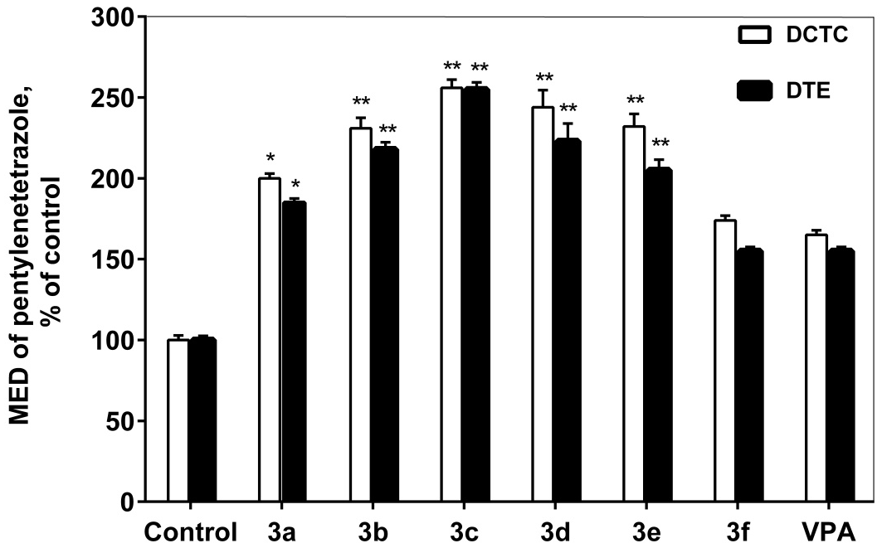
Figure 1. Anticonvulsant activity of compounds 3a-f at 3 h after oral administration. Values are given as mean ± SEM, n = 5 mice; for all groups p < 0.01 compared with control; * p < 0.05 and ** p < 0.01 compared with VPA
Evaluation of pentylenetetrazole-induced seizure susceptibility of compounds 3a-f was also carried out at long time period (24 h), as depicted in Figure 2. In this case, statistically significant difference was observed only in tonic phase of clonic-tonic seizures between naphthoquinones 3b (p < 0.01 vs VPA), 3e (p < 0.05 vs VPA), 3f (p < 0.01 vs VPA) and reference drug. It is noteworthy that antiseizure effect of compounds 3a, 3c, 3d were also demonstrated prolonged anticonvulsant action at 24 h after administration that is indicated as DCTC and DTE increase in 2 times when compared to control.
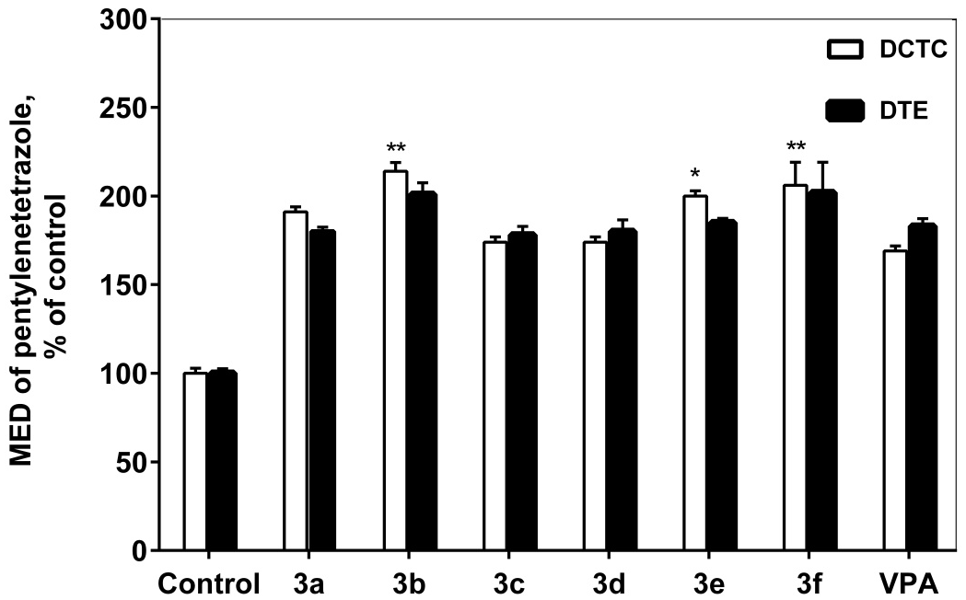
Figure 2. Anticonvulsant activity of compounds 3a-f at 24 h after oral administration. Values are given as mean ± SEM, n = 5 mice; for all groups p < 0.01 compared with control; * p < 0.05 and ** p < 0.01 compared with VPA
As demonstrated in Table 1, mean immobility period was reduced in animals treated both with naphthoquinone derivatives 3a-f and reference drug amitriptyline compared to control after 3 h after oral administration. When compared with amitriptyline, the antidepressant activity of compounds 3a-f did not exceed that of reference drug.
Table 1. Antidepressant activity of compounds 3a-f in forced swim test (FST).
Compound | Immobility time, s
Compound | 3 h after administration | 24 h after administration
Control | 95.0 ± 8.7 | 95.0 ± 8.7
3a | 51.7 ± 7.8 | 34.7 ± 4.9**
3b | 16.0 ± 6.7 | 39.3 ± 8.7**
3c | 46.3 ± 7.8 | 53.7 ± 3.2**
3d | 70.7 ± 5.2 | 20.0 ± 4.5**
3e | 39.0 ± 4.4 | 45.7 ± 4.7**
3f | 27.3 ±3.7 | 47.7 ± 3.0**
Amitriptyline | 25.7 ± 3.5 | 93.7 ± 4.4
All values are expressed as mean ± SEM; n = 5 mice; for all groups p < 0.01 compared with control; * p < 0.05 and ** p < 0.01 compared with amitriptyline.

However, there was no statistically significant difference in immobility time between control groups of animals and that treated with amitriptyline at long time period (24 h). At this time point, all synthesized naphthoquinone derivatives were found to possess significant antidepressant-like effect (p < 0.01 vs. amitriptyline) indicating a prolonged action of compounds 3a-f.

4. Conclusion

Heterocyclic N-derivatives naphthoquinone containing pyrazole and pyrimidine moieties have been synthesized in good yield and characterized by a series of analytical and spectroscopic methods (¹H NMR, FT-IR, ESI-MS, LC and elementary analysis). The activity of synthesized compounds as potential anticonvulsive and antidepressive agents was investigated on the models of PTZ-induced seizures and forced swim test (FST), accordingly. Pharmacological analyses showed that compounds 3a-f exhibit anticonvulsant and antidepressant properties at a dose 100 mg/kg both at short and long time period (3 h and 24 h after oral administration). Thus, naphthoquinone derivatives obtained at the present study demonstrate combined action on CNS and might be further studied as compounds useful for treating depressive disorders in patients with seizures.

5. References
1. A. K. Sharma, N. Dahiya, A. Khanapure, J. K. Kairi, Int. J. Basic Clin. Pharmacol. 2016, 5, 850‒854.
2. M. Á. Castro, A. M. Gamito, V. Tangarife-Castaño, B. Zapata, J. M. Miguel del Corral, A. C. Mesa-Arango, L. Betancur-Galvis, A. San Feliciano, Eur. J. Med. Chem. 2013, 67, 19‒27.
3. P. Ravichandiran, M. Masłyk, S. Sheet, M. Janeczko, D. Premnath, A. R. Kim, B. H. Park, M. K. Han, D. J. Yoo, ChemistryOpen 2019, 8, 589‒600.
4. I. Milackova, M. S. Prnova, M. Majekova, R. Sotnikova, M. Stasko, L. Kovacikova, S. Banerjee, M. Veverka, M. Stefek, J. Enzyme Inhib. Med. Chem. 2015, 30, 107‒113.
5. V. Prachayasittikul, R. Pingaew, A. Worachartcheewan, C. Nantasenamat, S. Prachayasittikul, S. Ruchirawat, V. Prachayasittikul, Eur. J. Med. Chem. 2014, 84, 247‒263.
6. K. Kobayashi, S. Nishiumi, M. Nishida, M. Hirai, T. Azuma, H. Yoshida, Y. Mizushina, M. Yoshida, Med. Chem. 2011, 7, 37‒44.
7. M. Bansal, B. Goel, S. Shukla, R. S. Srivastava, Med. Chem. Res. 2013, 22, 5349‒5355.
8. D. Dhingra, S. Bansal, Pharmacol. Rep. 2015, 67, 1024‒1032.
9. W. H. Choi, S. S. Hong, S. A. Lee, X. H. Han, K. S. Lee, M. K. Lee, B. Y. Hwang, J. S. Ro, Arch. Pharm. Res. 2005, 28, 400‒404.
10. H. Zhang, S. Wang, X. Wen, J-Z. Li, Z-S. Quan, Med. Chem. Res. 2016, 25, 1287‒1298.
11. K. Karrouchi, S. Radi, Y. Ramli, J. Taoufik, Y. N. Mabkhot, F. A. Al-Aizari, M. Ansar, Molecules 2018, 23, 1‒86.
12. M. J. Naim, O. Alam, F. Nawaz, M. J. Alam, P. Alam, J. Pharm. Bioallied. Sci. 2016, 8, 2‒17.
13. S. B. Wang, X. Q. Deng, Y. Zheng, Y. P. Yuan, Z. S. Quan, L. P. Guan, Eur. J. Med. Chem. 2012, 56, 139‒144.
14. M. V. Nesterkina, I. A. Kravchenko, Chem. Nat. Compd. 2016, 52, 237‒239.
15. M. V. Nesterkina, E. A. Alekseeva, I. A. Kravchenko, Pharm. Chem. J. 2014, 48, 82‒84.
16. G. Gupta, T. J. Jia, L. Y. Woon, D. K. Chellappan, M. Candasamy, K. Dua, Adv. Pharmacol. Sci. 2015, 2015, 1‒6.
17. A. V. Kalueff, Neurochem. Int. 2007, 50, 61‒68.
18. D. Calderón Guzmán, I. Espitia Vázquez, G. Barragán Mejía, N. Labra Ruiz, R. Rodríguez Pérez, D. Santamaria del Angel, F. Ayala Guerrero, H. Juárez Olguín, Proc. West Pharmacol. Soc. 2003, 46, 48‒50.

.

