Ionic Liquids: Simple or Complex Electrolytes?

Marija Bešter-Rogač*

University of Ljubljana, Faculty of Chemistry and Cehmical technology, Večna pot 113, SI-1000 Ljubljana, Slovenia

* Corresponding author: E-mail: marija.bester@fkkt.uni-lj.si
https://orcid.org/0000-0003-4284-5987, Google Scolar Marija Bester-Rogac

Paper presented as a key-note lecture at the 25th Annual Meeting of the Slovenian Chemical Society, Maribor, 25. – 27. 9. 2019 and
dedicated to the memory of Professor Joseph Barthel, who passed away in February 2019.

Abstract
Ionic liquids belong to the most investigated systems in last years and this field is still significantly growing with an increased focus on developing ionic liquds for specific applications, along with fundamental research. In present featured paper the similarity and differences between common, “classical” electrolytes and common surfactants and ionic liquids along with the surface-active ionic liquids are discussed in order to stress their significance and point out on their weak points. A short survey on the literature data reveals namely that ionic liquids in solutions behave like “classical” electrolytes and can be described by existing models in the range of their validity. There is still a lack of models describing well the concentrated electrolyte solutions and here ionic liquids, less limited by solubility as common electrolytes, can serve as model systems. The micellization of surface-active ionic liquids in aqueous solution can be described in the same way as at common surfactants, but surface-active ionic liquids offer more possibilities to study specific ion and isomer effect. They are also quite promising systems to study the aggregation processes in non-aqueous solutions.

Key words: Ionic liquids; Surface active ionic liquids; Aqueous solutions; Non-aqueous solutions
- Introduction

Ionic liquids (ILs) are molecules composed of anions and cations in which at least one component is an organic molecular structure that hinders efficient close packing. Thus, their melting points temperatures are below 100 °C and are therefore liquids at lower temperatures than other salts.

ILs can have useful physical properties, such as low or non-volatility, and are often used as solvents and electrolytes. As suitable systems for a wide range of applications they attracted the attention of many researchers. It turned out that ILs are more complex than molecular solvents and thus their bulk and interfacial structures are markedly different. They show rich structural diversity both in the nature of ions that can be employed as well as in the organization of these ions in the liquid phase. A sample of representative popular anions and cations chemical structures usually used in ILs is presented in Figure 1.²

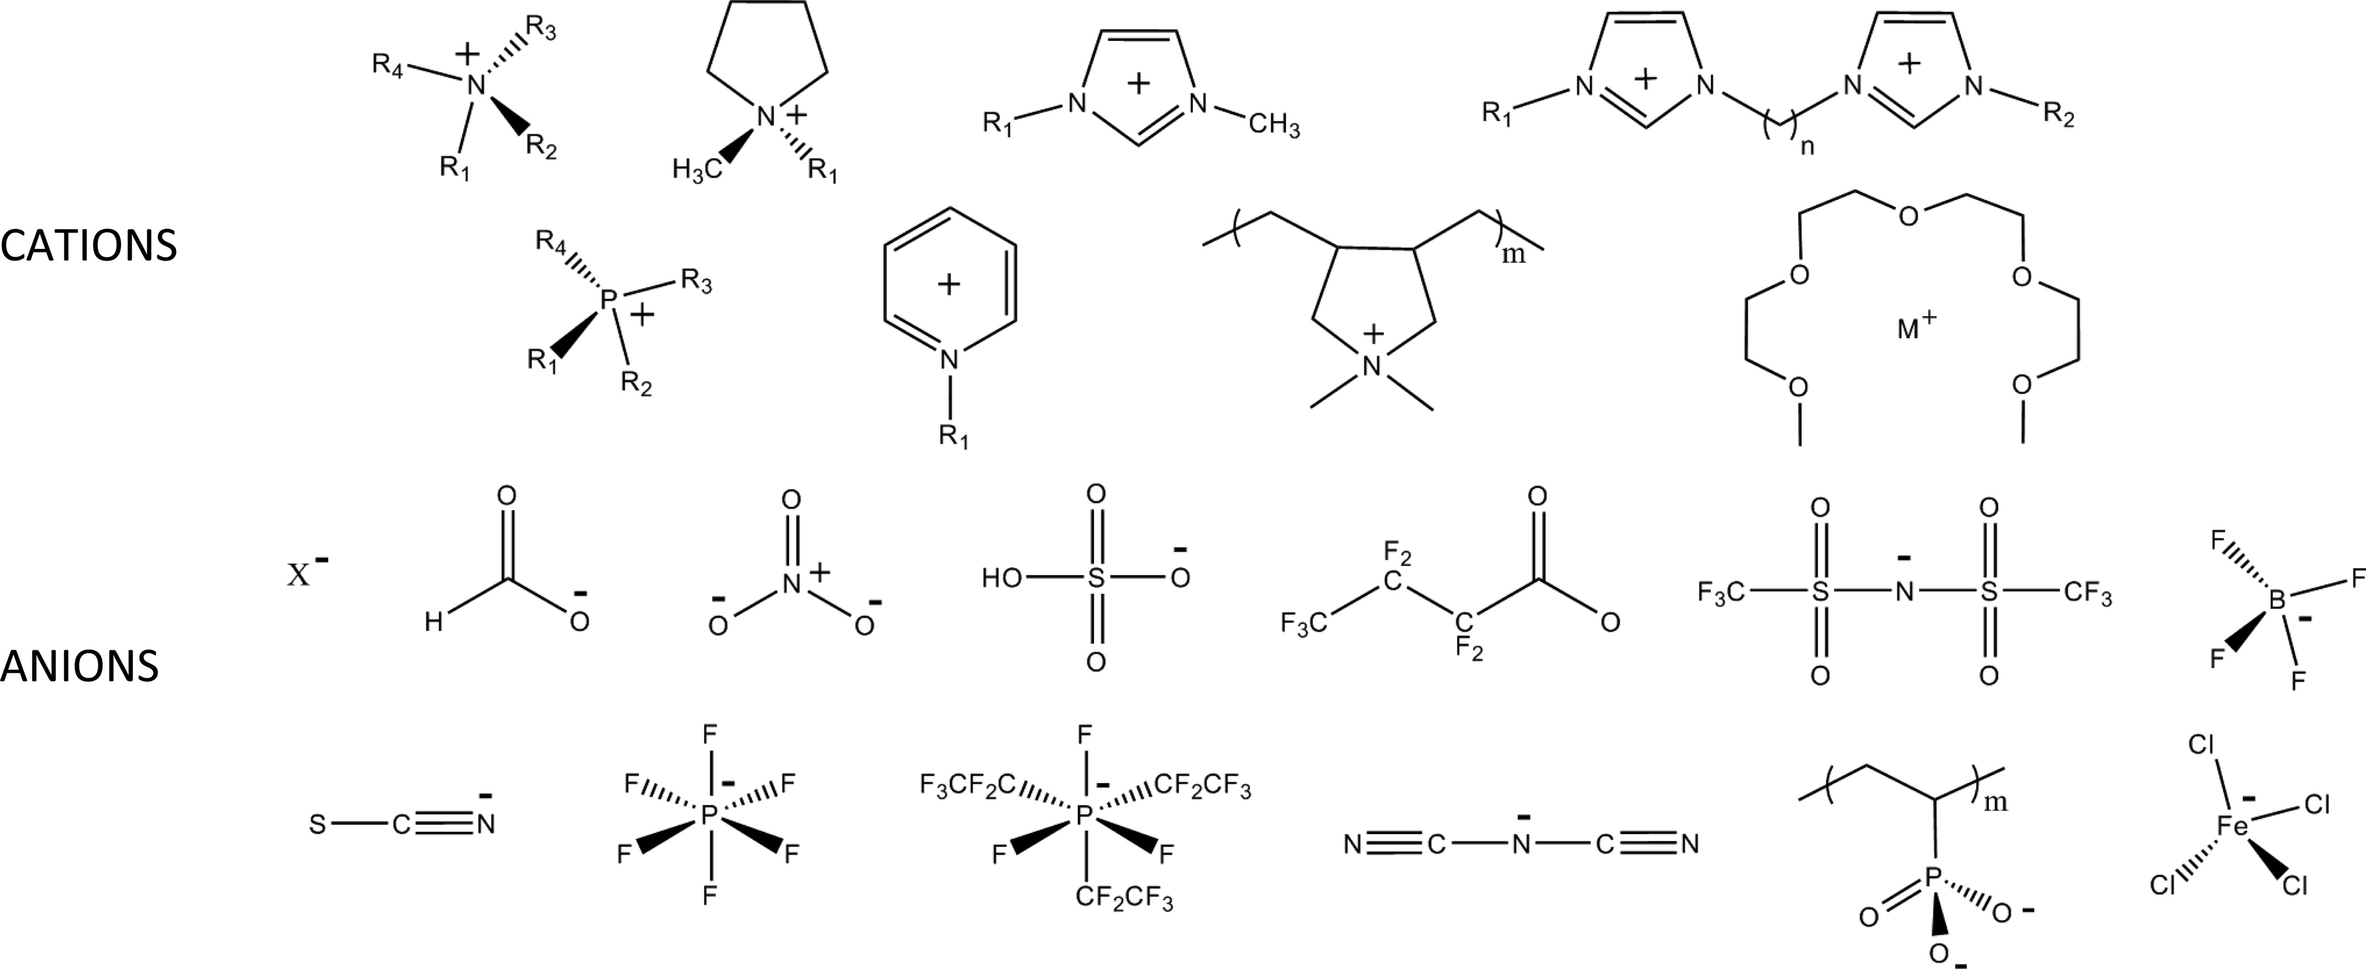

Figure 1. Some chemical structures of representative cations and anions used in ionic liquids.
From left to right, the cations (top row) include: ammonium, pyrrolidinium, 1-methyl-3-alkylimidazolium, 1,3-bis[3-methylimidazolium-1-yl]alkane; (second row) phosphonium, pyridinium, poly(diallyldimethylammonium), metal (M⁺) tetraglyme. The anions include (third row) halides, formate, nitrate, hydrogen sulfate, heptafluorobutyrate, bis(perfluoromethylsulfonyl)imide, tetrafluoroborate, (bottom row) thiocyanate, hexafluorophosphate, tris(pentafluoroethyl)trifluorophosphate, dicyanamide, poly(phosphonic acid), and tetrachloroferrate. Reproduced with permission from ref.²

By increasing the cationic alkyl side-chain length even the transition from the known spatially heterogeneous structure to a liquid crystal-like phase was observed.

However, the growing number of reviews dealing with the physico-chemical properties of ILs in their pure state has been extended to investigations their mixtures with molecular co-solvents. It turned out, that ILs in solutions can serve as excellent model (electrolyte) systems, because they exist in diverse structure and the hydrophobic part of the cation can be vary almost optional. Investigations of ion association of ILs in diverse organic solvents reveal namely that their ion pairing is entropy driven and thus associated with cation desolvation, in line with the only moderate strength of cation-solvent interactions., The association of imidazolium based ILs as model 1,1-electrolytes in water solutions is weak but evidently dependent on the molecular structure (alkyl chain length), which also strongly affects the mobility of imidazolium cations. According to experimental and computational results, hydrophobic hydration of the side chain on the imidazolium ring is most responsible for structure making/breaking properties of investigated imidazolium salts. Ionic liquids with long alkyl chains behave similar to conventional surfactants forming aggregates in water, but due to possible variations in the chain length and counter-ions they are extremely appropriate for studying self-assembly processes in solutions.

Thus, ILs exhibit properties from simple salts to liquid crystal-like structures and there are still many unexplored opportunities for manipulating their structure to control their functions and applications.

- Ionic Liquids in Their Pure State

The tuneabiliy of combinations of cations and anions and the possibility to achieve modification of the cation and/or the anion part offer access to ILs with targeted properties. On Figure 2 a schematic representation of the different type of possible interactions in imidazolium-based ionic liquid is presented. In addition, the hydrophobicity of cation can be varied by the length of side alkyl chains.

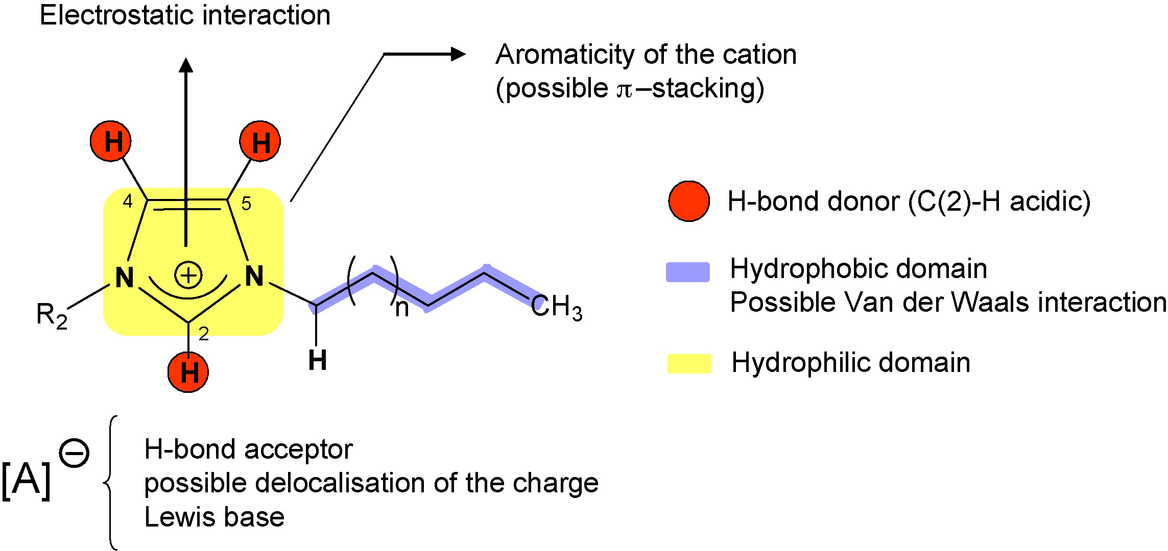

Figure 2: Schematic representation of the different type of interactions present in imidazolium-based ILs. Figure reproduced with permission from ref .⁹

Consequently, ILs in their pure state exist in very different structures. In Figure 3 an example for the structures in the bulk phase of imidazolium hexafluoro phosphate ([C_{n}mim]PF₆) is presented, where the increase in the length of side chain from 2 to 12 carbon atoms leads from globular to sponge-like structure.

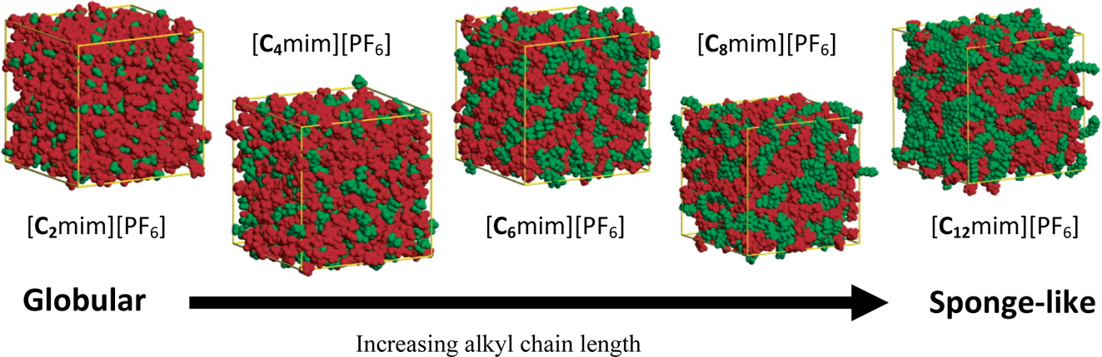

Figure 3. Snapshots of the bulk structure of [C_{n}mim]PF₆ ILs for n = 2−12. Each box shows 700 IL ion pairs at equilibrium with polar domains (red, anion + cation imidazolium ring) and nonpolar domains (green, cation alkyl chain) observed. Note the box dimensions are not the same length due to differences in ion size and box density. Figure reproduced with permission from ref.²

On the whole - dependent from the composition and building elements of an ionic liquid there are diverse possibilities for structuring-from ion pairs, hydrogen bond networking to ion clusters and – as seen already before- to self-assembled structures (Figure 4).

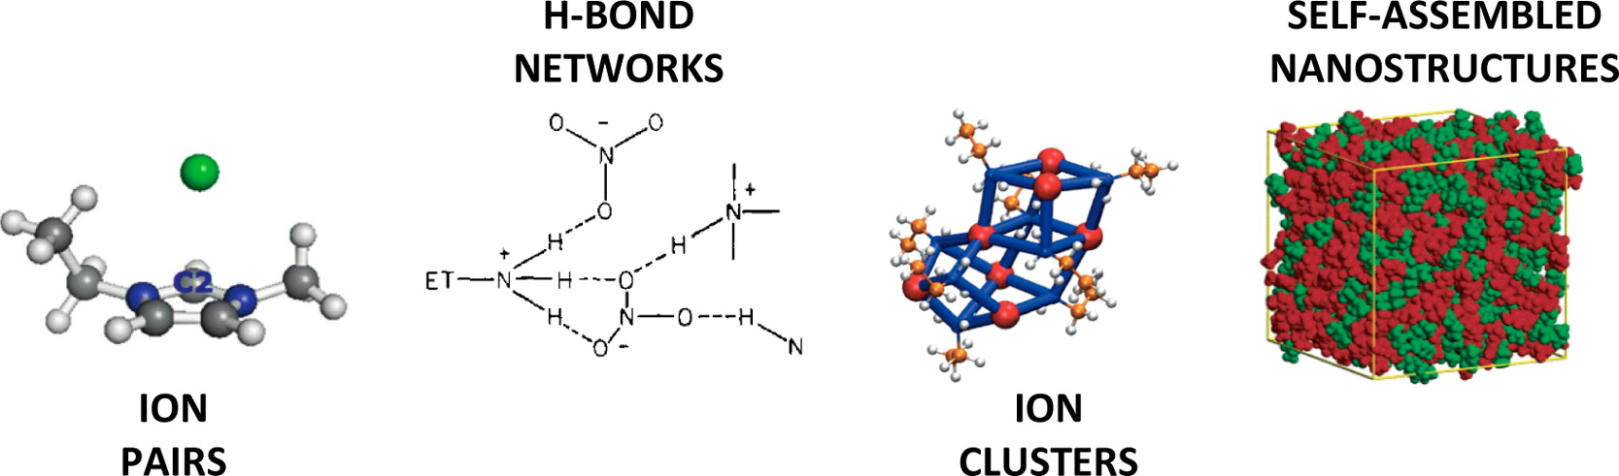

Figure 4. Different models for the bulk structure of ionic liquids. See text for details. Reproduced with permission from ref. ²
Thus, ILs even in their pure state form rather complicated and complex structure, whereas for example - sodium chloride, as the simplest electrolyte - the single unit has completely known unique properties. Sodium and chloride atoms are ascribed defined positions, so the structure of NaCl crystal has no diversity, should be easily to understood thus it is simple in comparison to diverse structures of ionic liquids. Therefore, ionic liquids can be doubtless judged as complex electrolyte in their pure state. The reason for this complexity is - as already mentioned - mainly in the structure of cations.

- Ionic Liquids in Solutions

Whereas understanding the properties of pure ILs is of fundamental interest, the practical applications generally require usually the admixture of other compounds, acting either as a reactant or product or as a cosolvent required for process optimization. Some earlier investigations,,, reveal that addition of an IL in an organic solvent enhances the electrochemical and thermal stability of IL/organic solvent binary mixtures which often reflects in higher electrical conductivity and better device performances at low temperature than comparable mixtures with high melting salts.

Recently, it has been demonstrated that ILs can serve as an excellent model system for investigating the influence of the ion structure on the mobility and ion pairing even in aqueous solutions, where the interionic interactions are weak.^{6,,} It turned out, that due to possible variations in the structure of chain length and counter-ions the surface active ionic liquids (SAILs) have the great potential for investigation of micellization process in aqueous solutions.^{8,,} Even more, SAILs were used also at investigations of aggregation behavior in non-aqueous solvents where solvophobic effect and the hydrogen-bonding interactions turned out as the main factors controlling the aggregates formation.,

  - Ionic Liquids in Aqueous Solutions

Ion Mobility. Recently, the mobility and the mechanism of ion pairing in aqueous solutions were investigated systematically on nine imidazolium based ionic liquids (ILs) from 1-methylimidazolium chloride, [mim]Cl, to 1-dodecyl-3-methylimidazolium chloride,
[C₁₂mim]Cl, with two isomers 1,2-dimethylimidazolium chloride, [1,2-mim]Cl, and 1,3-dimethylimidazolium chloride, [1,3-mim]Cl in the line.⁶ The values of their molar electric conductivity - as still one of the most suitable quantity for investigation of electrolyte solutions - for diluted solution of studied imidazolium based ILs at 298.15 K are presented on Figure 5 together with the data for NaCl aqueous solution for comparison.

Figure 5. Molar conductivities of investigated imidazole based ILs chlorides⁶ and NaCl at 298.15 K in water; symbols denote experiment and lines lcCM calculations.

As we can see here, the values for NaCl are only slightly higher from that for [mim]Cl. Thus, it can be assumed that studied ILs in diluted water solution behave like simple 1,1-electrolytes - molar conductivity is linear dependent on the square root of concentration.

The experimental molar conductivities of dilute (c ≈≤0.005 M) IL solutions were analyzed in the framework of Barthel’s low-concentration chemical model (lcCM) which describes successfully thermodynamic and transport properties of diluted solutions, yielding the molar conductivity of the solute at infinite dilution, Λ∞ and is the standard-state (infinite dilution) ion association constant, K_{A}, (details are given in ref. ). By using a literature value for , the limiting molar conductivity was split into separate ionic contributions, , and then limiting ionic conductivities were estimated for all cations. Consequently, the diffusion coefficients, , as the characteristic properties of ionic transport, which are not affected by inter ionic interactions, were calculated by using the relation

(1)

Values of for ILs cations, studied in⁶ at 298.15 K are presented in Figure 6 as a function of the number of C atoms in the alkyl side chain, together with values that were obtained from MD simulations that were carried out at the same temperature of 298 K.⁶

Figure 6. Diffusion coefficients of imidazolium based cations in water at 298.15K as a function of the number of carbon atoms in the side chain; ) experiment; ) MD simulations.⁶

Again, the diffusion coefficient of [mim]⁺ is only slightly lower from that for Na⁺, , and is decreasing with increasing length of alkyl chain (Figure 6), but not linearly with the growing number of C atoms in the side alkyl chain as it has been also obtained in MD simulations.^{6,} In addition, it was found that the aggregation tendency of cations with long alkyl chains at higher IL concentrations impedes their diffusivity.

This assumption was confirmed by the results of MD simulations at high concentrations. It was observed that within less than 1 ns [C₁₂mim]⁺ cations formed micelles that remained stable throughout the rest of the simulations as expected. In contrast, [mim]⁺ cations remained dispersed in water and did not show any signs of aggregation. The cation distribution in water is visualized for these two cases in Figure 7.⁶ The reduction of [C₁₂mim]⁺ diffusivity is thus also a result of the cation aggregation. [C₁₂mim]⁺ cations diffuse as members of these micelle aggregates, which move much slower through the solvent than single cations because of the large aggregate sizes.

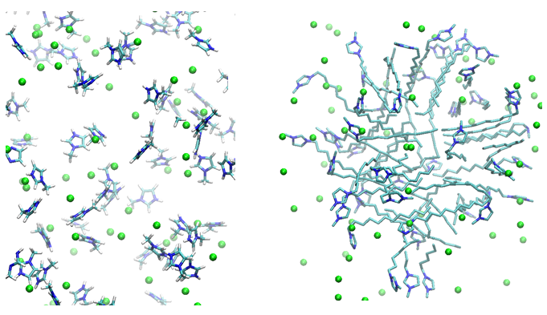

Figure 7: Representative structures of [mim][Cl] in solution (left hand side) and [C₁₂mim][Cl] (right hand side) taken from equilibrated MD simulations at very high IL concentrations (1.0 M and 1.2 M, respectively). It can be clearly seen that [C₁₂mim][Cl] forms micelles in contrast to [mim][Cl], which remained dispersed. The display of water and hydrogens was omitted for clarity. Color code: C = cyan, N = blue and Cl = green. Figure reproduced with permission from ref.⁶

Recently, for [C₂mim]Cl, [C₄mim]Cl, [C₆mim]Cl and [C₈mim]Cl the data on conductivity of concentrated aqueous solutions at 298.15 K, presented in Figure 8, were published. To reproduce this type of concentration dependence, the empirical Casteel-Amis four-parameter equation is widely used. Generally, data fitting is carried out on the molality scale. For the present systems, Castel-Amis equation can be reasonably applied in the mole-fraction scale of IL, x_{IL}, that is

(2)

where, κ_{max} is the highest electrical conductance for a given mixture, x_{IL,max} is the mole fraction of IL in which the electrical conductivity of the mixture at a given temperature shows a maximum, n and m are parameters of the fit. Casteel-Amis parameters are given in Table S1 in the Supplementary data and fitted conductivity values are graphically presented in Fig. 8. In the inset of Figure 8, the values for NaCl solutions are added for comparison.

Evidently, in all here presented systems, conductivity increases sharply in dilute region, due to the increase of number of free ions in solutions. But with addition of ILs it reaches maximum at near the same mole fraction around x_{IL} ≅ 0.05 and then it decreases. This trend is assumed to be the result of the competition between the increasing number of free ions available to contribute to the conductivity and the increasing system viscosity, impeding ion mobility. And here, the conductivity decreases also with the increasing alkyl chain length of the cation, whereas the viscosity is higher for ILs with longer side chain. As ions are added to the system ion diffusion is hindered by increasing viscous forces, resulting in a decrease in ion mobility and, thus, diffusion.

Figure 8. Specific conductivities of some imidazolim based ILs chlorides at 298.15 K in water as drown from the literature data.²⁵ Inset: Specific conductivities of some ILs chlorides and NaCl at 298.15 K in water. Symbols represent experimental values and lines the Casteel-Amis-type fitting (Eq. (2)) of the experimental data with parameters reported in Table S1 of the Supplementary data.

Actually, this behavior is not new - the same was observed by “common simple” electrolytes, where the maximum often was not reached due to limited solubility, as it is demonstrated here for NaCl in water (inset in Figure 8). And thus, ILs could be very helpful at studying the concentrated electrolyte solutions, where the reliable theories are still lacking.

Ion association. For in the ref.⁶ studied imidazolium based ILs in water it was found, that K_{A} values are small (~2.5 ≤ K_{A}≤ ~6) but distinctly higher than obtained with the same model recently for alkali metal halides in water. For [C₄mim]⁺, [C₆mim]⁺,]⁺ and [C₁₂mim]⁺, the binding free energies with Cl⁻ ,, were obtained also from MD simulations, using thermodynamic integration as specified in ref.⁶ From measured values of K_{A} binding free energies were calculated using the relation and in Figure 9 the comparisons of and is shown. Evidently, results from MD simulation are in reasonable agreement with the experiment.

Figure 9. Comparison of binding free energies for imidazolium based chlorides in water as function of number of C atom in the side alkyl chain as obtained from conductivity experiment, , and from MD simulations, . Adopted from ref.⁶

Despite the fact that conductivity measurements of dilute electrolyte solutions are probably still the most accurate route to ion-pair association constant, K_{A}, at least for symmetrical electrolytes,²³ such studies can determine only the overall association and thus yield little information on the nature of the aggregate(s) formed, while conventional spectroscopic techniques, like NMR or Raman spectroscopy, generally detect only contact CIPs. On the other hand, dielectric relaxation spectroscopy (DRS) is sensitive to all ion-pair types and allows their identification and quantification provided reasonably accurate dipole moments, μ_{i}, of the species formed are available or can be calculated., Having a look on DRS spectra for [C₄mim]Cl solution in water (Figure 10) we can see an area, which corresponds to ion pairs (IP).

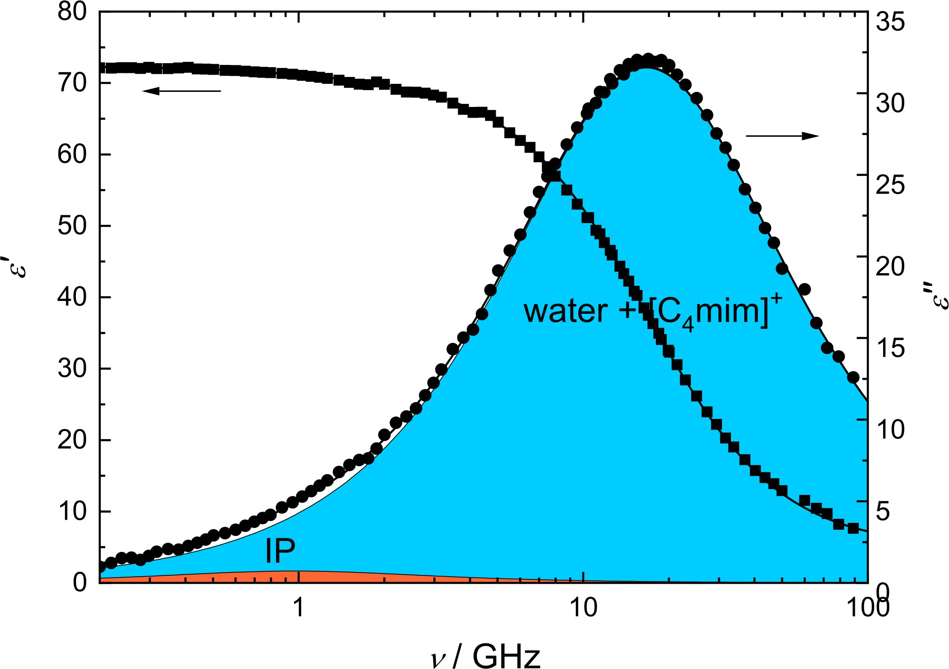

Figure 10. Relative permittivity, ε’(ν) () and dielectric loss, ε’’(ν) () spectrum of a representative [C₄mim]Cl solution in water (c = 0.4618 mol dm⁻³) at 298.15 K. Symbols represent experimental data, lines show the corresponding fit, and the shaded areas indicate the contributions of the individual processes to ε’’(ν). Adopted from ref.³²

Thus, MD simulations and experiments reveal that the association of investigated ILs as model 1,1 electrolytes in water solutions is weak but evidently dependent on the molecular structure (alkyl chain length), which also strongly affects the mobility of cations.

  - Ionic liquids in Non-aqueous Solutions

Pure ILs usually are quite viscous and less conductive, whereas the mixing of ILs with molecular liquids (co-solvents) cause a significant decrease of viscosity and a sharp increase of conductivity.^{11,12,13,14} A huge number of investigations of conductivity of mixtures of ILs with molecular solvents is available in the literature. Surprisingly, despite the large practical interest to such systems, systematic studies of the transport properties of binary mixtures of ILs and co-solvents in a broad concentration range - from diluted solutions to pure ILs - are still scarce. Thus, in this paper we will focus mainly our attention on that imidazolium based ILs, which are also well investigated in a broader concentration range in aqueous and non-aqueous solutions and thus the comparison of their properties is possible.

Diluted solutions. In Figure 11 a) the molar conductivities of 1-dodecyl-3-butilimidazolium chloride, [C₄mim]Cl in acetonitrile (AN),³² methanol (MetOH)⁵ and dimethyl sulfoxide (DMSO)⁵ are presented together with values in water.⁶ Evidently, the mobility of [C₄mim]⁺, indicated by the ionic limiting conductivity and the diffusion coefficients , is decreasing with increasing viscosity of the solvents (Table 1).

Figure 11. Molar conductivities of a) [C₄mim]Cl in AN,³² water,⁶ MetOH⁵ and DMSO⁵ and b) [C₄mim]Cl,³² [C₄mim]BF₄⁴ and TBABr in AN at 298.15 K; symbols denote experiment and lines lcCM calculations.

In Figure 11 b), the molar conductivities of [C₄mim]Cl,³² [C₄mim]BF₄⁴ and – for comparison - tetrabutylammonium bromide (TBABr)³³ as “classical” electrolyte in AN are shown. Whereas in water for [C₄mim]Cl only weak association was observed (K_{A} ≅ 5-6), it is expectedly more expressed in solvents with lower dielectric constants, but evidently depends strongly also on the anion as can be seen in Table 1, where literature data of molar limiting conductivity Λ∞ and association constants, K_{A} for [C₄mim]Cl and [C₄mim]BF₄ in water, DMSO, AN, N,N-Dimethylformamide (DMF), MetOH and dichloromethane (DCM) at 298.15 K are gathered, as obtained from lcCM model. Where the value of the ionic limiting conductivity is available, also the (average) values of the diffusion coefficient are listed.

Table 1. Literature data on molar limiting conductivity Λ∞ and association constants, K_{A} for [C₄mim]Cl and [C₄mim]BF₄ in water, DMSO, AN, DMF, MetOH and DCM at 298.15 K as obtained from lcCM model. Where possible, ionic limiting conductivity and the (average) values of the diffusion coefficients are given.ª
 | ε | η | Λ∞ |  | K_{A} |  |  |  | ⋅10¹⁰
 |  |  | [Cl]⁻ | [BF₄]⁻ | [Cl]⁻ | [BF₄]⁻ | [Cl]⁻ | [BF₄]⁻
H₂O | 78.36 | 0.8903 | 109.34^{b}  108.64^{c} | - | 5.2^{b}  6.2^{c} | - | 32.99^{b}  32.29^{c}  , | - | 8.69
DMSO | 46.52 | 1.9946 | 38.53^{d} | 41.51^{d} | 13.4^{d} | 4.6^{d} | 14.89^{d} | 14.53^{d} | 3.92
DMF | 36.81 | 0.845 |  | 89.83e |  | 10.6e
AN | 35.96 | 0.3413 | 173.91^{c} | 189.29^{f}  190.37^{g} | 63.7^{c} | 15.7^{f} 17.8^{g} | 81.55^{c} | 81.81^{f} | 21.75
MetOH | 32.63 | 0.5438 | 108.64^{d} | 121.84^{d}  128.4^{h} | 15.5^{d} | 37.7^{d}  57.5^{h} | 56.25^{d} | - | 14.98
DCM | 8.82 | 0.415 |  | 161.08^{i} |  | 479^{i}
ªUnits: η, mPa⋅s;Λ∞,, 10⁻¹⁰ m² s⁻¹
^{b}ref.⁶
^{c}ref.³²
^{d}ref.⁵
^{e}ref.
^{f}ref.⁴
^{g}ref.¹⁶
^{h}ref.¹⁷
^{i}ref.

Whereas values of Λ∞ are not very “sensitive” on the applied model for the analysis of conductivity data, the opposite is true for K_{A}. Even more, K_{A} values are also slightly dependent on the set upper distance limit at which the ions are still treated as ion pairs. However, the abundant different interactions acting together in ILs make them very complex (Figure 2), so that it is not surprising that the dielectric constant is incapable of adequately modeling the solvent–solute interactions and is has often failed in correlating solvents effects qualitatively and quantitatively. It is namely rather surprising, that K_{A} values for [C₄mim]Cl and [C₄mim]BF₄ in AN in MetOH are different despite very similar dielectric constants. However, obtained K_{A} for [C₄mim]BF₄ and [C₄mim]Cl in AN are in line with those reported for sodium tetraphenylborate (K_{A} = 13.9 at 298,15 K) and TBABr (K_{A} = 27.5 at 298.15 K³³).

Having a look on DRS spectra for [C₄mim]Cl solution in AN (Figure 12) in water (Figure 10) we can see an area, which corresponds to ion pairs (IP), and this area is much bigger in AN as in water. Thus, evidently the ion pair formation tendency is bigger in AN and thus the values of K_{A} obtained from conductivity data using lcCM model are of sense. It could be again concluded that ILs behave in solutions as common (“classical”) simple electrolytes, with more expressed ion association in solvents with lower dielectric constants.

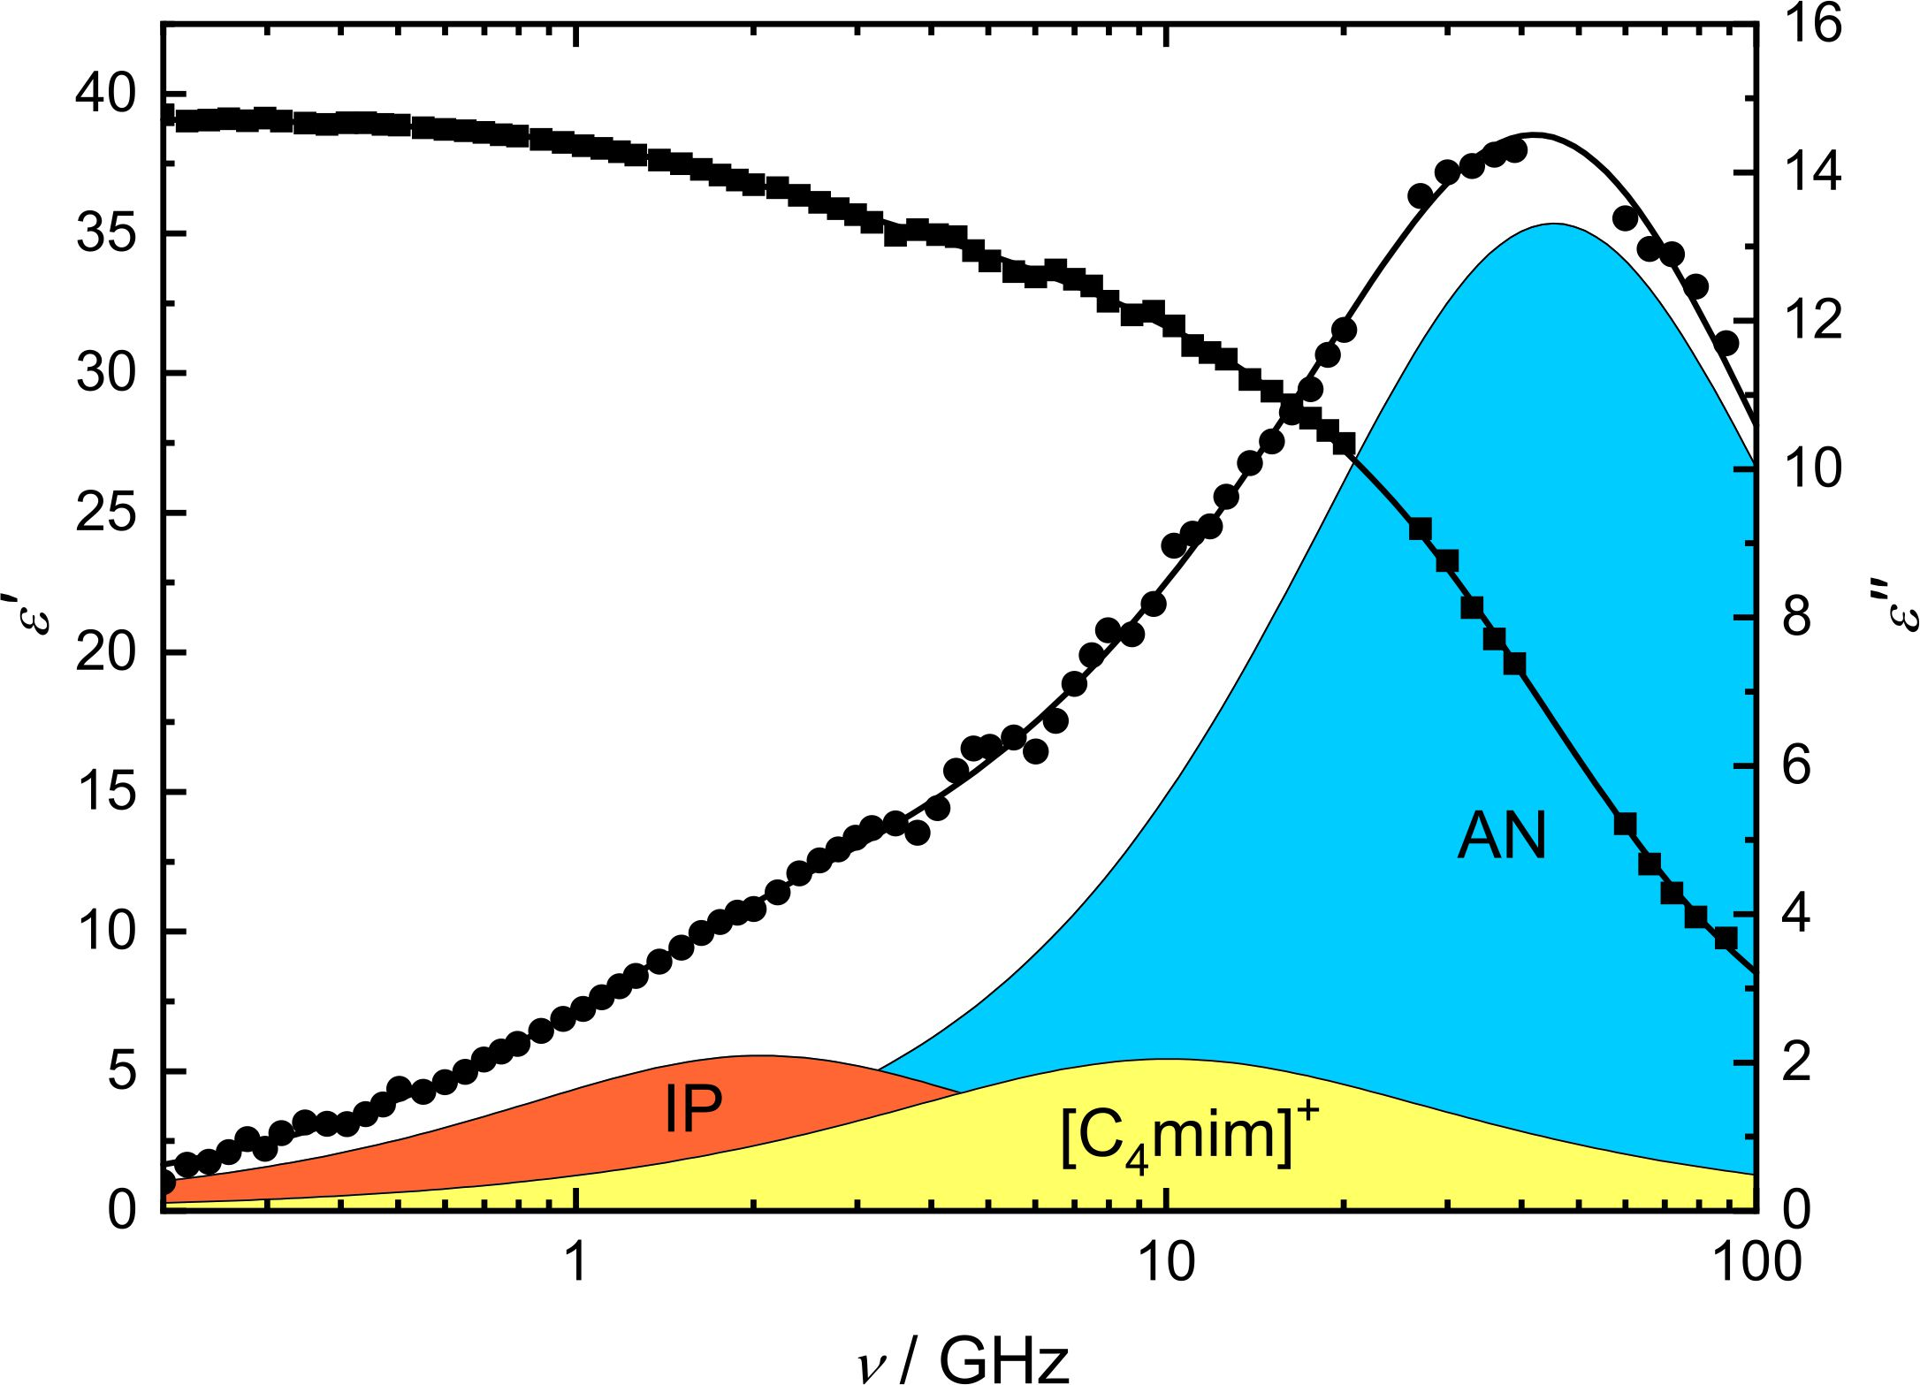

Figure 12. Relative permittivity, ε’(ν) () and dielectric loss, ε’’(ν) () spectrum of a representative [C₄mim]Cl solution in AN (c = 0.4658 mol dm⁻³) at 298.15 K. Symbols represent experimental data, lines show the corresponding fit, and the shaded areas indicate the contributions of the individual processes to ε’’(ν). Adopted from ref.³²

Concentrated solutions. Despite still growing number of studies and reviews dealing with physicochemical properties of ILs in the pure state and of their mixtures with cosolvents, the systematic studies on transport properties covering entire miscibility range are still scarce. In Figure 13 a) a some literature data on conductivity of contracted solutions of [C₄mim]BF₄ in AN, MetOH, DMSO, DCM, and propylene carbonate (PC, η = 2.512 mPas, ε = 64.96 at 298.15 K) are presented as determined by Stoppa et all. Conductivities of three imidazolium based tetrafluoroborates in AN from the same paper are shown in Figure 13 b) together with data on TBABr in AN for comparisons.

Figure 13. Specific conductivities, κ, of a) [C₄mim]BF₄ in AN,³⁷ MetOH,³⁷ DMSO,³⁷ DCM,³⁷ and PC³⁷ and b) [C₂mim]BF₄,³⁷ [C₄mim]BF₄,³⁷ [C₆mim]BF₄ ³⁷ and TBABr³⁸ in AN at 298.15 K as a function of molar fraction of IL, x_{IL}. Symbols represent experimental values and lines the Casteel-Amis-type fitting (Eq. (2)) of the experimental data with parameters reported in Table S1 of the Supplementary data.

From Figure 13 it is evident that conductivity follows the typical pattern of concentrated electrolyte solutions, discussed already in the paragraph 3.1. and presented in Figure 8 for aqueous solutions.⁶ After a rapid rise in low concentration region, κ passes through a well-defined maximum. As it follows from the data, presented in Figure 13 b) and table S1 in Supplementary data, κ for ILs in AN decrease with the increasing alkyl chain length of the cation, as it has been observed also for the aqueous solutions of IL_{S}, presented in Figure 8. Whereas in water solution the position of the conductivity maximum was more or less close to the x_{IL} ≅ 0.05, here the maximum is reached at higher concentration and it moves toward lower x_{IL} with increasing length of the side alkyl chain of cation.

Figure 13 a) reveals clearly, that κ for [C₄mim]BF₄ depends strongly on the solvent: when the viscosity increases (AN < MetOH < DMSO < PC), κ decreases. But DCM does not follow this order: despite the fact that its viscosity is very low (0.415 mPa s at 298.15 K), the conductivity of solutions of [C₄mim]BF₄ in DCM is close to that in DMSO and PC with much higher solvent viscosities (Table 1). This behavior can be ascribed to higher ion association in DCM due to the lower dielectric constant. The value, obtained in diluted solutions by Borun and Bald³⁵ (K_{A} = 479 at 298.15 K, Table 1) confirms strongly this assumption. Even more - also in other solvents the decrease of conductivity after maximum could be ascribed to stronger ion association. Unfortunately, there is no theory to describe well this behavior.

3.3 Surface Active Ionic Liquids

Aggregation/micellization in aqueous solutions. As it is already presented in Figure 7, it was confirmed by MD simulation that [C₁₂mim]Cl forms micelles at higher concentrations. Even more, the great potential of surface active ionic liquids (SAILs) at investigation of thermodynamic of micellization process in solutions due to possible variations in the structure of cations, side chain length and counter ions has been demonstrated recently.^{8,18,19,} The systems studied recently by Šarac et all⁸ are presented in Figure 14.

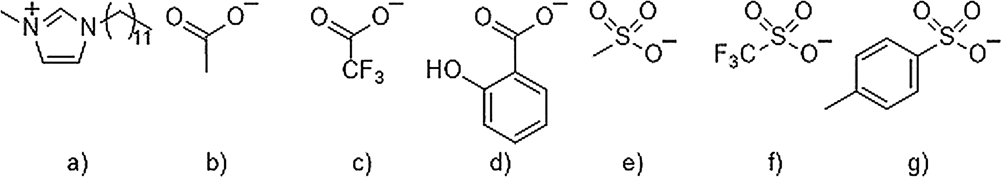

Figure 14. Structures of investigated systems in ref.8 : a) n =9 ([C₁₀mim]), n = 11 ([C₁₂mim]), n=13 ([C₁₄mim]) and n= 15 ([C₁₆mim]) cations in ([C_{X}mim]Cl) and b) OAc, c) TFA, d) Sal, e) OMs, f) OTf, and g) OTs anions in [C₁₂mim]X systems. Figure reproduced with permission from ref.⁸

It was found, that in many ways the behavior of SAILs is identical to those observed by “classical” cationic surfactants: the critical micelle concentration is decreasing with the length of hydrophobic chain (Figure 15) and expresses a minimum in the temperature dependence, but dependent strongly also on the counter ion.⁸

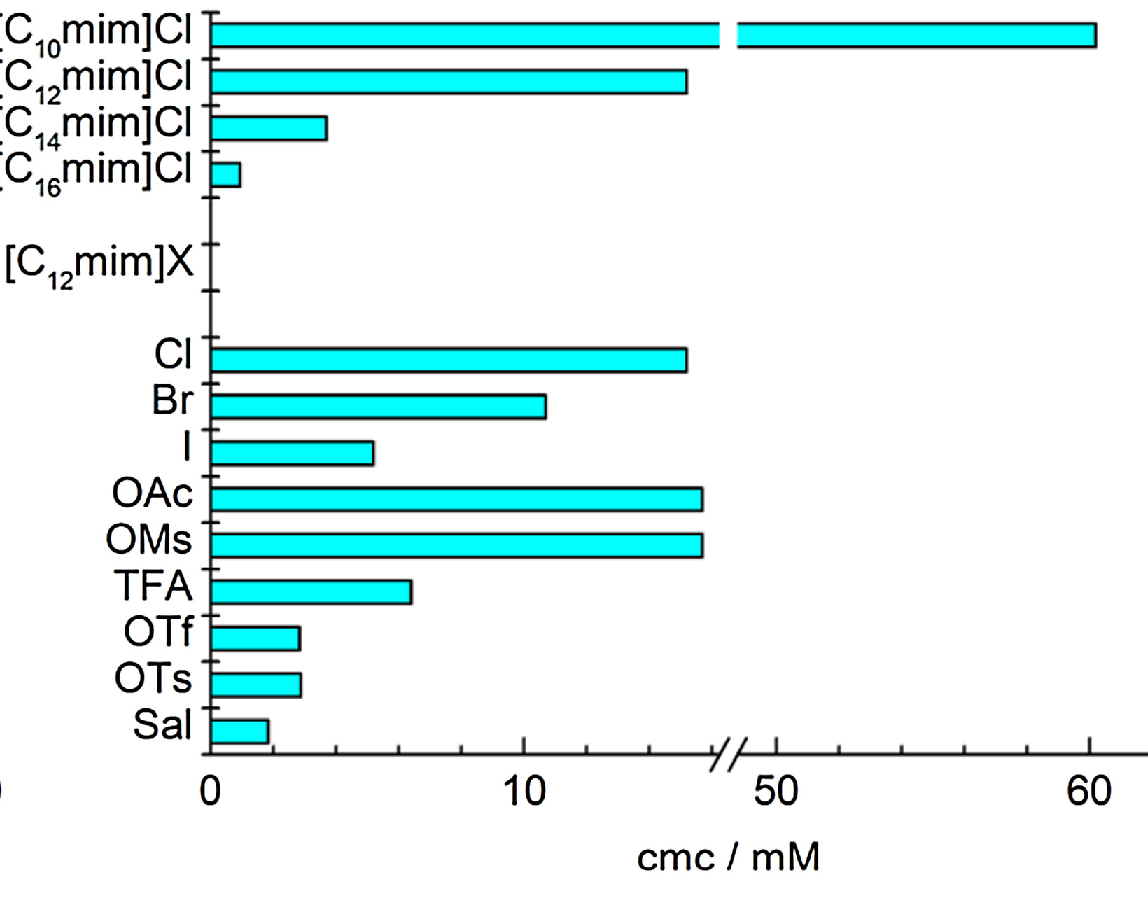

Figure 15. Critical micelle concentrations, cmc, for all investigated systems studied in ref.8 at 298.15 K. Figure reproduced with permission from ref.⁸

In general, the micellization process for SAILs is as usual endothermic at low temperatures and exothermic at high temperatures, but it was verified that the influence of counter ions plays an extremely important role.⁸ Even more, it was confirmed, that the hydrophobicity of counter ions evidently contributes to the heat capacity change and the water accessible surface area removal upon burial of non-polar group from the contact with water at micellization process.
The main driving force for the formation of micelles is presumably the apparent disaffinity of water to the nonpolar (interacting) surfaces known as hydrophobic effect. The parameter that illustrates this effect is the heat capacity of micellization, , which is always highly negative and can be ascribed to the removal of water molecules from contact with nonpolar surface area upon micelle formation. By modeling the micellization processes as a transfer of surfactant molecules into the micellar phase, the heat capacity can be expressed in terms of the change of water accessible nonpolar and polar surface areas, as derived by Spolar et al. from the protein folding studies:

(3)
where ΔA_{p} stand for the loss of water accessible polar and ΔA_{p} for nonpolar surface area upon protein folding. Because the hydrophilic head groups of non-ionic surfactants remain hydrated upon micelle formation, the “theoretical” contribution of water accessible nonpolar surface area change to the heat capacity change upon micelle formation, (th_{np}), can be assumed to reflect only the change in exposure of the hydrophobic tails to water. Consequently, the Eq. (3) is reduced to

(4)

This approach turned out as useful for a series of non-ionic surfactants.,

According to Richards, water accessible surface area of a methylene group is 30 Å² and 88 Å² for a methyl group. Thus, ΔA_{np} of the hydrophobic tails of the surfactants investigated in ref.⁸ is 358, 418, 478 and 538 Å² for the C₁₀, C₁₂, C₁₄ and C₁₆ alkyl chain, respectively, giving the values of (th_{np}) = -479, -560, -640 and -720 J⋅ K⁻¹⋅ mol⁻¹ for C₁₀, C₁₂, C₁₄ and C₁₆ alkyl chain, respectively. Comparison of (th_{np}), estimated by Eq. (4) with (exp), as illustrated in Figure 16 a), reveals that there is an evident discrepancy between
(th_{np}) and (exp). This discrepancy was explained in two ways:

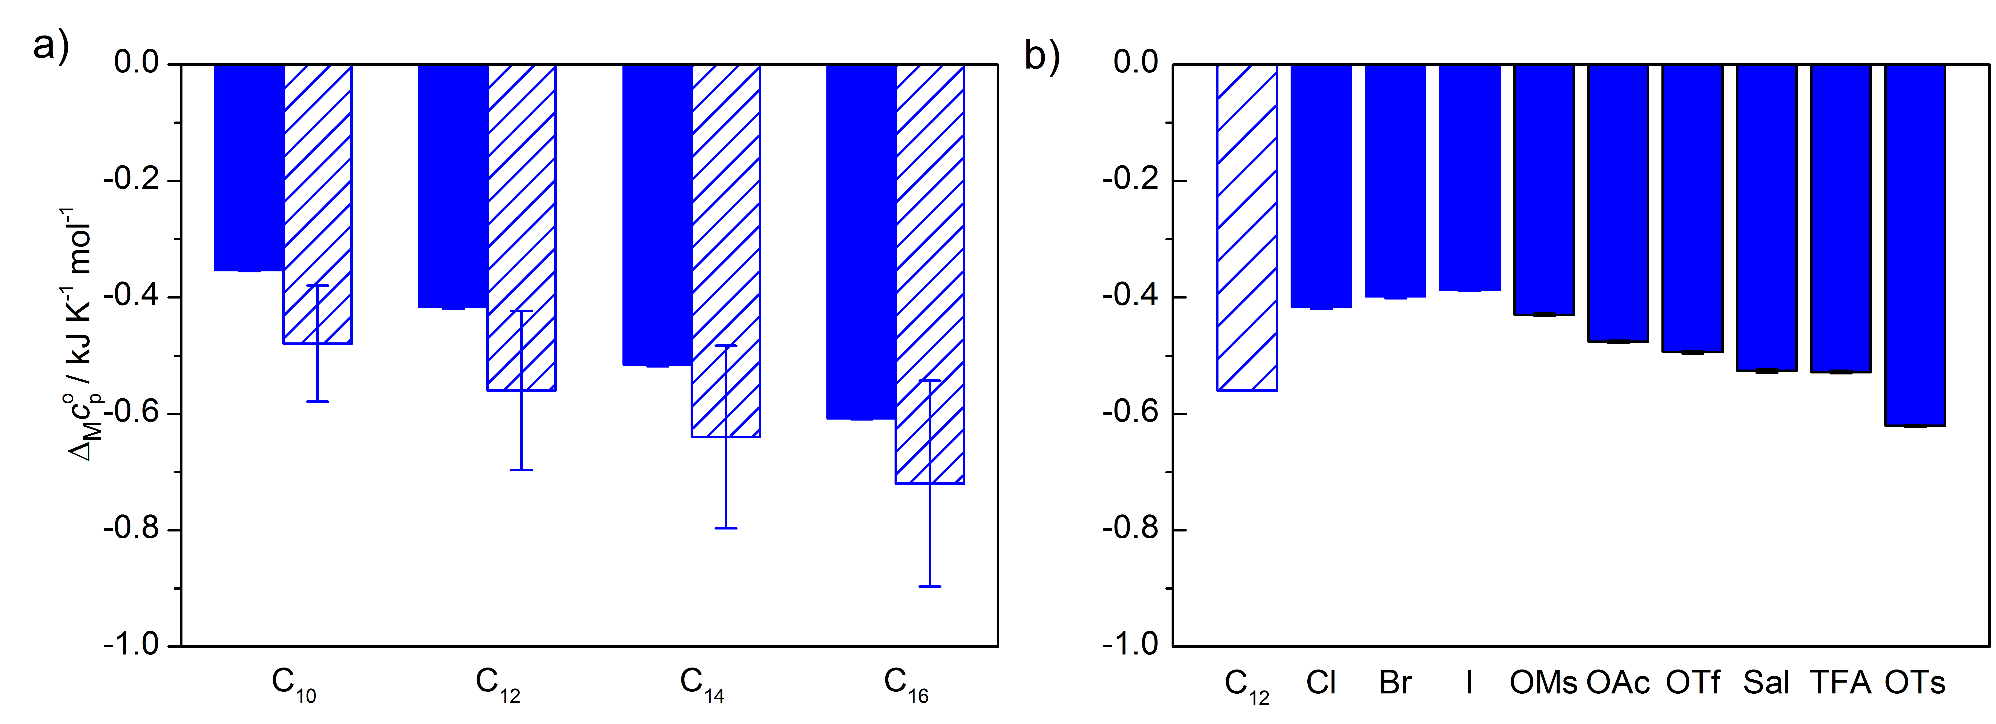

Fig. 16. Comparison of theoretical and experimental values of heat capacity changes upon micllization process, , for a) [C_{n}mim]Cl and b) [C₁₂ mim]X. Figure reproduced with permission from ref.⁸

a) It can be assumed that there are still water molecules in the interior of the micelle upon micellization and thus the ΔA_{np} estimated by approach of Richards⁴³ mentioned above overestimates. That is, the “real” ΔA_{np} is smaller than that of Richards.

b) The Eq. (4) holds well for non-ionic surfactants,^{41,42} but it probably is not valid for ionic surfactants. Positive contribution of removal of water accessible polar surface area to the heat capacity change of micellization should also be considered and cannot be neglected, consistent with the findings for the heat capacity change upon protein folding.⁴⁰

The influence of counterion on for [C₁₂mim]X systems⁸ is illustrated in Figure 16 b). For [C₁₂mim]Cl, [C₁₂mim]Br and [C₁₂mim]I it is obvious that the difference between (exp) and (th_{np}) increases along with an increase in size of anion. It is plausible to conjecture that the removal of water accessible polar surface area also increases along with an increase in size of counter ion binding onto the micelle but it can be concluded that ΔA_{p} part here cannot be neglected or/and that the hydrophobic parts of counter ions are incorporated in the micelles. In this case the contribution for the removal of the hydrophobic part of counterion from the contact with water after micellization to the can be assumed. Thus, the “hydrophobic” anions (OTs⁻, OTf⁻, TFA⁻ and Sal⁻) can be partially incorporated in the micelle and therefore the hydrophobic part of anion can contribute to the ΔA_{np} . The incorporation af counterions was, already confirmed for [C₁₆mim]OTs by Singh et al. using various methods and by for [C₁₂mim]OTf by DRS.

Recently, it was demonstrated on the dodecyltrimethylammonium chloride (DTACl) in the 0.01 M solutions of sodium ortho- (o-HBz, denoted previously as Sal), meta- (m-HBz), and para (p-HBz) hydroxybenzoate, that even small changes in the structure of anion of added salt, such as the position of the substituent on an aromatic ring, considerably influence the micellization process. However, it should be kept in mind, that the micellization of DTACl in that case was studied in the presence of NaCl, which also considerably affects the self-aggregation process. To prove the influence of isomerism of counterions on micellization of surfactant in water without any added compound the study of micellization of
[C₁₂mim]o-HBz, [C₁₂mim]m-HBz, [C₁₂mim]p-HBz together with the benzoate salt ([C₁₂mim])HBz (Figure 17) was carried out recently.¹⁹

Figure 17. Structures of investigated systems: a) [C₁₂mim]⁺; b) Bz– c) o-HBz–; d) m-HBz– e) p-HBz–. Figure reproduced with permission from ref. ¹⁹

It was found that the temperature dependence of cmc shows near U-shaped form (Figure 18 a)) but is strongly dependent on the presence and position of -OH group in the counterion. The micellization process of most is endothermic at low temperatures and becomes exothermic at high temperatures- phenomenon usual for ionic surfactants – for all her investigated systems, only at [C₁₂mim]o-HB it turned out the micellization is endothermic in the whole investigated temperature range. It is namely well-known that o-HBz⁻ provokes the formation of more compact elongated micelles by stronger interaction of o-HBz⁻ with surfactant molecule and its subsequent incorporation resulting in the highest exothermicity of micellization process in the case of o-HBz⁻. More details are available in ref.¹⁹

Figure 18. Temperature dependence of a) cmc and b) the standard enthalpy o micellization ∆_{M}H⁰ for [C₁₂mim]o-HBz, [C₁₂mim]m-HBz, [C₁₂mim]p-HBz and [C₁₂mim]p-HBz in water. Solid lines in a) represent the corresponding polynomial fits, cmc=A+BT+CT². Coefficients are given in Table S2 in Supplementary data. Solid lines in b) represent linear fit. Figure reproduced with permission from ref.¹⁹

Aggregation in non-aqueous solutions. Whereas the aggregation behavior of SAILs in aqueous solutions is relatively well investigated and understood, studies on the aggregation of SAILs in non-aqueous solvents are scarce although they are very important in many applications. Recently, the aggregation behavior and related physiochemical properties of [C₁₂mim]Br in DMSO, AN, N,N-dimethylformamide (DMF) and formamide (FA) was investigated by conductivity and density measurements.²⁰ It turned out that the aggregates formation in non-aqueous solvents is not as favored as in water what is actually similar to the behavior observed at some conventional ionic surfactants by Ray. The critical aggregation concentration, cac, as a function of the empirical parameters of solvent polarity are presented in Figure 19.

Figure 19. Critical aggregation concentration, cac, taken from the literature²⁰ as a function of empirical parameters of solvent polarity .

A bigger value reflects the weaker interaction between hydrocarbon and the solvents. Thus, interactions of the SAILs alkyl chain with organic solvents increase with decreasing values of the solvents. This reduces the tendency of the SAILs aggregation and increases its cac value. So, the cac values of the SAIL should increase with decreasing values of the solvents. Obviously, the reported data for DMF, AN and DMSO are in line with this prediction, but for FA this is not valid.²⁰ Thus, despite the fact, that “solvophobic effect” of the solvents plays an important role in the aggregation of the classical surfactants, and SAILs in non-aqueous solvents, also other factors may be predominant, as it is demonstrated here in the case of FA.

It is necessary to stress that DMSO, DMF and AN are aprotic solvents, while FA is protic solvent and capable of forming hydrogen-bonding. Based on molecular dynamic simulation, Hanke et al. reported that ionic liquids are strongly solvated by the hydrogen-bonding solvents, principally by forming hydrogen bonds with the anions. This indicates that the stronger hydrogen-bonding interactions of the SAILs anions with protic solvents would result in a decrease of the binding degree of the anions at the aggregates surface. In such a case, the electrostatic repulsion between the head groups of the SAIL cannot be decreased effectively, thus weakening the tendency towards aggregation. Therefore, it seems quite likely that the solvophobic effect and the hydrogen-bonding interactions of the SAIL anions with the solvents are the main factors controlling the aggregates formation of SAILs in non-aqueous solvents. Anyway, the work of Feng and coworkers²⁰ provides some very important new insight into the roles of solvophobic effect and hydrogen-bonding of non-aqueous solvents in the SAILs aggregation and supplies helpful guide how the aggregation of SAILs could be controlled and regulated by solvent properties.

- Concluding Remarks

It can be concluded that ILs are complex in their pure state, where the structure is strongly dependent on the structures of cation and anions enabling and/or hindering the package and/or arrangement. In solutions they behave like simple (“classical”) electrolytes and/or common (“classical”) surfactants thus they are sharing the “complexity“ of electrolyte solutions. But also, in solutions the structures of the ions play in very important role due to possibility of diverse ion-ion and ion-solvent interactions. Thus, let me mention only two fields, where the great potential of ILs due to their “tunability” of structures can be used:
a) There is still a lack of theories for concentrated electrolyte solutions. Whereas at “classical” electrolytes the limited solubility could be the reason for less effort in this way, with ILs in solutions the whole concentration range from pure solvent to pure electrolyte can be covered. Despite many studies, the observed maximum in the electrical conductivity (Figures 8 and 13) is still not described well and remains the challenge for the theoreticians.
b) With their wide possibilities of structures in hydrophobic part and counterions, SAILs are promising systems to study the aggregation processes in non-aqueous solutions.

Therefore, ILs can serve as excellent model systems for studying ionic interactions, hydrophobic effect, and specific ion effect to help us at broadening and deepening the knowledge on electrolyte and surfactant aqueous and non-aqueous solutions.

- Acknowledgements

I would like to thank my colleagues and friends Prof. Dr Richard Buchner (University of Regensburg, Germany) and Prof. Dr Slobodan Gadžuirć (University of Novi Sad, Serbia), Prof. Dr Milan Vraneš (University of Novi Sad, Serbia) and their Ph. D students Dr. Johannes Hunger, Dr. Alexander Stoppa, Dr. Sergej Friesen (University of Regensburg, Germany), Dr. Nebojša Zec, Dr. Snežana Papović, Dr. Aleksandar Tot (University of Novi Sad, Serbia) for fruitful longstanding collaboration in the field of ionic liquids. Valuable research work of Dr. Bojan Šarac (University of Ljubljana, Slovenia) and Ph. D students Dr. Martin-Tine Perger, Dr. Ana Kroflič, Dr. Jure Gujt, Dr. Žiga Medoš and Isidora Čobanov is acknowledged.

I am owing my debt to Prof. Alexander Apelblat (Ben Gurion University of the Negev, Beer-Sheva, Israel) and Dr. Roland Neueder (University of Regensburg, Germany) for sharing his knowledge on electrolyte solutions with me; Prof. Dr. Werner Kunz (University of Regensburg, Germany) for his optimistic and kind attitude; Dipl. Ing. Herbert Hilbinger (University of Regensburg, Germany) and Dipl. Ing. Dušan Habe (Test and Measurement Technique, Črnomelj, Slovenia) for their permanent and generous technical support.

However, my deepest debt and a profound appreciation go to Professor Dr Josef Barthel, who passed away in February 2019. Not only his friendship, kindness, help, good advice, and pleasant atmosphere in personal relations, but also his long-term support and strong inspiration of my research work encouraged me again and again to follow the - often not easy - scientific way. He supported my application for grant at Alexander von Humboldt foundation and hosted me at the Institute of Physical and Theoretical Chemistry at University of Regensburg (Germany) in 1994/95. After my return, he helped me to build the laboratories at home institution – he supported our application for small-X-ray scattering equipment donation at the Alexander von Humboldt foundation and took care of the donation of invaluable pieces of cells to the laboratory for electrical conductivity measurements. Without his generous help I would hardly continue my work. He involved me also in the community of solution chemists and put me on the way, where I met people who have been helping me to gather new knowledge and experiences and to overcome many borders. I am deeply grateful for that and for all that I received from him and I am thankful for all the time that was spent together.
The financial support by the Slovenian Research Agency through Bilateral projects (ARRS-BI-RS/16-17-023 and ARRS –Bi-DE/17-19-4) and through Grant No. P1-0201 is gratefully acknowledged. The networking support by the COST Actions CM1206 and CM1101 is appreciated.

- References

. T. L. Greaves, C. J. Drummond, Chem. Rev. 2015, 115, 11379−11448. DOI:10.1021/acs.chemrev.5b00158
. R-Hayes, G. G. Warr, R. Atkin. Chem. Rev. 2015, 115, 6357−6426. DOI: 10.1021/cr500411q
. Y. Ji, R. Shi, Y. Wang, G. Saielli, J. Phys. Chem. B 2013, 117, 1104−1109. DOI: 10.1021/jp310231f
. M. Bešter-Rogač, A. Stoppa, R. Buchner, J. Phys. Chem. B, 2014, 118, 1426−1435. DOI: 10.1021/jp412344a
. M. Bešter-Rogač, J. Hunger, A. Stoppa, R. Buchner, J. Chem. Eng. Data 2010, 55, 1799–1803. DOI: 10.1021/je900531b
. M. Bešter-Rogač, M.V. Fedotova, S.E. Kruchinin, M. Klähn. Phys. Chem. Chem. Phys., 2016, 18, 28594–28605. DOI: 10.1021/je900531b
. R. Tomaš, A. Tot, J. Kuhar, M. Bešter-Rogač. J. Mol. Liq. 2018, 254, 267–271. DOI: 10.1016/j.molliq.2018.01.076
. B. Šarac, Ž. Medoš, A. Cognigni, K. Bica, L.-J. Chen, M. Bešter-Rogač. Colloid Surf. A 2017, 532, 609–617. DOI: 10.1016/j.colsurfa.2017.01.062
. H. Olivier-Bourbigou, L.Magna, D.Morvan, Applied Catalysis A: General 2010, 373, 1–56. DOI: 10.1016/j.apcata.2009.10.008
. V. V. Chaban, O. V. Prezhdo, J. Phys. Chem. Lett. 2013, 4, 1423−1431. DOI: 10.1021/jz400113y
. M. Vraneš, S. Papović, A. Tot, N. Zec, S. Gadžurić, J. Chem. Thermodyn. 2014, 76, 161-171. DOI: 10.1016/j.jct.2014.03.025
. S. Papović, M. Bešter-Rogač, M. Vraneš, S. Gadžurić, J. Chem. Thermodyn. 2016, 99, 1-10. DOI: 10.1016/j.jct.2016.03.034
. S. Papović, M. Vraneš, B. Kordić, S. Filipović, M. Bešter-Rogač, S. Gadžurić, J. Chem. Thermodyn. 2016, 101, 260-269. DOI: 10.1016/j.jct.2016.06.012
S. Papović, N. Cvjetićanin, Slobodan Gadžurić, M. Bešter-Rogač, M. Vraneš, Phys.Chem.Chem.Phys. 2017, 19, 28139-, 28152. DOI: 10.1039/c7cp04478j
K. Yuyama, G. Masuda, H. Yoshida and T. Sato, J. Power Sources, 2006, 162, 1401-1408. DOI: 10.1016/j.jpowsour.2006.09.002
. O. N. Kalugin, I. V. Voroshylova, A. V. Riabchunova,,E. V. Lukinova, V. V. Chabanb, Electrochim. Acta 2013, 105, 188– 199. DOI: 10.1016/j.electacta.2013.04.140
. I. V. Voroshylova, S. R. Smaga, E. V. Lukinova, V. V. Chaban, O. N. Kalugin, J. Mol. Liq. 2015, 203, 7–15. DOI: 10.1016/j.molliq.2014.12.028
. I. Čobanov, B. Šarac, Ž. Medoš, M. Vraneš, S. Gadžurić, N. Zec, M. Bešter-Rogač, J. Mol. Liq. 2018, 271, 437–442. DOI: 10.1016/j.molliq.2018.08.152
. I. Čobanov, B. Šarac, Ž. Medoš, A. Tot, M. Vraneš, S. Gadžurić, N. Zec, M. Bešter-Rogač J. Mol. Liq. 2020, 301, 112419. DOI: 10.1016/j.molliq.2019.112419
. Q. Feng, H. Wang, S. Zhang, J. Wang, Colloid Surf. A 2010, 367, 7–11. DOI: 10.1016/j.colsurfa.2010.05.032
. Y. Pei, Q. Lu, Y. Niu, Y. Zhao, Y. Zhao, Z. Li, H. Wang, J. Wang, J. Chem. Eng. Data 2019, 64, 4708−4716. DOI: 10.1021/acs.jced.9b00040
. M. Bešter-Rogač, R. Neueder, J. Barthel, J. Solution Chem. 1999, 28, 1071-1086. DOI:
. J. M. G. Barthel, H. Krienke, W. Kunz, Physical Chemistry of Electrolyte Solutions: Modern Aspects, Springer, New York, 1998.
. B. L. Bhargava, M. L. Klein, Soft Matter, 2009, 5, 3475-3480. DOI: 10.1039/b908046e
. O. Nordness, P. Kelkar, M. A. Stadtherr, J. F. Brennecke, Mol. Phys. 2019, 117, 23-24. DOI:: 10.1080/00268976.2019.1635276
. J.F. Casteel, E.S. Amis, J. Chem. Eng. Data 1972, 17, 55-59. DOI: 10.1021/je60052a029
. M. Bešter-Rogač, R. Neueder, J. Barthel, J. Solution Chem. 2000, 29, 51-61. DOI:
. J. Gujt, M. Bešter-Rogač, B. Hribar-Lee, J. Mol. Liq. 2014, 190, 34-41. 1 DOI: 0.1016/j.molliq.2013.09.025
. G. Hefter, Pure Appl. Chem. 2006, 78, 1571–1586. DOI:10.1351/pac200678081571
. R. Buchner, Pure Appl. Chem. 2008, 80, 1239–1252. DOI:10.1351/pac200880061239
. R. Buchner, G. Hefter, Phys. Chem. Chem. Phys. 2009, 11, 8984–8999. DOI: 10.1039/b906555p
. M. Bešter-Rogač A. Stoppa, J. Hunger, G. Hefter, R. Buchner, Phys. Chem. Chem. Phys. 2011, 13, 17588–17598. DOI:10.1039/c1cp21371g
. M. Bešter-Rogač, R. Neueder, J. Barthel, Electrolyte Data Collection, Part 5c, in: R. Eckermann, G. Kreysa (Eds.): DECHEMA Chemistry Data Series, Vol XII, Frankfurt, Germany, 2015, p. 222
. A. Borun, A. Bald, J. Chem. Eng. Data 2012, 57, 475-481. DOI: 10.1021/je201014c
. A. Borun, A. Bald, Ionics 2016, 22, 859-867. DOI: 10.1007/s11581-015-1613-x
. J. Barthel, L. Iberl, J. Rossmaier, H. J. Gores, B. Kaukal, J. Solution Chem. 1990, 19, 321- 337. DOI: 10.1007/BF00648139
. A. Stoppa, J. Hunger, R. Buchner, J. Chem. Eng. Data 2009, 54, 472-479. DOI: 10.1021/je800468h
. M. Bešter-Rogač, R. Neueder, J. Barthel, Electrolyte Data Collection, Part 5c, in: R. Eckermann, G. Kreysa (Eds.): DECHEMA Chemistry Data Series, Vol XII, Frankfurt, Germany, 2015, pp. 416-417.
. Z. Kiraly, I. Dekany, J. Colloid Interface Sci. 2001, 242, 214-219. DOI: 10.1006/jcis.2001.7777
. R. S. Spolar, J. R. Livingstone, M. T. Record Jr., Biochemistry 1992, 31, 3947-3955. DOI: 10.1021/bi00131a009
. L. J. Chen, Y.-H. Sheu, P.-J. Li, J. Phys. Chem. 2004, 108, 19096-19098. DOI: 10.1021/jp045486a
. G. C. Kresheck, J. Phys. Chem. B 2009, 113, 6732-6735. DOI: 10.1021/jp9820469
. a) F. M. Richards, J. Mol. Biol. 1974, 82, 1-14. DOI: 10.1016/0022-2836(74)90570-1 b) F. M. Richards, Annu. Rev. Biophys. Bioeng. 1977, 6, 151-176. DOI: 10.1146/annurev.bb.06.060177.001055 c) F. M. Richards, Methods Enzymol. 1985, 115, 440-446. DOI: 10.1016/0076-6879(85)15032-9
44. G. Singh, T. S. Kang, J. Phys. Chem. B 2016, 120, 1092-1105. DOI:10.1021/acs.jpcb.5b09688
. S. Friesen, T. Buchner, A. Cognini, K. Bica, R. Buchner, Langmuir, 2017, 33, 9844-9856. DOI: 10.1021/acs.langmuir.7b02201
. B. Šarac, G. Meriguet, B. Ancian, M. Bešter-Rogač, Langmuir 2013, 29, 4460-4469. DOI: 10.1021/la400161n
. A. Kroflič, B. Šarac, M. Bešter-Rogač, J. Chem. Thermodyn. 2011, 43, 1557-1563. DOI: 10.1016/j.jct.2011.05.015
A. Ray, J. Am. Chem. Soc. 1969, 91, 6511–6512. DOI: 10.1021/ja01051a069
C. Reichardt, Solvents and Solvent Effects in Organic Chemistry, Third Edition 2003 WILEY-VCH Verlag GmbH & Co. KGaA, Weinheim, pp. 418-424.
. M. L. Moya, A. Rodriguez, M.D. Graciani, G. Femandez, J. Colloid Interface Sci. 2007, 316, 787–795. DOI: 10.1016/j.jcis.2007.07.035
M.J. Hollamby, R. Tabor, K.J. Mutch, K. Trickett, J. Eastoe, R.K. Heenan, I. Grillo, Langmuir 2008, 24, 12235–12240. DOI: 10.1021/la8020854
. C.G. Hanke, N.A. Atamas, R.M. Lynden-Bell, Green Chem. 2002, 4, 107–111. DOI: 10.1039/B109179B

