Prediction of Biological Activities, Structural Investigation and Theoretical Studies of
meta-cyanobenzyl Substituted Benzimidazolium Salts

Duygu Barut Celepci
Dokuz Eylül University, Faculty of Science, Department of Physics, İzmir, Turkey
E-mail: duygu.barut@deu.edu.tr
Abstract

The structural properties of meta-cyanobenzyl substituted N-heterocyclic carbene (NHC) precursors were investigated theoretically. The molecular and crystal structure of one of the compounds was determined by using the single-crystal X-ray diffraction method. Global reactivity descriptors were analyzed to understand the biological activity behaviors of the compounds with Density Functional Theory (DFT) B3LYP method with 6-31G* basis set. Vibrational frequencies and chemical shifts were computed and compared to experimental data. A predictive study for the biological activities was done using PASS (prediction of activity spectra for biologically active structures) online software. Biological activity predictions showed the analgesic, substance P antagonist, non-opoid and antiinflammatory activities of the compounds.

Keywords: N-heterocyclic carbene; crystal structure; DFT; PASS online

- Introduction

N-heterocyclic carbenes (NHC) are cyclic carbenes containing at least one amino substituent.¹ NHCs were first pioneered by Öfele, Wanzlick, and Schönherr in 1968 and the isolation of the first stable crystalline carbene was performed by Arduengo in 1991.²⁻⁴ After the stability of the NHC ligands was registered, they have been attracted great interest in the field of organic and organometallic chemistry. Especially, in medical applications, there have been various studies of metal-NHCs.⁵⁻⁷ The chelating effect of NHC precursors with unique sigma donor properties could be effective in biological activity.^{8,9} In our previous study, the investigations on the biological activity of NHC compounds containing cyanobenzyl substituents show that these compounds have exhibited biological activity.¹⁰
Biological experiments are often limited in terms of sample, time and cost. In this context, DFT-based reactivity descriptors are advantageous and generally be consistent with the experimental observations.¹¹ In recent years, the prediction of the reactivity of chemical systems is one of the main purposes of theoretical chemistry. Density functional theory (DFT) has been quite successful in providing the theoretical groundwork of this purpose. For analyzing and understanding the biological reactivity of the chemical systems, several reactivity descriptors have been proposed. In this work, biological reactivity studies of three compounds 2b, 2f and 2g were carried out through these global reactivity descriptors. Geometries of the compounds were optimized and bonding parameters were compared to the experimental data. Frontier molecule orbitals (HOMO and LUMO) and the energy values were computed. Natural bond orbital (NBO) analysis was used to analyze the stability of the molecules arising from hyperconjugative interactions and charge delocalization. The vibrational frequencies and chemical shifts were calculated and compared to the experimental ones. Also, PASS (prediction of activity spectra for biologically active structures) online software was used to predict the putative biological activity spectra of the compounds. DFT studies and PASS online predictions point out the similar activity results for the compounds.
It is believed that this kind of study will contribute to getting a better understanding of the chemical behavior of meta-cyanobenzyl substituted benzimidazolium salts. As proved by enzyme inhibition studies,¹⁰ these compounds can be a candidate as new drugs for therapy of some diseases such as glaucoma, epilepsy, gastric and duodenal ulcers, osteoporosis, mountain sickness, or neurological disturbances.

- Experimental

The synthesis, some spectroscopic results and enzyme inhibition studies of the compounds 2b, 2f, 2g and single-crystal X-ray diffraction studies of the 2f and 2g were reported previously.¹⁰

2.1 X-ray Crystallography
The single-crystal X-ray diffraction study of the compound 2b was performed by ω-scan technique, using a Rigaku-Oxford Xcalibur diffractometer with an EOS-CCD area detector operated at 50 kV and 40 mA using graphite-monochromated MoKα radiation (λ= 0.71073 Å) from an enhance X-ray source with CrysAlis^{Pro} software.¹² Data reduction and analytical absorption corrections were carried out by CrysAlis^{Pro} program.¹³ The structure was solved by the Intrinsic Phasing method with SHELXT and refined utilizing the SHELXL program^{14,15} incorporated in the OLEX2 program package.¹⁶ The crystallographic data and some parameters of refinement are placed in Table 1. Anisotropic thermal parameters were applied to all non-hydrogen atoms. All the hydrogen atoms were placed using standard geometric models and with their thermal parameters riding on those of their parent atoms.
Table 1. Crystal data and experimental details for the compound 2b.
Empirical Formula | C₂₃H₂₀BrN₃
Formula Weight | 418.33
Temperature (K) | 293(2)
Crystal System, space group | Orthorhombic, Pca2₁
a, b, c (Å) | 14.6406(7), 7.9998(4), 17.0884(9)
α, β, γ (°) | 90, 90, 90
V (Å³) | 2001.43(17)
Z | 4
Density (calculated) (g/cm³) | 1.388
Absorbtion coefficient (µ, mm⁻¹) | 2.066
F(000) | 856
Crystal size (mm³) | 0.360 × 0.259 × 0.253
Radiation | MoKα (λ=0.71073)
2θ range for data collection (°) | 6.054 to 51.364
Index ranges | -10≤ h ≤17, -9≤ k ≤9, -20≤ l ≤20
Reflections collected | 8295
Independent reflections | 3441 [R_{int} = 0.0322, R_{sigma} = 0.0441]
Restraints/Parameters | 4/245
Goodness-of-fit on F² | 1.015
Final R indices [I≥2σ(I)] | R₁ = 0.0335, wR₂ = 0.0599
R indices | R₁ = 0.0529, wR₂ = 0.0661
Largest diff. peak/hole (eÅ⁻³) | 0.20/-0.20

  - Computational Details
The compounds were optimized, chemical shifts and frontier molecular orbital energies were carried out by using DFT/B3LYP with the basis set 6-31G* by Gaussian 09W and GaussView 6.0 molecular visualization programs.^{17,18} Natural bond orbital (NBO) analysis was performed using NBO 3.1 program as implemented in the Gaussian 09 package at the same level of the theory.¹⁹ The normal mode assignments of the compounds were employed by VEDA²⁰ program and verified by GaussView 6.0. The NMR chemical shifts were computed in the gaseous state within GIAO (Gauge-Independent Atomic Orbital) approach by subtracting the shielding constants of TMS.²¹ The biological activity spectra of studied compounds were obtained by the PASS Online Program (http://www.way2drug.com/PASSOnline/).

3. Results & Discussions
3.1 Crystal structure of compound 2b
Single-crystal X-ray diffraction analyses reveal that the compound 2b crystallizes in the orthorhombic space group Pca2₁. The asymmetric unit of the compound contains a meta-cyanobenzyl-substituted benzimidazolium cation and a bromide anion (Fig. 1). The single-crystal X-ray diffraction studies reveal that the benzimidazolium ring system is almost coplanar with the r.m.s. deviation of 0.007(6) Å. Cyanobenzyl and methylbenzyl fragments lie to the different sides of the benzimidazole ring system, giving the cation a Z-shape. The dihedral angles between the benzimidazolium ring and the mean plane of these fragments are 67.83(9)° and 69.27(2)°, respectively. Two C–H···Br type intermolecular interactions are observed in the crystal structure; one is between the most acidic proton of the imidazolium cation and the bromide anion [C1–H1···Br1, H1···Br1=2.61 Å, C1–Br1=3.545(5) Å, C1–H1···Br1=155°], the other interaction is C16–H16B···Br1^{i} [H16B···Br1^{i}=2.85 Å, C16–Br1^{i}=3.813(6) Å, C1–H1···Br1^{i}=170°]. Fig. 2 displays the infinite chain occurs via these hydrogen bonds along the b-axis. The molecules stacked in the crystal structure to form a pincers-like packing motif, as shown in Fig. 3.

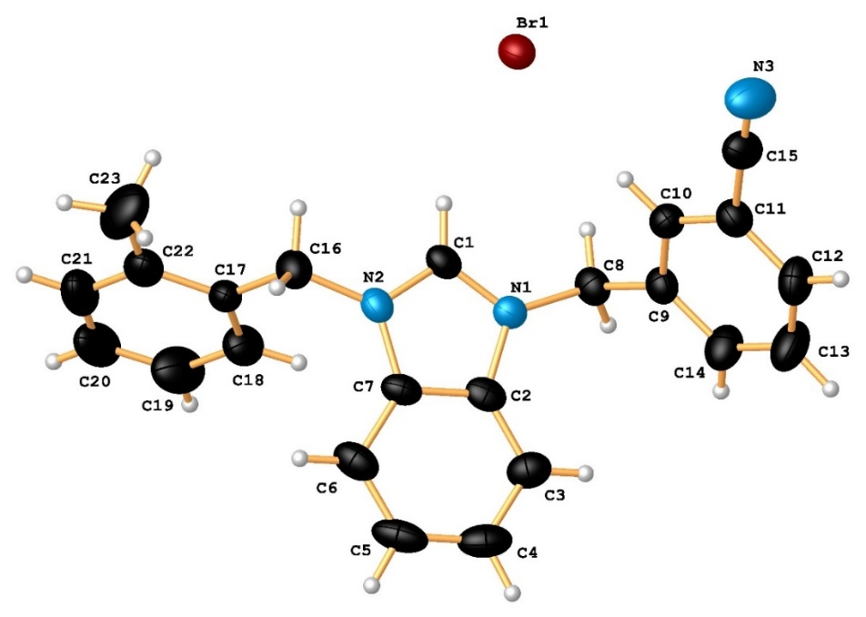

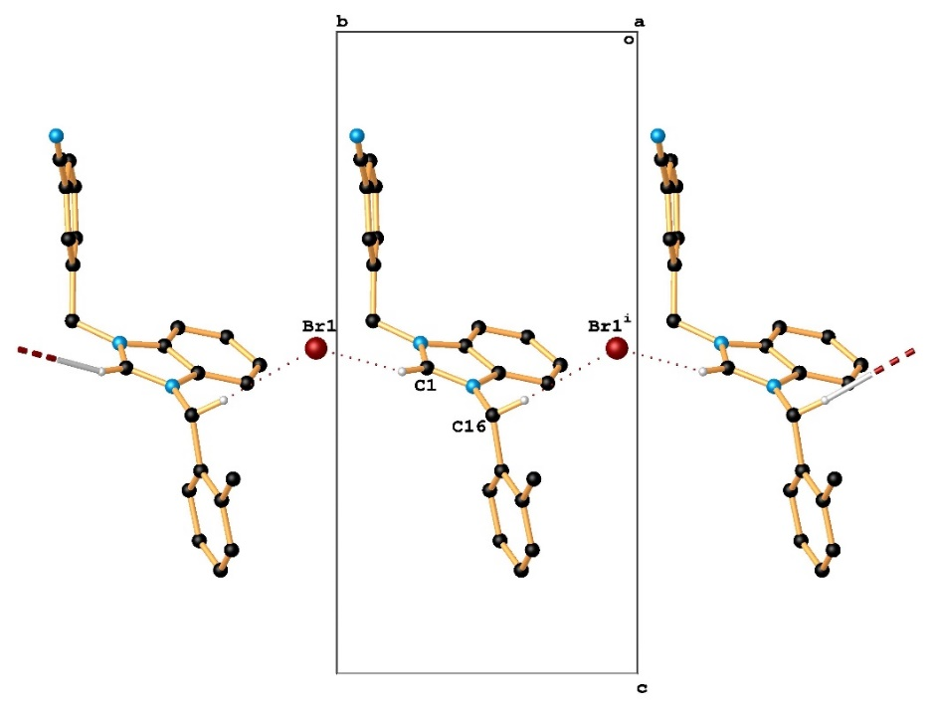
Fig. 1. Structure of 2b with ellipsoids plotted at 30% probability. Selected bond parameters (Å,°): N1–C1 1.327(6), N1–C2 1.389(5), N1–C8 1.472(5), N2–C1 1.326(5), N2–C7 1.389(6), N2–C16 1.459(6), N3–C15 1.138(7); N1–C1–N2 111.0(4), C1–N1–C8 125.6(4), N1–C8–C9 113.2(4), C2–N1–C8 126.3(4), C1–N2–C16 125.4(4), C7–N2–C16 127.0(4), N2–C16–C17 113.0(4), C11–C15–N3 177.2(8).

Fig. 2. Packing of the cation molecules of 2b through the intermolecular hydrogen bonds bridged by the bromide anions, which lead to the infinite chain along the b axes. All hydrogen atoms except those participating in the hydrogen bonds were omitted for clarity. Cation molecules are shown in the stick drawing style.
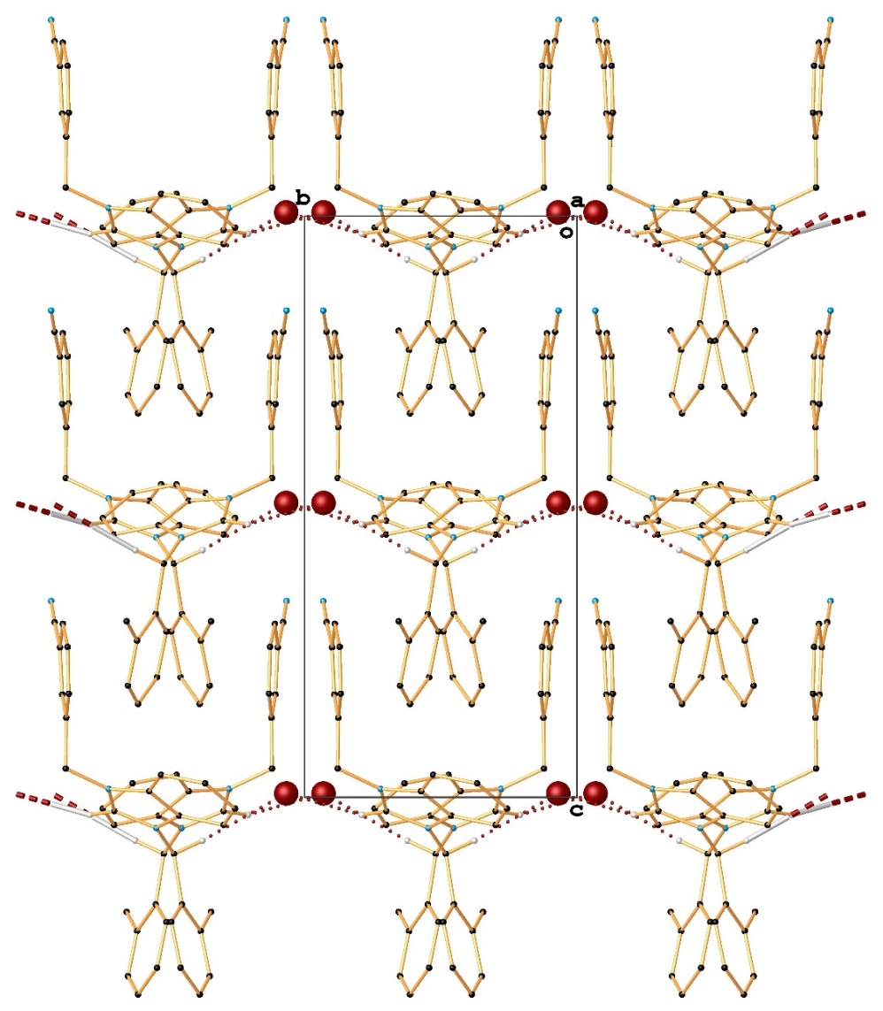

Fig. 3. Graphical representation of pincers-like packing motif the molecules within the unit cell for 2b.

3.2 Geometry Optimization, Frontier Molecular Orbitals and Global Reactivity Descriptors
The optimized ground state geometry of the compounds at DFT/B3LYP/6-31G* level of the theory is shown in Fig. 4. The correlations between the theoretical and experimental bonding parameters were displayed in Fig. S1 (see supplementary information file). It is clearly understood from the figure that there are some discrepancies between the experimental and computed bond parameters. While the theoretical calculations of the isolated structure were carried out in the gas phase, the fact that the experimental molecular structures were in a solid-state form likely caused these differences. Also, the experimental structures have intermolecular interactions, which may cause discrepancies in the bonding parameters.
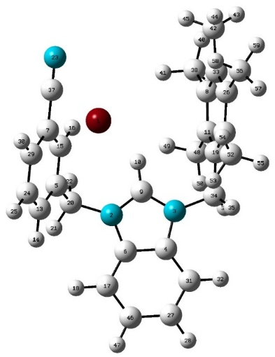
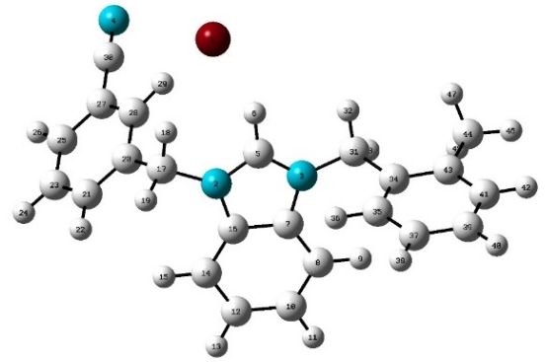
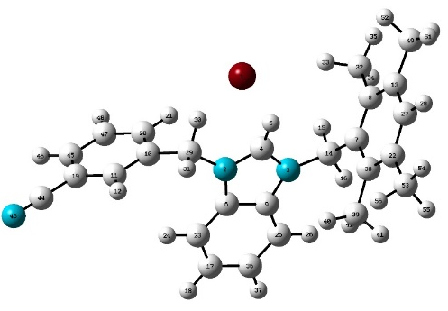
Fig. 4. Optimized geometries of the compounds 2b, 2f and 2g, respectively.
The FMOs theory involving HOMO and LUMO is one of the best theories to get an insight into the chemical stability of a molecule.²² The highest occupied molecular orbital (HOMO) represents the distribution and energy of the least tightly held electrons in the molecule and the lowest unoccupied molecular orbital (LUMO) describes the easiest route to the addition of more electrons to the system. The high value of E_{HOMO} indicates the ease of donating an electron to the unoccupied orbital of the receptor molecule, and the small value of E_{LUMO} means that it has small resistance to accept electrons so it will be more able to accept electrons. The difference between HOMO and LUMO energy values gives the HOMO-LUMO energy gap (E_{gap}) and it is an important stability index.²³ A molecule with large E_{gap} is described as a hard molecule, much less polarizable, and implies high molecular stability and aromaticity low reactivity in chemical reactions.^{24,25} The soft systems have small E_{gap}, they are highly polarizable and exhibit a significant degree of intramolecular charge transfer from the electron donor to the electron acceptor and conjugation that may influence the biological activity of the molecule.²⁶
To evaluate the energetic behavior of the compounds, the HOMO-LUMO analysis was carried out by using B3LYP/6-31G* method, and the plots are depicted in Table 2. As can be seen, compounds show different localization of the HOMOs and LUMOs. The HOMO of the 2b and 2g is located on the bromide anions, while in 2f, it is distributed to the bromide anion and the benzimidazolium fragment of the cation molecule. Similarly, LUMO electron density of 2f is spread over the cyanobenzyl moiety, but for 2b and 2g, the LUMO electrons are mainly located on the benzimidazolium ring. The values of energy separation between the HOMO-LUMO were found as 2.930, 3.845 and 3.011 eV, respectively.
The global reactivity descriptors calculated using the DFT method play an essential and reliable role to understand the biological activities in many studies. Some of these descriptors are; the global hardness (η), which measures the resistance to change in electron density; chemical potential (μ), measures the escaping tendency of an electron; electronegativity (χ), describes the ability of a molecule to attract electrons towards itself; electrophilicity index (ω), measures the susceptibility of chemical species to accept electrons; softness (S), is the inverse of hardness; the maximum charge transfer (ΔN_{max}), describes the propensity of the system to acquire additional electronic charge from the environment.^{27,28} The calculated values of reactivity descriptors of the compounds are listed in Table 3. The hardness values are following the order 2f > 2g > 2b, which suggests that 2b is the most reactive compound. The E_{gap} of 2b is also the smallest one, the electrophilicity index is the greatest and the maximum charge transfer capability is the highest. The dipole moments of the compounds are 15.136 Debye for 2b, 7.264 Debye for 2f and 13.600 Debye for 2g, proved that the most stable compound is 2f, while the 2b is the most reactive.

3.3 Mulliken Population Analysis, Natural Population Analysis (NPA) and Molecular Electrostatic Potential (MEP)

Mulliken atomic charges and natural population analysis (NPA) play an important role in quantum chemistry. The atomic charge distribution of acceptor and donor atoms in molecules is directly affected by parameters such as polarizability, refractivity, dipole moment, and other electronic structural parameters.²⁹ Mulliken population charge analysis and natural population analysis of structures were performed using B3LYP/6-31G* level of calculation and a list of all calculated atomic charges are given in Table S1 (see supplementary file). The analyses reveal the presence of electrophilic and nucleophilic atomic charges. According to the results, the bromide anions of the compounds display high nucleophilic behavior with their negative donor atomic charges, while the C_{carbene}-H protons have the highest positive charge value. So, bromide anions attack the hydrogen atom of carbene carbons, which is the most reactive site of the molecules.
The molecular electrostatic potential (MEP) is related to the electron density and is a useful descriptor in understanding the reactive behavior in both electrophilic and nucleophilic reactions and hydrogen bonding reactions.³⁰ In the MEP profile, the areas with major positive potential are specified by blue color, which demonstrates the strongest attraction, whereas the maximum negative potential sections have been presented red color, indicates the repulsion. Comparing with the X-ray data it was concluded that the MEP plots proved the intermolecular hydrogen bonds between the bromide anion and cation molecules for all structures (Table 2). The negative potential regions are over the electronegative bromide anions, which are responsible for the intermolecular C–H···Br hydrogen bonds. Also, the N≡C of cyanobenzyl groups of all structures have red colors which means these regions are the electron-rich nucleophilic regions. The net charges of the nitrogen atoms of cyanobenzyl groups confirmed the MEP output.
Table 2. The molecular orbitals for HOMO-LUMO and MEP diagrams of the compounds.
 | 2b | 2f | 2g
LUMO +2 | 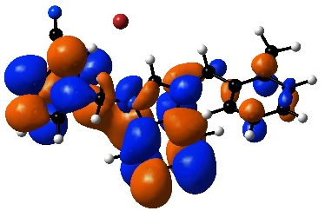 | 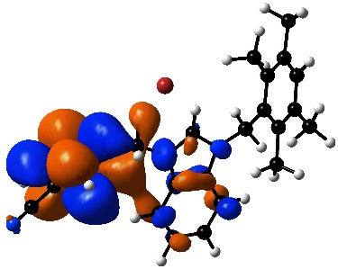 | 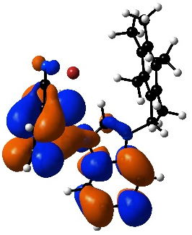
LUMO +1 | 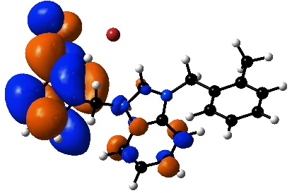 | 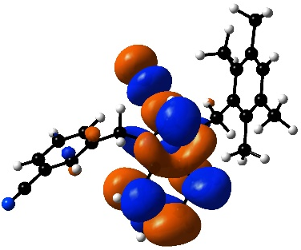 | 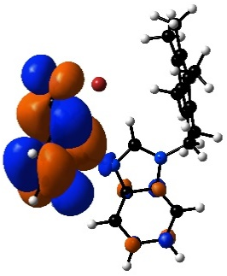
LUMO | 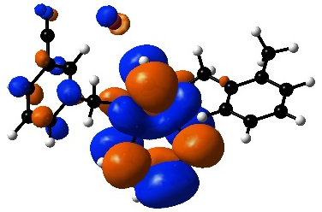 | 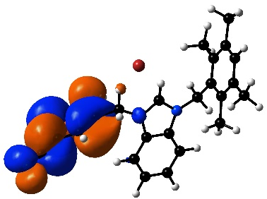 | 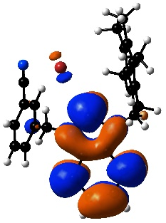
HOMO | 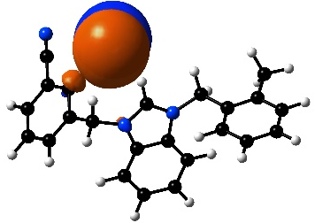 | 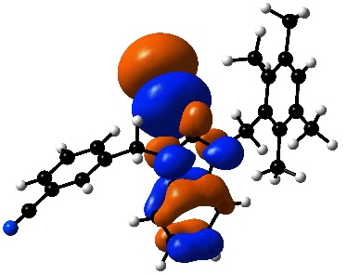 | 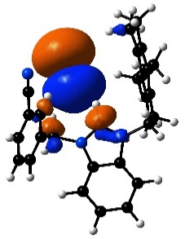
HOMO -1 | 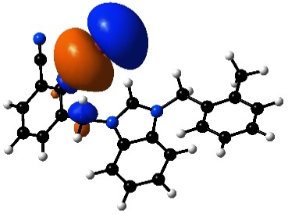 | 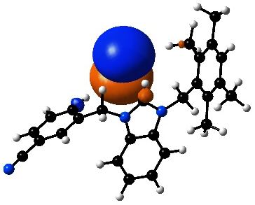 | 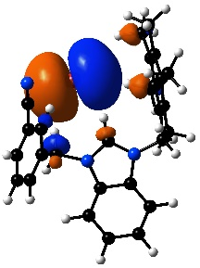
HOMO-2 | 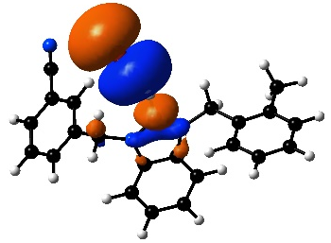 | 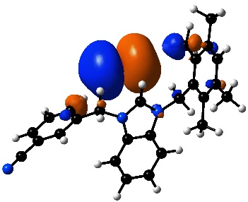 | 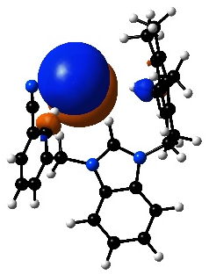
MEP | 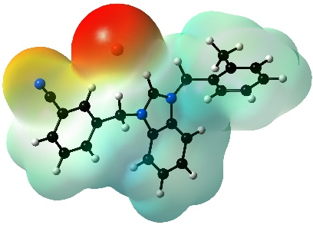 | 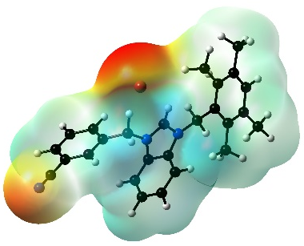 | 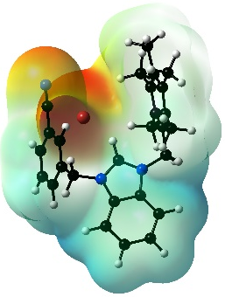

Table 3. Global descriptors of chemical reactivity of meta-cyanobenzyl substituted benzimidazolium salts.
(eV) | 2b | 2f | 2g
E_{HOMO} (-I) | -4.799 | -5.335 | -4.861
E_{LUMO} (-A) | -1.869 | -1.490 | -1.850
E_{gap} | 2.930 | 3.845 | 3.011
Electronegativity χ | 3.334 | 3.413 | 3.356
Chemical hardness η | 1.465 | 1.923 | 1.506
Electronic chemical potential μ | -3.334 | -3.413 | -3.356
Electrophilicity index ω | 3.794 | 3.029 | 3.739
Softness S | 0.341 | 0.260 | 0.332
Maximum charge transfer capability ΔN_{max} | 2.276 | 1.775 | 2.228

3.4 Natural Bond Orbital (NBO) Analysis

The natural bond orbital analysis (NBO) is an effective method for predicting the stereoelectronic interactions on the reactivity and dynamic behaviors of chemical compounds.³¹ It provides a convenient basis for investigating charge transfer or conjugative interaction in molecular systems. The interactions depend on the energy difference between interacting orbitals, and the strong interactions arise between predominant donor and acceptor. The second-order perturbation analysis of the Fock matrix is used to calculate stabilization energy $E\left(2\right)$ for each donor (i) and acceptor (j) within i→j delocalization. The estimated energy can be determined as$E\left(2\right)= {∆E}_{ij}=q_{i}\frac{F_{i,j}^{2}}{E_{j}-E_{i}}$; where $q_{i}$is donor orbital occupancy, $E_{i}$ and $E_{j}$ are diagonal elements and $F_{ij}$$F_{i,j}$is the off-diagonal NBO Fock matrix element. The larger the E(2) value means the more intensive interaction between electron donors and acceptors.³² The natural bond orbitals’ (NBO) calculations for the structures were performed at the DFT/B3LYP/6–31G* method. The stabilization energies of the most important interactions between donor and acceptor along with occupancy are given in Table 4. According to the table, the strongest interactions (π→π*) occur in the N-heterocyclic carbene ligand for all structures. In the 2b and 2g, the electron donation from a lone-pair orbital on the carbon atom of benzimidazole, LP(1) C16 and LP(1) C6, to the antibonding acceptors π* N3–C7 (233.49 kJ/mol), π* C12–C14 (58.10 kJ/mol) and π* N3–C4 (219.31 kJ/mol), π* C17–C46 (58.79) orbitals have also high stabilization energies. In the compound 2f, from the lone-pair orbital of LP(1) N3 to the π* N2–C4 has the energy of 82.11 kJ/mol.

Table. 4. The Second Order Perturbation Theory Analysis Results of the Fock Matrix in NBO Basis for 2b, 2f and 2g at B3LYP/6-31G* level of the theory.

 | Donor(i) | Acceptor(j) | ED_{i}(e) | ED_{j}(e) | E(2) kJ/mol | E_{j}–E_{i} (a.u) | F_{i,j} (a.u)
2b
 | π* N3–C7 | π* N2–C5 | 0.8166 | 0.4510 | 245.94 | 0.01 | 0.063
 | LP(1) C16 | π* N3–C7 | 1.0440 | 0.8166 | 233.49 | 0.08 | 0.123
 | LP(1) C16 | π* C12–C14 | 1.0440 | 0.3062 | 58.10 | 0.16 | 0.104
2f
 | π* C6–C9 | π* C25–C36 | 0.4719 | 0.3343 | 217.58 | 0.02 | 0.082
 | π* C10–C11 | π* C20–C47 | 0.3349 | 0.2821 | 190.65 | 0.01 | 0.081
 | π* C6–C9 | π* C17–C23 | 0.4719 | 0.3274 | 188.55 | 0.02 | 0.082
 | π* C19–C45 | π* C20–C47 | 0.3848 | 0.2821 | 179.27 | 0.02 | 0.082
 | LP(1) N3 | π* N2–C4 | 1.5551 | 0.5650 | 82.11 | 0.21 | 0.122
2g
 | π* N3–C4 | π* N2–C9 | 0.8011 | 0.4644 | 321.23 | 0.01 | 0.064
 | π* C12–C26 | π* C8–C33 | 0.3536 | 0.3265 | 261.24 | 0.01 | 0.081
 | LP(1) C6 | π* N3–C4 | 1.0410 | 0.8011 | 219.31 | 0.08 | 0.122
 | π* C11–C19 | π* C8–C33 | 0.3938 | 0.3265 | 177.46 | 0.02 | 0.084
 | LP(1) C6 | π* C17–C46 | 1.0410 | 0.3086 | 58.79 | 0.16 | 0.104

3.5 Vibrational Analysis
The experimental and calculated FT-IR spectra of the compounds are illustrated in Fig. 5. The unscaled theoretical frequencies using the B3LYP level of theory with 6–31G* basis set along with their IR intensities, probable assignments and potential energy distribution (PED) performed employing VEDA program for all structures are presented in Table S2. As seen in Fig. 5, the experimental fundamentals are nearly consistent with the calculated ones. The probable discrepancies can arise as a result of anharmonic and finite temperature effects.³³ As it is expected that C–H stretching modes belonging to the aromatic ring of the NHC salts were observed and calculated above 3000 cm⁻¹.³⁴ The CH_{carbene} stretching modes occur at 2960 cm⁻¹ for 2b and 2f and 2956 cm⁻¹ for 2g. The calculated assignments are 2772, 3256 and 3025 cm⁻¹, respectively. The benzonitrile N–C stretching vibrations have the PED contributions of 89% for all structures; the modes assigned at 2227, 2228 and 2229 cm⁻¹, while they were calculated at 2352, 2348 and 2351 cm⁻¹, respectively.

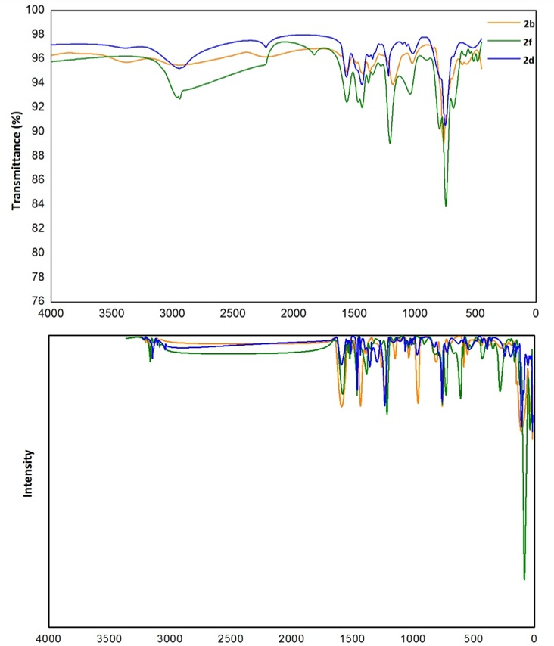

Fig. 5. The experimental (above) and calculated (below) IR spectra of the meta-cyanobenzyl substituted benzimidazolium salts.

3.6 Nuclear Magnetic Resonance (NMR) Studies
The compounds were characterized by ¹H, ¹³C NMR spectroscopy (Figs. S2-7). The theoretical GIAO ¹H and ¹³C chemical shift calculations (with respect to TMS in ppm) were carried out using the DFT/B3LYP method with 6–31G* basis set and compared with experimental chemical shift values (Tables S3, S4). The chemical shifts are converted to the TMS scale by subtracting the calculated absolute chemical shielding of TMS (δ=Σ₀−Σ) where δ is the chemical shift, Σ is the absolute shielding and Σ₀ is the absolute shielding of TMS, whose values are 32.18 and 189.73 ppm for B3LYP/6-31G*, respectively. There are some deviations of the chemical shift values, which may be due to the chemical environment of the C and H atoms in the molecules.
According to the tables, the signals of the carbene carbons appeared at 143.55, 142.2 and 134.4 ppm, while they were calculated at 139.27, 127.10 and 124.52 ppm, respectively. Hydrogen bonding has been recognized as the main interaction between the cations and anions of azolium salts leading to close arrangement between the counter anions and the most acidic C_{carbene}–H proton.³⁵⁻³⁸ A strong hydrogen bond acceptor is expected to polarize the C_{carbene}–H bond and slightly increase the acidity of the salt. As anticipated, bromide anions with four lone pairs of electrons are the hydrogen bonding acceptors that lead to the most downfield shifts of the ¹HC_{carbene}–H signal. These hydrogen bonding interactions were also determined by single-crystal X-ray diffraction studies.¹⁰ The most acidic protons (C_{carbene}–H) were observed at 10.13, 9.42 and 9.34 ppm, and calculated at 16.14, 9.81 and 12.79 ppm, respectively. The data also showed that the methylene carbon atoms had the least chemical shift values.

3.7 Computer-aided prediction of biological activities of the meta-cyanobenzyl-substituted benzimidazolium salts
The PASS (Prediction of Activity Spectra for Substances) computer program is an estimation tool, which allows predicting the probable profile of biological activity of a drug-like organic compound based on its structural formula. The average accuracy of prediction is about 95% according to leave-one-out-cross validation (LOOCV) estimation.^{39,40}
The biological activity spectra of the meta-cyanobenzyl substituted benzimidazolium salts were theoretically obtained by the PASS Online program and the analysis results were enlisted in Table 5. According to the data, all compounds are very likely to be analgesic, Substance P antagonist, non-opoid analgesic and anti-inflammatory with corresponding P_{a} values, which are higher than 0.7. Compounds also exhibit activity to the CYP2H substrate and CYP2C19 inducer. In our previous study, potential AChE inhibition properties of the compounds were investigated.¹⁰ PASS online studies proved that these compounds can be used as acetylcholine neuromuscular blocking agents, as well.

Table 5. Biological activity assessment using PASS online software.
Activity | 2b |  | 2f |  | 2g
 | P_{a} | P_{i} | P_{a} | P_{i} | P_{a} | P_{i}
Analgesic | 0.885 | 0.004 | 0.854 | 0.005 | 0.874 | 0.004
Substance P antagonist | 0.880 | 0.002 | 0.859 | 0.002 | 0.880 | 0.002
Analgesic, non-opioid | 0.843 | 0.004 | 0.805 | 0.005 | 0.827 | 0.005
Antiinflammatory | 0.769 | 0.009 | 0.787 | 0.008 | 0.751 | 0.010
CYP2H substrate | 0.653 | 0.049 | 0.633 | 0.055 | 0.653 | 0.049
CYP2C19 inducer | 0.557 | 0.008 | 0.546 | 0.008 | 0.557 | 0.008
Acetylcholine neuromuscular blocking agent | 0.557 | 0.041 | 0.529 | 0.057 | 0.557 | 0.041

4. Conclusion
As a result, this study contains theoretical aspects of three meta-Cyanobenzyl substituted N-heterocyclic carbene (NHC) precursors. The biological reactivity of the compounds was predicted by global reactivity descriptors and using PASS (prediction of activity spectra for biologically active structures) online. DFT and PASS online studies pointed out the activation of the compounds. The compound 2b was found to be the most reactive structure by both computational methods. The molecular and crystal structure of 2b was also determined by using the single-crystal X-ray diffraction method. Natural bond orbital (NBO) analysis was used to analyze the stability of the molecules arising from hyperconjugative interactions and charge delocalization. The vibrational frequencies and chemical shifts were calculated and compared to the experimental ones. Biological activity predictions showed that all structures have a high analgesic, substance P antagonist and non-opoid analgesic activities.

5. Supplementary
Crystallographic data as .cif files for the structure reported in this paper have been deposited at the Cambridge Crystallographic Data Center with CCDC 1971777 for 2b. Copies of the data can be obtained free of charge at http://www.ccdc.cam.ac.uk/conts/retrieving.html or from the Cambridge Crystallographic Data Center, 12, Union Road, Cambridge CB2 1EZ, UK. Fax: (+44) 1223-336-033, email: deposit@ccdc.cam.ac.uk.

6. Acknowledgments
The author acknowledges Dokuz Eylül University for the use of the Oxford Rigaku Xcalibur Eos Diffractometer (purchased under University Research Grant No: 2010.KB.FEN.13) and Assoc. Prof. Dr. Muhittin Aygün for the use of the Gaussian 09W/Gauss View package program. The author also thanks İnönü University Scientific and Technology Center for the use of the spectrometers.

7. References
1. S. Diez-Gonzalez, N. Marion, S. P. Nolan, Chem. Rev. 2009, 109, 3612–3676.
2. H. W. Wanzlick, H. J. Schönherr, Angew. Chem. Int. Ed. Engl. 1968, 7, 141–142.
3. K. Öfele, J. Organomet. Chem. 1968, 12, 42–43.
4. A. J. III Arduengo, R. L. Harlow, M. Kline, J. Am. Chem. Soc. 1991, 113, 361–363.
5. S. Akkoç, V. Kayser, I. Ö. İlhan, D. E. Hibbs, Y. Gök, P. A. Williams, B. Hawkins, F. Lai, J. Organomet. Chem. 2017, 839, 98–107.
6. I. Yıldırım, A. Aktaş, D. Barut Celepci, S. Kırbağ, T. Kutlu, Y. Gök, M. Aygün, Res. Chem. Intermed. 2017, 43, 6379–6393.
7. Y. Gök, S. Akkoç, H. Erdoğan, S. Albayrak, J. Enzyme Inhib. Med. Chem. 2016, 31, 1322–1327.
8. S. Budagumpi, S. Endud, Organometallics 2013, 32, 1537–1562.
9. Y. Sarı, A. Aktaş, P. Taslimi, Y. Gök, İ. Gülçin, J. Biochem. Mol. Toxicol. 2018, 32, e22009.
10. F. Türker, D. Barut Celepci, A. Aktaş, P. Taslimi, Y. Gök, M. Aygün, İ. Gülçin, Arch Pharm Chem Life Sci. 2018, 351, e1800029.
11. P. K. Chattaraj, S. Nath, and B. Maiti, Computational Medicinal Chemistry for Drug Discovery, 2003, Marcel Dekker, New York.
12. CrysAlis^{Pro} Software System, Version 1.171.38.43, 2015, Rigaku Corporation, Oxford, UK.
13. R. C. Clark, J. S. Reid, Acta Crystallogr. A. 1995, 51, 887–897.
14. G. M. Sheldrick, Acta Crystallogr. A. 2015, 71, 3–8.
15. G. M. Sheldrick, Acta Crystallogr. C. 2015, 71, 3–8.
16. O. V. Dolomanov, L. J. Bourhis, R. J. Gildea, J. A. K. Howard, H. Puschmann, J. Appl. Cryst. 2009, 42, 339–341.
17. M. J. Frisch, G. W. Trucks, H. B. Schlegel, G. E. Scuseria, M. A. Robb, J. R. Cheeseman, G. Scalmani, V. Barone, G. A. Petersson, H. Nakatsuji, X. Li, M. Caricato, A. Marenich, J. Bloino, B. G. Janesko, R. Gomperts, B. Mennucci, H. P. Hratchian, J. V. Ortiz, A. F. Izmaylov, J. L. Sonnenberg, D. Williams-Young, F. Ding, F. Lipparini, F. Egidi, J. Goings, B. Peng, A. Petrone, T. Henderson, D. Ranasinghe, V. G. Zakrzewski, J. Gao, N. Rega, G. Zheng, W. Liang, M. Hada, M. Ehara, K. Toyota, R. Fukuda, J. Hasegawa, M. Ishida, T. Nakajima, Y. Honda, O. Kitao, H. Nakai, T. Vreven, K. Throssell, J. A. Montgomery, Jr., J. E. Peralta, F. Ogliaro, M. Bearpark, J. J. Heyd, E. Brothers, K. N. Kudin, V. N. Staroverov, T. Keith, R. Kobayashi, J. Normand, K. Raghavachari, A. Rendell, J. C. Burant, S. S. Iyengar, J. Tomasi, M. Cossi, J. M. Millam, M. Klene, C. Adamo, R. Cammi, J. W. Ochterski, R. L. Martin, K. Morokuma, O. Farkas, J. B. Foresman, and D. J. Fox, Gaussian 09, Revision B.01. 2016, Gaussian, Inc., Wallingford CT.
18. R. Dennington, T. A. Keith, J.M. Millam, GaussView, Version 6, 2016, Semichem Inc., Shawnee Mission, KS.
19. E.D. Glendening, J.K. Badenhoop, A.E. Reed, J.E. Carpenter, F. Weinhold, NBO Version 3.1. 1995, Theoretical Chemistry Institute, University of Wisconsin, Maddison.
20. M. H. Jamroz, Vibrational Energy Distribution Analysis VEDA 4. 2004-2010, Warsaw.
21. R. Ditchfield. J. Chem. Phys. 1972, 56, 5688–5691.
22. S. Gunasekaran, R. A. Balaji, S. Kumeresan, G. Anand, S. Srinivasan, Can. J. Anal. Sci. Spectrosc. 2008, 53, 149–162.
23. J. Fleming, Frontier Orbitals and Organic Chemical Reactions. 1976, John Wiley & Sons, New York.
24. V. Arjunan, L. Devi, R. Subbalakshmi, T. Rani, S. Mohan, Spectrochim. Acta A. 2014, 130, 164–177.
25. O. A. El-Gammal, T. H. Rakha, H. M. Metwally, G. M. Abu El-Reash, Spectrochim. Acta A. 2014, 127, 144–156.
26. R. Bahnasawy, E. Shereafy, T. Kashar, J. Thermal Anal. Calorimetry, 1993, 39, 65–74.
27. H. Chermette, J. Comput. Chem. 1999, 20, 129–154.
28. L. H. Mendoza-Huizar, Acta Chim. Slov. 2014, 61, 694–702.
29. R. S. Mulliken, J Chem. Phys. 1955, 23, 1833–1840.
30. N. Okulik, A. H. Jubert, Internet Electron. J. Mol. Des. 2005, 4, 17–21.
31. P. Singh, S.S. Islam, H. Ahmad, A. Prabaharan, J Mol. Struct. 2018, 1154, 39–50.
32. R. J. Xavier, E. Gobinath, Spectrochim Acta A. 2012, 86, 242–251
33. M. Katari, E. Nicol, V. Steinmetz, G. van der Rest, D. Carmichael, G. Frison. Chem. Eur. J. 2017, 23, 8414–8423.
34. S. Gunasekaran, S. Ponnusamy. Indian J. Pure Ap. Phy. 2005, 43, 838–843.
35. A. G. Avent, P. A. Chaloner, M. P. Day, K. R. Seddon, T. Welton, J. Chem. Soc. Dalton Trans. 1994, 23, 3405–3413.
36. J. A. Cowan, J. A. C. Clyburne, M. G. Davidson, R. L. W. Harris, J. A. K. Howard, P. Kupper, M. A. Leech, S. P. Richards, Angew. Chem. Int. Ed. 2002, 41, 1432–1434.
37. N. Kuhn, A. Alsheikh, Coord. Chem. Rev. 2005, 249, 829–857.
38. H. V. Huynh, T. T. Lam, H. T. T. Luong, RSC Adv. 2018, 8, 34960–34966.
39. D. A. Filimonov, A. A. Lagunin, T. A. Gloriozova, A. V. Rudik, D. S. Druzhilovskii, P. V. Pogodin, V. V. Poroikov, Chem Heterocyc Compd. 2014, 50, 444–457.
40. D. A. Filimonov, V. V. Poroikov, RSC Publishing, 2008, Cambridge, 182–216.

