Prediction of Biological Activities, Structural Investigation and Theoretical Studies of
meta-cyanobenzyl Substituted Benzimidazolium Salts

Duygu Barut Celepci
Dokuz Eylül University, Faculty of Science, Department of Physics, İzmir, Turkey
E-mail: duygu.barut@deu.edu.tr
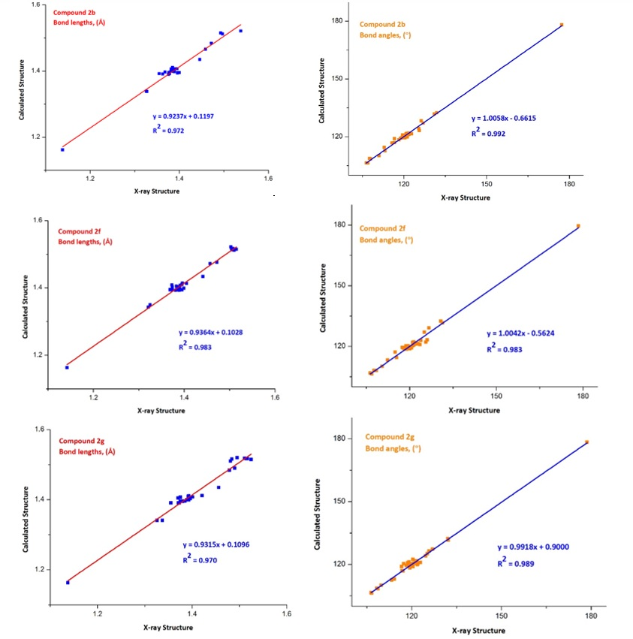

Fig. S1. The correlations between the theoretical and experimental bonding parameters for the compounds 2b, 2f and 2g.

Table S1. Mulliken population analysis (MPA) and Natural population analysis (NPA) from NBO calculation.
2b |  |  | 2f |  |  | 2g
Atom | Mulliken | NPA | Atom | Mulliken | NPA | Atom | Mulliken | NPA
Br1 | -0.6978 | -0.7907 | Br1 | -0.6471 | -0.7257 | Br1 | -0.6903 | -0.8109
N2 | -0.5255 | -0.3529 | N2 | -0.5217 | -0.3675 | N2 | -0.5232 | -0.3477
N3 | -0.5241 | -0.3614 | N3 | -0.5071 | -0.3605 | N3 | -0.5298 | -0.3555
N4 | -0.4746 | -0.2977 | N43 | -0.4778 | -0.3053 | N23 | -0.4764 | -0.3005
C5 | 0.2990 | 0.3222 | C4 | 0.3224 | 0.3063 | C4 | 0.3189 | 0.1400
C7 | 0.3061 | 0.1381 | C6 | 0.3265 | 0.1441 | C5 | 0.1469 | -0.0684
C8 | -0.1545 | -0.2414 | C7 | 0.0156 | -0.0688 | C6 | 0.3201 | 0.1451
C10 | -0.1427 | -0.2238 | C8 | 0.0810 | -0.0006 | C7 | 0.1184 | -0.1641
C12 | -0.1407 | -0.2243 | C9 | 0.3166 | 0.1485 | C8 | 0.0882 | 0.0065
C14 | -0.1485 | -0.2370 | C10 | 0.1110 | -0.0765 | C9 | 0.3224 | 0.3251
C16 | 0.3219 | 0.1413 | C11 | -0.2068 | -0.1885 | C11 | 0.1026 | 0.0052
C17 | -0.2802 | -0.2756 | C13 | 0.1434 | -0.0238 | C12 | 0.0969 | -0.0138
C20 | 0.1393 | -0.0704 | C14 | -0.2543 | -0.2627 | C13 | -0.1642 | -0.2071
C21 | -0.1757 | -0.2166 | C17 | -0.1451 | -0.2301 | C15 | -0.1881 | -0.1656
C23 | -0.1352 | -0.2302 | C19 | 0.1324 | -0.1723 | C17 | -0.1568 | -0.2420
C25 | -0.1298 | -0.1815 | C20 | -0.1477 | -0.1851 | C19 | 0.0001 | -0.1007
C27 | 0.1188 | -0.1623 | C22 | 0.1451 | -0.0282 | C20 | -0.2984 | -0.2783
C28 | -0.1786 | -0.1614 | C23 | -0.1564 | -0.2437 | C24 | -0.1352 | -0.2307
C30 | 0.2514 | 0.2828 | C25 | -0.1673 | -0.2537 | C26 | 0.0672 | -0.0207
C31 | -0.2382 | -0.2639 | C27 | -0.2474 | -0.2088 | C27 | -0.1408 | -0.2252
C34 | 0.0904 | -0.0656 | C29 | -0.2299 | -0.2607 | C29 | -0.1308 | -0.1820
C35 | -0.1711 | -0.2258 | C32 | -0.5746 | -0.7167 | C31 | -0.1636 | -0.2447
C37 | -0.1314 | -0.2271 | C36 | -0.1420 | -0.2283 | C33 | 0.0916 | 0.0040
C39 | -0.1198 | -0.2225 | C38 | 0.0753 | -0.0180 | C34 | -0.2583 | -0.2544
C41 | -0.1844 | -0.2200 | C39 | -0.5332 | -0.6924 | C37 | 0.2503 | 0.2837
C43 | 0.1330 | -0.0229 | C44 | 0.2371 | 0.2797 | C38 | -0.5478 | -0.7046
C44 | -0.5450 | -0.6982 | C45 | -0.1335 | -0.1802 | C42 | -0.5494 | -0.6988
H6 | 0.2673 | 0.2782 | C47 | -0.1419 | -0.2214 | C46 | -0.1416 | -0.2247
H9 | 0.1651 | 0.2575 | C49 | -0.5433 | -0.6924 | C48 | -0.5577 | -0.7067
H11 | 0.1525 | 0.2503 | C53 | -0.5396 | -0.6900 | C52 | -0.5516 | -0.6991
H13 | 0.1517 | 0.2500 | H5 | 0.2463 | 0.2914 | C56 | -0.5477 | -0.6986
H15 | 0.1588 | 0.2536 | H12 | 0.1531 | 0.2485 | H10 | 0.2812 | 0.2943
H18 | 0.2467 | 0.3014 | H15 | 0.2242 | 0.2799 | H14 | 0.1282 | 0.2306
H19 | 0.1710 | 0.2456 | H16 | 0.1727 | 0.2456 | H16 | 0.2215 | 0.2861
H22 | 0.1328 | 0.2330 | H18 | 0.1462 | 0.2474 | H18 | 0.1597 | 0.2500
H24 | 0.1450 | 0.2456 | H21 | 0.2137 | 0.2787 | H21 | 0.1693 | 0.2452
H26 | 0.1606 | 0.2538 | H24 | 0.1624 | 0.2561 | H22 | 0.2538 | 0.3026
H29 | 0.2216 | 0.2851 | H26 | 0.1525 | 0.2476 | H25 | 0.1445 | 0.2451
H32 | 0.2272 | 0.2831 | H28 | 0.1165 | 0.2284 | H28 | 0.1519 | 0.2500
H33 | 0.1847 | 0.2565 | H30 | 0.2159 | 0.2814 | H30 | 0.1596 | 0.2532
H36 | 0.1340 | 0.2373 | H31 | 0.1737 | 0.2453 | H32 | 0.1610 | 0.2532
H38 | 0.1396 | 0.2419 | H33 | 0.2239 | 0.2764 | H35 | 0.1789 | 0.2511
H40 | 0.1394 | 0.2418 | H34 | 0.1506 | 0.2367 | H36 | 0.1924 | 0.2563
H42 | 0.1335 | 0.2378 | H35 | 0.1553 | 0.2414 | H39 | 0.1439 | 0.2336
H45 | 0.1615 | 0.2389 | H37 | 0.1444 | 0.2464 | H40 | 0.1457 | 0.2345
H46 | 0.1689 | 0.2487 | H40 | 0.1620 | 0.2427 | H41 | 0.2197 | 0.2792
H47 | 0.1761 | 0.2488 | H41 | 0.1630 | 0.2446 | H43 | 0.1580 | 0.2405
 |  |  | H42 | 0.1470 | 0.2311 | H44 | 0.1573 | 0.2396
 |  |  | H46 | 0.1619 | 0.2541 | H45 | 0.1848 | 0.2558
 |  |  | H48 | 0.1584 | 0.2521 | H47 | 0.1518 | 0.2501
 |  |  | H50 | 0.1641 | 0.2429 | H49 | 0.2238 | 0.2813
 |  |  | H51 | 0.1533 | 0.2378 | H50 | 0.1229 | 0.2151
 |  |  | H52 | 0.1713 | 0.2467 | H51 | 0.1565 | 0.2406
 |  |  | H54 | 0.1585 | 0.2410 | H53 | 0.1453 | 0.2294
 |  |  | H55 | 0.1620 | 0.2395 | H54 | 0.1733 | 0.2507
 |  |  | H56 | 0.1573 | 0.2393 | H55 | 0.1587 | 0.2397
 |  |  |  |  |  | H57 | 0.1523 | 0.2373
 |  |  |  |  |  | H58 | 0.1690 | 0.2460
 |  |  |  |  |  | H59 | 0.1631 | 0.2442

Table S2. The observed and calculated vibrational frequencies (in ^{cm-1}) of the meta-cyanobenzyl substituted NHC salts.
 | Freq. (cm⁻¹)  Exp. | Freq. (cm⁻¹)  Calc. | IR_{intensity}  (km/mol) | PED (%) | Assignments
2b
 | 3180 | 3222 | 5 | C8H(36) | str. CH_{(aromatic)}
 |  | 3166 | 27 | C21H(32) | str. CH_{(aromatic)}
 |  | 3204 | 8 | C35H(46) | str. CH_{(aromatic)}
 |  | 3112 | 11 | C17H₂(41), C31H₂(49) | assym. str. CH₂
 |  | 3084 | 19 | C44H₃(48) | assym. str. CH₃
 | 3021 | 3037 | 21 | C44H₃(94) | sym. str. CH₃
 | 2980 | 3026 | 61 | C17H₂(50), C31H(40) | sym. str. CH₂
 | 2960 | 2772 | 1083 | C5H(95) | str. CH_{(carbene)}
 | 2227 | 2352 | 18 | N4-C30(89) | str. NC_{(benzonitrile)}
 | 1650 | 1672 | 11 | C7-C8(16) | str. CC
 |  | 1668 | 8 | C12-C14(15) | str. CC
 |  | 1666 | 3 | C34-C35(32) | str. CC
 |  | 1650 | 4 | C20-C28(27) | str. CC
 | 1563 | 1553 | 99 | N2-C5(41) | str. NC_{(benzimidazole)}
 | 1525 | 1525 | 13 | C44H₃(21) | bend CH₃
 | 1483 | 1505 | 13 | C17H₂(61), C31H₂(49) | bend (scissoring) CH₂
 | 1447 | 1450 | 6 | C44H₃(82) | bend (umbrella) CH₃
 | 1422 | 1417 | 27 | C17H₂(10), C31H₂(13) | bend (wagging) CH₂
2f
 | 3155 | 3218 | 9 | C25H(49) | str. CH_{(aromatic)}
 |  | 3169 | 35 | C20H(53) | str. CH_{(aromatic)}
 |  | 3169 | 31 | C27H(98) | str. CH_{(aromatic)}
 |  | 3117 | 22 | C32H₃(25), C49H₃(36), C53H₃(56), C39H₃(31) | assym. str. CH₃
 | 3082 | 3039 | 34 | C32H₃(27), C49H₃(56), C53H₃(83), C39H₃(32) | sym. str. CH₃
 |  | 3131 | 2 | C29H₂(49), C14H₂(45) | assym. str. CH₂
 | 3072 | 3075 | 20 | C29H₂(49), C14H₂(45) | sym. str. CH₂
 | 2960 | 3256 | 6 | C4H(25) | str. CH_{(carbene)}
 | 2228 | 2348 | 38 | N43-C44(89) | str. NC_{(benzonitrile)}
 | 1602 | 1668 | 24 | C10-C11(37) | str. CC
 |  | 1657 | 9 | C36-C25(13) | str. CC
 |  | 1652 | 5 | C8-C13(29), | str. CC
 |  | 1631 | 5 | C19-C45(28) | str. CC
 | 1563 | 1577 | 117 | N2-C4(40) | str. NC_{(benzimidazole)}
 |  | 1557 | 7 | C14H₂(28) | bend CH₂
 | 1510 | 1525 | 14 | C32H₃(17), C49H₃(21), C53H₃(17) | bend CH₃
 | 1452 | 1451 | 1 | C32H₃(16), C49H₃(38), C53H₃(40) | bend (umbrella) CH₃
2g
 | 3190 | 3204 | 9 | C13H(28) | str. CH_{(aromatic)}
 |  | 3147 | 61 | C15H(50) | str. CH_{(aromatic)}
 |  | 3128 | 19 | C38H₃(24), C42H₃(27), C48H₃(41), C52H₃(24), C56H₃(27) | assym. str. CH₃
 |  | 3144 | 45 | C20H₂(17), C34H₂(12) | assym. str. CH₂
 |  | 3039 | 31 | C38H₃(17), C42H₃(39), C48H₃(26), C52H₃(18), C56H₃(17) | sym. str. CH₃
 |  | 3022 | 271 | C20H₂(14), C34H₂(24) | sym. str. CH₂
 | 2956 | 3025 | 465 | C9H(15) | str. CH_{(carbene)}
 | 2229 | 2351 | 18 | N23-C37(89) | str. NC_{(benzonitrile)}
 | 1665 | 1665 | 7 | C17-C6 (45) | str. CC
 |  | 1651 | 5 | C7-C15 (30) | str. CC
 |  | 1621 | 4 | C8-C11 (32) | str. CC
 | 1560 | 1591 | 50 | N2-C9 (26) | str. NC_{(benzimidazole)}
 |  | 1547 | 9 | C38H₃(16), C42H₃(15), C48H₃(13), C52H₃(16), C56H₃(15) | bend CH₃
 | 1533 | 1530 | 15 | C17H₂ (18), C31H₂ (15) | bend (scissoring) CH₂
 | 1430 | 1444 | 3 | C38H₃(17), C42H₃(15), C48H₃(17), C52H₃(24), C56H₃(17) | bend (umbrella) CH₃

Table S3. Theoretical and experimental ¹³C chemical shifts (with respect to TMS in ppm) for the compounds.
2b |  |  | 2f |  |  | 2g
Atom | Exp | Calc | Atom | Exp | Calc | Atom | Exp | Calc
C5 | 143.55 | 139.27 | C4 | 142.2 | 127.10 | C4 | 134.4 | 124.52
C7 | 130.68 | 125.92 | C6 | 134.4 | 123.77 | C5 | 133.5 | 131.18
C8 | 114.38 | 108.72 | C7 | 136.4 | 126.04 | C6 | 134.4 | 125.51
C10 | 127.36 | 119.56 | C8 | 132.3 | 133.75 | C7 | 112.2 | 110.53
C12 | 127.36 | 119.73 | C9 | 134.7  3 | 125.72 | C8 | 133.4 | 135.55
C14 | 114.56 | 108.02 | C10 | 132.9 | 128.26 | C9 | 142.1 | 137.80
C16 | 130.68 | 124.38 | C11 | 132.8 | 126.93 | C11 | 130.6 | 133.63
C17 | 50.57 | 49.16 | C13 | 135.0 | 129.73 | C12 | 131.6 | 125.72
C20 | 132.98 | 129.00 | C14 | 46.5 | 47.04 | C13 | 132.8 | 125.72
C21 | 132.92 | 125.33 | C17 | 114.4 | 118.02 | C15 | 133.2 | 131.90
C23 | 129.34 | 120.43 | C19 | 112.2 | 107.62 | C17 | 114.6 | 106.77
C25 | 128.34 | 127.50 | C20 | 133.3 | 131.71 | C19 | 136.4 | 115.99
C27 | 112.37 | 111.10 | C22 | 135.0 | 128.05 | C20 | 49.4 | 46.50
C28 | 132.48 | 132.30 | C23 | 112.2 | 108.73 | C24 | 132.0 | 120.48
C30 | 118.89 | 106.81 | C25 | 112.2 | 104.80 | C26 | 133.4 | 128.38
C31 | 49.57 | 48.70 | C27 | 130.6 | 127.76 | C27 | 127.3 | 119.72
C34 | 136.03 | 125.23 | C29 | 49.6 | 52.28 | C29 | 132.3 | 127.03
C35 | 129.38 | 117.79 | C32 | 15.9 | 17.63 | C31 | 114.6 | 106.80
C37 | 127.33 | 120.47 | C36 | 114.6 | 117.93 | C33 | 133.2 | 134.63
C39 | 129.38 | 121.89 | C38 | 132.0 | 128.46 | C34 | 47.0 | 47.81
C41 | 129.89 | 124.99 | C39 | 15.9 | 17.84 | C37 | 118.9 | 106.91
C43 | 133.78 | 128.57 | C44 | 118.9 | 107.41 | C38 | 17.2 | 18.77
C44 | 21.42 | 20.77 | C45 | 133.4 | 127.37 | C42 | 17.5 | 18.74
 |  |  | C47 | 127.3 | 123.87 | C46 | 127.3 | 119.94
 |  |  | C49 | 20.7 | 22.76 | C48 | 16.9 | 19.12
 |  |  | C53 | 20.7 | 22.10 | C52 | 16.9 | 17.91
 |  |  |  |  |  | C56 | 17.2 | 18.85

Table S4. Theoretical and experimental ¹H chemical shifts (with respect to TMS in ppm) for the compounds.
2b |  |  | 2f |  |  | 2g
Atom | Exp | Calc | Atom | Exp | Calc | Atom | Exp | Calc
H6 | 10.13 | 16.14 | H5 | 9.42 | 9.81 | H10 | 9.34 | 12.79
H9 | 7.99 | 6.92 | H12 | 7.92 | 7.36 | H14 | 7.85 | 7.28
H11 | 7.66 | 7.20 | H15,16 | 5.77 | 5.54, 4.93 | H16 | 7.95 | 9.94
H13 | 7.67 | 7.28 | H18 | 7.70 | 6.98 | H18 | 7.60 | 7.68
H15 | 7.99 | 7.51 | H21 | 7.83 | 9.60 | H21,22 | 5.78 | 4.39, 8.67
H18,19 | 5.77 | 8.72, 4.37 | H24 | 7.61 | 6.49 | H25 | 7.76 | 7.04
H22 | 7.36 | 7.41 | H26 | 7.63 | 7.29 | H28 | 7.68 | 7.51
H24 | 7.22 | 7.22 | H28 | 9.42 | 6.99 | H30 | 8.24 | 7.29
H26 | 8.09 | 7.40 | H30,31 | 5.82 | 5.99, 4.35 | H32 | 7.62 | 7.53
H29 | 8.07 | 10.07 | H33,34, 35 | 2.21 | 4.44, 1.95, 2.08 | H35,36 | 5.75 | 5.05, 5.01
H32,33 | 5.89 | 5.56, 5.08 | H37 | 7.68 | 7.19 | H39,40,41 | 2.28 | 1.95, 2.21, 3.54
H36 | 7.39 | 6.30 | H40,41,42 | 2.21 | 1.30, 1.95, 1.78 | H43,44,45 | 2.28 | 2.15, 2.27, 2.51
H38 | 7.34 | 7.02 | H46 | 8.23 | 7.48 | H47 | 7.70 | 7.53
H40 | 7.20 | 7.20 | H48 | 7.75 | 7.33 | H49,50,51 | 2.25 | 4.11, 1.60, 2.06
H42 | 7.39 | 7.23 | H50,51,52 | 2.28 | 2.42, 1.81, 2.54 | H53,54,55 | 2.25 | 1.39, 2.05, 2.05
H45,46,47 | 2.31 | 2.42, 2.19, 2.39 | H54,55,56 | 2.28 | 1.86, 2.24, 2.02 | H57,58,59 | 2.28 | 1.92, 2.24, 2.19

Fig. S2. ¹³C NMR spectrum of the compound 2b.

Fig. S3. ¹H NMR spectrum of the compound 2b.

Fig. S4. ¹³C NMR spectrum of the compound 2f.

Fig. S5. ¹H NMR spectrum of the compound 2f.

Fig. S6. ¹³C NMR spectrum of the compound 2g.

Fig. S7. ¹H NMR spectrum of the compound 2g.

