Prediction of Biological Activities, Structural Investigation and Theoretical Studies of
meta-cyanobenzyl Substituted Benzimidazolium Salts

Duygu Barut Celepci^{1*}, Aydın Aktaş^{2,3}
¹Dokuz Eylül University, Faculty of Science, Department of Physics, İzmir, Turkey
² İnönü University, Vocational School of Health Service, 44280, Malatya, Turkey
³ İnönü University, Faculty of Science, Department of Chemistry 44280, Malatya, Turkey
E-mail: duygu.barut@deu.edu.tr

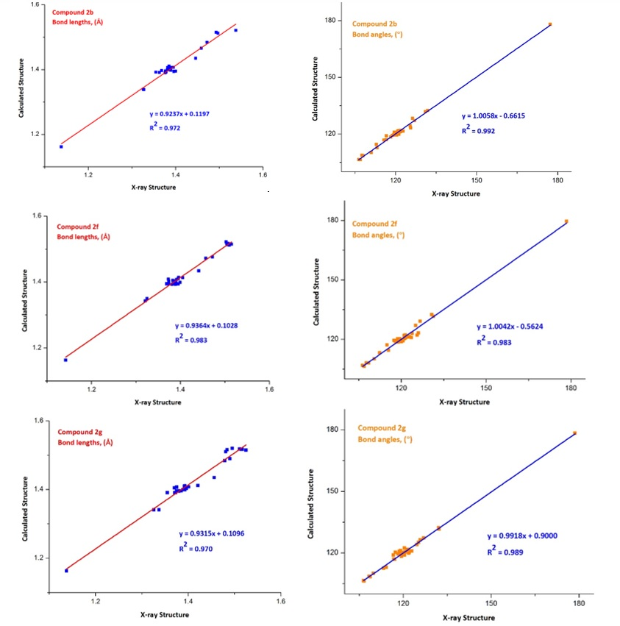

Fig. S1. The correlations between the theoretical and experimental bonding parameters for the compounds 2b, 2f and 2g.

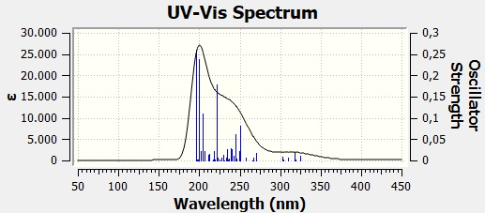

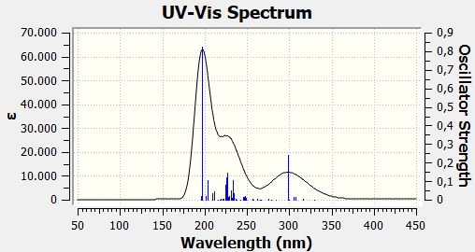

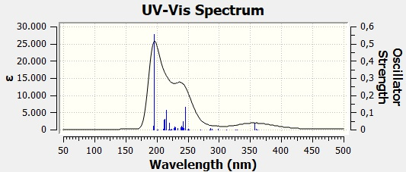

Fig. S2. Theoretical UV-Vis spectra of 2b, 2f and 2g, respectively.

Table S1. Mulliken population analysis (MPA) and Natural population analysis (NPA) from NBO calculation.
2b |  |  | 2f |  |  | 2g
Atom | Mulliken | NPA | Atom | Mulliken | NPA | Atom | Mulliken | NPA
Br1 | -0.6978 | -0.7907 | Br1 | -0.6471 | -0.7257 | Br1 | -0.6903 | -0.8109
N2 | -0.5255 | -0.3529 | N2 | -0.5217 | -0.3675 | N2 | -0.5232 | -0.3477
N3 | -0.5241 | -0.3614 | N3 | -0.5071 | -0.3605 | N3 | -0.5298 | -0.3555
N4 | -0.4746 | -0.2977 | N43 | -0.4778 | -0.3053 | N23 | -0.4764 | -0.3005
C5 | 0.2990 | 0.3222 | C4 | 0.3224 | 0.3063 | C4 | 0.3189 | 0.1400
C7 | 0.3061 | 0.1381 | C6 | 0.3265 | 0.1441 | C5 | 0.1469 | -0.0684
C8 | -0.1545 | -0.2414 | C7 | 0.0156 | -0.0688 | C6 | 0.3201 | 0.1451
C10 | -0.1427 | -0.2238 | C8 | 0.0810 | -0.0006 | C7 | 0.1184 | -0.1641
C12 | -0.1407 | -0.2243 | C9 | 0.3166 | 0.1485 | C8 | 0.0882 | 0.0065
C14 | -0.1485 | -0.2370 | C10 | 0.1110 | -0.0765 | C9 | 0.3224 | 0.3251
C16 | 0.3219 | 0.1413 | C11 | -0.2068 | -0.1885 | C11 | 0.1026 | 0.0052
C17 | -0.2802 | -0.2756 | C13 | 0.1434 | -0.0238 | C12 | 0.0969 | -0.0138
C20 | 0.1393 | -0.0704 | C14 | -0.2543 | -0.2627 | C13 | -0.1642 | -0.2071
C21 | -0.1757 | -0.2166 | C17 | -0.1451 | -0.2301 | C15 | -0.1881 | -0.1656
C23 | -0.1352 | -0.2302 | C19 | 0.1324 | -0.1723 | C17 | -0.1568 | -0.2420
C25 | -0.1298 | -0.1815 | C20 | -0.1477 | -0.1851 | C19 | 0.0001 | -0.1007
C27 | 0.1188 | -0.1623 | C22 | 0.1451 | -0.0282 | C20 | -0.2984 | -0.2783
C28 | -0.1786 | -0.1614 | C23 | -0.1564 | -0.2437 | C24 | -0.1352 | -0.2307
C30 | 0.2514 | 0.2828 | C25 | -0.1673 | -0.2537 | C26 | 0.0672 | -0.0207
C31 | -0.2382 | -0.2639 | C27 | -0.2474 | -0.2088 | C27 | -0.1408 | -0.2252
C34 | 0.0904 | -0.0656 | C29 | -0.2299 | -0.2607 | C29 | -0.1308 | -0.1820
C35 | -0.1711 | -0.2258 | C32 | -0.5746 | -0.7167 | C31 | -0.1636 | -0.2447
C37 | -0.1314 | -0.2271 | C36 | -0.1420 | -0.2283 | C33 | 0.0916 | 0.0040
C39 | -0.1198 | -0.2225 | C38 | 0.0753 | -0.0180 | C34 | -0.2583 | -0.2544
C41 | -0.1844 | -0.2200 | C39 | -0.5332 | -0.6924 | C37 | 0.2503 | 0.2837
C43 | 0.1330 | -0.0229 | C44 | 0.2371 | 0.2797 | C38 | -0.5478 | -0.7046
C44 | -0.5450 | -0.6982 | C45 | -0.1335 | -0.1802 | C42 | -0.5494 | -0.6988
H6 | 0.2673 | 0.2782 | C47 | -0.1419 | -0.2214 | C46 | -0.1416 | -0.2247
H9 | 0.1651 | 0.2575 | C49 | -0.5433 | -0.6924 | C48 | -0.5577 | -0.7067
H11 | 0.1525 | 0.2503 | C53 | -0.5396 | -0.6900 | C52 | -0.5516 | -0.6991
H13 | 0.1517 | 0.2500 | H5 | 0.2463 | 0.2914 | C56 | -0.5477 | -0.6986
H15 | 0.1588 | 0.2536 | H12 | 0.1531 | 0.2485 | H10 | 0.2812 | 0.2943
H18 | 0.2467 | 0.3014 | H15 | 0.2242 | 0.2799 | H14 | 0.1282 | 0.2306
H19 | 0.1710 | 0.2456 | H16 | 0.1727 | 0.2456 | H16 | 0.2215 | 0.2861
H22 | 0.1328 | 0.2330 | H18 | 0.1462 | 0.2474 | H18 | 0.1597 | 0.2500
H24 | 0.1450 | 0.2456 | H21 | 0.2137 | 0.2787 | H21 | 0.1693 | 0.2452
H26 | 0.1606 | 0.2538 | H24 | 0.1624 | 0.2561 | H22 | 0.2538 | 0.3026
H29 | 0.2216 | 0.2851 | H26 | 0.1525 | 0.2476 | H25 | 0.1445 | 0.2451
H32 | 0.2272 | 0.2831 | H28 | 0.1165 | 0.2284 | H28 | 0.1519 | 0.2500
H33 | 0.1847 | 0.2565 | H30 | 0.2159 | 0.2814 | H30 | 0.1596 | 0.2532
H36 | 0.1340 | 0.2373 | H31 | 0.1737 | 0.2453 | H32 | 0.1610 | 0.2532
H38 | 0.1396 | 0.2419 | H33 | 0.2239 | 0.2764 | H35 | 0.1789 | 0.2511
H40 | 0.1394 | 0.2418 | H34 | 0.1506 | 0.2367 | H36 | 0.1924 | 0.2563
H42 | 0.1335 | 0.2378 | H35 | 0.1553 | 0.2414 | H39 | 0.1439 | 0.2336
H45 | 0.1615 | 0.2389 | H37 | 0.1444 | 0.2464 | H40 | 0.1457 | 0.2345
H46 | 0.1689 | 0.2487 | H40 | 0.1620 | 0.2427 | H41 | 0.2197 | 0.2792
H47 | 0.1761 | 0.2488 | H41 | 0.1630 | 0.2446 | H43 | 0.1580 | 0.2405
 |  |  | H42 | 0.1470 | 0.2311 | H44 | 0.1573 | 0.2396
 |  |  | H46 | 0.1619 | 0.2541 | H45 | 0.1848 | 0.2558
 |  |  | H48 | 0.1584 | 0.2521 | H47 | 0.1518 | 0.2501
 |  |  | H50 | 0.1641 | 0.2429 | H49 | 0.2238 | 0.2813
 |  |  | H51 | 0.1533 | 0.2378 | H50 | 0.1229 | 0.2151
 |  |  | H52 | 0.1713 | 0.2467 | H51 | 0.1565 | 0.2406
 |  |  | H54 | 0.1585 | 0.2410 | H53 | 0.1453 | 0.2294
 |  |  | H55 | 0.1620 | 0.2395 | H54 | 0.1733 | 0.2507
 |  |  | H56 | 0.1573 | 0.2393 | H55 | 0.1587 | 0.2397
 |  |  |  |  |  | H57 | 0.1523 | 0.2373
 |  |  |  |  |  | H58 | 0.1690 | 0.2460
 |  |  |  |  |  | H59 | 0.1631 | 0.2442

Table S2. The observed and calculated vibrational frequencies in cm⁻¹ of the meta-cyanobenzyl substituted NHC salts.
 | Freq. (cm⁻¹)  Exp. | Unscaled Freq. (cm⁻¹)  Calc. | IR_{intensity}  (km/mol) | PED (%) | Assignments
2b
 | 3180 | 3222 | 5 | C8H(36) | str. CH_{(aromatic)}
 |  | 3166 | 27 | C21H(32) | str. CH_{(aromatic)}
 |  | 3204 | 8 | C35H(46) | str. CH_{(aromatic)}
 |  | 3112 | 11 | C17H₂(41), C31H₂(49) | assym. str. CH₂
 |  | 3084 | 19 | C44H₃(48) | assym. str. CH₃
 | 3021 | 3037 | 21 | C44H₃(94) | sym. str. CH₃
 | 2980 | 3026 | 61 | C17H₂(50), C31H(40) | sym. str. CH₂
 | 2960 | 2772 | 1083 | C5H(95) | str. CH_{(carbene)}
 | 2227 | 2352 | 18 | N4-C30(89) | str. NC_{(benzonitrile)}
 | 1650 | 1672 | 11 | C7-C8(16) | str. CC
 |  | 1668 | 8 | C12-C14(15) | str. CC
 |  | 1666 | 3 | C34-C35(32) | str. CC
 |  | 1650 | 4 | C20-C28(27) | str. CC
 | 1563 | 1553 | 99 | N2-C5(41) | str. NC_{(benzimidazole)}
 | 1525 | 1525 | 13 | C44H₃(21) | bend CH₃
 | 1483 | 1505 | 13 | C17H₂(61), C31H₂(49) | bend (scissoring) CH₂
 | 1447 | 1450 | 6 | C44H₃(82) | bend (umbrella) CH₃
 | 1422 | 1417 | 27 | C17H₂(10), C31H₂(13) | bend (wagging) CH₂
2f
 | 3155 | 3218 | 9 | C25H(49) | str. CH_{(aromatic)}
 |  | 3169 | 35 | C20H(53) | str. CH_{(aromatic)}
 |  | 3169 | 31 | C27H(98) | str. CH_{(aromatic)}
 |  | 3117 | 22 | C32H₃(25), C49H₃(36), C53H₃(56), C39H₃(31) | assym. str. CH₃
 | 3082 | 3039 | 34 | C32H₃(27), C49H₃(56), C53H₃(83), C39H₃(32) | sym. str. CH₃
 |  | 3131 | 2 | C29H₂(49), C14H₂(45) | assym. str. CH₂
 | 3072 | 3075 | 20 | C29H₂(49), C14H₂(45) | sym. str. CH₂
 | 2960 | 3256 | 6 | C4H(25) | str. CH_{(carbene)}
 | 2228 | 2348 | 38 | N43-C44(89) | str. NC_{(benzonitrile)}
 | 1602 | 1668 | 24 | C10-C11(37) | str. CC
 |  | 1657 | 9 | C36-C25(13) | str. CC
 |  | 1652 | 5 | C8-C13(29), | str. CC
 |  | 1631 | 5 | C19-C45(28) | str. CC
 | 1563 | 1577 | 117 | N2-C4(40) | str. NC_{(benzimidazole)}
 |  | 1557 | 7 | C14H₂(28) | bend CH₂
 | 1510 | 1525 | 14 | C32H₃(17), C49H₃(21), C53H₃(17) | bend CH₃
 | 1452 | 1451 | 1 | C32H₃(16), C49H₃(38), C53H₃(40) | bend (umbrella) CH₃
2g
 | 3190 | 3204 | 9 | C13H(28) | str. CH_{(aromatic)}
 |  | 3147 | 61 | C15H(50) | str. CH_{(aromatic)}
 |  | 3128 | 19 | C38H₃(24), C42H₃(27), C48H₃(41), C52H₃(24), C56H₃(27) | assym. str. CH₃
 |  | 3144 | 45 | C20H₂(17), C34H₂(12) | assym. str. CH₂
 |  | 3039 | 31 | C38H₃(17), C42H₃(39), C48H₃(26), C52H₃(18), C56H₃(17) | sym. str. CH₃
 |  | 3022 | 271 | C20H₂(14), C34H₂(24) | sym. str. CH₂
 | 2956 | 3025 | 465 | C9H(15) | str. CH_{(carbene)}
 | 2229 | 2351 | 18 | N23-C37(89) | str. NC_{(benzonitrile)}
 | 1665 | 1665 | 7 | C17-C6 (45) | str. CC
 |  | 1651 | 5 | C7-C15 (30) | str. CC
 |  | 1621 | 4 | C8-C11 (32) | str. CC
 | 1560 | 1591 | 50 | N2-C9 (26) | str. NC_{(benzimidazole)}
 |  | 1547 | 9 | C38H₃(16), C42H₃(15), C48H₃(13), C52H₃(16), C56H₃(15) | bend CH₃
 | 1533 | 1530 | 15 | C17H₂ (18), C31H₂ (15) | bend (scissoring) CH₂
 | 1430 | 1444 | 3 | C38H₃(17), C42H₃(15), C48H₃(17), C52H₃(24), C56H₃(17) | bend (umbrella) CH₃

Table S3. Theoretical and experimental ¹³C chemical shifts (with respect to TMS in ppm) for the compounds.
2b |  |  | 2f |  |  | 2g
Atom | Exp | Calc | Atom | Exp | Calc | Atom | Exp | Calc
C5 | 143.55 | 139.27 | C4 | 142.2 | 127.10 | C4 | 134.4 | 124.52
C7 | 130.68 | 125.92 | C6 | 134.4 | 123.77 | C5 | 133.5 | 131.18
C8 | 114.38 | 108.72 | C7 | 136.4 | 126.04 | C6 | 134.4 | 125.51
C10 | 127.36 | 119.56 | C8 | 132.3 | 133.75 | C7 | 112.2 | 110.53
C12 | 127.36 | 119.73 | C9 | 134.7  3 | 125.72 | C8 | 133.4 | 135.55
C14 | 114.56 | 108.02 | C10 | 132.9 | 128.26 | C9 | 142.1 | 137.80
C16 | 130.68 | 124.38 | C11 | 132.8 | 126.93 | C11 | 130.6 | 133.63
C17 | 50.57 | 49.16 | C13 | 135.0 | 129.73 | C12 | 131.6 | 125.72
C20 | 132.98 | 129.00 | C14 | 46.5 | 47.04 | C13 | 132.8 | 125.72
C21 | 132.92 | 125.33 | C17 | 114.4 | 118.02 | C15 | 133.2 | 131.90
C23 | 129.34 | 120.43 | C19 | 112.2 | 107.62 | C17 | 114.6 | 106.77
C25 | 128.34 | 127.50 | C20 | 133.3 | 131.71 | C19 | 136.4 | 115.99
C27 | 112.37 | 111.10 | C22 | 135.0 | 128.05 | C20 | 49.4 | 46.50
C28 | 132.48 | 132.30 | C23 | 112.2 | 108.73 | C24 | 132.0 | 120.48
C30 | 118.89 | 106.81 | C25 | 112.2 | 104.80 | C26 | 133.4 | 128.38
C31 | 49.57 | 48.70 | C27 | 130.6 | 127.76 | C27 | 127.3 | 119.72
C34 | 136.03 | 125.23 | C29 | 49.6 | 52.28 | C29 | 132.3 | 127.03
C35 | 129.38 | 117.79 | C32 | 15.9 | 17.63 | C31 | 114.6 | 106.80
C37 | 127.33 | 120.47 | C36 | 114.6 | 117.93 | C33 | 133.2 | 134.63
C39 | 129.38 | 121.89 | C38 | 132.0 | 128.46 | C34 | 47.0 | 47.81
C41 | 129.89 | 124.99 | C39 | 15.9 | 17.84 | C37 | 118.9 | 106.91
C43 | 133.78 | 128.57 | C44 | 118.9 | 107.41 | C38 | 17.2 | 18.77
C44 | 21.42 | 20.77 | C45 | 133.4 | 127.37 | C42 | 17.5 | 18.74
 |  |  | C47 | 127.3 | 123.87 | C46 | 127.3 | 119.94
 |  |  | C49 | 20.7 | 22.76 | C48 | 16.9 | 19.12
 |  |  | C53 | 20.7 | 22.10 | C52 | 16.9 | 17.91
 |  |  |  |  |  | C56 | 17.2 | 18.85

Table S4. Theoretical and experimental ¹H chemical shifts (with respect to TMS in ppm) for the compounds.
2b |  |  | 2f |  |  | 2g
Atom | Exp | Calc | Atom | Exp | Calc | Atom | Exp | Calc
H6 | 10.13 | 16.14 | H5 | 9.42 | 9.81 | H10 | 9.34 | 12.79
H9 | 7.99 | 6.92 | H12 | 7.92 | 7.36 | H14 | 7.85 | 7.28
H11 | 7.66 | 7.20 | H15,16 | 5.77 | 5.54, 4.93 | H16 | 7.95 | 9.94
H13 | 7.67 | 7.28 | H18 | 7.70 | 6.98 | H18 | 7.60 | 7.68
H15 | 7.99 | 7.51 | H21 | 7.83 | 9.60 | H21,22 | 5.78 | 4.39, 8.67
H18,19 | 5.77 | 8.72, 4.37 | H24 | 7.61 | 6.49 | H25 | 7.76 | 7.04
H22 | 7.36 | 7.41 | H26 | 7.63 | 7.29 | H28 | 7.68 | 7.51
H24 | 7.22 | 7.22 | H28 | 9.42 | 6.99 | H30 | 8.24 | 7.29
H26 | 8.09 | 7.40 | H30,31 | 5.82 | 5.99, 4.35 | H32 | 7.62 | 7.53
H29 | 8.07 | 10.07 | H33,34, 35 | 2.21 | 4.44, 1.95, 2.08 | H35,36 | 5.75 | 5.05, 5.01
H32,33 | 5.89 | 5.56, 5.08 | H37 | 7.68 | 7.19 | H39,40,41 | 2.28 | 1.95, 2.21, 3.54
H36 | 7.39 | 6.30 | H40,41,42 | 2.21 | 1.30, 1.95, 1.78 | H43,44,45 | 2.28 | 2.15, 2.27, 2.51
H38 | 7.34 | 7.02 | H46 | 8.23 | 7.48 | H47 | 7.70 | 7.53
H40 | 7.20 | 7.20 | H48 | 7.75 | 7.33 | H49,50,51 | 2.25 | 4.11, 1.60, 2.06
H42 | 7.39 | 7.23 | H50,51,52 | 2.28 | 2.42, 1.81, 2.54 | H53,54,55 | 2.25 | 1.39, 2.05, 2.05
H45,46,47 | 2.31 | 2.42, 2.19, 2.39 | H54,55,56 | 2.28 | 1.86, 2.24, 2.02 | H57,58,59 | 2.28 | 1.92, 2.24, 2.19

Fig. S3. ¹³C NMR spectrum of the compound 2b.

Fig. S4. ¹H NMR spectrum of the compound 2b.

Fig. S5. ¹³C NMR spectrum of the compound 2f.

Fig. S6. ¹H NMR spectrum of the compound 2f.

Fig. S7. ¹³C NMR spectrum of the compound 2g.

Fig. S8. ¹H NMR spectrum of the compound 2g.

