Electronic Supplementary Information
Structural diversity in oxadiazole-containing silver complexes
dependent on the anions
Long Zhao,^{†1} Long-Yan Xie,^{†1} Xiu-Li Du,^{†1} Kai Zheng,¹ Ting Xie,¹ Rui-Rui Huang,¹ Jie Qin,^{*1} Jian-Ping Ma,^{*2} Li-Hong Ding³
¹School of Life Sciences, Shandong University of Technology, Zibo 255049, P. R. China
²College of Chemistry, Chemical Engineering and Materials Science, Shandong Normal, University, Jinan 250014, P. R. China
³Lanzhou University of Arts and Sciences, Lanzhou, 730000, P. R. China
*Corresponding author: Jie Qin, E-mail: qinjietutu@163.com
Jian-Ping Ma E-mail: xxgk123@163.com
Tel.: 0086-533-2780271; Fax: 0086-533-2781329.
† These authors contributed equally to this work.
Measurement of antibacterial activity
The antibacterial activities of compounds were evaluated against two Gram-negative bacterial strains, Escherichia coli ATCC 35218 and Pseudomonas aeruginosa ATCC 27853, and two Gram-positive bacterial strains, Bacillus subtilis ATCC 6633 and Staphylococcus aureus ATCC 6538. The antibacterial activity was measured as IC₅₀ (half minimum inhibitory concentrations), determined by a colorimetric method using the dye MTT (3-(4,5-dimethylth-iazol-2-yl)-2,5-diphenyl tetrazoliumbromide). A stock solution of the synthesized compounds (50 μg/mL) in DMSO were prepared and graded quantities of the test compounds were incorporated in specified quantity of sterilized liquid MH medium (soluble starch 1.5 g, casein hydrolysate 17.5 g, beef extract 1000 mL). A specified quantity of the medium containing the test compound was poured into microtitration plates. Suspension of the microorganism was prepared to contain approximately 10⁵ cfu/mL and applied to microtitration plates with serially diluted compounds in DMSO to be tested and incubated at 37°C for 24 h. After the MICs were visually determined on each of the microtitration plates, 50 μL of PBS (phosphate buffered saline 0.01 mol/L, pH 7.4, Na₂HPO₄•12H₂O 2.9 g, KH₂PO₄ 0.2 g, NaCl 8.0 g, KCl 0.2 g, and distilled water 1000 mL) containing 2 mg of MTT/mL was added to each well. Incubation was continued at room temperature for 4-5 h. The content of each well was removed, and 100 μL of isopropanol containing 5% 1 mol/L HCl was added to extract the dye. After 12 h of incubation at room temperature, the optical density was measured at 550 nm. Streptomycin was used as a positive control.

Table S1. Selected bond distances (Å) and angles (°) for L.
C1-S1 | 1.800(3) | C2-N2 | 1.292(3)
C2-O1 | 1.364(3) | C2-S1 | 1.726(2)
C3-N1 | 1.287(3) | C3-O1 | 1.374(3)
C3-C4 | 1.454(3) | C4-C5 | 1.384(3)
C4-C9 | 1.392(3) | C5-C6 | 1.403(3)
C6-C7 | 1.391(3) | C6-C13 | 1.462(3)
C7-C8 | 1.395(3) | C8-C9 | 1.388(3)
C8-C10 | 1.467(3) | C10-N6 | 1.279(3)
C10-O3 | 1.368(3) | C11-N5 | 1.294(3)
C11-O3 | 1.360(3) | C11-S3 | 1.730(2)
C12-S3 | 1.799(3) | C13-N3 | 1.281(3)
C13-O2 | 1.369(3) | C14-N4 | 1.293(3)
C14-O2 | 1.355(3) | C14-S2 | 1.728(2)
C15-S2 | 1.795(3) | N1)-N2 | 1.414(3)
N3)-N4 | 1.423(3) | N5)-N6 | 1.418(3)
C2-S1-C1 | 98.47(12) | O1-C3-C4 | 118.1(2)
N1-C3-C4 | 129.7(2) | O3-C10-C8 | 118.0(2)
N6-C10-C8 | 129.1(2) | C11-S3-C12 | 99.07(12)
N3-C13-C6 | 131.4(2) | O2-C13-C6 | 115.8(2)
C14-S2-C15 | 99.41(12)
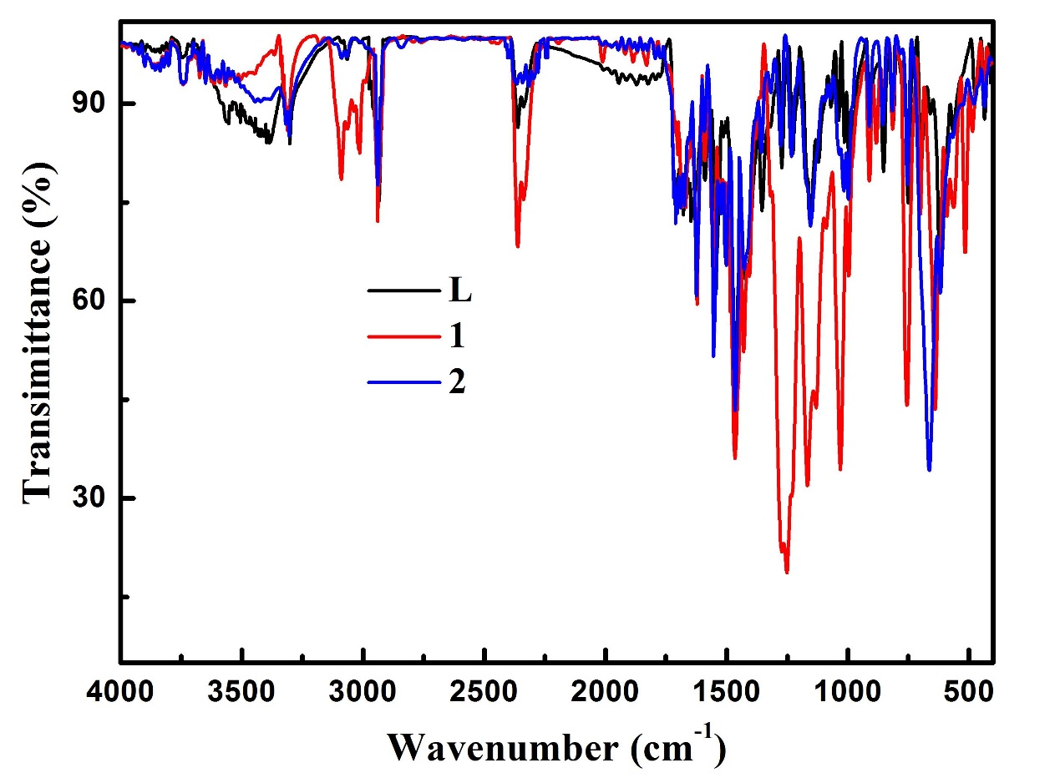
Figure S1. IR spectra of L, 1, and 2.

Figure S2. 12-membered {Ag₄N₈} saddle-like ring.
Figure S3. Butterfly-like penta-nuclear block in 2. Ag2···Ag3 interactions are shown as dotted lines.

