Statement of novelty
- A series of novel 1-deoxynojirimycin derivatives connected to a terminal tertiary amine through introducing alkyl chains of various length were synthesized. Preliminary glucosidase inhibition and anticancer activities in vitro were evaluated.
- Compound 7d showed improved and selective inhibitory activity against β-glucosidase compared to DNJ. Compounds 8b and 8c were moderate and selective α-glucosidase inhibitors.
- Analysis of the kinetics of enzyme inhibition indicated that 7d inhibited β-glucosidase in a competitive manner.
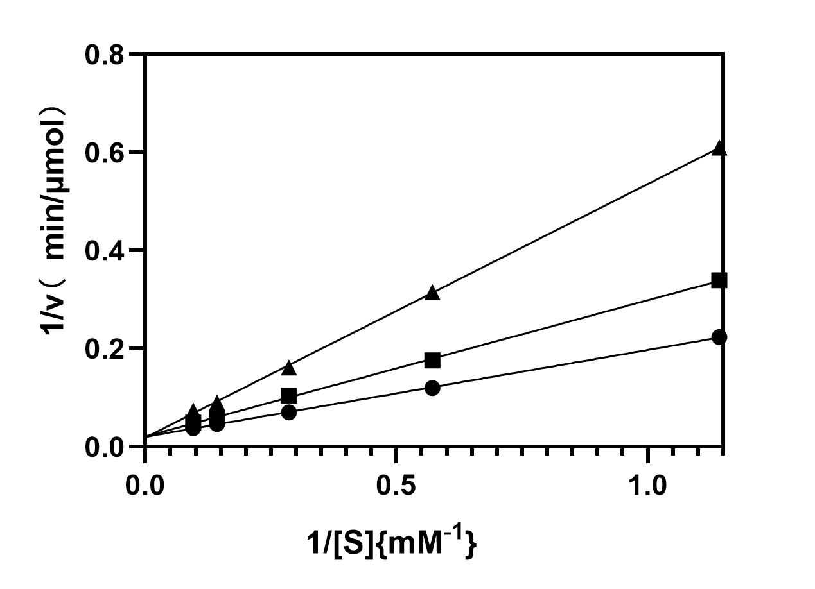
- Our result provides useful clues that a lengthening of the alkyl chain linking DNJ provides better selectivity towards α-glucosidase. The size of the hydrophobic group at the alkyl chain, especially its nature differs greatly for the selective inhibition aganist α- and β-glucosidases.

