Supplementary data

Synthesis, characterization and biological activity of some dithiourea derivatives

Felix Odame, Eric. C. Hosten, Jason Krause, Michelle Isaacs, Heinrich C. Hoppe, David Khanye, Yasien Sayed, Carminita Frost, Kevin Lobb, and Zenixole R. Tshentu

Cytotoxicity assay – single concentration screen
To assess the overt cytotoxicity of the compounds, they were incubated at a fixed concentration of 20 µM in 96-well plates containing HeLa (human cervix adenocarcinoma) cells for 48 h. Incubations were carried out at 37 °C in a 5% CO₂ incubator in culture medium consisting of DMEM suppplemented with 10% fetal calf serum. The numbers of cells surviving drug treatment were determined by adding 20 µl 0.54 mM resazurin in phosphate-buffered saline to each well, incubating at 37 °C for an additional 2 h and reading resorufin fluorescence at excitation/emission wavelengths of 560 nm/590 nm in a Spectramax M3 microplate reader. The results were expressed as % viability – the resorufin fluorescence in compound-treated wells relative to untreated controls. The compounds were tested in duplicate and standard deviations (SD) derived. Emetine (which induces cell apoptosis) was used as a control drug standard.

pLDH (Malaria) assay – single concentration screen
Malaria parasites (Plasmodium falciparum strain 3D7) were maintained in RPMI 1640 medium containing 2 mM L-glutamine and 25 mM Hepes (Lonza). The medium was further supplemented with 5% Albumax II, 20 mM glucose, 0.65 mM hypoxanthine, 60 µg/mL gentamycin and 2-4% hematocrit human red blood cells. The parasites were cultured at 37 oC under an atmosphere of 5% CO₂, 5% O₂, 90% N₂ in a sealed T75 culture flask. Single concentration screening was conducted by adding 20 µM of the compounds to parasite cultures in a 96-well, clear plates and incubating for 48 h in a 37°C CO₂ incubator. After 48 h, 20 µL of culture was removed from each well and combined with 125 µL of a mixture of Malstat and NBT/PES solutions (44 mM Tris, pH 9, containing 0.18 M L-lactic acid, 0.13 mM acetylpyridine adenine dinucleotide, 0.39 mM nitrotetrazolium blue chloride, 0.048 mM phenazineethosulphate and 0.16% (v/v) Triton X-100) in a fresh 96-well plate to determine parasite lactate dehydrogenase (pLDH) enzyme activity in the wells. After a 30 minute incubation at ambient temperature, formazan formation was quantified in a Spectramax M3 microplate reader by reading absorbance at 620 nm. For each compound concentration, % parasite viability – the pLDH activity in compound-treated wells relative to untreated controls – was calculated. Compounds were tested in duplicate and standard deviations (SD) derived. For comparative purposes, Chloroquine (a standard anti-malarial drug) was used as a standard (IC₅₀ values range from 0.01-0.05 µM.)
Trypanosoma brucei assay – single concentration screen
To assess trypanocidal activity, compounds were added to cultures of Trypanosoma brucei (strain 427) in 96-well plates at a fixed concentration of 20 µM. The cultures contained 2.4x105 trypanosome parasites in IMDM medium containing 10% fetal calf serum, 1 mM hypoxanthine and HMI-9 supplement. After a 24-h incubation at 37°C in a 5% CO₂ incubator, parasites surviving drug treatment were enumerated by adding 20 µL/well 0.54 mM resazurin in phosphate-buffered saline and incubation continued for a further 24 h. The reduction of resazurin to resorufin by viable cells was quantified in a Spectramax M3 microplate reader by measuring resorufin fluorescence (Exc560/Em590). The results were expressed as % parasite viability – the resorufin fluorescence in compound-treated wells relative to untreated controls. The compounds were tested in duplicate and standard deviations (SD) derived. The compounds that reduced parasite viability to <20% were further tested using a dose-response assay. Three-fold serial dilutions of test compounds were incubated with parasites and % parasite viability determined using resazurin as described above. Plots of log[compound] vs. % parasite viability were used to calculate IC₅₀ values by non-linear regression analysis. Pentamidine (an existing drug treatment for trypanosomiasis) was used as a control drug standard.

HIV-1 protease assay
The kinetic profile of HIV-1 Protease was characterized at various inhibitor concentrations (100 nM to 0.0500 nM) by measuring the cleavage of the synthetic substrate (Abz-Thr-Ile-pNO₂Phe-Gln-Arg-NH₂) concentrations at an excitation/emission wavelength of 340 nm/490 nm using a BioTek SynergyMx fluorimeter. Positive controls used in the assay were pepstatin (14 nM to 0.080 mM) and ritonavir (100 nM to 0.05 nM). The fluorescence was measured using a BioTek SynergyMx microtitre plate reader. Excitation/Emission: 340 nm/490 nm. The assay is based on the ability of protease to cleave (Abz-Thr-Ile-pNO₂Phe-Gln-Arg-NH₂) It cleaves the pNO₂Phe bond which causes Abz to fluoresce the rate of fluorescence was determined. Buffer 1 (72.73 mM NaAc, pH 5.0) (55 µL) was added to the inhibitor (20 µL, 100 µM), 20 μL of protease (20 nM) was added to the well and incubated at 25 °C for an hour. 120 µL of the substrate (Abz-Thr-Ile-pNO₂Phe-Gln-Arg-NH₂) was dissolved in buffer 2 (60 mM NaAc, 2 M NaCl, 2.4% DMSO, pH 5.0) was added per well (50 µM). The substrate was prepared by dissolving the fluorogenic substrate (10 mg) in 50% acetonitrile (20 mL) and further diluting the the stock to 83.3 µM with buffer 2 (1.44 mL substrate + 7.2 mL buffer 2) to give a final concentration of 50 µM. The stock was covered with aluminium foil and stored at −80 °C. The mixture was incubated for 30 seconds. The reaction rate was measured using relative fluroscence at Ex 337 nm/Em 425 nm using a BioTek SynergyMx microtitre plate reader, every second for 1 minute (Excitation bandwidth = 2.5 nm; Emission bandwidth = 5 nm).

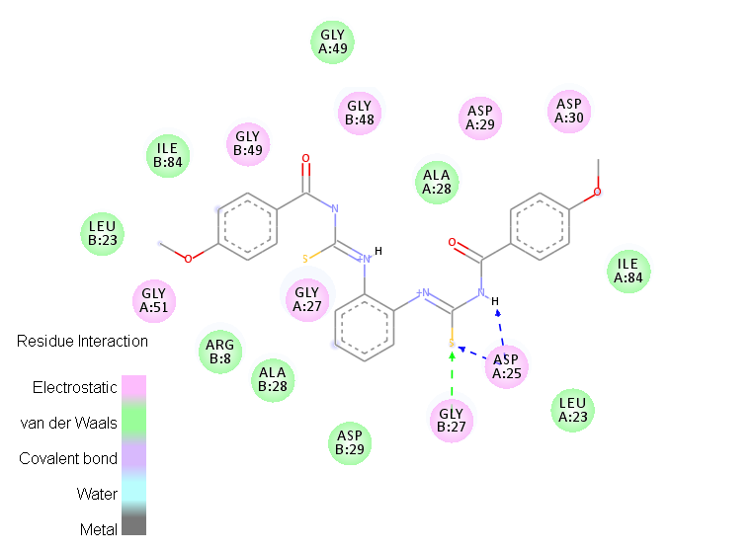
Figure S1 2D representation of 1-(4-methoxybenzoyl)-3-[2-({[(4-methoxylphenyl)
formamido]methanethioyl}amino)phenyl]thiourea (8) in the HIV-1 protease binding site.
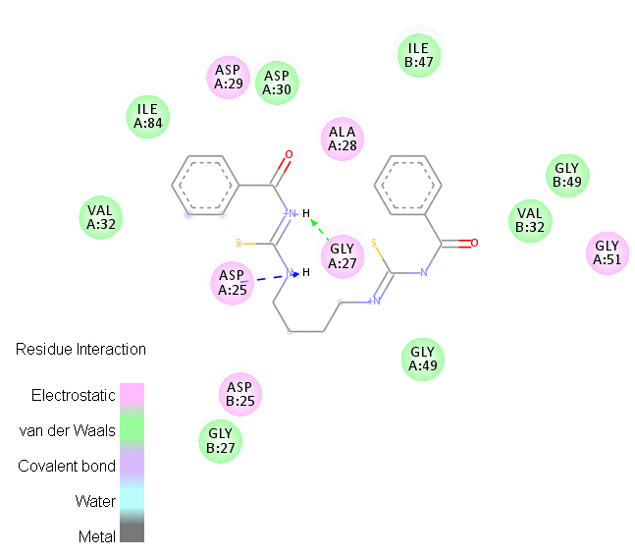
Figure S2 2D representation of 3-benzoyl-1-(4-{[(phenylformamido)methanethioyl]
amino}butyl)thiourea (14) in the HIV-1 protease binding site.
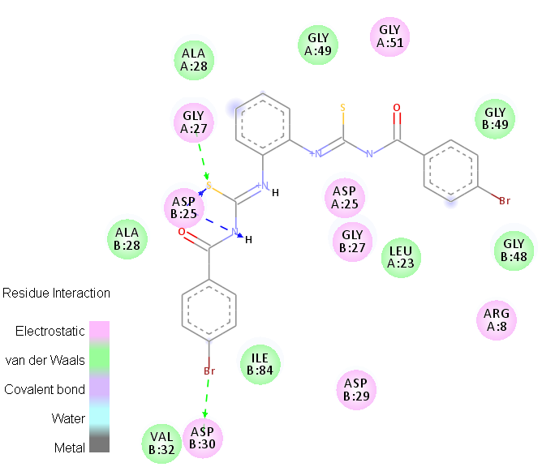
Figure S3 2D representation of 1-(4-bromobenzoyl)-3-[2-({[(4-bromophenyl)formamido]
methanethioyl}amino)phenyl]thiourea (7) in the HIV-1 protease binding site.

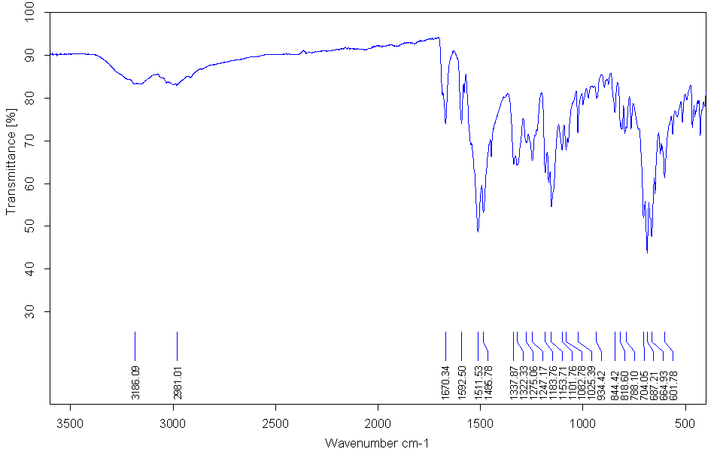
Figure S4 IR spectrum of 1-benzoyl-3-(5-methyl-2-{[(phenylformamido)methanethioyl] amino}phenyl)thiourea (1).

Figure S5 ¹H NMR spectrum of 1-benzoyl-3-(5-methyl-2-{[(phenylformamido) methanethioyl] amino}phenyl)thiourea (1).

Figure S6 ¹³C NMR spectrum of 1-benzoyl-3-(5-methyl-2-{[(phenylformamido) methanethioyl] amino} phenyl)thiourea (1).

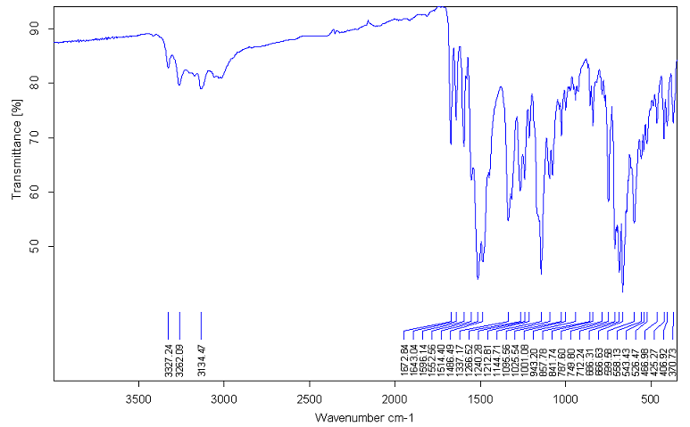
Figure S7 IR spectrum of 1-benzoyl-3-(2-{[(phenylformamido)methanethioyl]amino} phenyl)thiourea (2).

Figure S8 ¹H NMR spectrum of 1-benzoyl-3-(2-{[(phenylformamido)methanethioyl] amino}phenyl)thiourea (2).

Figure S9 ¹³C NMR spectrum of 1-benzoyl-3-(2-{[(phenylformamido)methanethioyl] amino}phenyl)thiourea (2).

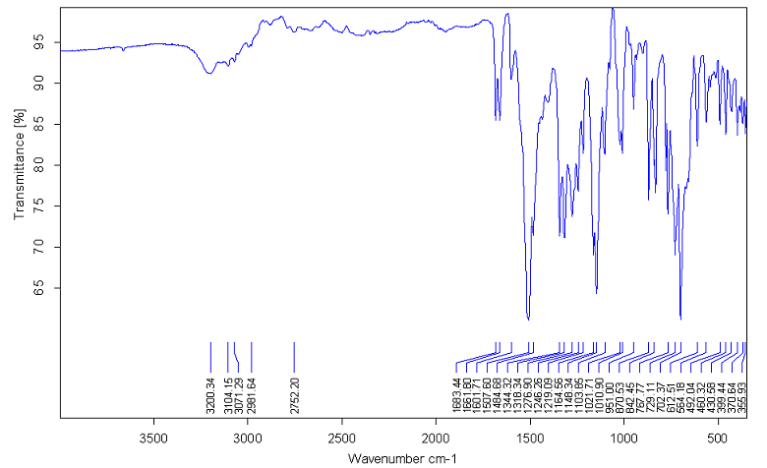
Figure S10 IR spectrum of 1-(4-nitrobenzoyl)-3-[2-({[(4-nitrophenyl)formamido] methanthioylphenyl]thiourea}amino) (3).

Figure S11 ¹H NMR spectrum of 1-(4-nitrobenzoyl)-3-[2-({[(4-nitrophenyl)formamido] methanthioylphenyl]thiourea}amino) (3).

Figure S12 ¹³C NMR spectrum of 1-(4-nitrobenzoyl)-3-[2-({[(4-nitrophenyl)formamido] methanthioyl phenyl]thiourea }amino) (3).

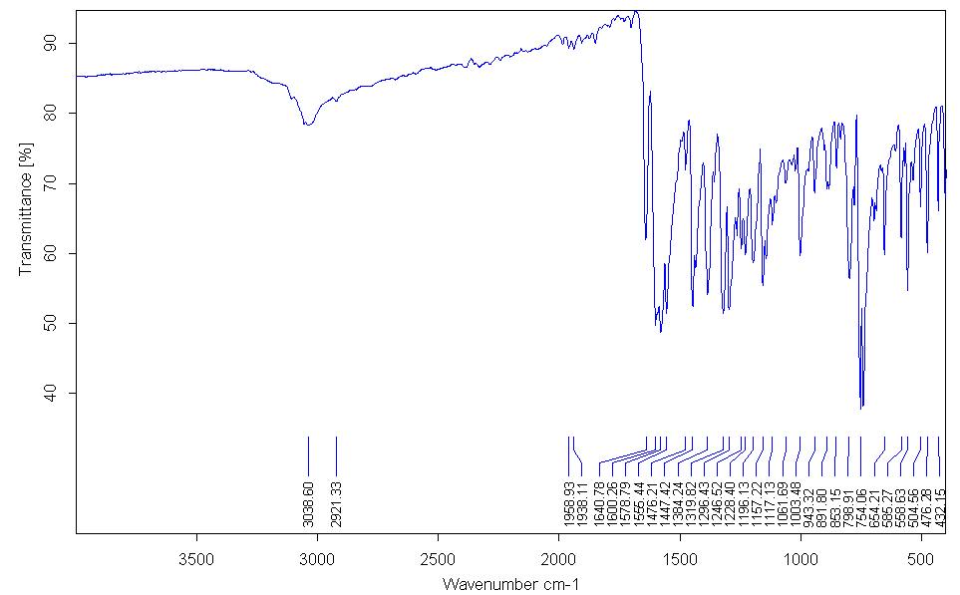
Figure S13 IR spectrum of 1-(4-chlorobenzoyl)-3-[2-({[(4-chlorophenyl)formamido] methanethioyl}amino)phenylthiourea (4).

Figure S14 ¹H NMR spectrum of 1-(4-chlorobenzoyl)-3-[2-({[(4-chlorophenyl) formamido]methanethioyl}amino)phenylthiourea (4).

Figure S15 ¹³C NMR spectrum of 1-(4-chlorobenzoyl)-3-[2-({[(4-chlorophenyl) formamido]methanethioyl}amino)phenylthiourea (4).

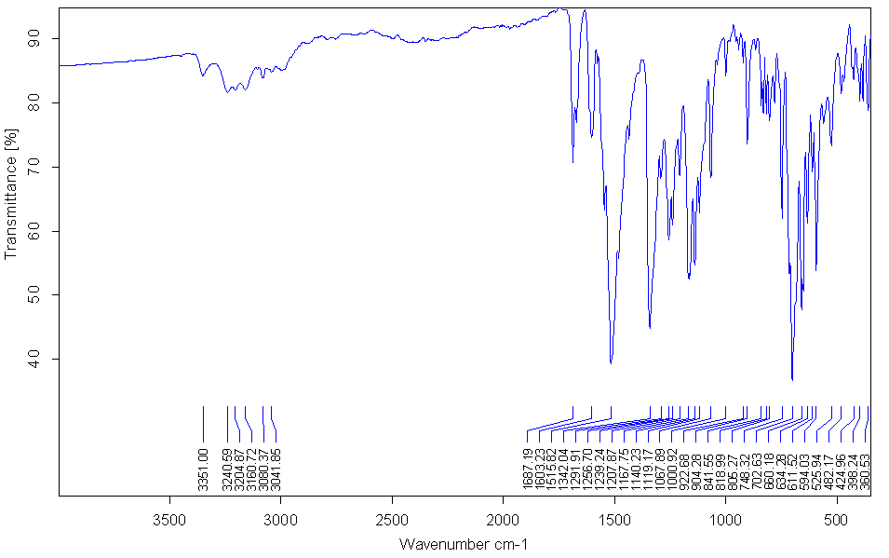
Figure S16 IR spectrum of 1-(3-nitrobenzoyl)-3-[2-({[(3-nitrophenyl)formamido] methane}amino)phenyl]thourea (5).

Figure S17 ¹H NMR spectrum of 1-(3-nitrobenzoyl)-3-[2-({[(3-nitrophenyl)formamido] methane}amino)phenyl]thourea (5).

Figure S18 ¹³C NMR spectrum of 1-(3-nitrobenzoyl)-3-[2-({[(3-nitrophenyl) formamido] methane}amino)phenyl]thourea (5).

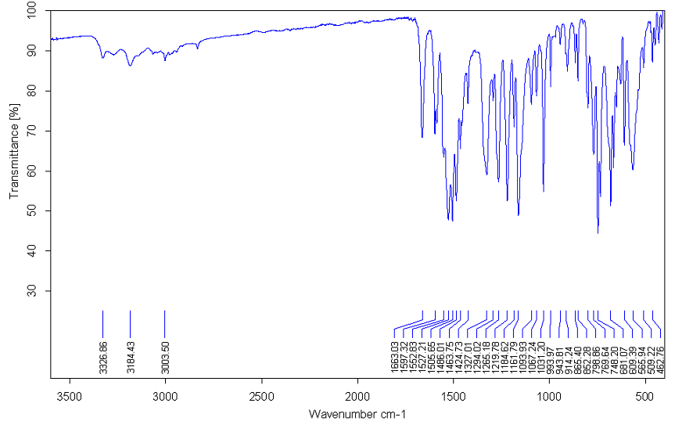
Figure S19 IR spectrum of 1-(3-methoxybenzoyl)-3-[2-({[(3-methoxyphenyl)formamido] methanethioyl}amino)phenyl]thiourea (6 ).

Figure S20 ¹H NMR spectrum of 1-(3-methoxybenzoyl)-3-[2-({[(3-methoxyphenyl) formamido]methanethioyl}amino)phenyl]thiourea (6).

Figure S21 ¹³C NMR spectrum of 1-(3-methoxybenzoyl)-3-[2-({[(3-methoxyphenyl) formamido] methanethioyl}amino)phenyl]thiourea (6).

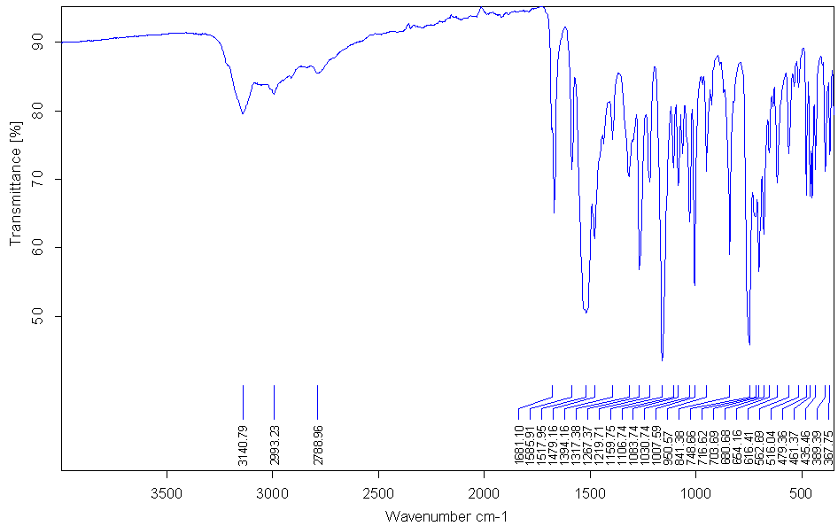
Figure S22 IR spectrum of 1-(4-bromobenzoyl)-3-[2-({[(4-bromophenyl)formamido] methanethioyl}amino)phenyl]thiourea (7).

Figure S23 ¹H NMR spectrum 1-(4-bromobenzoyl)-3-[2-({[(4-bromophenyl)formamido] methanethioyl}amino)phenyl]thiourea (7).

Figure S24 ¹³C NMR spectrum of 1-(4-bromobenzoyl)-3-[2-({[(4-bromophenyl) formamido] methanethioyl}amino)phenyl]thiourea (7).

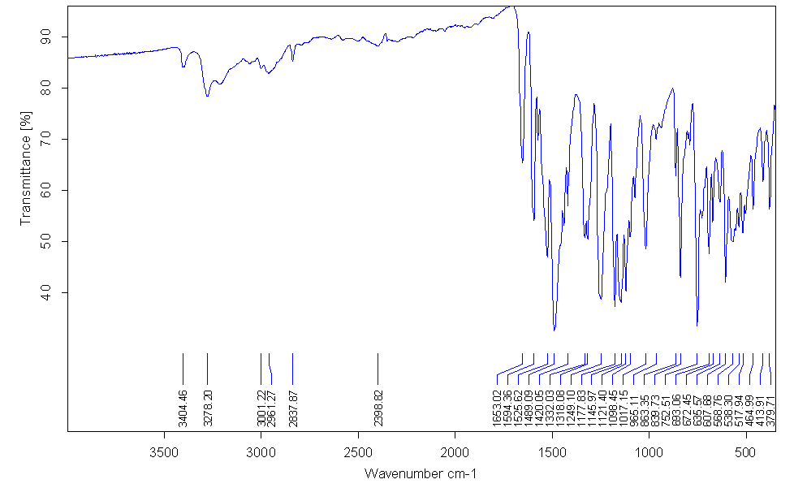
Figure S25 IR spectrum of 1-(4-methoxybenzoyl)-3-[2-({[(4-methoxylphenyl) formamido]methanethioyl}amino)phenyl]thiouea (8).

Figure S26 ¹H NMR spectrum of 1-(4-methoxybenzoyl)-3-[2-({[(4-methoxylphenyl) formamido]methanethioyl}amino)phenyl]thiouea (8).

Figure S27 ¹³C NMR spectrum of 1-(4-methoxybenzoyl)-3-[2-({[(4-methoxylphenyl) formamido]methanethioyl}amino)phenyl]thiouea (8).

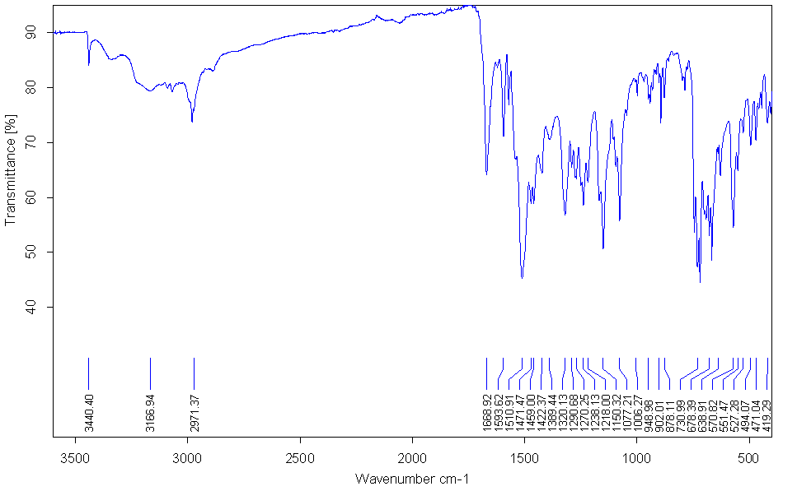
Figure S28 IR spectrum of 1-(3-chlorobenzoyl)-3-[2-({[(3-chlorophenyl)formamido] methanethioyl} amino)phenyl]thiourea (9).

Figure S29 ¹H NMR spectrum of 1-(3-chlorobenzoyl)-3-[2-({[(3-chlorophenyl) formamido]methanethioyl}amino)phenyl]thiourea (9).

Figure S30 ¹³C NMR spectrum of 1-(3-chlorobenzoyl)-3-[2-({[(3-chlorophenyl) formamido] methanethioyl}amino)phenyl]thiourea (9).

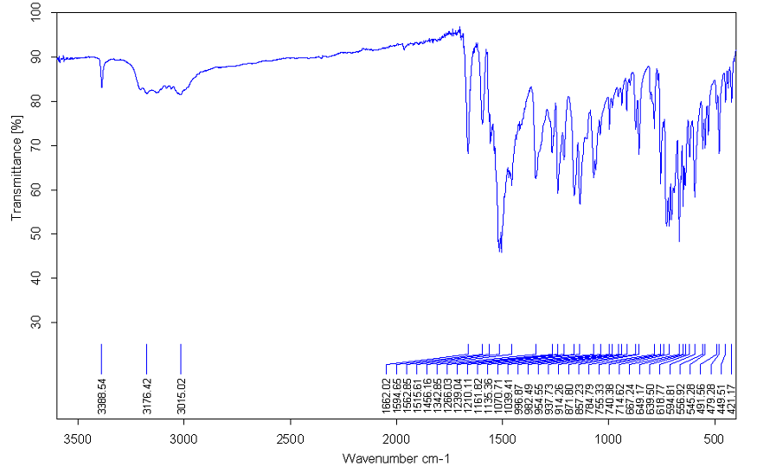
Figure S31 IR spectrum of 1-(3-bromobenzoyl)-3-[2-({[(3-bromophenyl)formamido] methanethioyl}amino)phenyl]thiourea (10).

Figure S32 ¹H NMR spectrum of 1-(3-bromobenzoyl)-3-[2-({[(3-bromophenyl) formamido] methanethioyl}amino)phenyl]thiourea (10).

Figure S33 ¹³C NMR spectrum of 1-(3-bromobenzoyl)-3-[2-({[(3-bromophenyl) formamido]methanethioyl}amino)phenyl]thiourea (10).

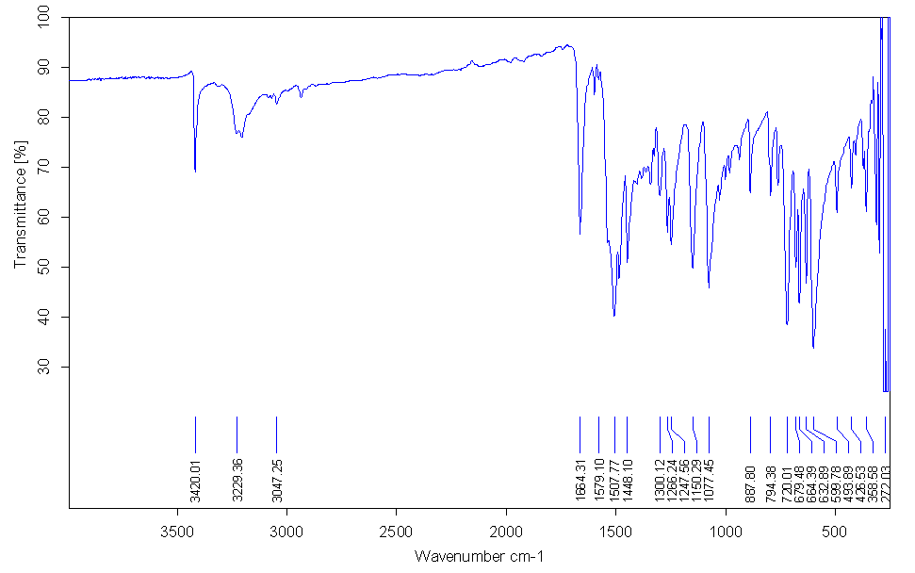
Figure S34 IR spectrum of 3-benzoyl-1-(2-{[(phenylformamido)methanethioyl] amino}ethyl)thiourea (11).

Figure S35 ¹H NMR spectrum of 3-benzoyl-1-(2-{[(phenylformamido)methanethioyl] amino}ethyl)thiourea (11).

Figure S36 ¹³C NMR spectrum of 1 3-benzoyl-1-(2-{[(phenylformamido)methanethioyl] amino}ethyl)thiourea (11).

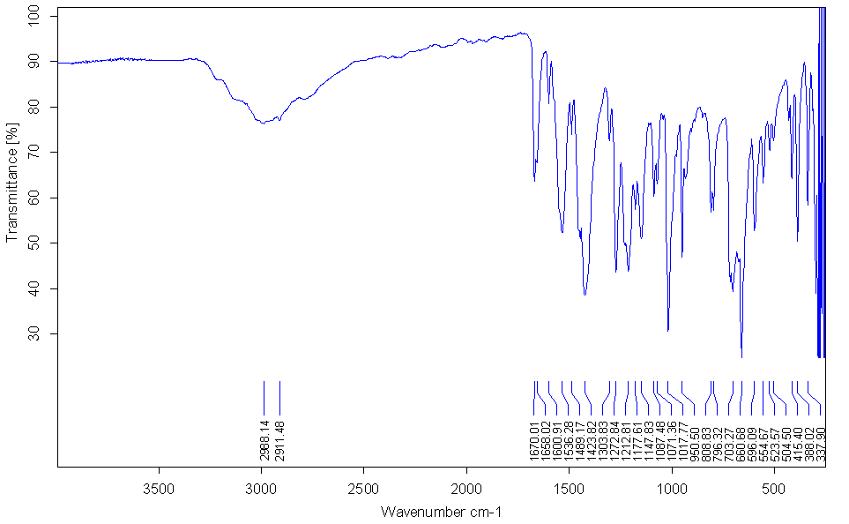
Figure S37 IR spectrum of 3-benzoyl-1{[(phenylformido)methanethioyl]amino}thiourea (12).

Figure S38 ¹H NMR spectrum of 3-benzoyl-1{[(phenylformido)methanethioyl]amino} thiourea (12).

Figure S39 ¹³C NMR spectrum of 3-benzoyl-1{[(phenylformido)methanethioyl] amino}thiourea (12).

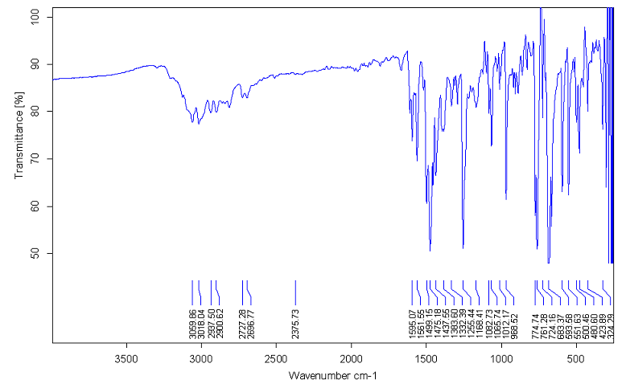

Figure S40 IR spectrum of 3-benzoyl-1-(phenylamino)thiourea (13).

Figure S41 ¹H NMR spectrum of 3-benzoyl-1-(phenylamino)thiourea (13).

Figure S42 ¹³C NMR 3-benzoyl-1-(phenylamino)thiourea (13).

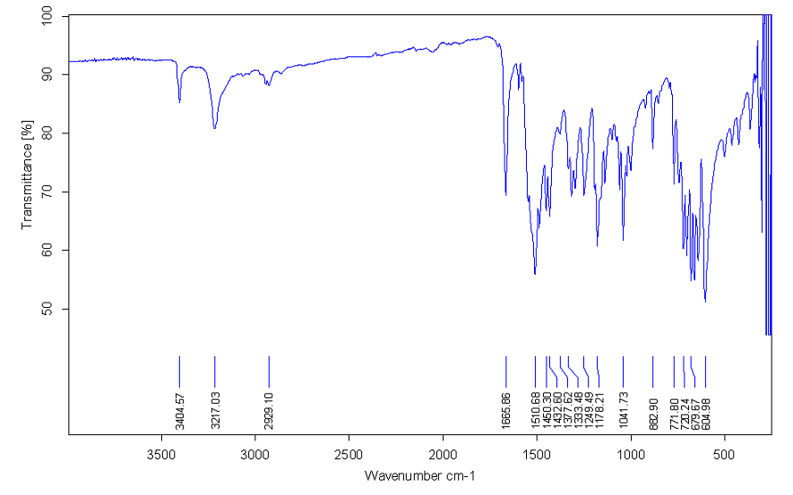
Figure S43 IR spectrum of 3-benzoyl-1-(4-{[(phenylformamido)methanethioyl] amino}butyl)thiourea (14).

Figure S44 ¹H NMR spectrum of 3-benzoyl-1-(4-{[(phenylformamido) methanethioyl] amino}butyl)thiourea (14).

Figure S45 ¹³C NMR spectrum of 3-benzoyl-1-(4-{[(phenylformamido)methanethioyl] amino}butyl)thiourea (14).

BIOLOGICAL STUDIES
Table S3 The residual % parasite (Trypanosoma brucei) viability obtained for the individual compounds (1-12).

Compound | % Viability
1 | 46.39
2 | 101.23
3 | 106.15
4 | 100.07
5 | 96.85
6 | 104.23
7 | 68.39
8 | 102.17
9 | 61.95
10 | 17.92
11 | 101.34
12 | 11.24

The table below shows the IC₅₀ value obtained for compound 10 and 12, followed by the dose-response plots and % viability ±SD data used to prepare the graphs.

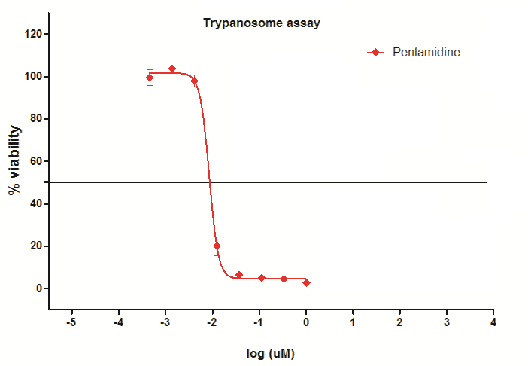
Figure S46 Dose-response plots for the determination of IC₅₀ of compound Pentamidine

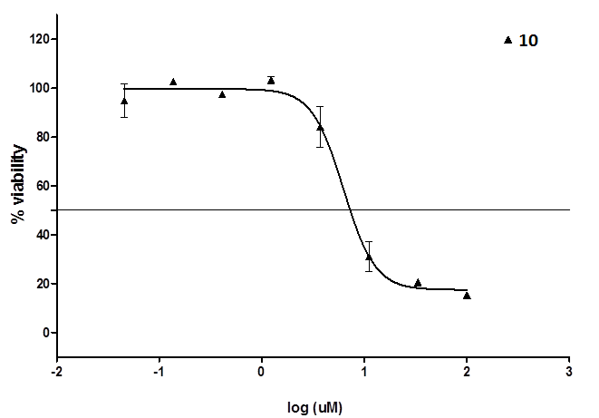
Figure S47 Dose-response plots for the determination of IC₅₀ of compound 10

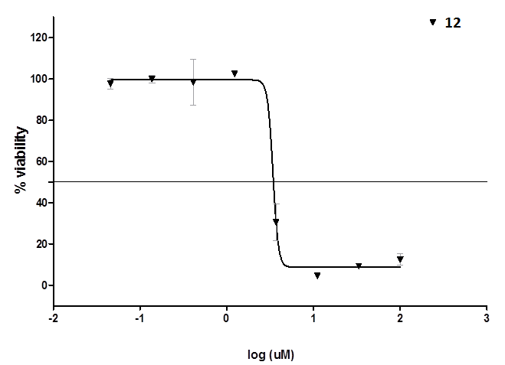
Figure S48 Dose-response plots for the determination of IC₅₀ of compound 12

Table S4 IC₅₀ value obtained for compound 10 and 12.

Compound | IC₅₀(μM)
10 | 6.271
12 | ~ 3.413
Pentamidine | 0.008507

