Temperature Dependent Behavior of Isotactic and Atactic Poly(Methacrylic Acid) in the Presence of MgCl₂ and CaCl₂
Patricija Hriberšek¹ and Ksenija Kogej^{1,}*
¹Department of Chemistry and Biochemistry, Faculty of Chemistry and Chemical Technology, University of Ljubljana, SI-1000 Ljubljana, Slovenia

*Corresponding author:
Ksenija Kogej (ORCID: 0000-0002-6291-1032)
Faculty of Chemistry and Chemical Technology, University of Ljubljana, Večna pot 113, SI-1000 Ljubljana, Slovenia
Tel.: 01-4798-538;
E-mail: ksenija.kogej@fkkt.uni-lj.si

Abstract
Temperature (T) induced nanoparticle formation of isotactic (iPMA) and atactic (aPMA) poly(methacrylic acid) chains is investigated in aqueous solutions in the presence of divalent cations (Mg²⁺ and Ca²⁺) by UV spectroscopy, visual observations and pyrene fluorimetry. In aPMA solutions, aggregation and phase separation take place with increasing T. The onset of aPMA aggregation (heating) and re-dissolution of the aggregates (cooling) is shifted to lower Ts with increasing ionic strength of the solutions. iPMA associates partly decompose upon heating, but stable nano-sized particles are present at all Ts. Structural characterization of the aggregates was carried out by dynamic and static light scattering measurements at 25 °C. Results revealed that aggregates of both PMAs with Mg²⁺ ions involve a lot of water and have a rather even mass distribution. This is attributed to strong hydration of Mg²⁺ ions and their preference towards monodentate binding to carboxylate groups. Differently, Ca²⁺ ions bind more strongly and in a bidentate manner, they lose the hydration water and form aggregates with several structure elements, depending on chain tacticity.

KEYWORDS: temperature-responsive polymers; poly(methacrylic acid) isomers; atactic; isotactic; divalent cations; intermolecular association

Introduction
Despite the ubiquitous presence of polyelectrolytes in chemistry, biology and physics, their interactions with numerous species, among those also with oppositely charged and multivalent metal ions, still present one of the most challenging aspects of macromolecule chemistry. These interactions have a significant effect on size, charge and structure of the polymer molecules in solutions, on dynamics of polymer chains, kinetics of eventual phase separation, and furthermore have implications to biological systems, since metal ions perform important functions in biological processes.¹⁻³ Among the most common cations found in nature and in living systems are divalent Mg²⁺ and Ca²⁺. Since these two ions play a crucial role in stabilizing the structure of many proteins, many have been performed on their interactions with macromolecules.^{1,4−10} For example, Mg²⁺ is responsible for the DNA replication^{1,5} and Ca²⁺ has a stabilizing function in bones, teeth and shells.^{1,11} They are both so-called hard ions and prefer to bind to hard ligands containing oxygen, such as carboxylates, carbonyls, water, and hydroxyl groups.^{1,12} However, Mg²⁺ and Ca²⁺ each has specific properties that make them different from each other. Apart from small ionic (0.65 Ǻ¹³) and significantly larger hydrated radius (4.76 Ǻ^{13,14}), one of the main characteristics of Mg²⁺ is strong interaction with hydration water molecules leading to a bulky hydration sphere with a hexa-coordinated geometry around this ion. The slow exchange rate of the hydrated water molecules is responsible that Mg²⁺ ions do not readily lose water molecules.^{1,4,6,12−18} These features of Mg²⁺ play a crucial role in stabilizing the monodentate binding of Mg²⁺ to carboxylate group (see Scheme S1 in Supporting Information (SI)).^{1,4,12,13,17}
Ca²⁺ has quite different properties in comparison to Mg²⁺ and therefore participates in different biochemical processes.^{11,13} Its ionic radius (0.99 Ǻ¹³) is considerably larger in comparison to Mg²⁺ and this leads to significant flexibility in the coordination number of its complexes with various ligands. The water coordination numbers for Ca²⁺ range from 6 to 8, but also up to 12 is possible, which leads to irregular geometry of the ion’s coordination sphere.^{1,11−13} Hydrated radius of Ca²⁺ thus depends on the coordination number, but is always smaller than that of Mg²⁺. For coordination numbers 6−8, the hydrated radius is 2.95 Ǻ.¹³ These properties cause that Ca²⁺ can easily lose water molecules from its hydration sphere.^{13,15,16} Its complexes, in which bidentate binding prevails,¹⁷ are therefore classified as 'dry'. There are two types of bidentate binding of Ca²⁺ to carboxylate groups: chelating bidentate and bridging bidentate binding (see Scheme S1). In chelating coordination, one central Ca²⁺ ion is bound to two oxygen atoms of one carboxyl group, whereas in bridging coordination Ca²⁺ bridges two different carboxyl groups via their oxygen atoms.¹⁹
Interactions of macromolecules and counterions are important also in the (bio)technological, industrial, and pharmaceutical fields, where synthetic polymers are more commonly used.^{2,3} For example, poly(acrylic acid) is a promising candidate for controlling water hardness²⁰ and poly(methacrylic acid) (PMA) is widely studied due to its pH- and temperature dependent behavior,²¹⁻²⁴ which is very appropriate in targeted drug delivery.²⁵ The atactic form of PMA (aPMA) is known to form intermolecular associates in dilute aqueous solutions²⁶ and gels in concentrated solutions upon heating. ^{22−24,27,28} On the other hand, the isotactic form (iPMA) forms intermolecular associates upon cooling.^{26,28,30} Our previous results show that the added simple salt, in particular the cation charge, affects the temperature at which association takes place, either by heating (aPMA) or by cooling (iPMA).²⁸
The main focus of this paper is to compare the effect of biologically relevant divalent Mg²⁺ and Ca²⁺ cations on the temperature-dependent association of iPMA and aPMA chains in aqueous solutions. For this purpose, we first carry out UV spectroscopy measurements supported by visual observations in the temperature range between 0 and 95 °C to clarify the effect of polymer tacticity on the association process. To identify the role that the specific nature of Mg²⁺ and Ca²⁺ plays in the interaction with carboxylate groups on PMA isomers, fluorescence measurements using pyrene as a polarity probe are used. Finally, the molecular characteristics of the associates are determined by dynamic (DLS) and static light scattering (SLS), which are further supported by pH measurements, both carried out at 25 °C.

Experimental

Materials
The aPMA sample (product number P2419-MAA) with the weight (M_{w}) and number average molar masses (M_{n}) of M_{w} = 159 900 g mol⁻¹ and M_{n} = 123 000 g mol⁻¹ and a polydispersity index (PDI) of PDI = 1.3 was purchased from Polymer Source Inc (Montreal, QC, Canada). iPMA was obtained by acidic hydrolysis of its ester form, isotactic poly(methylmetacrylate) (iPMMA), which was synthesized following the procedure reported in the literature^{29,30} at the Catholic University of Leuven. Detailed description of hydrolysis and further purification of iPMA was described previously.^{29,31} The molecular characteristics of the starting iPMMA were the following: the triad content or tacticity was 94% of isotactic, 4% of syndiotactic, and 2% of atactic triads, M_{w} = 138 000 g mol⁻¹, M_{n} = 30 000 g mol⁻¹, and PDI = 4.6. After hydrolysis and purification, the M_{w} and PDI (M_{w} = 69 500 g mol⁻¹ and PDI = 3) were determined by size exclusion chromatography, and the degree of hydrolysis (> 98%) was determined from the ¹H nuclear magnetic resonance spectrum of the sample in D₂O.
MgCl₂ (> 98%; Sigma Aldrich, St. Louis, Missouri, USA) and CaCl₂ (in the form CaCl₂ × 2H₂O; pro analysis, Merck KGaA, Darmstadt, Germany) were used to prepare stock salt solutions in water. The exact concentration of salts (c_{s}) was determined by potentiometric titration using a standardized AgNO₃ solution. Pyrene (optical grade) for fluorimetric measurements was purchased from Aldrich (Darmstadt, Germany). The saturated solutions of pyrene in aqueous MgCl₂ and CaCl₂ were prepared as reported previously.^{32,33}

Preparation of solutions
Stock solution of aPMA was prepared at a degree of ionization (α_{N}) α_{N} = 0 by dissolving the dry polymer in water. After one day of stirring, the solution was filtered through 0.45 μm Millex HV filter and the exact polymer concentration (c_{m}, in g L⁻¹) was determined by potentiometric titration with a standardized NaOH solution.
The iPMA does not dissolve in water at α_{N} = 0.^{29,34,35} Therefore, the iPMA stock solution was prepared at a higher α_{N} (> 0.8) to ensure that the polyacid was completely dissolved. A calculated volume of 1 M NaOH was slowly added to the iPMA suspension in water under continuous stirring to obtain the desired α_{N} value. The dissolution process at room temperature was slow. The iPMA suspension was stirred for several days with occasional heating to ∼50 °C, which accelerated the dissolution. When the polymer was visually dissolved, the solution was filtered through 0.45 μm Millex HV filter and the exact α_{N} and c_{m} values were determined by potentiometric titration, first with 0.1 M NaOH in the direction of increasing α_{N} (to determine the concentration of the still protonated COOH groups) and then with 0.1 M HCl in the direction of decreasing α_{N} (to determine the total concentration of carboxyl groups).
Due to differences in solubility, different procedures were used also for the preparation of a- and iPMA solutions with added MgCl₂ and CaCl₂. Solutions of aPMA with a desired salt concentration (c_{s}) were prepared by adding a calculated volume of concentrated salt solutions to the aPMA stock solution and diluting the solution with triple distilled water to adjust the concentration of aPMA and the ionic strength (I) to the desired values. For all the measurements with aPMA, α_{N} = 0, c_{m} = 2 g L⁻¹ (or in moles of COOH groups per volume, designated as c_{p}, c_{p} = 0.023 mol L⁻¹), and the concentration of MgCl₂ and CaCl₂ was c_{s} = 0.033 mol L⁻¹, which corresponds to I = 0.1 and 0.2 mol L⁻¹, respectively (these data are collected in Table S1). UV and pH measurements with aPMA were performed also at higher I (or c_{s}) values, i.e. in the range I = 0.1–0.5 mol L⁻¹.
For the preparation of iPMA solutions with the lowest possible α_{N}, at which the polyacid was still soluble, a calculated amount of 0.1 M HCl was gradually added to the stock solution with α_{N} > 0.8, which resulted in some NaCl in solution. The NaCl was removed by dialysis using dialysis membranes Float-A-Lyzer G2 with a molecular weight cutoff MWCO = 3.5−5 kDa. Finally, calculated amounts of concentrated MgCl₂ or CaCl₂ solutions and water were added slowly and under continuous stirring to adjust I and c_{p} to the desired final values, so as in the case of aPMA. The final I values were 10 times lower in comparison to aPMA, because iPMA precipitated from solutions with I = 0.1 mol L⁻¹ in the presence of the studied divalent cations. For both, MgCl₂ and CaCl₂, I was 0.01 (or c_{s} = 0.0033 mol L⁻¹) and 0.02 mol L⁻¹ (or c_{s} = 0.0067 mol L⁻¹) and α_{N} was 0.2. In the case of MgCl₂, the iPMA solution with α_{N} = 0.2 and I = 0.02 mol L⁻¹ was stable (no precipitation occurred). However, in the case of CaCl₂, α_{N} in iPMA solution with I = 0.02 mol L⁻¹ could not be reduced to α_{N} = 0.2, because the solution became opaque when α_{N} was decreased from α_{N} > 0.8 to α_{N} = 0.63 and remained cloudy even after prolonged stirring. This solution was therefore studied at α_{N} = 0.63. All I, c_{s}, and α_{N} values for iPMA solutions are reported in Table S1.

Methods

Visual Observations
In order to obtain visual information about temperature-dependent aggregation of a- and iPMA chains in aqueous solutions, samples were kept in cuvettes and equilibrated at different temperatures (T) (T = 15, 25, 45, 55, 65, 75, 85 and 95 °C) in a Julabo circulator. aPMA in MgCl₂ and CaCl₂ precipitated on a macroscopic scale during heating. The samples were photographed and the photographs are presented in Tables S2 and S3. For iPMA, only pictures at 25 °C are shown (Table S4), because the solutions were transparent in the whole temperature range. Photographs of iPMA in CaCl₂ with I = 0.02 mol L⁻¹ and α_{N} = 0.63 (not shown) resembled the case of aPMA at 75 °C.

UV Measurements
The UV absorbance (A) was recorded with a UV-Vis spectrophotometer Cary BIO 100 (Varian, Australia) at a wavelength λ = 280 nm in the temperature range between 0 and 95 °C. To avoid condensation on the cuvette walls, measurements were carried by blowing dry nitrogen around the cuvette. Samples were degassed prior to measurements. The heating and cooling rate programs were different for a- and iPMA solutions and are reported in Table S5.

Fluorimetric Measurements
Fluorimetric measurements were performed by using pyrene as the external fluorophore. The fluorescence emission spectra of pyrene were recorded on a PerkinElmer model LS-100 luminescence spectrometer in the direction of increasing temperature (from 15 to 95 °C) with a step of 10 °C, also under nitrogen flow similar to UV measurements. The excitation light wavelength was 330 nm, the recording speed was 100 nm min⁻¹, and 20 emission spectra were collected in the wavelength region 350−450 nm and averaged. From the averaged spectra, the ratio of intensities of the first (I₁) and the third (I₃) vibrational peak in the emission spectrum of pyrene or so-called pyrene polarity ratio (I₁/I₃) was calculated.

Light Scattering
In order to obtain the information on size and structure of a- and iPMA associates in MgCl₂ and CaCl₂ solutions, dynamic (DLS) and static light scattering (SLS) measurements were performed with the 3D-DLS-SLS cross-correlation spectrometer from LS Instruments GmbH (Fribourg, Switzerland). The measurements were carried out only at 25 °C. The source of incident light was the He-Ne laser with a wavelength λ₀ = 632.8 nm. Intensity of scattered light was collected in the angular range between 40° and 150° with a step of 10° after keeping the samples at 25 °C for 30 min. At each angle, five correlation functions were collected and averaged. For processing the measured correlation functions, CONTIN analysis was used. Prior to light scattering (LS) measurements, all a- and iPMA solutions were filtered through hydrophilic and low protein binding Millex-HV filters (diameter 13 mm, pore size 0.45 μm) directly into the sealable dust-free cylindrical quartz LS sample cells. LS measurements were performed 3 days after filtration. Due to opacity, iPMA solution in 0.0067 mol L⁻¹ CaCl₂ (I = 0.02 mol L⁻¹ and α_{N} = 0.63; see above) was studied without being filtered. Note that the 3D cross-correlation technique was designed especially for the characterization of such strongly turbid samples.³⁶ After 2 weeks two phases were observed in the cuvette in this case. The one at the bottom was more turbid than the upper one. By changing the height of the cuvette in the decalin bath, we were able to perform the LS characterization of both phases separately.
LS experiments identified two (in some cases three) populations of particles in iPMA and aPMA solutions (see examples of calculated hydrodynamic radii (R_{h}) distributions in Figure S1). The R_{h} values of smaller particles (R_{h} < 10 nm, assigned to individual chains, and 10 nm < R_{h} < 20 nm, assigned to small pre-associates; not reported) did not depend on the angle. We were interested in the R_{h} values of larger particles (70-200 nm), which were assigned to inter-chain associates and designated as R_{h,ass}. Their values depended considerably on the angle of observation. For further calculations, the R_{h,ass} values at θ = 0° were obtained by extrapolation of the measured R_{h,ass} to zero angle. Due to large size of the associates, their radius of gyration (R_{g,ass}) could be determined from the angular dependency of the LS intensity following the procedures reported previously.³⁷⁻³⁹ From R_{h,ass} at θ = 0° and R_{g,ass}, the shape parameter (ρ) was calculated as ρ = R_{g,ass}/R_{h,ass}. This parameter is often used to characterize mass distribution within the scattering particles.^{37,38} All further details of LS data evaluation were reported previously.³⁷⁻⁴⁰

pH Measurements
The pH values of the samples were measured by using the combined glass micro-electrode from Mettler Toledo (type InLab® 423; Schwerzenbach, Switzerland) and the Iskra pH meter model MA 5740 (Ljubljana, Slovenia).

Results and Discussion

Temperature dependent behavior of iPMA and aPMA in the presence of MgCl₂ and CaCl₂

UV Spectroscopy and Visible Observations
In Figure 1, A is presented as a function of temperature for aPMA (α_{N} = 0) solutions with I = 0.1 mol L⁻¹ and for iPMA (α_{N} = 0.2) solutions with I = 0.01 mol L⁻¹ in the presence of both, MgCl₂ and CaCl₂. In addition, measurements for aPMA at higher I (= 0.2–0.5 mol L⁻¹) are shown in Figure 2. The data demonstrate that aqueous aPMA solutions with added MgCl₂ and CaCl₂ behave as polymer mixtures with so-called lower critical solution temperature (LCST) behavior. The LCST behavior (hase separation induced by heating) is inferred from the fact that UV absorbance is close to zero at low temperatures (below 70 and 80 °C in CaCl₂ and MgCl₂, respectively; Figure 1b) and steeply increases at high temperatures. Strong increase in A indicates the formation of larger particles in solution, which is ultimately followed by precipitation and phase separation of the polymer (see visual observations reported below). Clearly, the increase in A is more pronounced in the presence of Ca²⁺ ions. For the aPMA-CaCl₂ solution, a plateau in A is reached between 80 and 90 °C, followed by a fall as T approaches 95 °C. We anticipate that this final drop in A is
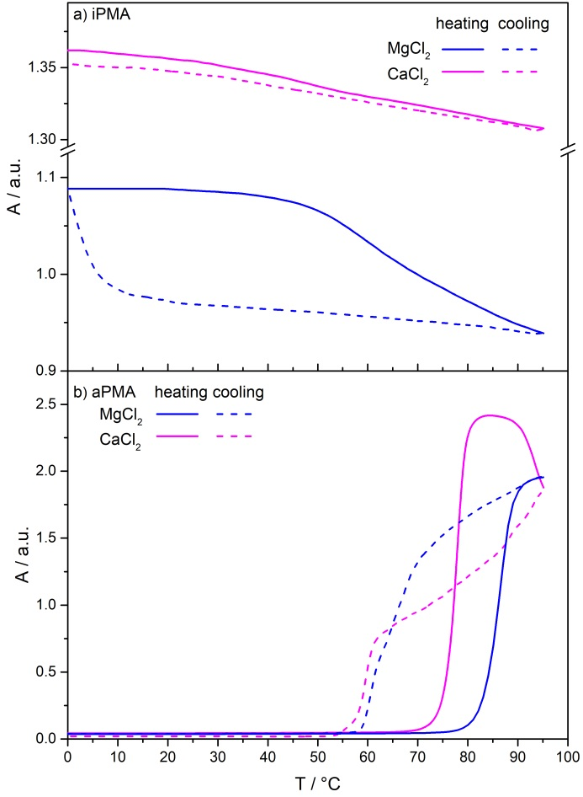
Figure 1. UV absorbance at 280 nm as a function of temperature for a) iPMA (c_{p} = 0.022 mol L⁻¹, α_{N} = 0.20) in MgCl₂ and CaCl₂ with I = 0.01 mol L⁻¹, and for b) aPMA (c_{p} = 0.023 mol L⁻¹, α_{N} = 0) in MgCl₂ and CaCl₂ with I = 0.1 mol L⁻¹. Heating (solid line) and cooling (dashed line) were performed according to the temperature programs reported in Table S5.
a consequence of the fact that the aPMA precipitate in the presence of CaCl₂ is effectively removed from the solution by settling down to the bottom of the cuvette, whereas it still fills the whole cuvette in the MgCl₂ solution at this I (= 0.01 mol L⁻¹; for more details see photographs in Table S2). The LCST for aPMA-CaCl₂ solution clearly appears at lower Ts in comparison with that in aPMA-MgCl₂ solution (see the LCST values reported in Table S6 and the method for their determination shown in Figure S2).
During cooling the aPMA-MgCl₂ solution back to the initial temperature, the absorbance first decreases gradually and then drops steeply to 0 at lower temperatures (below approximately 59 °C) as compared to the heating direction. Meanwhile, the initial drop in A upon cooling the aPMA-CaCl₂ solution is steeper, but reaches zero at approximately the same temperature (at around 58 °C) as in MgCl₂ solution. The drop in A to zero indicates that aPMA aggregates, which form in the presence of MgCl₂ and CaCl₂ upon heating, disintegrate upon cooling. We conclude that Mg²⁺ and Ca²⁺ cations induce reversible association of aPMA chains at elevated temperatures. These findings are in agreement with our recent report on intermolecular association of aPMA chains in the presence of cations with increasing charge.²⁸ The formation of aPMA precipitate in the CaCl₂ solution is similar to that in LaCl₃.²⁸ This is not surprising, since both cations (Ca²⁺ and La³⁺) are known to bind to carboxylate groups in a bidentate manner.¹⁹ The La³⁺ cations are also recognized as Ca²⁺ analogs in living systems and can thus act as substitutes of Ca²⁺ in many proteins and cell membranes.⁴¹⁻⁴³ However, in the case of aPMA the presence of trivalent La³⁺ ions at I = 0.1 mol L⁻¹ induces irreversible precipitation from solution (no re-dissolution takes place upon cooling), whereas Ca²⁺ precipitates re-dissolve at the same I.
Visual observations for aPMA (α_{N} = 0) solutions are in good agreement with the UV results (see photographs presented in Table S2 for the heating and in Table S3 for the cooling direction). When temperature increases above 75 °C, the aPMA solutions in MgCl₂ and CaCl₂ first become turbid. Fine flakes of precipitated aPMA are formed in the presence of MgCl₂, which do not readily settle down; the solution remains turbid. In CaCl₂ solutions, on the other hand, the precipitation of aPMA is considerably more extensive; the precipitate first takes up the whole space (see for example the photograph taken at 85 °C, Table S2) and settles to the bottom of the cuvette or is partially stuck to the glass wall with further heating to 95 °C, explaining the plateau in A values in aPMA-CaCl₂ solution at 80−90 °C (maximum turbidity) and their steep drop towards 95 °C (partial removal of the precipitate from solution).
The LCST values for aPMA in the presence of MgCl₂ and CaCl₂ were determined in a broader range of I values (up to 0.5 mol L⁻¹). Heating of aPMA-MgCl₂ solution at higher I (> 0.1 mol L⁻¹) leads to a similar plateau and a drop in A values as highlighted above for CaCl₂ solution for all I (c.f. Figure 2). With increasing I, the rise in A shifts to lower LCSTs, whereas
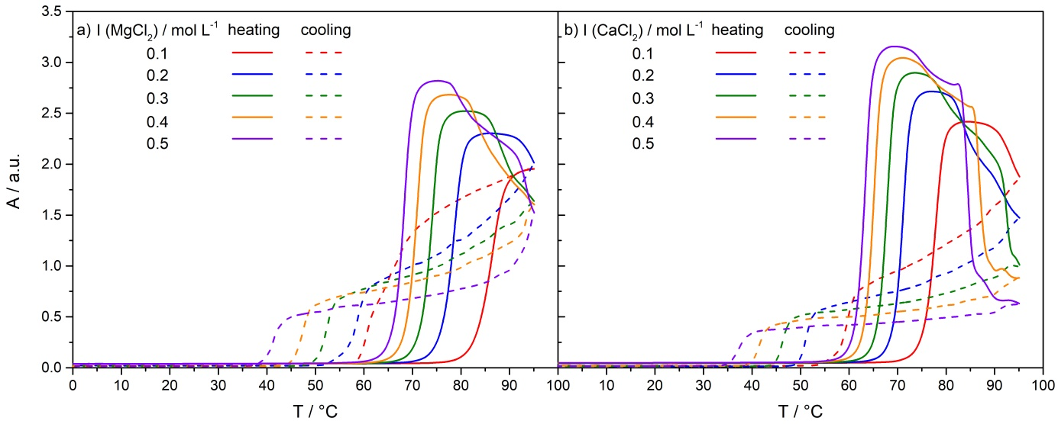
Figure 2. UV absorbance at 280 nm as a function of temperature for aPMA (c_{p} = 0.022 mol L⁻¹, α_{N} = 0) in a) MgCl₂ and b) CaCl₂ solutions with I = 0.1, 0.2, 0.3, 0.4 and 0.5 mol L⁻¹. The heating (solid lines) and cooling (dashed lines) were performed with a rate of 1 °C min⁻¹.
the plateau shifts to higher A due to higher turbidity and more extensive precipitation of aPMA from solutions at higher MgCl₂ concentration. Another important observation is that upon cooling the plateau, and consequently the associated critical temperature of de-association, designated as T_{de-ass},²⁸ also shift to lower temperatures with increasing I. A strong hysteresis is clearly seen in the plots in Figure 2, indicating that T_{de-ass} is considerably lower than LCST (see T_{de-ass} and LCST values reported in Table S6 and plotted in Figure 3).
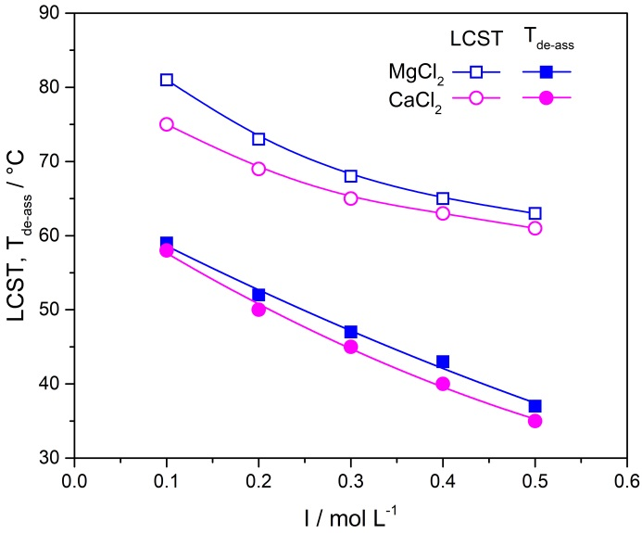
Figure 3. The dependences of LCST and T_{de-ass} on ionic strength (I) for aPMA (c_{p} = 0.023 mol L⁻¹, α_{N} = 0) in MgCl₂ and in CaCl₂ solutions.
Similar behavior is observed also for aPMA in the presence of CaCl₂. Again, a strong hysteresis is detected along the heating and cooling paths. Nevertheless, some key differences between MgCl₂ and CaCl₂ solutions can be extracted from these plots. During heating, the plateau in A reaches higher values when Ca²⁺ cations are present, which means that these divalent cations induce more extensive association and consequently more extensive precipitation of aPMA from the solution in comparison to Mg²⁺ cations. This can be inferred also from a much steeper drop in A towards the end of the heating cycle in CaCl₂ solutions (compare Figure 2b with Figure 2a). In agreement with this, the T_{de-ass} and in particular the LCST values, are lower for aPMA in CaCl₂, suggesting a more effective intermolecular association of aPMA induced by Ca²⁺ ions. However, in the case of both divalent chlorides, the LCST and T_{de-ass} decrease with increasing I. Interestingly, T_{de-ass} approaches body temperature at the highest ionic strength of 0.5 mol L⁻¹ (T_{de-ass} = 35 and 37 °C in CaCl₂ and MgCl₂, respectively). From the obtained results we can conclude that changing I of the solutions strongly affects the LCST and T_{de-ass} values for aPMA in aqueous MgCl₂ and CaCl₂ solutions, in spite of the fact that the PMA chain is almost uncharged at α_{N} = 0.
The opposite effect of temperature is found for the iPMA isomer as demonstrated by the plot of UV absorbance in Figure 1a. It should be emphasized right from the start that α_{N} (= 0.2) is not negligible in the iPMA case, which puts electrostatic interactions at the forefront in this case. In contrast to aPMA (α_{N} = 0), the UV absorbance is high in iPMA (α_{N} = 0.2) solutions at low temperatures and starts to decrease at higher temperatures, but never drops to zero, so as is the case with aPMA. This is most clearly seen for the iPMA solution with added MgCl₂: A is roughly constant up to 40 °C and starts to decrease more steeply above 50 °C, but does not drop below A ≈ 0.95 even when approaching 95 °C. In the presence of CaCl₂, the measured A values are even higher (A ≈ 1.3−1.35), suggesting that the concentration and/or size of the iPMA associates are larger than in MgCl₂ solution. In addition, no significant drop in A values can be identified from the curves for iPMA in CaCl₂ and the hysteresis is almost absent, which suggests stronger interactions and different kinetics of the association process as compared to MgCl₂. However, by inspecting the enlarged plot for iPMA-CaCl₂ solution (Figure S3) we see that the trend in A values is similar to the one in MgCl₂ or in other chlorides.²⁸ This type of behavior of aqueous iPMA solutions was previously ascribed to so-called upper critical solution temperature (UCST) behavior, denoting polymer mixtures where phase separation (or merely association) is achieved upon cooling.²⁸ The high A values in iPMA (α_{N} = 0.2) solutions with added MgCl₂ and CaCl₂ are attributed to the presence of intermolecular associates that are abundant in these solutions in the whole temperature range (A stays high even at 95 °C). Similar to these observations, it was found previously that iPMA associates are stable in the whole temperature range in aqueous solutions with added trivalent La³⁺ ions, however they largely decomposed upon heating in the presence of monovalent Na⁺ ions.²⁸ This again indicates the important role of electrostatics (counterion charge) in intermolecular association of iPMA (α_{N} = 0.2) chains.
Visual observations of iPMA solutions show that, in spite of high absorbance, no macroscopic phase separation (or precipitation) occurs in iPMA (α_{N} = 0.2) solutions at I = 0.01 mol L⁻¹ (therefore only the photograph at 25 °C is presented in Table S4), indicating that iPMA associates are formed on a mesoscopic scale, as already established for iPMA solutions with mono- and trivalent cations under the same conditions (i.e. at I = 0.01 mol L⁻¹).²⁸ The iPMA (α_{N} = 0.2) system is, however, very sensitive to salt concentration as the polymer precipitates from solution when I exceeds 0.01 mol L⁻¹ (see Experimental and discussion below). Again, the relatively high charge of the iPMA chain plays the key role here.

Fluorescence Measurements
Pyrene fluorescence measurements were used to follow the micropolarity of the aggregates’ interior in aPMA and iPMA solutions. It is expected that pyrene, as a very hydrophobic molecule, would solubilize inside the aggregates if they are composed of a non-polar core. It is well-known that aPMA chains at low α_{N} adopt a compact conformation with hydrophobic methyl groups forming the interior and offering a suitable solubilization site for pyrene. We were interested in how the tacticity and added divalent metal ions affect the polarity of microenvironment in aPMA (α_{N} = 0) and iPMA (α_{N} = 0.2) solutions.
The emission spectra of pyrene for both PMA isomers in MgCl₂ and CaCl₂ solutions are presented in Figure S4. From these spectra, the pyrene polarity ratio I₁/I₃ was calculated. The obtained values are reported in Table S8 and plotted as a function of temperature in Figure 4. The immediately evident feature of the spectra in Figure S4 is the decrease in fluorescence intensity with increasing temperature, which significantly distorts the spectrum for aPMA in CaCl₂ solution at 95 °C. This is attributed to extensive precipitation of aPMA from this solution, as discussed above. No I₁/I₃ value is therefore reported for aPMA in CaCl₂ at the highest temperature.
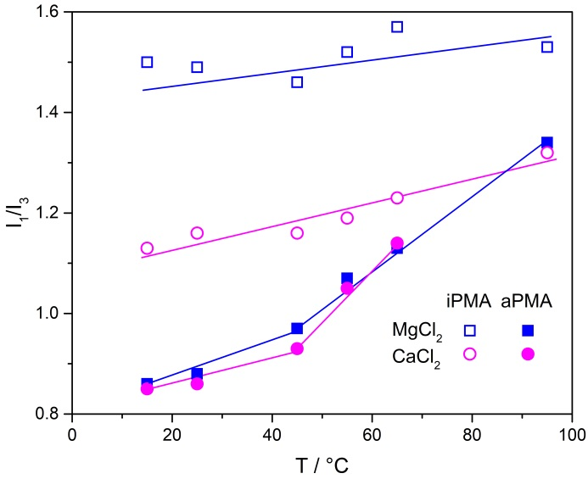
Figure 4. Temperature dependence of the pyrene intensity polarity ratio (I₁/I₃) for iPMA (c_{p} = 0.022 mol L⁻¹, α_{N} = 0.20) in MgCl₂ and CaCl₂ solutions with I = 0.01 mol L⁻¹ and for aPMA (c_{p} = 0.023 mol L⁻¹, α_{N} = 0) in MgCl₂ and CaCl₂ solutions with I = 0.1 mol L⁻¹.
The most obvious result of Figure 4 is that I₁/I₃ values are higher in iPMA (above 1.4 in iPMA-MgCl₂ and above 1.1 in iPMA-CaCl₂ solutions) than in aPMA solutions (here I₁/I₃ values start at around 0.85 at low Ts) and only weakly increase with temperature with no evident change of slope in the iPMA case. The value I₁/I₃ ≈ 1.5 in iPMA-MgCl₂ solutions points to a rather high polarity of microenvironment where pyrene molecules reside in these solutions. For comparison, I₁/I₃ is 1.3 in methanol, 1.35 in ethyl acetate, and around 1.7 (depending on the presence of eventual ions) in water.³³ These high I₁/I₃ values are attributed to strong interactions of Mg²⁺ ions with water molecules, due to which these cations bring a lot of water into the associates with iPMA. At the same time the monodentate binding of Mg²⁺ is weaker in comparison with cations that release the hydration water (like Ca²⁺).³⁷ However, the iPMA (α_{N} = 0.2) chains must be hold rather strongly in these associates, considering that they are charged and thus also repel each other. As proposed previously²⁸ we attribute the stability of the iPMA associates to strong cooperative intermolecular H-bonds between unionized COOH groups on different iPMA chains and in case of Mg²⁺ ions also to H-bonds between COOH groups and the hydration water molecules around the ion. The presence of large amounts of water in the iPMA-MgCl₂ associates contributes to the observed high I₁/I₃ values.
The I₁/I₃ values for iPMA in CaCl₂ are somewhat lower (I₁/I₃ ≈ 1.1−1.3) than in MgCl₂ solutions, which can be explained by bidentate Ca²⁺ binding to carboxylate groups.^{11,17−19} This type of binding is accompanied by elimination of water from cation’s hydration sphere and thus also from the associates. Consequently, the polarity of these associates is determined mainly by H-bonded COOH groups and is thus expected to be lower. Altogether, fluorescence measurements show that the interior of the iPMA associates is actually rather polar (in contrast to aPMA; see below) and stems from polar COOH groups and/or water in these associates. Strong H-bonding between COOH groups is facilitated by their suitable isotactic orientation on the iPMA chain. Meanwhile, the charged COO⁻ groups are positioned on the surface and grant the solubility of the associates in water.
The pyrene polarity ratio in aPMA solutions at temperatures below 45 °C is I₁/I₃ ≈ 0.85−0.95 (irrespective of the cation) and demonstrates a considerably less polar microenvironment of the aPMA aggregates. This can be explained by so-called hydrophobic interactions that force the methyl groups to hide inside the cores of the aPMA aggregates, which is well known. The irregular orientation of COOH groups on aPMA actually facilitates the formation of such hydrophobic cores as a result of higher flexibility of the aPMA chain and at the same time does not allow extensive H-bonding (as in the iPMA case). The hydrophilic COOH groups are positioned mostly on the surface and protect the core against the water solvent. Above 45 °C, an increase is observed in I₁/I₃ values for aPMA solutions in both, MgCl₂ and CaCl₂, which is attributed to precipitation of aPMA aggregates from solutions. Some of the pyrene molecules remain accumulated inside these precipitates and are removed from water, whereas the remaining ones detect the polarity of water without aPMA.
The above conclusions apply also to higher I values, however the increasing in I has no significant effect on the I₁/I₃ ratio. Its value depends primarily on chain tacticity (see the I₁/I₃ values measured at 25 °C in Table S9).

LS Characterization of aPMA and iPMA Associates at 25 °C
Further structural information about the associates was obtained by LS measurements at 25 °C. In Table 1, the R_{h,ass}, R_{g,ass} and ρ values are reported for aPMA (α_{N} = 0) and iPMA (α_{N} = 0.2) associates in MgCl₂ and CaCl₂ solutions. The R_{h,ass} values (the dynamic LS data) are shown in Figures 5a and 5b as a function of q² (q is the scattering vector given by the relationship q = (4πn₀/λ₀)sin(θ/2), with n₀ the refractive index of the medium and λ₀ the wavelength of the incident light). From these dependencies, the zero angle values were obtained by using either linear function or second order polynomial for extrapolation to θ = 0°. In Figures 5c and 5d, the static LS data are presented for both PMA isomers in the form of a Kratky plot (i.e. the dependence of (qR_{g})²P(θ) on qR_{g}) and compared with the calculated curves for some well-known particle topologies.
The DLS results show that aPMA particles in the presence of both divalent salts have more or less comparable hydrodynamic radii (160−190 nm). However, the radii of gyration (the SLS result) of these particles are considerably smaller in the presence of Ca²⁺ ions, leading to lower ρ values in this case. The value ρ ≈ 0.70 (aPMA-CaCl₂ with I = 0.01 mol L⁻¹) indicates micro-gel like structure of particles with mass concentrated in the core surrounded

Table 1. Hydrodynamic radii (R_{h,ass}), radii of gyration (R_{g,ass}) and parameter ρ (= R_{g,ass}/R_{h,ass}) for associates of iPMA (c_{p} = 0.022 mol L⁻¹, α_{N} = 0.20) and aPMA (c_{p} = 0.023 mol L⁻¹, α_{N} = 0) in the presence of MgCl₂ and CaCl₂ at different I and at 25 °C.
 | iPMA |  |  |  | aPMA
Added salt | I /  mol L⁻¹ | R_{h,ass} / nm | R_{g,ass} / nm | ρ | I /  mol L⁻¹ | R_{h,ass} / nm | R_{g,ass} / nm | ρ
MgCl₂ | 0.01 | 75 | 73 | 0.97 | 0.1 | 178 | 164 | 0.92
 | 0.02 | 177 | 180 | 1.02 | 0.2 | 191 | 160 | 0.84
CaCl₂ | 0.01 | 65 | 76 | 1.16 | 0.1 | 161 | 109 | 0.68
 | 0.02^{a)} | 111^{b)} | 153^{b)} | 1.37^{b)} | 0.2^{b)} | 178^{b)} | 125^{b)} | 0.70^{b)}
 |  | 184^{c)} | 127^{c)} | 0.69^{c)}
^{a)}α_{N} = 0.63; ^{b)}upper phase; ^{c)}lower phase
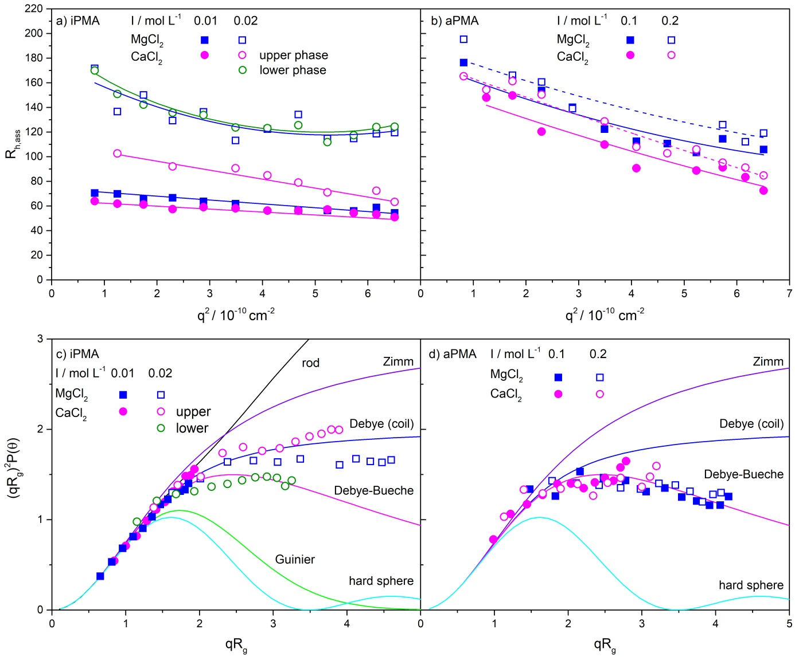
Figure 5. Hydrodynamic radii (R_{h,ass}) as a function of q² for a) iPMA (c_{p} = 0.022 mol L⁻¹, α_{N} = 0.20) in MgCl₂ and CaCl₂ with I = 0.01 mol L⁻¹ (full squares) and I = 0.02 mol L⁻¹ (open symbols) (note that α_{N} = 0.63 for iPMA in CaCl₂ with I = 0.02 mol L⁻¹) and for b) aPMA (c_{p} = 0.022 mol L⁻¹, α_{N} = 0) in the corresponding salt solutions with I = 0.1 mol L⁻¹. The Kratky plot (the dependence of (qR_{g})²P(θ) on qR_{g}) for selected topologies (solid lines; for details on these scattering functions see⁴⁴) and the experimental data for c) iPMA (α_{N} = 0.20 for all salt solutions, except for CaCl₂ with I = 0.02 mol L⁻¹ where α_{N} = 0.63) and d) aPMA associates (α_{N} = 0) in aqueous solutions of MgCl₂ and CaCl₂ with I = 0.1 mol L⁻¹.
by a water swollen corona, whereas ρ ≈ 0.90 in both aPMA-MgCl₂ solutions points to a more even mass distribution. For comparison, a homogeneous mass distribution, such as in a hard sphere, would result in ρ = 0.778. Lower ρ values in the presence of CaCl₂ are actually expected due to the preference of strong bidentate binding of Ca²⁺ to carboxylate groups as discussed above. Ca²⁺ ions release coordinated water molecules upon binding to carboxylate groups, the aggregates’ interior is thus ′drier′ (leaving only the outer layers hydrated) and therefore more compact. On the other hand, Mg²⁺ ions remain strongly hydrated due to their pronounced inability to dehydrate and thus the aPMA chains in MgCl₂ solutions form rather loose and more water swollen aggregates. Such environment offers more mobility to the chains and the structure is more permeable for the solvent, which altogether leads to higher ρ values. Still, ρ ≈ 0.90 for aPMA-MgCl₂ aggregates is far from values known for random coils of single chains in a θ-solvent (ρ ≈ 1.5).
The Kratky plots for aPMA aggregates in both metal chlorides (Figure 5d) confirm the suggested structures. The data points coincide with the Debye-Bueche scattering function, which is valid for micro-gel like particles with a core-shell structure and at the same time demonstrate that the increase in I does not greatly affect the structure, which is reasonable in case of aPMA (α_{N} = 0) with charge close to zero. The experimental points for aPMA in CaCl₂ solutions show a noticeable upturn from the Debye-Bueche towards the Debye scattering function at high qR_{g} values. This kind of upturns were previously attributed to the excluded-volume interactions,^{37,40} which may be more pronounced in case of Ca²⁺ ions in view of their stronger interaction with carboxyl groups. We actually demonstrate in the following (see results of pH measurements below), that Ca²⁺ ions replace some H⁺ ions form COOH groups and thus increase the ionization of aPMA.
Different from aPMA, R_{h,ass} and R_{g,ass} values for iPMA associates in MgCl₂ and CaCl₂ with lower I (= 0.01 mol L⁻¹) are significantly smaller in comparison to those in solutions with higher I (= 0.02 mol L⁻¹). This result is reasonable, because salt concentration should play a more important role in the case of partly charged iPMA (α_{N} = 0.2) chains: higher salt concentration (higher I) contributes to stronger electrostatic screening and enables more extensive intermolecular association and formation of larger particles. However, ρ values for iPMA-Mg²⁺ associates are not much affected by I (ρ ≈ 1), whereas those for iPMA-Ca²⁺ associates range from 0.69 (the lower phase formed in the CaCl₂ solution with I = 0.02 mol L⁻¹ and α_{N} = 0.63; see Experimental section) to 1.37 (the upper phase in the same solution). In the Kratky plot we see that the experimental data for larger particles in iPMA solutions show a systematic positive shift from the Debye-Bueche function at high qR_{g} values. We attribute these observations to a possibility that different structural elements are present in the iPMA-Ca²⁺ associates. Let’s assume that the bidentate binding of Ca²⁺ proceeds predominately via bridging interaction with carboxyl groups on neighboring iPMA chains (i.e. intermolecularly), whereas the chelating (intramolecular) binding is less likely (see a scheme of both binding modes in Figure 6). The bridging bidentate binding with a concomitant pronounced dehydration of Ca²⁺ ions may induce structural elements of higher rigidity within these complexes, in particular considering also the isotacticty of the chain, and contributes to shifting of the points in the Kratky plot toward more rode-like structures. On the other hand, portions of the iPMA chains that are not involved in this complexation (presumably the more ionized parts) form coil-like outer regions with higher ρ (c.f. ρ = 1.16 and 1.37 for the homogeneous sample at I = 0.011 mol L⁻¹ and for the upper phase at I = 0.02 mol L⁻¹, respectively) around the compacted parts.
At the end we should shortly comment also the result for the lower (precipitated phase) in iPMA-CaCl₂ solution with I = 0.02 mol L⁻¹ and α_{N} = 0.63 (note that these are average values for the whole sample). Here, ρ (= 0.69) is again very low and the points in the Kratky plot fit the Debye-Bueche function, showing that associates in the precipitated phase are much more compact as compared to the upper more solvated and dilute phase. We also presume, that α_{N} may be lower than the average value (α_{N} = 0.63) in the precipitate.
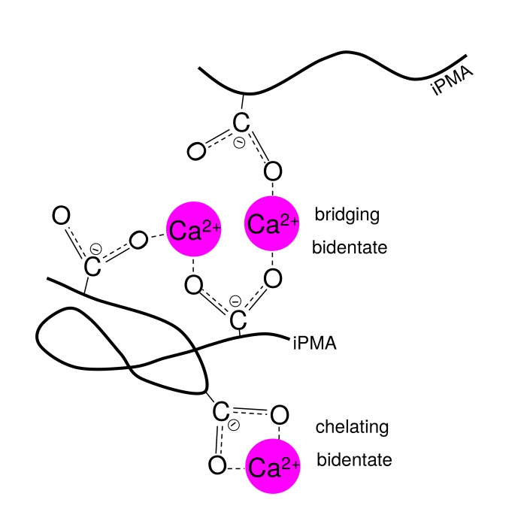
Figure 6. Cartoon depicting proposed ways of bidentate binding (chelate and bridging) of Ca²⁺ to COO⁻ groups on iPMA chains.
We conclude the discussion of LS results by proposing that PMA-Ca²⁺ associates could also include interactions in terms of so-called egg-box model, commonly used in interpretation of gelation phenomena of alginates and pectates, which belong to a class of polysaccharides with carboxylate groups.^{7,9,10} According to the egg-box model, interaction between COO⁻ groups on the polysaccharide and divalent cations is cooperative if the ion has an appropriate size to fit into the space in the egg-box, which is formed by the polyion backbone. Ca²⁺ fulfils this criterion, while Mg²⁺ is too small.⁷ By proposing the existence of egg-box-like structural elements into which Ca²⁺ ions fit due to their size, one can understand both, the formation of more gel-like precipitates in aPMA-CaCl₂ and more complex structural observations for iPMA-CaCl₂ solutions.

pH and Degree of Ionization
In support of the above interpretation of differences between MgCl₂ and CaCl₂ solutions, we report the pH values for both PMA solutions, from which the degree of ionization (α_{i}) of COOH groups was calculated from α_{i} = α_{N} + ([H⁺] – [OH⁻])/c_{p} (in this equation, [H⁺] and [OH⁻] are the molar hydronium and hydroxide concentrations). These measurements are reasonable only for aPMA solutions with α_{N} = 0, because binding of cations has pronounced effect on ionization of COOH groups if α_{N} = 0, whereas with iPMA with α_{N} = 0.2 (or α_{N} = 0.63) this effect is negligible (see the measured pH and calculated α_{i} values in Table S10). The α_{i} values in aPMA solutions are plotted in Figure 7 as a function of I. Clearly, α_{i} increases (from 0.013 at I = 0 to 0.036 at I = 0.5 mol L⁻¹) with increasing I in aPMA-CaCl₂ solutions, but changes negligibly in aPMA-MgCl₂ solutions. The pronounced (threefold) increase in the presence of CaCl₂ is attributed to the replacement of H⁺ cations from COOH groups upon bidentate binding of Ca²⁺ as predicted above. As a result, some H⁺ ions are released into the solution, pH decreases, and α_{i} increases. On the contrary, the monodentate binding of Mg²⁺ ions to COOH groups is weaker and indirect (via hydration water molecules). Mg²⁺ is not able to replace H⁺ from the COOH group and has no (or negligible) effect on α_{i}. This clearly supports the above interpretations.
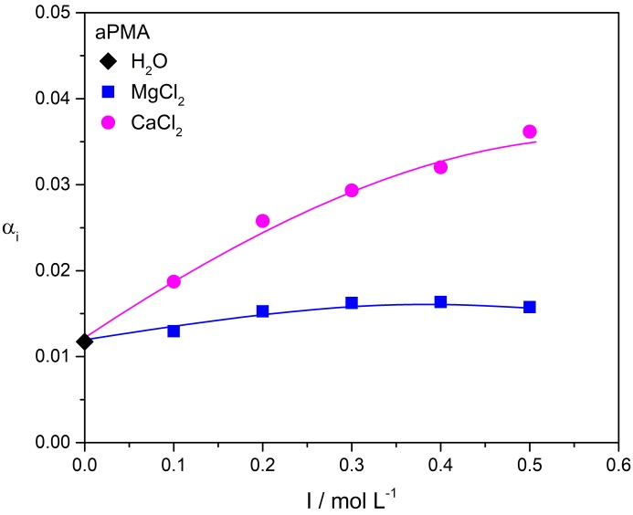
Figure 7. Calculated α_{i} values for aPMA (c_{p} = 0.023 mol L⁻¹, α_{N} = 0) in dependence on I in aqueous MgCl₂ and CaCl₂ solutions.

Conclusions
Our main interest in this study was the comparison of temperature induced intermolecular association in dilute aqueous solutions of two chemically identical PMA isomers, aPMA and iPMA, in the presence of divalent cations Mg²⁺ and Ca²⁺. UV spectroscopy and visual observations reveal that heating of aPMA solutions from 0 to 95 °C leads to intermolecular association and aggregate growth and finally to precipitation of aPMA from solution. Since the aPMA-Mg²⁺ and aPMA-Ca²⁺ re-dissolve upon cooling it was concluded that the process of association is reversible. Increasing I in aPMA solutions (0.1−0.5 mol L⁻¹) leads to a decrease in the temperature at which phase separation occurs. iPMA behaves oppositely, which means that heating induces partial de-association of the aggregates, but the process is reversible and associates are reformed upon cooling. Nevertheless, iPMA-Mg²⁺ and iPMA-Ca²⁺ associates are stable in solution in the whole temperature range.
Considerable differences in micropolarity of the aPMA and iPMA aggregates in the presence of Mg²⁺ and Ca²⁺ ions are found by pyrene fluorescence measurements. The micropolarity of the iPMA associates is higher in comparison with the aPMA ones, which is attributed to different distribution of CH₃ and COOH groups within the associates. It is proposed that the cores of iPMA associates are composed of COOH groups, connected via cooperative H-bonds, in contrast to the aPMA ones where the CH₃ groups reside in the aggregate interior. The polarity of the aggregates’ interior in the iPMA-MgCl₂ solutions is the highest and close to that of water due to strong hydration of Mg²⁺ ions.
The LS measurements in iPMA and aPMA solutions in MgCl₂ and CaCl₂ show that both PMAs formed intermolecular associates with dimensions in the nanometer range at low α_{N} values. The values of the shape parameter ρ indicate either micro-gel like particles (ρ ≈ 0.7) or more water permeable structures (ρ ≈ 0.90) or even a combination of rode-like and coil-like regions in the same aggregate (ρ ≈ 1.37). This latter case was identified with iPMA aggregates in the presence of Ca²⁺ ions.

Acknowledgements
This work was financially supported by the Slovenian Research Agency (ARRS), through the Physical Chemistry program P1-0201.

References
- T. Dudev, C. Lim, Chem. Rev. 2003, 103, 773−787.
- M. Muthukumar, Macromolecules 2017, 50, 9528−9560.
- F. Cilurzo, C. G. M. Gennari, F. Selmin, G. Vistoli, Mol. Pharm. 2010, 7, 421−430.
- T. Dudev, C. Lim, Acc. Chem. Res. 2007, 40, 85–93.
- Schauss, F. Dahms, B. P. Fingerhut, T. Elsaesser, J. Phys. Chem. Lett. 2019, 10, 238–243.
- S. Kavitha, P. Deepa, M. Karthika, R. Kanakaraju, J. Mol. Graph. Model. 2018, 85, 13–24.
- J. Mattai, J. C. T. Kwak, J. Phys. Chem. 1984, 88, 2625−2629.
- Y. Fang, S. Al-Assaf, G. O. Phillips, K. Nishinari, T. Funami, P. A. Williams, L. Li, J. Phys. Chem. B 2007, 111, 2456-2462.
- X. Wang, H. G. Spencer, Polymer 1998, 39, 2759−2764.
- L. Q. Wan, J. Jiang, D. E. Arnold, X. E. Guo, H. H. Lu, V. C. Mow, Cell. Mol. Bioeng. 2008, 1, 93–102.
- J. Krebs, in: R. A. Mayers (Ed.): Encyclopedia of Molecular Cell Biology and Molecular Medicine, 2nd Edition, Wiley-VCH Verlag GmbH & Co. KGaA, Weinheim, Germany, 2004, pp. 133–170.
- A. Kaufman Katz, J. P. Glusker, S. A. Beebe, C. W. Bock, J. Am. Chem. Soc. 1996, 118, 5752–5763.
- M. E. Maguire, J. A. Cowan, Biometals 2002, 15, 203–210.
- W. Johnen-Dechent, M. Kettler, Clin. Kidney J. 2012, 5, i3–i14.
- M. Eigen, Pure Appl. Chem. 1963, 6, 97–115.
- H. Diebler, M. Eigen, Pure Appl. Chem. 1969, 20, 93–116.
- T. Dudev, C. Lim, J. Phys. Chem. B 2004, 108, 4546–4557.
- J. V. Needham, T.Y. Chen, J. J. Falke, Biochemistry 1993, 32, 3363–3367.
- R. Konradi, J. Rühe, Macromolecules 2004, 37, 6954–6961.
- D. M. Chang, JAOCS, 1983, 60, 618−622.
- A. Silberberg, J. Eliassaf, A. Katchalsky, J. Polym. Sci. 1957, 23, 259−284.
- M. Sedlák, Colloid Polym. Sci. 2017, 295, 1281−1292.
- M. Sedlák, Č. Konňák, Macromolecules 2009, 42, 7430−7438.
- M. Sedlák, Č. Konňák, Macromolecules 2009, 42, 7439−7446.
- A. K. Bajpai, S. K. Shukla, S. Bhanu, S. Kankane, Prog. Polym. Sci. 2008, 33, 1088−1118.
- K. Kogej, Polymers 2016, 8, 168.
- J. Eliassaf, A. Silberberg, Polymer 1962, 3, 555−564.
- P. Hriberšek, K. Kogej, Macromolecules, 2019, 52, 7028−7041.
- E. Van den Bosch, Q. Keil, G. Filipcsei, H. Berghmans, H. Reynaers, Macromolecules 2004, 37, 9673−9675.
- W. E. Goode, F. H. Owens, R. F. Fellmann, W. H. Snyder, J. E. Moore, J. Polym. Sci. 1960, 46, 317− 331.
- B. Jerman, K. Kogej, Acta Chim. Slov. 2006, 53, 264–273.
- K. Kogej, J. Škerjanc, Langmuir 1999, 15, 4251−4258.
- D. Y. Chu, J. K. Thomas, J. Am. Chem. Soc. 1986, 108, 6270−6276.
- E. M. Loebl, J. J. O’Niell, J. Polym. Sci. 1960, 45, 538−540.
- N. Vlachy, J. Dolenc, B. Jerman, K. Kogej, J. Phys. Chem. B 2006, 110, 9061−9071.
- C. Urban, P. Schurtenberger, J. Colloid Interface Sci. 1998, 207, 150–158.
- P. Hriberšek, K. Kogej, Polymers 2019, 11, 605.
- S. Sitar, V. Aseyev, K. Kogej, Soft Matter 2014, 10, 7712−7722.
- S. Sitar, V. Aseyev, K. Kogej, Polymer 2014, 55, 848−854.
- E. V. Tarassova, V. Aseyev, A. Filippov, H. Tenhu, Polymer 2007, 48, 4503−4510.
- H. G. Brittain, F. S. Richardson, R. B. Martin, J. Am. Chem. Soc. 1976, 98, 8255–8260.
- R. B. Martin, F. S. Richardson, Q. Rev. Biophys. 1979, 12, 181–209.
- C. G. Dos Remedios, Cell Calcium 1981, 2, 29–51.
- P. Kratochvil, in: M. B. Huglin (Ed.): Particle scattering functions in light scattering from polymer solutions, Academic Press Inc.: London and New York, 1972, pp. 333−384.
- E. J. Robertson, A. P. Carpenter, C. M. Olson, R. K. Ciszewski, G. L. Richmond, J. Phys. Chem. C 2014, 118, 15260−15273.

Povzetek
Z UV spektroskopijo, vizualnim opazovanjem in fluorimetrijo na osnovi pirena smo proučevali vpliv temperature na tvorbo asociatov med verigami izotaktične (iPMA) in ataktične poli(metakrilne kisline) (aPMA) v vodnih raztopinah v prisotnosti dvovalentnih kationov (Mg²⁺ in Ca²⁺). Gretje raztopin aPMA povzroči agregacijo verig, kar vodi do makroskopske ločitve faz. Z naraščajočo ionsko jakostjo raztopin se nastop agregacije (segrevanje) oziroma de-agregacija (ohlajanje) aPMA verig pomika k nižjim temperaturam. Nasprotno pa asociati iPMA med segrevanjem razpadejo, a le delno, tako da so stabilni delci z nano-dimenzijami prisotni v raztopini v celotnem temperaturnem območju. Strukturno karakterizacijo agregatov smo izvedli z meritvami dinamičnega in statičnega sipanja svetlobe pri 25 °C. Rezultati kažejo, da agregati obeh PMA z Mg²⁺ vključujejo precej vode, porazdelitev mase znotraj delcev pa je precej enakomerna. To pripisujemo močni hidrataciji Mg²⁺ ionov, zaradi česar Mg²⁺ ioni favorizirajo monodentatno vezavo na karboksilatne skupine. Ca²⁺ ioni pa se vežejo nanje na bidentatni način in zato močneje kot Mg²⁺ ioni, pri čemer izgubijo hidratno vodo in tvorijo agregate z več strukturnimi elementi, kar je odvisno od taktičnosti verige.

