Cobaltosic Oxide Catalysts for Catalytically Removing Hydrogen from Tail Chlorine
Tong Zhang,Ling Xue,Jianwei Xue*,Fuxiang Li,Zhiping Lv
College of Chemistry and Chemical Engineering,Taiyuan University of Technology,Taiyuan 030024,China.
Correspomding author: Jianwei Xue,e-mail: xuejianwei@tyut.edu.cn
Abstract
Mixed reactant gases were prepared according to the composition and content of tail chlorine in industry:Cl₂(65%-80%),N₂(6-16%),O₂(8%-10%) and H₂(1.5%-4%).The catalytic reaction was carried out in a fixed-bed,which used an inexpensive substance of cobaltosic oxide as a catalyst to catalyze the reaction of hydrogen with oxygen and chlorine to achieve safe and effective dehydrogenation.The cobaltosic oxide was used reaction catalyst,which could be divided into the non-supported catalyst,and the supported cobaltosic oxide catalyst Co₃O₄/ZSM-5.From the experiment,it was concluded that the stability and catalytic performance of Co₃O₄/ZSM-5 catalyst was superior to Co₃O₄ alone.With 1%wt. of the Co₃O₄ loading of the Co₃O₄/ZSM-5 catalyst ,the superior catalytic performance was observed at 50°C under the calcination temperature of 300°C.A 99.59% average conversion of hydrogen achieved,accompanied by hydrogen-chloride with higher selectivity than hydrogen-oxygen reaction.
Graphical abstract

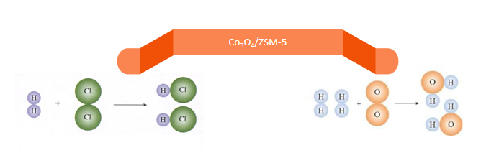
Keywords: Cobaltosic oxide; Co₃O₄/ZSM-5; tail chlorine; dehydrogenation

1.Introduction
The chlor-alkali industry is an important part of basic chemical industry,which is a key component in the manufacture of thousands of downstream chemicals . ¹ Chlorine and sodium hydroxide,as two major products of the chlor-alkali industry,are diffusely used as raw materials for other processes and rank among the most important inorganic commodities (handbook of chemical economics,2018).² Given the recent devolopment,both the production of chlor-alkali and the scale of industrial equipment have reached new hights.By the end of 2018,there will be 161 caustic soda enterprises in China with a total output of 42.59 million tons.³ Looking forward to 2019,the demand for caustic soda is still expected to be better.The accompanying tail chlorine-chlorine tail gas will inevitably become an important issue in the industrial production of chlor-alkali.Tail chlorine comes from chlor-alkali industry,which is a process of compressed liquefaction preparation liquid chlorine enriched in chlorine gas,including chlorine gas,nitrogen,oxygen and hydrogen.There is a risk that the mixture will explode due to hydrogen accumulation when used in downstream products.The existence of hydrogen has become a great potential safety hazard. ⁴ Thus.it is highly desired to explore and develop how to remove hydrogen from chlorine tailings environment-friendly and effectively.
There are four common industrial methods for dehydrogenation of tail chlorine: synthetic hydrochloric acid,absorption-desorption,and lye absorption and PSA pressure swing adsorption. ^{5,6} The synthesis of hydrochloric acid by burning hydrogen and chlorine at high temperature to produce hydrochloric acid, ⁷ while tail chlorine is consumed.This is a mature method in industry,but at present the economic benefit of this method is too poor.Dehydrogenation with green catalysts is in line with the national energy conservation and emission reduction and green development concept,which can reduce hydrogen content and even completely dehydrogenate.In the 1950s,it was discovered that hydrogen and chlorine could be catalyzed into hydrogen chloride to remove hydrogen.Kulcsar and Geza scholars for the first time in 1957 used activated carbon as a carrier of load type catalyst under 250°C,chlorine and hydrogen for hydrogen chloride.Subsequently, ⁸Allen and Coolen et al.. investigated that the reaction should be controlled within a certain temperature range,otherwise the side reaction occurred at an excessively high reaction temperature. ^{9,10} Rsearchers showed that some precious metals (platinum,palladium,rhodium,etc.) and its alloys,as well as cheap manganese metals reduced the hydrogen content in tail chlorine to less than 10⁻⁶ in a certain temperature range (200-400°C).Pieters et al. with SiO₂ carrier load K,La and Cu chloride preparation as a catalyst,when residual hydrogen content in the best conditions of PPM level,they then used the activated alumina catalyst carrier load the precious metal Pt made around 260°C catalytic reaction. ¹¹
The previous studies on the dehydrogenation performance of tail chlorine have also made some progress.Hanhan Wang et al.developed the effect of Pd and Pt as catalysts for tail-chlorine catalytic dehydrogenation at low temperature,but as a precious metal they were not only expensive,but also had a low repetition rate. ¹² Therefore,Xi Liu employed cheap metal Fe₂O₃/Al₂O₃ to obtain the superior catalytic performance with conversion rate of hydrogen of 84.11% at reaction temperature of 70°C and calcination temperature of 500°C.Among tthat route,it was found that production of the ferric chloride of by products.This method can not only achieve dehydrogenation effect,but also prepare ferric chloride products. ¹³
Because of the poor stability of iron-based catalysts,the experiment adopted cobalt-based catalyst to catalyze chlorine dehydrogenation of tail chlorine and ZSM-5 with larger specific surface area was used as carrier to prepare catalyst.ZSM-5 zeolite is one of the most widely used zeolites because of its thermal stability,unique channel structure,large surface,acidity and shape-selectivity.It has been proverbially utilized as the support in various moderate acid-catalyzed reactions. ¹⁴ This method has low energy consumption and simple process,which fundamentally solves the safety problem of tail chlorine containing hydrogen without causing secondary pollution to the environment.

2.Experiment

2.1 Catalyst preparation
Co₃O₄ supported on ZSM-5 catalysts were prepared using the volume impregnation method with Co(NO₃)₂·6H₂O.A series of cobalt nitrate aqueous solutions with different mass fractions were prepared,and then the cobalt nitrate aqueous solution with the same volume was soaked for 24h with 1g ZSM-5 at room temperature.After that,it was dried in a oven at 100°C for 12h,and finally calcined for 6 hours at 300°C -700°C. ¹⁵ Then put it into the sample bag and label it for later use.

2.2 Catalyst characterization
After reaction,the product mixture content detection of l ml was quantitatively analyzed by gc-900 gas chromatograph with a 3mm*3m 5A molecular sieve stainless steel packed column and a thermal conductivity cell detector.Argon was used as a carrier gas with a gas velocity of 15ml/min (0.05mpa).The temperature of vaporization chamber and detector were 100°C accompanied by column temperature of 55°C and bridge current of 60 mA.The X-ray diffraction (XRD) patterns of the catalyst were obtained by using a diffractometer (XRD-6000) ,operating at 40 kv and 30 ma with Cu-ka palladium and nickel filtering.Scanning electron microscope pattern of the catalysts was taken by JEOL9（JSM-6010PLUS/L） operated at 10-20kv and 10mm ,which was conducted to investigate the morphology of samples.Element analysis (EDS) was used to assist in the analysis of the SEM electron micrograph.The N₂ adsorption–desorption was employed to measure the surface area and pore volume by using a NOVA 2000e analyzer.

2.3 Experimental steps
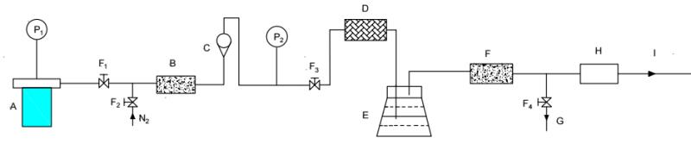
A.GastankB.Calcium chloride dryerC.RotorflowmeterD.Quartz tube reactorE.Sodium hydroxide solution F.Calcium oxide dryerG.SamplingdeviceH.Tail gas treatmentI.Tail gas outletF₁,F₂,F₃,F₄.The valveP₁,P₂.Vacuum manometer
Figure 1.The device for removing hydrogen from the tail chlorine
The experimental procedure is as follows: Firstly,0.5g catalyst was put into the fixed-bed reactor system as shown in Figure 1,and the whole pipeline was purged with nitrogen to remove water.Then,the tail chlorine mixture simulated according to the composition of industrial tail chlorine (3.97% H₂,9.93% O₂,13.25% N₂ and 72.85% Cl₂) was put into the reactor. ^{16,17} The hydrogen content of the tail chlorine after dehydrogenation was analyzed by gas chromatography and the conversion rate of hydrogen was calculated to detect its catalysis and properties of chemical agents.

2.4 Hydrogen conversion calculation method
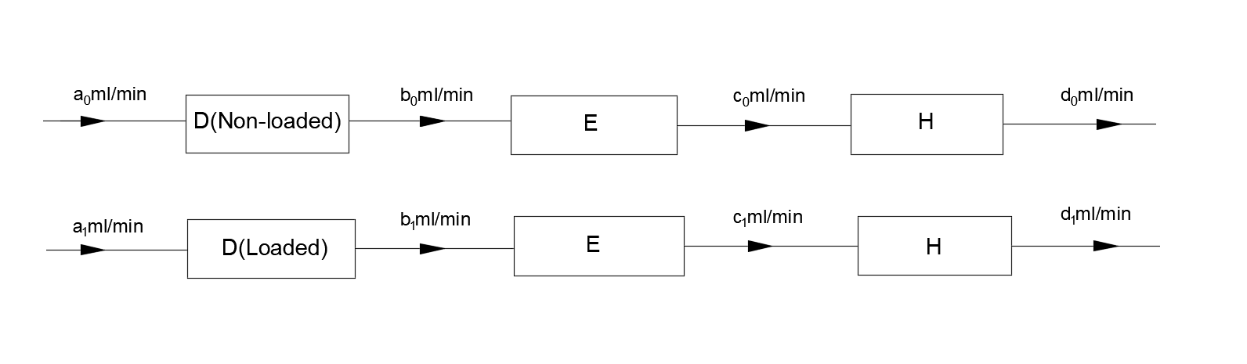
Figure 2.Calculation of hydrogen content in a gas mixture
The above figures show the changes of gas flow rate before and after the reaction,respectively.The conversion rate of each reactant was defined as eq 1,
(1)
Where the initial velocity is described as a0 and a1..After reaction,it’s b0 and b1.c0 and c1 are exhibited with the absorption of chlorine and 5.6 is the velocity after reaction with sodium carbonate.Hence,the hydrogen conversion rate and oxygen conversion rate are set as eq 2 and eq 3 severally,
(2)
(3)
Where ,and are respectively the volume concentrations of hydrogen,oxygen,and nitrogen in the mixture before the reaction,while ,and are after the reaction.Since the hydrogen is only about 4% and the proportion of chlorine gas is more higher,it is reasonable to assume that the gas velocity is basically unchanged after the reaction.As suggested by eq 4 and eq 5,
a₀=a₁=b₀≈b₁ ₍₄₎ c₀=d₀≈c₁=d_{1(5) ,}
Eq 6 and eq 7 can be obtained by substituting the above formula into the conversion rate formula,
(6) ;(7),
It would found that hydrogen - oxygen reaction and hydrogen - chlorine are involved in the reaction.The selectivity of hydrogen - oxygen is calculated as eq 8,
=
= (8),
The selectivity of hydrogen - chlorine,as a consequence,can be reckoned as eq 9,
=1-
=1- (9).

3.Results and Discussion

3.1 X-ray diﬀraction

Figure 3.The XRD patterns of Co₃O₄ at different reaction temperature

As suggested by Figure 3,the characteristic diﬀraction peaks of Co₃O₄ were obtained at 19.0°,31.3°,36.9°,38.6°,44.8°,55.7°,59.4°,and 65.3°.After the reaction,a weak characteristic diﬀraction peaks of catalyst presented at 75.8°,which indicated that a trace of cobalt chloride was generated in the catalytic reaction process.

Figure 4.The XRD patterns of Co₃O₄/ZSM-5 at different reaction temperatureure
Figure 5.The XRD patterns of Co₃O₄/ZSM-5 at different calcination temperature

Figure 6.The XRD patterns of Co₃O₄/ZSM-5 at different loading
The XRD analysis of Co₃O₄/ZSM-5 at different reaction temperatureure was presented in Figure 4,which was loaded with 1 %wt.and calcined at 600°C.Compared with unloaded cobaltosic oxide,the characteristic diffraction peak of cobaltosic oxide also presented at about 45° in Figure 4,exhibiting that the presence of cobalt element in the form of Co₃O₄.Thanks to decreased zeolite crystallinity after impregnation and calcination,the characteristic peak strength of Co₃O₄/ZSM-5 is weaker than that of Co₃O₄ catalyst.It was assumed that the catalyst had good stability due to there is no diffraction peak of cobalt chloride.
The XRD analysis of Co₃O₄/ZSM-5 at different calcination temperatureure was set as Figure 5,which are loaded with 1 %wt. and participated in reaction at 50°C.From Figure 5,it can be seen that the characteristic diffraction peak corresponding to cobaltosic oxide all presented at about 45° at different calcination temperature.However,the strength of peak decreased indistinctly with increase of calcination temperature,which illustrated that the enhanced temperature was unfavourable to the crystallization of cobaltosic oxide.The consecutive high-intensity peaks of ZSM-5 having a specific 2θ value of 23°–25° were commonly found in each catalyst sample,indicating that after calcination as well as reaction ZSM-5 structure clearly preserved.
For various Co₃O₄ loadings,the XRD analysis of catalysts were set as Figure 6,which were calcined at 300°C and participated in reaction at 50°C.As suggested by Figure 6,all the catalysts revealed characteristic peaks of ZSM-5 crystal in the ranges of 2θ= 23~25 which were evident that the crystalline framework of the ZSM-5 was retained after the loading in all the catalysts. ¹⁸ With increasing loading of Co₃O₄/ZSM-5,the characteristic diffraction peak of ZSM-5 became weaker due to the active components are unhomogeneously coated on the surface of the carrier.

3.2 SEM analysis
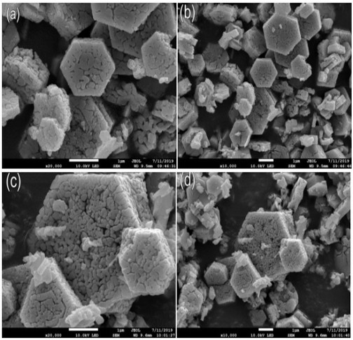

Figure 7.The SEM of Co₃O₄ before (a,b) and after reaction(c,d)

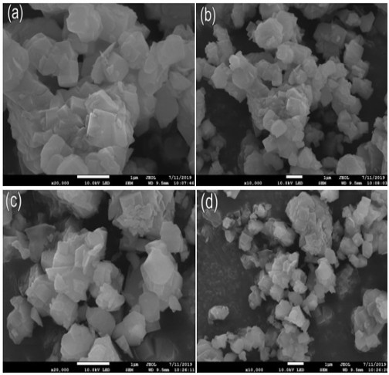
Figure 8.SEM images of Co₃O₄/ZSM-5 before (a,b) and after reaction(c,d)
Figure7 shows the SEM images of Co₃O₄ samples before and after catalytic reaction.As can be seen from figure a and b,cobaltosic Oxide particles with hexagonal structure and smooth surface ,which was arranged neatly,loose and fine before reaction.In contrast to figure a and c,the phenomenon of agglomerating occurred in the catalyst after the reaction.With the destruction of some hexagonal structure of particles,the particle size became larger,and there seemed to be traces of corrosion of hydrogen chloride and water on the surface.It was performed that the SEM images of Co₃O₄ supported on ZSM-5.Co₃O₄ supported on ZSM-5 showed irregular shape and good dispersity on the ZSM-5 support.The distribution of samples after reaction was loose,but the overall change is not significant.

3.3 EDS analysis
Table 1.elemental analysis of Co₃O₄ catalyst
Element | C | O | Co
Co₃O₄(before) (w%) | 1.00 | 24.93 | 74.07
Co₃O₄(before) (at%) | 2.87 | 53.76 | 43.37
Co₃O₄(after) (w%) | 1.05 | 24.46 | 74.49
Co₃O₄(after) (at%) | 3.03 | 53.09 | 43.88

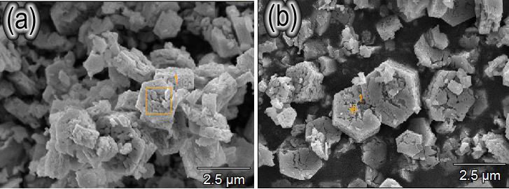

Figure 9.EDS spectra of Co₃O₄ catalyst before (a) and after (b) reaction

Table 2.elemental analysis of Co₃O₄/ZSM-5 catalyst
Element | C | O | Al | Si | Co
Co₃O₄/ZSM-5(before) (w%) | 1.46 | 47.19 | 2.53 | 35.33 | 13.49
Co₃O₄/ZSM-5(before) (at%) | 2.67 | 65.06 | 2.07 | 27.74 | 2.45
Co₃O₄/ZSM-5(after) (w%) | 2.77 | 48.84 | 2.49 | 34.54 | 11.35
Co₃O₄/ZSM-5(after) (at%) | 4.91 | 64.99 | 1.96 | 26.18 | 1.95

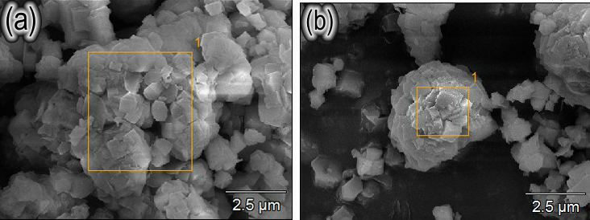

Figure 10..EDS spectra of Co₃O₄/ZSM-5 catalyst before (a) and after (b) reaction

The analysis of EDS test results exhibited that there was no drastic change of the elements before and after the reaction,no matter cobalt oxide or cobalt oxide loaded,which can also be supported by the SEM results.The morphology of pure cobalt oxide changed after reaction,while the cobalt oxide after loading was basically the same.This further revealed that Co₃O₄/ZSM-5 made more excellent performance in terms of catalytic activity and stability .

3.4 Nitrogen adsorption-desorption
Figure 11.The N₂ adsorption-desorption equilibrium curves
Figure 12.The pore dimension distribution

(a)ZSM-5;(b)1%Co₃O₄/ZSM-5;(c)1%Co₃O₄/ZSM-5 after reactiion;(d))3%Co₃O₄/ZSM-5;(e))4%Co₃O₄/ZSM-5

Table3.Pore size and surface area distribution of ZSM-5,Co₃O₄/ZSM-5 and Co₃O₄/ZSM-5 after reaction
Sample | Surface Area/m₂.g⁻¹ | Pore Volume/cc.g⁻¹ | Pore Diameter/nm
ZSM-5 | 362.648 | 0.035 | 3.83
1%Co₃O₄/ZSM-5 | 319.814 | 0.033 | 3.816
1%Co₃O₄/ZSM-5 after reaction | 322.807 | 0.03 | 3.819
3%Co₃O₄/ZSM-5 | 303.363 | 0.031 | 3.817
4%Co₃O₄/ZSM-5 | 283.703 | 0.035 | 3.053

Figure 11 shows the textural properties of ZSM-5,1%Co₃O₄/ZSM-5,1%Co₃O₄/ZSM-5after reactiion,3%Co₃O₄/ZSM-5 and4%Co₃O₄/ZSM-5,which were presented by nitrogen adsorption-desorption isotherm.According to the classification of IUPAC and the characteristics of curves in Figure 11,the isotherms of both curve exhibited type-IV isotherm with the H3 hysteresis type of loop ,which indicates that it is monolayer saturated adsorption.What is more,he material has a slit structure and uneven interior,and the loading of active components was composed of lamellar particles.By comparing the shape characteristics of the five curves in the figure,it can be determined that the pore structure of the catalyst has not changed significantly before and after the loading and reaction,indicating that the internal structure of ZSM-5 was relatively stable.
The pore size distribution was analyzed by the BJH model.Combined with the comprehensive analysis of Figure 12 and Table 2 above,it was found that the pore distribution of ZSM-5 was mainly at about 3.83 nm.While the pore size of the Co₃O₄/ZSM-5 was mainly at about 3.81 nm,which are loaded with 1%wt. and 3%wt..The pore size at 3.05 nm with 4%wt..As shown in picture b and c ,the pore diameter of catalyst are decreased while the specific surface area are increased,which is owing to the corrosion of chlorine gas pairs and the blockage of pore channels by active components after dehydrogenation reaction.Through the diffusion of the carrier,Co²⁺ diffused to the active site of the catalyst,partially replacing Al³⁺ in the zsm-5 skeleton.As the ionic radius of Co²⁺ is larger than that of ^{Al3}+,the pore diameter of catalyst decreases. ¹⁹

3.5 Catalytic Performance at different temperature of Co₃O₄
Figure13.Theoverall conversion rateof Co₃O₄
Figure14.The average conversion rateof Co₃O₄
Figure15.The average selectivityof Co₃O₄

Combining with Figure13 and 14,it can be observed that the hydrogen conversion increased with increasing temperature.Especially it increased up to surpass 99% with relative stability when the reaction temperature enhanced above 130°C.The overall conversion rate dropped with the time developed as presented in figure 13,which suggested that the performance of catalytic dehydrogenation reaction decreased gradually.Cobalt chloride was formed in the reaction by analysis of XRD.Consequently,it is the reason taht the formation of cobalt chloride,hydrogen chloride and water has damaged the catalyst including reducing the surface area and weakening the activity of catalyst.Nevertheless,the total conversion rate of hydrogen increased with the rise of temperature and the catalyst of Co₃O₄ had good stability.
As demostrated in figure 15,the selectivity of hydrogen and chlorine reactions was obviously higher than that of hydrogen and oxygen reactions at different reaction temperatures.With the rise of temperature,the selectivity of hydrogen-chlorine reaction decreased gradually,while the selectivity of hydrogen-oxygen reaction increased generally.To sum up,the optimal reaction temperature for chlorine removal of hydrogen from tail was 130°C,which was more favorable for hydrogen and oxygen reactions.

3.6 Catalytic performance of Co₃O₄/ZSM-5

3.6.1 Effect of Different Reaction Temperatures

Figure 16.The overall conversion rate of Co₃O₄/ZSM-5
Figure 17.The average conversion rate of Co₃O₄/ZSM-5
Figure 18.The average selectivity of Co₃O₄/ZSM-5

The catalytic performance of Co3O4/ZSM-5 at different reaction temperatureure was acquired in Figure 16,which was loaded with 1 %wt.and was calcined at 600°C.The conversion rate of hydrogen removal catalyzed by catalyst increased first and then decreased with the rise of temperature.Samples exhibited an average conversion rate of 99.04% at the reaction temperature of 50°C,which shows the enhanced catalytic performance.The reduction of hydrogen conversion rate meansed that hydrogen removal performance was gradually weakened as illustrated in Figure 16.This is because the formation hydrogen chloride and water has damaged the catalyst like reduced the surface area and weakened the activity of catalyst.It can been presented from the figure 17 that the average hydrogen conversion first increasesd and then fell with the enhancement of temperature.First of all,the performance of catalytic dehydrogenation was obviously advanced from 30°C to 50°C for the reason that the velocity of gas molecule increased with the enhancemente of temperature.The corrosion of catalyst by chlorine gas was accelerated at surpass 50°C,resulting in unsatisfactory catalytic dehydrogenation of catalyst.Therefore,the optimum reaction temperature for the removal of hydrogen from tail chlorine catalyzed by Co₃O₄/ZSM-5 catalyst is 50°C.
As suggested by figure 18,the selectivity of hydrogen and chlorine reactions was obviously higher than that of hydrogen and oxygen reactions at different reaction temperatures.With the rise of temperature,the selectivity of hydrogen-chlorine reaction decreased gradually,while the selectivity of hydrogen-oxygen reaction increased generally.To sum up,the optimal reaction temperature for chlorine removal of hydrogen from tail was 130°C,which was more favorable for hydrogen and oxygen reactions.

3.6.2 Effect of Different Calcination Temperature

Figure 19.The overall conversion of Co₃O₄/ZSM-5
Figure 20.The average conversion of Co₃O₄/ZSM-5
Figure 21.The average selectivity of Co₃O₄/ZSM-5

The catalytic performance of Co₃O₄/ZSM-5 at different calcination temperatureure was set as Figure 19,which are loaded with 1 %wt.and participated in reaction at 50°C.It can be obviously seen that the best performance for catalyzing the dehydrogenation was obtained under the calcination temperature of 500°C,with the average conversion ratr of Co₃O₄/ZSM-5 reached to 99.59%.It can be revealed that hydrogen removal performance was gradually weakened with increasing of calcination temperatureure.Combined with the analysis of XRD,the optimum calcination temperature of the catalytic dehydrogenation is 300°C.
Can see clearly from Figure 21,selectivity of hydrogen chloride reaction were higher than that of hydrogen and oxygen reaction selectivity under different calcination temperature.With the increase of calcination temperature,hydrogen and chloride reaction selectivity was slightly elevated,while hydrogen and oxygen reaction selectivity was reduced somewhat,which is more inclined to the reaction of hydrogen and chlorine.

3.6.3 Effect of Loading amounts on Catalytic Performance

Figure 22.The overall conversion of Co3O4/ZSM-5
Figure 23.The average conversion ofCo3O4/ZSM-5
Figure 24.The average selectivity of Co3O4/ZSM-5

The catalytic performance of Co₃O₄/ZSM-5 at loading amount was illustrated in Figure 22,which was calcined at 600°C and participated in reaction at 50°C.Next,the loading amount of Co₃O₄/ZSM-5 was investigated in the catalytic dehydrogenation reaction as shown in the figure.It can be seen obviously that the change of average hydrogen conversion rate can be divided into four stages.First of all,The average conversion of hydrogen advanced dramatically with the load amount less than 0.8%.And then the average conversion of hydrogen slowed down as the load increased from 0.8% to 1%.After that,when the loading of Co₃O₄ is between 1% and 2%,the conversion of hydrogen began to decline tardily.Finally,the conversion of hydrogen fell rapidly with the loading amount of cobaltosic oxide exceeding 2%.It is the reason that the amount of catalyst loading corresponds to the active component.Less active components with lower loading,leading to poor catalytic performance of the catalyst.So catalytic activity increased greatly with the increase of the Co₃O₄ loading of the ZSM-5 catalyst.Afterwards,excessive loading will not bring about good results,which blocked the pores and holes of the carrier and reduced the reaction surface area,the catalytic effect of the catalyst decreased rapidly.Based on analysis of the experimental data,the active components were evenly dispersed on the surface of the carrier and the catalytic activity was the highest when the average hydrogen conversion rate reached 99.60% with the loading amount of 1%.
As presented in figure 24,with elevating loading of catalyst,the selectivity of hydrogen-oxygen reaction and hydrogen chloride reaction was not observed the significiant change,indicating that loading has little impact on the selectivity of hydrogen.

3.7 Activity Test
In this experiment,Co₃O₄/ZSM-5 was used as catalyst,which was loaded with 1%wt.and calcined at 300°C.and reacted continuously for 540 minutes at 50°C,with a sampling interval of 30 minutes each time.
Figure 25.Total conversion rate of hydrogen in the catalytic reaction of Co₃O₄/ZSM-5 over time
From Figure 25,it can be seen that the catalytic dehydrogenation effect was relatively stable during the reaction time of 120 minutes,which total conversion rate of hydrogen in the catalytic reaction of Co₃O₄/ZSM-5 achieved above 99%.After that,the catalytic activity decreased gradually. After the reaction time of 540 minutes ,total conversion rate of hydrogen only dropped at 88.48%,meaning that excellent catalytic stability was significantly exhibited.

4.Conclusion
Combined with the performance characterization analysis and experimental data of hydrogen removal catalyst,we can see that Co₃O₄/ZSM-5 catalyst not only dropped the reaction temperature but also showed better stability than Co₃O₄.The analysis of XRD characterization illustrated that Co₃O₄ catalyst produced extremely small amounts of cobalt chloride after the catalytic reaction and the active component of Co₃O₄/ZSM-5 catalyst is Co₃O₄.The SEM images and N₂ adsorption and desorption characterization showed that the pore structure of the catalyst was blocked and the active components were separated from the surface of the carrier,which was consistent with the reduction of catalytic performance of the catalyst in the experiment.By comparing the catalytic dehydrogenation effect of cobalt tetroxide at different reaction temperatures,the optimum temperature of 130 °C showed the best stability.Co₃O₄/ZSM-5 calcined at at 300°C was used as a catalyst with a load content of 1%wt.,It’s average hydrogen conversion rate catalyzed within 110 minutes of reaction at 50°C was 99.59%,and only decreased to 88.48% after 540 minutes,which still showed certain catalytic activity.Whether Co₃O₄ or Co₃O₄/ZSM-5 catalyzed the dehydrogenation of tail-chlorine,the selectivity of hydrochlorine reaction was higher than that of hydrogen and oxygen reaction.Therefore,we can believe that cobalt tetroxide is more conducive to catalyzing the reaction of hydrogen and chlorine.

5.Acknowledgement
The authors thank the National Natural Science Foundation of China (No.
50972097) and the Natural Science Foundation of Shanxi (No.2008011025) for
supporting this work.

6.Conflict of Interest
The authors declare no conflict of interest

7.Reference
- H. Khasawneh, M. N. Saidan, M. Al-Addous , Energy Explor. Exploit. 2019, 37, 1053-1072. DOI: 10.1177/0144598719839767.
- J. I. Otashu, M. Baldea, Comput. Chem. Eng. 2019,121,396-408. DOI: 10.1016/j.compchemeng.2018.08.030.
- P. C. Zhang, China Chlor-Alkali. 2019,2,1-3. DOI: 10.3969/j.issn.1009-1785.2019.02.001.
- S. Peantong, S. Tangjitsitcharoen, IOP Conference Series: Materials Science and Engineering. 2017, 215,012018. DOI: 10.1088/1757-899X/215/1/012018.
- J. P. Zhang, D. S. Li, Y. Z. Chen, Environ. Prot. 2004, 12, 22-24. DOI: 10.3969/j.issn.0253-9705.2004.12.005.
- K. T. Chue , J. N. Kim , Y. J. Yoo ,S. H. Cho , R. T. Yang, Ind. Eng. Chem. Res. 1995,34, 591-598. DOI: 10.1021/ie00041a020
- K. Kato,M. kawaguchi, Method and apparatus for purifying polluted soil,and apparatus for emitting chlorine-containing gas and apparatus for decomposing polluted gas using the same, US Patent Number 20000741332, date of parent January 24, 2002.
- G. J. Kulcsar, M. Kulcsar-Novakova, Stud. Cercet. Chim. 1957,8,221-230.
- G. C. Allen, G. P. Butt, Removal of hydrogen from chlorine, GB Patent Number 1388292, date of parent March 26, 1975.
- H. Coolen, Catalytic removal of hydrogen from chlorine, ZA Patent Number 6804493, date of parent January 12, 1970.
- W. J. M. Pieters, F. Wenger, Removal of low concentrations of hydrogen from chlorine gas, US Patent Number 4224293, date of parent September 23,1980.
- H. H. Wang, T. T. Lu, Y. N. Li, B. Wu, J. W. Xue, F. X. Li, Z. P. .Lv, J. Chemistry. 2016, 2090-9063. DOI: 10.1155/2016/5620316
- X. Liu, L, Xue, X. Q. Chen, J. S. Liu, H. H. Wamg, J. W. Xue, F. X. Li, Z. P. Lv, Quim. Nova 2019,42, 319-328. DOI: 10.21577/0100-4042.20170322
- T . Kanazawa, Appl. Catal., B 2006, 65, 185-190. DOI: 10.1016/j.apcatb.2006.01.001
- B. Zhang, X. B. Zhang, L. Y. Xu, Y. J. Zhang, Y. H. Qin, C. F. Liang, React. Kinet., Mech. Catal. 2013,110, 207-214. DOI: 10.1007/s11144-013-0589-7
- S. J. Luo , Chlor-Alkali Ind. 1991 ,2,23-25.
- G. K. Liu, F. J. Lin, Chlor-Alkali Ind. 2006,3,24-26. DOI: 10.3969/j.issn.1008-133X.2006.03.009.
- X. T. Zhang, Y. Yan, R. Soc, Open Sci. 2018,5,8. DOI: 10.1098/rsos.180587.
- X. W. Zou, J. Z. Yao, X. M. Yang, W. L. Song, W. G. Lin, Chin. J. Process Eng. 2007,6,1107-1113. DOI: 10.1016/S1001-6058(07)60030-4.

