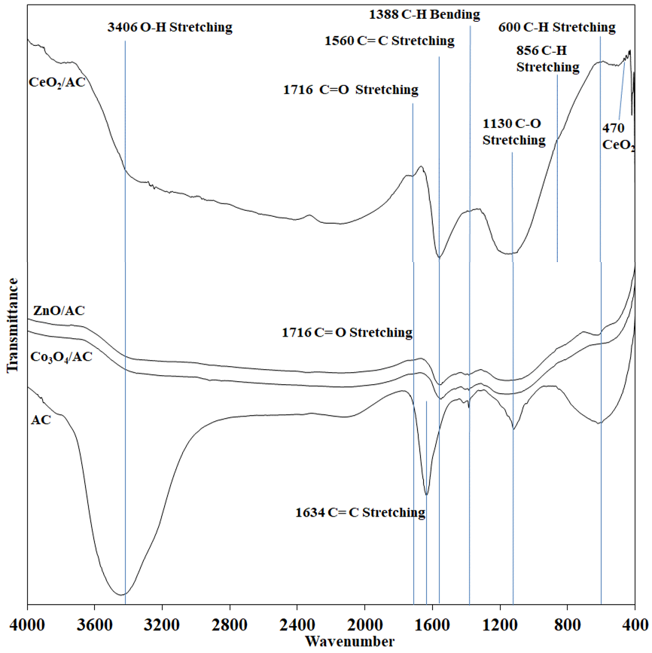
Figure 1. IR spectra of AC and various MO/AC.

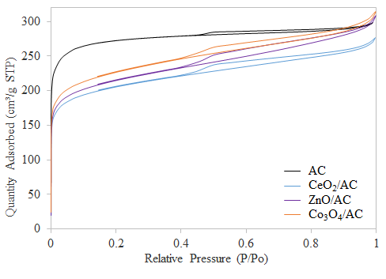
Figure 2. N₂ adsorption-desorption isotherms of the adsorbents.

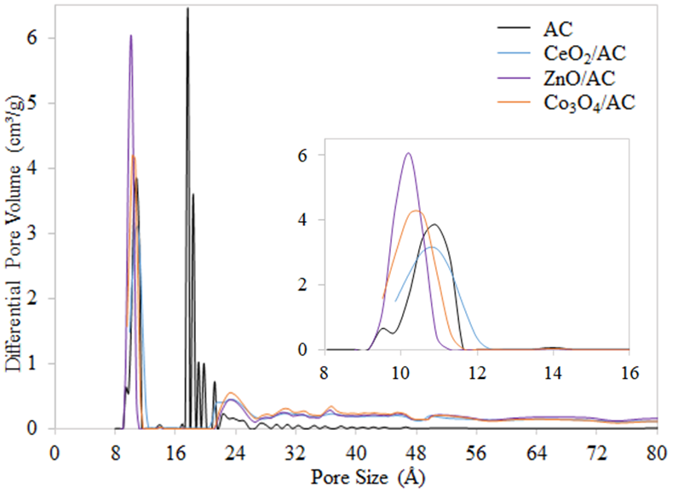
Figure 3. Pore size distribution.

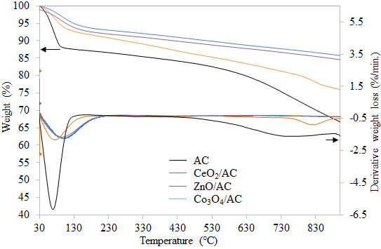
Figure 4. Thermal stability of the adsorbents.

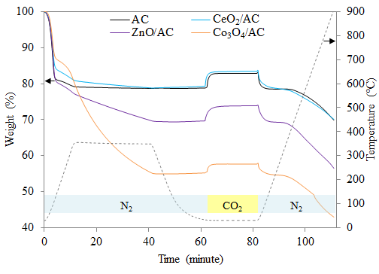
Figure 5. Simultaneous CO₂ adsorption and desorption for all adsorbents with adsorption temperature of 30 ℃.

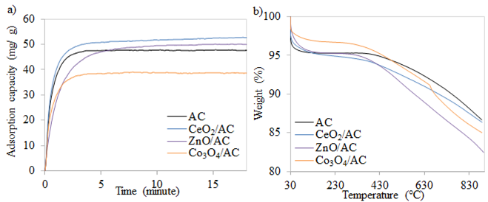
Figure 6. Narrow-angle for the a) CO₂ adsorption at 30 ℃ and b) desorption process.

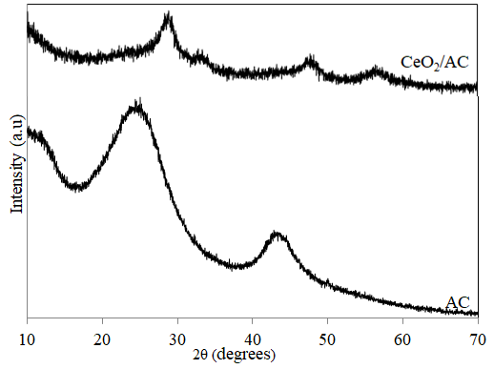
Figure 7. XRD diffractograms.

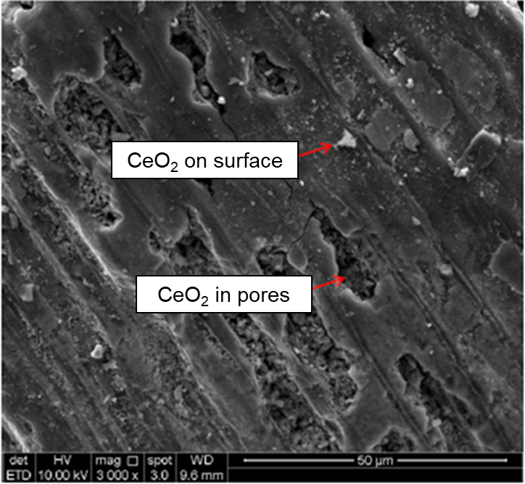
Figure 8. SEM images of CeO₂/AC.

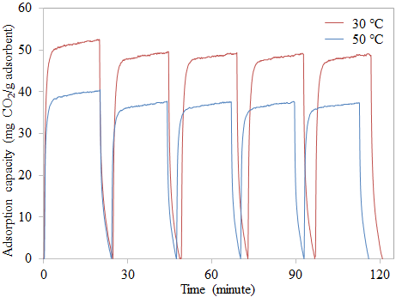
Figure 9. Five cycles of CO₂ capture at adsorption temperature of 30 and 50 ℃.

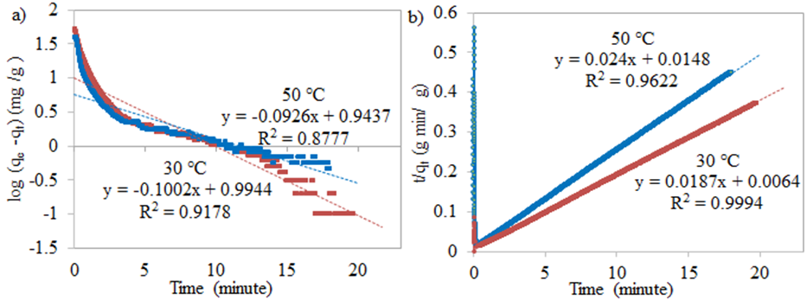
Figure 10. Kinetic plot a) pseudo-first-order kinetic model and b) pseudo-second-order kinetic model at different adsorption temperatures for CeO₂/AC.
H. Hameed, Energy 2013, 61, 440-446.

