Adsorption Kinetics for CO₂ Capture using Cerium Oxide Impregnated on Activated carbon

Azizul Hakim Lahuri^{1*}, Michael Ling Nguang Khai², Afidah Abdul Rahim², Norazzizi Nordin²

¹Department of Science and Technology, Faculty of Agriculture, Science and Technology, Universiti Putra Malaysia Bintulu Campus, P.O Box 396, Nyabau Road, 97008 Bintulu, Sarawak, Malaysia.
²School of Chemical Sciences, Universiti Sains Malaysia, 11800 Gelugor, Pulau Pinang, Malaysia.

*Corresponding author: azizulhakim@upm.edu.my

ABSTRACT
Various metal oxides of CeO₂, ZnO, and Co₃O₄ impregnated on AC were synthesized to determine the CO₂ capture efficiency and analyze with adsorption kinetics model. Batch kinetic studies showed that CeO₂/AC is the most efficient adsorbent with an equilibrium time of 10 minutes was needed to obtain adsorption capacity of 52.68 mg/g. CO₂ adsorption at 30 ℃ exhibits the optimum temperature with only 6.53% loss in adsorption capacity after 5 cycles of CO₂ adsorption-desorption. The CeO₂ on AC was detected through XRD and the SEM image shows well-distributed CeO₂ particles on AC surfaces. CO₂ adsorption at 30 ℃ shows best fitted with pseudo-second-order kinetics with the R² is 0.9994 and the relative error between calculated and experimental adsorption capacity is only 1.32%. The adsorption considering chemisorption responsible for improving adsorption capacity. The addition of CeO₂ on AC enhanced the adsorption capacity by providing active sites to attract CO₂.

Keywords: CO₂ capture; adsorption kinetics; cerium (IV) oxide; activated carbon; recyclability

1. INTRODUCTION
Human population evolution leads to an increase in energy consumption as well as CO₂ gas production from transportation and developing industrial activities. CO₂ is one of the major greenhouse gases that has eventually induced growing concern among the communities due to its environmental effects. Based on National Oceanic and Atmospheric Administration (NOAA)¹, the global CO₂ concentration in the earth’s atmosphere during January 2020 was reported to be 413.40 ppm or which accounts for an increment of 0.63 % compared to 410.83 ppm in January 2019. The current annual mean global CO₂ growth rate at approximately 2.94 ppm in 2019 may cause severe climatic change such as global warming and a rise in seawater level².

The large emission of CO₂ gas from fossil fuel power plants led to a Carbon Capture and Storage (CCS) process which aims to reduce CO₂ emission from a large point source³. In September 2008, an integrated pilot-scale CCS power plant has started operating and estimated to account for a reduction in CO₂ emission up to approximately 80 % compared to power plants without CCS⁴. In order to sustain a better environment for future generations, several approaches to sorption-based technologies were developed to reduce environmental pollution caused by the mass emission of CO₂ gas.

Adsorption technologies as an alternative to the most mature amine-based solvent processes⁵ have started to be considered in the early 1990’s⁶. Liquid amine-based absorbent suffers from a series of unfavorable conditions including the corrosive nature of amines, high cost and high regeneration energy⁷. Therefore solid adsorbents which has a wider temperature range of regeneration, yielding less waste during recycling and with an easier disposing of the procedure of spent adsorbent⁸. Among these technologies, adsorption-based is preferred over absorption-based due to the drawbacks of absorption with aqueous alkanolamine solutions such as high equipment corrosion rate, high energy consumption in regeneration and a large absorbent volume required while adsorbents such as amine-based chemical adsorbents with large surface area, large CO₂ adsorption capacity, high adsorption and desorption rates, high tolerance to moisture, and high selectivity towards CO₂⁹. Furthermore, Yu et al. also reported that 60 % of total energy is consumed for the regeneration of CO₂-rich chemical absorbents⁹.

CO₂ adsorption on solid sorbents can be classified into two mechanisms namely physical adsorption which involving intermolecular forces and chemical adsorption which involve the sharing of electrons by the adsorbent and the adsorbate¹⁰. The emergence of active researches toward solid CO₂ adsorbents along with their properties and performances provides good insights into further developing the progress in this field. Among the adsorption-based sorbents, it includes the low-temperature solid adsorbents (< 200 ℃) such as carbon-based adsorbents¹¹, zeolite-based adsorbents¹², metal-organic framework based adsorbents¹³, alkali metal carbonate-based adsorbents¹⁴, amine-based solid adsorbents¹⁵, the intermediate-temperature solid adsorbents (200-400 ℃) and high-temperature solid adsorbents (> 400 ℃) such as calcium-based adsorbents¹⁶ and alkali ceramic-based adsorbents⁷. Hence, a further modification to obtain easy handling than liquid absorbent by using support materials to impregnate the amine-based sorbent. Several amine-based adsorbents were reported such as monoethanolamine (MEA) on AC¹⁷ exhibits low adsorption capacity (15.40 mg/g) due to the large molecule coating the AC microporous surfaces. Kamarudin et al.¹⁸ have reported various types of amine-functionalized kenaf with tetraethylenepentamine (TEPA) on kenaf showed the highest adsorption capacity (40.22 mg/g) than MEA on kenaf and raw kenaf. A larger molecule of octadecylamine (ODA) on silica gel (SG) which pre-treated at 600 ℃ was found similarly adsorption capacity (15.61 mg/g)¹⁵ with MEA on AC.

The calcium-based adsorbent is a classically used metal oxide adsorbent for capturing CO₂ due to its high reactivity with CO₂ and low-cost material. The reversible reaction between CaO and CO₂ is shown in Equation 1. The forward reaction depicts the adsorption of CO₂ at a temperature between 600 to 700 ℃⁷ to form CaCO₃ while backward reaction depicts the regeneration of CO₂ but requires high heat supply up to 900 to 950 ℃ for next cycle of CO₂ adsorption¹⁹⁻²¹.

CaO (s) + CO₂ (g) ⇌ CaCO₃ (1)

Therefore, an alternative metal oxide was used as adsorbent of CO₂ such as iron oxides (FeO, Fe₂O₃, and Fe₃O₄)²², TiO₂²³, γ-Al₂O₃²³, CeO₂²⁴, SiO₂²⁴, ZrO₂²⁴, and ZnO²⁵. According to Chanapattharapol et al.¹⁰, iron oxide doped MCM-41 adsorbent prepared by impregnation reported higher CO₂ adsorption than the undoped MCM-41 partly due to increased surface area and electron transfer from metal to CO₂. Numerous studies were reported on CO₂ adsorption on activated carbon (AC) due to it is widely available, low cost, and green product. However, AC only offers a weak interaction by physisorption²². Thus, surface modification on the carbonaceous support can contribute to higher selectivity towards CO₂ and increase the adsorption capacity of the porous material. AC surface modification by adding metal oxide of alkali metal, alkaline earth metal, and transition metal provides basicity sites on the AC surfaces. A study reported a successful surface modification of AC loaded with Fe₂O₃ with 103.7 mg/g adsorbent with physisorption mainly contributed by AC and chemisorption contributed by Fe₂O₃²⁶. Other studies were reported using NiO²⁷, MgO²⁸ and CuO²⁹ to modify the AC surfaces and enhance its adsorption capacity. It is notably metal oxide loading on AC increase the adsorption capacity due to significantly attract more CO₂ to be chemically bonded and provide better chemisorption properties for the adsorbent.

Recently, ionic liquid-based and deep eutectic solvent (DES)-based materials were applied to the CO₂ capture. Marliza et al. reported ionic liquid functionalized SiO₂ shows highest adsorption capacity for 1-butyl-3-methylimidazolium trifluoromethanesulfonate, [bmim][CF₃SO₃]/SiO₂ than SiO₂ only³². Addition of NiO to the 1-ethyl-3-methylimidazolium hydrogensulfate, [emim][HSO₄] functionalized SiO₂ shows enhance in adsorption capacity due to higher surface area than 10%[emim][HSO₄]/SiO₂³³. Green technology application through the DES of Choline chloride: urea (ChCl:U) is biocompatible, non-toxic, biodegradable, inexpensive and easy to prepare³⁴. The ChCl:U functionalized silica gel was found to have lower adsorption capacity (22.30 mg/g) due to lower surface area (317.50 m²/g)³⁴ of the adsorbent rather than ChCl:U functionalized AC³⁵ which exhibits higher surface area (581.23 m²/g) and adsorption capacity. Nonetheless, the significance of desorption properties for the adsorbents are not reported for these works. The performance of various adsorbents was tabulated in Table 1.

In the present work, double activation will be performed on AC to reactivate the surfaces. The metal oxides of ZnO, CeO₂, and Co₃O₄ was added to the modified AC. These metal oxides were chosen based on the previous study which the metal oxides on AC are not yet discovered its adsorption capacity and adsorption kinetics. Hence, the specific aim of this work is to measure the adsorption capacity, evaluate the desorption properties, identify the most efficient metal loaded on AC, and determine optimum adsorption temperature with adsorption kinetics analysis for CO₂ capture.

Table 1. Adsorption capacities of various adsorbents.
Adsorbent | Adsorption  Capacity (mg/g) | Adsorption  Temperature (℃) | CO₂  Purity | Sources
35%ODA/SG600 | 15.61 | 25 | 99 % | 15
MEA/AC | 15.40 | 25 | 15 % | 16
Raw kenaf | 27.46 | 30 | 99.99 % | 17
50%MEA-Kenaf | 34.36 | 30 | 99.99 % | 17
50%TEPA-Kenaf | 40.22 | 30 | 99.99 % | 17
MCM-41 | 35.00 | 25 | n.a | 10
Fe₂O₃/MCM-41 | 38.40 | 25 | n.a | 10
NiO | 14.14 | 25 | 99 % | 25
CeO₂ | 48.00 | 25 | > 99.5 % | 30
Fe₂O₃ | 17.00 | 25 | 99 % | 31
SiO₂ | 33.73 | 25 | 99 % | 32
1%[bmim][CF₃SO₃]/SiO₂ | 66.71 | 25 | 99 % | 32
10%NiO/[emim][HSO₄]/SiO₂ | 48.80 | 25 | 99 % | 33
10%[emim][HSO₄]/SiO₂ | 26.70 | 25 | 99 % | 33
10%ChCl:U/SG200 | 22.30 | 30 | 99 % | 34
ChCl:U/AC | 39.40 | 25 | 15 % in N₂ | 35

2. EXPERIMENTAL

2.1 Sample Preparation
Charcoal activated carbon (Qrec), cobalt (II) sulfate heptahydrate (Hamburg), cerium (III) nitrate hexahydrate (Nacalai Tesque), and zinc sulfate heptahydrate (R&M) were used as precursors. Moisture removal was conducted by drying the AC in an oven for 2 hours at 110 ℃. AC was performed double activation by using readily purchase AC to reactivate by using KMnO₄. For the support treatment, AC was weighed to 5 g and was added into a solution of 0.1 M KMnO₄. The mixture was shaken for 20 minutes at 200 rpm and followed by filtering and rinsing with 200 mL distilled water. The AC was dried in an oven overnight at 110 ℃. The adsorbents were prepared by a conventional wet impregnation method. Generally, 0.1 M metal salt was prepared in a 50 mL volumetric flask. AC was added to the metal salts solution and shaken for 8 hours at 200 rpm. The mixture was filtered and rinsed with 400 mL of 1 % NaHCO₃ solution and followed by soaking overnight in 600 mL of 1 % NaHCO₃ solution. Soaked samples were filtered and rinsed with distilled water and allowed to air dry for 2 hours. The samples were dried overnight in an oven at 110 ℃. The resultant adsorbents were denoted as metal oxide/activated carbon (MO/AC) where MO represents Co₃O₄, CeO₂, ZnO.

2.2 CO₂ Adsorption and Desorption
The CO₂ adsorption was measured by using thermogravimetric analysis-derivative thermogravimetry (TGA-DTG) from a Simultaneous Thermal Analyzer (STA) 6000, Perkin Elmer. Approximately 10 mg of each sample was cleaned at 350 ℃ in the N₂ atmosphere prior to adsorption measurement. The adsorbent was heated from 30 to 350 ℃ at 30 ℃/min and was cooled to 30 ℃. The CO₂ adsorption was conducted at 30 ℃ for 20 minutes. The adsorption capacity was measured from the weight gained after the saturation exposure. Finally, the gas feed was switched to the N₂ atmosphere and was heated again up to 900 ℃ for the desorption process. The carbonate dissociation temperature was determined to perform the recyclability test at different adsorption temperature.

2.3 Adsorbent Characterization
The infrared spectra of various metal oxides supported on AC were recorded between 400 and 4000 cm⁻¹ using FTIR (PerkinElmer) with KBr pellet method for sample preparation. N₂ adsorption-desorption isotherms were measured on a static volumetric technique instrument (Micromeritics ASAP 2020) for determination of the BET surface area, mesopore surface area, micropore surface area, total pore volume, micropore volume, and the average pore diameter. The pore size distribution was computed using DFT method. Approximately 0.5 g of each adsorbent was degassed at 350 ℃ under vacuum prior to the measurement for the elimination of humidity gases trapped in the adsorbents. A water circulating bath was used to control the temperature. The N₂ adsorption-desorption isotherms were recorded at liquid nitrogen temperature of 77 K, and applied in a relative pressure (P/Po) ranging from 0 to 1.0. The surface area (S_{BET}) was calculated by using a commonly used method called Brunauer-Emmett-Teller (BET) method. All surface area measurements were calculated from the nitrogen adsorption-desorption isotherms by assuming the N₂ molecule to be 0.162 nm². The t-plot method was used to calculate the mesopore surface area (S_{meso}), micropore surface area (S_{micro}) and micropore volume (V_{micro}). The total pore volume (V_{tot}) was obtained by converting the amount of N₂ gas adsorbed (in cm³/g at STP) at relative pressure to the volume of gas adsorbate.

The most efficient adsorbent was characterized by its phase composition and surface morphology. X-ray Diffraction (XRD) pattern was obtained by using XRD diffractometer (Bruker D8 Advance). The crystal structures were verified by recording 2θ diffraction angle from 10° to 70° and matched with standard diffraction data (JCPDS) file for interpretation of the crystalline phase. The surface micrograph of the most efficient adsorbent was observed using a scanning electron microscope (Quanta 650 field emission gun SEM).

2.4 Adsorption optimization and recyclability test
The most efficient adsorbent was optimized with different adsorption temperatures of 30 and 50 ℃. The recyclability test was performed for 5 cycles of CO₂ adsorption and desorption by using the aforementioned TGA-DTG analysis. Generally, for the first cycle, the adsorbent will start with the cleaning process, cooled to desirable adsorption temperature (30 or 50 ℃), CO₂ adsorption, and CO₂ desorption process. After cooling to desirable adsorption temperature, the second cycle CO₂ adsorption starts again and followed by the desorption process. These methods were repeated up to 5 times to determine the regeneration properties of selected adsorbents.

2.5 Adsorption kinetics study
The experimental data for CO₂ adsorption of the most efficient adsorbent at different adsorption temperatures were analyzed with kinetic models such as the pseudo-first-order kinetic model and pseudo-second-order kinetic model. The adsorption kinetics describes CO₂ uptake rate controls with adsorption time of adsorbate uptake at the solid and gas interface.

3. RESULTS AND DISCUSSION

3.1 Adsorbent characterization
FTIR spectra were recorded to investigate the functional groups of activated carbon before and after impregnation with various metal oxides as it offers the properties of molecules and characteristics of chemical bonds. The IR spectra and absorption bands are shown in Figure 1 and Table 2 respectively. A typical band at 3406 cm⁻¹ is indicative of O-H stretching due to the hydrogen bond caused by moisture content in the sample²². The intensity of the strong band decreased after the impregnation of metal oxide onto activated carbon. This indicating that moisture content was decreased which might be due to the metal oxides deposited on AC blocked the moisture to be easily trapped.

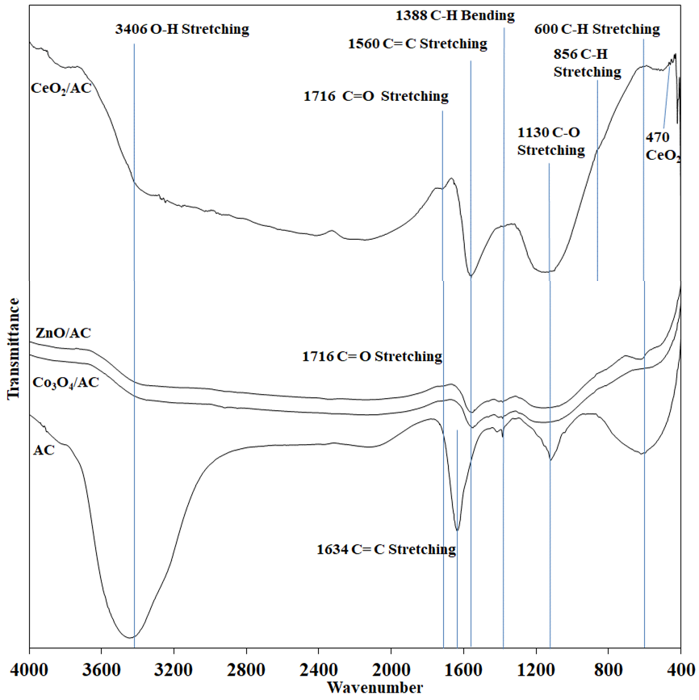
Figure 1. IR spectra of AC and various MO/AC.

Table 2. Vibrational frequencies IR spectroscopy of various MO/AC.
Vibrational modes | This study (cm⁻¹) | Reference (cm⁻¹)
O-H Stretching | 3406 | 3412
C=O stretching | 1716 | 1716
C=C Stretching | 1634 | 1633
C=C Stretching | 1560 | 1550
C-H Bending | 1388 | 1390
C-O Stretching | 1130 | 1130
C-H Stretching | 600 | 600
Ce-O | 470 | 459
The bands at 1643, 1388 and 600 cm⁻¹ are reported to be characteristic absorption bands of activated carbon corresponding to C=C stretching, C-H bending and C-H stretching respectively³⁶. The decrease of intensities in these bands after impregnation with metal oxides is indicative of the deposition of metal oxides has reduced the absorption bands for AC³⁷. Nonetheless, reactivating the AC for the MO/AC adsorbents contribute to the alteration of surface nature by introducing oxygen-containing functional groups of C=O at 1716 cm⁻¹and changing intensities for C-O stretching at 1130 cm⁻¹. This explains KMnO₄ oxidizing the surface of AC, besides forming pores structure which is in agreement with Zhang et al.³⁸. The peak at 1634 shows a large redshift of 74 cm⁻¹ compared to 1560 cm⁻¹, after loading of metal oxides which also occurred in a study conducted by Zhao et al.³⁹ using silver loaded on activated carbon. While the bands at 470 cm⁻¹ are ascribed to the characteristic bands of metal oxides CeO₂⁴⁰ respectively.

The N₂ adsorption-desorption isotherms are shown in Figure 2. According to IUPAC classification, all of the isotherms exhibit Type I isotherm⁴¹. The initial steep region is attributed to strong adsorption by a typical microporous material. Hysteresis loop closing at around relative pressure 0.4 can be observed in all isotherms, indicating that the mesoporosity of slit-shaped pores to be present in the samples²⁶. The adsorbents show H4 hysteresis that associated with porous materials which indicating a narrow slit-shaped pore⁴². The N₂ adsorption-desorption isotherm for AC has the highest steep initial region ascribed from high micropore structure that easily occupied. The hysteresis of metal oxides loaded AC shows a larger area indicating of high mesopore structure. These are correlated with the textural properties tabulated in Table 3. The formation of mesopores may be due to that metal oxide burning off carbon wall and enlarging pore sizes during thermal treatment.

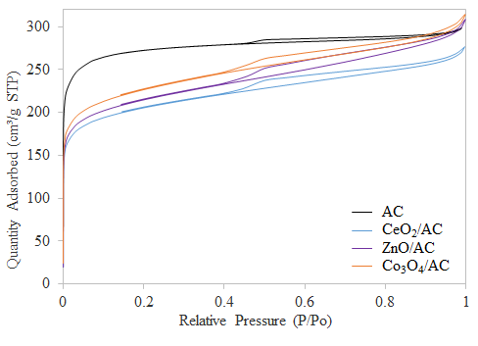
Figure 2. N₂ adsorption-desorption isotherms of the adsorbents.

Table 3. The textural characteristics of the adsorbents.
Adsorbent |  | AC | CeO₂/AC | ZnO/AC | Co₃O₄ /AC
Surface area | S_{BET} (m²/g) | 1043.6 | 763.4 | 792.9 | 838.5
Surface area | S_{meso} (m²/g) | 171.0 | 254.1 | 280.4 | 302.2
Surface area | S_{micro} (m²/g) | 872.6 | 509.4 | 512.5 | 536.3
Pore Volume | V_{total} (cm³/g) | 0.46 | 0.42 | 0.45 | 0.47
Pore Volume | V_{micro} (cm³/g) | 0.35 | 0.21 | 0.21 | 0.22
Average pore  diameter  (nm) |  | 1.8 | 2.2 | 2.3 | 2.2
where S_{BET} is surface area by BET method; S_{mic} is micropore surface area by t-plot method; V_{total} is single point total pore volume; V_{micro} is micropore volume by the t-plot method

The BET surface area decreased with the loading of metal oxides onto AC samples (Table 3) indicating that the pores of the AC are blocked or covered²⁶. However, an increase in micropore surface area and mesopore surface area ascribed from reactivation of ACs by chemical treatment with KMnO₄ prior to metal oxide impregnation. It is notably Co₃O₄/AC has a higher surface area compared to CeO₂/AC and ZnO/AC. This presumes that the Co₃O₄ particles are deposited on AC surfaces instead of pores due to larger particle size. Thus, the pores generated from Co₃O₄ also contribute to the increment of the adsorbent’s surface area. The reduction in micropore volume after impregnated with metal oxides is mainly attributed to the addition of metal oxides particles which tend to deposit on the AC surfaces, deposited on the pores and fill the pores.

The density functional theory (DFT) method was used to compute pore size distribution (Figure 3) of the microporous AC containing various metal oxides. Although AC has a lower intensity of distribution at the region of 0.9-1.2 nm as shown in the inset of Figure 3, the AC possessed the highest distribution in the region of 1.6-2.0 nm. Thus, it has a high micropore structure in which the diameter of the pores is below 2 nm. Most of the metal oxides generated unable to enter the pores below 1.2 nm because the distribution in the region is less affected. Nonetheless, the distribution in the region of 1.6-2.0 nm was diminished might be due to the possibility of the metal oxides able to enter the pores or deposited on the pores. Above the 2.1 nm, higher distribution of pore size attributed by the pores of metal oxides generated on AC.

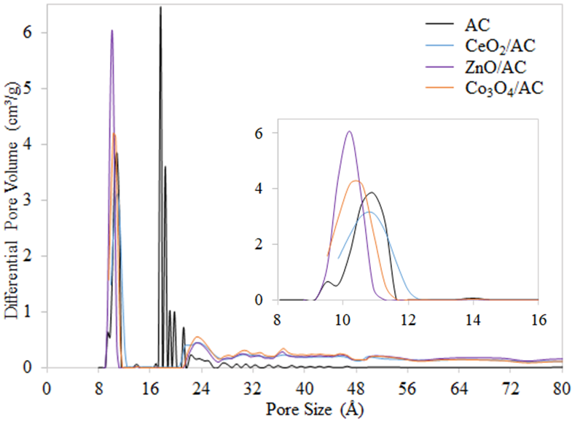
Figure 3. Pore size distribution.

Thermal stability of various metal oxides impregnated on AC was computed using thermogravimetric analysis by heating up to 900℃ (Figure 4). The initial steep region of weight loss was attributed to moisture removal. No distinct peak of derivative weight loss was observed at higher temperature implying that the samples were resistant toward heat. The Co₃O₄/AC shows a derivative weight loss peak at a temperature of 830 ℃ which corresponded to the decomposing temperature of Co₃O₄⁴³. This phenomenon can be attributed to two possible factors of decomposition during thermal treatment for Co₃O₄ is incomplete or the regeneration of Co₃O₄.

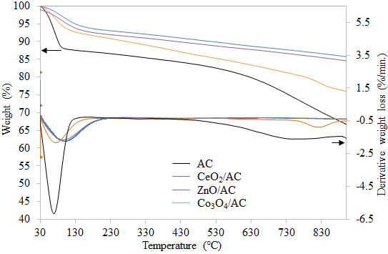
Figure 4. Thermal stability of the adsorbents.

3.2 CO₂ capture
CO₂ capture was performed using TGA and the wide-angle of the thermograms was plotted as shown in Figure 5. The CO₂ adsorption and desorption process are shown in the narrow-angle of Figures 6a and 6b respectively. The adsorption capacity was obtained from the weight gain of Figure 6a. At the beginning of the adsorption, it is observed that the initial steep region indicates the amount of CO₂ adsorbed on CeO₂/AC and AC are faster than ZnO/AC and Co₃O₄/AC. Eventually, the adsorption gradually decreases when the progress of the adsorption process reaches equilibrium. Figure 6a demonstrated the adsorption process has reached equilibrium state at the time of 5 minutes for AC and Co₃O₄/AC; 10 minutes for CeO₂/AC; 13 minutes for ZnO/AC. Steep initial region corresponded to stronger binding force in between CO₂ with metal oxides and CO₂ with micropores of AC. At the knee-shaped region, the multilayer CO₂ adsorption on the adsorbent formed by occupying CO₂ adsorbate on the uneven bonded CO₂ surface and creating CO₂-CO₂ interaction. It is noteworthy to observe that CeO₂/AC and ZnO/AC show higher adsorption capacity at equilibrium state compared to AC only. This is indicative of CeO₂ and ZnO possesses higher basic properties compared to Co₃O₄. Whereas AC was unable to hold CO₂ strongly compared to those with the presence of metal oxides on AC. Although AC only exhibits the highest surface area, the adsorption capacity was observed lower than CeO₂/AC. This explains reactivate the AC by using chemical activation of KMnO₄ may improve AC surface nature, may altering the properties of AC, including pore structure and purity. The significance of double activation increasing the oxygen functional group that resulting enhancement of AC surfaces and adsorption capacity.

Furthermore, the AC surface modification by impregnation of CeO₂ provides basic active sites that chiefly responsible for the formation of carbonate species and enhancing adsorption capacity. The formation of carbonate species by CO₂ chemisorption reaction pathway can be simplified as in Equation 2.

CO₂ (adsorbate) + O (surface of CeO₂) [CO₂-O] CO₃ (chemisorption) (2)

The chemisorption allows the active sites from the oxygen surface of CeO₂ to exchange electron with CO₂ forming carbonate species product. This could be the reason for the presence of metal oxides that may hold the CO₂ firmly at equilibrium state compared to AC only. Lower in adsorption capacity for Co₃O₄/AC compared to AC only might also be attributed to the weakly adsorbed CO species by cobalt ion which can be fully desorbed at 230K (-43 ℃) as reported by Ferstl et al.⁴⁴.

The thermograms for the desorption process (Figure 6b) shows CeO₂/AC has the highest weight loss up to around 400 ℃ for CO₂ regeneration. It has a relatively lower CO₂ desorption temperature of 160-280 ℃⁴⁵. Hence, the carbonate product will be dissociated to regenerate as CO₂ and leaving the adsorbent that suitable to be reused for the next cycle. The desorption temperature above 400 ℃ resulting in greater weight loss for all adsorbents. Thus, the desorption temperature up to 400 ℃ will be deployed for the recyclability test.

The adsorption capacity for all adsorbents and similar works were tabulated in Table 4. Among the synthesized adsorbents, CeO₂/AC shows the highest adsorption capacity of 52.78 mg/g at equilibrium. Therefore, CeO₂/AC was chosen as the most efficient adsorbent for further performance optimization through the recyclability test at different adsorption temperature. In comparison with unmodified AC was used to load with 10 % CeO₂ (ACCe-HT) and CuO (ACCu-HT) separately by using hydrothermal treatment ⁴⁶ shows lower adsorption capacity than this work (Table 4). Meanwhile, Heo et al.²⁸ deployed a slightly complicated method than that of this work but obtaining a comparable CO₂ adsorption capacity through 12 minutes microwave radiated synthesis of MgO on microporous carbon (MC).

Several common activating agents were reported such as zinc chloride (ZnCl₂), potassium hydroxide (KOH), hydrochloric acid (HCl), nitric acid (HNO₃) and phosphoric acid (H₃PO₄)⁴⁷. This study reported double activation of AC by reactivating with KMnO₄. The significance of chemical activation over physical activation was reported in which chemical activation by using ZnCl₂ is a promising method to obtain better textural properties for AC derived from palm kernel shell (PCAC)⁴⁸. By loading BaO on PCAC, it was observed to be the best adsorbent for CO₂ capture ascribed from the highest BET surface area. Meanwhile, Plaza et al.⁴⁹ reported AC from the spent coffee ground shows higher CO₂ adsorption capacity by chemical activation using KOH than physical activation.

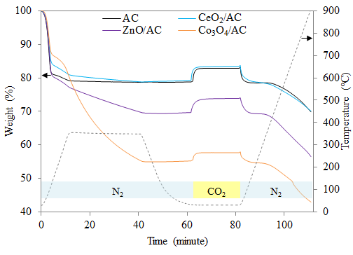
Figure 5. Simultaneous CO₂ adsorption and desorption for all adsorbents with adsorption temperature of 30 ℃.
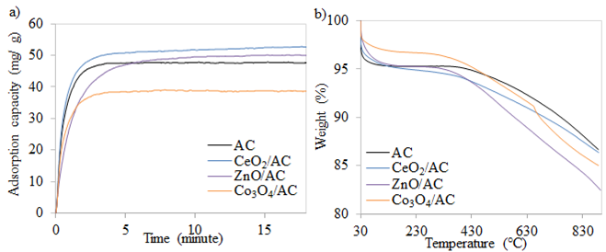
Figure 6. Narrow-angle for the a) CO₂ adsorption at 30 ℃ and b) desorption process.

Table 4. Adsorption capacities of various sorbents.
Adsorbent | Adsorption  Capacity (mg/g) | Adsorption  Temperature (℃) | CO₂  Purity | Sources
AC | 52.01 | 30 | 99 % | This study
CeO₂/AC | 52.78 | 30 | 99 % | This study
ZnO/AC | 52.06 | 30 | 99 % | This study
Co₃O₄/AC | 43.17 | 30 | 99 % | This study
ACCe-HT | 37.66 | 30 | 20 % | 47
ACCu-HT | 25.74 | 30 | 20 % | 47
Mg-MCs-12 | 53.68 | 40 | 15 % in N₂ | 28

The phase composition of CeO₂/AC was determined by XRD diffractograms as shown in Figure 7. Typical graphitic structure for AC with broad amorphous diffraction peaks at 2θ values of 26º and 43º. After loading with CeO₂, the amorphous peaks decreased and shifted from 26 º and 43º toward 29º and 48º respectively. Another new diffraction peak was observed at 56º. These three diffraction peaks are the reflections of the (111), (220) and (311) crystallographic planes of the cubic CeO₂ phase⁵⁰. The CeO₂/AC surface morphology (Figure 8) shows the well-distributed of fine particles CeO₂ on AC surfaces. Reactivating the AC resulting scavenging effect to the AC surface and resulting slightly enlargement of the pore structure. The SEM image supporting the prediction from the textural properties with a possibility of the CeO₂ able to enter the pores of AC and deposited on AC surfaces.

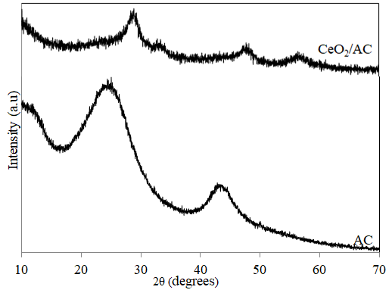
Figure 7. XRD diffractograms.

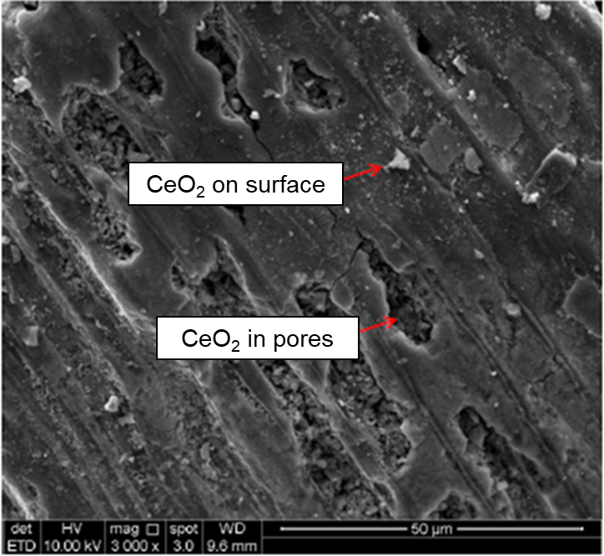
Figure 8. SEM images of CeO₂/AC.

3.3 Recyclability test
Five cycles of CO₂ adsorption-desorption was conducted to optimize the performance for CeO₂/AC at different adsorption temperature of 30 and 50 ℃ (Figure 9). It is interesting to note that the adsorption capacity is higher for the adsorption temperature of 30 ℃ than 50 ℃. At adsorption temperature of 30 ℃, the loss in adsorption capacity was only 6.53 % with a decrease from first to fifth cycles is 52.50 mg CO₂/ g adsorbent to 49.07 mg CO₂/ g adsorbent respectively. Whereas at adsorption temperature of 50 ℃, there was a 7.86% loss in adsorption capacity with a decrease from first to fifth cycles is 40.56 mg CO₂/ g adsorbent to 37.37 mg CO₂/ g adsorbent respectively. This build relationship that adsorption capacity decrease as the adsorption temperature increase. According to Rashidi et al.⁵¹, an exothermic process where physisorption is favored at lower temperature implies the existence of physisorption throughout the process of adsorption. Thus, at a temperature above 30 ℃, the adsorbate of CO₂ has the tendency to desorb during the adsorption period has reach equilibrium and leads to lower adsorption capacity.

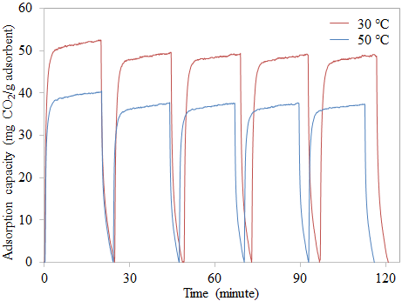
Figure 9. Five cycles of CO₂ capture at adsorption temperature of 30 and 50 ℃.

3.4 Kinetic Analysis
The CO₂ adsorption kinetics data for CeO₂/AC at different operating adsorption temperatures from the first cycle was fitted by using two kinetic models namely pseudo-first-order (Equation 3), pseudo-second-order kinetic model (Equation 4).
$\log\left(q_{e}- q_{t}\right)= \log{q_{e}}-\left(\frac{k_{1}}{2.303}\right)t$ (3)
$\frac{t}{q_{t}}= \frac{1}{k_{2}q_{e}^{2}}+\left(\frac{1}{q_{e}}\right)t$ (4)
where q_{t} and q_{e} are the adsorption capacity at any particular time t and at equilibrium respectively, and k₁ is the pseudo-first-order kinetic constant, k₂ is the pseudo-second-order kinetic constant and (k₂·q_{e}²) is initial adsorption rate. The kinetic linear plot using two equations above to evaluate the mechanism of the adsorption process is shown in Figure 10. The kinetic parameters were tabulated in Table 5.

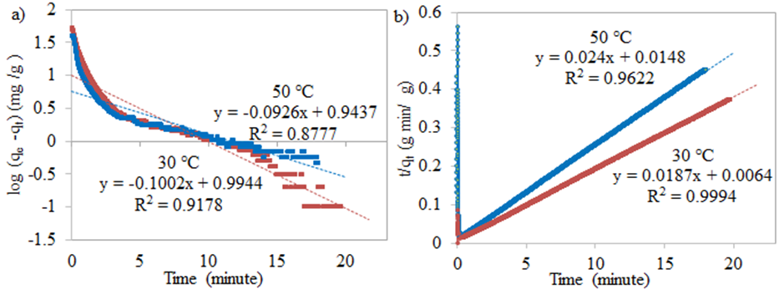
Figure 10. Kinetic plot a) pseudo-first-order kinetic model and b) pseudo-second-order kinetic model at different adsorption temperatures for CeO₂/AC.

Table 5. Kinetic parameters of CO₂ adsorption onto CeO₂/AC.
Kinetic model | Parameter | Temperature (℃)
Kinetic model | Parameter | 30 | 50
Kinetic model | q_{e(act)} (mg/g) | 52.78 | 40.56
Pseudo-first order kinetic | q_{e(cal)} (mg/g) | 9.87 | 8.78
Pseudo-first order kinetic | k₁(1/min) | 0.2308 | 0.2132
Pseudo-first order kinetic | R² | 0.9178 | 0.8777
Pseudo-first order kinetic | Relative error (%) | 81.29 | 78.34
Pseudo-first order kinetic | q_{e(cal)} (mg/g) | 53.47 | 41.67
Pseudo-first order kinetic | k₂ (g/mg  min) | 0..0546 | 0.0389
Pseudo-first order kinetic | h (mg/g min) | 156.14 | 67.57
Pseudo-first order kinetic | R² | 0.9994 | 0.9622
Pseudo-first order kinetic | Relative error (%) | 1.32 | 2.74
where q_{e(act)} = actual adsorption capacity; q_{e(cal)} = calculated adsorption capacity

Pseudo-second-order kinetic model shows the correlation coefficient values of R² are 0.9994 and 0.9622 for both adsorption temperatures of 30 and 50 ℃ respectively. The relative error between actual adsorption capacity and calculated adsorption capacity shows only 1.32 and 2.74 % for adsorption temperatures of 30 and 50 ℃ respectively. The pseudo-first-order kinetic model shows high R² at 0.9178 and 0.8777 for CO₂ adsorption at 30 and 50 ℃ respectively. Nonetheless, the calculated adsorption capacity significantly deviates from the actual adsorption capacity with a relative error of 81.29 and 78.34 % for adsorption temperatures at 30 and 50 ℃ respectively. Based on these R² values and relative errors, the pseudo-second-order kinetic model fits the CO₂ adsorption kinetic profiles relatively better than the pseudo-first-order kinetic model at both adsorption temperatures of 30 and 50 ℃. This suggests the CO₂ adsorption incline towards chemisorption although both of the physisorption and chemisorption have existed. It might be the limiting step involving the exchange electron between CeO₂ and CO₂ adsorbate resulting in the adsorption process mainly governed by monolayer adsorption referring to chemical phenomena. This proving that AC surface reactivation with the addition of CeO₂ could enhance the adsorption capacity by chemisorption.

4. CONCLUSION
Various metal oxides impregnated on chemically reactivate of AC were successfully synthesized. SEM images and XRD pattern confirm that CeO₂ were highly dispersed on the AC surface. FTIR showed the characteristic peaks for the increased oxygen-containing functional group on activated carbon. All the MO/AC showed great thermal stability with high resistance toward heat up to 900 ℃ except Co₃O₄/AC. The CeO₂/AC exhibited the most efficient adsorbent with an adsorption capacity of 52.78 mg/g at the equilibrium state of 10 minutes. It showed only a 6.53% loss in adsorption capacity after five cycles and a relatively lower desorption temperature of 160-280 ℃ which requires less energy consumption. The pseudo-second-order kinetic model was best fitted compared to the pseudo-first-order kinetic model with a relatively higher correlation coefficient which implies not only physisorption but chemisorption is significant for CeO₂/AC.

5. ACKNOWLEDGEMENT
The authors are grateful to the Department of Science and Technology, Universiti Putra Malaysia Kampus Bintulu and School of Chemical Sciences, Univerisiti Sains Malaysia for the research facilities. The authors wish to thanks the Ministry of Higher Education for the financial support for grant numbers of GP-IPM-9657200, GP-IPM-9559000, 1001.PKIMIA.811333 and 1001.PKIMIA.822215.

6. REFERENCES

1. National Oceanic and Atmospheric Administration (NOAA), Recent Global CO₂, https://www.esrl.noaa.gov/gmd/ccgg/trends/global.html (accessed: March 3rd, 2020)

2. N. Mimura, P. Jpn. Acad. B Phys. Bio. Sci. 2013, 89(6), 281-301.

3. J. R. Fanchi, C. J. Fanchi, Energy in the 21st Century, Fourth Edition, World Scientific, Singapore, Singapore, 2016.
4. B. Metz, O. Davidson, H. D. Coninck, M. Loos, L. Meyer, IPCC special report on carbon dioxide capture and storage, Cambridge University Press, New York, United States, 2005.
5. W. Yuan, Z. Li, A. Otto, M. Robinius, D. Stolten, Energy Procedia. 2017, 114, 650-665.
6. E. S. Kikkinides, R. T. Yang, S. H. Cho, Ind. Eng. Chem. Res. 1993, 32, 2714-2720.
7. Q. Wang, Q. J. Luo, Z. Zhong, A. Borgna, Energ. Environ. Sci. 2011, 4(1), 42-55.
8. J. Gale, Y. Kaya, Greenhouse Gas Control Technologies, Pergamon, New York, United States, 2003.
9. C. H. Yu, C. H. Huang, C. S. Tan, Aerosol Air Qual. Res. 2012, 12(5), 745-769.
10. K. C. Chanapattharapol, S. Krachuamram, S. Youngme, Micropor. Mesopor. Mat. 2017, 245, 8-15.
11. A. E. Ogungbenro, D. V. Quang, K. Al-Ali, M. R. M. Abu-Zahra, Energy Procedia. 2017, 114, 2313-2321.
12. R. Kodasma, J. Fermoso, A. Sanna, Chem. Eng. J. 2018, 358, 1351-1362.

13. C. E. Bien, K. K. Chen, S. C. Chien, B. R. Reiner, L. C. Lin, C. R. Wade, W. S. W. Ho, J. Am. Chem. Soc. 2018, 140(40), 12662-12666.

14. S. S. Shang, A. Hanif, M. Z Sun, Y. M. Tian, Y. S. Ok, I. K. M.Yud, D. C.W. Tsang, Q. F. Gue, J. Shang, J. Hazard, Mater. 2019, 373, 285-293.

15. M. N. Abu Tahari, A. Hakim, T. S. Marliza, N. H. Mohd, M. A. Yarmo, Mater. Sci. Forum 2017, 888, 529-533.

16. M. A. Naeem, A. Armutlulu, Q. Imtiaz, C. R. Meller, ChemPhysChem. 2017, 18, 3280-3285.
17. A. Boonpoke, S. Chiarakorn, N. Laosiripojana, S. Towprayoon, Korean J. Chem. Eng. 2012, 29, 89-94.

18. K. S. N. Kamarudin, N. Zaini, N. E. A. Khairuddin, J. Environ. Chem. Eng. 2018, 6, 549-559.

19. S. Lin, T. Kiga, Y. Wang, K. Nakayama, Energy Procedia 2011, 4, 356-361.

20. S. C. Tian, J. G. Jiang, F. Yan, K. M. Li, X. J. Chen, V. Manovic, Green Chem. 2016, 18, 4022-4031.

21. S. Wongsakulphasatch, K. Sukchoknamchai, N. Suthapot, W. Praikaew, C. Chaisuk, W. Kiatkittipong, N. Laosiripojana, S. Assabumrungrat, S. MATEC Web of Conferences 2018, 192, 03057.

22. A. Hakim, T. S. Marliza, M. N. Abu Tahari, W. N. R. Wan Isahak, M. R. Yusop, M. W. Mohamed Hisham, M. A. Yarmo, Ind. Eng. Chem. Res. 2016, 55(29), 7888-7897.

23. J. Baltrusaitis, J. Schuttlefield, E. Zeitler, V. H. Grassian, 2011. Chem. Eng. J. 2011, 170, 471-481.

24. K. Yoshikawa, H. Sato, M. Kaneeda, J. N. Kondo, J. CO₂ Util. 2014, 8, 34-38.

25. Y. M. Wang, R. Kováčik, B. Meyer, K. Kotsis, D. Stodt, V. Staemmler, H. S. Qiu, F. Traeger, D. Langenberg, M. Muhler, C. Wöll, Angew. Chem. Int. Edit. 2007, 46, 5624-5627.

26. A. Hakim, M. N. Abu Tahari, T. S. Marliza, W. N. R. Wan Isahak, M. R. Yusop, M. W. M. Hisham, M. A. Yarmo, J. Teknol. (Sci. Eng.). 2015, 77(33), 75-84.

27. A. Hakim, W. N. R. Wan Isahak, M. N. Abu Tahari, M. R. Yusop, M. H. Mohamed Wahab, M. A. Yarmo, Adv. Mat. Res. 2015, 1087, 45-49.

28. Y. J. Heo, S. J. Park, Sci. Rep. 2017, 5653, 1-9.

29. W. N. R. Wan Isahak, Z. A. Che Ramli, A. Z. Lahuri, M. R. Yusop, M. H. Mohamed Wahab, M. A. Yarmo, Adv. Mat. Res. 2015, 1087, 111-115.
30. C. Slotowski, S. Marre, P. Dagault, O, Babot, T. Toupance, C. Aymonier, J. CO₂ Uti., 2017, 20, 52-58.
31. A. Hakim, M. A. Yarmo, T. S. Marliza, M. N. A. Tahari, W. Z. Samad, M. R. Yusop,M. W. M. Hisham, N. Dzakaria, Malaysian J. Anal. Sci. 2016, 20(6), 1286-1298.
32. T. S. Marliza, M. A. Yarmo, A. Hakim, M. N. A. Tahari, Y. H. Taufiq-Yap, Mater. Sci. Forum, 2017, 888, 485-490.

33. T. S. Marliza, M. A. Yarmo, A. Hakim, M. N. A. Tahari, M. W. M. Hisham, Y. H. Taufiq-Yap, AIP. 2017, 20008, 1-8.
34. Z. Ghazali, N. H. Hassan, M. A. Yarmo, L. P. Teh, R. Othaman, Sains Malays. 2019, 48(5), 1025-1033.
35. N. Z. Zulkurnai, U. F. Md. Ali, N. Ibrahim, N. S. Abdul Manan, E3S Web Conf. 2018, 34, 02030.
36. S. Ge, Z. Liu, Y. Furuta, W. Peng, Saudi J. Biol. Sci. 2017, 24(6), 1370-1374.

37. G. Zhang, J. Qu, H. Liu, A. T. Cooper, R. Wu, Chemosphere 2007, 68(6), 1058-1066.

38. G. Zhang, Y. Sun, P. Zhao, Y. Xu, A. Su, J. Qu, J. CO₂ Util. 2017, 20, 129-140.

39. H. Zhao, F. Wang, Y. Ning, B. Zhao, F. Yin, Y. Lai, K. Hu, Sci. Rep. 2013, 3, 1511.

40. G. H. Hara Priya, N. Sunganya, V. Jaisankar, Int. J. Adv. Chem. Sci. Appl. 2015, 3, 6-14.

41. K. S. W. Sing, D. H. Everett, R. A. W. Haul, L. Moscou, R. A. Pierotti, J. Rouquerol, Pure & Appl. Chem. 1985, 57(4), 603-619.

42. J. B. Condon, Surface Area and Porosity Determinations by Physisorption: Measurements and Theory, first ed., Oxford, United Kingdom, Elsevier B. V., 2006.

43. G. A. El-Shobaky, A. S. Ahmad, A. N. Al-Noaimi, H. G. El-Shobaky, J. Therm. Anal. 1996, 46(6), 1801-1808.

44. P. Ferstl, S. Mehl, M. A. Arman, M. Schuler, A. Toghan, B. Laszlo, J. Knudsen, J. Phys. Chem. C 2015, 119(29), 16688-16699.

45. V. Savin, V. Sobolev, Z. Eremenko, Z. Grigor'eva, J. Anal. Chem.-USSR. 1985, 59(3), 571-575.

46. H. Madzaki, W. A. W. A. K. Ghani, S. Y. Thomas Choong, U. Rashid, N. Muda, J. Kejuruteraan. 2018, 30(1), 31-38.

47. I. Senturk, M. Alzein, Acta Chim. Slov. 2020. 67, 1-15.

48. A. R. Hidayu, N. Muda, Procedia Eng. 2016. 148, 106-113.

49. M. G. Plaza, A. S. Gonzalez, C. Pevida, J. J. Pis, F. Rubiera, Appl. Energy. 2012, 99, 272-279.

50. H. Qin, H. Chen, X. Zhang, G. Yang, Y. Feng, J. Chem. Technol. Biot. 2014, 89(9), 1402-1409.
51. N. A. Rashidi, S. Yusup, B. H. Hameed, Energy. 2013, 61, 440-446.

