Adsorption Kinetics Study for CO₂ Capture using Cerium Oxide Impregnated on Activated carbon

Azizul Hakim Lahuri^{1*}, Michael Ling Nguang Khai², Afidah Abdul Rahim², Norazzizi Nordin²

¹Department of Science and Technology, Faculty of Agriculture, Science and Technology, Universiti Putra Malaysia Bintulu Campus, P.O Box 396, Nyabau Road, 97008 Bintulu, Sarawak, Malaysia.
²School of Chemical Sciences, Universiti Sains Malaysia, 11800 Gelugor, Pulau Pinang, Malaysia.

*Corresponding author: azizulhakim@upm.edu.my

ABSTRACT
Studies conducted on CO₂ capture has been growing extensively. Various metal oxides namely CeO₂, ZnO, and Co₃O₄ impregnated on AC were synthesized by conventional wet impregnation method for CO₂ capture studies. These adsorbents were characterized by using XRD, N₂ adsorption-desorption isotherm, FTIR, SEM, and TGA-DTG. The CO₂ adsorption data were analyzed with adsorption kinetics of pseudo-first and pseudo-second-order kinetic model. CeO₂/AC is the most efficient adsorbent with adsorption capacity of 52.68 mg CO₂/g adsorbent. The optimum temperature of CO₂ adsorption was 30 ℃ with only 6.53% loss in adsorption capacity after 5 cycles of CO₂ adsorption-desorption. Pseudo-second order kinetics best fitted CO₂ adsorption temperature of 30 ℃ with the R² is 0.9994 and only 1.32 % of relative error between calculated and experimental adsorption capacity. This indicates CO₂ adsorption is not mainly governed by physisorption but considering chemisorption to be responsible for improving adsorption capacity.

Keywords: CO₂ capture; adsorption kinetics; cerium (IV) oxide; activated carbon; recyclability

1. INTRODUCTION
Human population evolution leads to an increase in energy consumption as well as CO₂ gas production by vehicles and developing industrial activities. CO₂ is one of the major greenhouse gases that has eventually induced growing concern among the communities due to its environmental effects. Based on National Oceanic and Atmospheric Administration (NOAA),¹ the global CO₂ concentration in the earth’s atmosphere during April 2019 was reported to be 411.50 ppm or which accounts for an increment of 0.65 % compared to 408.85 ppm in April 2018. Current annual mean global CO₂ growth rate at approximately 2.82 ppm per year may cause severe climatic change such as global warming and rise in sea water level.²

The large emission of CO₂ gas from fossil fuel power plants led to a Carbon Capture and Storage (CCS) process which aims to reduce CO₂ emission from a large point source.³ In September 2008, an integrated pilot-scale CCS power plant started operating and estimated to account for a reduction in CO₂ emission up to approximately 80 % compared to power plant without CCS.⁴ Several approaches to sorption-based technologies were developed to reduce environmental pollution caused by mass emission of CO₂ gas in order to sustain a better environment for future generations.

Liquid amine-based adsorbent suffers from a series of unfavorable conditions including the corrosive nature of amines, high cost and high regeneration energy.⁵ Therefore solid adsorbents which has a wider temperature range of regeneration, yielding less waste during recycling and with an easier disposing of procedure of spent adsorbent.⁶ Among these technologies, adsorption-based is preferred over absorption-based due to the drawbacks of absorption with aqueous alkanolamine solutions such as high equipment corrosion rate, high energy consumption in regeneration and a large absorbent volume required while adsorbents such as amine-based chemical adsorbents with large surface area, large CO₂ adsorption capacity, high adsorption and desorption rates, high tolerance to moisture, and high selectivity towards CO₂.⁷ Furthermore, Yu et al. also reported that 60 % of total energy is consumed for the regeneration of CO₂-rich chemical absorbents.⁷ CO₂ adsorption on solid adsorbents can be classified into two mechanisms namely physical adsorption which involves intermolecular forces and chemical adsorption which involve the sharing of electrons by the adsorbent and the adsorbate.⁸

The emergence of active researches toward these solid CO₂ adsorbents along with their properties and performances provide good insights into further developing the progress in this field. Among the adsorption-based adsorbents, it includes the low-temperature solid adsorbents (< 200 ℃) such as carbon-based adsorbents,⁹ zeolite based adsorbents,¹⁰ metal organic framework based adsorbents,¹¹ alkali metal carbonate based adsorbents,¹² amine-based solid adsorbents,¹³ the intermediate-temperature solid adsorbents (200-400 ℃) and high-temperature solid adsorbents (> 400 ℃) such as calcium based adsorbents¹⁴ and alkali ceramic based adsorbents.⁵

The calcium-based adsorbent is a classically used metal oxide adsorbent for capturing CO₂ due to its high reactivity with CO₂ and low-cost material. The reversible reaction between CaO and CO₂ is shown in Equation 1. The forward reaction depicts the adsorption of CO₂ at a temperature between 600 to 700 ℃⁵ to form CaCO₃ while backward reaction depicts the regeneration of CO₂ but requires high heat supply up to 900 to 950 ℃ for next cycle of CO₂ adsorption.¹⁵⁻¹⁷

CaO (s) + CO₂ (g) ⇌ CaCO₃ (1)

Therefore, an alternative metal oxide was used as adsorbent of CO₂ such as iron oxides (FeO, Fe₂O₃, and Fe₃O₄),¹⁸ TiO₂, γ-Al₂O₃,¹⁹ CeO₂, SiO₂, ZrO₂,²⁰ and ZnO.²¹ According to Chanapattharapol et al.,⁸ iron oxide doped MCM-41 adsorbent prepared by impregnation reported higher CO₂ adsorption than the undoped MCM-41 partly due to increased surface area and electron transfer from metal to CO₂.

Numerous studies were reported on CO₂ adsorption on activated carbon (AC) due to it is widely available, low cost, and green product. However, AC only offers a weak interaction by physisorption.¹⁸ Thus, surface modification on the carbonaceous support can contribute to higher selectivity towards CO₂ and increase the adsorption capacity of the porous material. AC surface modification by adding metal oxide of alkali, alkaline earth metal, and transition metal provide basicity sites on the AC surfaces. A study reported a successful surface modification of AC loaded with Fe₂O₃ with 103.7 mg/g adsorbent with physisorption mainly contributed by AC and chemisorption contributed by Fe₂O₃.¹² Other studies were reported using NiO,²² MgO and CuO²³ to modify the AC surfaces and enhance its adsorption capacity. It is notably metal oxide loading on AC increase the adsorption capacity due to significantly attract more CO₂ to be chemically bonded and provide better chemisorption properties for the adsorbent.

In the present work, metal oxides of ZnO, CeO₂, and Co₃O₄ was used to loading on AC. These metal oxides were chosen based on the previous study which the metal oxides on AC are not yet discovered its adsorption capacity and adsorption kinetics. Hence, the specific aim of this work is to measure the adsorption capacity, identify the most efficient metal loaded on AC, and determine optimum adsorption temperature with adsorption kinetics analysis in CO₂ capture.

2. EXPERIMENTAL

2.1 Sample Preparation
Charcoal activated carbon (Qrec), cobalt (II) sulfate heptahydrate (Hamburg), cerium (III) nitrate hexahydrate (Nacalai Tesque), and zinc sulfate heptahydrate (R&M) were used as precursors. AC was dried in an oven for 2 hours at 110 ℃. For the support treatment, AC was weighed to 5 g and added into a solution of 0.1 M KMnO₄ and shaken for 20 minutes at 200 rpm. The mixture was then filtered and rinsed with 200 mL distilled water and further dried in an oven overnight at 110 ℃. The adsorbents were prepared by a conventional wet impregnation method. Generally, 0.1 M metal salt was prepared in a 50 mL volumetric flask. AC was added to the solution of metal salts solution and shaken for 8 hours at 200 rpm. Then the mixture was filtered and rinsed with 400 mL of 1 % NaHCO₃ solution and followed by soaking overnight in 600 mL of 1 % NaHCO₃ solution. Soaked samples were filtered and rinsed with distilled water and allowed to air dry for 2 hours. The samples were dried overnight in an oven at 110 ℃. The resultant adsorbents were denoted as metal oxide/activated carbon (MO/AC) where MO represent Co₃O₄, CeO₂, ZnO.

2.2 CO₂ Adsorption and Desorption
The CO₂ adsorption was measured by using thermogravimetric analysis-derivative thermogravimetry (TGA-DTG) from a Simultaneous Thermal Analyzer (STA) 6000, Perkin Elmer. Approximately 10 mg of each sample was cleaned at 350 ℃ in N₂ atmosphere prior to adsorption measurement. The adsorbent was heated from 30 to 350 ℃ at 30 ℃/min and was cooled to 30 ℃. The CO₂ adsorption was conducted at 30 ℃ for 20 minutes. The adsorption capacity was measured from the weight gained after the saturation exposure. Finally, the gas feed was switched to N₂ atmosphere and was heated again up to 900 ℃ for desorption process. The carbonate dissociation temperature was determined to perform the recyclability test.

2.3 Adsorbent Characterization
The infrared spectra of various metal oxides supported on AC were recorded between 400 and 4000 cm⁻¹ using FTIR (PerkinElmer) with KBr pellet method for sample preparation. N₂ adsorption-desorption isotherms were measured on a static volumetric technique instrument (Micromeritics ASAP 2020) for determination of the BET surface area, mesopore surface area, micropore surface area, total pore volume, micropore volume, and the average pore diameter. The pore size distribution was computed using DFT method. Approximately 0.5 g of each adsorbent was degassed at 350 ℃ under vacuum prior to the measurement for the elimination of humidity gases trapped in the adsorbents. Water circulating bath was used to control the temperature. The N₂ adsorption-desorption isotherms were recorded at liquid nitrogen temperature of 77 K and applied in a relative pressure (P/Po) ranging from 0 to 1.0. The surface area (S_{BET}) was calculated by using a commonly used method called Brunauer-Emmett-Teller (BET) method. All surface area measurements were calculated from the nitrogen adsorption-desorption isotherms by assuming the N₂ molecule to be 0.162 nm². The t-plot method was used to calculate the mesopore surface area (S_{meso}), micropore surface area (S_{micro}) and micropore volume (V_{micro}). The total pore volume (V_{tot}) was obtained by converting the amount of N₂ gas adsorbed (in cm³/g at STP) at relative pressure to the volume of gas adsorbate.

The most efficient adsorbent was identified its phase composition and surface morphology. X-ray Diffraction (XRD) pattern was obtained by using XRD diffractometer (Bruker D8 Advance). The crystal structures were verified by recording 2θ diffraction angle from 10° to 70° and matched with standard diffraction data (JCPDS) file for interpretation of the crystalline phase. The surface micrograph of the most efficient adsorbent was observed using a scanning electron microscope (Quanta 650 field emission gun SEM).

2.4 Adsorption optimization and recyclability test
The most efficient adsorbent was optimized with different adsorption temperature of 30 and 50 ℃. The recyclability test was performed for 5 cycles of CO₂ adsorption and desorption by using aforementioned TGA-DTG analysis. Generally, for the first cycle, the adsorbent will start with the cleaning process, cooled to desirable adsorption temperature (30 or 50 ℃), CO₂ adsorption, and CO₂ desorption process. After cooling to desirable adsorption temperature, the second cycle CO₂ adsorption starts again and followed by desorption process. These methods were repeated up to 5 times to determine the regeneration properties of selected adsorbents.

2.5 Adsorption kinetics study
The experimental data for CO₂ adsorption of the most efficient adsorbent was analyzed with kinetic models such as pseudo-first-order kinetic model, pseudo-second-order kinetic model, and intra-particle diffusion model. The adsorption kinetics study describes CO₂ uptake rate controls with adsorption time of adsorbate uptake at solid and gas interface.

3. RESULTS AND DISCUSSION

3.1 Adsorbent characterization
FTIR spectra were recorded to investigate the functional groups of activated carbon before and after impregnation with various metal oxides as it offers the properties of molecules and characteristics of chemical bonds. The IR spectra and absorption bands are shown in Figure 1 and Table 1 respectively. A typical band at 3406 cm⁻¹ is indicative of O-H stretching due to hydrogen bond caused by moisture content in the sample.¹⁸ The intensity of the strong band decreased after impregnation of metal oxide onto activated carbon. This indicating that moisture content was decreased which might be due to the metal oxides deposited on AC blocked the moisture to be easily trapped.

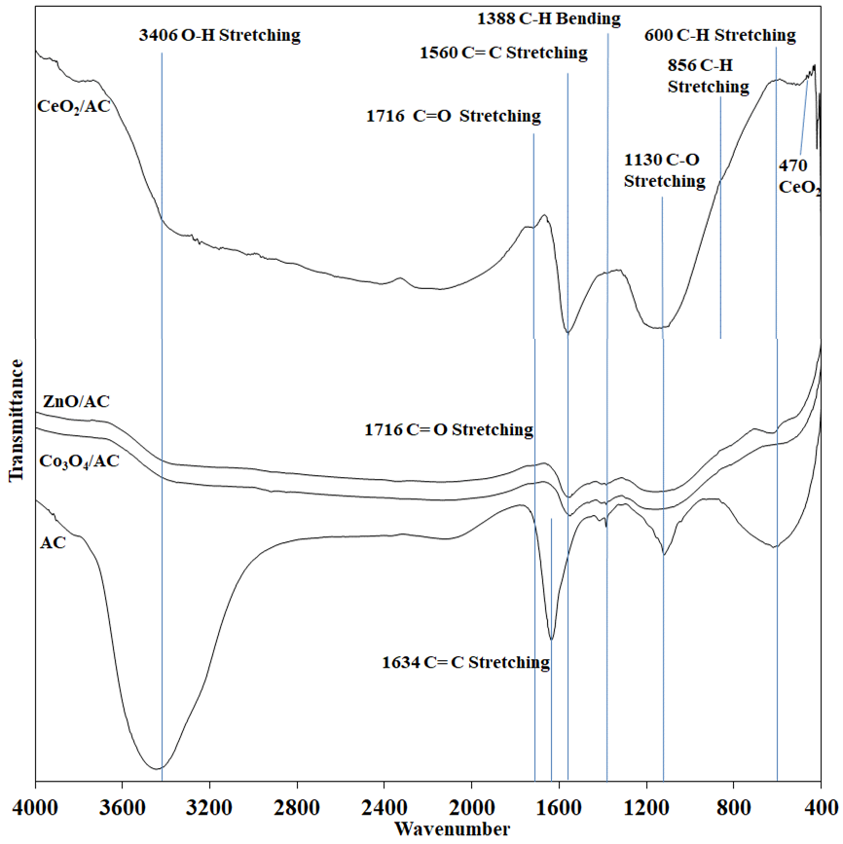
Figure 1. IR spectra of AC and various MO/AC.

Table 1. Vibrational frequencies IR spectroscopy of various MO/AC.
Vibrational modes | This study (cm⁻¹) | Reference (cm⁻¹)
O-H Stretching | 3406 | 3412
C=C Stretching | 1634 | 1633
C=C Stretching | 1560 | 1550
C-H Bending | 1388 | 1390
C-O Stretching | 1130 | 1130
C-H Stretching | 600 | 600
Ce-O | 470 | 459

The bands at 1643, 1388, 1130 and 600 cm⁻¹ are reported to be characteristic absorption bands of activated carbon corresponding to C=C stretching, C-H bending, C-O stretching and C-H stretching respectively.²⁴ The decreasing of intensities in these bands after impregnation of metal oxides are indicative of the deposition of metal oxides has reduced the absorption bands for AC.²⁵ The peak at 1634 shows a large redshift of 74 cm⁻¹ compared to 1560 cm⁻¹, after loading of metal oxides which also occurred in a study conducted by Zhao et al.²⁶ using silver loaded on activated carbon. While the bands at 470 cm⁻¹ are ascribed to the characteristic bands of metal oxides CeO₂²⁷ respectively.

The N₂ adsorption-desorption isotherms are shown in Figure 2. According to IUPAC classification, all of the isotherms exhibit Type I isotherm.²⁸ The initial steep region is attributed to strong adsorption by a typical microporous material. Hysteresis loop closing at around relative pressure 0.4 can be observed in all isotherms, indicating that mesoporosity of slit-shaped pores to be present in the samples.²⁹ The adsorbents show H4 hysteresis that associated with porous materials which indicating a narrow slit-shaped pore.³⁰ The N₂ adsorption-desorption isotherm for AC has the highest steep initial region ascribed from high micropore structure that easily occupied. The hysteresis of metal oxides loaded AC shows a larger area indicating of high mesopore structure. These are correlated with the textural properties tabulated in Table 2. The formation of mesopores may be due to that metal oxide burning off carbon wall and enlarging pore sizes during thermal treatment.

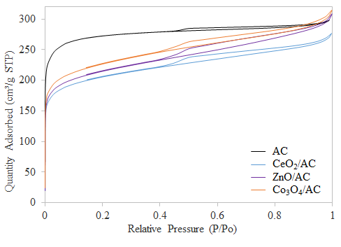
Figure 2. N₂ adsorption-desorption isotherms of the adsorbents.

Table 2. The textural characteristics of the adsorbents.
Adsorbent |  | AC | CeO₂/AC | ZnO/AC | Co₃O₄ /AC
Surface area | S_{BET} (m²/g) | 1043.6 | 763.4 | 792.9 | 838.5
Surface area | S_{meso} (m²/g) | 171.0 | 254.1 | 280.4 | 302.2
Surface area | S_{micro} (m²/g) | 872.6 | 509.4 | 512.5 | 536.3
Pore Volume | V_{total} (cm³/g) | 0.46 | 0.42 | 0.45 | 0.47
Pore Volume | V_{micro} (cm³/g) | 0.35 | 0.21 | 0.21 | 0.22
Average pore  diameter  (nm) |  | 1.8 | 2.2 | 2.3 | 2.2
where S_{BET} is surface area by BET method; S_{mic} is micropore surface area by t-plot method; V_{total} is single point total pore volume; V_{micro} is micropore volume by the t-plot method

The BET surface area decreased with the loading of metal oxides onto AC samples (Table 2) indicating that the pores of the AC are blocked or covered.²⁹ However, an increase in micropore surface area and mesopore surface area were observed might be due to all ACs chemically treated with KMnO₄ prior to metal oxide impregnation. This resulting KMnO₄ oxidizing the surface of AC and form pore structure which is in agreement with Zhang et al..³¹ It is notably Co₃O₄ /AC has higher surface area compared to CeO₂/AC and ZnO/AC. This presumes the formation of Co₃O₄ contributed to the increment of the adsorbent. The reduction in micropore volume after impregnated with metal oxides is mainly attributed to the addition of metal oxides which tend to deposit on the AC surfaces, deposited on the pores and fill the pores.

Density functional theory (DFT) method was used to compute pore size distribution (Figure 3) of the microporous AC containing various metal oxides. Although AC has a lower intensity of distribution at the region of 0.9-1.2 nm as shown in the inset of Figure 3, the AC possessed the highest distribution in the region of 1.6-2.0 nm. Thus, it has a high micropore structure which the diameter of the pores is below 2 nm. Most of the metal oxides generated unable to enter the pores below 1.2 nm because of the distribution at the region is less affected. Nonetheless, the distribution at the region of 1.6-2.0 nm was diminished might be due to the possibility of the metal oxides able to enter the pores or deposited on the pores. Above the 2.1 nm, higher distribution of pore size attributed by the pores of metal oxides generated on AC.

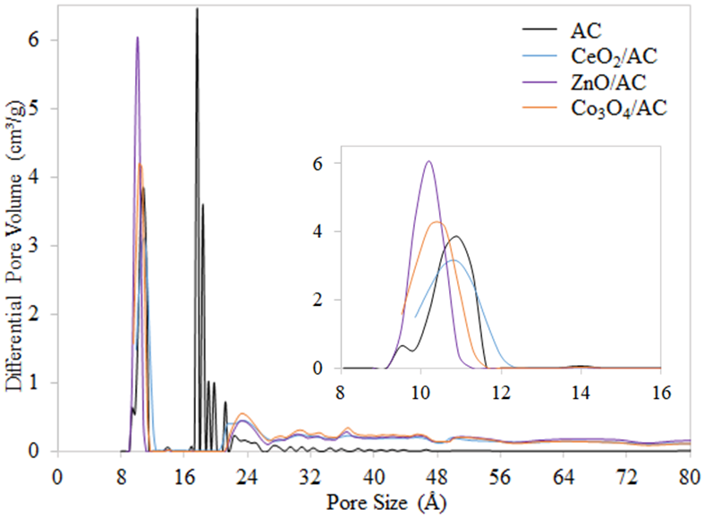
Figure 3. Pore size distribution.

Thermal stability of various metal oxides impregnated on AC was computed using thermogravimetric analysis by heating up to 900℃ (Figure 4). The initial steep region of weight loss was attributed to moisture removal. No distinct peak of derivative weight loss was observed at higher temperature implying that the samples were resistant toward heat. The Co₃O₄/AC shows a derivative weight loss peak at a temperature of 830 ℃ which corresponded to the decomposing temperature of Co₃O₄.³² This phenomenon can be attributed to two possible factors of decomposition during thermal treatment for Co₃O₄ is incomplete or the regeneration of Co₃O₄.

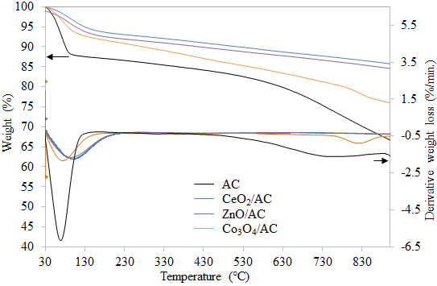
Figure 4. Thermal stability of the adsorbents.

3.2 CO₂ capture
CO₂ capture was performed using TGA and the wide angle of the thermograms was plotted as shown in Figure 5. The CO₂ adsorption and desorption process are shown in the narrow angle of Figure 6a and 6b respectively. The adsorption capacity was obtained from weight gained of Figure 6a. It is noteworthy to observe that CeO₂/AC and ZnO/AC shows higher adsorption capacity compared to AC only. This is indicative of CeO₂ and ZnO possess higher basic properties compared to Co₃O₄. Although AC only exhibits the highest surface area, the surface modification by impregnation of metal oxides provides basic active sites that chiefly responsible for enhancing CO₂ adsorption capacity. The lower adsorption capacity of Co₃O₄/AC compared to AC only might also be attributed to the weakly adsorbed CO species by cobalt ion which can be fully desorbed at 230K (-43 ℃) as reported by Ferstl et al..³³ Based on the adsorption capacity for all adsorbents tabulated in Table 3, CeO₂/AC shows the highest adsorption capacity (52.78 mg/g). Furthermore, CeO₂/AC have relatively lower desorption temperature of 160-280 ℃.³⁴ The thermograms for the desorption process (Figure 6b) shows CeO₂/AC has the highest weight loss up to around 400 ℃ for CO₂ regeneration. It was observed that the desorption temperature above 400 ℃ resulting in greater weight loss for all adsorbents. Therefore, CeO₂/AC was chosen as the most efficient adsorbent for further optimization of the performance of recyclability test at different adsorption temperature.

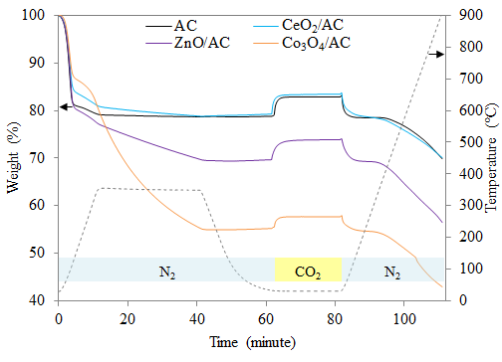
Figure 5. Simultaneous CO₂ adsorption and desorption for all adsorbents with adsorption temperature of 30 ℃.

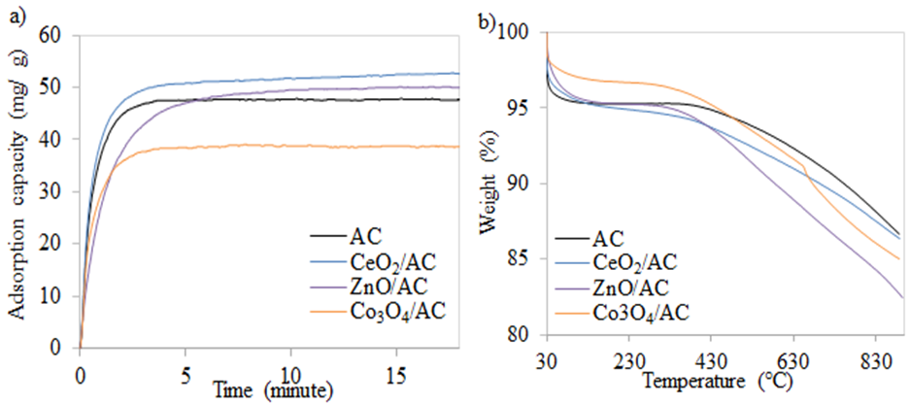
Figure 6. Narrow-angle for the a) CO₂ adsorption at 30 ℃ and b) desorption process.

Table 3. Adsorption capacity of various MO/AC at 30 ℃ adsorption temperature.
Adsorbent | Adsorption Capacity (mg/g)
AC | 52.01
CeO₂/AC | 52.78
ZnO/AC | 52.06
Co₃O₄/AC | 43.17

The phase composition of CeO₂/AC was determined by XRD diffractograms as shown in Figure 7. Typical graphitic structure for AC with broad amorphous diffraction peaks at 2θ values of 26º and 43º. After loading with CeO₂, the amorphous peaks decreased and shifted from 26 º and 43º toward 29º and 48º respectively. Another new diffraction peak was observed at 56º. These three diffraction peaks are the reflections of the (111), (220) and (311) crystallographic planes of the cubic CeO₂ phase.³⁵ The CeO₂/AC surface morphology (Figure 8) shows the well-distributed of fine particles CeO₂ on AC surfaces. The SEM image is supporting the prediction from the result of textural properties with some of the CeO₂ able to enter the pores of AC and deposited on AC surfaces.

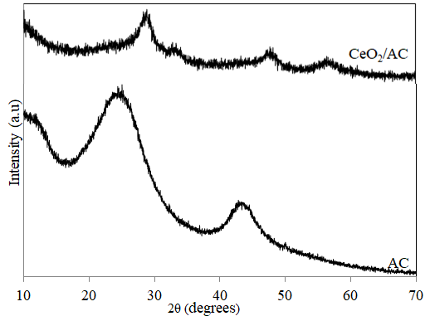
Figure 7. XRD diffractograms.

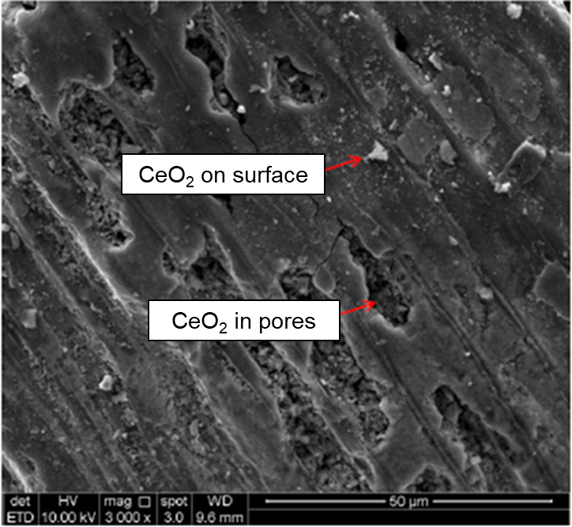
Figure 8. SEM images of CeO₂/AC.

3.3 Recyclability test
Five cycles of CO₂ adsorption-desorption was conducted to optimize the performance for CeO₂/AC at different adsorption temperature of 30 and 50 ℃ (Figure 9). It is interesting to note that the adsorption capacity is higher at the adsorption temperature of 30 ℃ rather than 50 ℃. At adsorption temperature of 30 ℃, the loss in adsorption capacity was only 6.53 % with a decrease from first to fifth cycles is 52.50 mg CO₂/ g adsorbent to 49.07 mg CO₂/ g adsorbent respectively. Whereas at adsorption temperature of 50 ℃, there was 7.86% loss in adsorption capacity with a decrease from first to fifth cycles is 40.56 mg CO₂/ g adsorbent to 37.37 mg CO₂/ g adsorbent respectively. This build relationship that adsorption capacity decrease as the adsorption temperature increase. According to Rashidi et al.,³⁶ an exothermic process where physisorption is favoured at lower temperature implies the existence of physisorption throughout the process of adsorption. Thus, at a temperature above 30 ℃, the adsorbate of CO₂ has the tendency to desorb during the adsorption period and leads to lower adsorption capacity.

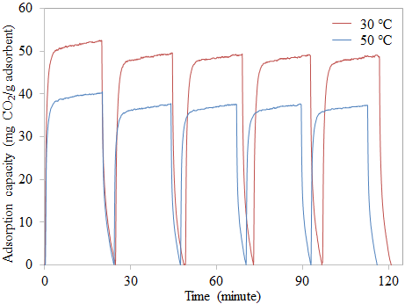
Figure 9. Five cycles of CO₂ capture at adsorption temperature of 30 and 50 ℃.

3.4 Kinetic Analysis
The CO₂ adsorption for CeO₂/AC at different operating temperatures from the first cycle was modeled by using two kinetic models namely pseudo-first order (Equation 2), pseudo-second-order kinetic model (Equation 3).
$\log\left(q_{e}- q_{t}\right)= \log{q_{e}}-\left(\frac{k_{1}}{2.303}\right)t$ (2)
$\frac{t}{q_{t}}= \frac{1}{k_{2}q_{e}^{2}}+\left(\frac{1}{q_{e}}\right)t$ (3)
where q_{t} and q_{e} are the adsorption capacity at any particular time t and at equilibrium respectively, and k₁ is the pseudo-first-order kinetic constant, k₂ is the pseudo-second-order kinetic constant and (k₂·q_{e}²) is initial adsorption rate. The kinetic linear plot using two equations above are shown in Figure 10. These two plots are to evaluate the mechanism of the adsorption process. The kinetic parameters were tabulated in Table 4.

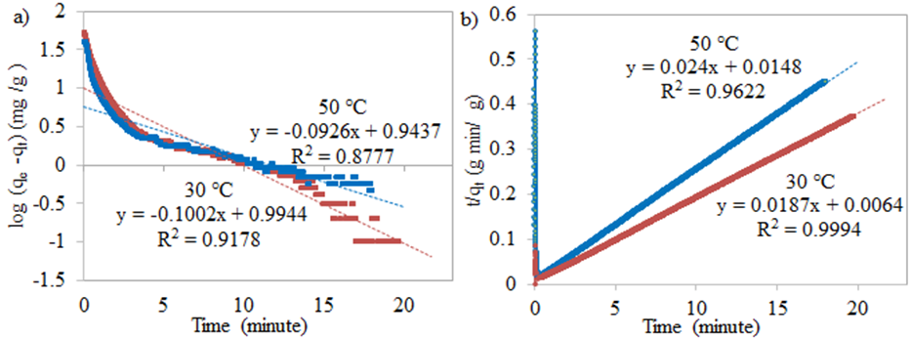
Figure 10. Kinetic plot a) pseudo-first-order kinetic model and b) pseudo-second-order kinetic model at different adsorption temperatures for CeO₂/AC.

Table 4. Kinetic parameters of CO₂ adsorption onto CeO₂/AC.
Kinetic model | Parameter | Temperature (℃)
Kinetic model | Parameter | 30 | 50
Kinetic model | q_{e(act)} (mg/g) | 52.78 | 40.56
Pseudo-first order kinetic | q_{e(cal)} (mg/g) | 9.87 | 8.78
Pseudo-first order kinetic | k₁(1/min) | 0.2308 | 0.2132
Pseudo-first order kinetic | R² | 0.9178 | 0.8777
Pseudo-first order kinetic | Relative error (%) | 81.29 | 78.34
Pseudo-first order kinetic | q_{e(cal)} (mg/g) | 53.47 | 41.67
Pseudo-first order kinetic | k₂ (g/mg  min) | 0..0546 | 0.0389
Pseudo-first order kinetic | h (mg/g min) | 156.14 | 67.57
Pseudo-first order kinetic | R² | 0.9994 | 0.9622
Pseudo-first order kinetic | Relative error (%) | 1.32 | 2.74
where q_{e(act)} = actual adsorption capacity; q_{e(cal)} = calculated adsorption capacity
Pseudo-second order kinetic model shows the correlation coefficient values of R² are 0.9994 and 0.9622 for 30 and 50 ℃ respectively. The relative error between actual adsorption capacity and calculated adsorption capacity is only 1.32 and 2.74 % for adsorption temperatures of 30 and 50 ℃ respectively. Although the pseudo-first-order kinetic model shows high R² at 0.9178 and 0.8777 for 30 and 50 ℃ respectively. But the relative error between actual adsorption capacity and calculated adsorption capacity is significantly high compared to the pseudo-second-order kinetic model with 81.29 and 78.34 % adsorption temperatures of 30 and 50 ℃ respectively. Based on these R² values and relative errors, the pseudo-second-order kinetic model fits the CO₂ adsorption profile relatively better than the pseudo-first-order kinetic model at both adsorption temperatures of 30 and 50 ℃. This suggests the existence of both physisorption and chemisorption but the CO₂ adsorption incline towards chemisorption. It might be the limiting step involving exchange electron between adsorbent and adsorbate. The adsorption process not mainly governed by physical phenomena but also chemical phenomena. This proving that AC surface modification with addition CeO₂ could enhance the adsorption capacity.

4. CONCLUSION
Various metal oxides impregnated on activated carbon were successfully prepared by impregnation method. SEM images and XRD pattern confirm that CeO₂ were highly dispersed on the AC surface. FTIR showed the characteristic peaks of various metal oxides confirming their presence on activated carbon. All the MO/AC showed great thermal stability with high resistance toward heat up to 900 ℃ except Co₃O₄/AC. The CeO₂/AC exhibited the most efficient adsorbent with adsorption capacity of 52.78 mg CO₂/g adsorbent. It showed only 6.53% loss in adsorption capacity after five cycles and relatively lower desorption temperature of 160-280 ℃ which required less energy. The pseudo-second-order kinetic model was best fitted compared to the pseudo-first-order kinetic model with relatively higher correlation coefficient which implied not only physisorption but chemisorption is significant in CeO₂/AC.

5. ACKNOWLEDGEMENT
The authors are grateful to the Department of Science and Technology, Universiti Putra Malaysia Kampus Bintulu and School of Chemical Sciences, Univerisiti Sains Malaysia for the research facilities. The authors wish to thanks the Ministry of Higher Education for the financial support for grant numbers of GP-IPM-9657200, GP-IPM-9559000, 1001.PKIMIA.811333 and 1001.PKIMIA.822215.

6. REFERENCES

1. National Oceanic and Atmospheric Administration (NOAA), Recent Global CO₂, https://www.esrl.noaa.gov/gmd/ccgg/trends/global.html (accessed: March 20, 2019)

2. N. Mimura, Proceedings of The Japan Academy, Series B Physical and Biological Sciences. 2013, 89(6), 281-301.

3. J. R. Fanchi, C. J. Fanchi, Energy in the 21st Century, Fourth Edition, World Scientific, Singapore, Singapore, 2016.
4. B. Metz, O. Davidson, H. D. Coninck, M. Loos, L. Meyer, IPCC special report on carbon dioxide capture and storage, Cambridge University Press, New York, United States, 2005.
5. Q. Wang, Q. J. Luo, Z. Zhong, A. Borgna, Energ. Environ. Sci. 2011, 4(1), 42-55.
6. J. Gale, Y. Kaya, Greenhouse Gas Control Technologies, Pergamon, New York, United States, 2003.
7. C. -H. Yu, C. -H. Huang, C. -S. Tan, Aerosol Air Qual. Res. 2012, 12(5), 745-769.
8. K. C. Chanapattharapol, S. Krachuamram, S. Youngme, Micropor. Mesopor. Mat. 2017, 245, 8-15.
9. A. E. Ogungbenro, D. V. Quang, K. Al-Ali, M. R. M. Abu-Zahra, Energ. Procedia 2017, 114, 2313-2321.
10. R. Kodasma, J. Fermoso, A. Sanna, Chem. Eng. J. 2018, 358, 1351-1362.

11. C. E. Bien, K. K. Chen, S. -C. Chien, B. R. Reiner, L. -C. Lin, C. R. Wade, W. S. W. Ho. J. Am. Chem. Soc. 2018, 140(40), 12662-12666.

12. S. S. Shang, A. Hanif, M. Z Sun, Y. M Tian, Y. S. Ok, I. K.M.Yud, D. C.W. Tsang, Q. F. Gue, J. Shang. J. Hazard, Mater. 2019, 373, 285-293.

13. M. N. Abu Tahari, A. Hakim, T. S. Marliza, N. H. Mohd, M. A. Yarmo, Meter. Sci. Forum 2017, 888, 529-533.

14. M. A. Naeem, A. Armutlulu, Q. Imtiaz, C. R. Meller, ChemPhysChem 2017, 18, 3280-3285.

15. S. Lin, T. Kiga, Y. Wang, K. Nakayama, Energ. Procedia 2011, 4, 356-361.

16. S. C. Tian, J. G. Jiang, F. Yan, K. M. Li, X. J. Chen, V. Manovic, Green Chem. 2016, 18, 4022-4031.

17. S. Wongsakulphasatch, K. Sukchoknamchai, N. Suthapot, W. Praikaew, C. Chaisuk, W. Kiatkittipong, N. Laosiripojana, S. Assabumrungrat, S. MATEC Web of Conferences 2018, 192, 03057.

18. A. Hakim, T. S. Marliza, M. N. Abu Tahari, W. N. R. Wan Isahak, M. R. Yusop, M. W. Mohamed Hisham, M. A. Yarmo, Ind. Eng. Chem. 2016, 55(29), 7888-7897.

19. J. Baltrusaitis, J. Schuttlefield, E. Zeitler, V. H. Grassian, 2011. Chem. Eng. J. 2011, 170, 471-481.

20. K. Yoshikawa, H. Sato, M. Kaneeda, J. N. Kondo, J CO₂ Util. 2014, 8, 34-38.

21. Y. -M. Wang, R. Kováčik, B. Meyer, K. Kotsis, D. Stodt, V. Staemmler, H. -S. Qiu, F. Traeger, D. Langenberg, M. Muhler, C. Wöll, Angew. Chem. Int. Edit. 2007, 46, 5624-5627.

22. A. Hakim, W. N. R. Wan Isahak, M. N. Abu Tahari, M. R. Yusop, M. H. Mohamed Wahab, M. A. Yarmo, Adv. Mat. Res. 2014, 1087, 45-49.

23. W. N. R. Wan Isahak, Z. A. Che Ramli, A. Z. Lahuri, M. R. Yusop, M. H. Mohamed Wahab, M. A. Yarmo, Adv. Mat. Res. 2015, 1087, 111-115.

24. S. Ge, Z. Liu, Y. Furuta, W. Peng, Saudi J. Biol. Sci. 2017, 24(6), 1370-1374.

25. G. Zhang, J. Qu, H. Liu, A. T. Cooper, R. Wu, Chemosphere 2007, 68(6), 1058-1066.

26. H. Zhao, F. Wang, Y. Ning, B. Zhao, F. Yin, Y. Lai, K. Hu, K. (2013). Green “planting” nanostructured single crystal silver. Sci. Rep. 2013, 3, 1511.

27. G. H. Hara Priya, N. Sunganya, V. Jaisankar, Int. J. Adv. Chem. Sci. Appl. 2015, 3, 6-14.

28. K. S. W. Sing, D. H. Everett, R. A. W. Haul, L. Moscou, R. A. Pierotti, J. Rouquerol, Pure & Appl. Chem. 1985, 57(4), 603-619.

29. A. Hakim, M. N. Abu Tahari, T. S. Marliza, W. N. R. Wan Isahak, M. R. Yusop, M. W. M. Hisham, M. A. Yarmo, Jurnal Teknologi, 2015, 77(33), 75-84.

30. J. B. Condon, Surface Area and Porosity Determinations by Physisorption: Measurements and Theory, first ed., Oxford, United Kingdom, Elsevier B. V., 2006.

31. G. Zhang, Y. Sun, P. Zhao, Y. Xu, A. Su, J. Qu, J. CO₂ Util. 2017, 20, 129-140.

32. G. A. El-Shobaky, A. S. Ahmad, A. N. Al-Noaimi, H. G. El-Shobaky, J. Therm. Anal. 1996, 46(6), 1801-1808.

33. P. Ferstl, S. Mehl, M. A. Arman, M. Schuler, A. Toghan, B. Laszlo, J. Knudsen, J. Phys. Chem. C 2015, 119(29), 16688-16699.

34. V. Savin, V. Sobolev, Z. Eremenko, Z. Grigor'eva, Zhurnal Fizicheskoj Khimii 1985, 59(3), 571-575.
35. H. Qin, H. Chen, X. Zhang, G. Yang, Y. Feng, J. Chem. Technol. Biot. 2014, 89(9), 1402-1409.
36. N. A. Rashidi, S. Yusup, B. H. Hameed, Energy 2013, 61, 440-446.

