Synthesis and Characterization of Cross Linked Acetoguanamine Polymer Complexes: Investigation of Their Thermal and Magnetic Properties

Gurkan Guney¹, Saban Uysal²* and Ziya Erdem Koc³
¹University of Karabuk, Institue of Natural and Applied Sciences, Department of Polymer Engineering, 78050 KARABUK-TURKEY
²University of Karabuk, Faculty of Science, Department of Chemistry, 78050 KARABUK- TURKEY
³University of Selcuk, Faculty of Science, Department of Chemistry, 42075 KONYA- TURKEY
*Corresponding Author: ph: +9 (0532) 303 30 35 e-mail: sabanuysal@karabuk.edu.tr

Abstract
In this study, 2,4-diamino-6-methyl-1,3,5-triazine (Acetoguanamine) was used as the starting material. 2,4-diamino-6-methyl-1,3,5-triazine (Acetoguanamine) was boiled under reflux with glutaraldehyde and terephthaldehyde in acetonitrile. And, s-triazine-containing polymer ligands (IV and V) were obtained by these condensation reactions. These target s-triazin containing polymer ligands we obtained were analyzed by ¹H-NMR, FT-IR and elemental analysis. Then, polymeric metal (Co²⁺, Ni²⁺ and Cu²⁺) complexes of the polymeric ligands (VI-XI) were obtained from the interaction with CoCl₂.6H₂O, NiCl₂.6H₂O and CuCl₂.2H₂O at 60℃ in ethyl alcohol. The structures of these complexes were also illuminated and elucidated using FT-IR, elemental analysis and magnetic susceptibility analysis. The polymerization degrees of the polymeric ligands were determined by the molecular weight determination study with the viscometer.
Keywords: Acetoguanamine, s-triazine, Schiff bases, cross-linked polymeric complexes, thermal decomposition, magnetic properties.

- Introduction
In recent years, an important class of compounds consisting of substituted s-triazine derivatives has been a growing interest in the using of s-triazine derivatives in different fields.^{1, 2} The remarkable reactivity and unique structure of the s-triazine moiety attracted the researchers to utilize it in the modification and construction of new materials.³ s-Triazine based polymers have a high transparency and an enormous thermal and mechanical stability.^{4, 5} They have been widely used as matrixes for advanced composites or as resins in their own right for structural applications, especially for automotive, aerospace and microelectronic utilities.⁶ Acetoguanamine (2,4-diamino-6-methyl-1,3,5-triazine) is one of the most widely used s-triazine derivatives, because it is a commercially available, inexpensive material and it has an excellent ability to undergoes nucleophilic substitution reaction under controlled temperature,^{7, 8} which allow it to be useful in many material and pharmaceutical,^{9, 10} and industrial applications.¹¹⁻¹³
The design and synthesis of supramolecular polynuclear metal complexes have been an area of rapid growth for the past 20 years.¹⁴ During the last decade, a remarkable development in the preparation of self-assembled architecture through metal ion coordination has been observed.⁸ The motivation behind much of the studies related with polynuclear metal complexes has been provided by the prospect of producing a wide range of purpose-built materials with predetermined structures and potential applications in separation, gas storage, molecular recognition, and catalysis.^{8, 14, 15} The preparation of polymetallic complexes can be achieved using rationally designed polydentate ligands.¹⁶ On the other hand, it has been demonstrated that the 1,3,5-triazine ring is a suitable structural element to be incorporated into thermotropic liquid crystals.¹⁷

Schiff base chemistry, formed by the reversible condensation of amines and aldehydes has been made available in biomedicine as a result of its high efficiency and inoffensive by-product (only water).¹⁸⁻²⁰ The Schiff-base cross-linked injectable hydrogels were reported to have tunablebgelation kinetics, biodegradability, and self-repair functions.²¹⁻²³

We now report the synthesis and characterization of polymeric Schiff base including two imin groups as new templates. The condensation reaction of acetoguanamine (2,4-diamino-6-methyl-1,3,5-triazine) with glutaraldehyde and terephthaldehyde in acetonitrile gave the desired polynuclear metal complexes moieties in a single step.²⁴ The NH₂ groups were then modified with dimeric acetoguanamine (2,4-diamino-6-methyl-1,3,5-triazine) as a single-directional linker,⁶⁻¹⁰ followed by treatment with o(II), Ni(II) and Cu(II)¹¹⁻²⁰ to give the mentioned new cross linked polymeric Schiff bases metal complexes which we call Polymeric Ligands IV and V.

- Experimental
  - Reagents and solvents
Both of solvents (acetonitrile and ethanol), asetoguanamine (1), glutaraldehyde, teraftaldehyde and o-phenylenediamine, acetic acid, CoCl₂.6H₂O, NiCl₂.6H₂O, CuCl₂.2H₂O and natrium hydroxide were bought from Sigma and they were used without further purification. The ¹H NMR spectra of the polymers were taken with an Agilent NMR VNMRS spectrometer at 400 MHz, through their dimethylsulfoxide (DMSO-d₆) solutions. The internal standard of the NMR measurements was tetramethylsilane (TMS). FTIR spectra were taken by Perkin Elmer 1600 Spectrum 100 ATR Polarization (4000–440 cm⁻¹). Thermogravimetric Analysis (TGA) were performed using Hitachi STA7300 instrument. Elemental analyses were realized on a Leco 932 CHNS device where the results were in good harmony with the theoretical values. The metal contents of each complex were defined on a Varian, Vista AX CCD Simultaneous model ICP-AES. The pH values of all solutions were measured from a Milwaukee Mi 150 pH meter. Magnetic moment values of the metal complexes were determined with a Sherwood Scientific MX Gouy magnetic susceptibility apparatus using the Gouy method with Hg[Co(SCN)₄] as calibrant. The effective magnetic moments per metal atom, μ_{eff}, were calculated using the well-known formula µ_{eff} $=2.84\sqrt{X_{M}}T$ B.M., where χ_{M} is the molar susceptibility.

  - Synthesis of polymeric ligands
    - Synthesis of IV
Acetoguanamine (0.125 g, 1.00 mmol) was solved in 25 mL acetonitrile under reflux for an hour. Equivalent amount of glutaraldehyde solution (%2) was added to this solution drop by drop. Then, 5-6 drops of acetic acid were dropped as catalyst. This mixture was boiled under reflux for 3 hrs. The resulting precipitate was filtered off and dried under vacuum at 60 °C.
¹H-NMR data for IV: 7.50 ppm (2H, triplet), 2.40 ppm (3H, singlet), 2.20-2.05 ppm (6H, multiplet); FTIR (cm⁻¹) data for IV= 2926, 2854 (CH_{aliphatic}), 1655 (CH=N), 1537 (CH=N_{triazine}).

    - Synthesis of V
Acetoguanamine (0.125 g, 1.00 mmol) was solved in 25 mL acetonitrile under reflux for an hour. Then, teraftalaldehyde (0,134 g, 1.00 mmol) was added to this solution portionwise. And then, 2 mL of acetic acid were dropped as catalyst. This mixture was boiled under reflux for 2 hrs. The resulting precipitate was filtered off and dried under vacuum at 60 °C.
¹H-NMR data for V: 8.80 ppm (2H, singlet), 8.05-7.70 ppm (4H, multiplet), 2.40 ppm (3H, singlet); FTIR (cm⁻¹) data for V: 3115 (C-H aromatic), 1633 (CH=N), 1556 (CH=N triazine).

  - Synthesis of cross-linked polymeric complexes (VI-XI)
IV / V (0.44 g/ 0.51 g, 1.00 mmol) were solved in 50 mL of 0.1 N HCl solution. Then, equivalent amount of 0.001 M CoCl₂.6H₂O, NiCl₂.6H₂O, CuCl₂.2H₂O in ethanol were added to these solutions drop by drop. These mixtures were heated under reflux at 60 °C. Finally, the pH of the system was adjusted to around 6.00 with NaOH 5%. The resulting precipitate (the Co(II), Ni(II), Cu(II) cross-linked polymeric complexes of AGGA and AGTA) were filtered off and dried under vacuum at 60 °C.

FTIR (cm⁻¹) data for VI: 2926, 2854 (CH_{alifatic}), 1662 (CH=N), 1545 (CH=N_{triazine}), 540 (Co-N); FTIR (cm⁻¹) data for VII: 2926, 2854 (CH_{alifatic}), 1662 (CH=N), 1545 (CH=N_{triazine}), 541 (Ni-N); FTIR (cm⁻¹) data for VIII: 2926, 2854 (CH_{alifatic}), 1662 (CH=N), 1545 (CH=N_{triazine}), 540 (Cu-N); FT-IR (cm⁻¹) data for IX: 3115 (C-H aromatic), 1648 (CH=N), 1568 (CH=N triazine), 545 (Co-N); FT-IR (cm⁻¹) data for X: 3115 (C-H aromatic), 1648 (CH=N), 1568 (CH=N triazine), 546 (Ni-N); FT-IR (cm⁻¹) data for XI: 3115 (C-H aromatic), 1648 (CH=N), 1568 (CH=N triazine), 545 (Cu-N).
- Results and Discussions
In this study, 2,4-diamino-6-methyl-1,3,5-triazine (Acetoguanamine) was used as the starting material. 2,4-diamino-6-methyl-1,3,5-triazine (Acetoguanamine) was boiled under reflux with glutaraldehyde and terephthaldehyde in acetonitrile using acetic acid as catalyst. And, s-triazine-containing polymer ligands codded as IV and V were obtained by these condensation reactions. These target s-triazin containing polymer ligands obtained were analyzed by ¹H-NMR, FT-IR, TGA and elemental analysis. Then, polymeric metal (Co²⁺, Ni²⁺ and Cu²⁺) complexes of the polymeric ligands codded as (VI-XI) were obtained from the interaction with CoCl₂.6H₂O, NiCl₂.6H₂O and CuCl₂.2H₂O at 60℃ in ethyl alcohol. The structures of these complexes were also illuminated and elucidated using FT-IR, elemental analysis, thermogravimetric analysis and magnetic susceptibility analysis. The polymerization degrees of the polymeric ligands were determined by the molecular weight determination study with the viscometer.
Scheme 1: The synthetic route of polymeric ligands and their cross linked polymeric complexes.

Table 1. The elemental analysis data and physical properties of all ligands and complexes.
[Emprical Formula]  (Compound Codes) | μ_{eff}  (B.M.)  296 K | M.P °C | Color | [M_{w}] | Yield % | Contents (%)  Calculated/Found
 |  |  |  |  |  | C | H | N | M**
C₁₁H₁₇N₅ (IV) | Dia | 106 | White | [219.29]_{n} | 68 | 60.25  60.20 | 7.81  7.75 | 31.94  31.91 | -
C₁₄H₁₅N₅ (V) | Dia | 108 | Yellow | [253.31]_{n} | 65 | 66.38  65.15 | 5.97  5.85 | 27.65  27.12 | -
C₂₂H₃₄N₁₀Co (VI) | 3.76 | >400* | Orange | [497.52]_{n} | 58 | 53.11  53.08 | 6.89  6.85 | 28.15  28.12 | 11.85  11.82
C₂₂H₃₄N₁₀Ni (VII) | 2.81 | >400* | Brown | [497.28]_{n} | 60 | 53.14  53.10 | 6.89  5.12 | 28.17  28.15 | 11.80  11.77
C₂₂H₃₄N₁₀Cu (VIII) | 1.76 | >400* | Claret Red | [502.13]_{n} | 55 | 52.62  52.58 | 6.83  6.82 | 27.90  27.86 | 12.66  12.62
C₂₈H₂₉N₁₀Co (IX) | 3.75 | >400* | Violet | [564.54]_{n} | 62 | 59.57  59.13 | 5.18  5.07 | 24.81  24.62 | 10.44  10.40
C₂₈H₂₉N₁₀Ni (X) | 2.79 | >400* | Dark Green | [564.30]_{n} | 65 | 59.60  59.55 | 5.18  5.12 | 24.82  24.77 | 10.40  10.38
C₂₈H₂₉N₁₀Cu (XI) | 1.75 | >400* | Light Green | [569.16]_{n} | 67 | 59.09  59.02 | 5.14  5.11 | 24.61  24.58 | 11.16  11.13
*Decomposition point, ** M = Co(II), Ni(II) ve Cu(II), μ_{eff} = Effective magnetic moment

3.1. Interpretation of ¹H NMR Spectra
In the ¹H-NMR spectrum of the resulting s-triazine-containing polymer IV, the triplet for 2 protons at 7.50 ppm, the singlet for 3 protons at 2.40 ppm and the multiplet for 6 protons in the range of 2.20-2.05 ppm were observed and attributed to CH=N group, CH₃ group on triazine and aliphatic CH/CH₂ groups, respectively. As for the polymer V, the singlet for 2 protons at 8.80 ppm, the multiplet for 4 protons in the range of 8.05-7.70 ppm and the singlet for 3 protons at 2.40 ppm were observed and attributed to CH=N group, aromatic CH and CH₃ group on triazine, respectively. These peaks observed in the NMR spectra proved that both structures were successfully obtained.²⁵⁻²⁸

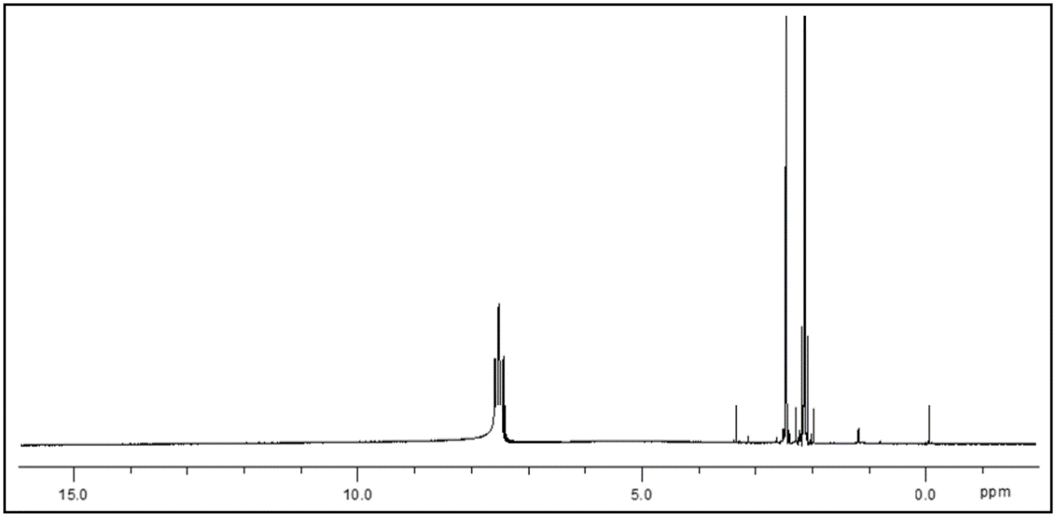
Figure 1. ¹H NMR spectrum of IV.

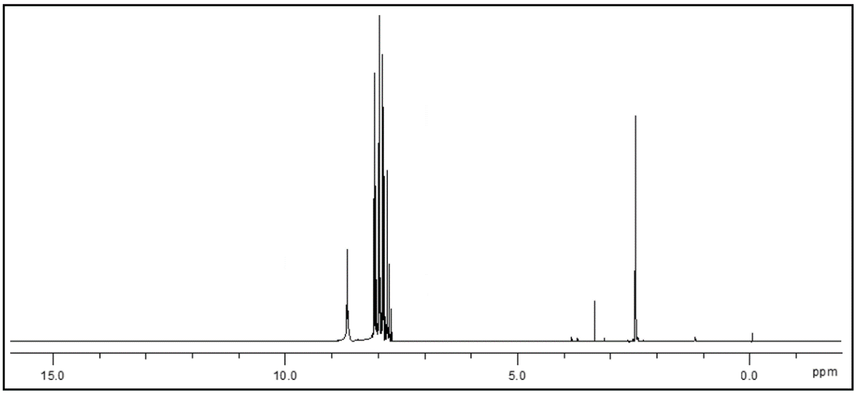
Figure 2. ¹H NMR spectrum of V.

3.2. Interpretation of FTIR Spectra
The FTIR spectra of the polymer ligands and their complexes we synthesized were recorded and the bands we observed were summarized in the experimental section. Firstly, when we look at the FTIR spectra of the polymer ligands we synthesized, C = N bands from the central s-triazine groups were observed at 1537 cm⁻¹ and 1556 cm⁻¹ for IV and V, respectively. Disappearance of N-H bending band at 3391 cm-1 and N-H bending band at 1510 cm-1 for acetoguanamine and instead, appearance of C=N stretching bands at 1655 cm⁻¹ and 1633 cm⁻¹ for IV and V, respectively, aliphatic C-H stretching bands at 2926 cm⁻¹ and 2854 cm⁻¹ for IV and aromatic C-H stretching band at 3115 cm⁻¹ for V proves that glutaraldehyde and teraftalaldehyde linked to the s-triazine ring of acetoguanamine.^{5, 29, 30}

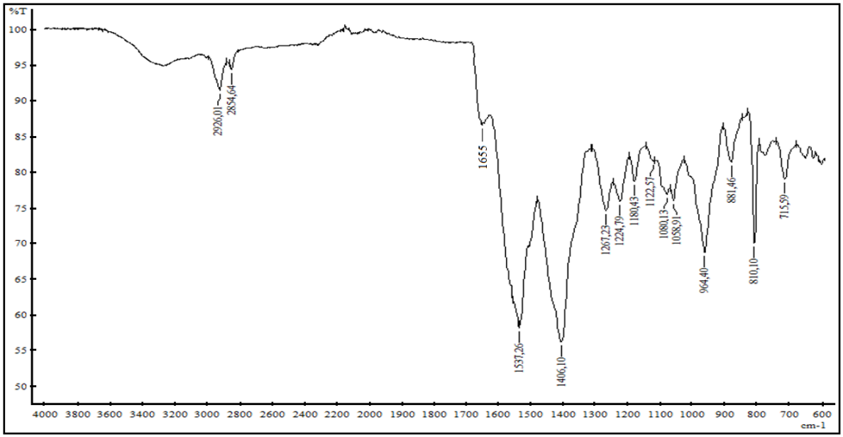
Figure 3: FTIR spectrum of IV.
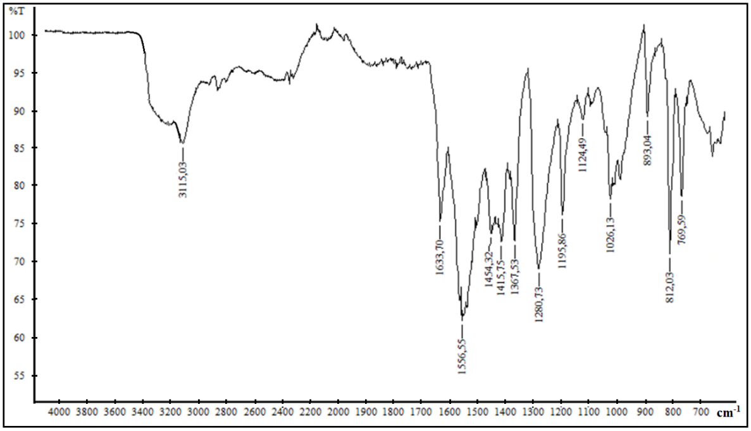
Figure 4: FTIR spectrum of V.
Schiff base polymeric complexes were obtained from the reaction of polymer Schiff base ligands (IV and V) with metal salts of CoCl₂.6H₂O, NiCl₂.6H₂O and CuCl₂.2H₂O under reflux in ethanol. In the FT-IR spectra of the obtained complexes, bands of C=N Schiff base and s-triazine C=N groups were observed to shift to 12-15 cm⁻¹ higher wave number after complex formation. In addition, M-N stretching bands were observed at 540 cm⁻¹ and 545 cm⁻¹, respectively.^{5, 28, 29, 31-34}

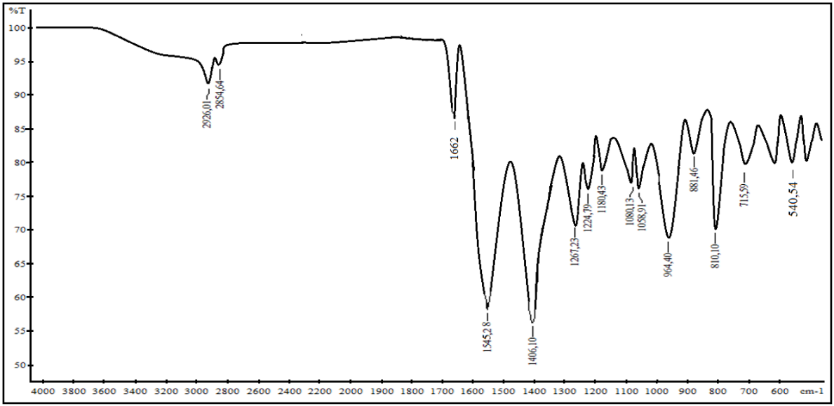
Figure 5. FTIR spectrum of Co(II) cross polymer complex of IV.

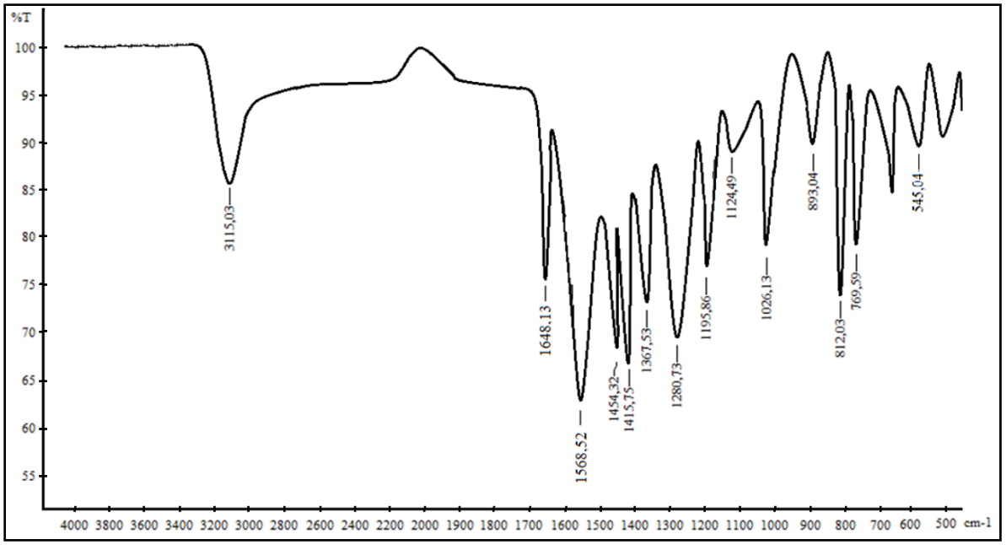
Figure 6: FTIR spectrum of Co(II) cross polymer complex of V.

3.3. Interpretation of Magnetic Data
In order to obtain information about the magnetic characters and geometries of s-triazine-containing polymeric complexes, effective magnetic moment (µ_{eff}) values were measured at 25 ºC. µ_{eff} values of all complexes are given in Table 1. All polymeric complexes were determined as paramagnetic with d⁷, d⁷, d⁸, d⁸, d⁹ and d⁹ metal ions electron arrangement for VI-XI, respectively. Their effective magnetic moment (µ_{eff}) values were determined as follows: 3.76, 3.75, 2.81, 2.79, 1.76 and 1.75 B.M for each Co(II), Ni(II) and Cu(II) ions in [(b_{2g})²(e_{g})³(b_{1g})¹(a_{1g})¹], [(b_{2g})²(e_{g})⁴(b_{1g})¹(a_{1g})¹] and [(b_{2g})²(e_{g})⁴(b_{1g})²(a_{1g})¹] electronic arrangement, respectively. According to our results, it was concluded that these complexes have distorted octahedral geometry (flat tetragonal distortion).^{5, 32, 35-39}

3.4. Interpretation of Thermal Analyses Curves
In order to determine the thermal behavior of the ligands and complexes we obtained, the ligands and complexes were heated in a nitrogen atmosphere at a temperature of 50-1000°C at a rate of 10 °C/min. When we interpret the TGA graphs obtained as a result of thermal analysis, we observed that the ligands and complexes decompose in two steps.

However, we observed that the ligand V begins to decompose at a temperature of about 65 °C higher than the ligand IV, that the main skeleton is degraded immediately after both ligands begin to decompose. The experimentally observed mass loss corresponds approximately to the mass of glutaraldehyde for the ligand IV and teraftaldehyde for the ligand V. After 5.5% moisture loss of the ligand IV in the temperature range of 90-105 °C, the weight loss in the first step began at 480 °C and was completed at 485 °C. The weight loss in this step is about 33%. After 4.5% moisture loss of the ligand V in the temperature range of 90-105 °C, the weight loss in the first step began at 545 °C and was completed at 550 °C. The weight loss in this step is about 40%. It was calculated that the weight losses in the last steps observed around 650 °C were equal to the mass of the remaining s-triazine ring.^{5, 40}

When we examined the TGA curves of the Co(II), Ni(II) and Cu(II) complexes of these ligands, we observed that the decomposition temperature shifted to about 40 °C higher. When we look at the rate of decomposition, we observed that there is not much difference compared to ligands. That is, while these polymeric complexes using metal ions as crosslinkers decompose, the 5-membered aliphatic chain from glutaraldehyde, and the aromatic ring from teraphthaldehyde, which are the polymerizing groups, appear to decompose, firstly. It was calculated that the weight losses in the last steps observed in the temperature range of 680-720 °C were equal to the mass of the remaining s-triazine ring. The metal halide salts remain in the complexes without decomposition.^{5, 40}

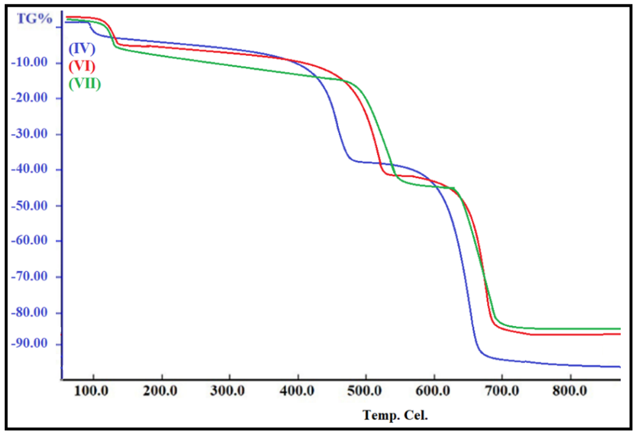
Figure 7. TGA curves of IV, VI and VII

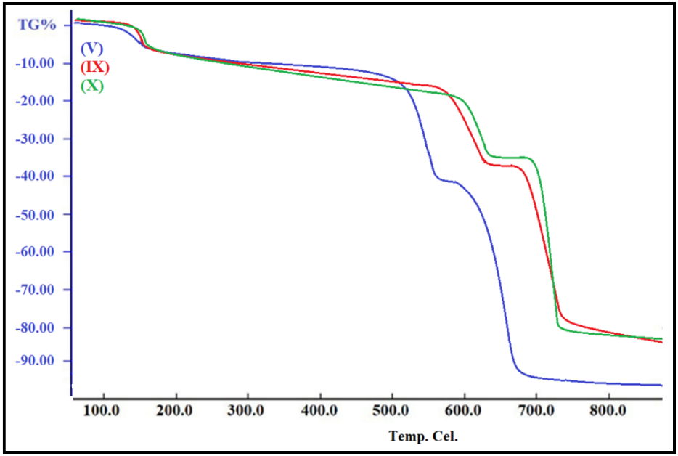
Figure 8. TGA curves of V, IX and X

3.5. Interpretation of Average Molecular Weight of Polymer Ligands
In order to determine the average molecular weights of the IV and V polymers we synthesized here; we measured their viscosity using the Ostwald viscometer. The measurement results are as follows: ŋ=1.494 (for IV), ŋ=1.985 (for V). Using the equation ŋ = kµα (µ = molecular weight) (using polystyrene as standard, k = 1.7 x 10⁻⁴ and α = 0.78), the average molecular weight of these polymers was calculated. The average molecular weights (µ) of the polymers (IV and V) obtained by this method are 9850 and 14170 g/mol, respectively. Using these data, it is concluded that these polymers consist of an average of 48 and 56 monomer units, respectively.^{5, 41, 42}

- Conclusion
In this work, we synthesized two novel s-triazine-cored Schiff base polymeric ligands including acetoguanamine group and their six-novel cross-linked polynuclear complexes. These complexes are the first examples of these s-triazine-cored Schiff base polymeric complexes coordinated by imine groups to the Co(II), Ni(II) or Cu(II) centers. The magnetic data for the complexes show good harmony with the d⁷ (S = 3/2) (for Co(II) complexes), the d⁸ (S = 1) (for Ni(II) complexes) and d⁹ (S = 1/2) (for all Cu(II) complexes) metal ion in distorted octahedral geometry (flat tetragonal distortion). When we interpret the TGA graphs obtained as a result of thermal analysis, we observed that the ligands and complexes decompose in two steps. It has been observed that these polymeric complexes are thermally stable complexes until 480 °C. According to the results of viscosity measurement, it can be concluded that polymeric ligands (IV and V) have average 48 and 56 monomer units, respectively.

- Conflict of Interest
The authors declare that there is no conflict of interest related to this work.

- Acknowledgement
We acknowledge that this study was financially supported by the Karabuk University Scientific Research Projects Coordinatorship (Project No: KBÜBAP-17-YL-036).

- References
1. S. M. Osman, S. N. Khattab, E. A. Aly, E. Kenawy and A. El-Faham, J Polym Res 2017, 24.
2. Z. E. Koc, H. Bingol, A. O. Saf, E. Torlak and A. Coskun, J Hazard Mater 2010, 183, 251-255.
3. G. Blotny, Tetrahedron 2006, 62, 9507-9522.
4. S. Uysal, Z. E. Koc, S. Celikbilek and H. I. Ucan, Synthetic Commun 2012, 42, 1033-1044.
5. S. Uysal, J Incl Phenom Macro 2013, 76, 223-230.
6. G. P. Yu, C. Liu, J. Y. Wang, X. P. Li and X. G. Jian, Polym Degrad Stabil 2010, 95, 2445-2452.
7. A. El-Faham, S. M. Soliman, H. A. Ghabbour, Y. A. Elnakady, T. A. Mohaya, M. R. H. Siddiqui and F. Albericio, J Mol Struct 2016, 1125, 121-135.
8. Z. E. Koc, J Heterocyclic Chem 2011, 48, 769-775.
9. M. Xie, W. Wei, Z. F. Jiang, Y. G. Xu and J. M. Xie, Ceram Int 2016, 42, 4158-4170.
10. H. S. Patel and S. N. Desai, J Polym Mater 2008, 25, 519-527.
11. J. W. Grate, K. F. Mo and M. D. Daily, Angew Chem Int Edit 2016, 55, 3925-3930.
12. C. A. Figg, T. Kubo and B. S. Sumerlin, Acs Macro Lett 2015, 4, 1114-1118.
13. J. F. Zhou, J. J. Wang, K. K. Jin, J. Sun and Q. Fang, Polymer 2016, 102, 301-307.
14. P. Gamez, P. de Hoog, M. Lutz, A. L. Spek and J. Reedijk, Inorg Chim Acta 2003, 351, 319-325.
15. P. Gamez, P. de Hoog, M. Lutz, W. L. Driessen, A. L. Spek and J. Reedijk, Polyhedron 2003, 22, 205-210.
16. P. de Hoog, P. Gamez, W. L. Driessen and J. Reedijk, Tetrahedron Lett 2002, 43, 6783-6786.
17. D. Goldmann, D. Janietz, C. Schmidt and J. H. Wendorff, Liq Cryst 1998, 25, 711-719.
18. M. E. Belowich and J. F. Stoddart, Chem Soc Rev 2012, 41, 2003-2024.
19. C. D. Meyer, C. S. Joiner and J. F. Stoddart, Chem Soc Rev 2007, 36, 1705-1723.
20. Y. Xin and J. Y. Yuan, Polym Chem-Uk 2012, 3, 3045-3055.
21. G. H. Deng, C. M. Tang, F. Y. Li, H. F. Jiang and Y. M. Chen, Macromolecules 2010, 43, 1191-1194.
22. F. Y. Liu, F. Y. Li, G. H. Deng, Y. M. Chen, B. Q. Zhang, J. Zhang and C. Y. Liu, Macromolecules 2012, 45, 1636-1645.
23. X. L. Wu, C. L. He, Y. D. Wu and X. S. Chen, Biomaterials 2016, 75, 148-162.
24. S. Uysal and Z. E. Koc, J Mol Struct 2016, 1109, 119-126.
25. Z. E. Koc and H. I. Ucan, Transit Metal Chem 2007, 32, 597-602.
26. Z. E. Koc and S. Uysal, Helv Chim Acta 2010, 93, 910-919.
27. S. Uysal and Z. E. Koc, J Hazard Mater 2010, 175, 532-539.
28. B. Therrien, J Organomet Chem 2011, 696, 637-651.
29. S. Uysal and H. I. Ucan, J Incl Phenom Macro 2010, 68, 165-173.
30. I. T. Ahmed and A. A. A. Boraei, Spectrosc Lett 2005, 38, 47-59.
31. R. Shanmugakala, P. Tharmaraj and C. D. Sheela, J Mol Struct 2014, 1076, 606-613.
32. D. J. Reid, J. E. W. Cull, K. D. S. Chisholm, A. Langlois, P. H. Lin, J. Long, O. Lebel, I. Korobkov, R. Y. Wang, J. D. Wuest, M. Murugesu and J. Scott, Dalton T 2011, 40, 5009-5017.
33. M. Shao, M. X. Li, Z. X. Wang, X. He and H. H. Zhang, Cryst Growth Des 2017, 17, 6281-6290.
34. Q. L. Zhu, C. B. Tian, C. J. Shen, T. L. Sheng, S. M. Hu and X. T. Wu, Crystengcomm 2013, 15, 2120-2126.
35. B. Isci and S. Uysal, J Incl Phenom Macro 2018, 92, 281-299.
36. N. K. Chaudhary and P. Mishra, Bioinorg Chem Appl 2017.
37. F. Mendizabal, C. Olea-Azar, G. Zapata-Torres and F. Eisner, J Mol Struc-Theochem 2001, 543, 23-37.
38. R. A. Polunin, N. P. Burkovskaya, S. V. Kolotilov, M. A. Kiskin, A. S. Bogomyakov, S. A. Sotnik and I.
39. L. Eremenko, Russ Chem B+ 2014, 63, 252-266.
40. Z. E. Koc and S. Uysal, J Inorg Organomet P 2011, 21, 400-406.
41. C. Gao and D. Yan, Prog Polym Sci 2004, 29, 183-275.
42. S. S. Mahapatra and N. Karak, Polym Degrad Stabil 2007, 92, 947-955.

