Selective colorimetric detection of Mn²⁺ and Cr²⁺ ions using silver nanoparticles modified with sodium dodecyl sulfonate and cyclodextrin
Maryam Akhondi ª, Effat Jamalizadeh ^{b}*
ª Department of Chemistry, University of Shahid Bahonar , Kerman, Iran.
E-mail: m.akhondi@sci.uk.ac.ir
^{b} Department of Chemistry, University of Shahid Bahonar , Kerman, Iran.
E-mail: Jamalizadeh@uk.ac.ir

Abstract
The aim of the study was determination of manganese (Mn²⁺) and chromium (Cr²⁺) ions in aqueous systems with a simple, rapid, sensitive, selective and cost-effective colorimetric approach. Sodium dodecyl sulfonate (SDS) and β-cyclodextrin (CD) have been applied as both stabilizer and surface functionalizing agent for silver nanoparticles (AgNPs) synthesis. Synthesized silver nanoparticles were characterized by FT-IR spectroscopy, UV–visible spectroscopy, scanning electron microscopy (SEM) and dynamic light scattering (DLS) techniques. The effect of pH on stability of nanoparticles was investigated. Sodium dodecyl sulfonate modified silver nanoparticle (SDS-AgNP) and sodium dodecyl sulfonate with β-cyclodextrin modified silver nanoparticle (SDS-CD-AgNP) demonstrated sensitive and selective colorimetric detection of Mn²⁺ and Cr²⁺ ions at ppm level, respectively. The resulted SDS-AgNPs and SDS-CD-AgNPs solution show a change in color sensed by eye from yellow to to orange upon adding Mn²⁺ and Cr²⁺ ions, respectively, while other metal ions, do not induce such a change. In addition, the results of SEM and DLS for both sensors show aggregation of nanoparticles after adding Mn²⁺ or Cr²⁺. The results indicate the synthesis of silver nanoparticles, SDS-AgNPs and SDS-CD-AgNPs, as simple, rapid, sensitive, selective colorimetric sensors with high potential for rapid and on-site detection of Cr and Mn ions.

Keywords: Silver nanoparticles, Sodium dodecyl sulfonate, β-cyclodextrin, Colorimetric sensor

1. Introduction
Manganese and Chromium are essential trace elements for many life processes of human body such as enzyme activity, bone growth, fat metabolism and so on.^{1,2} Although these elements are essential to biological activities, but the excessive levels of them can be toxic for the health and may lead to fatal diseases.^{3,4} Essential quality standard for Mn (0.05 mg/L) and Cr (0.1 mg/L) have been adopted at EU level.^{5,6} Therefore, determination of these ions has become a necessary need for remedial processes. As a result, many efforts have been done to detect Mn and Cr ions with high selectivity and sensitivity.
Conventional methods for the detection of metal ions are mostly spectroscopy based techniques such as fluorescent probes,^{7,8} atomic absorption,^{9,10} Surface enhanced raman spectroscopy,¹¹ inductively coupled plasma atomic emission¹² and inductively coupled plasma mass spectroscopies.¹³⁻¹⁵ However, some of these methods are not widely used due to high cost, multi-step sample pretreatments and time-consuming.^{16,17} The attempts to overcome these limitations led to development of alternative colorimetric sensors. Several colorimetric assays for detecting metal ions in aqueous solutions based on the use of sensitive chromophores or fluorophores,¹⁸ polymers,^{19,20} oligonucleotides,²¹ DNA,^{22,23} and metal nanoparticles^{24,25} have been developed as high sensitivity, simplicity, speed, and ease of use without the need of any special apparatus.²⁶ Noble metal nanoparticles, especially gold and silver nanoparticles have attracted considerable attention in preparing metal ion sensors due to their size and morphology dependent optical properties, strong surface plasmon resonance properties, high extinction coefficient at visible region, highly stable dispersions, good biocompatibility and chemical inertness.²⁷⁻³¹ Notably, silver nanoparticles have attracted much attention because of lower price and higher extinction coefficients than those of gold nanoparticles.^{16,32,33} The performance of these sensors is based on the surface plasmon resonance (SPR)-induced color variance of nanoparticles, as a result of signal–analyte interaction.^{27, 34-36}
Nanoparticles surface functionalization affect the interaction between nanoparticles and metal ions ,^{35, 37} which is critical in the development of noble nanoparticles as colorimetric sensor for metal ions. For example, the researches on Ag nanoparticles (AgNPs) surface functionalization by octamethoxy resorcin[4]arene tetrahydrazide (OMRTH) as reducing and stabilizing agent for colorimetric detection of cadmium,³⁸ synthetized AgNPs by cysteic acid (CA) as capping agent for detection of manganese ions,¹⁷ Glutathione-stabilized silver nanoparticles as colorimetric sensor for nickel ions,³⁹ thiodisuccinic acid functionalized silver nanoparticles as a sensor for lead ions,³⁵ β-cyclodextrin-functionalized silver nanoparticles for detection of mercury and sulfide ions, ⁴⁰ glutathione (GSH)-modified silver nanoparticles as sensor for cobalt ions,⁴¹ dopamine-silver nanoparticles as sensor for copper ions⁴² and N-acetyl-L-cysteine-stabilized silver nanoparticles for detection of iron ions (III).⁴³
The purpose of this study is to develop a simple, rapid, efficient and cost-effective method for determination of some metal ions by functionalized silver nanoparticles. Therefore, in this work, two new AgNPs based colorimetric sensors were readily prepared with SDS and SDS-CD as the stabilizing agents without further modification and investigated as colorimetric sensors for Cr and Mn ions, respectively.
2. Experimental
2.1 Materials
Silver nitrate (AgNO₃≥99%) and β-cyclodextrin (CD, ≥97%), sodium borohydride (NaBH₄, 98%), Hydrochloric acid (HCl, 37%) , sodium hydroxide (NaOH, 97%) and Sodium dodecyl sulfonate (SDS , ≥99.0%) were purchased from Sigma-Aldrich.
2.2 Instrumentation
UV-vis spectra were recorded on a spectrophotometer (Varian, Cary50), using a 1 cm of quartz cell. Scanning electron microscopy (SEM) images were obtained using a field-emission scanning electron microscope (KYKT, model EM-3200). The FT-IR spectra were recorded using FT-IR spectrometer (Brucker, model Tensor 27) in the region 4,000–400 cm⁻¹ using KBr pellets. Dynamic light scattering (DLS) measurements were performed for colloidal solutions (Malvern, model ZEN3600). The pH measurements were performed using a pH-meter (METROHM, Model 713).
2.3 Synthesis of AgNps
Silver nanoparticles were prepared by reducing AgNO₃ with NaBH₄ in presence of SDS or mixture of CD and SDS as stabilizing agents. Briefly, 0.1 g of stabilizing agent dissolved in 50 ml deionized water. Then 1.0 mL of AgNO₃ aqueous solution (0.001M) was slowly added into above solution under vigorous stirring for 30 min. Finally, 0.001 g NaBH₄ was added into the solution, which causes the color change from yellow to orange.
2.4 pH-dependent stability study of AgNps
There are several important factors that affect stability of the silver nanoparticles.⁴⁴ In this section we will investigate the effect of pH on the stability of AgNPs by monitoring the color variation and UV–vis intensity changes of the AgNPs solution upon addition of HCl or NaOH solution (0.1 M). In order, to study the effect of pH on the stability of AgNPs, the absorption spectra were recorded after 30 minutes of mixing.
2.5 Cation-sensing studies
The AgNPs sensor behavior in solution containing various metal ions such as Na⁺, K⁺, Mg²⁺, Ca²⁺, Al³⁺, As³⁺, Co²⁺, Cu²⁺, Ni²⁺, Zn²⁺, Cd²⁺, Fe²⁺, Hg²⁺, Mn²⁺ and Cr²⁺ ions was studied by recording the UV–vis absorption spectra upon their addition. Thus, 1ml of each ion solution (10 𝜇M) was added into 1ml of the freshly prepared AgNPs solution.
For all samples, after 2 minutes of mixing, the photographs were taken using a digital camera under daytime light and absorption spectra were recorded using spectrophotometer. SDS-AgNPs and SDS-CD-AgNPs
In order to investigate anti-interferential capability of SDS-AgNP sensors, a mixture of each ion solution (Na⁺, K⁺, Mg²⁺, Ca²⁺, Al³⁺, As³⁺, Co²⁺, Cu²⁺, Ni²⁺, Zn²⁺, Cd²⁺, Fe²⁺, Hg²⁺and Cr²⁺) with Mn²⁺ ions was prepared by adding 1ml of each ion solution (10 μM) into 1ml 10 μM Mn²⁺ ion solution, then 1ml of each solutions was mixed with 1mL SDS-AgNPs solution. This procces was repeated for the SDS-CD-AgNPs with a mixture of each ion solution (Na⁺, K⁺, Mg²⁺, Ca²⁺, Al³⁺, As³⁺, Cr²⁺, Co²⁺, Cu²⁺, Ni²⁺, Zn²⁺, Cd²⁺, Fe²⁺, Hg²⁺ and Mn²⁺) with Cr²⁺ ions.
3. Results and discussion
Characterization of Silver Nanoparticles
The synthesized AgNPs were characterized by UV-visible spectroscopy, FT-IR spectroscopy, SEM and DLS techniques. AgNPs absorption spectra in the UV-visible region show a specific absorbance band due to the excitation mode of their surface plasmons by incident light. Based on Mie’s theory, spherical nanoparticles have only one SPR band depending on their size.^{27,45-47} Thus, the UV spectrum used to confirm synthesis of AgNPs, Figure 1. UV-Visible spectrum shows an absorption maximum which appear at 410 and 400 nm for SDS-AgNPs and SDS-CD-AgNPs, respectively. These values are in good agreement with the literature values for AgNPs.⁴⁸ The difference in UV–vis absorption spectra between the SDS-AgNP and SDS-CD-AgNP spectrums is due to the variation in the size distribution of the AgNPs as confirmed using SEM and DLS (Figure 2 and Figure 3). Thus, the results show that both of the nanoparticles are spherical. But compering these nanoparticles show that SDS-CD-AgNPs have a smaller size with narrow size distribution than SDS-AgNPs.
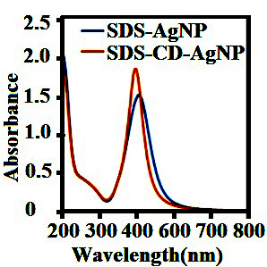
Figure 1. The UV-vis spectrum of the synthesized SDS-AgNPs
and SDS-CD-AgNPs.
The effective diameter of the AgNPs in the aqueous solution (pH= 7) is measured by dynamic light scattering (DLS), Figure 2. The results of SEM and DLS show that the most of SDS-AgNPs are spherical and often agglomerated into small aggregates (Figure 3a) with the average hydrodynamic diameter of 25-45 nm. Similarly, SEM and DLS data of SDS-CD-AgNPs show uniform particles with an average size of 10-20 nm and spherical shape.
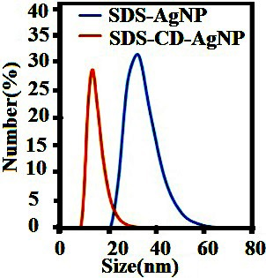
Figure. 2 The DLS plot of the SDS-AgNPs and SDS-CD-AgNPs
in aqueous solution at pH=7.

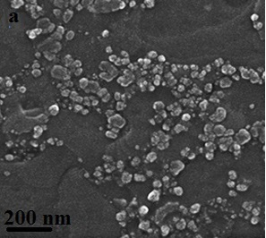
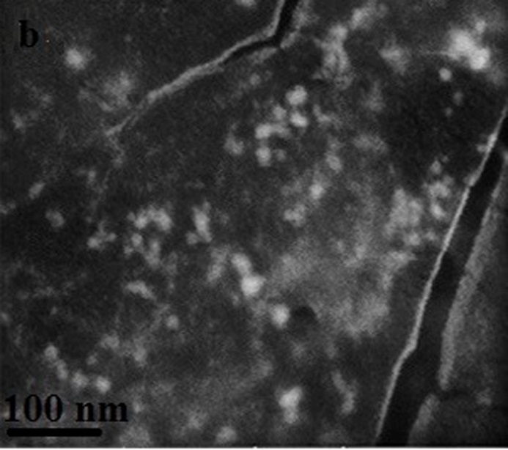
Figure. 3 SEM images of the synthesized AgNPs: (a) SDS-AgNPs
and (b) SDS-CD-AgNPs.

In Figure 4a, the FTIR spectra of the Sodium dodecyl sulfonate (SDS) SDS powder shows the presence of bonds like –CH3, S=O, –CH2–, C–O–S, which are in good agreement with the literature values⁴⁹). In addition, the spectra of β-CD in Figure 4b shows such bonds as O–H, C–H, C–O–C, which is in good agreement with the literature values.⁵⁰ The FTIR spectra of the SDS-AgNPs and SDS-CD-AgNPs are also recorded in order to identify the functional groups of the SDS and β-CD involved in the synthesis of the AgNPs. According to the FTIR spectrums at Figure 4a and 4b, the sharp peaks belonging to the β-CD and SDS were observed in the spectrum of the AgNPs. These results indicate the presence of β-cyclodextrin and SDS as capping agent of AgNPs.

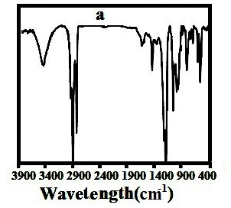
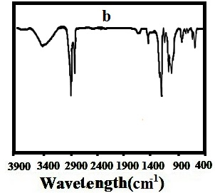
Figure. 4 FTIR spectrum of the synthesized AgNPs (a) SDS-AgNP
(b) SDS-CD-AgNP.

3.1 pH-dependent stability study of AgNPs
As the pH of the solution may influence on the surface charge and aggregation of NPs,⁵¹ the pH-dependent stability of SDS-AgNps and SDS-CD-AgNps were studied by UV-visible absorption measurements at the pH range 1-13, Figure 5. The results indicated that the SDS-AgNPs are stable in the pH range of 3-11, while according to significant changes in the SPR absorption intensity and color of solutions at lower pH < 3 and upper pH > 11, nanoparticles are instable. With increasing pH in alkaline media, the adsorption intensity decreased significantly which can be due to the formation of magnesium and chromium hydroxide.²⁹ At higher pH (pH > 11), SDS-AgNPs aggregate immediately, which shows a solution color change from yellow to orange, as well as a decrease of the SPR absorption intensity and the appearing new peak at 547nm. According to the Mie’s theory, due to the exhibition of two bands, SDS-AgNPs may not to be spherical and have an anisotropic shape at this range of pH.^{46, 47, 52}
From absorption spectra and image of the SDS-CD-AgNPs, it is seen that the particles are stable when pH value changes from 3 to 13, while according to significant changes in the SPR absorption intensity and color of solutions at lower pH < 3 nanoparticles are instable.
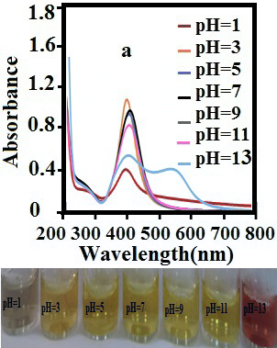
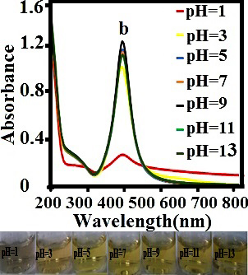
Figure. 5 Effect of pH on the stability of the (a) SDS-AgNPs and (b)
SDS-CD-AgNPs.

3.2 Selectivity assay of AgNPs
Figures 6 and 7 show that SDS-AgNPs and SDS-CD-AgNPs when tested against a range of other physiologically and environmentally important cations have remarkable selectivity for Mn²⁺ and Cr²⁺ ions, respectively. Figures 6 and 7 show that the other metal ions have no clear effect on the color or UV absorption, reveals that SDS-AgNPs and SDS-CD-AgNPs are efficiently selective for Mn²⁺ and Cr²⁺ ions, respectively.
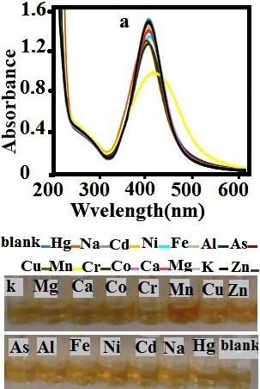
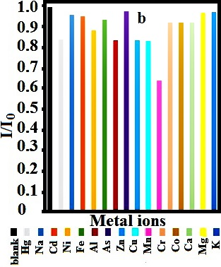
Figure. 6 (a) UV–vis spectra and photographic images after addition
of 50 μM of different metal ion salts and (b) bar graphs of UV-vis intensity
changes of SDS-AgNPs at 400 nm.
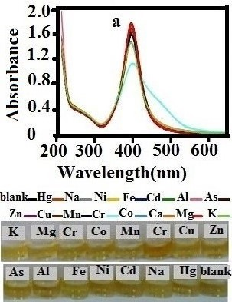
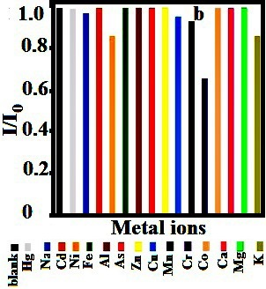
Figure. 7 (a) UV–vis spectra and photographic images after addition
of 50 μM of different metal ion salts and (b) bar graphs of UV-vis intensity
changes of SDS-CD-AgNPs at 410 nm.

The sensitivity of SDS-AgNPs toward Mn^{II} was evaluated by varying the concentration of Mn^{II} ions, Figure 8a. UV–vis spectra showed that by increasing the concentration of Mn ions in SDS-AgNPs solution, the intensity of the absorption band at 410 nm gradually decreased, at the same time (1.0 minute) and when the concentration of Mn^{II} ions in the solution reached to about 6.0 µM, the color change can be easily detectable by naked eye, the color of the solutions changed from yellow to orange. As well as, according to Figure 8b, the value of changes in the absorption intensity maximum at λ₄₁₀ showed a linear relationship with the concentration of Mn^{II} in the range from 6.0 µM to 9.0 µM. The detection limit of 6.0 µM could be obviously detected by UV-vis spectroscopy. Similarly, Figure 9a, for SDS-CD-AgNPs shows that by increasing Cr^{II} concentration from 3.0 µM to 9.0 µM, the UV-vis absorption peak intensity at 400 nm decreased and the color of the solutions changed from yellow to orange. As well as, Figure 9b shows a linear relationship with the concentration of Cr^{II} in the range from 3.0 µM to 9.0 µM and the detection limit of 3.0 µM could be obviously detected by UV-vis spectroscopy.
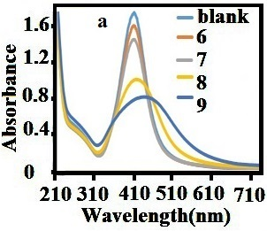
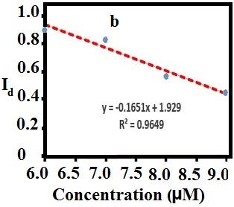
Figure. 8 (a) absorption spectral changes observed for SDS-AgNPs
after addition of of MnII ions at concenteration range from 6.0 µM to
9.0 µM and (b). Plot of changes in the absorption intensity maximum
at λ410 of Ap-AgNPs against MnII ion concentration from 6.0 µM to 9.0 µM.
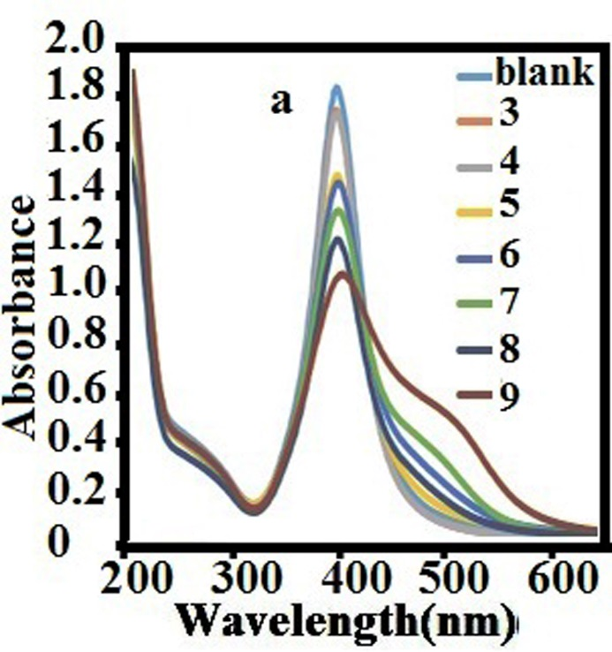
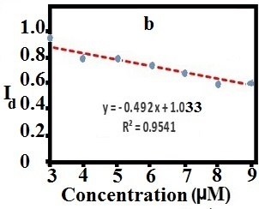
Figure. 9 (a) absorption spectral changes observed for SDS-CD-AgNPs
after addition of of CrII ions at concenteration range from 3 µM to 9.0 µM
and (b). Plot of changes in the absorption intensity maximum at λ400 of
SDS-CD-AgNPs against CrII ions concentration from 3.0 µM to 9.0 µM.
Furthermore, the selectivity of AgNPs was investigated in the presence of other competitive ions. According to the UV-vis spectra, Figure 10, the SDS-AgNPs possess high detection ability and selectivity toward Mn²⁺ in the presence of other cations. Similary, the UV-vis spectra result shows the anti-interferential capability of the SDS-CD-AgNPs, Figure 11. In addition, the results indicate that, solution contacting both Cr²⁺ and Hg⁺ ions, changes from yellow to brown and a change in the SPR band was observed. As well as the absorption ratios of this solution is much lower than the other solutions. These results indicate that the sensing of Cr²⁺ ions is also possible in the presence of other metals ions and SDS-CD-AgNP has good selectivity to Cr²⁺ ions, moreover there is probably of using SDS-CD-AgNP solution contining Cr²⁺ ions as Hg²⁺ sensor (Figure 12), similar research has been done in this regard.^{11, 32}
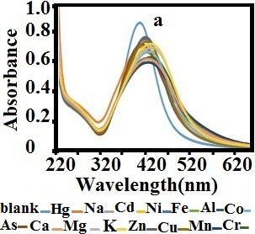
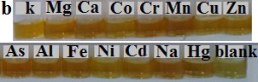
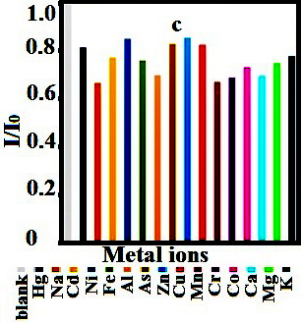
Figure. 10 (a) UV–vis spectra, photographic image and (b) bar graphs
of UV-vis intensity changes of SDS-AgNPs at 400 nm in the presence of
different metal ions.
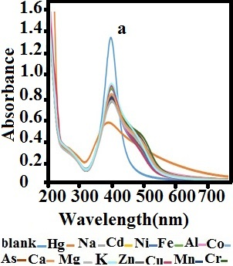
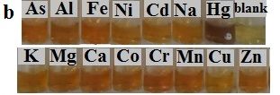

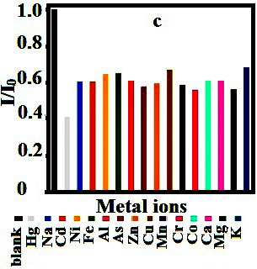
Figure. 11 (a) UV–vis spectra, photographic image and (b) bar graphs
of UV-vis intensity changes of SDS-CD-AgNPs at 410 nm in the presence
of different metal ions.
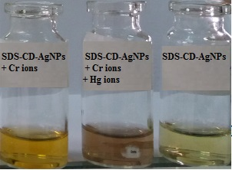
Figure. 12 photographic image of SDS-CDAgNPs solution containing
Cr²⁺ as colorimetric sensor for Hg²⁺ ion.

3.3 Real-time UV-Vis response of AgNP sensors toward desired ions
Figure. 13a shows the changes of SDS-AgNPs absorbance spectrum with the time after addition of Mn²⁺ ions. As the Figure shows, after nearly 1 min the colorimetric response of sensor was observed and also after 14 min the aggregation is completed and there is no change in the absorbance signals.
Similarly, Figure 13b shows that after the addition of Cr²⁺ into SDS-CD-AgNPs solution firstly there is a decreasing in the SPR peak intensity, then it reaches relatively to constant values in 6 min.

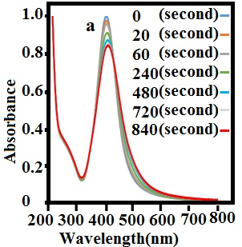
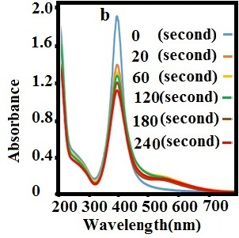
Figure. 13 Time course of the spectral response of (a) the SDS-AgNPs
at presence of 0.8 μM Mn²⁺ ions and (b) SDS-CD-AgNPs at presence of
0.8 μM Cr²⁺ ions.

3.4 Optimization of the conditions for the Mn²⁺ or Cr²⁺ measurement
In the following, the effect of the concentration of the AgNps and pH on the detection of Mn²⁺ or Cr²⁺ ions were investigated.
3.5 Effect of the concentration of the AgNps
The effects of the dosage of AgNps on their colorimetric sensing ability is examined as follows: firstly, different concentration of AgNPs were prepared with dilution of AgNPs solutions in different volume of deionized water as blank solutions (2:1, 1:1, and 1:2 V:V). Then different volume ratio of AgNPs solutions to desired ion solution is prepared (2:1, 1:1, and 1:2).
The absorption spectra and image of Figure 14 reveal that an increase in the volume ratio of AgNPs solutions to desired ion solution cause a decrease in analytical signal. Thus, the volume ratio of 2:1 of AgNPs to ion solution with maximal changes in SPR peaks and color of solution was selected as optimal ratio for detection of desired ions by both sensors.
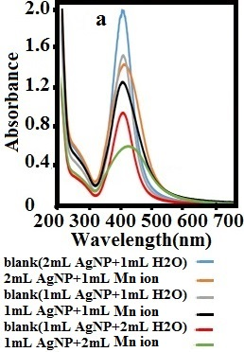
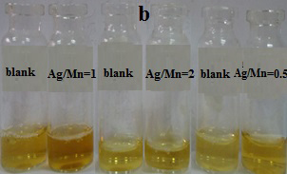
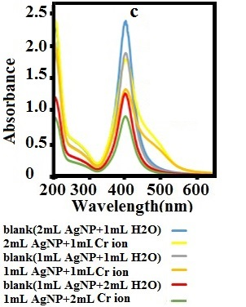
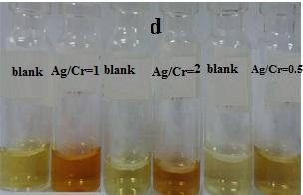
Figure 14. UV–vis spectra and photographic images of 2:1, 1:1, and
1:2 volume ratio of (a, b) SDS-AgNPs solutions to Mn²⁺ ions solution
and (c, d) SDS-CD-AgNPs solutions to Cr²⁺ ions solution.

3.6 Effect of pH on the detection of Mn²⁺ or Cr²⁺ ions
The effect of the pH on the performance of the sensors was tested as follows: 1mL AgNPs solution was mixed with 0.1 ml HCl or NaOH solutions with different concentrations. Next, 1 mL 10 μM Mn²⁺ or Cr²⁺ ions solution was added to the AgNPs solutions. Figure 15 show effect of pH (1 to 13) on the colorimetric response of the sensors. According to Figure 15, by adding desired ions to all of the solutions, a change in color and decrease in the absorbance ratio is clearly observed. These results indicate that, both sensors keep their sensing capability at pH 3 to 13. The pH 5 and 11 were selected as the best pH values for detection of manganese ion by SDS-AgNPs in acidic and basic media, respectively. Also, the pH 3 and 9 were selected as the best pH values for detection of chromium ion by SDS-CD-AgNPs in acidic and basic media, respectively.

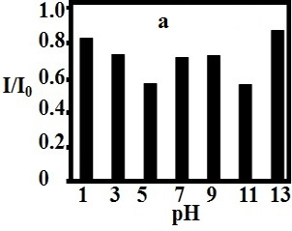
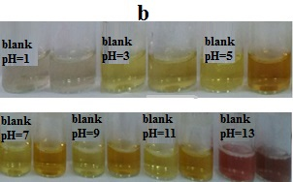
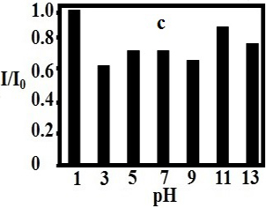
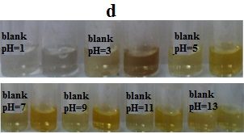
Figure. 15 Bar graphs of UV-vis intensity changes and photographic
images of (a, b) SDS-AgNPs and (c, d) SDS-CD-AgNPs at different
pH levels.

3.7 SEM and DLS analysis
To explain the mechanism of sensing of the AgNPs to detect desired, the nanoparticles were examined before and after desired exposure using UV-vis, SEM and DLS observations. According to the above results, the color of both nanoparticles changes from yellow to orange in the presence of desired ions. The results of SEM and DLS (Figure 16) for SDS-AgNPs sensor show that SDS-AgNPs are dispersed with an average size of 20 nm, but after adding Mn²⁺ ions a significant aggregation of nanoparticles is observed. Similary, Figure 17 shows SEM and DLS of SDS-Cd-AgNPs sensor, as Figure show dispersed SDS-CD-AgNPs with ∼20 nm diameter, but after adding Cr²⁺ ions aggregation of nanoparticles is occurred. According to the Uv-Visible results, with increasing the metal ions concentration (Mn²⁺ or Cr²⁺), a red shift in the AgNPs SPR band was seen which could be due to the complexing action of SDS or CD- SDS surface functionality with metal ions (Mn²⁺ or Cr²⁺), leads to the aggregation of NPs.^{16,17,29,53,54} The assay procedure for the colorimetric detection of the cysteine is illustrated in Figure 18.

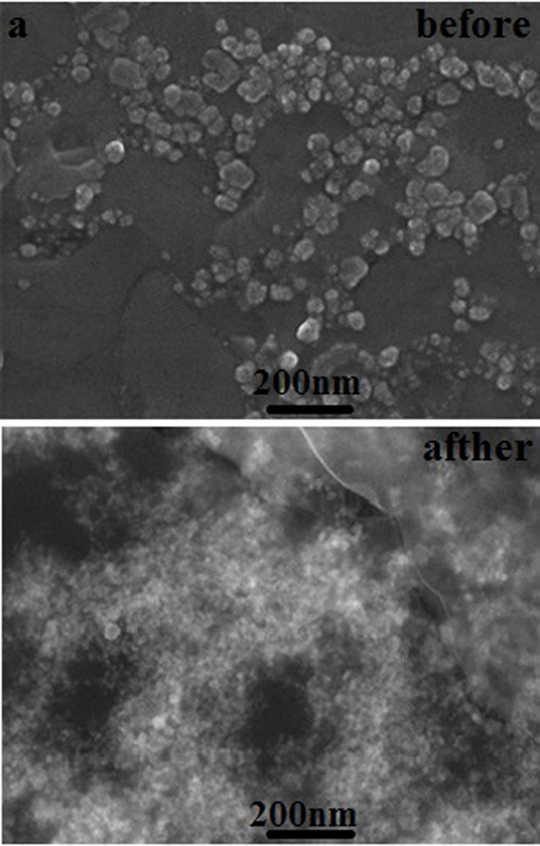
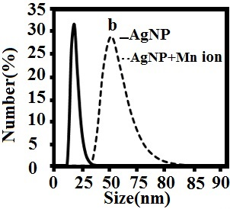
Figure. 16 (a) SEM images and (b) DLS spectrum of SDS-AgNPs
before and after the addition of 0.5 µM of Mn²⁺ ions.

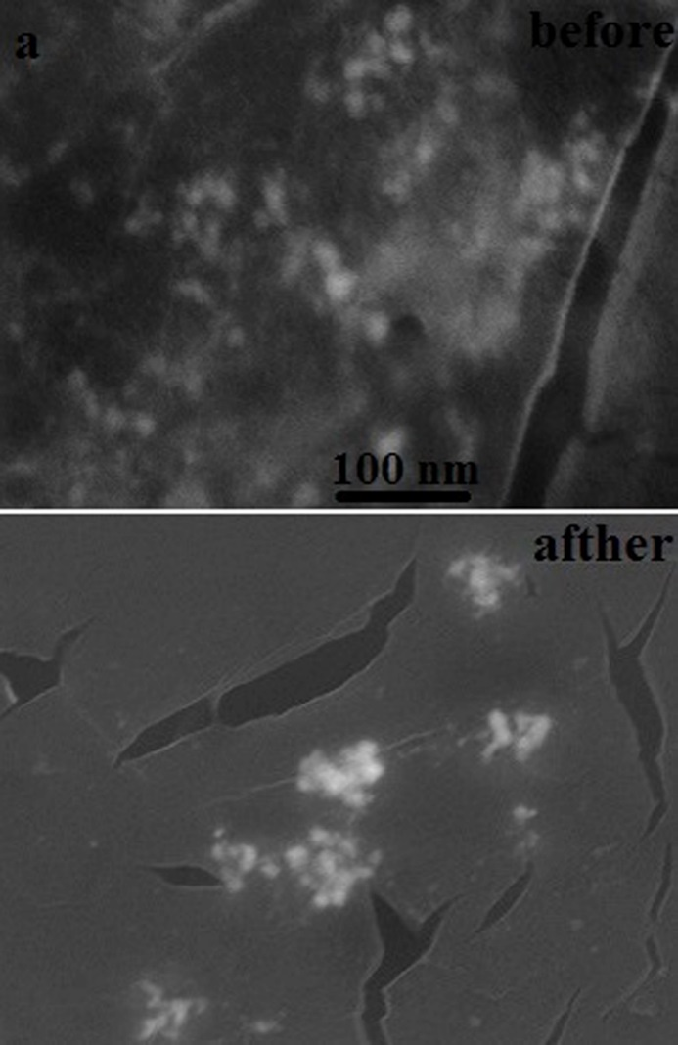
Figure. 17 (a) SEM images and (b) DLS spectrum of SDS-CD-AgNPs
before and after the addition of 0.5 µM of Cr²⁺ ions.

Figure. 18 Schematic illustration of the detection mechanism of Mn²⁺ and Cr²⁺ ions based on the aggregation of SDS-AgNPs and SDS-CD-AgNPs respectively.
4. Conclusion
In summary, two types of stable silver nanoparticles were synthesized with SDS and combination of SDS and β-CD, which successfully utilized as colorimetric sensor for Mn^{II} and Cr^{II} ions at ppm level, respectively. Upon adding desired ions, both AgNPs solutions change from yellow to orange which is detect by the naked eye and UV-vis spectroscopy. Indeed, the desired ions can be detected rapidly based on the color change of the system, which is results of aggregation Ag nanoparticles by adsorbing metal ions on their surface.

5. Refrences
1. J.L. Aschner, M. Aschner, Mol. Aspects Med. 2005, 26, 353-362.
2. R. Achmad, B. Budiawan, E. Auerkari, Achmad et al. 2017, 2, 1-8.
3. M. Faisal, S. Hasnain, J. Pharmacol. Toxicol. 2006, 1, 248-258.
4. S.L. O’Neal, W. Zheng, , Curr Environ Health Rep. 2015, 2, 315-328.
5. S.H. Frisbie, E.J. Mitchell, H. Dustin, D.M. Maynard, B. Sarkar, Environ Health Perspect. 2012, 120, 775-778.
6. M. Deveau, J Toxicol Environ Health A. 2010, 73, 235-241.
7. J. Mao, Q. He, W. Liu, Anal Bioanal Chem. 2010, 396, 1197-1203.
8. K. Dutta, R.C. Deka, D.K. Das, J Fluoresc. 2013 ,23, 1173-1178.
9. U. Divrikli, M. Soylak, L. Elci, Environ Monit Assess. 2008, 138, 167-172.
10. V. Doroschuk, S. Lelyushok, V. Ishchenko, S. Kulichenko, Talanta. 2004, 64, 853-856.
11. W. Zhou, B.-C. Yin, B.-C. Ye, Biosens Bioelectron. 2017, 87, 187-194.
12. A. Ramesh, B.A. Devi, H. Hasegawa, T. Maki, K. Ueda, Microchem J. 2007, 86, 124-130.
13. A. Milne, W. Landing, M. Bizimis, P. Morton, Anal Chim Acta. 2010, 665, 200-207.
14 H. Gurleyuk, D. Wallschläger, J Anal At Spectrom. 2001, 16, 926-9302001.
15. E. Grygo-Szymanko, A. Tobiasz, N. Miliszkiewicz, D. Dudek-Adamska, S. Walas, Anal Lett. 2017, 50, 2147-2160.
16. Y. He, X. Zhang, Sens. Actuator B-Chem. 2016, 222, 320-324.
17. Y.-X. Qi, Z.-b. Qu, Q.-X. Wang, M. Zhang, G. Shi, Anal Chim Acta. 2017, 980, 65-71.
18. Y. Zhao, Z. Zhong, J Am Chem Soc. 2006, 128, 9988-9989.
19. X. Liu, Y. Tang, L. Wang, J. Zhang, S. Song, C. Fan, S. Wang, Adv Mater. 2007, 19, 1471-1474.
20. I.-B. Kim, U.H. Bunz, J Am Chem Soc. 2006, 128 ,2818-2819.
21. S.-J. Liu, H.-G. Nie, J.-H. Jiang, G.-L. Shen, R.-Q. Yu, J Anal Chem. 2009, 81, 5724-5730.
22. D. Zhang, M. Deng, L. Xu, Y. Zhou, J. Yuwen, X. Zhou, Eur J Chem. 2009, 15 , 8117-8120.
23. M. Hollenstein, C. Hipolito, C. Lam, D. Dietrich, D.M. Perrin, Angew Chem Int Ed Engl. 2008, 120, 4418-4422.
24. M. Rex, F.E. Hernandez, A.D. Campiglia, Anal. Chem. 2006, 78, 445-451.
25. Y.-R. Kim, R.K. Mahajan, J.S. Kim, H. Kim, ACS App Mater Inter. 2009, 2 , 292-295.
26. P. Vasileva, T. Alexandrova, I. Karadjova, J. chem. 2017, 2017.
27. B. Paul, A. Tiwari, J Environ Sci. Toxicol. Food Technol. 2015, 1 , 01-07.
28. M. Sabela, S. Balme, M. Bechelany, J.M. Janot, K. Bisetty, Adv Eng Mater. 2017, 19,1700270.
29. M. Annadhasan, T. Muthukumarasamyvel, V. Sankar Babu, N. Rajendiran, ACS Sustainable Chem. Eng. 2014, 2, 887-896.
30. C. Burda, X. Chen, R. Narayanan, M.A. El-Sayed, Chem. Rev. 2005, 105, 1025-1102.
31. R. Shukla, V. Bansal, M. Chaudhary, A. Basu, R.R. Bhonde, M. Sastry, Langmuir. 2005, 21 ,10644-10654.
32. V.V. Kumar, S.P. Anthony, Sensor Actuat B Chem. 2014, 191, 31-36.
33. W. Leesutthiphonchai, W. Dungchai, W. Siangproh, N. Ngamrojnavanich, O. Chailapakul, Talanta. 2011 ,85, 870-876.
34. T. Kim, C.-H. Lee, S.-W. Joo, K. Lee, J Colloid Interface Sci. 2008, 318, 238-243.
35. L. Wei, Z. Yuping, C. Chengxing, C. Wentao, L. Runqiang, Q. Lingbo, 2011 Third International Conference 2011, 1013-1016.
36. K. Aslan, J.R. Lakowicz, C.D. Geddes, Anal Biochem. 2004, 330, 145-155.
37. E. Priyadarshini, N. Pradhan, Sens Actuators B Chem. 2017, 238, 888-902.
38. B.A. Makwana, D.J. Vyas, K.D. Bhatt, S. Darji, V.K. Jain, Appl Nanosci. 2016, 6, 555-566.
39. H. Li, Z. Cui, C. Han, Sens Actuators B Chem. 2009, 143, 87-92.
40. R. Rajamanikandan, M. Ilanchelian, Mater Today Commun. 2018, 15, 61-69.
41. H.K. Sung, S.Y. Oh, C. Park, Y. Kim, Langmuir. 2013, 29, 8978-8982.
42. Y.-r. Ma, H.-y. Niu, Y.-q. Cai, Chem. Commun. 2011, 47, 12643-12645.
43. X. Gao, Y. Lu, S. He, X. Li, W. Chen, Anal Chim Acta. 2015, 879, 118-125.
44. J.K. Patra, K.-H. Baek , J Nanomater. 2014, 2014, 219.
45. S. Jongjinakool, K. Palasak, N. Bousod, S. Teepoo, Energy procedia. 2014, 56, 10-18.
46. G. Mie, Ann. Phys. 1908, 25, 377-442.
47. H. Wang, Y. Wang, J. Jin, R. Yang, Anal. Chem. 2008, 80, 9021-9028.
48. S. Agnihotri, S. Mukherji, S. Mukherji, RSC Adv. 2014, 4, 3974-3983.
49. X. Gao, J. Chorover, J Colloid Interface Sci. 2010, 348, 167-176.
50. H. Rachmawati, C.A. Edityaningrum, R. Mauludin, Aaps Pharmscitech. 2013, 14, 1303-1312.
51. Z. Qiao, Y. Yao, S. Song, M. Yin, J. Luo, J Mater Chem B. 2019, 7, 830-840.
52. D.V. Leff, P.C. Ohara, J.R. Heath, W.M. Gelbart, J Phys Chem Biophys. 1995, 99, 7036-7041.
53. X. Wu, Y. Xu, Y. Dong, X. Jiang, N. Zhu, Anal. Methods. 2013, 5, 560-565.
54. M. Elavarasi, A. Rajeshwari, S.A. Alex, D.N. Kumar, N. Chandrasekaran, A. Mukherjee, Anal. Methods. 2014, 6, 5161-5167.

