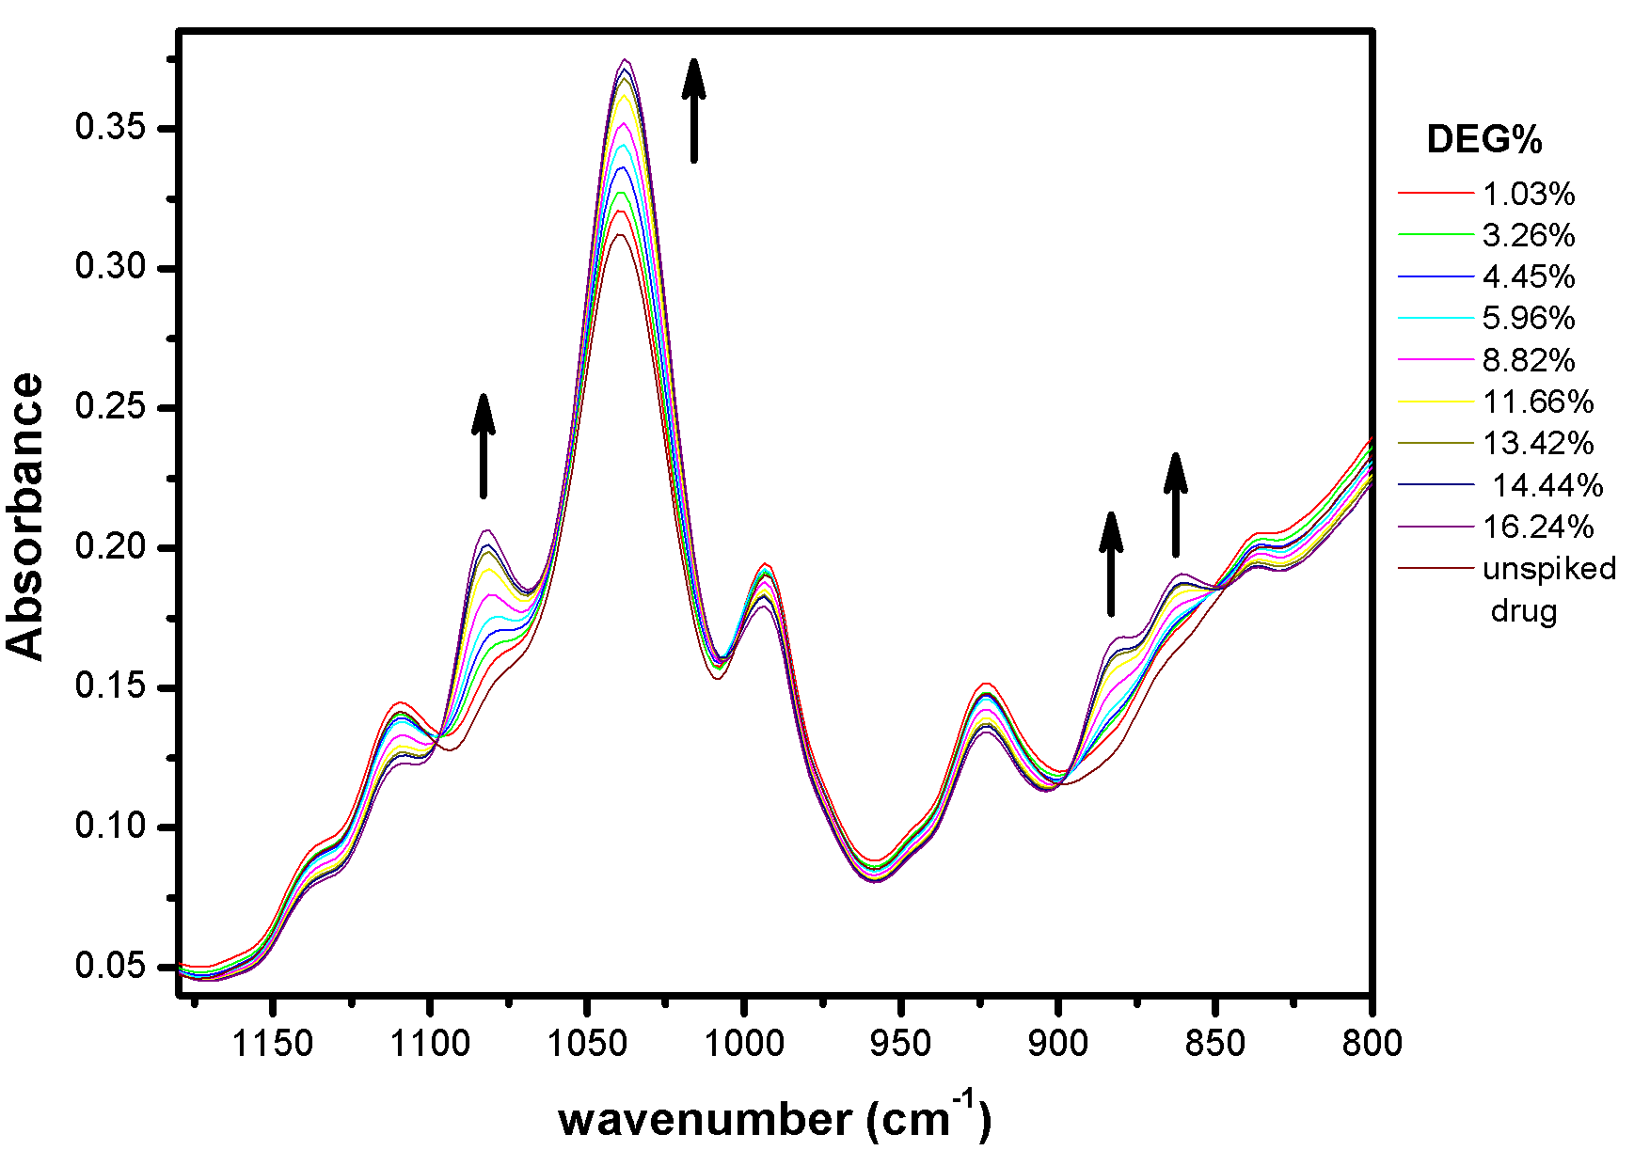
Identification and determination of diethylene glycol (DEG) in a glycerin-based products was successfully achieved using FTIR spectroscopy. A cough syrup (Hederal), two paracetamol syrup formulations and two food supplements (Better Stevia and Lemon Balm) were spiked with different amounts of DEG ranging from 0.5 to 20% by mass. The characteristic DEG wavenumbers 881 and 1083 cm⁻¹ were used for its quantitative determination in the studied samples.

