Article
Ab-initio Study of Citrate Ion as an Oxygen-Rich Complexing Agent.
A.G. Rojas-Hernández¹, A. De Leon²*, R.A. Sabory-García¹, R. Ramírez-Bon³, D. Berman-Mendoza¹ and S.J. Castillo¹
¹ Departamento de Investigación en Física, Universidad de Sonora, Blvd. Luis Encinas y Rosales S/N, Col. Centro, Hermosillo, Sonora, México
² Centro de Investigación y Estudios Avanzados del IPN. Unidad Querétaro. Apdo. Postal 1-798, 76001, Querétaro, Qro. México
³ Departamento de Ciencias Químico-Biológicas, Universidad de Sonora, Blvd. Luis Encinas y Rosales S/N, Col. Centro, Hermosillo, Sonora, México
Abstract: Theoretical studies on conformational analysis, geometry optimizations and frequencies for citrate at the MP2/LANL2DZ level portrait it as a promising candidate for a complexing agent for cadmium (II) ion (Cd²⁺) and cadmium sulfide (CdS). Natural Bond Orbital (NBO) charges, Delocalization Indices, HOMO/LUMO gaps and surfaces along with absolute electronegativity values were employed to analyze the interactions among the configurations obtained. The most stable structures involved the interaction between the LUMO of Cd²⁺/CdS and the most dense region of the HOMO of the citrate ion.
Keywords: HOMO/LUMO surfaces; complexing agent; CdS; citrate ion

1. Introduction
The synthesis of CdS films, which are used on solar cells through a cheap technique such as chemical bath deposition (CBD)¹ is highly dependable on the complexing agent used. The optimum semiconductor films are produced modulating temperature,² pH³ and reactive concentration.⁴ In this technique, the thin films are deposited on substrates in contact with dilute chemical baths containing metallic ions. Thus, the morphology of the film is highly dependent on the precipitation of the solid phase. Therefore, the complexing agents play a crucial role on the structure of the thin film being deposited. One of the complexing agents used experimentally is ammonia.⁵ However, its volatility and toxicity have contributed to a search for other materials. Among them, are ethylene-diamine (ED) [6], ethylenediaminetetraacetic acid (EDTA),⁶ polyethyleneimine,⁷ acetylacetone⁸ and glycine.⁹ There are only a handful of complexing agents proposed and few studies on the interactions involved between complexing agent and CdS. Therefore, our aim is to propose new complexing agents that can show a good affinity with CdS to enhance the homogeneity of the morphology and structure of the film. Therefore, we propose citrate ion as a complexing agent for CdS based on our previous studies^{9,10} that show a high relationship between the stability of CdS and an oxygen rich complexing agent. The main goal of this paper is to analyze the participation of the oxygens in the citrate ion on the interaction between it and Cd²⁺/CdS and citrate ion through charges, delocalization indices, HOMO/LUMO and absolute electronegativity.

2. Methodology
We employed Gaussian 09¹¹ software for ab-initio quantum mechanical calculations at the second order perturbation Møller Plesset MP2¹² level of theory in conjunction with the LANL2DZ¹³ basis set. We used global orbital cutoffs and fine convergence criteria. We examined the Hessian matrix to confirm the energy minima configurations had only positive vibrational frequencies which pertain to energy minima and not transition states. Basis set superposition error (BSSE)¹⁴ calculations and zero-point energies were employed to correct the energies.
Dissociation energies (ΔE) are obtained from:
$∆E=E_{system}-E_{citrate ion}-E_{{Cd}^{2+}/CdS}$,
Where system refers to the system formed by Cd²⁺ or CdS and the citrate ion. The terms $E_{citrate ion}$ and $E_{{Cd}^{2+}/CdS}$ refer to the energy in kcal/mol of the optimized structures of the citrate ion, Cd²⁺ and CdS on an individual level, respectively. In the first set of results, we studied the systems Cd²⁺-citrate ion, while the second set of results pertain to the CdS-citrate ion systems. For all the systems, we calculated the difference between the Lowest Unoccupied Molecular Orbital (LUMO) and the Highest Occupied Molecular Orbital referred to as GAP in eV on Table 1.
We calculated absolute electronegativity, $χ$, for all the systems,¹⁵
$$χ=\frac{I+A}{2}$$
Where -ε_{HOMO}=I and -ε_{LUMO}=A, HOMO stands for Highest Occupied Molecular Orbital and LUMO, for Lowest Unoccupied molecular orbital.
In addition, we report charges in au obtained via Natural Bond Orbital (NBO) analyses¹⁶ using Gaussian 09. Delocalization indices, DI(A,B) between atoms A and B, calculated through the AIMALL software¹⁷ to analyze bonds and interactions between the atoms in the molecular species.

3. Results and Discussion
The interaction between citrate ion and cadmium (pale yellow) can be considered an acid-base one. The calculated values of χ for the citrate ion and cadmium were of 4.78 x 10⁻²⁰ J and 1.87 x 10⁻²⁰ J, respectively. It is expected that Cd²⁺ attracts electrons and the citrate ion donates them. This is confirmed by NBO charges and delocalization indices.
Figure 1 shows the optimized geometry of citrate ion and the CdS in conjunction with their HOMO and LUMO surfaces. The energy minima configurations formed by the interaction between citrate ion and Cd²⁺ are depicted in Figure 2 in order of stability whereas the first structure is the most stable.
In structure 1, the citrate ion displays 3 hydrogen bonds involving its deprotonated carboxyl groups with delocalization indices of DI(H6,O11)=0.04, DI(O13,H15)=0.10 and DI(H5,O16)=0.04 and distances of 2.48 Å, 1.77 Å and 2.37 Å, respectively. The first structure of Fig. 2 has a dissociation energy of -1065.20 KJ/mol. To form this structure, C4 and C7 moved their attached atoms to interact with cadmium, but shares one hydrogen bond with citrate ion from Fig.1 but with a smaller DI(O13,H15)=0.06. The transfer of electrons from the citrate ion to cadmium is confirmed by its decrease in charge to 0.85 au and DI(O12,Cd18)=0.51. Structure 2 has a dissociation energy of -798.36 KJ/mol. It does not retain any of the hydrogen bonds the lone citrate ion had, which could account for an increase in energy compared to structure 1. However, its high stability is most likely supported by the interaction of Cd with the ion on the region where most of the citrate ion’s HOMO is located. It forms 1 hydrogen bond with DI(H15,O16)=0.06 and shows charge transfer between Cd and 3 oxygens with DI values of DI(O11,Cd18)=0.47, DI(O12,Cd18)=0.48, DI(O17,Cd18)=0.39 and distances of 2.08 Å, 2.11 Å and 2.15 Å, leaving Cd with a charge of 1.65 au. Structure 3 is the least stable system. It does not retain any of the lone citrate ion’s hydrogen bonds. It forms a hydrogen bond with DI(O10,H15)=0.10. It also forms a single bond betwee 2 oxygens, with DI(O13,O16)=1.08 which increases the repulsion between them, rising the dissociation energy to -283.34 KJ/mol and the charge of Cd to -0.02 au. Structures 1-3 all showed similar absolute electronegativity values of 1.60 x 10⁻²⁰ J, 1.53 x 10⁻²⁰ J and 1.52 x 10⁻²⁰ J, respectively. HOMO/LUMO gaps of structures 1 and 3 were very similar, with values of 2.40 x 10⁻¹⁹ J and 2.68 x 10⁻¹⁹ J, respectively, while that of structure 2 was of 1.76 x 10⁻¹⁸ J indicating its lower ability as a conductor in comparison.

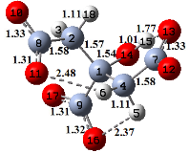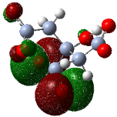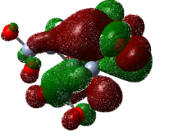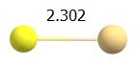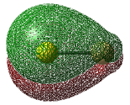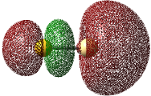
Figure 1. Selected geometrical parameters of citrate ion and CdS whereby bond lengths are in angstroms (Å). HOMO and LUMO surfaces are depicted for both substances.
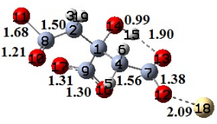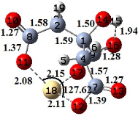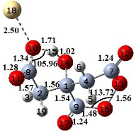
1 2 3
HOMO
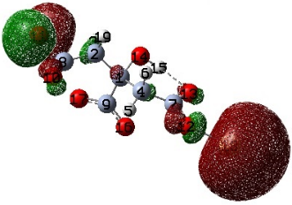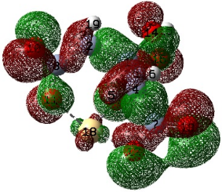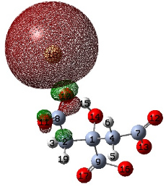
LUMO
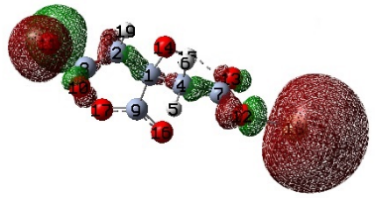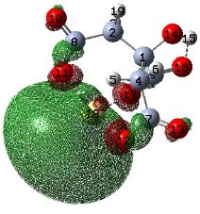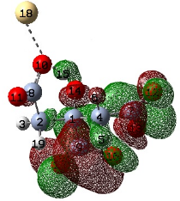
Figure 2. Selected geometrical parameters of the systems citrate ion-Cd whereby bond lengths are in angstroms (Å) and angles in °. HOMO and LUMO surfaces are depicted for all the configurations.
Table 1. MP2/LANL2DZ dissociation energies with zero point corrections, HOMO/LUMO gaps and absolute electronegativity are listed under ΔE(0K) in kJ/mol; GAP and χ in ( x 10⁻¹⁹ J), respectively for structures 1-11 shown on Figs. 1-3.

System | ΔE | GAP | χ
1 | -1065.20 | 2.40 | 0.16
2 | -798.36 | 17.6 | 0.15
3 | -283.34 | 2.68 | 0.15
4 | -518.36 | 14.7 | 0.38
5 | -514.16 | 14.8 | 0.38
6 | -506.40 | 14.7 | 0.38
7 | -499.44 | 14.8 | 0.31
8 | -478.53 | 14.9 | 0.32
9 | -470.91 | 14.9 | 0.32
10 | -241.98 | 18.0 | 0.33

Table 2. Delocalization Indices of citrate ion and structures 1-3.
 |  | DI(A,B)
A | B | citrate |  | 1 |  | 2 |  | 3
C8 | O10 | 1.24 |  | 1.51 |  | 1.41 |  | 1.14
H6 | O11 | 0.04 |  | --- |  | --- |  | ---
C8 | O11 | 1.28 |  | 0.75 |  | 1.04 |  | 1.38
C7 | O12 | 1.28 |  | 1.02 |  | 1.05 |  | 1.53
C7 | O13 | 1.21 |  | 1.34 |  | 1.44 |  | 0.82
O10 | H15 | --- |  | --- |  | --- |  | 0.10
O13 | H15 | 0.10 |  | 0.06 |  | --- |  | ---
H5 | O16 | 0.04 |  | --- |  | --- |  | ---
C9 | O16 | 1.25 |  | 1.30 |  | 1.37 |  | 0.83
O13 | O16 | --- |  | --- |  | --- |  | 1.08
H15 | O16 | --- |  | --- |  | 0.06 |  | ---
C9 | O17 | 1.27 |  | 1.30 |  | 1.11 |  | 1.54
O10 | Cd18 | --- |  | --- |  | --- |  | 0.26
O11 | Cd18 | --- |  | --- |  | 0.47 |  | ---
O12 | Cd18 | --- |  | 0.51 |  | 0.48 |  | ---
O17 | Cd18 | --- |  | --- |  | 0.39 |  | ---

Table 3. NBO charges in au for citrate ion and systems 1-3.
 | citrate | 1 | 2 | 3
C1 | 0.28 | 0.28 | 0.25 | 0.25
C2 | -0.54 | -0.57 | -0.54 | -0.53
H3 | 0.23 | 0.32 | 0.24 | 0.25
C4 | -0.56 | -0.53 | -0.56 | -0.54
H5 | 0.23 | 0.25 | 0.21 | 0.24
H6 | 0.25 | 0.22 | 0.27 | 0.28
C7 | 1.00 | 1.08 | 0.98 | 0.99
C8 | 1.00 | 1.01 | 0.99 | 0.99
C9 | 1.00 | 0.95 | 0.97 | 0.98
O10 | -0.98 | -0.64 | -0.76 | -1.00
O11 | -0.93 | -0.47 | -1.05 | -0.80
O12 | -0.93 | -1.05 | -1.04 | -0.64
O13 | -0.97 | -0.84 | -0.74 | -0.34
O14 | -0.93 | -0.88 | -0.87 | -0.87
H15 | 0.52 | 0.54 | 0.53 | 0.56
O16 | -0.95 | -0.89 | -0.79 | -0.38
O17 | -0.93 | -0.88 | -1.00 | -0.63
Cd18 | --- | 0.86 | 1.65 | -0.02
H19 | 0.20 | 0.24 | 0.26 | 0.23

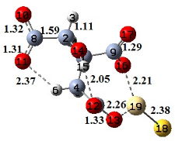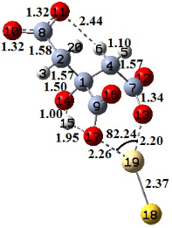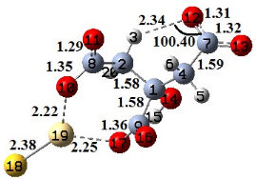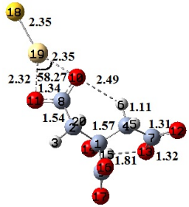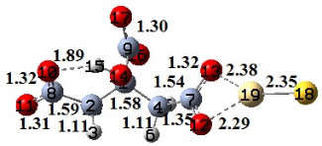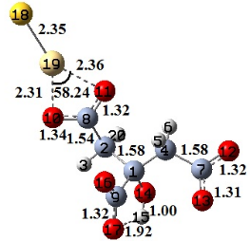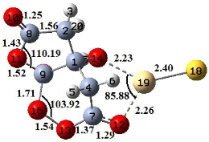
4 5 6 7 8 9 10
HOMO
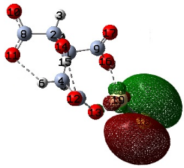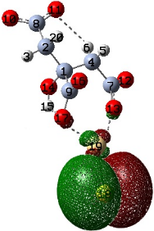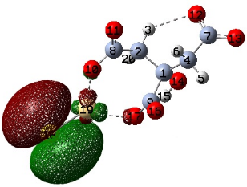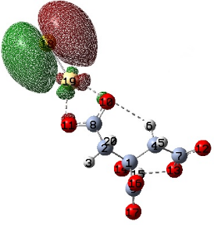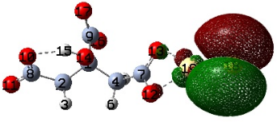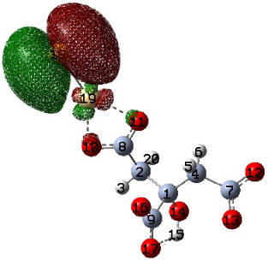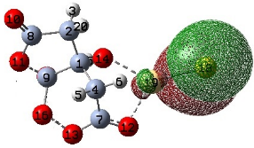
LUMO
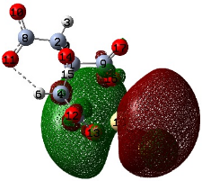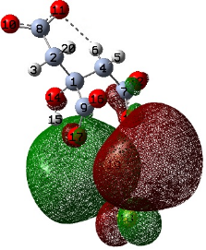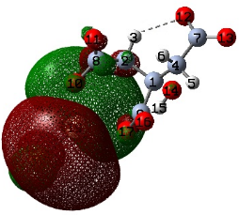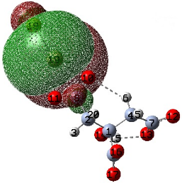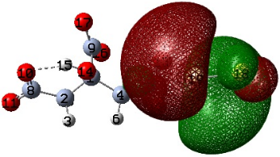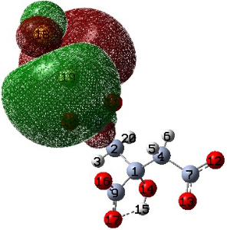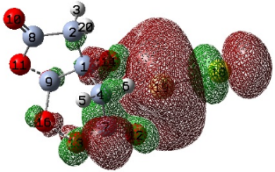
Figure 3. Selected geometrical parameters of the systems citrate ion-CdS whereby bond lengths are in angstroms (Å) and angles in °. HOMO and LUMO surfaces are depicted for all the configurations.

Table 4. Delocalization Indices of structures 4-10
 |  | DI(A,B)
A | B | 4 | 5 | 6 | 7 | 8 | 9 | 10
H6 | O10 | --- | --- | --- | 0.04 | --- | --- | ---
C8 | O10 | 1.27 | 1.27 | 1.10 | 1.20 | 1.25 | 1.19 | 1.54
H6 | O11 | 0.04 | 0.04 | --- | --- | --- | --- | ---
C8 | O11 | 1.27 | 1.27 | 1.35 | 1.19 | 1.27 | 1.22 | 0.91
C9 | O11 | --- | --- | --- | --- | --- | --- | 0.76
H3 | O12 | --- | --- | 0.05 | --- | --- | --- | ---
C7 | O12 | 1.29 | 1.33 | 1.27 | 1.28 | 1.16 | 1.25 | 1.27
C7 | O13 | 1.15 | 1.09 | 1.26 | 1.23 | 1.24 | 1.28 | 1.06
O10 | H15 | --- | --- | --- | --- | 0.07 | --- | ---
O12 | H15 | 0.06 | --- | --- | --- | --- | --- | ---
O13 | H15 | --- | --- | --- | 0.09 | --- | --- | ---
C9 | O16 | 1.09 | 1.34 | 1.37 | 1.24 | 1.24 | 1.30 | 0.54
O13 | O16 | --- | --- | --- | --- | --- | --- | 1.04
H15 | O16 | --- | --- | --- | --- | --- | --- | ---
C9 | O17 | 1.36 | 1.10 | 1.08 | 1.31 | 1.32 | 1.24 | 1.29
H15 | O17 | --- | 0.07 | 0.05 |  | --- | 0.07 | ---
O10 | Cd19 | --- | --- | 0.33 | 0.28 | --- | 0.30 | ---
O11 | Cd19 | --- | --- | --- | 0.30 | --- | 0.27 | ---
O12 | Cd19 | --- | --- | --- | --- | 0.30 | --- | 0.30
O13 | Cd19 | 0.30 | 0.31 | --- | --- | 0.30 | --- | ---
O14 | Cd19 | --- | --- | --- | --- | --- | --- | 0.30
O16 | Cd19 | 0.32 | --- | --- | --- | --- | --- | ---
O17 | Cd19 | --- | 0.30 | 0.31 | --- | --- | --- | ---
S18 | Cd19 | 1.22 | 1.23 | 1.22 | 1.33 | 1.32 | 1.32 | 1.02
Table 5. NBO charges in au for systems 4-10.
 | 4 | 5 | 6 | 7 | 8 | 9 | 10
C1 | 0.29 | 0.28 | 0.29 | 0.28 | 0.28 | 0.29 | 0.15
C2 | -0.52 | -0.52 | -0.53 | -0.52 | -0.53 | -0.51 | -0.27
H3 | 0.22 | 0.21 | 0.27 | 0.23 | 0.19 | 0.23 | 0.14
C4 | -0.54 | -0.53 | -0.53 | -0.55 | -0.51 | -0.53 | -0.27
H5 | 0.21 | 0.21 | 0.22 | 0.22 | 0.25 | 0.23 | 0.15
H6 | 0.27 | 0.26 | 0.22 | 0.23 | 0.20 | 0.20 | 0.12
C7 | 1.01 | 1.03 | 1.00 | 1.00 | 1.05 | 1.00 | 0.52
C8 | 1.00 | 0.99 | 1.00 | 1.05 | 1.00 | 1.04 | 0.48
C9 | 0.98 | 0.99 | 0.98 | 0.96 | 0.96 | 0.97 | 0.50
O10 | -0.94 | -0.94 | -1.00 | -0.94 | -0.93 | -0.95 | -0.32
O11 | -0.93 | -0.93 | -0.84 | -0.94 | -0.93 | -0.92 | -0.34
O12 | -0.89 | -0.86 | -0.93 | -0.92 | -0.96 | -0.96 | -0.42
O13 | -0.97 | -1.02 | -0.95 | -0.94 | -0.90 | -0.92 | -0.20
O14 | -0.87 | -0.88 | -0.87 | -0.90 | -0.90 | -0.91 | -0.49
H15 | 0.51 | 0.51 | 0.50 | 0.54 | 0.54 | 0.53 | 0.29
O16 | -1.02 | -0.84 | -0.81 | -0.96 | -0.96 | -0.90 | -0.16
O17 | -0.82 | -1.01 | -1.02 | -0.89 | -0.88 | -0.94 | -0.43
S18 | -1.38 | -1.38 | -1.38 | -1.33 | -1.34 | -1.33 | 0.27
Cd19 | 1.21 | 1.21 | 1.20 | 1.14 | 1.15 | 1.15 | 0.66
H20 | 0.20 | 0.21 | 0.19 | 0.24 | 0.23 | 0.22 | 0.13

The next set of structures (4-10) are the energy minima geometries of the interaction between citrate ion and CdS. As in structures 1-3, the transfer of electrons happens from the citrate ion to CdS. Observing Fig. 1, the LUMO is denser on Cd, which indicates it is prone to accepting electrons. It can also be seen that the HOMO of the citrate ion lies mostly on the deprotonated carboxyl groups from (O16-C9-O17) –to a lesser extent on (O10-C8-O11) – and on (O12-C7-O13)–. The most stable structures of this set (4-6) show interactions between Cd19 and the (O16-C9-O17) – group.
Configuration 4, the most stable structure of this set with a dissociation energy of -518.36 KJ/mol, configuration 4 involves these first and third groups. The interaction of Cd19 is with O13 and O16, with delocalization indices of DI(O13,Cd19)=0.30 and DI(O16,Cd19)=0.32. The charges of Cd and S were of 1.21au and -1.38au, respectively. Structure 5 has a dissociation energy of -514.16 KJ/mol, very close to that of structure 4. Its interaction also occurs with oxygens of different deprotonated carboxyl groups. Its DI values were of DI(O13,Cd19)=0.31 and DI(O17,Cd19)=0.30. The charges of Cd and S showed the same values as in structure 4. In structure 6, Cd interacts with 2 oxygens of different groups, with DI values of DI(O10,Cd19)=0.33 and DI(O17,Cd19)=0.31. Its dissociation energy is very close to that of structures 4 and 5, with a value of -506.40 kcal/mol. The charges of Cd and S were almost the same as in the last two structures, with values of 1.20 and -1.38 au, respectively. Structures 4-6 had similar values of HOMO/LUMO gaps and absolute electronegativities.
Configuration 7, with a dissociation energy of -499.44 KJ/mol depicts the interaction between Cd19 and two oxygens of the same functional group with DI(O10,Cd19)=0.28 and (DI(O11,Cd19)=0.30. It shows two hydrogen bonds with DI(H6,O10)=0.04 and DI(O13,H15)=0.09 The charges of Cd and S were of 1.14 au and -1.33 au. Configuration 8 interacts with two oxygens of the functional group (O12-C7-O13)– with DI(O12,Cd19)=0.30 and DI(O13,Cd19)=0.30 but only has one hydrogen bond with DI(O10,H15)=0.07. This could account for a smaller dissociation energy of -478.53 KJ/mol. The charges of Cd and S are similar to those of structure 7, with values of 1.15 au and -1.34 au, respectively. For Structure 9, similarly as in structure 7, the interaction between Cd and citrate is with the same functional group, with DI(O10,Cd19)=0.30 and DI(O11,Cd19)=0.27. It only has 1 hydrogen bond with DI(H15,O17)=0.07 with a dissociation energy of -470.91 KJ/mol. Absolute electronegativity for systems 7-9 have similar values of electronegativity (1.48 x 10⁻¹⁸ J for 7 and 1.49 x 10⁻¹⁸ J for 8 and 9). Their HOMO/LUMO gaps are quite similar, with values of 3.12 x 10⁻²⁰ J, 3.20 x 10⁻²⁰ J and 3.19 x 10⁻²⁰ J.
The last structure, configuration 10 portrays the least stable structure with a dissociation energy of -241.98 KJ/mol. This great difference in energy could be due to a bond formed between O13 and O16 with DI(O13,O16)=1.04. As for the interactions between Cd and oxygens, DI(O12,Cd19)=0.30 and DI(O14,Cd19)=0.30. The charges of Cd and S were of 0.66 and 0.27, greatly influenced by the O13-O16 bond. This last structure has an absolute electronegativity of 3.28 x 10⁻²⁰ J and a larger HOMO/LUMO gap of 1.80 x 10⁻¹⁸ J.

4. Conclusions
The oxygens in the citrate ion played on important role on the interaction between it and Cd²⁺/CdS. This was described by NBO charges, delocalization indices, HOMO/LUMO surfaces and gap and electronegativity. The transfer of electrons occurs from the citrate ion to Cd²⁺ or CdS. The most stable structures are formed when the deprotonated carboxyl groups on the citrate ion with greater HOMO density participate. The calculations that support this were dissociation energies, charges and delocalization indices, HOMO/LUMO and electronegativity.
The most stable structure for citrate ion-Cd²⁺ was formed from the interaction DI(O12,Cd18)=0.51, portraying 3 hydrogen bonds. The most stable structure for citrate ion-CdS displayed DI(O13,Cd19)=0.30 and DI(O16,Cd19)=0.32 with also 3 hydrogen bond. The least stable structures 3 and 10 both show the formation of a O13-O16 bond with DI’s of 1.08 and 1.04, respectively and no hydrogen bonds.
Acknowledgements: CONACyT and ACARUS of the University of Sonora are thanked for their support.

References
1. G. Hodes, Chemical Solution Deposition of Semiconductor Films, Marcel Dekker Inc., New York, Basel, 2003.
2. Rabeel, Z.; Abbas, M.; Basit, M.; Shah, N.A.; Ahmad I.; Ul Hassan, M.S.U. J. Adv. Nanomater. 2017, 2, 112-120.
3. J. Barman, J.P. Borah, K.C. Sarma, Chalcogenide Letters 2008, 5, 265-271.
4. H. Khallaf, I.O. Oladeji, G. Chai, L. Chow, Thin Solid Films 2008, 516, 7306-7312.
5. J.L. Chen, S.F. Yang, C.C. Wu, S. Ton, Separation and Purif. Tech. 2011, 79, 157-163.
6. S. Soundeswaran, O. Senthil Kumar, R.F. Dhanasekaran, Mater. Lett. 2004, 58, 2381-2385.
7. A. de Leon, M.C. Acosta-Enríquez, A.F. Jalbout, A. Apolinar-Iribe, S.J. Castillo, J. Mol. Struct: THEOCHEM 2010, 957, 90-93.
8. A. de Leon, F. Rocha-Alonso, E.F. Velázquez, S.J. Castillo, A. Apolinar-Iribe, Chalcogenide Letters, 2013, 10, 555-564.
9. A. de Leon, M.C. Acosta-Enríquez, S.J. Castillo, D. Berman-Mendoza, A.F. Jalbout, J. Mol. Struct: THEOCHEM 2010, 951, 34-36.
10. A. de Leon, M. Ruiz-Preciado, M.A. Quevedo-Lopez, A.G. Rojas-Hernandez, A. de Leon, A. Apolinar-Iribe, R. Ochoa-Landin, G. Valencia-Palomo, S.J. Castillo, Digest J. Nanomater. Biostruct. 2017, 4, 1057-1067.
11.Gaussian 09, Revision A.02, M. J. Frisch, G. W. Trucks, H. B. Schlegel, G. E. Scuseria, M. A. Robb, J. R. Cheeseman, G. Scalmani, V. Barone, G. A. Petersson, H. Nakatsuji, X. Li, M. Caricato, A. Marenich, J. Bloino, B. G. Janesko, R. Gomperts, B. Mennucci, H. P. Hratchian, J. V. Ortiz, A. F. Izmaylov, J. L. Sonnenberg, D. Williams-Young, F. Ding, F. Lipparini, F. Egidi, J. Goings, B. Peng, A. Petrone, T. Henderson, D. Ranasinghe, V. G. Zakrzewski, J. Gao, N. Rega, G. Zheng, W. Liang, M. Hada, M. Ehara, K. Toyota, R. Fukuda, J. Hasegawa, M. Ishida, T. Nakajima, Y. Honda, O. Kitao, H. Nakai, T. Vreven, K. Throssell, J. A. Montgomery, Jr., J. E. Peralta, F. Ogliaro, M. Bearpark, J. J. Heyd, E. Brothers, K. N. Kudin, V. N. Staroverov, T. Keith, R. Kobayashi, J. Normand, K. Raghavachari, A. Rendell, J. C. Burant, S. S. Iyengar, J. Tomasi, M. Cossi, J. M. Millam, M. Klene, C. Adamo, R. Cammi, J. W. Ochterski, R. L. Martin, K. Morokuma, O. Farkas, J. B. Foresman, and D. J. Fox, Gaussian, Inc., Wallingford CT, 2016.
12. M. Head-Gordon, J.A. Pople, M.J. Frisch, J. Chem. Phys. Lett. 1988, 153, 503-506.
13. T.H. Dunning, Jr., P.J. Hay, In Modern Theoretical Chemistry; Schaefer III, H.F., Ed.
Vol. 3, Plenum Press: New York, 1976; pp. 1-28.
14. S. Simon, M. Duran, J.J. Dannenberg. J. Chem. Phys. 1996 , 105, 11024-11031.
15. R.G. Pearson Inorg. Chem. 1988, 27, 734-740.
16. F. Weinhold, "Natural Bond Orbital Methods," in Encyclopedia of Computational Chemistry, Schleyer, P.v.R; Allinger, N. L.; Clark, T.; Gasteiger, J.; Kollman, P. A.; Schaefer III, H. F.; Schreiner P. R. (Eds.), (John Wiley & Sons, Chichester, UK, 1998), Vol. 3, pp. 1792-1811.
17. T.A. Keith, AIMALL (Version 19.02.13), TK Gristmill Software, Overland Park KS, USA, 2019 (aim.tkgristmill.com)

* corresponding author: aned.deleon@unison.mx

