Table 1 Crystal data and structure refinement details for the complex 1
Formula | C₂₃H₁₉N₃O₅Zn
Fw | 482.78
Color | yellow
Crystal size/mm³ | 0.31 0.17 0.11
Crystal system | orthorhombic
Space group | Pbca
a (Å) | 9.5869(3)
b (Å) | 18.6505(7)
c (Å) | 23.2010(9)
α (°) | 90
β (°) | 90
γ (°) | 90
V (Å³) | 4,148.3(3)
Z | 8
2θ range for data collection (°) | 6.844-58.782
Reflections collected | 12,374
Independent, observed  Reflections (Rint) | 4,878(0.0212)
d_{calcd.} (g/cm³) | 1.546
μ (mm⁻¹) | 1.226
T (K) | 293(2)
F (0 0 0) | 1,984.0
R1, wR2 | 0.0353, 0.0790
S | 1.043
Δρ(max,min) (e/ Å³) | 0.29, -0.40

Table 2 Selected bond lengths (Å) and bond angles (°)
Distance | (Å) | Distance | (Å)
Zn(1)-O(2) | 2.0131(14) | Zn(1)-N(1) | 2.1047(17)
Zn(1)-O(3) | 1.9320(14) | Zn(1)-N(2) | 2.1927(18)
Zn(1)-O(4) | 1.9871(15)
Anlge | (°) | Anlge | (°)
O(2)-Zn(1)-N(1) | 95.21(7) | O(3)-Zn(1)-N(2) | 87.86(6)
O(2)-Zn(1)-N(2) | 169.02(7) | O(4)- Zn(1)-O(2) | 93.89(7)
O(3)-Zn(1)-O(2) | 90.11(6) | O(4)- Zn(1)-N(1) | 109.65(7)
O(3)-Zn(1)-O(4) | 122.84(7) | O(4)- Zn(1)-N(2) | 96.28(7)
O(3)-Zn(1)-N(1) | 126.71(7) | N(1)- Zn(1)-N(2) | 77.47(7)

Table 3 Hydrogen bonds for the complex 1
D–H···A | D–H, Å | H···A, Å | D···A, Å | D–H···A, °
O(4)–H(4A)···O(1)^{i} | 0.86 | 1.87 | 2.713(2) | 167.6
C(8)–H(8)···O(1) | 0.93 | 2.26 | 2.852(3) | 120.6
O(5)–H(5D)···O(1)^{ii} | 0.85 | 1.96 | 2.787(2) | 164.9
O(5)–H(5E)···N(3)^{iii} | 0.85 | 1.98 | 2.823(2) | 171.2
O(4)-H(4B)···O(5) | 0.82 | 1.83 | 2.643(2) | 168
Symmetric code: (i) 1/2+x, 3/2-y, 1-z; (ii) 1+x, +y, +z;(iii) 1/2+x, +y, 1/2-z.

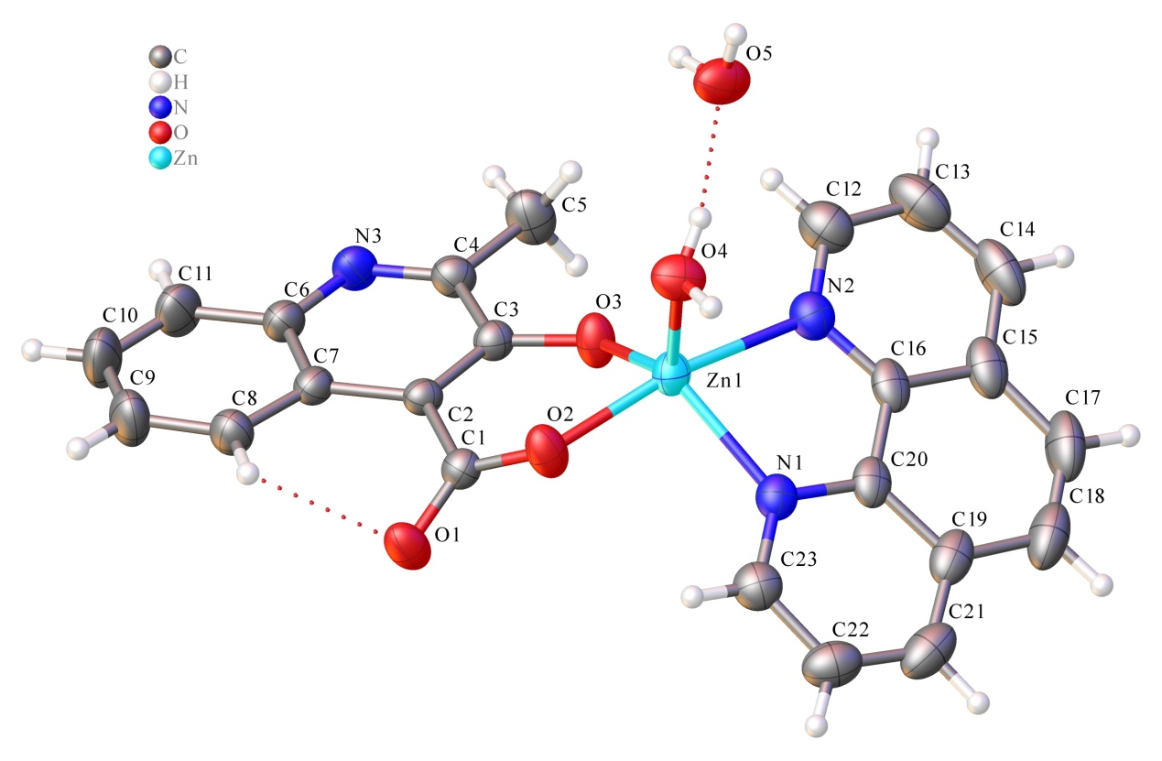
Fig. 1. The molecular structure of the title complex (1)
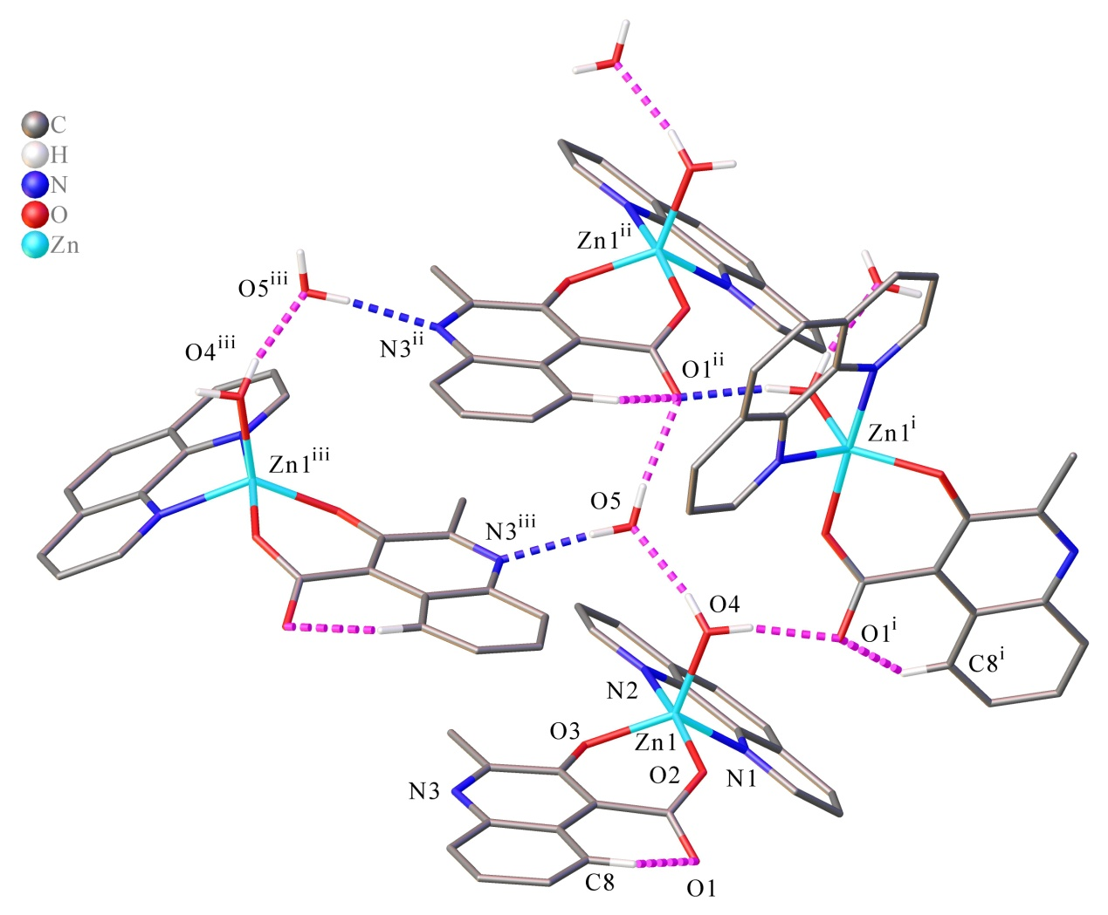
Fig. 2. The hydrogen bond diagram of the title complex (1). Hydrogen atoms not involved in the motif shown were removed for clarity. Symmetric code: (i) 1/2+x, 3/2-y, 1-z; (ii) 1+x, +y, +z;(iii) 1/2+x, +y, 1/2-z.
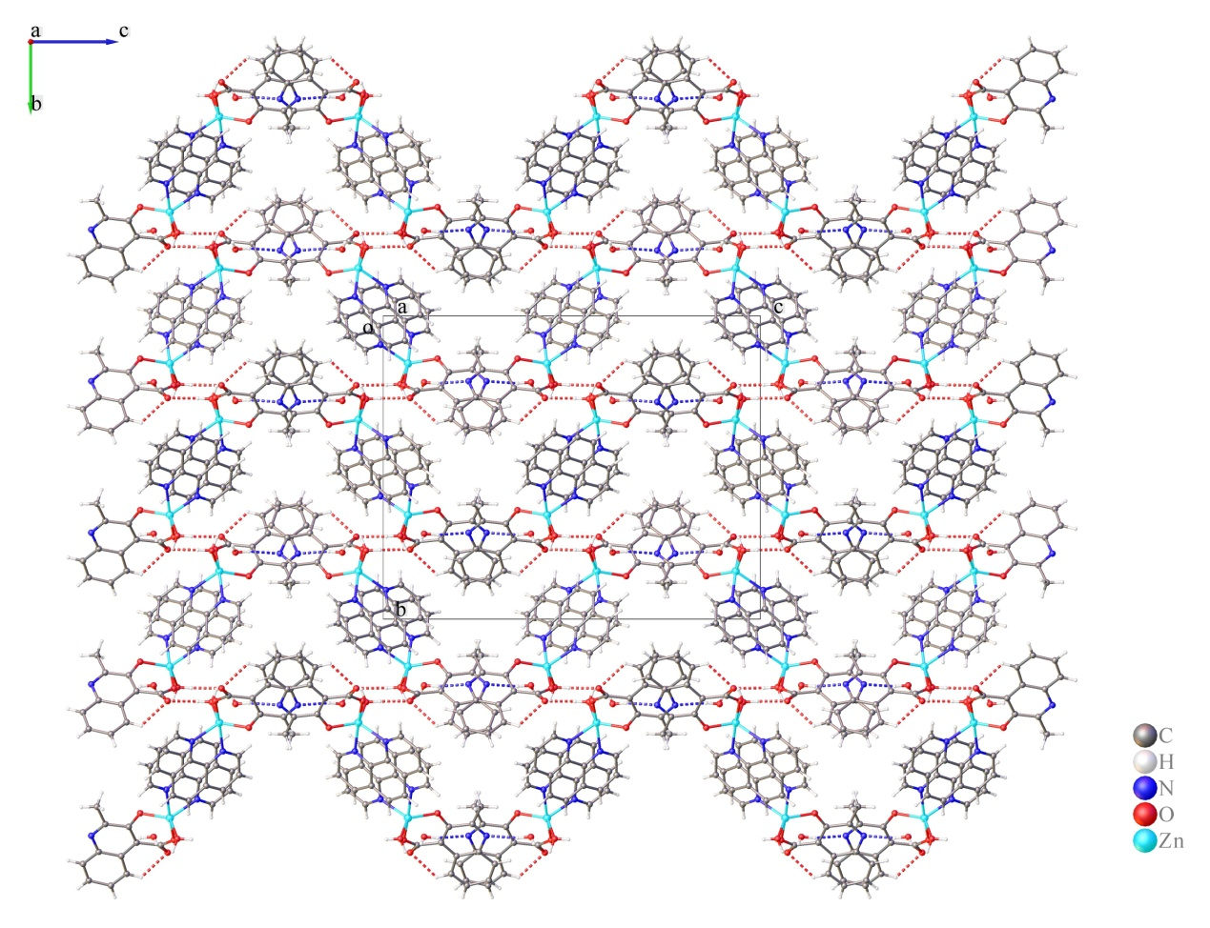
Fig. 3. The packing diagram of the title complex (1) with the dashed lines representing the hydrogen bonding interactions. Symmetric code: (i) 1/2+x, 3/2-y, 1-z; (ii) 1+x, +y, +z;(iii) 1/2+x, +y, 1/2-z.
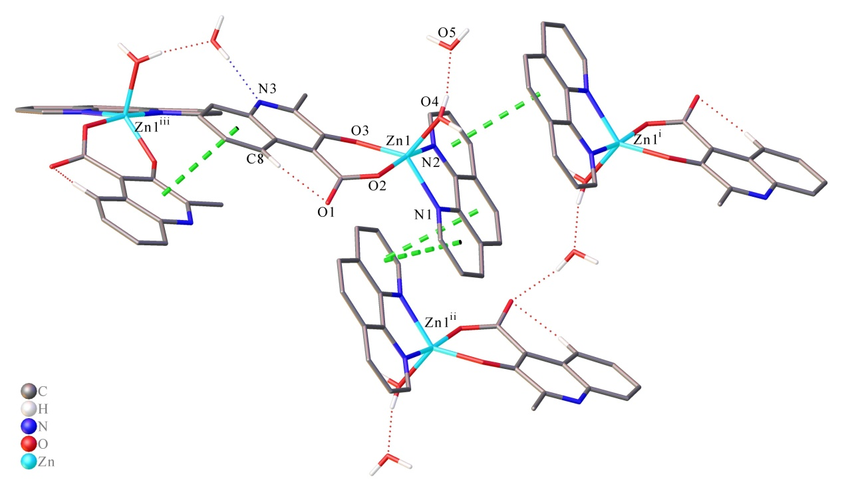
Fig. 4. The π…π stacking interactions diagram of the title complex (1) . Symmetric code Cg₃^{i}: 1-x, 1-y, 1-z; Cg4^{ii}: 2-x, 1-y, 1-z; Cg₅^{iii}: -1/2+x, +y, 1/2-z
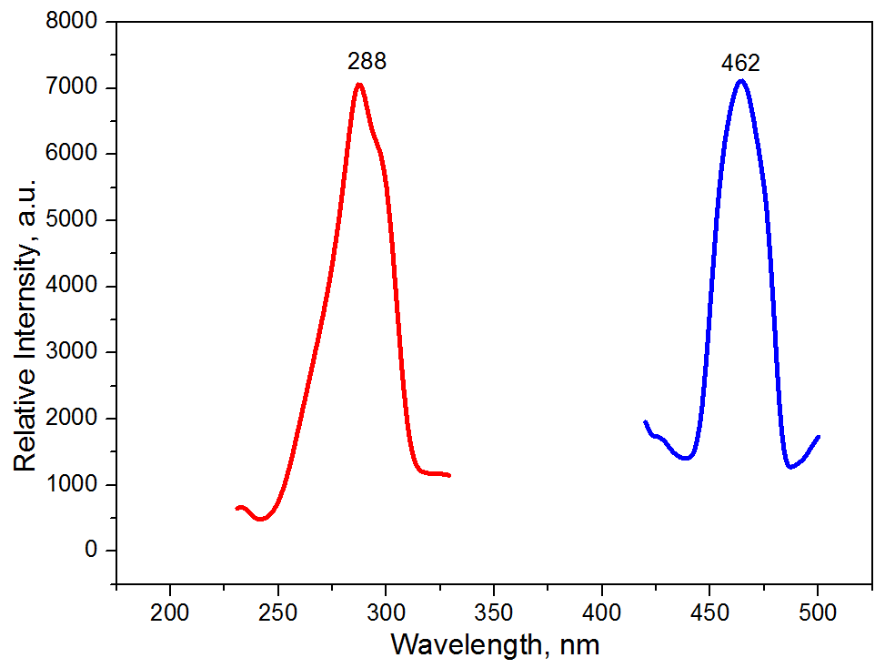
Fig. 5 The solid state excitation (red) and emission (blue) spectra of the title complex (1) at room temperature (color figure available online)
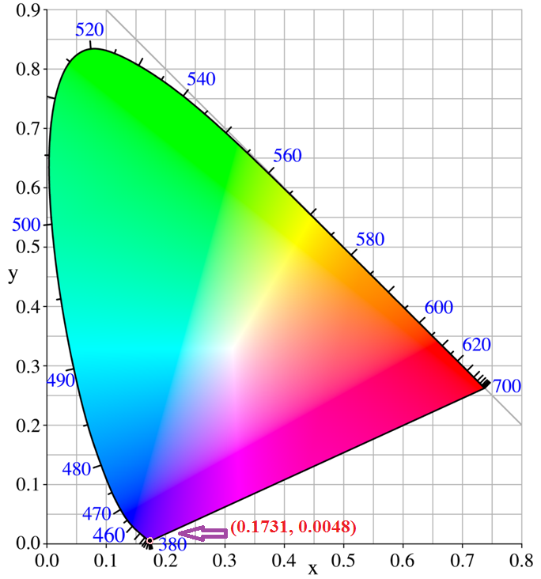
Fig. 6 CIE Chromaticity diagram and chromaticity coordinates of the emission spectrum of the title complex (1)

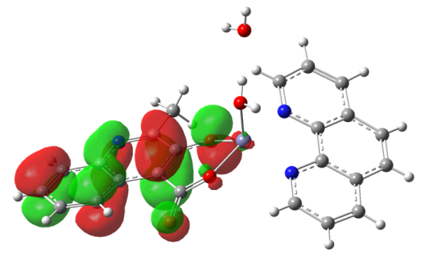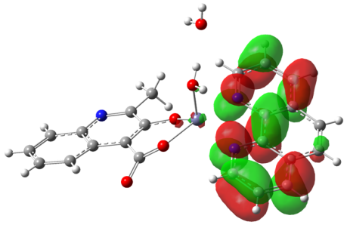
HOMO LUMO
Fig. 7 HOMO and LUMO of the title complex (1) with isosurface of 0.003 a.u.
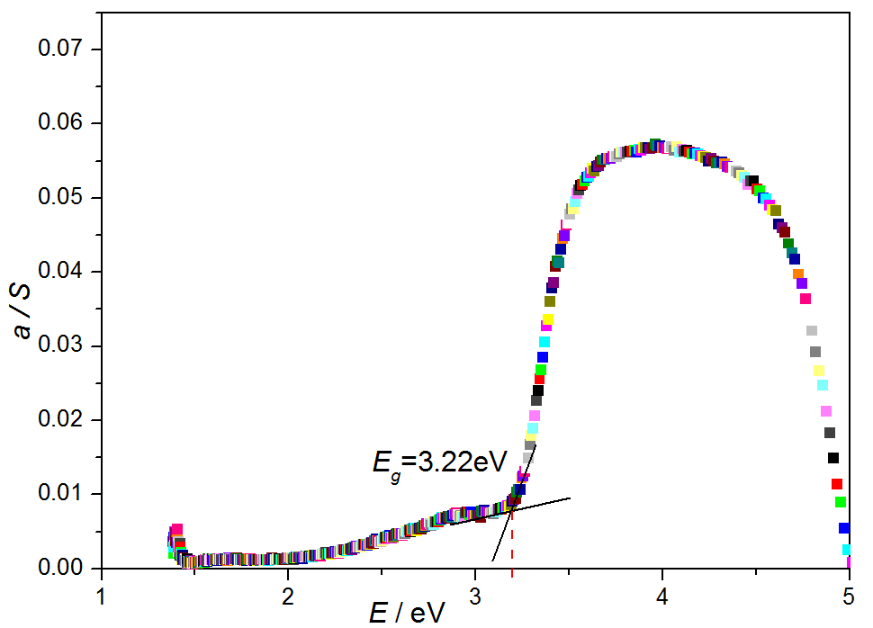
Fig. 8 the Solid –state UV-Vis diffuse reflectance spectrum of the title complex (1)

