Graphical Abstract:
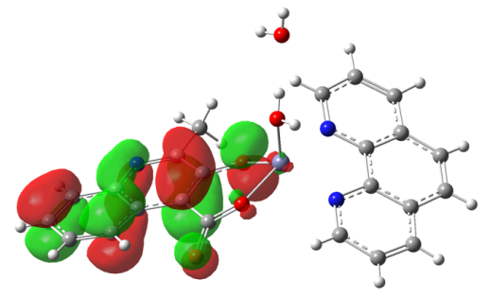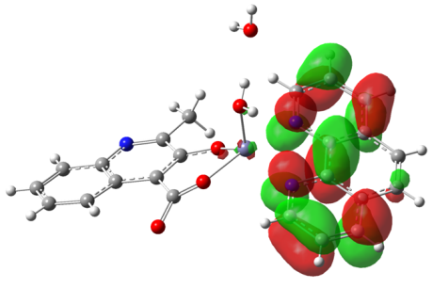
HOMO LUMO
A novel zinc complex is synthesized via solvothermal reactions. It is characteristic of an isolated structure. It displays a wide and intense photoluminescence emission band in the violet blue region. Theoretical study reveals that the photoluminescence emission is originated from the ligand-to-ligand charge transfer transition.

