Solvothermal Preparation, Crystal Structure, Photoluminescence and Semiconductor Properties of a Novel Mononuclear Zinc Complex
Xiu-Guang Yi, ^{1,}* Xiao-Niu Fang, ¹ Jin Guo, ¹ Jia Li¹ and Zhen-Ping Xie ²
¹ School of Chemistry and Chemical Engineering, Jinggangshan University, Institute of Applied Chemistry, Ji’an Jiangxi 343009, China
² Ji’an Academy of Forestry Sciences, Ji’an Jiangxi 343009, China
*Corresponding author: E-mail: jayxgggchem@163.com
Tel: +86(796)8100490; fax: +86(796)8100490
Abstract
A novel mononuclear zinc complex [ZnL(Phen)(H₂O)]·(H₂O) (1) with the mixed ligands of Phen (Phen = 1,10-phenanthroline) and 3-hydroxy-2-methylquinoline-4- carboxylic acid (HL) was synthesized by solvothermal synthesis and its crystal structure was characterized by X-ray single-crystal diffraction method. The complex (1) is characteristic of an isolated structure. The molecules in (1) are connected through the interactions of hydrogen-bonding and π…π bonds of rings to give a three-dimensional (3-D) supramolecular reticular structure. The fluorescence result discovers a wide emission band in the violet blue region. Time-dependent density functional theory (TDDFT) calculations reveal that this emission can be attributed to ligand-to-ligand charge transfer (LLCT). Solid-state diffuse reflectance shows there is a narrow optical band gap.
Keywords: Solvothermal preparation; photoluminescence; Semiconductor; Zinc.
1. Introduction
In recent years, metal complexes have attracted more and more attention due to their numerous properties, which endow them potential application in the fields of catalysis, medicine, photoluminescence, semiconductor materials, and so on.¹⁻⁴ So far, researchers have been engaged in a large number of studies on the properties of lanthanide and transition metal complexes.⁵⁻⁷ In these characteristics, photoluminescence is particularly attractive to us. The interesting photoluminescence properties of transition complexes mainly come from the d¹⁰ orbital electron configuration rich in transition metal elements. To our knowledge, zinc complexes can usually show strong photoluminescence emission as long as the d¹⁰ electron transitions of the transition ions can efficiently happen. Up to date, many researchers devote themselves to the design, preparation and characterization of novel transition photoluminescence materials.⁸⁻¹³
However, the semiconductor properties of zinc complexes have rarely been reported with a large number of studies on photoluminescence properties.¹⁴⁻¹⁷ Semiconductor materials are actually attractive because they are potential photocatalysts for dealing with environmental crises, future pollution and energy shortages. Organic semiconductors are relatively rare in semiconductor materials, but they will attract more and more attention. So far, some transition metal-organic semiconductor complexes have been documented, such as, [Ln(IA)₃(H₂O)₂]_{n}(Hg₃Cl₉)_{n}4n(H₂O),¹⁸ Zn(O₂CCH₃)₂(H₂O)_{2,}¹⁹ NiL₂(L = 2-ethoxy-6- (N-methyliminomethyl)phenolate).²⁰ As the result, transition metal-organic semiconductor complexes are still needed to be explored.
In order to synthesize metal coordination compounds, it is crucial to consider appropriate organic ligands. Because the composition of organic ligands can determine the crystal structure and function of metal complexes. Many organic ligands, such as aromatic sulfonic acid, aromatic carboxylic acid and N-heterocyclic derivatives,^{21,22} are used in the preparation of metal complexes. Hydroxyquinoline carboxylic acid is an interesting organic ligand with multiple ligand sites, which contains not only phenolic hydroxyl group, carboxyl group, but also nitrogen atom.
Based on this, we are interested in the crystal engineering of transition metal Zn (II) compounds with 3-hydroxy-2-methylquinoline-4-carboxylic acid (HL) and 1,10-phenanthroline (Phen) as the mixed ligands. In this article, we report the solvothermal synthesis, X-ray crystal structure, photoluminescent and semiconductor properties, as well as time-dependent density functional theory (TDDFT) calculations for the novel zinc (II) complex, [ZnL(Phen)(H₂O)]·H₂O (1), (Phen = 1,10-phenanthroline and HL = 3-hydroxy-2-methylquinoline-4-carboxylic acid ), which is an isolated mononuclear structure.
2. Experimental
2.1. Materials and Instrumentation
The reagents and chemicals for the synthesis of the title compound were analytical reagent grade, commercially available and applied without further purification. Infrared spectra were recorded in the Nicolet iS10 spectrometer using KBr pellets. The photoluminescence study with solid state samples performed on the FX-97XP fluorescence spectrometer. The solid state UV/Vis diffuse reflectance spectroscopy was carried out TU-1901 UV/Vis spectrometer with an integrating sphere in the wavelength range of 190-900 nm. BaSO₄ power was used as a reference, on which the finely ground powder sample was coated as a 100% reflectance. 1H NMR spectra were measured on Bruker Avance 400 MHz instrument with dimethyl sulfoxide (DMSO) as solvent. TDDFT investigations were carried out by means of the Gaussian 09 suite of program packages.
2.2. Synthesis of 3-hydroxy-2-methylquinoline-4-carboxylic acid (HL)
Synthesis of isatin: indigo (131 g, 0.5mol), K₂Cr₂O₇ (74 g, 1.0mol) and distilled water (200 mL) were added into three flasks of 500 mL and stirred, After cooling, dilute H₂SO₄ (10%, 250mL ) were added and kept stirring at 43℃ for 1.5 h. The mixture was diluted with twice its volume of distilled water, filtered off, dissolved 10% NaOH solution, filtered again, acidified with 10% HCl to pH = 7. Yield: 116g (90%); m.p. 210℃; HRMS m/z (ESI) calcd for C₈H₅NO₂ ([M+H)⁺ 147.0320, found 147.0826.
Synthesis of HL: isatin (73.5 g, 0.5 mol) and NaOH (20 g, 0.5 mol) were dissolved into a sufficient amount of distilled water and filtered. The filtrate and NaOH (20 g, 0.5 mol) were added into chloroacetone (92 g, 1.0 mol), and hydrochloric acid was added dropwise to adjust pH = 7, filtered. Yield: 96 g(95%); m.p. 225℃; HRMS m/z (ESI) calcd for C₁₁H₉NO₃ ([M+H)⁺ 203.0582, found 203.0548. ¹H NMR (400MHz, DMSO) δ 9.15(s, 1H), 7.93(d, J = 8.0Hz 1H), 7.64(t, J = 8.0 Hz, 1H), 7.60-7.52(m, 2H), 2.70(s, 3H).
The ligand HL was prepared according to the literature,²³ as shown in Scheme 1.
Scheme 1: Synthetic route of ligand HL
2.3. Synthesis of [ZnL(Phen)(H₂O)]·(H₂O) (1)
The title compound was prepared by mixing Zn(CH₃COO)₂·2H₂O (1 mmol, 219.5 mg), HL (1 mmol, 203 mg), Phen (1 mmol, 180 mg), 1 mL Triethylamine and 10 mL distilled water in a 25 mL Teflonlined stainless steel autoclave. The mixture was heated to 393 K and kept at this temperature for 7 days. When the mixture was cooled slowly down to room temperature, yellow crystals suitable for X-ray analysis were washed and collected. The yield was 85% (based on zinc). IR (KBr, cm⁻¹): 3424(vs), 1624(w), 1580(w), 1518(m), 1483(s), 1446(m), 1351(vs), 1320(s), 851(vs), 821(w), 773(w), 726(s); Anal. Calcd for C₂₃H₁₉N₃O₅Zn: C, 57.22; H, 3.97; N, 8.70; found: C, 57.30; H, 3.95; N, 8.75%.
2.4. Crystal Structure Determination
The single crystal X-ray diffraction data of the title complex was collected on a SuperNova CCD X-ray diffractometer with graphite monochromated Mo-Kα radiation (λ = 0.71073Å) by means of a ω scan method. The data reduction and empirical absorption corrections were performed with CrystalClear software.²⁴ Using Olex2,²⁵ The structure for the title complex was solved with the ShelXT,²⁶ the structure solution program using Intrinsic Phasing and refined with the ShelXL refinement package using Least Squares minimization.²⁷ All of the non-hydrogen atoms were generated based on the subsequent Fourier difference maps and refined anisotropically. The hydrogen atoms were located theoretically and ride on their parent atoms. Crystallographic data and structural refinements for the title complex (1) are summarized in Table 1. Selected bond lengths and bond angles for the crystal structure are displayed in Table 2. The hydrogen bonding interactions are presented in Table 3.

Table 1 Crystal data and structure refinement details for the complex 1
Formula | C₂₃H₁₉N₃O₅Zn
Fw | 482.78
Color | yellow
Crystal size/mm³ | 0.31 0.17 0.11
Crystal system | orthorhombic
Space group | Pbca
a (Å) | 9.5869(3)
b (Å) | 18.6505(7)
c (Å) | 23.2010(9)
α (°) | 90
β (°) | 90
γ (°) | 90
V (Å³) | 4,148.3(3)
Z | 8
2θ range for data collection (°) | 6.844-58.782
Reflections collected | 12,374
Independent, observed  Reflections (Rint) | 4,878(0.0212)
d_{calcd.} (g/cm³) | 1.546
μ (mm⁻¹) | 1.226
T (K) | 293(2)
F (0 0 0) | 1,984.0
R1, wR2 | 0.0353, 0.0790
S | 1.043
Δρ (max, min) (e/ Å³) | 0.29, -0.40

Table 2 Selected bond lengths (Å) and bond angles (°)
Distance | (Å) | Distance | (Å)
Zn(1)-O(2) | 2.0131(14) | Zn(1)-N(1) | 2.1047(17)
Zn(1)-O(3) | 1.9320(14) | Zn(1)-N(2) | 2.1927(18)
Zn(1)-O(4) | 1.9871(15)
Angle | (°) | Angle | (°)
O(2)-Zn(1)-N(1) | 95.21(7) | O(3)-Zn(1)-N(2) | 87.86(6)
O(2)-Zn(1)-N(2) | 169.02(7) | O(4)- Zn(1)-O(2) | 93.89(7)
O(3)-Zn(1)-O(2) | 90.11(6) | O(4)- Zn(1)-N(1) | 109.65(7)
O(3)-Zn(1)-O(4) | 122.84(7) | O(4)- Zn(1)-N(2) | 96.28(7)
O(3)-Zn(1)-N(1) | 126.71(7) | N(1)- Zn(1)-N(2) | 77.47(7)

Table 3 Hydrogen bonds for the complex 1
D–H···A | D–H, Å | H···A, Å | D···A, Å | D–H···A, °
O(4)–H(4A)···O(1)^{i} | 0.86 | 1.87 | 2.713(2) | 167.6
C(8)–H(8)···O(1) | 0.93 | 2.26 | 2.852(3) | 120.6
O(5)–H(5D)···O(1)^{ii} | 0.85 | 1.96 | 2.787(2) | 164.9
O(5)–H(5E)···N(3)^{iii} | 0.85 | 1.98 | 2.823(2) | 171.2
O(4)-H(4B)···O(5) | 0.82 | 1.83 | 2.643(2) | 168
Symmetric code: (i) 1/2+x, 3/2-y, 1-z; (ii) 1+x, +y, +z;(iii) 1/2+x, +y, 1/2-z.
3. Results and Discussion
3.1 Structural Description
Single crystal X-ray diffraction analysis reveals that the title complex (1) is a neutral molecule and its structure is crystallized in the space group Pbca of the orthorhombic system. The metal Zn (II) ion is sitting at the inversion center and is pentacoordinated rectangular pyramid by the HL, Phen and water molecule, yielding a rectangular pyramid geometry. The Zn²⁺ ion is coordinated by three oxygen atoms and two nitrogen atoms, of which two oxygen atoms are from HL ligand, one oxygen atom is from coordinated water molecule, two nitrogen atoms are from Phen ligand. Quinolinecarboxylate (L⁻) and Phen act as the bidentate ligand, water molecule acts as the monodentate ligand coordinated to the zinc metal center, as presented in Fig.1. The bond distance of Zn(1)-O(2) is 2.0131(14) Å, Zn(1)-O(3) is 1.9320(14) Å, Zn(1)-O(4) is 1.9871(15) Å, while that Zn(1)-N(1) is 2.1047(17) Å, Zn(1)-N(2) is 2.1927(18) Å. These are comparable with that reported in the references.²⁸⁻³⁰ The intramolecular hydrogen bond can be found between the carbon atom and carboxyl oxygen atom group and the coordination water and lattice water group (C(8)–H(8)···O(1); O(4)-H(4B)···O(5)). The intermolecular hydrogen bond O(4)–H(4A)···O(1)^{i} (Symmetric code O(1)^{i}: 1/2+x, 3/2-y, 1-z) can been found between the coordination water and the another carboxy oxygen atom, O(5)–H(5D)···O(1)^{ii} (Symmetric code O(1)^{ii}: 1+x, +y, +z) can been found between the lattice water and the another coordination water molecule, O(5)–H(5E)···N(3)^{iii} (Symmetric code N(3)^{iii}: 1/2+x, +y, 1/2-z) can been found between the lattice water and the another N from HL, forming a three-dimensional supramolecular structure, as presented in Fig. 2. and Fig.3. Meanwhile, in the title complex (1), there are strong offset face-to-face π…π stacking interaction between Cg₁…Cg₃^{i}, Cg₁…Cg₄^{ii}, Cg₂…Cg₅^{iii}, Cg₃…Cg₃^{i}.( Symmetric code Cg₃^{i}: 1-x, 1-y, 1-z; Cg4^{ii}: 2-x, 1-y, 1-z; Cg₅^{iii}: -1/2+x, +y, 1/2-z), as present in Fig.4. The centroid-centroid distance of Cg₁…Cg₃^{i} is 3.7671(14) Å, with the shift distance 1.521(3) Å, and the twish angle of 0.09(16)°. The centroid-centroid distance of Cg₁…Cg₄^{ii} is 3.7530(14) Å, with the shift distance 1.283(3) Å, and the twish angle of 1.3(3)°. The centroid-centroid distance of Cg₂…Cg₅^{iii} is 3.8831(12) Å, with the shift distance 1.435(4) Å, and the twish angle of 8.7(3) °. The centroid-centroid distance of Cg₃…Cg₃^{i} is 3.5459(19) Å, with the shift distance0.902(4) Å, and the twish angle of 0.0(8)°.
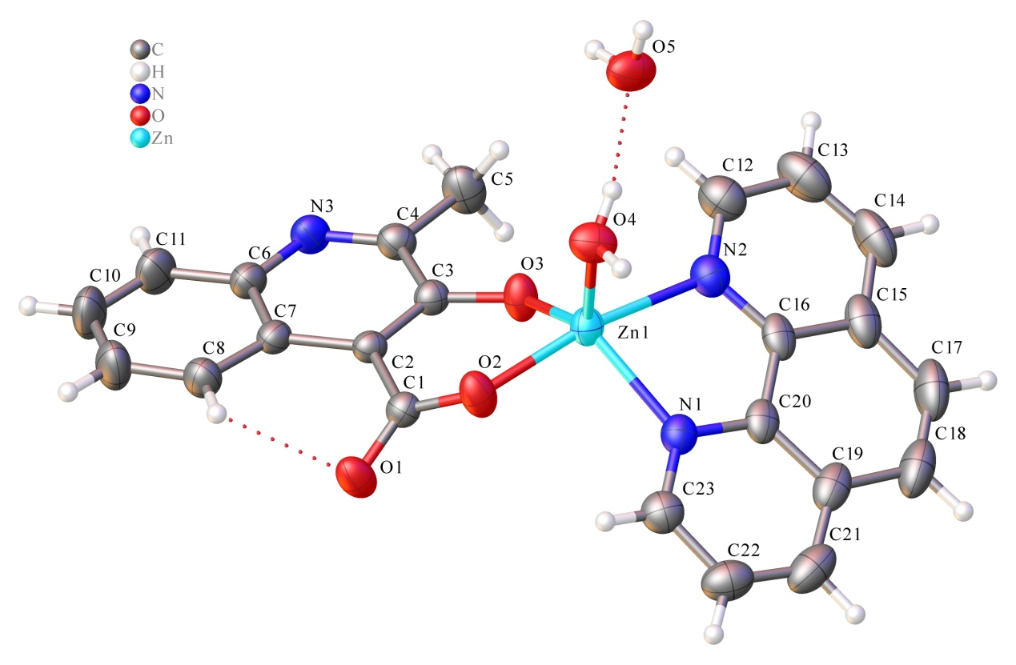
Fig. 1. The molecular structure of the title complex (1)
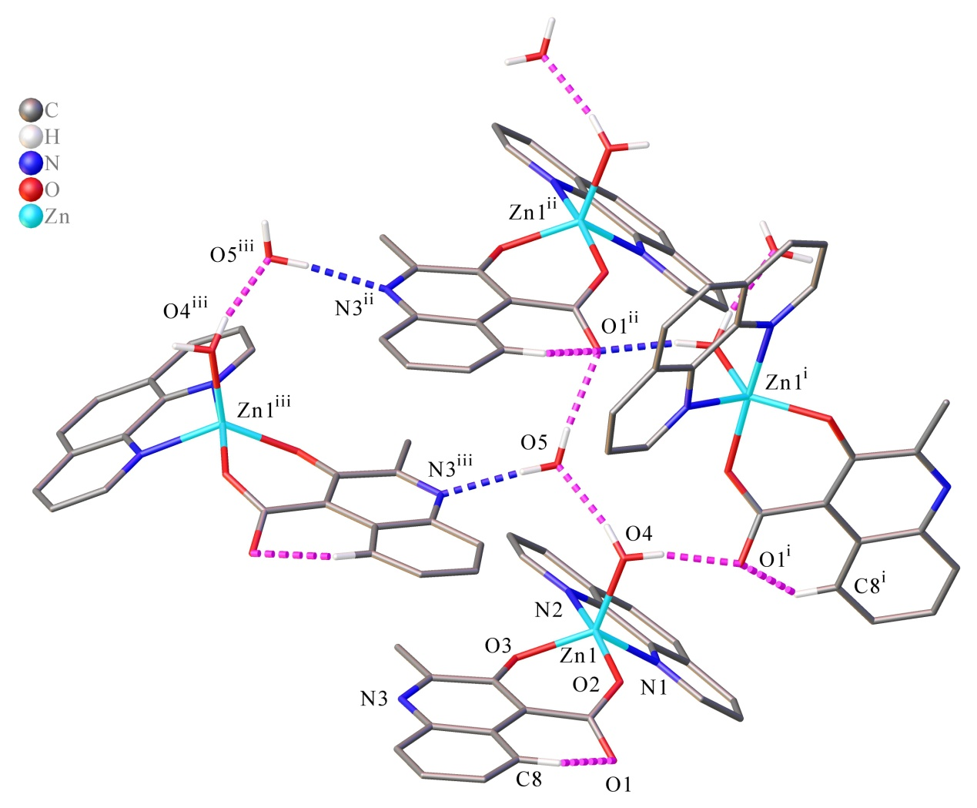
Fig. 2. The hydrogen bond diagram of the title complex (1). Hydrogen atoms not involved in the motif shown were removed for clarity. Symmetric code: (i) 1/2+x, 3/2-y, 1-z; (ii) 1+x, +y, +z;(iii) 1/2+x, +y, 1/2-z.
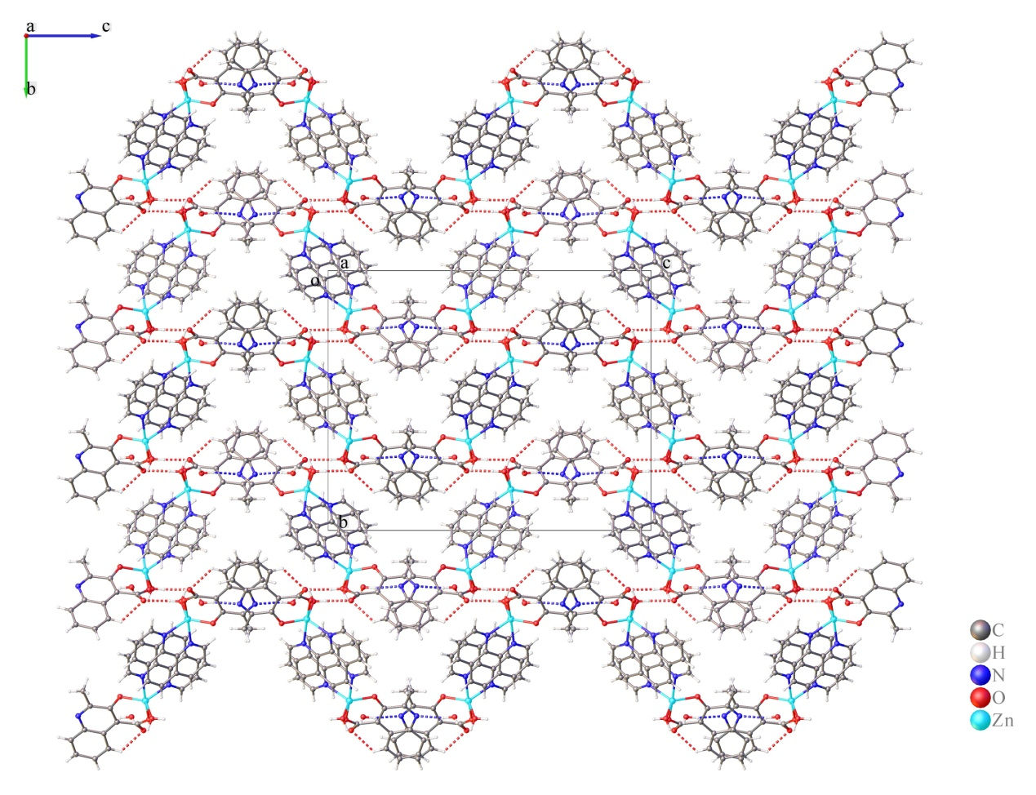
Fig. 3. The packing diagram of the title complex (1) with the dashed lines representing the hydrogen bonding interactions. Symmetric code: (i) 1/2+x, 3/2-y, 1-z; (ii) 1+x, +y, +z;(iii) 1/2+x, +y, 1/2-z.
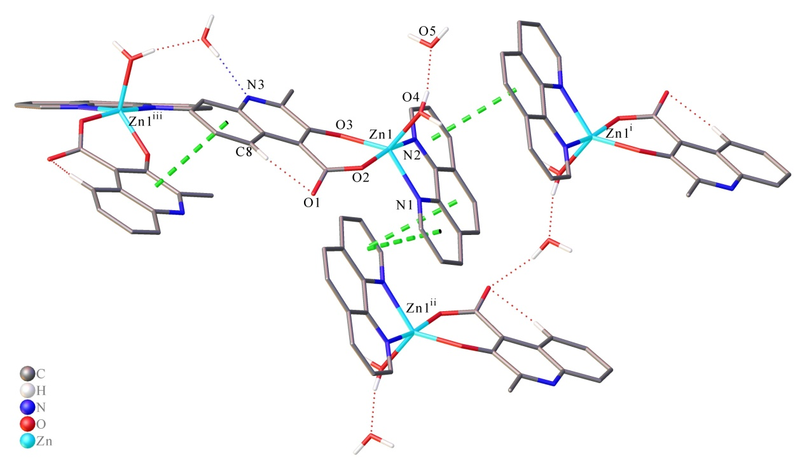
Fig. 4. The π…π stacking interactions diagram of the title complex (1) . Symmetric code Cg₃^{i}: 1-x, 1-y, 1-z; Cg4^{ii}: 2-x, 1-y, 1-z; Cg₅^{iii}: -1/2+x, +y, 1/2-z.

3.2. Photoluminescence
In recent years, the photoluminescence of coordination compounds have gained increasing interest.³¹⁻³³ Generally, coordination compounds containing lanthanide and transition elements can exhibit photoluminescence behavior because they possess rich 4f-orbit and 3/4d-orbit electron configurations. Many studies about the photoluminescence performance of lanthanide and transition compounds have been conducted so for.³⁴⁻³⁵ The title complex contain Zn²⁺ ions, therefore, we deemed that zinc and HL complexes can possibly exhibit interesting photoluminescence performance. Based on the above considerations and in order to reveal its potential photoluminescent properties, we carried out the photoluminescence spectra with solid state samples at room temperature and the result is presented in Fig. 5. It is obvious that the photoluminescent spectrum of the title complex displays an effective energy absorption residing in the wavelength range 325-325 nm. Upon the emission of 462 nm, the excitation spectrum shows a band at 288 nm. We further measured the corresponding photoluminescence emission spectrum of the title compound. Upon excitation at 288 nm, the emission spectrum is characterized by a sharp band at 462 nm in the blue purple region of the spectrum. The emission band of the title complex (1) is located in the blue purple light region with the CIE (Commission Internationale de I'Éclairage) Chromaticity coordinate (0.1731, 0.0048) (Fig. 6), As a result, the title complex is a potential blue purple photoluminescent material.
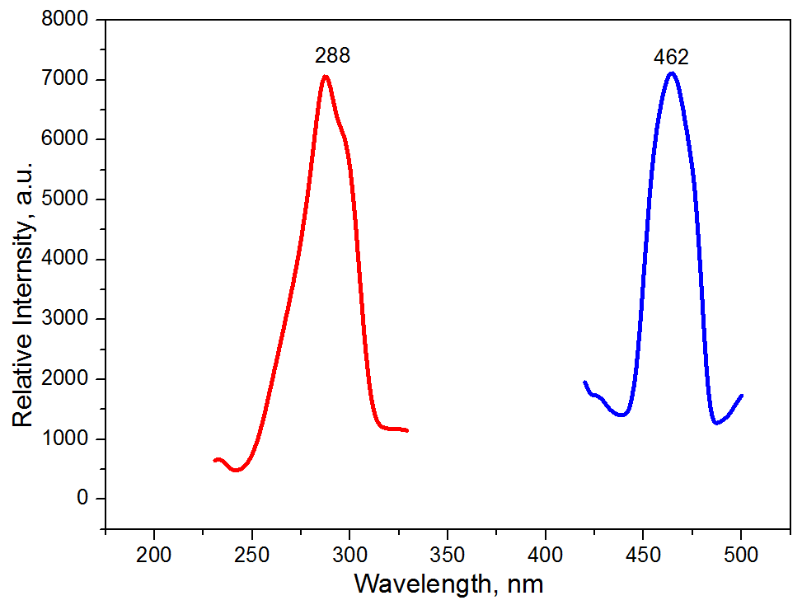
Fig. 5. The solid state excitation (red) and emission (blue) spectra of the title complex (1) at room temperature (color figure available online)
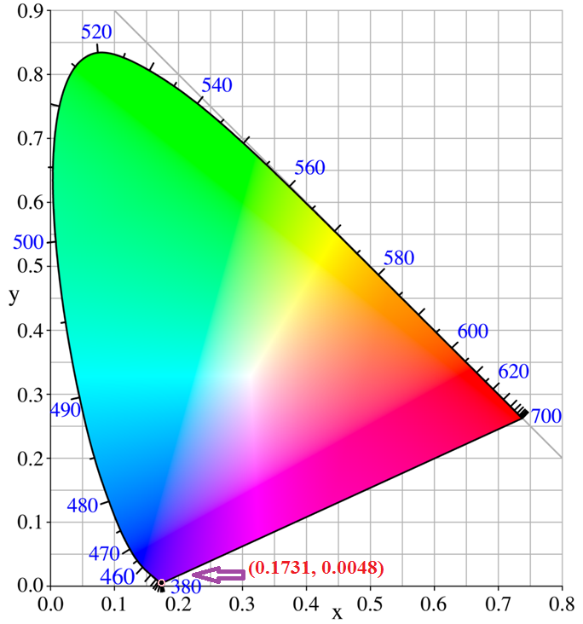
Fig. 6. CIE Chromaticity diagram and chromaticity coordinates of the emission spectrum of the title complex (1)
3.3. TDDFT Calculations
In order to investigate the fluorescence essentiality of the title complex (1), we performed its theoretical calculation in light of the time-dependent density functional theory (TDDFT) based on the B3LYP function with basis set of SDD for Zn and 6-31G* for C, H, O, N and carried out by means of the Gaussian09 program.³⁶⁻³⁸ The ground state geometry was truncated from its single crystal X-ray data (without optimization). The characteristics of the highest occupied molecular orbital (HOMO) and the lowest unoccupied molecular orbital (LUMO) of the title complex (1) are given in Fig. 7. It is easy to find out that the electron population of the singlet state of HOMO is dominantly located at the HL ligand with an energy of -0.14331 hartree. However, the electron density of the LUMO is largely distributed on the Phen ligand with an energy of -0.10413 hartree. The energy difference between LUMO and HOMO is 0.03918 Hartree, and this is small enough to allow the charge transfer from HOMO to LUMO. In light of the observation, it is proposed that the essence of the photoluminescence of the title complex (1) could be assigned to the ligand-to-ligand charge transfer (LLCT; from the HOMO of the π-orbital of ligand HL to the LUMO of the π-orbital of ligand Phen). This calculation result is in good agreement with the experimental observations.
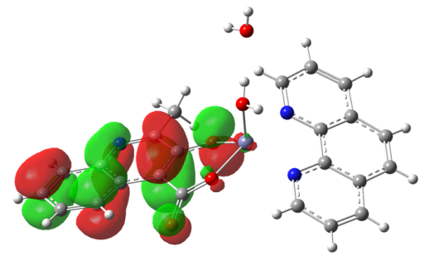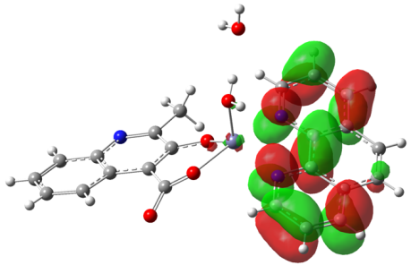
HOMO LUMO
Fig. 7. HOMO and LUMO of the title complex (1) with isosurface of 0.003 a.u.
3.4. Solid state UV/Vis diffuse reflectance spectroscopy
To investigate the semiconductive properties of the complex (1), the solid-state UV/Vis diffuse reflectance spectra of powder sample of the complex (1) was measured at room temperature, using barium sulfate as the reference for 100% reflectivity. After measuring the solid-state diffuse reflectance spectra, the data was treated with the Kubelka-Munk function that is known as α/S=(1-R)²/(2R). With regard to this function, the parameter α means the absorption coefficient, S means the scattering coefficient, and R means the reflectance, which is actually wavelength independent when the size of the particle is larger than 5 μm. From the α/S vs energy gap diagram, we can obtain the value the optical band gap, which can be extrapolated from the linear portion of the absorption edges. The solid-state UV-Vis diffuse reflectance spectrum reveals that complex (1) has a narrow optical energy band gap of 3.22 eV, as shown in Fig. 8. As a result, the title complex (1) is a possible candidate for narrow band gap semiconductors. The energy band gap of 3.22 eV of complex (1) is obviously larger than those of GaAs (1.4 eV), CdTe (1.5 eV), and CuInS2 (1.55eV),³⁹⁻⁴¹ which are well known as highly efficient band gap photovoltaic materials.
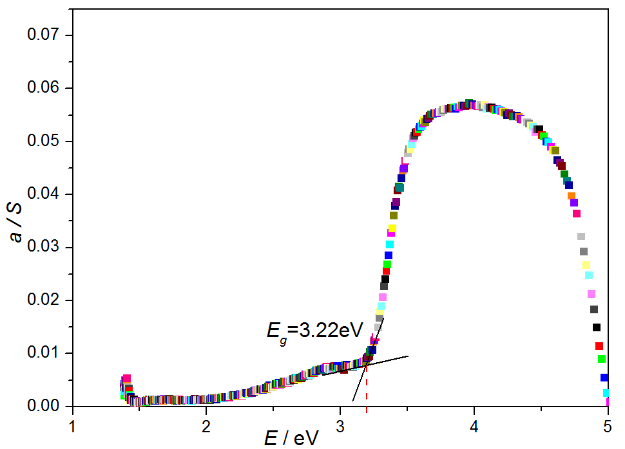
Fig. 8. the Solid –state UV-Vis diffuse reflectance spectrum of the title complex (1)
4. Conclusions
In summary, by using a hydrothermal reaction, we have synthesized a novel zinc complex with mixed ligands. The complex is characterized by a mononuclear isolated structure of the orthorhombic Pbca spatial system, which is constructed into a three-dimensional structure by intermolecular hydrogen bonds and intermolecular π…π bonds. The title complex display blue purple light photoluminescence, which is due to the ligand-to-ligand charge transfer (LLCT; from the HOMO of the HL to the LUMO of the Phen) as shown by the TDDFT calculation. Solid-state UV/Vis diffuse reflectance spectroscopy measurements reveal that the title complex is a candidate used for wide optical band gap organic semiconductors. In the future we will devote to preparing more crystalline transition metal crystal complexes and researching their structures and properties in order to understand the relationship between synthesis methods, crystal structures and properties.
5. Acknowledgements
This work was supported by the NSF of China (51363009), Jiangxi Provincial Department of Education’s Item of Higher Education and Teaching Reform (JXJG-17-9-14), Doctoral Research Startup Foundation of Jinggangshan University (JZB1905), and Natural Science Foundation Project of Jinggangshan University (JZ1901).
6. Appendix A. Supplementary Material
Crystallographic data for the structural analysis have been deposited with the Cambridge Crystallographic Data Centre, CCDC No.1913492 for the title complex (1). Copies of this information may be obtained free of charge from the Director, CCDC, 12 Union Road, Cambridge, CBZ 1EZ, UK (Fax: +44-1223-336033; email: deposit@ccdc.cam.ac.uk or http://www.ccdc.cam.ac.uk).
7. References
1. W. H. Zhao, V. Ferro , M. V. Baker, Coord. Chem. Rev. 2017, 339, 1-16.
DOI:10.1016/j.ccr.2017.03.005
2. M. Hu, X. Z. Ai, Z. M. Wang, Z. J. Zhang, H. L. Chong, W. M. Zhang, J. Lin, H. H. Yang, B. G. Xing, Nano Res. 2018, 11, 5474-5498.
DOI:10.1007/s12274-018-2138-1.
3. H. J. Chen, G. Y. Lyu, Y. F. Yue, T. W. Wang, D. P. Li, H. Shi, J. N. Xing, J. Y. Shao, R. Zhang, J. Liu, J. Mater. Chem. C 2019, 7, 7249-7258.
DOI:10.1039/C9TC01520E.
4. L. H. Abdel-Rahman, A. M. Abu-Dief, R. M. Shehata, F. M. Atlam, Appl. Organomet. Chem.
2019, 33, E4699-4700.
DOI:10.1002/aoc.4699.
5. D. Lionetti, V. W. Day, J. D. Blakemore, Dalton Trans.2017, 46, 11779-11789.
DOI: 10.1039/c7dt02577g.
6. V. Balzani, A. Juris, M. Venturi, S. Campaqna, S. Serroni, Chem. Rev. 1996, 96, 759-834.
DOI: 10.1002/chin.199630316.
7. T. Husch, L. Freitaq, M. Reiher, J.Chem.Theory Comput. 2018, 14, 2456-2468.
DOI: 10.1021/acs.jctc.8b00061.
8. Y. J. Huo, H. Lin, R. Chen, M. Makarova, Appl. Phys. Lett.2011, 98, 011111-011113.
DOI: 10.1063/1.3534785.
9. J. Hou, X. Wang, D. Fu, C. Ko, Y. Chen, Y. Sun, K. X. Wang, K. Dong, S. Tongay, J. Yao,
K. Liu, J. Wu, Small 2016, 12, 3976-3984.
DOI: 10.1002/smll.201601021.
10. K. M. Mccreary, M. Currie, A. T. Hanbicki, H. J. Chuang, B. T. Jonker, ACS Nano. 2018,
11, 7988-7994.
DOI: 10.1021/acsnano.7b02554.
11. X. D. Ma, B. T. Diroll, W. Cho, I. Fedin, R. D. Schaller, D. V. Talapin, G.-P. Wiederecht,
Nano Lett. 2018, 18, 4647-4652.
DOI: 10.1021/acs.nanolett.8b00347.
12. L. Z. Lin, Q. X. Zhong, J. T. Hong, H. L. Chen, W. T. Chen, Inorganica Acta. 2018, 479, 30- 35.
DOI: 10.1016/j.ica.2018.04.039.
13. M. Hamer, J. Zultak, A. V. Tyurnina, D. Terry, A. Barinov, A. Garrner, J. Donoghue, A. P. Rooney, V. Kandyba, A. Giampietri, A. J. Graham, N. R. Wilson, Mater. Science 2019, 13,
2136-2142.
DOI: 10.1021/acsnano.8b08726.
14. T. Dietl, H. Ohno, F. Matsukura, J. Cibert, D. Ferrand, Science 2000, 287, 1019-1022.
DOI: 10.1126/science.287.5455.1019.
15. W. K. Hyoun, J. K. Yong, M. Ali, Y. K. Sung, S. K. Myung, H.-B. Jae, S. K. Sang, Senors &
Acturators B:Chem. 2017, 249, 590-601.
DOI: 10.1016/j.snb.2017.03.149.
16. K. Makoto, S. Tohru, H. Yukiko, S. Katsuaki, A. Yoshio, Sci. Rep. 2018, 8, 10839.
DOI: 10.1038/s41598-018-27953-6.
17. J. G. Kang, K. Taekim, S. Piljeon, A. Facchetti, J. Kim, S. K. Park, RSC Adv. 2019, 9, 6193- 6198.
DOI: 10.1039/C8RA09917K.
18. X. G. Yi, Z. X. Zhang, W. T. Chen, L. Z. Lin, H. L. Chen, J. Solid State Chem. 2018, 266, 16- 22.
DOI:10.1016/j.jssc.2018.07.004.
19. D. L. Reger, A. Debreczeni, M. D. Smith, Inorg. Chem. 2011, 50, 11754-11764.
DOI: 10.1021/ic201830h.
20. Y. F. Wu, S. Zhao, H. X. Na, P. Y. Yang, H. B. Xu, Y. X. Zhang, Y. L. Chen, M. H. Zeng, Inorg. Chem. 2018, 57, 12683-12689.
DOI: 10.1021/acs.inorgchem.8b01841.
21. S. Tripathi, S. Sachan, G. Anantharaman, Polyhedron 2016, 119, 55-70.
DOI:10.1016/j.poly.2016.08.009.
22. D. Dhara, P. Kalita, S. Mondal, R. S. Narayanan, K. R. Mote, V. Huch, M. Zimmer, C. B. Yildiz, D. Scheschkewitz, V. Chandrasekhar, A. Jana, Chem. Sci. 2018, 9, 4235- 4243.
DOI: 10.1039/c8sc00348c.
23. X. G. Yi, Y. Z. Liu, X. N. Fang, X. Y. Zhou, Y. X. Li, Chinese Struct. Chem. 2019, 38, 325- 330.
DOI:10.14102/j.cnki.0254-5861.2011-2065.
24. Rigaku, CrystalClear Version 1.35, Rigaku Corporation, 2002.
25. O. V. Dolomanov, L. J. Bourhis, R. J. Gildea, J. Appl. Cryst.2009, 42, 339-341.
DOI: 10.1107/S0021889808042726.
26. G. M. Sheldrick, Acta Cryst. A 2015, 71, 3-8.
DOI:10.1107/S2053273314026370.
27. G. M. Sheldrick, Acta Cryst. C 2015, 71, 3-8.
DOI: 10.1107/S2053229614024218.
28. I. D. Brown, Altermat,D., Acta Cryst. B 1985, 41, 240-244.
DOI: 10.1107/S0108768185002051.
29. L. Tian, N. Yang, G. Zhao, Inorg. Chem. Commun.2010, 13, 1497-1500.
DOI: 10.1016/j.inoche.2010.08.026.
30. O. Kozachuk, K. Khaletskaya, M. Halbherr, Eurjin. Org. Chem. 2012, 10, 1688-1695.
DOI: 10.1002/ejic.201101295.
31. G. Gheno, M. Bortoluzzi, R. Ganzerla, F. Enrichi, J. Lumin.2014, 145, 963-969.
DOI: 10.1016/j.jlumin.2013.09.027.
32. S. S. Zhang, H. F. Su, Z. Wang, X. P. Wang, W. X. Chen, Q. Q. Zhao, C. H. Tung, D. Sun, L. S. Zheng, Chem. Eur. J. 2018, 24, 1998-2003.
DOI: 10.1002/chem.201705264.
33. Y. Wang, Y. Y. Li, J. Han, X. Tang, L. Ni, L. Wang, RSC Adv. 2016, 6, 82309-82320.
DOI: 10.1039/C6RA16327K.
34. F. Q. Huang, K. Mitchell, J. A. Ibers, Inorg. Chem. 2001, 40, 5123-5126.
DOI: 10.1002/chin.200147027.
35. M. D. Allendorf, C. A. Bauer, R. K. Bhakta, R. J. T. Houk, Chem. Soc. Rev. 2009, 38, 1330- 1352.
DOI: 10.1039/b802352m.
36. A. D. Becke, J. Chem. Phys. 1993, 98, 5648-5652.
DOI: 10.1063/1.464913.
37. C. Lee, W. Yang, R. G. Parr, Phys. Rev. B 1988, 37, 785-789.
DOI: 10.1103/physrevb.37.785.
38. M. J. Frish, et al., Gaussian 09, Revision A.02, Gausian, Inc., Wallingford CT, 2009.
39. K. Zweibel, R. Mitchell, Advan. in solar energy 1989, 6, 485-579.
DOI:10.1007/978-1-4613-9948-3₋5.
40. W. Bensch, P. Dűrichen, Eur. J. Solid State Inorg. Chem. 1996, 129, 1207-1210.
DOI: 10.1002/cber.19961291011.
41. R. Tillinski, C. Rumpf, C. Näther, P. Dűrichen, I. Jess, S. A. Schunk, W. Z. Bensch,
ChemInform 1998, 624, 1285-1290.
DOI: 10.1002/chin.199841004.

