Encapsulation of Dirhenium(III) Carboxylates into Zirconium
Phosphate
Anastasiia Slіpkan,a,b Nataliia Shtemenko,a,b Dina Kytovaa,b and Alexander Shtemenko*a

ªUkrainian State University of Chemical Technology, Gagarin Ave. 8, Dnipro, Ukraine, 49005
^{b}Dnipro University of Technology, Dmytro Yavornytskiy Ave. 19, Dnipro, Ukraine,49005

*Tel.+380 (97) 392 91 52 е-mail: shtemenko@ukr.net

Abstract
Present work reports synthesis of zirconium phosphate nanoparticles containing dirhenium(III) substance bis-dimethylsulfoxide-cis-tetrachlorodi-μ-pivalatodirhenium(III) with formula cis-Re₂(C(CH₃)₃COO)₂Cl₄∙2DMSO (I) and θ-zirconium phosphate with formula θ-Zr(HPO₄)₂∙6H₂O (ZrP). The intercalation process was controlled by EAS. Due to the spectral characteristics of the quadruple bond the conclusion was made that the obtained intercalated compounds had cis-configuration of ligands around cluster dirhenium fragment. The proposed mechanism of intercalation includes substitution of the axial ligands of I by phosphate groups of ZrP first on the surface of ZrP, than in the inner layers. Two received products of the intercalation were characterized by SEM, XRPD, FT-IR, TGA analysis witnessing about successful intercalation process. The formation of new phases with interlayer distances of 10.53 – 16.6 Å was found, the average size of obtained platelets was 100-200 nm.

Keywords

Dirhenium(III) carboxylates, zirconium phosphate, nanoparticles, intercalation.

Introduction
Layered Zr(IV) phosphates ZrP with α, β, γ and θ-structures, α-Zr(HPO₄)₂·H₂O, β-Zr(HPO₄)₂·2H₂O, θ-Zr(HPO₄)₂·6H₂O and γ-ZrPO₄·H₂PO₄·2H₂O are well known as convenient, long storing and non-toxic preparations, that due to labile protons of POH groups can be used for many chemical processes. ^{1,2,3} ZrP is one of the most studied inorganic cation exchange material with high thermal stability, solid-state ion conductivity, resistance to ionizing radiation and is known as a host capable to incorporate different types of guest molecules.⁴
Crystal structure of ZrP presents a lattice with Zr⁴⁺ ions bonding to oxygen atoms from three different phosphate groups producing covalently connected three-dimensional cross linked planes. The fourth oxygen atom of tetrahedral phosphate group is protonated and points towards the interlayer space. Water molecules in the interlayer space form hydrogen bonds with hydroxyl groups and are perpendicular to the layer. θ-ZrP is hydrated phase of α-ZrP, which is similar in structure to the α-ZrP, but differs by five additional interlaminar water molecules in space, thus the distance between the layers increases up to 10.3 Å (Fig. 1А).
Fig. 1 Structure of Zr(HPO₄)₂·6H₂O (θ-ZrP) (a) and
cis-Re₂(C(CH₃)₃COO)₂Cl₄·2DMSO (I) (b) with linear dimensions.

Upon dehydration, θ-ZrP is converted to α-ZrP (the distance between the layers is 7.6 Å) without formation of any other intermediate phase.⁵ The efficiency of intercalation to all types of ZrP depends on the distance between the layers and size of intercalated molecules.⁶ Cations (less than 2.63 Å) or small molecules can be intercalated within the layers of α-ZrP. However, intercalation of large cations here was very low. Due to the larger interlaminar space θ-ZrP can include large molecules and cations, such as insulin and other,^{6,7} that was the platform for our choice among the described modification of ZrP. It was shown that different in properties (solubility, charge, polarity) substances such as doxorubicin, insulin, amino acids and various organometallic complexes could be intercalated into ZrP layers.^{5,6,8-13}
Dirhenium(III) carboxylates with the unique quadruple bond were described as anticancer, anti-anemic, nephro- and hepato-protecting substances, possessing mighty antioxidant properties due to δ-bond unsaturation.¹⁴⁻¹⁷ Being nontoxic, these compounds present a perspective platform for creation of a new class of Re-containing medicines. Bis-dimethylsulfoxide-cis-tetrachlorodi-μ-pivalatodirhenium(III) of common formula cis-Re₂(C(CH₃)₃COO)₂Cl₄·2DMSO (I) and structure shown on the Fig.1В was studied in the model of tumor-growth and showed essential antioxidant and anticancer activities as a component of the antitumor rhenium-platinum antitumor system.^{18,19} Among them the substances with superoxidedismutase activity and abilities to interact with proteins were found. The valuable biological properties of these compounds were better realized in the forms of liposomes, than in water solutions,^{20,21} that occurred due to lipid layer protection of dirhenium substances from hydrolysis and also by existing of the equilibrium inside the liposome, that enhanced chemical potential of the preparations. Thus, the approach to create nano- carriers for delivery of the quadruple-bonded complexes is very promising.
The ZrP nanoplatelets may be prepared by methods of intercalation or exfoliation [22]. The last method had some disadvantages, for example necessity of the preintercalator, which may be toxic. That’s why we consider reasonable to use the intercalation procedure.
Thus, taking into account all above, the aim of the present work was to investigate the process of intercalation of cis-Re₂(C(CH₃)₃COO)₂Cl₄·2DMSO (I) into θ-ZrP and to obtain I/ZrP nanoplatelets by intercalation method.

Experimental section

  - Materials and methods
All used chemicals were of analytical grade purity. θ-ZrP was obtained according to ⁵ with some modifications (see below). cis-Re₂(C(CH₃)₃COO)₂Cl₄·2DMSO (I) was obtained according to.¹⁶

  - Synthetic methods

    - Synthesis of θ-ZrP: 200 ml of 0.05 M water solution of ZrOCl₂·8H₂O was added to preheated up to 94º C 200 ml of 6 M H₃PO₄ in a 500 ml round bottom flask. The resulting solution was constantly stirred at 94°C for 48 h. The product was a crystalline precipitate centrifuged and washed several times with water and dried at 80°C for 48 hours.
    - Synthesis of I/θ-ZrP composites. The process of intercalation of I in θ-ZrP was conducted in isopropyl alcohol (IPA), not in water, to avoid possible hydrolytic processes of dirhenium(III) complexes. First the suspension of I and θ-ZrP in IPA in the molar ratios of I and θ-ZrP 1:5 and 1:30 was prepared: the required amount of θ-ZrP was suspended in 5.0·10-3 M solution of I. The molar ratios of I : θ-ZrP 1:5 and 1:30 were taken according to the similar investigations of intercalation process between θ-ZrP and platinides.²³ Then the suspension was stirred vigorously at 60ºC for 5 days. The intercalation process was controlled by each day measurements of pH and UV-vis absorption spectra (EAS) of the supernatant of a centrifuged aliquot. Constant pH and UV-vis absorbance indicated the end of intercalation process. The reaction mixture was cooled, centrifuged (micro-cenrifuge type 320; Mechanica Precyzyjna, Poland) at 14000xg, filtered, washed three times with IPA, dried and weighted.

  - Measurements
pH was controlled by pH-meter-millivoltmeter pH-150 MA. UV-vis absorption spectra were measured in IPA using spectrophotometer "Specord M-40" (Germany).
Calculations of three-dimension structures and linear dimensions were made with the help of the Mercury (Mercury for Windows, version 3.6 using the crystal structure of I ¹⁶) program for crystal structure visualization, exploration and analysis.
Scanning electron micrographs (SEM) of the samples were performed using a Tescan Mira 3 LMU scanning electron microscope at an acceleration voltage of 30 kV. Samples were prepared using Digiprep 251 and MicraCut 151 (Metkon). The speed of rotation of the disk – 50-600 rpm, the speed of rotation of the samples 50-150 rpm.
Zeta potentials of ZrP nanoplatelets were determined using Zeta Sizer Nano S (Malvern, UK) at 25°C at pH 7.4.
X-ray diffraction (XRPD) measurements were performed from 5 to 60ºC using X-ray diffractometer PANalytical X’Pert High Score with a copper anode source (K_{α1}, λ=1.5406 Å).
IR spectra were recorded in the range of the 4000-400 cm⁻¹ in KBr tablets in infrared spectrophotometer FT-IR Spectrum BX, (Perkin Elmer).
Thermo gravimetric analysis (TGA analysis) was conducted on the derivatograph Q-1500D Paulik-Paulik-Erday on air in the interval 20-1000оС with the speed 10⁰С/min of temperature changing. α-Al₂O₃ served as an etalon. The mistake in determined temperature intervals was not more than 5%. After that another modification of thermal destruction investigation, i.e. method of thermal exposures was used. The weighted sample of the substance was placed in the glass reactor for thermal exposures and was heated in inert atmosphere under the temperatures of earlier determined temperatures of the weight losses during 4 h. After each exposure the sample was weighted and the weight loss was determined.
The drug encapsulation efficiency (EE) of the composites was measured by spectrophotometric method according to ² at different time intervals at 14900 сm⁻¹ using Eq. (1):

EE(%) = [(Total I – I in supernatant) / Total I] x100% (1)

Results and Discussion
  - Spectral investigation of intercalation I with ZrP.
Spectral analysis were used by us to investigate interactions of different types of dirhenium cluster compounds with 1-palmitoyl-2-oleylphosphatidylcholin (POPC) preparation of liposomes,^{20,24} proteins ²⁵ and zirconium phosphate ^{26,27} due to ability of the quadruple bond to absorb in the visible area.
Different structural types of Re₂⁶⁺ derivatives had the characteristic absorption maxima in the visible area, the position of which were dependent from quantity of hyperconjugated cycles around Re₂⁶⁺ center. The effect of hyperconjugation was realized due to the interaction of the delocalized π-bond of μ-carboxylic ligands group and the δ-component of the quadruple Re-Re bond. If dichlorotetra-μ-isobutiratodirhenium(III) Re₂(i-PrCOO)₄Cl₂ had maximum absorption in the area 20000 cm⁻¹, the bidentate coordinated tetra-μ-phosphates [Re₂(HPO₄)₄(H₂O)₂]²⁻ and [Re₂(HPO₄)₂(H₂PO₄)₂(H₂O)₂]·4H₂O had the δ→δ* absorption band at 15625 cm⁻¹. The replacement of carboxylic ligands on phosphate or chlorine groups would shift the absorption band δ→δ* to low energy region (batochromic shift). So, the analogical spectral picture was expected to be seen in the present experiment.
Before starting the experiment, two important measurements were done: 1. The spectrum of ZrP in IPA was investigated, and no any absorption in the area 12000 – 22000 cm⁻¹ was detected; 2. Solution of I in IPA in concentration 10⁻³M was heated at 60ºC during 5 days with spectral investigations and it was found that the intensity of characteristic band of I (15625 cm⁻¹) was not changed. These measurements supported the idea, that any changes in the investigated area of the spectrum should be the reason of I and ZrP interactions.
On the figure 2 EAS of the reaction mixtures of I with ZrP at 1:30 and 1:5 molar ratio over time are presented.
Fig. 2 EAS of the reaction mixture of I (10⁻³M ) and ZrP in IPA: a) at 1:30 ratio over time; b) at 1:5 ratio over time; control – IPA

In both variants of the experiment the sharp increase of intensity of the characteristic bond was noticed together with the shift from 15625 cm⁻¹ to 14900 cm⁻¹ that definitely witnessed about interactions of I with ZrP and formation of new complexes of I with phosphate groups from ZrP (I/ZrP) on the surface layers. Then the decreasing of intensity of the band 14900 cm⁻¹ took place. To our mind, during the following process of intercalation the concentration of I decreased due to penetration of I to interlayer space of ZrP. As more molecules of I penetrated to interlayer space and formed new complexes, as more the equilibrium I + ZrP ↔ I/ZrP was shifted to the side of the intercalation and formation of new complexes and accordingly we watched the decreasing of the characteristic band 14900 cm⁻¹.
Earlier it was shown by us, that dicarboxylates of dirhenium(III) reacted with POPC by substitution of axial chlorine groups on phosphate groups.^{20,24} In our experiment we investigated the little batochromic shift in the area of quadruple bond absorption that may propose the substitution of the carboxylic groups by phosphate from ZrP. But, it was proved, that dicarboxylates reacted with POPC by another type, i.e. by substitution of chlorine atoms on phosphate groups. ^{20,24}
The interaction of dicarboxylates with POPC was followed by decrease of the bands 15400-15700 cm⁻¹ and concomitant appearance of a new band at 12133 cm⁻¹, the intensity of which increased dramatically with time.²⁴ These two features are characteristics of a Re₂(δ)→Re₂(δ*) electron transition for trans-dicarboxylates.¹⁵ The process possibly involves substitution of the chloride groups of a dicarboxylates by POPC via oxygen atoms from the phosphate groups which initiates a cis-trans rearrangement of the bridging carboxylate ligand.
In our experiments we did not detect the appearance of absorption in the area 12000 сm⁻¹ that confirmed another mechanism of interaction without formation of trans-product. Thus, the possible explanation of the spectral characteristic of the reaction mixture is substitution of the DMSO in I by phosphate groups of ZrP without formation of trans-derivatives and the only obtained product is the presented one on the Fig. 3 with remained cis-configuration.
Fig. 3 The proposed formula of the product of the reaction between I and phosphate groups on the surface layers of ZrP

It is necessary to note, that the quadruple bond between two rhenium atoms has unique spectral properties: first to absorb in the visible area due to the δ→δ* transition of the spectrum, where no any organic molecules can absorb; second very important property of the band is the dependence of absorption from the quantity of organic ligands around cluster Re₂⁶⁺ fragment and their orientation. These two facts make possible to demonstrate the mechanism of intercalation of the dirhenium(III) compound first taking place on the surface of ZrP, than in its inner layers and to show the configuration of the intercalated molecule. To our knowledge such mechanisms have not been shown yet for any intercalated substance.

  - SEM
The SEM images of I/ZrP intercalation product 1:30 and 1:5 showed that hexagonal like shape of initial ZrP was stored (Fig. 4).
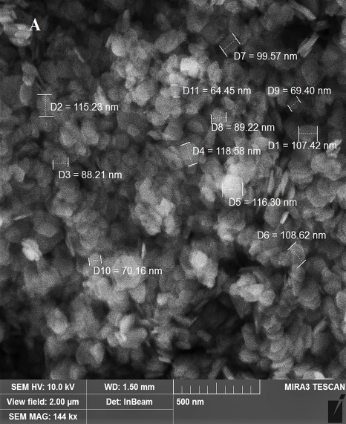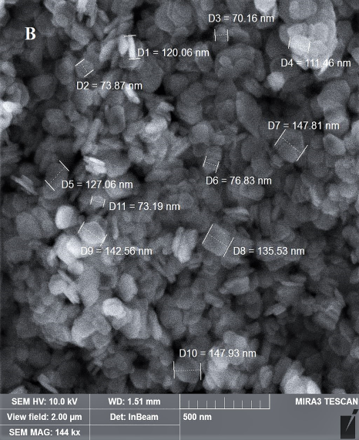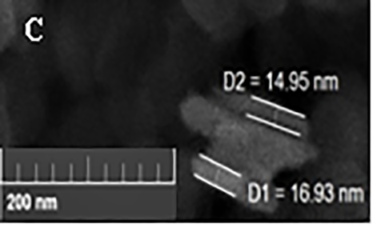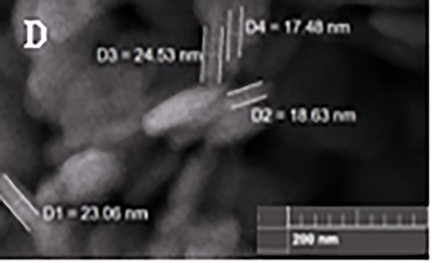
Fig. 4 The SEM images of the I/ZrP: A,C – 1:30, B,D – 1:5

Average diameter of platelets is 104 nm for 1:30 adduct (Fig. 4A) and 120 nm for 1:5 adduct (Fig. 4B). The thickness for them is approximately 15.7 nm and 24.5 nm accordingly (Fig.4 C,D).
Zeta potential of both preparations I/ZrP is -37±2 mV showing that obtained nanoplatelets are stable in aqueous medium.¹² The obtained nanoparticles have a platelet-like shape. Such shapes were shown to have some advances in comparison to spherical ones due to better adhesion, margination and binding properties. For example, the binding probability of a nanorods was found to be three times higher than that of a nanospheres with the same volume.²⁸ The obtained SEM data together with spectral investigations point that ZrP can be used as a matrix for cluster rhenium(III) with cis-configuration of carboxylate ligands.

  - X-ray powder diffraction
The reaction of intercalation of I into interlayers is topotactic,⁶ i.e. solid phase reaction during which the packaging of atoms in the crystal of the reagent is practically the same, only distances between some atoms in several directions are changing. The diffraction peaks at lowest 2θ angle correspond to the interlayer distance which depends on the intercalated substance.²⁹ The XRPD patterns of I/ZrP for molar ratios 1:30 and 1:5 show appearance of new peaks (Fig. 5 B,C), indicating the formation of new phases.
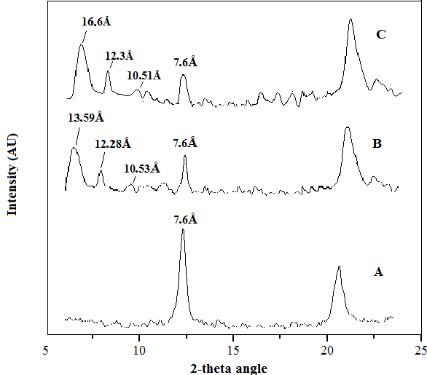
Fig. 5 X-ray diffraction α-ZrP (A), I/ZrP 1:30 (B) and I/ZrP=1:5 (С)

In the absence of intercalated substances the distance between layers of α-ZrP corresponds to 7.6 Å (Fig. 5A). The presence of this peak in the diffraction patterns of the intercalation products indicates that the formed phases are mixed. Intensity of this peak is lower in patterns B and C than in A, pointing the reducing of this phase with increasing of concentration of I.
Formations of new phases are followed with appearance of first order diffraction peak 13.59 Å for I/ZrP 1:30 (Fig. 5B) and 16.6 Å for I/ZrP=1:5 (Fig. 5C); besides, both composites show the second and the third peaks: 12.28 Å and 10.53 Å for I/ZrP 1:30 (Fig. 5B); 12.3 Å and 10.51 Å for I/ZrP=1:5 (Fig. 5C).
Three-dimensional structure and lineal dimensions of I are presented on the Fig. 6.
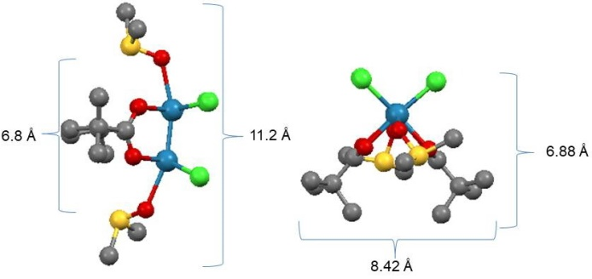
Fig. 6 Structure of I showing its dimensions as calculated by Mercury

If lineal dimensions for I molecule are known 11.2 х 8.42 х 6.88 Å3 and are presented on the Fig. 6, and interlayer distance in ZrP is also known to be 6.6 Å, this allows us to predict the interlayer distances in the newly formed phases and approximate coordination of the I molecules between ZrP layers. For instance, for I/ZrP 1:30 the shown interlayer distance 13.59 Å may correspond to disposition of I molecules parallel to ZrP layers (6.88 Å + 6.6 Å = 13.48 Å); accordingly the diffraction peak 16.6 Å may correspond to perpendicular disposition of I to ZrP layers (11.2 Å + 6.6 Å = 17.8 Å). A little decrease between calculated and real distances may be explained by compressing of ZrP layers and/or by hiding (interaction) of branched ligands of I into so called “pockets” of ZrP.⁶
Thus, the analysis of XRPD patterns of newly synthesized I/ZrP products gives confirmation about formation of new intercalated products and imagination about possible disposition of I between layers of ZrP.

  - FT-IR data.
The obtained FT-IR data for I/ZrP 1:30 and 1:5 were identical, so we demonstrate data only for the first one in comparison with primary substances (Table 1).

Table 1 Characteristic frequencies (сm⁻¹) and their correspondence in the FT-IR spectra of I, ZrP and I/ZrP 1:30

Substance | ν_{s}(CO) | δ_{as},ν_{s}  (C(CH₃)₃COO-) | ν_{s}(H₂O),  ν_{s}(OH-) | ν_{s}  (DMSO) | ν_{s}(P – O),  ν_{s}(P – OH) | ν_{s}(M – O)
I | 1420 | 2800  1470-1430 | 3500 | 1225-980 | ̶ | 390-480
ZrP | ̶ | ̶ | 1620  3500 | ̶ | 1200  1100-940 | 522
I/ZrP  1:30 | ̶ | ̶ | 1620  3500 | ̶ | 1200 | 522

The data presented in the table show the disappearance of the absorption bands in I/ZrP 1:30 characteristic for I structure, indicating that I is absent on the surface of the composite and support the earlier speculations about successful intercalation procedure. The only difference in spectra of initial ZrP and the complex I/ZrP is the absence of the band 1100-940 сm⁻¹ in the last one referred to fluctuations of phosphate groups that may occur due to involvement of phosphate groups in the reaction.

  - TGA analysis.
Thermograms of both intercalation products show three weight losses (Fig.7).
First weight loss under 120⁰С corresponds to the loss of coordinated water in zirconium phosphate; the second under 250-350⁰С – to the thermo destruction of I with formation of the trans-isomer;³⁰ and the third – to condensation of phosphate groups and formation of zirconium pyrophosphate. ³¹

Fig.7. Thermograms of I/ZrP: a) I/ZrP 1:5; b) I/ZrP 1:30.

The weight losses in the first and second stages of thermograms for the I/ZrP 1:5 were: 9%; 13,2% (Fig. 7А) and for the I/ZrP 1:30 9%; 10% (Fig. 7В). Low levels of weight losses could be the result of quickly temperature increasing, so we decided to undertake another modification of thermal destruction investigation (see Materials and methods), i.e. method of thermal exposures. In this modification method following weight losses for the I/ZrP 1:5 were: 8,87% under 120о С; 29,89% under 250-350о С of heating and for I/ZrP 1:30 9,8% and 10,9% accordingly.

  - Drug loading studies.
The time-depending drug encapsulation efficiency (EE) studies of I/ZrP 1:5 and I/ZrP 1:30 (Fig. 8) showed not so rapid uptake of I as it was found for example for curcumin (120 min). ²
This may be explained by more necessary time for the reaction of substitution in comparison with time for the formation of hydrogen bonds between the hydroxyl groups of curcumin and negatively charged phosphate groups of ZrP. The maximum EE (66%) were reached only on the 5th day for I/ZrP 1:30 and 26% для I/ZrP 1:5.

Fig. 8 Time-dependent I encapsulation efficiency of ZrP nanoplatelets

Our further investigations are aimed on obtaining of the mixed composites (for example I + cisplatin, or I + doxorubicin) and on studying of their biological activities. This direction is very promising due to the following reasons: anticancer properties of solely introduced I and some alkylcarboxylates were not very essential, as it is known about introduction of other cytostatics; the group of Prof. A. Clearfield recently have shown good perspectives of ZrP composites as medicines ^{31,32} as in several biological models ZrP-composites were shown to be more active than free substances.

Conclusions
The method of intercalation of I, the representative of cis-carboxylate of dirhenium(III) compounds, into θ-ZrP was elaborated. The possible mechanism of intercalation is substitution of the axial ligands by the layers phosphate groups to the cluster center Re₂⁶⁺ producing a new phases with interlayer distances of 10.53 – 16.6 Å and average size of platelets 100-200 nm. Two received products of the intercalation process were characterized by appropriate methods. Existence of the quadruple bond in the structure of I made possible to demonstrate the mechanism of intercalation of the dirhenium(III) compound first taking place on the surface of ZrP, than in its inner layers and to show the configuration of the intercalated molecule. The obtained result is the starting point for synthesis of mixed ZrP nanocarriers on the base of quadruple-bonding compounds with promising biological properties.

Acknowledgments
We are grateful to the Ministry of Education and Science of Ukraine (Grants 0107U000528 and 0111U000111) the studies were supported by.

References
- W. J. Roth, B. Gil, W. Makowski, B. Marszaleka and P. Eliasova, Chem. Soc. Rev. 2016, 45, 3400- 3438.
- H. Kalita, B. N. Prashanth Kumar, S. Konar, S. Tantubay, M. Kr. Mahto and M. Mandal, Mater. Sci. Eng: C. 2016, 60, 84-91.
- J. Gonzalez-Villegas, Y. Kan, V. I. Bakhmutov, A. Garcia-Vargas, M. Martinez, A. Clearfield and J. L. Colon, Inorg. Chim. Acta. 2017, 468, 270-279.
- A. Diaz, V. Saxena, J. Gonzalez, A. David, B. Casanas, C. Carpenter, J. D. Batteas, J. L. Colon, A. Clearfield and M. D. Hussain, Chem. Commun. 2012, 48, 1754-1756.
- A. A. Marti and J. L. Colon, Inorg. Chem. 2003, 42, 2830–2832.
- A. Diaz, A. David, R. Perez, M. L. Gonzalez, A. Baez, S. E. Wark, P. Zhang, A. Clearfield and J. L. Colon, Biomacromolecules. 2010, 11, 2465–2470.
- A. A. Marti, N. Rivera, K. Soto, L. Maldonado and J. L. Colon, Dalton Trans. 2007, 17, 1713-1718.
- A. Clearfield, R. H. Blessingt and J. A. Stynes, J. Inorg, nucl. Chem. 1968, 30, 2249-2258.
- U. Costantino, J. Chem. Soc., Dalton Trans. 1979, 2, 402-405.
- R. Backov, D. J. Jones and J. Roziere, Chem. Commun. 1996, 1, 599-600.
- F. Carn, A. Derre, W. Neri, O. Babot, H. Deleuze and R. Backov, New J. Chem. 2005, 29, 1346-1350.
- V. Saxena, A. Diaz, A. Clearfield and J. D. Batteas, M. D. Hussain, Nanoscale. 2013, 5, 2328-2336.
- S. Shakshooki, B. E. Ali, S. El-Rais and M. El-Rais, Am. J. Chem. 2014, 4, 22-28.
- N. Shtemenko, P. Collery and A. Shtemenko, Anticancer Res. 2007, 27, 2487-2492.
- A. Shtemenko, P. Collery. N. Shtemenko, K. Domasevich, E. Zabitskaya and A. Golichenko, J. Chem. Soc., Dalton Trans. 2009, 26, 5132-5136.
- N. I. Shtemenko, H. T. Chifotides, K. V. Domasevich, A. A. Golichenko, S. A. Babiy, Z. Li, K. V. Paramonova, A. V. Shtemenko and K. R. Dunbar, J. Inorg. Biochem. 2013, 129, 127-134.
- A. A. Golichenko, K. V. Domasevitch, D. E. Kytova and A. V. Shtemenko, Acta Cryst. 2015, 71, 45-47.
- I. V. Leus, I. A. Klenina, K. А. Zablocka, A. A. Golichenko, A. V. Shtemenko and N. I. Shtemenko, Biopolymers and Cell. 2011, 27, 465–471.
- K. L. Shamelashvili, N. I. Shtemenko, І. V. Leus, S. O. Babiy and O. V. Shtemenko, Ukr. Biochem. J.. 2016, 88, 29-39.
- N. Shtemenko, O. Berzenina, D. Yegorova and A. Shtemenko, Chem. Biodivers. 2008, 5, 1660–1667.
- Y. Zhu, T. Shimizu, T. Kitajima, K. Morisato, N. Moitra, N. Brun, T. Kiyomura, K. Kanamori, K. Takeda, H. Kurata, M. Tafu and K. Nakanishi, New J. Chem. 2015, 39, 2444-2450.
- F. Xia, H. Yong, X. Han and D. Sun, Nanoscale Res. Lett. 2016, 11, 1-7.
- E. J. Rivera, C. Figueroa, J. L. Colon, L. Grove and W. B. Connick, Inorg.Chem., 2007, 46, 8569-8576.
- Z. Li, N. I. Shtemenko, D. Y. Yegorova, S. O. Babiy, A. J. Brown, T. Yang, A. V. Shtemenko and K. R. Dunbar J Liposome Res. 2015, 25, 78-87.
- I.V. Leus, I.O. Klenina, K.A. Zablotska, O.A. Golichenko, O.V. Shtemenko, N.I. Shtemenko Biopolymers and Cell. 2011, 27, 465–471 (In Ukrainian).
- A.V. Slipkan, D.E. Kytova, A.V. Shtemenko, Ukr. Chem. J. 2017, 83, 35-41 (In Ukrainian).
- A.V. Slipkan, D.E. Kytova, A.V. Shtemenko, Voprosy khimii i khimicheskoi tekhnologii. 2018, 2, 39-45 (In Ukrainian).
- S. Shah, Y. Liu, W. Hu and J. Gao, J. Nanosci. Nanotechnol. 2011, 11, 919–928.
- H. Maeda and Y. Matsumura, Adv. Drug. Deliv. Rev. 2011, 63, 129–130.
- M. Iziumskyi, S. Melnyk and A. V. Shtemenko Chem. Met. Alloys. 2013, 6, 121-124.
- B. M. Mosby, A. Diaz, V. Bakhmutov and A. Clierfield, ACS Appl. Mater. Interfaces. 2014, 6, 585-592.
- A. Diaz, M. L. Gonzalez, R. J. Perez, A. David, A. Mukherjee, A. Baez, A. Clearfield and J. L. Colon, Nanoscale, 2013, 5, 11456-1146.

