Conversion of bis(methanoato-κO)-tris(pyridine-κN)-copper(II) to
catena-poly[[methanoato-κO)-(μ₂-methanoato-κ²O:O')-bis(pyridine-κN)-copper(II)] monohydrate]

Amalija Golobič, Fedja Marušič, Primož Šegedin, Marta Počkaj*

ªFaculty of Chemistry and Chemical Technology, University of Ljubljana, Večna pot 113, 1000 Ljubljana, Slovenia.
* Corresponding author: E-mail: marta.pockaj@fkkt.uni-lj.si.

ABSTRACT: Blue prismatic crystals of mononuclear [Cu^{II}(O₂CH)₂(Py)₃] (Py = pyridine, C₅H₅N), 1, were prepared from reaction solution containing dry pyridine and dinuclear [Cu₂^{II}(O₂CH)₄(Py)₂]. When a portion of solution together with crystals was exposed to air moisture, crystals of 1 dissolved in mother liquid. Simultaneously, blue needles of 2, i.e. covalently linked one-dimensional chain structure with formula [Cu(O₂CH)₂(Py)₂]_{n}·nH₂O, grew out of the solution. The process lasted few minutes and was observed under optical microscope. The conversion from 1 to 2 takes place also outside of solution in the solid state. Single crystal X-ray diffraction data were collected at 150 K for 1 and after that for 2, originating from the same reaction solution. This paper reports the structures of both compounds. Alternative synthesis method of 2 arising from a mixture of copper methanoate and pyridine is also reported.
Keywords: copper(II) methanoates; pyridine; crystal structure determination; structure conversion.

1 Introduction:
The coordination chemistry of copper(II) with different carboxylate ligands is very diverse, mainly due to the versatility of coordination modes of carboxylate ligand which with its four lone electron pairs can be coordinated to 1−4 metal centres.¹ Additionally, different alkyl chain lengths of different carboxylates represent a greater or lesser sterical obstacle on a way to a formation of complex molecules. However, the smallest carboxylate ligand, i.e. methanoate anion, is thus the one with the least steric influences. If additional N-donor ligand from the family of (substituted) pyridines is introduced besides the methanoato ligand, the diversity of the obtained crystal structures further increases. In this case, mononuclear, dinuclear paddle-wheel like or polynuclear coordination moieties are formed.² Interestingly, only four crystal structures of copper(II) with pyridine and methanoato ligand are listed in CSD, i.e. mononuclear [Cu(O₂CH)₂(Py)₂(H₂O)₂] (refcode AFMPCA)³, dinuclear paddle-wheel [Cu₂(O₂CH)₄(Py)₂] (refcode AFMPCB)³, and polynuclear
[Cu(O₂CH)₂(Py)₂]_{n}·nH₂O (refcodes FORPCU and FORPCU01).^{3,4} Crystal structures with substituted pyridines are more frequent, e.g. with 2-methylpyridine,^{5,6} 3-methylpyridine,^{6,7}
4-methylpyridine,⁶ 2,6-dimethylpyridine,⁸ 3-hydroxypyridine,⁹ 4-aminopyridine,¹⁰ etc.
In this paper, the synthesis and characterization of two copper(II) coordination compounds with methanoato and pyridine ligands is described. In both compounds, the coordination number of central copper(II) is five, which is less usual than four- or sixfold coordination.¹¹⁻¹³

2 Experimental:
2.1. Syntheses
All reagents and chemicals were purchased from commercial sources and used without further purification. The identity of the intermediate compounds was proven by means of X-ray powder diffraction (see Supplementary Information).
α-Cu(O₂CH)₂ was synthesized via modified published synthesis pathway.¹⁴ To concentrated HCOOH (11.9 mL), water (0.8 mL) and powdered Cu₂(OH)₂CO₃ (2.0 g, 9.0 mmol) were added. The reaction mixture was refluxed for one hour, and left in the refrigerator at approx. 5 °C overnight. Dark blue crystalline product was filtered off, dried in the air for 20 minutes and additionally in a desiccator over solid KOH for 24 hours. Yield: 95%.
[Cu₂(O₂CH)₄(Py)₂] was prepared from α-Cu(O₂CH)₂ (1.0 g, 6.5 mmol), pyridine (1.2 mL, 14.9 mmol) and acetonitrile (20 mL). The reaction mixture was stirred at room temperature for two hours. The obtained green powder was filtered off, dried in the air for 20 minutes and additionally in a desiccator over solid KOH for 24 hours. Yield: 88%.
[Cu(O₂CH)₂(Py)₃] (1). The flask with 10 mL of dry pyridine (dried with KOH) was placed in an inert atmosphere and purged with argon. While stirring, 0.40 g of powdered [Cu₂(O₂CH)₄(Py)₂] was added. The flask was put into an oil bath which was heated to 50 °C. After 10 min the reaction solution was poured through the filter paper, the flask with the filtrate was sealed and put in the refrigerator at approx. 5 °C. After one month the blue prisms were obtained, suitable for X-ray structural analysis. The compound 1 is very sensitive to the presence of moisture. Crystals of 1 were stable for several weeks, if they were kept in a hermetically sealed container. Upon exposure to air moisture, the crystals of 1 transformed into 2 very quickly. Thus, the other analyses of 1, with exception of single crystal X-Ray structural analysis could not be performed.

[Cu(O₂CH)₂(Py)₂]·H₂O (2). Compound 2 was prepared in two different ways:
A) 0,75 g α-Cu(O₂CH)₂ was added into 10 mL of pyridine while stirring. The reaction mixture was cautiously heated until the previously blue solution became dark violet. At that time the hot solution was poured through the filter paper. The filtrate was left to stand in the refrigerator at approx. 5 °C for 24 hours. After that time blue needles of the product 2 were obtained; the crystals suitable for X-ray structural analysis were filterred off and dried in air. Yield: 68%. Anal. Calc. for C₁₂H₁₄CuN₂O₅: C, 43.70; H, 4.28; N, 8.50; Cu, 19.27. Found: C, 43.53; H, 4.36; N, 8.46; Cu, 19.15. Magnetic susceptibility (RT): μ_{eff}, 1.83 BM. IR: ν_{asym}(CO₂), 1626, 1589, 1579 cm^{–1}, ν_{sym}(CO₂), 1326 cm^{–1}. UV-VIS (nujol): λ_{max} 638, 270 nm.
B) The single crystals of 2 were obtained also from 1 as follows. Single crystals of 1 together with the mother liquid were left in the open Petri dish. After few minutes, the crystals of 1 dissolved completely and single crystals of 2 grew out of the reaction solution. Such single crystal of 2 was used for structural determination described in this paper.

2.2. Physical measurements
CHN elemental analyses were performed with a Perkin-Elmer 2400 CHN Elemental Analyzer. The amount of copper was determined electrogravimetrically with Pt electrodes.
The infrared spectra were measured on solid samples using a Perkin-Elmer Spectrum 100 series FT-IR spectrometer equipped with ATR.
Electronic spectra were recorded as nujol mulls and also as solutions (water, acetonitrile, methanol, DMSO) on Perkin Elmer UV/VIS/NIR Spectrometer Lambda 19 between 200 and 860 nm.
Magnetic susceptibility of the substance was determined at room temperature by the Evans method using powdered samples and a Sherwood Scientific MSB-1 balance with HgCo(NCS)₄ as a calibrant. Diamagnetic corrections were estimated from Pascal’s constants and the effective magnetic moments were calculated using the equation: μ_{eff} = 2.828(χMT)^{1/2}.
For X-ray structure determination, the single crystals of both compounds were surrounded by silicon grease, mounted on the tip of glass fibres and transferred to the goniometer head in the stream of liquid nitrogen. For compound 2, the single crystal obtained with decomposition of 1 as well as this from deliberate synthesis of 2 was used to prove that both possess the same crystal structure (the data included in this paper refer to the single crystal of 2 that was prepared from 1). Diffraction data for structure analysis were collected on a Nonius Kappa CCD diffractometer using Nonius COLLECT software and monochromated Mo Kα radiation at 150 K.¹⁵ Data reduction and integration were performed with the DENZO-SMN program suite.¹⁶ The initial structural model containing coordination molecule was obtained via direct methods using the SIR97 structure solution program.¹⁷ A full-matrix least-squares refinement on F² magnitudes with anisotropic displacement parameters for all non-hydrogen atoms using SHELXL-2013 was employed.¹⁸ All H atoms were initially located in difference Fourier maps and were further treated as riding on their parent atoms with C(aromatic)−H distance of 0.93 Å. The oxygen of water molecule is symmetry disordered due to its position near mirror plane in 2, while the hydrogen atoms bound to it lie on a mirror plane. The positions of both hydrogens were obtained from a difference Fourier map and refined using AFIX 3 command: only their displacement parameters were refined using the U_{iso}(H)=1.2U_{eq}(O) constraint. Details on crystal data, data collection and structure refinement are given in Table 1. Figures depicting the structures were prepared with ORTEP3 and Mercury. ^{19, 20}
CCDC 1019407 (1) and 1019408 (2) contain the supplementary crystallographic data. These data can be obtained free of charge from The Cambridge Crystallographic Data Centre via www.ccdc.cam.ac.uk/data_request/cif.

Table 1. Crystal data, data collection and structure refinement.
Crystal data | 1 | 2
Formula | C₁₇H₁₇CuN₃O₄ | C₁₂H₁₄CuN₂O₅
M_{r} | 390.87 | 329.79
Cell setting, space group | monoclinic, C2/c | orthorhombic, Pnma
a (Å) | 12.2422(2) | 9.6528(2)
b (Å) | 9.5968(2) | 14.1667(3)
c (Å) | 15.5626(4) | 10.3540(2)
β (°) | 108.8790(10) | 90
V (Å³) | 1730.03(6) | 1415.89(5)
Z | 4 | 4
D_{x} (Mg m⁻³) | 1.501 | 1.547
μ (mm⁻¹) | 1.289 | 1.562
F(000) | 804 | 676
Crystal form, colour | platelet, blue | needle, blue
Crystal size (mm) | 0.05 x 0.26 x 0.44 | 0.03 x 0.06 x 0.32
Data collection
T (K) | 150(2) | 150(2)
Radiation type, wavelength | Mo Kα, 0.71073 Å | Mo Kα, 0.71073 Å
Diffractometer | Nonius Kappa CCD diffractometer | Nonius Kappa CCD diffractometer
Data collection method | ω scan | ω scan
Absorption correction | multi-scan | multi-scan
No. of measured, independent and observed reflections | 12534, 1975, 1741 | 20392, 1688, 1454
Criterion for observed reflections | F² > 2.0 σ(F²) | F² > 2.0 σ(F²)
R_{int} | 0.045 | 0.039
θ range (°) | 3.30−27.48 | 2.88−27.49
h range | −1515 | −1212
k range | −1212 | −1818
l range | −2020 | −1313
Refinement
Refinement method | full-matrix least-squares refinement on F² | full-matrix least-squares refinement on F²
R (on F_{obs}), wR (on F_{obs}), S | 0.0304, 0.0658, 1.078 | 0.0265, 0.0669, 1.108
No. of contributing reflections | 1975 | 1688
No. of parameters | 115 | 108
No. of restraints | none | none
(Δ/σ)_{max}, (Δ/σ)_{ave} | <0.001, <0.001 | <0.001, <0.001
Δρ_{max}, Δρ_{min} (eÅ⁻³) | 0.33, −0.47 | 0.33, −0.42

3 Results and Discussion:
In a symmetrical coordination molecule of 1 (Figure 1) in which a twofold axis runs through atoms Cu1−N2−C9, the central copper(II) ion is surrounded by three pyridine molecules and two monodentately bound methanoato ligands. Thus the coordination number is five, and the value of Addison τ₅ parameter²¹ (0.29) confirms that the central ion lies in a square pyramidal environment as usual for copper(II) compounds with such coordination number. The two pyridines as well as the two methanoates in a basal plane of the square pyramid are positioned trans to each other. The methanoato ligand is slightly closer than the basal pyridine: the corresponding distances are 1.9716(13) Å for Cu1−O1 and 2.0391(15) Å for Cu1−N1. The coordination bond to the apical pyridine ligand is prolonged in comparison with these from basal plane (2.246(2) Å, Cu1−N2). Data on selected bond lengths and angles for 1 are given in Table 2.

Table 2. Selected bond lengths and angles (Å, °) for 1 and 2. (Sym. codes: (i) −x, y, −z+1/2; (ii) x−1/2, y, −z+1/2; (iii) x, −y+1/2, z).
1
Cu1−O1 | 1.972(1) | O1−Cu1−N1 | 92.09(6)
Cu1−N1 | 2.039(2) | O1−Cu1−N1^{i} | 88.95(6)
Cu1−N2 | 2.246(2) | O1−Cu1−N2 | 87.32(4)
O1−Cu1−O1^{i} | 174.63(8) | N1−Cu1−N2 | 101.25(4)
N1−Cu1−N1^{i} | 157.49(9)
2
Cu1−O1 | 1.954(2) | Cu1−O4^{ii} | 1.975(2)
Cu1−O3 | 2.281(2) | Cu1−N1 | 2.019(2)
N1−Cu1−N1^{iii} | 169.79(8) | O3−Cu1−N1 | 94.78(4)
O1−Cu1−O4^{ii} | 177.85(7) | O3−Cu1−O4^{ii} | 84.18(6)
O1−Cu1−N1 | 91.48(4) | O4^{ii}−Cu1−N1 | 88.70(4)
O1−Cu1−O3 | 93.67(6)

When exposed to water, even in traces from the air, the crystal structure 1 converts into more symmetrical 2 with the formula [Cu(O₂CH)₂(Py)₂]_{n}·nH₂O, in which Cu(II) and both methanoates as well as the hydrogen atoms from water molecule lie on a mirror plane. The central Cu(II) ion in 2 remains five-coordinate in a shape of distorted square pyramid with Addison parameter value τ₅=0.14 (Fig. 2).²¹ As in 1, the basal plane is defined with two nitrogens from two pyridine molecules and two oxygens from two methanoato ligands. Similarly, pyridines as well as the methanoates are positioned trans to each other. The deviations from the basal mean plane are significantly smaller than in 1. One of the two symmetry independent methanoato ligands is monodentate (Cu1−O1 1.954(2) Å), while the other acts as a bidentate bridge between the adjacent Cu(II) ions in a syn-anti mode. The corresponding distances Cu1−O4^{i} and Cu1−O3 are 1.975(2) and 2.281(2) Å, respectively (i = x−1/2, y, −z+1/2). As in 1, the distances between Cu1 and equatorial O-ligands are shorter than towards the apical one. With the assistance of the bridging methanoato ligand, infinite chains of [Cu(O₂CH)₂(Py)₂]_{n} running parallel to the crystallographic a axis are formed (Figure 4). Water molecules are hydrogen bonded to O atoms of two methanoato ligands from the neighbouring coordination moieties of the same chain. In this way the structure is additionally stabilized. The geometry of hydrogen bonds is presented in Table 3.

Figure 1. The ORTEP representation of coordination molecule in 1. (i) −x, y, −z+1/2.

Figure 2. The ORTEP representation of coordination environment of Cu(II) in 2 and a formation of chains. (i = x−1/2, y, −z+1/2). Dashed lines represent hydrogen bonds.

Table 3. Hydrogen bond geometry in 2.
D−H...A | D−H (Å) | H...A (Å) | D...A (Å) | D−H...A (°) | Sym. code of A
O5−H5A...O4 | 0.85 | 2.01 | 2.757(3) | 145.5 | x−1/2, y, −z+1/2
O5−H5B...O2 | 0.87 | 1.97 | 2.749(3) | 147.6 | x+1/2, y, −z+1/2

The structure of 2 was previously described^{3,4} but both crystal structures were determined at room temperature whereas ours was performed at 150 K. Low temperature and room temperature unit cell parameters and atoms' coordinates are similar, consequently the arrangement of atoms is basically the same. Disorder of water molecules is present also at 150 K, probably indicating the static nature of disorder.
The structure conversion process from 1 to 2 was relatively fast. When the mother liquor with the crystals of 1 was exposed to air, it took approximately 15 minutes for the following changes to happen. At first, the prismatic blue crystals of 1 dissolved in mother liquid. At the same time, new needle-like blue crystals of 2 were growing out of the solution (Fig. 3). The conversion from 1 to 2 took place also outside of the solution, i.e. in the solid state, when crystals of 1 were left in air on a filter paper. Visual change from optically clear to opaque crystals can be seen on Fig. 4. The single crystal experiment was run on opaque crystal, from which the powder pattern was extracted afterwards. The obtained powder pattern has shown the presence of compound 2 and the absence of 1 very clearly (Fig. 5). The same changes were observed with single crystal of 1, used for data collection at 150 K. The crystal was extensively surrounded by vacuum grease which to some extent protected its exposure against moisture and thus slowed down the conversion process. After 24 h at ambient temperature, the single crystal experiment was repeated and the powder pattern extracted from it. As shown in Fig. S3, the structure conversion from 1 to 2 can be confirmed.

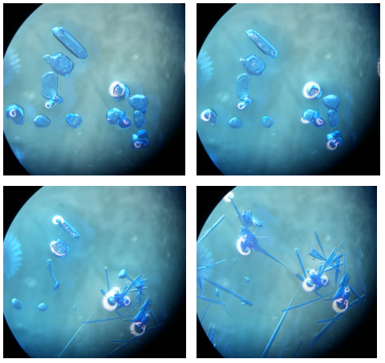
Figure 3. The conversion of blue prisms of 1 to needle-like crystals of 2 in mother liquor. The identity of the crystals was confirmed by the determination of unit cell parameters.

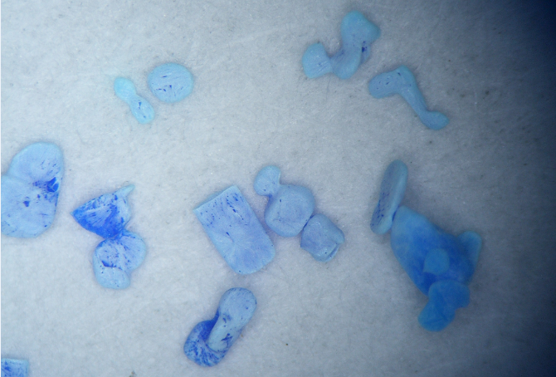
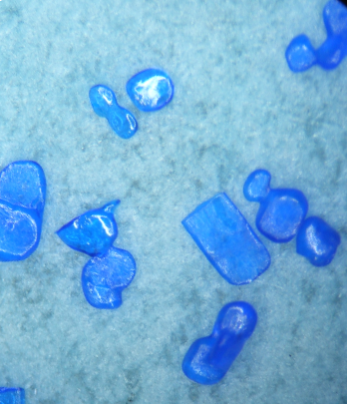
Fig. 4. Prismatic crystals of 1 just after taking out of the solution (left) and getting opaque after few minutes (right).

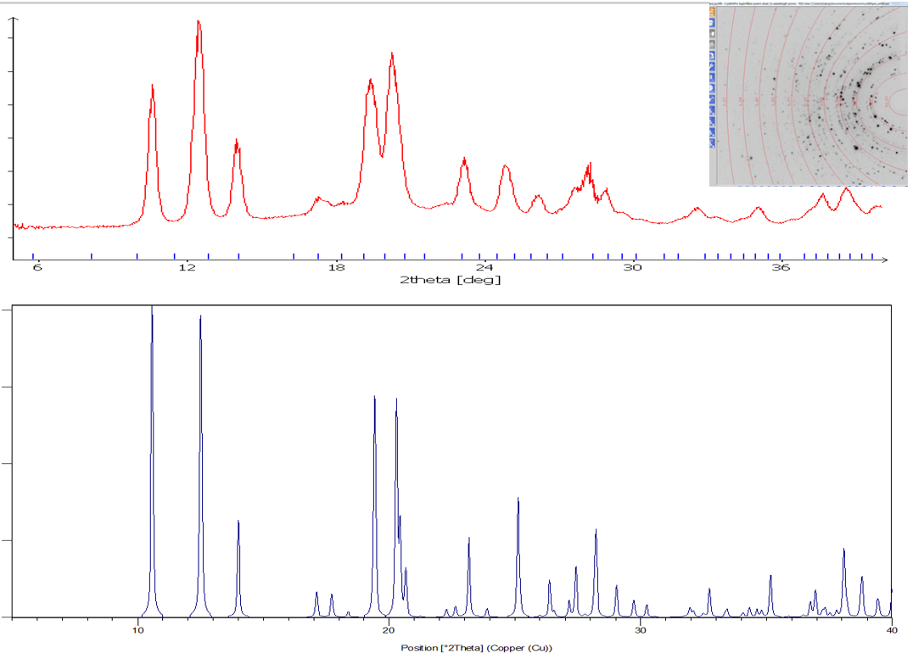
Fig. 5. Upper graph represents the extraction of the powder pattern from the single crystal experiment, performed on opaque prism from Fig. S3. The powder pattern below is calculated from the crystal structure 2. By comparison of both patterns, the formation of 2 from 1 on air can be confirmed. Powder pattern extraction was performed by CrysAlis software.²²

According to the observations, the structure conversion should not require significant reorganization of the atoms and molecules in the crystal. When comparing coordination environment of copper(II) in both title structures (cf. Figs. 1 and 2), the first difference between 1 and 2 can be observed in the apical ligand while the basal planes of the square pyramid remain mostly the same in both compounds; instead of pyridine in apical position in 1, a bridging methanoato ligand is present in 2 which enables the formation of polynuclear complex molecules. The second difference is in the presence of water in 2. One would expect that (i) the crystal packing of 1 should enable apical pyridine to leave the structure, and water to enter the structure simultaneously, and that (ii) monomeric coordination molecules should be arranged and oriented properly that the neighbouring molecules can connect into chains via methanoato bridges. A drawing of molecular packing in 1 (Fig. 6) reveals that the apical pyridine ligands (drawn black) are located in virtual channels running along monoclinic c axis. Through the latter the water molecules can enter while the pyridine ones can leave the structure. Crystal packing of 2 is represented in Fig. 7d. Considering the second requirement, at first glance molecules in 1 are not properly oriented to join themselves into chains as in 2 since the uncoordinated oxygen atoms of methanoato ligands are not oriented towards copper(II) ions. The proposed mechanism for the conversion of 1 to 2 is shown in Fig. 7: after removal of apical pyridines and entering of water the remaining coordination moieties rotate and move slightly to achieve an orientation that enables uncoordinated O atom of (every second) methanato ligand to coordinate to neighbouring Cu atom - making this way bridging methanoato ligands from the monodentate ones and consequently chains - to which the water molecules attach. All of proposed steps probably take place simultaneously.

Figure 6. The packing of coordination molecules in 1; a view along c axis. The channels through which the apical pyridine molecules (shown in black) can leave the structure and the water molecules enter it can be observed. Hydrogen atoms are omitted for clarity.

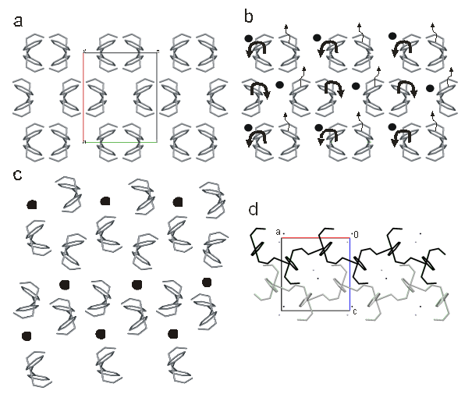
Figure 7. The proposed mechanism of conversion from 1 to 2. a) Pyridine molecules leave out the structure 1 (cf. Fig. 6), b) water molecules shown as black dots enter the structure, c) coordination moieties rearrange and consequently form chains to which water molecules are hydrogen bonded as in 2 (d). Narrow arrows show the direction of movement of complex molecules while the bold ones represent their rotations.

4 Conclusions
Crystal structures of two methanoato copper(II) complexes with pyridine, i.e. [Cu(O₂CH)₂(Py)₃] (1) and [Cu(O₂CH)₂(Py)₂]_{n}·nH₂O (2) at 150 K were determined by single-crystal X-ray diffraction. In both compounds, central Cu(II) is five-coordinated in a shape of square pyramid. In both complexes, the basal meanplane is formed by two nitrogens from coordinated pyridine molecules and two oxygens from two monodentately bound methanoato ligands. The apical atom is either nitrogen from the third coordinated pyridine molecule in 1 or oxygen from bridging methanoato ligand in 2. The distance Cu−apical is about 0.25 Å longer than the distances Cu−equatorial. In 2 five coordinated copper(II) moieties are connected into chains through bridging methanoato ligands. To such chains water molecules are hydrogen bonded. Compound 2 was prepared in two ways: by heating copper(II) methanoate in pyridine and also from compound 1. The conversion from 1 into 2 was observed in the solution as well as in the solid state at exposure to water from air. Crystal packing in 1 enables entering of water and release of pyridine. Only little further structure reorganisation is needed to achieve chain structure of 2.

5 Acknowledgements
Financial support of the Ministry of Higher Education, Science and Technology of the Republic of Slovenia is gratefully acknowledged (grants P1-0175 and X-2000). The authors also thank Leja Erzin for optimization of syntheses.

6 References
1. D. A. Dickie, P. T. K. Lee, O. A. Labeodan, G. Schatte, N. Weinberg, A. R. Lewis, G. M. Bernard, R. E. Wasylishen, J. A. C. Clyburne, Dalton Trans. 2007, 2862–2869, and references therein.
2. F. H. Allen, Acta Crystallogr. 2002, B58, 380−388.
3. M. A. Bernard, M. M. Borel, F. Busnot, A. Leclaire, Rev. Chim. Miner. 1979, 16, 124–133.
4. B. A. Cartwright, L. Couchman, A. C. Skapski, Acta Crystallogr. 1979, B35, 824–827.
5. B. Kozlevčar, E. Mate, Z. Jagličić, L. Glažar, A. Golobič, P. Strauch, J. Moncol, N. Kitanovski, P. Šegedin, Polyhedron 2009, 28, 2759–2765.
6. M. Yamanaka, H. Uekusa, S. Ohba, Y. Saito, S. Iwata, M. Kato, T. Tokii, Y. Muto, O. W. Steward, Acta Crystallogr. 1991, B47, 344–355.
7. M. M. Borel, F. Busnot, A. Leclaire, Rev. Chim. Miner. 1977, 14, 286–294.
8. M. M. Borel, A. Busnot, F. Busnot, A. Leclaire, Rev. Chim. Miner. 1980, 17, 202–208.
9. B. Kozlevčar, L. Glažar, G. Pirc, Z. Jagličić, A. Golobič, P. Šegedin, Polyhedron 2007, 26, 11–16.
10. G. A. van Albada, S. A. Komaei, H. Kooijman, A. L. Spek, J. Reedijk, Inorg. Chim. Acta 1999, 287, 226–231.
11. M. A. Sharif, M. Tabatabaee, V. Beik, H. R. Khavasi, Acta Chim. Slov. 2012, 59, 289–293.
12. S. Esmaielzadeh, E. Zarenezhad, Acta Chim. Slov. 2018, 65, 416–428.
13. Y.-L. Sang, X.-S. Lin, Acta Chim. Slov. 2019, 66, 168–172.
14. N. Burger, H. Fuess, Solid State Commun. 1980, 34, 699–703.
15. Collect Software. Nonius BV. Delft, The Netherlands, 2000.
16. Z. Otwinowski, W. Minor, Methods Enzymol. 1997, 276, 307–326.
17. A. Altomare, M. C. Burla, M. Camalli, G. L. Cascarano, C. Giacovazzo, A. Guagliardi, A. G. G. Moliterni, G. Polidori, R. Spagna, J. Appl. Crystallogr. 1999, 32, 115–119.
18. SHELXL2013. G. M. Sheldrick, University of Göttingen, Germany, 2013.
19. L. J. Farrugia, J. Appl. Crystallogr. 1997, 30, 565–565.
20. C. F. Macrae, P. R. Edgington, P. McCabe, E. Pidcock, G. P. Shields, R. Taylor, M. Towler, J. van de Streek, J. Appl. Crystallogr. 2006, 39, 453−457.
21. A. W. Addison, N. T. Rao, J. Reedijk, J. van Rijn, G. C. Verschoor, J. Chem. Soc., Dalton Trans. 1984, 1349−1356.
22. Agilent (2014). CrysAlis PRO. Agilent Technologies Ltd, Yarnton, Oxfordshire, England.
Graphical contents

