Biophysical properties and cytotoxicity of feruloylated Helix lucorum hemocyanin
Maya Guncheva^{1*}, Krassimira Idakieva¹, Svetla Todinova², Elena Stoyanova³, Denitsa Yancheva¹
¹Institute of Organic Chemistry with Centre of Phytochemistry, Bulgarian Academy of Sciences; Sofia 1113, Bulgaria;
²Institute of Biophysics and Biomedical Engineering, Bulgarian Academy of Sciences, Sofia 1113, Bulgaria;
³Institute of Biology and Immunology of Reproduction, Bulgarian Academy of Sciences, Sofia 1113, Bulgaria
*corresponding author: maiag@orgchm.bas.bg (M. Guncheva)

Abstract
For the first time Helix lucorum hemocyanin (HlH) have been feruloylated. Two HlH conjugates with 40- and 120- ferulic acid residues were prepared, denoted as FA-HlH-1 and FA-HlH-2. Expectedly, the feruloylation of HlH induced a rearrangement of the protein molecule, a decrease in α-helical structure at expense of β-structures was observed. In addition, the FA-HlH conjugates were more prone to aggregation, which is probably due to stabilization of the partially unfolded protein molecules by non-covalent bonding. Interestingly, the thermal stability of HlH was not affected by the modification. The native and feruloylated HlH were not toxic to normal fibroblasts (BJ cells). We observed decrease in cell viability of breast cancer MCF-7 cells to about 66% after a 48h exposure to 70 µg/well of FA-HlH-2.

Keywords: hemocyanin conjugates; ferulic acid; conformational stability; thermal stability; cytotoxicity

1. Introduction

Ferulic acid (FA) is a naturally occurring anti-oxidant, radical scavenging and photoprotective agent with huge therapeutic potential. It has been reported that FA have also strong hepatoprotective activity.¹Much attention has been paid in the literature on the beneficial role of FA in the treatment and prevention of Alzheimer’s disease, a serious neurodegenerative disorder.² In addition, FA inhibits melanin production, therefore can be involved in formulations for skin depigmentation.³ Interestingly, graft copolymers containing ferulic and hyaluronic acid exhibit wound healing properties and can be involved in medicines for treatment of chronic and acute wounds.⁴ On the other hand, chitosan-FA conjugates are proposed as novel drug delivery system based ,⁵ while FA-modified glycol chitosan exhibited remarkable neuroprotective activity and can be applied in functional restoration of traumatically injured spinal cord, a life-threatening trauma.⁶
Here we report the preparation of two FA-hemocyanin conjugates. Hemocyanins (Hc) are large complex respiratory proteins freely dissolved in the hemolymph of arthropods and mollusks .⁷ Hc isolated from Keyhole limpet (KLH) is commercialized and is applied as an immunotherapeutic in case of prostate cancer for several decades.⁸ Currently, many other vaccines against non-Hodgkins lymphoma, cutaneous melanoma, breast and bladder cancer, that are based on KLH undergo clinical trials. In addition, the whole protein or its subunits are used protein carriers or adjuvants .⁸ Many other Hcs have been isolated and structurally characterized, some exhibit anticancer, immunostimulatory, antiviral, antifungal activities in in vitro and in vivo assays.⁹ Hc from Helix lucorum (HlH) has been recently isolated and characterized.¹⁰ Lately, it has been reported that HlH and its structural subunits are cytotoxic to bladder carcinoma cells .¹¹
The aim of the study is to prepare FA-HlH conjugates and to assess the effect of the feruloylation on the HlH conformation and thermal stability. Cytotoxic effect of the FA-HlH conjugates against fibroblasts (BJ cells), hormone-dependent breast cancer cells (MCF-7 cells) and hormone-independent breast cancer cells (MDA-MB-231 cells). Experiments with the native HlH were conducted for comparison.

2. Materials and Methods
2.1. Materials
Ferulic acid (>99%), N-(3-Dimethylaminopropyl)-N′-ethylcarbodiimide hydrochloride (>98%) (EDC), N- hydroxysuccinimide (>98%) (NHS), thiazolyl blue tetrazolium bromide (98%, MTT), Dulbecco’s Modified Eagle’s (DMEM) low glucose medium, fetal bovine serum, 0.25% trypsin-EDTA solution and penicillin-streptomycin-amphotericin B antibiotic and disposable PD-10 columns were purchased from Sigma-Aldrich.
Hc was isolated from hemolymph of Helix lucorum garden snails as described in.¹⁰ All other used organic solvents and salts were analytical grade.
The human breast carcinoma cell lines (MCF-7 and MDA-MB-231) and normal human skin fibroblasts (BJ cell line) were obtained from the American Type Culture Collection (ATCC).

2.2. Preparation of FA-HlH conjugates
At first, FA was stirred with EDC/NHS in 50 mM phosphate saline buffer (PBS)(pH 7.2) at stoichiometric molar ratio of FA/EDC/NHS = 1:2:2 for 2 h at room temperature. Then, a 100-to 500-fold molar excess of the obtained NHS-ester of FA was added to the native HlH dissolved in PBS. The mixture was stirred at room temperature for 4 h at room temperature, and then incubated at 4ºC overnight. The FA-HlH conjugates were purified on prepacked PD-10 desalting columns following the manufacturer’s instructions.
The concentration of the native and feruloylated HlH was determined using the Bradford assay.¹²
Absorbance spectra of the protein samples were recorded on Evolution™ 300 UV-Vis Spectrophotometer (Thermo Electron Corporation) equipped with a Peltier temperature control accessory with the highest resolution (1 nm). The degree of feruloylation was estimated using the differences in the spectra of the native and the feruloylated HlH at 315 nm. The molar extinction coefficient of ferulic acid at 315 nm in PBS (pH 7.2, 50 mM) is 13 740 L. mol⁻¹. cm⁻¹.
2.3. Fourier-transform Infrared spectroscopy (FTIR)
FTIR spectra were recorded on Bruker Vertex 70 spectrometer equipped with a diamond ATR accessory in the frequency region 4000–600 cm⁻¹ with 128 scanning at resolution of 1 cm⁻¹. Protein samples were dissolved in PBS buffer (pH 7.2, 50 mM) at concentration of 20 mg/mL. All spectra were obtained after subtraction of the buffer baseline and were strictly collected under the same conditions, after adjusting the subtraction baseline until a flat baseline was obtained in the 2000–1700 cm⁻¹ region. Second derivatives were obtained using Savitzky-Golay algorithm based on 25 smoothing points. Curve fitting of the amide I band from 1700 to 1600 cm−1, in water, was performed using Opus software version 5.5 according to the Local Least Squares algorithm. The initial bandwidth of all components was set to 12 cm⁻¹ and the components were approximated by mixed Lorentzian/Gaussian functions. Amide I band positions are assigned to the corresponding secondary structures according to the literature .¹³

2.4. Differential Scanning Calorimetry (DSC)
DSC scans were carried out on a high-sensitivity differential scanning microcalorimeter DASM-4 (Biopribor, Pushchino, Russia), with a sensitivity > 0.017 mJ K-1 and a noise level < ±0.05 μW. The protein samples were dissolved in PBS (pH 7.2, 50 mM) at a concentration of 3 mg/mL. Heat capacity versus temperature profiles were obtained in the range 30–110ºC at scan rate 1K.min⁻¹.Sample scans were buffer-subtracted, concentration normalized and corrected with the progress baseline. DSC curves were analyzed using ORIGIN (MicroCal Software) program. Experimental deconvolution of heat capacity curves into individual components by a successive annealing procedure was applied following the approach of Idakieva et al.¹⁴

2.5. Cell culture
BJ, MCF-7 and MDA-MB-231 cells were maintained in a complete growth DMEM low glucose medium supplemented with 10% (v/v) fetal bovine serum and penicillin-streptomycin-amphotericin B antibiotic mixture under a humidified atmosphere of 5% CO₂ at 37ºC. The medium was changed every other day.

2.6. Cell viability assay
Methylthiazolyldiphenyl-tetrazolium bromide (MTT) assays were carried out to evaluate the cytotoxic effect of FA-HlH on BJ, MCF-7 and MDA-MB-231 cells.¹⁵ The cells were seeded in 96-well plate at density of 1x10⁴ cells per well and cultured in complete growth medium for 24 h. Then, cells were incubated with 0-70 µg/well of native or FA-modified HlH for 24 h and 48 h. The culture medium was changed to 100μL serum-free medium containing 500μg/mL MTT and plates were incubated for 3 h at 37°C and 5% CO₂. The formazan salts were dissolved in 120μL of dimethylsulfoxide (DMSO) and the absorbance was measured at 544 nm on FLUOstar Optima microplate reader (BMG Labtech, Germany). Samples containing only DMSO were used as a blank control. Control experiments containing untreated with FA-HlH or HlH cells were carried out. The survival of the cells, treated with HlHs was presented in percentages from the corresponding control. Two independent experiments were performed for each cell line.

2.7. Statistical analysis
Data were analyzed by one-way ANOVA followed by Tukey–Kramer post-hoc test. The values were considered to be significantly different if the p value was < 0.05.

3. Results and Discussion
3.1. Synthesis and biophysical characterization of the FA-HlH conjugates
Ferulic acid was covalently linked to the accessible ε-amino groups of lysine residues and N-terminal amino groups of HlH via activated ester method (Scheme 1).
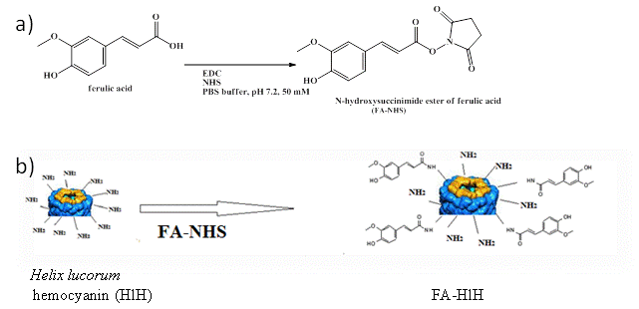
Scheme 1: Steps in chemical modification of Helix lucorum hemocyanin with ferulic acid: a) activation of the carboxylic group of ferulic acid; b) Conjugation of ferulic acid and primary amino groups of the hemocyanin.

The reaction was conducted under mild reaction conditions in PBS buffer (pH 7.2), at which primary amino groups are positively charged and exposed to the protein surface. The intermediate, NHS ester of ferulic acid was not isolated and synthesis was performed in one step. An excess of folic acid (100- to 500- fold) was used in order to obtain conjugates with high degree of substitution. Two FA-HlH conjugates containing 40- and 120 ferulic acid residues were prepared and isolated, and were denoted as FA-HlH-1 and FA-HlH, respectively.
We applied ATR-FTIR spectroscopy to assess the effect of the modification on the HlH secondary structure. Spectra of FA-HlH-1, FA-HlH-2 and native HlH were compared in the Amide I band region (1700-1600 cm⁻¹), which is mainly due to C=O stretching vibrations (70-80%) of the amide groups and is known as conformationally sensitive.¹³ For the three protein samples, the original, the second derivative and the deconvoluted spectra scaled to an identical area under Amide I and Amide II (1700-1400 cm⁻¹) are given in the Supplementary (Fig. S1). The spectra were analyzed using 7 (native HlH and FA-HlH-1) or 8 (FA-HlH-2) bands having a centre within 1600–1615; 1615–1640; 1640–1660; 1660–1690; and 1690–1700 cm⁻¹, which are assigned to extended conformations or side-chains residues, β-sheets; α-helical, coiled or disordered structures; β-turns and antiparallel β-sheet structures.¹³ As obtained from the FTIR studies, the conformation of the native and the two feruloylated HlHs are reported in Table 1.
Table 1. Secondary structure band assignments for the native and ferulic acid-conjugated Helix lucorum hemocyanin in 50 mM PBS buffer (pH 7.2).
Assignment of the secondary structure components¹³ | HlH native |  | FA-HlH-1 |  | FA-HlH-2
Assignment of the secondary structure components¹³ | Band position (cm⁻¹) | Relative area (%) | Band position (cm⁻¹) | Relative area (%) | Band position (cm⁻¹) | Relative area (%)
anti-parallel β-sheets | – | – | 1609 | 11.31 | 1613;  1694 | 10.91  2.12
β -structures (sheets and turns) | 1629;  1633;  1664;  1676  1690 | 0.15;  8.0;  11.76;  23.31;  7.90 | 1621;  1633;  1667;  1683 | 7.31;  14.0;  12.74  10.73 | 1624;  1632;  1666;  1682 | 10.28;  14.57;  15.80;  7.74
α-helices | 1653 | 30.39 | 1651 | 20.79 | 1653 | 23.7
unordered structures/random coils | 1642 | 18.4 | 1644 | 23.13 | 1642 | 14.57
FA-HlH-1 (40 ferulic acid residues); FA-HlH-2 (120 ferulic acid residues)

We observed a decrease in α-helices at expense of β-structures, which is an indication that HlH is partially unfolded due to the feruloylation. In the spectra of FA-HlH-1 and FA-HlH-2 are found the typical bands that are assigned to protein aggregates, which are probably additionally stabilized by non-covalent interactions involving the aroma ring of the substituents.
Interestingly, despite of the observed conformational changes of the HlH induced by the modification, the thermal stability of the protein remained mostly unaffected. DSC profiles of the native HlH, FA-HlH-1 and FA-HlH-2 are depicted in Fig. 1.
Fig. 1. DSC profiles of the thermal unfolding of native HlH (a) and conjugated with 40 and 120-ferulic acid residues, FA-HlH-1 (b) and FA-HlH-2 (c).
The experiment was conducted at a protein concentration of 3 mg/mL in PBS (pH 7.2, 50 mM), and heating rate – 1K/min.

As seen the three DSC curves have asymmetric shape, which is due to the complex multimeric structure of hemocyanins and is in agreement with the literature data on the thermal denaturation of another Hc in phosphate-saline buffer.¹⁶ The thermal denaturation temperatures of the feruloylated HlH are slightly shifted toward the higher temperatures (by up to 5ºC) in comparison to denaturation temperatures of the native HlH. DSC curves were experimentally deconvoluted using a successive annealing procedure as previously described by Idakieva et al ,¹⁵ which allowed more precise estimation of the thermodynamic parameters, transition temperature (Tm_{i}) and calorimetric enthalpy (ΔH_{i}) (Table 2). Apparently, the thermal stability of HlH was preserved after the modification.

Table 2. The thermodynamic parameters of the native and ferulic acid modified HlH thermal denaturation.
Sample | T_{m1}  (°C) | ∆H₁  (kJ mol⁻¹) | T_{m2} (°C) | ∆H₂  (kJ mol⁻¹) | T_{m3}  (°C) | ∆H₃  (kJ mol⁻¹) | T_{m4} (°C) | ∆H₄  (kJ mol⁻¹) | T_{m5} (°C) | ∆H₅  (kJ mol⁻¹) | ∆H_{total}  (kJ mol⁻¹) | ∆H_{cal}  (kJ mol⁻¹)
native HlH | 49.9 | 38080 | 55.2 | 10752 | 67.6 | 92858 | 75.7 | 99308 | 79.8 | 22263 | 263261 | 279337
FA-HlH-1 |  |  | 60.4 | 40802 | 68.3 | 79585 | 75.4 | 77372 | 80.4 | 20111 | 217870 | 214977
FA-HlH-2 |  |  | 58.9 | 72399 | 68.5 | 70882 | 75.5 | 67464 | 81.0 | 27466 | 239091 | 245351
FA-HlH-1 (40 folic acid residues); FA-HlH-2 (120 folic acid residues)

3.2. Comparison of the cytotoxicity of the native and the feruloylated HlH
The effect of FA-HlH-1 and FA-HlH-2 on the cell viability of human fibroblasts (BJ cells) was tested in a concentration range between 25 and 200 µg/well (Fig 2).
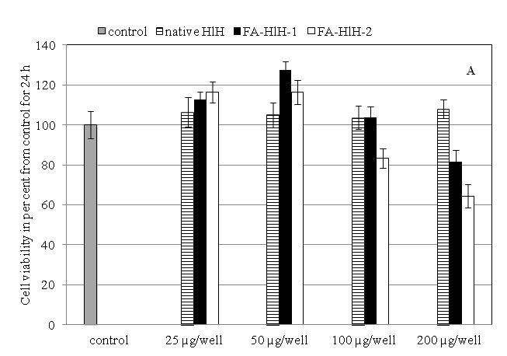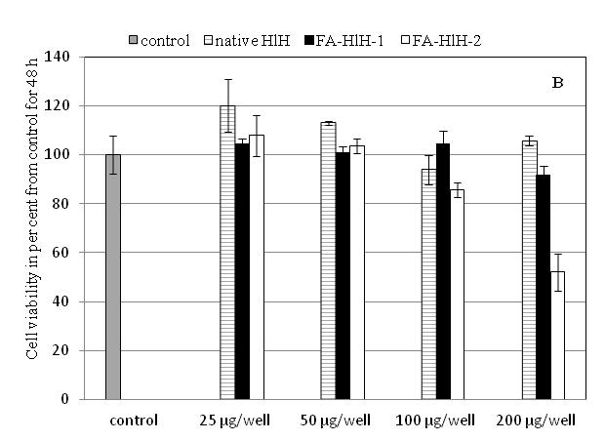
Fig. 2. Antiproliferative effect of native and ferulic acid conjugated HlH on normal fibroblasts (BJ cells) after 24 h (A) and 48 h (B) incunation. Data are presented as mean±SD, p<0.05, n=3.

We observed a slight increase in proliferation or no effect after a 24h exposure of the BJ cells to 25 or 50 µg/mL of the native or feruloylated HlH. For the same samples, not evidence of any sign of toxicity was observed even after longer incubation time. Reduction in BJ cell growth was observed after a 24h-treatment with 200 µg/well (18.4±5%, P<0.001) of FA-HlH-1, a similar effect was produced by 100 µg/well of FA-HlH-2. The lowest cell viability of the BJ cells, 64.1 and 51.1%, was detected after 24 and 48 h, respectively of incubation with 200 µg/mL FA-HlH-2.
Cytotoxicity of the feruloylated HlH against two breast cancer cell lines, a hormone-dependent (MCF-7) and a hormone-independent (MDA-MB-231), was estimated at concentrations from 10 to 70µg/well, which are not toxic for normal fibroblasts. The native and the two feruloylated HlHs produce a similar effect within one and the same cell line. The effect was more pronounced for FA-HlH-2, especially for the MCF-7 cells, for which we noticed concentration dependence (Fig. 3). The three Hcs had negligible cytotoxic effects on MDA-MB-231 cells, even at a concentration of 70 µg/well, the highest tested concentration (Fig. 4).

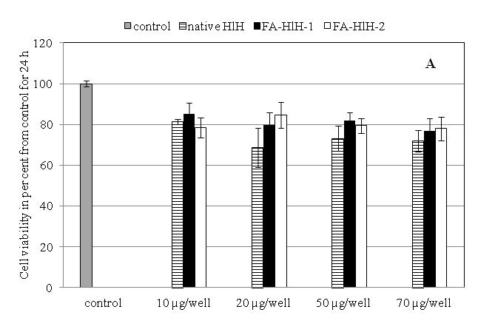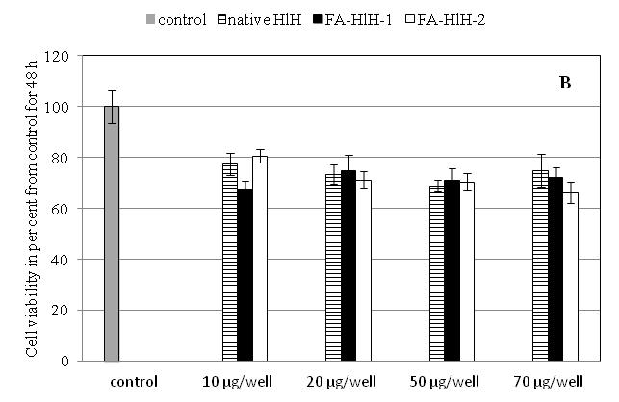

Fig.3. Effect of native HlH and ferulic acid conjugated HlH on MCF-7 cell viability after 24 h (A) and 48 h (B) incubation. Data are presented as mean±SD, p<0.05, n=3.

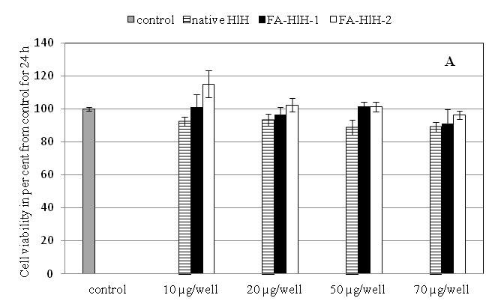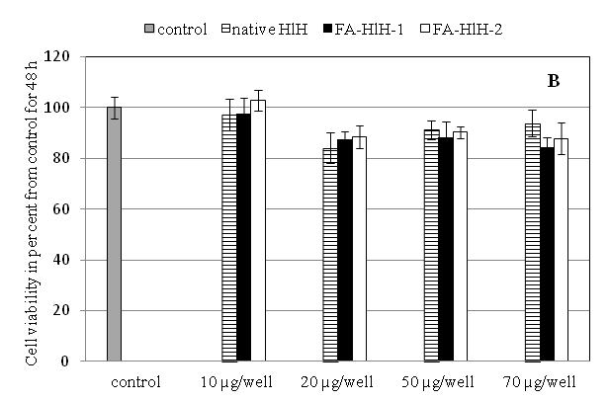
Fig. 4. Effect of native HlH and ferulic acid conjugated HlH on MDA-MB-231 cell viability after 24 h (A) and 48 h (B) incubation. Data are presented as mean±SD, p<0.05, n=3.

The moderate to excellent activity and selectivity of the native and the feruloylated HlH towards MCF-7 cells makes them promising for future studies in view of their biopharmaceutical potential.

Acknowledgements: The financial support of the Bulgarian National Science Fund (Project: ДКОСТ 01/27) is gratefully acknowledged.

REFERENCES
1. R. Rukkumani, K. Aruna, P. S. Varma, V. P. Menon, J. Med. Food. 2004, 7, 456–461.
2. S.F. Nabavi, K. P. Devi, D.S. Malar, A. Sureda, M. Daglia, S.M. Nabavi, Mini-Rev. Med. Chem. 2015, 15, 776–788.
3. H. Maruyama, F. Kawakami, T. T. Lwin, M. Imai, F. Shamsa, Biol. Pharm. Bull. 2018, 41, 806–810.
4. G. Valacchi, G. Grisci, C. Sticozzi, Y. Lim, M. Paolino, G. Giuliani, R. Mendichi,. G. Belmonte, R. Artusi, A. Zanardi, P. Garofalo, G. Giorgi, A. Cappelli, L. Rovati, J. Mat. Chem. B. 2015, 3, 7037–7045.
5. C. Li, J.-B. Li, Int. J. Biol. Macromol. 2017, 105, 1539–1543.
6. W. Wu, S.-Y. Lee, X. Wu, J. Y. Tyler, H. Wang, Z. Ouyang, K. Park, X.M. Xu, J.X. Cheng,
Biomaterials 2014, 35, 2355–2364.
7. C. Gatsogiannis, O. Hofnagel, J. Markl, Stefan Raunser, Structure 2015, 23, 93–103.
8. J.R. Harris, J. Markl, Micron 1999, 30, 597–623.
9. C. J. Coates, J. Nairn, Dev. Comp. Immunol. 2014, 45, 43–55.
10. L. Velkova, I. Dimitrov, H. Schwarz, S. Stevanovic, W. Voelter, B. Salvato, P. Dolashka-Angelova, Comp. Biochem. Physiol. B Biochem. Mol. Biol. 2010, 157, 16–25.
11. A. Dolashki, P. Dolashka, A. Stenzl, S. Stevanovic, W. K. Aicher, L. Velkova, R.Velikova, W. Voelter, Biotechnol. Biotechnol. Equip. 2019, 33, 20–32.
12. M. Bradford, Anal. Biochem. 1976, 72, 248–254.
13. A. Barth, Biochim. Biophys. Acta. 2007, 1767, 1073–1101.
14. K. Idakieva, C. Gielens, N. Siddiqui, L. Doumanova, B. Vasseva, Kostov, V.L. Shnyrov, Z. Naturfors. B. 2007, 62a, 499 – 506.
15. T. Mosmann, J. Immunol. Meth. 1983, 65, 55–63.
16. K. Idakieva, K. Parvanova, S.Todinova, Biochim. Biophys. Acta. 2005, 1748, 50– 56.

