Supporting information
Biophysical properties and cytotoxicity of feruloylated Helix lucorum hemocyanin
Maya Guncheva^{1*}, Krassimira Idakieva¹, Svetla Todinova², Elena Stoyanova³, Denitsa Yancheva¹
¹Institute of Organic Chemistry with Centre of Phytochemistry, Bulgarian Academy of Sciences; Sofia, Bulgaria;
²Institute of Biophysics and Biomedical Engineering, Bulgarian Academy of Sciences, Sofia, Bulgaria;
³Institute of Biology and Immunology of Reproduction, Bulgarian Academy of Sciences Sofia Bulgaria
*corresponding author: maiag@orgchm.bas.bg (M. Guncheva)

2. Fourier-transform Infrared spectroscopy (FTIR)
FTIR spectra were recorded on Bruker Vertex 70 spectrometer equipped with a diamond ATR accessory in the frequency region 4000–600 cm⁻¹ with 128 scanning at resolution of 1 cm⁻¹. Protein samples were dissolved in PBS buffer (pH 7.2, 50 mM) at concentration of 20 mg/mL. All spectra were obtained after subtraction of the buffer baseline and were strictly collected under the same conditions, after adjusting the subtraction baseline until a flat baseline was obtained in the 2000–1700 cm⁻¹ region. Second derivatives were obtained using Savitzky-Golay algorithm based on 25 smoothing points. Curve fitting of the amide I band from 1700 to 1600 cm−1, in water, was performed using Opus software version 5.5 according to the Local Least Squares algorithm. The initial bandwidth of all components was set to 12 cm⁻¹ and the components were approximated by mixed Lorentzian/Gaussian functions. Amide I band positions are assigned to the corresponding secondary structures according to the literature [13].

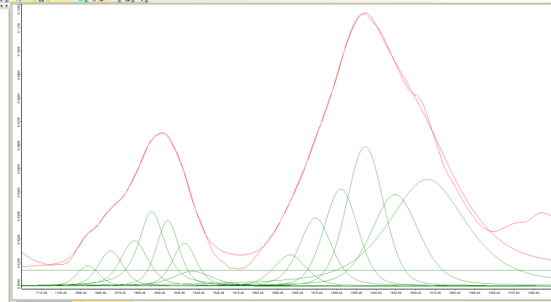

Fig. S1A. Original (a), second derivative and deconvoluted ATR-FTIR spectra in Amide I region of native HlH in PBS buffer (pH 7.2, 50 mM) at concentration of 20 mg/mL.

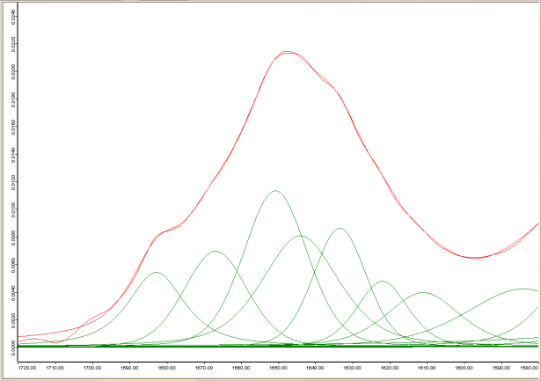
Fig. S1B. Original (a), second derivative and deconvoluted ATR-FTIR spectra in Amide I region of FA- HlH-1( HlH containing 40 ferulic acid residues) in PBS buffer (pH 7.2, 50 mM) at concentration of 20 mg/mL.

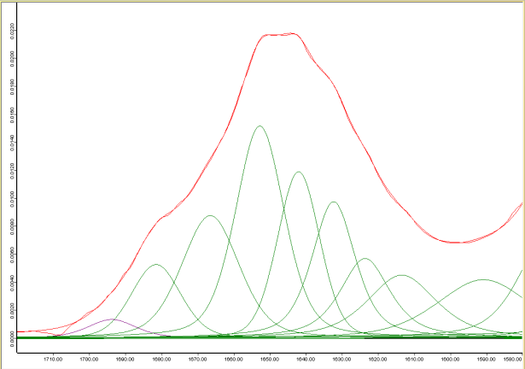
Fig. S1C. Original (a), second derivative and deconvoluted ATR-FTIR spectra in Amide I region of FA- HlH-2( HlH containing 120 ferulic acid residues) in PBS buffer (pH 7.2, 50 mM) at concentration of 20 mg/mL.

3. Differential Scanning Calorimetry (DSC)
DSC scans were carried out on a high-sensitivity differential scanning microcalorimeter DASM-4 (Biopribor, Pushchino, Russia), with a sensitivity > 0.017 mJ K-1 and a noise level < ±0.05 μW. The protein samples were dissolved in PBS (pH 7.2, 50 mM) at a concentration of 3 mg/mL. Heat capacity versus temperature profiles were obtained in the range 30–110ºC at scan rate 1K.min⁻¹.Sample scans were buffer-subtracted, concentration normalized and corrected with the progress baseline. DSC curves were analyzed using ORIGIN (MicroCal Software) program. Experimental deconvolution of heat capacity curves into individual components by a successive annealing procedure was applied following the approach of Idakieva et al [14].

Fig. S2. An example of the successive annealing procedure for the native HlH.
- Complete calorimetric profile of HlH-free (solid black line) in PBS (pH 7.2, 50 mM) buffer at a heating rate of 1.0 Kmin⁻¹ and the successive scans, stopped at 51 °C, 56 °C, 69 °C, 76 °C and 86 °C respectively (dash dot lines).
- Result of the deconvolution of the experimental contour (short dash line), which provides five individual components (blue lines).

4. Cell viability assay
Methylthiazolyldiphenyl-tetrazolium bromide (MTT) assays were carried out to evaluate the cytotoxic effect of FA-HlH on BJ, MCF-7 and MDA-MB-231 cells [15]. The cells were seeded in 96-well plate at density of 1x10⁴ cells per well and cultured in complete growth medium for 24 h. Then, cells were incubated with 0-70 µg/well of native or FA-modified HlH for 24 h and 48 h. The culture medium was changed to 100μL serum-free medium containing 500μg/mL MTT and plates were incubated for 3 h at 37°C and 5% CO₂. The formazan salts were dissolved in 120μL of dimethylsulfoxide (DMSO) and the absorbance was measured at 544 nm on FLUOstar Optima microplate reader (BMG Labtech, Germany). Samples containing only DMSO were used as a blank control. Control experiments containing untreated with FA-HlH or HlH cells were carried out. The survival of the cells, treated with HlHs was presented in percentages from the corresponding control. Two independent experiments were performed for each cell line.

