Facile synthesis of poly(DMAEMA-co-MPS)-coated porous silica nanocarriers as dual-targeting drug delivery platform: Experimental and biological investigations
Mohammad Hegazy^{a,b,*}, Pei Zhouª, Guangyu Wuª, Nadia Taloub^{a,c}, Amany Ahmed^{d,e}, Xin Huangª and Yudong Huangª

a MIIT Key Laboratory of Critical Materials Technology for New Energy Conversion and Storage, Key Laboratory of Microsystems and Microstructures Manufacturing, School of Chemistry and Chemical Engineering, Harbin Institute of Technology, Harbin 150001, China
b Department of Polymer Chemistry, Faculty of Science, Menoufia University, Shebin El-Kom 32511, Egypt
c LIPE Laboratory, University of Constantine 3, 25000 Constantine, Algeria
d College of Life Science, Northeast Forestry University, Harbin 150040, China
e Botany Department, Faculty of Science, Menoufia University, Shebin El-kom 32511, Egypt

* Corresponding author: dr_hegazy2000@yahoo.com.
A B S T R A C T
Inorganic structures with functionalized polymers play important roles in diverse biological trends. Herein, thermal and CO₂ dual-stimuli nanomaterials composed of mesoporous silica nanoparticles (MSN) anchored with two grafted copolymers: poly(3-methacryloxypropyltrimethoxysilane) “PMPS” & poly(N,N-dimethylaminoethyl methacrylate) “PDMAEMA” were synthesized via one step reaction and characterized by BET as well as BJH methods to estimate pore sizes, pore volumes and surface areas. The smart PDMAEMA acted as active gatekeeper to adjust the loading or in vitro release processes of a fungicidal drug loaded inside the mesopores by altering temperature or CO₂ of the tested environment. Furthermore, treating the nanomaterials by CO₂ for few minutes was found to have a bactericidal effect with promising results as indicated by the disk diffusion technique. In general, the positive biological activity against selected strains of bacteria and fungi indicates that, these particles may be helpful for engineering more efficient antifungal or antibacterial agents for pharmaceutical applications.
Keywords: CO₂-responsive release, thermal-triggered release, biopolymeric materials, antimicrobial agents
Introduction
Over the past two decades, smart polymeric materials have been exploited for versatile applications e.g. ion absorbance capacity,¹ wastewater treatment,² cargo delivery systems,³ photodynamic and photothermal effects.⁴ A famous example is MSN which have been used widely as drug carriers in biomedical technologies, thanks to several merits e.g. biocompatibility, easiness of surface-modification, and controllable mesopore sizes.⁵ PDMAEMA was applied as CO₂ responsive polymer in aqueous solutions as a result of protonation of the tertiary amine group which can also deprotonate reversibly by N₂ stimulation, i.e. swelling-shrinking effect.⁶ Furthermore, this smart polymer showed pretty good thermo-responsiveness, as it can from coil-to-globule states by changing temperatures degrees and showed a lower critical solution temperature (LCST) in aqueous solutions,⁷ which is similar character to the well-known thermosensitive poly (N-isopropylacrylamide) (PNIPAAm).^{8,9} More interestingly, quaternization of terminal amino groups of PDMAEMA had promising antimicrobial activity against some bacterial strains.¹⁰

Because of the possible applications in various promising areas including material science and life science, this study aims to synthesize and characterize pharmaceutical nanocontainers with dual-sensitive character to release the loaded cargos with response to CO₂ or temperature or both together, followed by biological evaluation against microbial strains as illustrated in Scheme 1. We exploited the alkoxysilane moity of silicon derivative monomer 3-methacryloxypropyltrimethoxysilane (MPS) to link it (through a condensation reaction) with silanols surface of MSN from one side, while the other side (active double bond) was polymerized simultaneously with N,N-dimethylaminoethyl methacrylate (DMAEMA) monomer via thermal polymerization using AIBN as azo initiator.^{11,12} The growing PDMAEMA onto MSN surface was used as a cap to maintain or trigger anidulafungin, which utilized as a model antifungal drug. The release behavior of the cargo was investigated by the two mentioned responses and tested against some microorganisms to evaluate the biological activity. The advantages of this construction are not only for the simple synthesis via one-step experiment, but also lie for obtaining high drug loading capacity, efficacious response for thermo‑ or CO₂‑stimuli and the potential application as antifungal or antibacterial agents, especially after converting PDMAEMA into its cationic form.

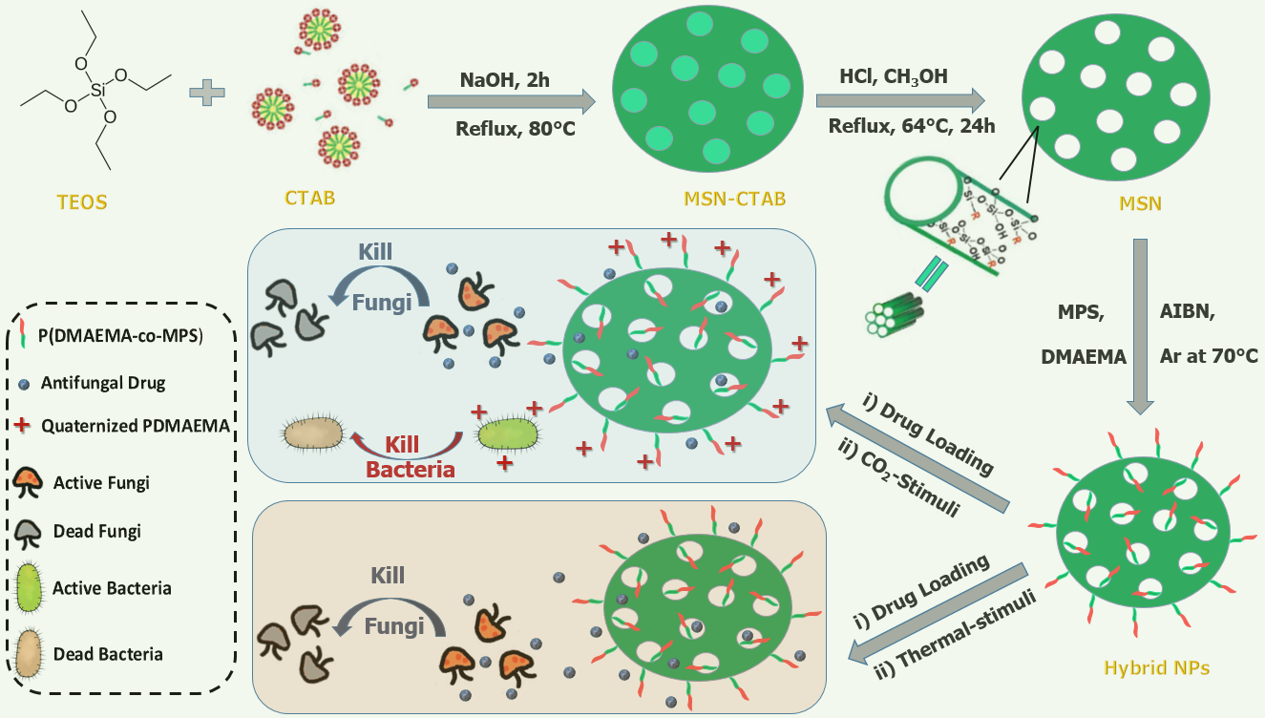
Scheme 1. Schematic illustration of MSN/P(MPS-co-DMAEMA) generation followed by drug loading, then CO₂ and hyperthermia induced release through dual-functional biomedical platform.
Materials and characterization techniques
The chemicals and reagents were purchased with analytical grade via Sigma-Aldrich. The specific surface areas and mesoporous structures were obtained through N₂ adsorption–desorption isotherms. The loading and releasing contents of anidulafungin drug were studied by UV-Vis spectrophotometry at λmax of 303 nm. Random isolates from Escherichia coli (E.coli, gram negative bacteria) as well as Candida albicans (C. albicans, fungi) were obtained from College of Life Science, Northeast Forestry University, Harbin, China. The culture medium was nutrient agar (NA) which prepared by adding agar (20 gm), beef extract (3 gm), peptone (5 gm) and sodium chloride (5 gm) then completed to one liter of deionized water.

Methods
MSN/P(MPS-co-DMAEMA) nanocarriers were prepared by established polymerization method,¹³ and then loaded with anidulafungin drug after several purification according to Rahoui et al.¹⁴ The loading content of the drug was estimated from UV-Vis spectra via Eq. (1).

$$Loading content (\%)=\frac{initial amount of drug- supernatant free amount of drug }{weight of drug loaded nanocarriers }× 100 \left(1\right)$$

On contrast, In vitro drug release experiments were tested in physiological saline solution (PSS) and estimated according to Eq. (2) at different time periods (from 1h to 24h).^{5, 14} The release behavior in PSS (100 mM) using dialysis membrane (molecular weight cut-off: 8000-14000 Da) were calculated by detecting the corresponding absorbance peak of anidulafungin at 303 nm using different environments including: (i) temperature lower and higher LCST of PDMAEMA (i.e. 25 °C & 45 °C) and (ii) bubbling with CO₂ for 10 min at the two mentioned temperatures.

$$Releasing content (\%)=\frac{amount of drug in the release medium }{amount of drug loaded into nanocarriers }× 100 (2)$$

The antimicrobial activity for the nanocarriers containing anidulafungin (NCA) was tested (after the releasing process with the two stimuli) using the well diffusion technique. The inoculum density in chosen NA plate was 10⁸ CFU.ml⁻¹, which related to the 0.5 McFarland turbidity scale.¹⁵ The seeded plates were dried in the incubator at 36 °C for 25 min. A borer of cork with 7 ml diameter was applied to cut uniform wells onto the inoculated agar surface, then around 100 μl of every sample (20 mg/ml) was added to the well. Free anidulafungin and tetracycline were used (with the same concentration as NCA) as positive control for antifungal and antibacterial activities, respectively. Deionized water and filter paper were used as the negative control (around 100 μl of the solvent). The plates were accordingly incubated for one day at the normal body temperature (37 °C). By the end of incubation time, the biological activity was tested by through inhibition zones in millimeters.¹⁶

3. Results and conclusions
Both MSN and MSN/P(MPS-co-DMAEMA) nanocarriers were synthesized and characterized by N₂ sorption isotherms (Fig.1), using BET and BJH methods. For both materials, the isotherms were of type IV, which suggesting the mesoporous nature¹⁷ as indicated in Fig.1A. The high surface area of 705 m² g⁻¹ for MSN had decreased considerably to 257 m² g⁻¹ after coating with copolymer layer to obtain MSN/P(MPS-co-DMAEMA) (see Table 1), which matching well with a similar study.¹⁸ Similarly and from pore size distribution curves (Fig.1B) and the same Table, there was a decrease in the pore volume (from 0.66 to 0.51 mL/g) along with the mean pore diameter (from 8.82 to 6.53 nm), when going from MSN to MSN/P(MPS-co-DMAEMA). The maintained large pore volume and high surface area for MSN/P(MPS-co-DMAEMA nanocarriers refers to that their mesopores have not been blocked after anchoring both PMPS & PDMAEMA on the silica surface, and consequently have the opportunity to carry the drug in the next step.

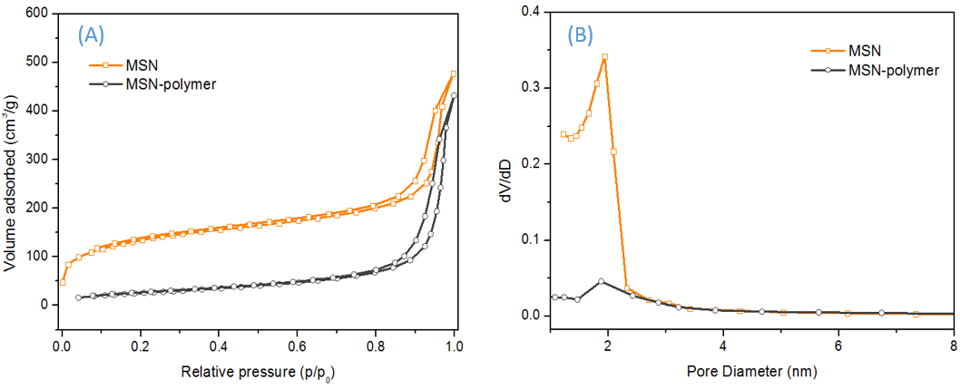

Figure 1. (A) N₂ adsorption desorption isotherms and (B) pore size distribution curves for MSN and MSN/P(MPS-co-DMAEMA) .

Table 1. Structure parameters of MSN and MSN/P(MPS-co-DMAEMA) derived from nitrogen sorption.
Samples | BET surface area (m²/g) | Pore volume (mL/g) | Mean pore diameter (nm)
MSN | 705 | 0.66 | 8.82
MSN/P(MPS-co-DMAEMA) | 257 | 0.51 | 6.53

For drug encapsulation studies, anidulafungin was chosen as a model antifungal agent, especially for treatment of candidemia caused by candida albicans yeast. The loading content (%) was calculated by UV-Vis spectrophotometry at λmax of 303 nm according to Eq. (1) and it was 17.9±0.7%, which is still higher than most surface-modified MSN previous studies (lower than 10%). This could be attributed to the hydrogen bonds and strong electrostatic interactions between the drug and nanocarriers.

The triggered release of anidulafungin from NCA was tested by the dialysis method in PSS, according to Eq. (2) under the following environments: (i) 25 °C, (ii) 45 °C, (iii) 25 °C & bubbling with CO₂ for 10 min and (iv) 45 °C & bubbling with CO₂ for 10 min. The results demonstrated that, the extended copolymer can perform as a smart gatekeeper for this system according to CO₂ or temperature changes. For the gas-response, the extended PDMAEMA is hydrophobic at neutral or alkaline pH values with collapsed uncharged chains, while it can convert into the weak cationic character in acidic medium with water-soluble, protonated and extended chains (i.e. after treated with CO₂ gas).¹⁹ On the other hand, the releasing of anidulafungin at hyperthermia state could be related to thermo-responsive features of the PDMAEMA segments. When the temperature increased (above LCST), the extended PDMAEMA units would shrink to the globular structure due to weakening or breaking of hydrogen bonds, which resulting in collapsed PDMAEMA chains.²⁰

After the releasing processes via dual stimuli from NCA, we evaluated the biological activity through antimicrobial screening using two organisms (E.coli, & C. albicans) according to Table 2. Free anidulafungin and tetracycline were used as positive control for the antifungal and antibacterial properties, respectively. The results showed that NCA did not express important antimicrobial impact on these microorganisms except an exceedingly weak impact on C. albicans, which perhaps due to the very small leakage of anidulafungin from NCA at room temperature (entry 1 in Table 2). Bubbling with CO₂ for 10 min at this room temperature (single CO₂ stimulus, entry 2 in Table 2), showed a moderate antifungal effect against C. albicans, but a very strong one
against E. coli, which could be attributed to formation of ionene polymers (cationic polymers include positive nitrogen or phosphor in their backbones) after reacting with CO₂ gas. This is in a good agreement with recent studies, which proved that the cationic PDMAEMA⁺ has a strong bactericidal effect against E. coli and some other bacterial strains.^{10,21}

On the other hand, upon heating to 45 °C (temperature stimulus alone), no antibacterial impact occurred, but a very strong antifungal effect was obtained. This reflects that, the temperature stimulus cannot convert PDMAEMA into its quaternary ammonium salt PDMAEMA⁺ (which is the key point for bacteria killing), however, this stimulus can release the loaded anidulafungin extremely which inhibited the growth of the yeast considerably (entry 3 in Table 2). Bubbling with CO₂ gas at this elevated temperature reduced the loaded cargo a little bit to a strong inhibition growth of C. albicans and further this effect converted PDMAEMA to PDMAEMA⁺ with strong inhibition too for E. coli growth (entry 4 in Table 2). It is clear that, the most important steps for antifungal and antibacterial effects were for pure temperature stimulus and pure CO₂ stimulus, respectively. Using both of stimuli together is also effective against the two microbes, but not like the pure one.
 | Antimicrobial activity on
Stimuli Type | E. coli (Bacteria) | C. albicans (Yeast)
25 °C | NA | +
25 °C + CO₂ | ++++ | ++
45 °C | NA | ++++
45 °C + CO₂ | +++ | +++

Table 2. The cytotoxicity effect of each stimuli on two selected microbial strains E. coli and C. albicans which symbolized by +: weak, ++: medium, +++: strong and ++++: very strong.

4. Conclusion
In this article, a temperature- and CO₂-seneitive delivery system composed of grafted copolymer capped MSN was explained. A poly(DMAEMA)-co-poly(MPS) shell on MSN was constructed via a facile one step reaction (condensation & polymerization) and characterized successfully. The grafted copolymer showed both temperature- and CO₂-seneitive release properties for the antifungal anidulafungin drug, which then confirmed by killing C. albicans yeast, with low to moderate results (high in some cases). Most importantly, the PDMAEMA coating can kill E. coli bacteria effectively upon converting to its cationic form through CO₂ responses. This novel strategy of designing dual-responses via particles-coating followed by evaluating the biological activity, can provide an inspiration for engineering of advanced bionanomaterials.

Acknowledgments
This work was supported by the National Natural Science Foundation of China (No. 21871069) and Open Project of Key Laboratory of Microsystems and Microstructures Manufacturing (2016KM003).

Notes
The authors declare no competing financial interest.

References
1. P. Zhou, L. Wang, G. Wu, Y. Zhou, M. Hegazy, X. Huang, ChemistrySelect 2017, 2, 6249–6253.
2. G. Wu, X. Liu, P. Zhou, L. Wang, M. Hegazy, X. Huang, Y. Huang, Mater. Sci. Eng.C 2018, 94, 524-533.
3. N. Rahoui, M. Hegazy, B. Jiang, N. Taloub, Y. D. Huang, Am. J. Anal. Chem. 2018, 9, 273-285.
4. N. Rahoui, P. Zhou, N. Taloub, M. Hegazy, Y. D. Huang, IOP Conf. Ser.: Mater. Sci. Eng. 2018, 389, 012009.
5. M. Hegazy, P. Zhou, G. Wu, L. Wang, N. Rahoui, N. Taloub, X. Huang, Y. Huang, Polym. Chem. 2017, 8, 5852–5864.
6. W. Fan, X. Tong, F. Farnia, B. Yu, Y. Zhao, Chem. Mater. 2017, 29, 5693–5701.
7. X. Tang, X. Liang, L. Gao, X. Fan, Q. Zhou, J. Polym. Sci. Part A: Polym. Chem. 2010, 48, 2564–2570.
8. P. Zhou, S. Wu, X. Liu, M. Hegazy, G. Wu, X. Huang, ACS Appl. Mater. Interfaces 2018, 10, 38565–38573.
9. G. Wu, X. Liu, P. Zhou, Z. Xu, M. Hegazy, X. Huang, Y. Huang, Mater. Sci. Eng. C 2019, 99, 1153-1163.
10. Y. Xue, H. Xiao, Y. Zhang, Int. J. Mol. Sci. 2015, 16, 3626–3655.
11. S. El-Hamouly, M. Azab, M. Hegazy et al., Asian J. Chem. 2012, 24, 176-180.
12. P. Zhou, S. Wu, M. Hegazy, H. Li, X. Xu, H. Lu, Xin Huang, Mater. Sci. Eng. C 2019, 104, 109914.
13. M. Hegazy, N. Rahoui, A. A. Elyazed, D. E. Fouad, Xin Huang, Yudong Huang, Polym. Korea 2019, 43, 387-393.
14.N. Rahoui, B. Jiang, N. Taloub, M. Hegazy, Y. D. Huang, J. Biomater. Sci., Polym. Ed. 2018, 29, 1482–1497.
15. N. Longkumer, K. Richa, R. Karmaker, V. Kuotsu, A. Supong, L. Jamir, P. Bharali, U. B. Sinha, Acta Chim. Slov. 2019, 66, 276–283.
16. M. Hegazy, S. El-Hamouly, M. Azab, S. Beshir, M. Zayed, Polym. Sci. Ser. B 2014, 56, 182–190.
17. A. Vasile, M. Ignat, M. F. Zaltariov, L. Sacarescu, I. Stoleriu, D. Draganescu, M. Dumitras, Lacramioara Ochiuz, Acta Chim. Slov. 2018, 65, 97–107.
18. N. Rahoui, B. Jiang, M. Hegazy, N. Taloub, Y. Wang, M. Yu, Y. D. Huang, Colloids Surf. B: Biointerf. 2018, 171, 176–185.
19. H. Che, M. Huo, L. Peng, Q. Ye, J. Guo, K. Wang, Y. Wei, J. Yuan, Polym. Chem. 2015, 6, 2319–2326.
20. H. Zou, W. Yuan, Polym. Chem. 2015, 6, 2457–2465.
21. B. Wang, Q. Xu, Z. Ye, H. Liu, Q. Lin, K. Nan, Y. Li, Y. Wang, L. Qi, H. Chen, ACS Appl. Mater. Interfaces 2016, 8, 27207–27217.

