List of suggested reviewers
- Prof. dr Tomaž Bratkovič, Faculty of pharmacy, University of Ljubljana, Ljubljana, Slovenia
E-mail: Tomaz.bratkovic@ffa.uni-lj.si
Skills and expertize: among others chemistry, biology, pharmacy, medicine
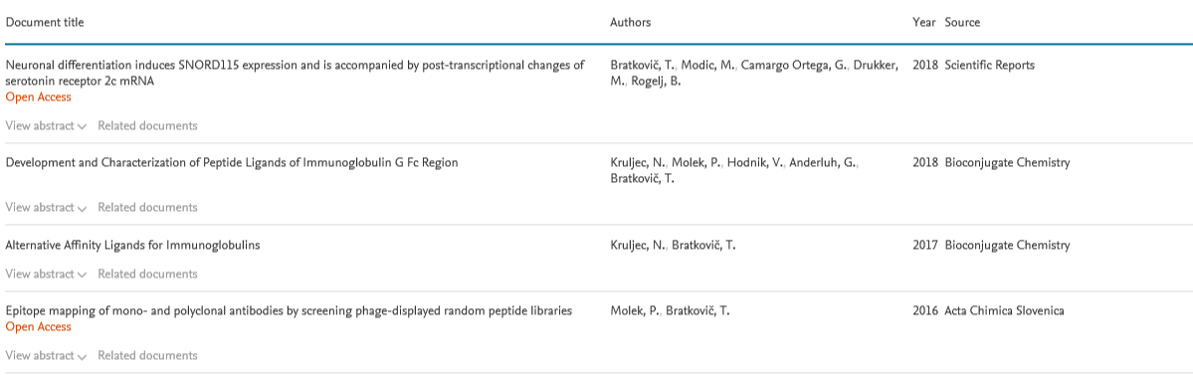

- Dr Aleš Berlec, assistant professor, Institut Jožef Štefan, Ljubljana, Slovenia
E-mail: Ales.berlec@ijs.si
Research subject area: among others medicine, pharmacology, toxicology and pharmaceutics, chemistry, multidisciplinary
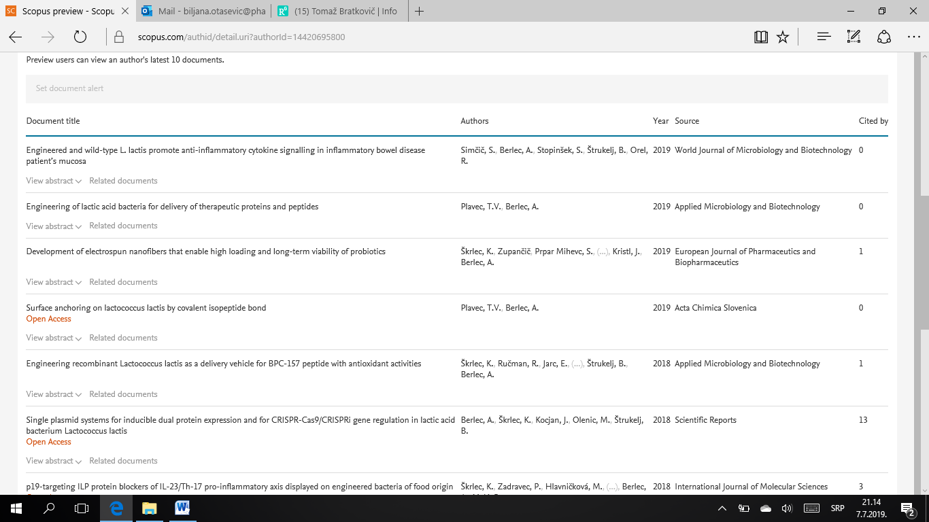

- Dr Jelena Arsenijević, University of Belgrade-Faculty of pharmacy, Department of pharmacognosy, Belgrade, Serbia
E-mail: jelena.arsenijevic@gmail.com
Research subject area: among others immunilogy and microbiology, pharmacology, toxicology and pharmaceutics, chemistry, medicine
