Studies on morphology and photoluminescent properties of Tb³⁺ doped YbPO₄ nanostructures synthesized by different synthetic methods

Heena Khajuria, Manesh Kumar, Lobzang Tashi, Rajinder Singh, and Haq Nawaz Sheikh*

Department of Chemistry, University of Jammu, Jammu 180 006, India

Corresponding author:
H. N. Sheikh
Address: Department of Chemistry, University of Jammu,
Baba Sahib Ambedkar Road, Jammu 180 006, India.
E-mail addresses: hnsheikh@rediffmail.com
Abstract
The morphology dependent optical properties of Tb³⁺ in YbPO₄ host lattice have been investigated. 10 % Terbium doped ytterbium phosphate (YbPO₄: Tb³⁺) nanostructures (NSs) were synthesized by five different synthetic methods i.e. sonochemical method, hydrothermal method, solvothermal method, sacrificial template method and coprecipitation method. Structural facets and optical properties of fabricated nanoparticles were studied in detail by powder X-ray diffraction (PXRD), Fourier transform infrared spectrum (FTIR), scanning electron microscopy (SEM), transmission electron microscopy (TEM), energy dispersive X-ray spectra (EDS), and photoluminescence (PL) techniques. We have investigated the impact of synthetic procedures employed on the morphology and uniformity of synthesized NSs and consequently on the optical properties of the NSs. The intense green emission from the nanophosphor shows that phosphor can be used in IR-sensors, LEDs and as solar spectrum converters.
Keywords: sonochemical synthesis; hydrothermal synthesis; solvothermal synthesis; sacrificial template synthesis; coprecipitation synthesis; luminescence

- Introduction
Phosphate compounds are suitable host matrices for lanthanide ions to fabricate luminescent substances. Among LnPO₄, ytterbium phosphate (YbPO₄), are well-known as useful host lattice (materials) for lanthanide ions for the synthesis of phosphors [1-3]. The optical properties of lanthanide based phosphors mostly depend on their shape, size, surface chemistry, uniformity and dimensionality. In general luminescent materials with small particle size have lower luminescence quantum efﬁciency and shorter ﬂuorescence lifetime than larger particle size materials or their bulk counterparts [4,5]. This is owing to low crystallinity and large number of surface defects associated with them. Reducing the size of particle to nano dimensions cause increase in the surface-to-volume ratio of the material which leads to dominance of surface effects [6-10]. In addition to this, the presence of ligands/capping agents and surface-adsorbed ions/molecules (H₂O, CO₂) also lead to luminescence quenching. Molecules in proximity to surface of nanoparticles can diminish the intensity, since the vibrational states of chemical bonds like O-H, C-H or N-H match the phonon states of the host material resulting in non-radiative relaxation of the excited lanthanide ions [11,12]. These structural aspects in turn can be controlled by the synthesis methods and reaction conditions [13-17]. The photoluminescent nanomaterials can be fabricated by various techniques viz., hydrothermal, solvothermal, sonochemical assisted thermal decomposition, and co-precipitation etc. Hydrothermal and solvothermal methods endow some convenient advantages over the conventional methods, such as potential to control over the crystal growth, its simplicity and relatively low temperature for reaction [18-20]. These methods permit exceptional control over morphology, particle size and crystallinity of material. Among these techniques, sonochemical method is the best method to synthesize nanostructure materials because it is green synthesis method carried out at room temperature [21]. It is based on acoustic cavitation resulting from the continuous formation, growth and implosive collapse of bubbles in a liquid. It has become one of the useful, green, simple and fast methods for the synthesis as well as doping of nanostructures. Apart from these, the sacrificial template-directed chemical synthesis method based on the Kirkendal effect has been established to be an effective approach to obtain the desired hollow inorganic materials [22, 23]. In this method, the shell of desired product forms around the surface of the sacriﬁcial template and takes the shape of the template. Thus, various physicochemical changes evolved in the synthesis of nonmaterial under different synthetic conditions influence the phase, morphology and properties of nanostructures.
In the present work, 10% Terbium doped ytterbium phosphate (YbPO₄: Tb³⁺) nanostructures were synthesized by five different synthetic methods such as hydrothermal method, solvothermal method, sacrificial template method, sonochemical method and co precipitation method to study their effect on morphology and luminescent properties of as prepared nonmaterial. Tb³⁺ is chosen as dopant for doping YbPO₄ host matrices. Yb³⁺ ions act as sensitizer ion for Tb³⁺ ions which shows green emission [24-26]. YbPO₄: Tb³⁺ nanostructures were examined by powder X-ray diffraction (PXRD), Fourier transform infrared spectrum (FTIR), scanning electron microscopy (SEM), transmission electron microscopy (TEM), energy dispersive X-ray spectra (EDS), and photoluminescence (PL) techniques. The effect of synthesis method on the uniformity, structure and the optical properties of the YbPO₄: Tb³⁺ nanostructures were studied in detail. Nanostructures of different morphology have been obtained through different synthesis routes. The intense green emission from the nanophosphor shows that phosphor can be used in IR-sensors, LEDs and as solar spectrum converters.
- Experimental
2.1. Materials
Ytterbium (III) nitrate pentahydrate Yb(NO₃)₃.5H₂O (99.9 %), terbium(III) nitrate hydrate Tb(NO₃)₃.H₂O (99.9 %) and ammonium dihydrogen phosphate were purchased from Alfa Aesar (Massachusetts, United States) and used as received without further purification. Urea was purchased from Himedia (Mumbai, India) and sodium hydroxide from Sigma Aldrich (United States). Deionized water was used throughout.

  - Synthesis of YbPO_{4:} Tb³⁺ nanostructures
2.2.a Sonochemical method
In a typical synthesis, 20 mL aqueous solution of 0.9 mmol Yb(NO₃)₃.H₂O and 0.1 mmol Tb(NO₃)₃.6H₂O was sonicated for 15 minutes. Thereafter 10 mL aqueous solution of 1 mmol NH₄H₂PO₄ was added dropwise to the above mentioned mixture. The pH of solution is maintained at 3 by adding ammonia solution. The mixture was then sonicated for additional 1 h. After that, the precipitates were collected and washed with deionised water and ethanol and then dried at 70 °C for 12 h.

2.2.b Hydrothermal method
In a typical synthesis, 0.9 mmol (0.344 g) of Yb(NO₃)₃.6H₂O was added to 10 mL aqueous solution of 1 mmol (0.1921 g) citric acid. The reaction mixture was stirred for 10 minutes and after that an aqueous solution of 0.5 mmol (0.057 g) NH₄H₂PO₄ was added dropwise. After further vigorous stirring for 30 minutes more, as obtained mixture was transferred into a autoclave, sealed and maintained at 180 °C for 18 h. Once the autoclave cooled to room temperature naturally, the precipitates were collected, centrifuged and washed with deionised water and ethanol three times and then dried at 70 °C for 12 h in air [27].
2.2.c Solvothermal method
In a typical synthesis, 0.9 mmol (0.323 g) of Yb(NO₃)₃.6H₂O and 0.1 mmol (0.034 g) Tb(NO₃)₃.6H₂O were added to mixture of 5 mL oleic acid and 5 mL ethylene glycol. The reaction mixture was vigorously stirred for 10 minutes. After that solution of 0.5 mmol (0.057 g) NH₄H₂PO₄ in ethylene glycol was added dropwise to the above mentioned reaction mixture. After further stirring for 30 minutes, the mixture so obtained was transferred into autoclave, sealed and heated at 180 °C for 18 h. The autoclave was cool to room temperature naturally; the product was centrifuged, washed with deionised water and ethanol thrice a time then dried at 70 °C for 12 h in air.
2.2.d Coprecipitation method
20 mL aqueous solution of 0.9 mmol (0.323 g) of Yb(NO₃)₃.6H₂O and 0.1 mmol (0.034 g) Tb(NO₃)₃.6H₂O and 20 mL aqueous solution of NH₄H₂PO₄ was stirred for 15 min. Two solutions were mixed together and stirred for another 10 minutes. After that solution of NaOH was added to reaction mixture of Yb(NO₃)₃.6H₂O, Tb(NO₃)₃.6H₂O and NH₄H₂PO_{4.} The reaction mixture was vigorously stirred at 80 °C for 30 minutes. The as prepared sample was collected, centrifuged, washed with deionised water and ethanol three times and then dried at 70 °C for 12 h in air [28].
2.2.e Sacrificial template method
Synthesis of Yb(OH)CO₃: 10 mol% Tb³⁺ template: The Yb(OH)CO₃:Tb³⁺ precursor was prepared by urea-based homogeneous precipitation process. In a typical synthesis, 0.9 mmol (0.323 g) Yb(NO₃)_{3.}6H₂O and 0.1 mmol (0.034 g) Tb(NO₃)_{3.} 6H₂O were dissolved in 50 mL deionized water. Then, 2.0 g of urea was added into the as prepared lanthanide aqueous solution with continues stirring. The solution was stirred vigorously for 2 h at room temperature and heated to 90 °C for another 2 h in an oil bath in order to get the milky-white suspension. The precipitated Yb(OH)CO₃:Tb³⁺ were filtered and then washed with ethanol and deionised water three times.
Synthesis of YbPO₄: 10 mol% Tb³⁺ : In a typical synthesis, the as-prepared sample of Yb(OH)CO₃:Tb³⁺ rods acting as template was dispersed into 15 mL deionized water by ultrasonic treatment for 30 min, labelled as solution A. A separate solution B was prepared by dissolving 1 mmol (0.115 g) NH₄H₂PO₄ in 15 mL deionised water and mixed with solution A with vigorous agitation. Finally, 30 mL of the resulting reaction mixture was transferred into Teflon lined stainless steel autoclave, seal and heated at 180 °C for 18 h. The autoclave was cool down to room temperature naturally. The products were collected, centrifuged and washed with DI water and ethanol three times and dried at 60 °C for 24 h in air [29].
The samples prepared by sonochemical method, hydrothermal method, solvothermal method, sacrificial template method and coprecipitation method are designated as YbPO₄:Tb³⁺ (SC), YbPO₄: Tb³⁺ (HT), YbPO₄: Tb³⁺ (ST), YbPO₄: Tb³⁺ (Sac), YbPO₄: Tb³⁺ (CP) respectively as shown in Fig. 1.

Fig. 1 Overview of obtained YbPO_{4:} Tb³⁺ nanostructures
2.3 Characterization
The crystalline structure of the powder samples was assessed by X-ray diffraction using a Panalytical Xpert Pro diffractometer with Cu-Kα radiation at 45 kV and 40 mA, and 2θ ranging from 10° to 70°. The infrared spectra of NRs were measured on a Shimadzu Prestige-21 Fourier Transform spectrometer over the range of wave number 4000 – 400 cm^{–1}, and standard KBr pellet technique was employed. The morphology of the samples was inspected using a field emission scanning electron microscope (FE-SEM) and transmission electron microscope (TEM). TEM images were taken using a Hitachi (H-7500) transmission electron microscope at an accelerating voltage of 100 kV. To obtain the TEM images, ethanolic solution of the sample is first subjected to sonication to form a very fine suspension. 10 µL of this suspension is then carefully poured onto a carbon copper grid using a micropipette and dried under an electric light. The dried samples are then loaded into the TEM machine. SEM was performed using Nova Nano SEM-450 field emission scanning electron microscope at an accelerating voltage of 5.0 kV. For getting SEM images, the well dried samples are fixed on a metal grid with adhesive, dehydrated and then observed in the microscope. Steady state excitation and emission spectra of the samples were recorded on a Cary Eclipse spectrophotometer equipped with a Xenon lamp as the excitation source. The analysis of optical property of prepared samples was conducted in the powder form, as the lanthanide phosphates are insoluble in most of the solvents. All of the measurements were performed at room temperature.
Particle size determination
Each SEM image has a measurement scale at the bottom left corner for size measurements. Using J image software, particle size of each clearly visible nanoparticle in the image was measured. After size of all of the nanoparticles was measured, a histogram was created in order to show the size distribution of the nanoparticles in each sample.

3. Results and discussion
3.1 PXRD Measurements
The crystalline nature and phase purity of the as prepared nanocomposites were explored by PXRD study. Fig. 2 depicts powder X-ray diffraction patterns of the undoped YbPO₄, YbPO₄: Tb³⁺ (SC), YbPO₄: Tb³⁺ (HT), YbPO₄: Tb³⁺ (ST), YbPO₄: Tb³⁺ (Sac) and YbPO₄: Tb³⁺ (CP) nanostructures. The PXRD patterns of all prepared phases are in good agreement with the tetragonal phase of YbPO₄ (JCPDS card no. 45-0530) space group (I4₁/amd) [30, 31]. No other phase impurity was detected by PXRD analysis, demonstrating the phase purity of as prepared nanostructure. The result indicates that the doping of Tb³⁺ ions in the YbPO₄ nanocrystals has little influence on its crystal structure due to the similar ionic radius of Tb³⁺ = (0.104 nm) and Yb³⁺ = (0.098 nm). The broadened peaks in PXRD patterns suggest the nano range of as prepared nanomaterials. The broadening of PXRD peaks can be correlated with the particle size measured from SEM images using J image software. The particle size of YbPO₄: Tb³⁺ (SC), YbPO₄: Tb³⁺ (HT), YbPO₄: Tb³⁺ (ST), YbPO₄: Tb³⁺ (Sac), and YbPO₄: Tb³⁺ (CP) nanostructures is found to be ~ 170 nm, ~ 600 × 80 nm, ~ 70 nm, ~ 300-400 nm, ~100 nm respectively from SEM images. The observed particle size of nanostructures is in accordance to the broadening of PXRD peaks.

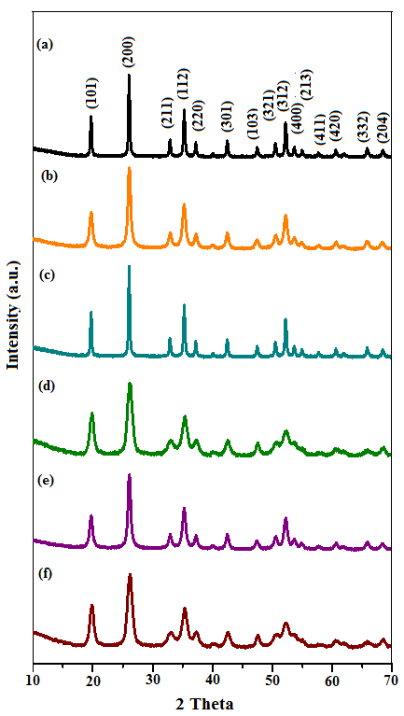

Fig. 2 PXRD patterns of (a) undoped YbPO₄ (b) YbPO₄:Tb³⁺ (SC) (c) YbPO₄: Tb³⁺ (HT) (d) YbPO₄: Tb³⁺ (ST) (e) YbPO₄: Tb³⁺ (Sac) (f) YbPO₄: Tb³⁺ (CP)

3.2 FTIR spectra
The presence of chelating agent and chemical composition on the surface of the nonmaterial has been examined by FT-IR spectra. Fig. 3 shows the FT-IR spectra of undoped YbPO₄, YbPO₄: Tb³⁺ (SC), YbPO₄: Tb³⁺ (HT), YbPO₄: Tb³⁺ (ST), YbPO₄: Tb³⁺ (Sac) and YbPO₄: Tb³⁺ (CP) nanostructures. The bands near 1100 cm^{–1} are assigned the stretching modes of the PO₄^{3–} groups of as prepared samples. The splitting of the band indicated the presence of low symmetry crystal phase. The two characteristics bending vibrational modes of the PO₄^{3–} group are at 650 and 520 cm^{–1} [32, 33]. It can be noted that when YbPO₄ host is doped Tb³⁺ ions the infra red band around 1100 cm^{–1} slightly shifted to higher wave number because of stronger interaction between Tb³⁺ and PO₄³⁻ as compare to Yb³⁺ and PO₄³⁻ units [34]. The presence of hydroxyl groups and water molecules on surface of synthesized nanomaterials can be ascertained by infrared bands in the range of 3200-3600 cm^{–1} (stretching vibrations) and 1625 cm^{–1} (bending). The characteristic IR bands (ʋ_{as}1680 and ʋ_{s} 1384 cm⁻¹) of ligands (citric acid and oleic acid) are not appeared clearly in FTIR spectra of YbPO₄: Tb³⁺ (HT) and YbPO₄: Tb³⁺ (ST) due to their overlapping with other peaks.
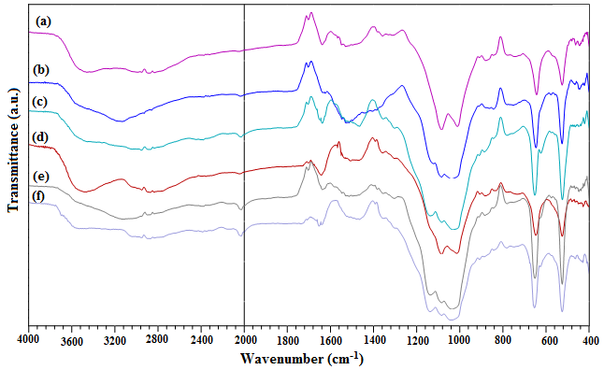
Fig. 3 FTIR spectra of (a) undoped YbPO₄ (b) YbPO₄: Tb³⁺ (SC) (c) YbPO₄: Tb³⁺ (HT) (d) YbPO₄: Tb³⁺ (ST) (e) YbPO₄: Tb³⁺ (Sac) (f) YbPO₄: Tb³⁺ (CP)
3.3 SEM and TEM studies
The structured and morphological facets of the as synthesized nanostructuires were probed by the scanning electron microscopy (SEM) and transmission electron microscopy (TEM) analysis. The scanning electron and transmission electron micrographs of terbium doped ytterbium phosphate nanocomposite as synthesized via different synthetic procedures are shown in Figs. 4-9. SEM images of YbPO₄: Tb³⁺ (SC) dispose the square shaped flakes like morphology of particle size ~ 170 nm. The nanorods like morphology of YbPO₄: Tb³⁺ of size 600 × 80 nm was obtained via hydrothermal method (fig 5). The YbPO₄: Tb³⁺ samples synthesized by solvothermal and co-precipitation method show the nanoparticles like morphology with particle size of 70 and 100 nm respectively. The oleic acid and ethylene glycol may play role in the fabrication of nanoparticles. The overall mechanism of their action is such that their molecules embrace the nanocrystals and control their excess growth. Thus, in these syntheses, small sized particles are obtained. Fig. 7 shows Yb(OH)CO₃: Tb³⁺ precursor SEM and TEM micrographs. It shows the spherical morphology of precursor. After its treatment with phosphate source spherical YbPO₄: Tb³⁺ nanostructures are formed with diameter 300-400 nm and display rather rough morphological features as compare to the precursor nanostructures. Thus, nanostructures of different morphology are obtained when synthesis is carried out by different synthetic methods. TEM images also agree well with the SEM results. The selected area electron diffraction (SAED) patterns of as synthesized nanomaterial were shown in Fig. 10. The presence of bright spots in SAED patterns of YbPO₄: Tb³⁺ (SC) and YbPO₄: Tb³⁺ (HT) indicate their monocrystalline nature (Fig. 10 a, b). However, SAED patterns of YbPO₄: Tb³⁺ (ST), YbPO₄: Tb³⁺ (Sac) and YbPO₄: Tb³⁺ (CP) shows diffuse rings indicating their polycrystalline nature.
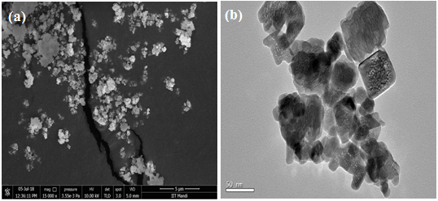
Fig. 4 (a) SEM and (b) TEM images of YbPO₄: Tb³⁺ (SC)
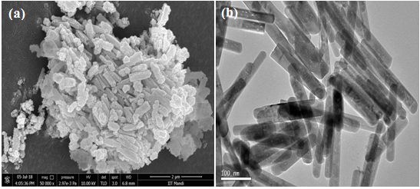
Fig. 5 (a) SEM and (b) TEM images of YbPO₄: Tb³⁺ (HT)

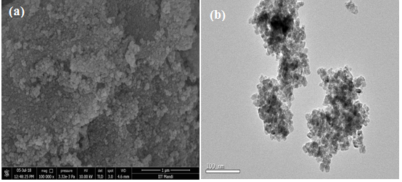
Fig. 6 (a) SEM and (b) TEM images of YbPO₄: Tb³⁺ (ST)
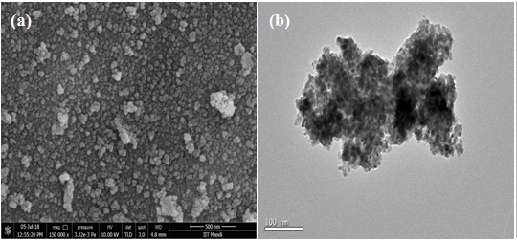
Fig. 7 (a) SEM and (b) TEM images of Yb(OH)CO₃: Tb³⁺ precursor

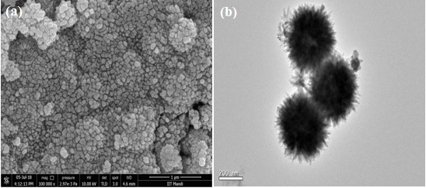
Fig. 8 (a) SEM and (b) TEM images of YbPO₄: Tb³⁺ (Sac)
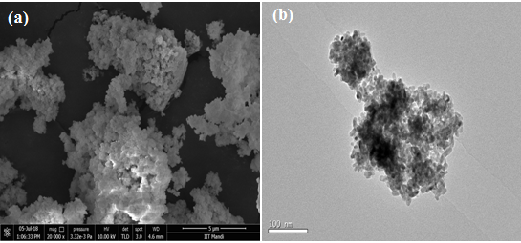
Fig. 9 (a) SEM and (b) TEM images of YbPO₄: Tb³⁺ (CP)
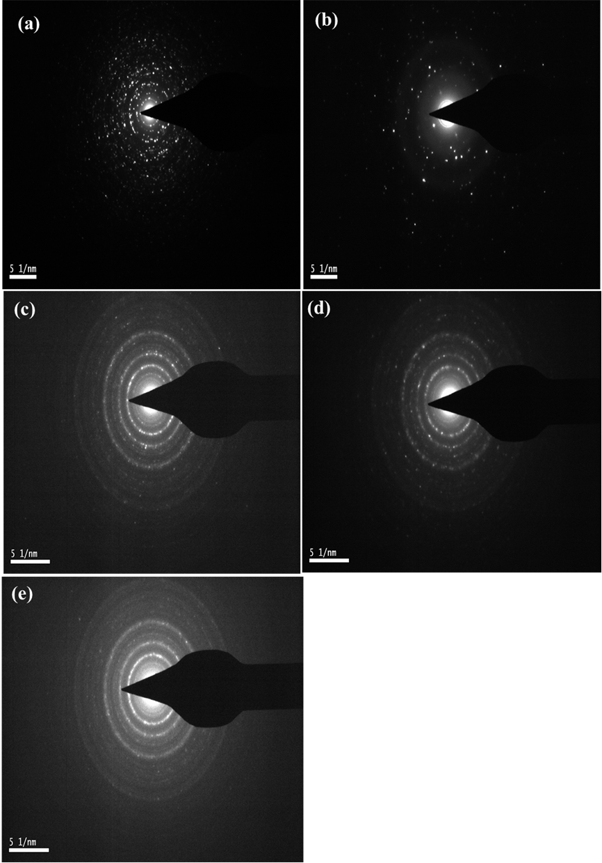
Fig. 10 SAED pattern of (a) YbPO₄: Tb³⁺ (SC) (b) YbPO₄: Tb³⁺ (HT) (c) YbPO₄: Tb³⁺ (ST) (d) YbPO₄: Tb³⁺ (Sac) (e) YbPO₄: Tb³⁺ (CP)
3.4 EDS analysis
Energy dispersive X-ray spectra were recorded to investigate the presence of dopant (Tb³⁺) and it concentration in the doped YbPO₄ nanoparticles represented in Fig. 10. The EDS results suggest that the nanocrystal fabricated YbPO₄: Tb³⁺ nanostructures are makeup of Yb, Tb, P and O. Table 1 represent the weight percent (Wt. %) and atomic percent (At. %) data for synthesized YbPO₄: Tb³⁺ phases. There is a slight variation in weight and atomic % of constituents is found, as synthesized by different synthetic routes.
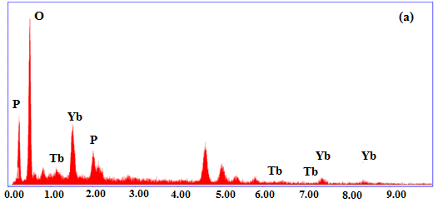

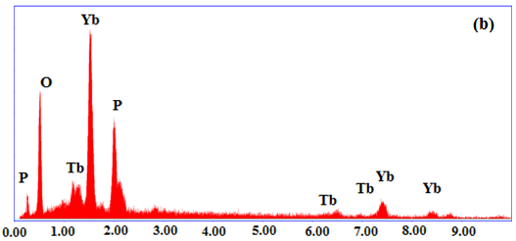
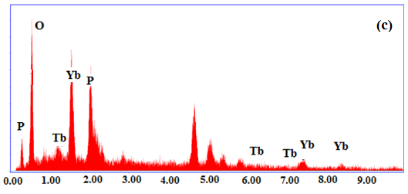
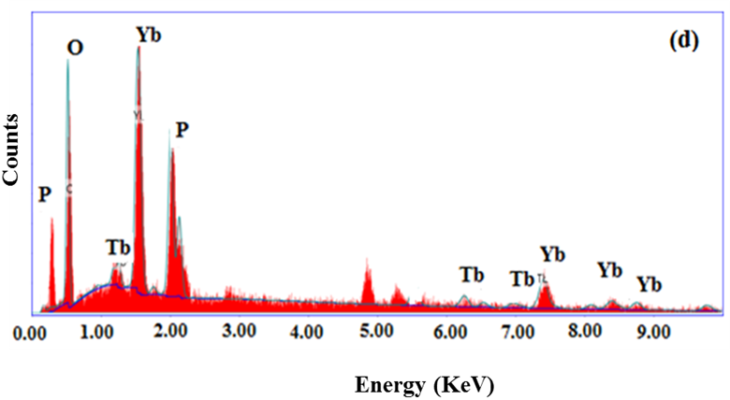
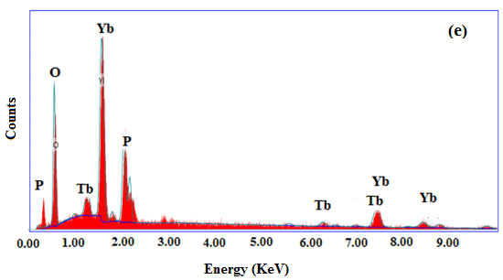
Fig. 11 EDS spectra of (a) YbPO₄: Tb³⁺ (SC) (b) YbPO₄: Tb³⁺ (HT) (c) YbPO₄: Tb³⁺ (ST) (d) YbPO₄: Tb³⁺ (Sac) (e) YbPO₄: Tb³⁺ (CP)
Table 1 Atomic and Weight % of elements present in YbPO₄: Tb³⁺ nanostructures
Elements | YbPO₄:Tb³⁺ (SC) |  | YbPO₄:Tb³⁺ (HT) |  | YbPO₄:Tb³⁺ (ST) |  | YbPO₄:Tb³⁺ (Sac) |  | YbPO₄: Tb³⁺  (CP)
Elements | Wt. % | At. % | Wt.% | At. % | Wt. % | At. % | Wt. % | At. % | Wt. % | At. %
Ytterbium | 30.93 | 4.82 | 51.48 | 12.51 | 34.22 | 5.34 | 58.16 | 16.46 | 56.39 | 14.72
Terbium | 9.27 | 1.57 | 8.48 | 2.24 | 0.42 | 0.07 | 8.78 | 2.71 | 7.53 | 2.14
Phosphorus | 8.91 | 7.77 | 15.71 | 21.32 | 19.30 | 16.83 | 13.73 | 21.70 | 13.70 | 19.98
Oxygen | 50.88 | 85.83 | 24.33 | 63.93 | 46.05 | 77.75 | 19.33 | 59.14 | 22.37 | 63.16

3.6 Photoluminescence
The excitation and emission photoluminescence spectra of YbPO₄:Tb³⁺ nanostructures are shown in Fig. 12 and Fig. 13 respectively. We have selectively monitored excitation of Tb³⁺ doped YbPO₄ nanostructures at 543 nm (⁵D₄→⁷F₅ transition). The prominent peaks in the range of 200–280 nm may be attributed to the transitions of 4f⁸ → 4f⁷5d¹ of Tb³⁺ [35]. The other weak excitation bands ranging from 300–400 nm can be assigned to the f–f transition of Tb³⁺. These bands are significant for emission spectra exhibited by UV-Chips [36]. The highest intensity peak at 370 nm is due to ⁷F₆ → ⁵G₆ transition of Tb³⁺. The excitation spectra of YbPO₄: Tb³⁺ nanostructures imply that the phosphor can convert ultraviolet wavelength to visible wavelength on emission. Thus the conversion of ultraviolet light into visible light indicates that the fabricated YbPO₄: Tb³⁺ can act as ultraviolet light absorber in solar cells to show effective conversion efficiency. In the emission spectrum of YbPO₄:Tb³⁺ four prominent peaks near 490, 543, 584 and 621 nm are observed when selectively excited at 394 nm. These emission peaks are assigned to the transitions ⁵D₄→⁷F₆ (490 nm), ⁵D₄→⁷F₅ (543 nm), ⁵D₄→⁷F₄ (584 nm) and ⁵D₄→⁷F₃ (621 nm) [37]. The ⁵D₄–⁷F₅ transition is stronger comparing with other transitions and is responsible for green light emission. From the PL spectra, the variation in the emission intensity is observed for LaPO₄: Tb³⁺ prepared in different conditions. It is worth noting that YbPO₄: Tb³⁺ (Sac) exhibit highest and YbPO₄: Tb³⁺ (ST) possess least intense emission.
The difference in photoluminescence intensity can be interpreted from surface area, and particle size aspects of phosphor, as PL intensity is highly affected by these parameters [38-41]. It is well established fact that the surface area of nanoparticles increases with a decrease in crystallite size. In general, larger the surface area, higher will be the defects into the crystal of a phosphor [42, 43]. It is seen that defects into phosphor crystal have serious impact on photoluminescence emission of materials. These defects lead to non-radioactive decay of electrons and holes recombination. The number of electron/hole recombinations via radiative pathways must be increased in order to generate intense emission from the material. The efficiency of radiative decay can be enhanced by defects minimizations which in turn can controlled by the degree of crystallinity and surface area. The efficiency of radiative decay can be improved by increasing crystallinity and decreasing surface area. From the SAED and XRD patterns shown in fig. 2 and fig. 10, it is clear that the all the prepared samples are highly crystalline. However, they differ in their particle size and morphology. Herein, the particle size for YbPO₄: Tb³⁺ in the descending order are YbPO₄: Tb³⁺ (Sac) > YbPO₄: Tb³⁺ (HT) > YbPO₄: Tb³⁺ (SC) > YbPO₄: Tb³⁺ (CP) > YbPO₄: Tb³⁺ (ST) which is consistent with the luminescence intensity. Highest PL intensity is observed from YbPO₄: Tb³⁺ (Sac) which may be due to its larger particle size, spherical morphology and lower surface area. YbPO₄: Tb³⁺ prepared by hydrothermal method possesses nanorods like morphology. The phosphors with nanorod morphology presented directional growth and lower surface area resulting in the enhanced emission intensity. The particle sizes of the samples prepared by sonochemical and coprecipitation methods are lower than that of YbPO₄: Tb³⁺ (Sac) and YbPO₄: Tb³⁺ (HT) and PL intensity is also less intense than that of YbPO₄: Tb³⁺ (Sac) and YbPO₄: Tb³⁺ (HT) indicating correlation of particle size and PL intensity. The particle size of the YbPO₄: Tb³⁺ (ST) is lowest and thus, surface area will be highest. Therefore, it can be interpreted that a number of holes and electron in the excited state may be expected to return to the ground state through non-radiative decay processes. Thus, it possesses lowest PL intensity. Moreover, another reason for their lowest PL intensity may be the presence of surface adsorbed solvent molecules which quenches the radiative transition.
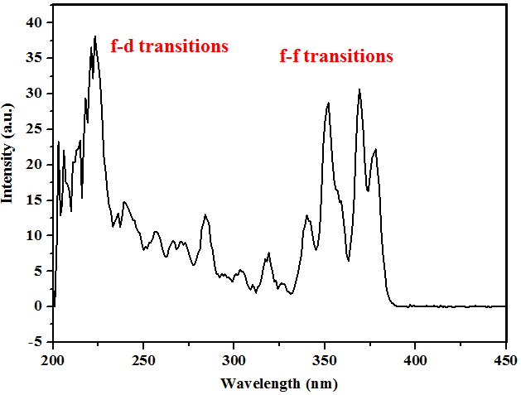
Fig. 12 Excitation spectra of YbPO₄: Tb³⁺ nanostructures
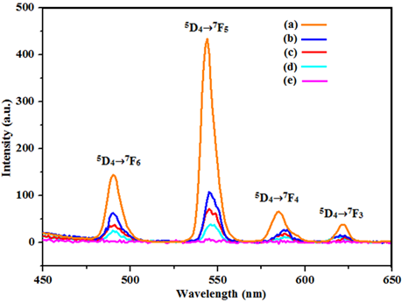
Fig. 13 Emission spectra of (a) YbPO₄: Tb³⁺ (Sac) (b) YbPO₄: Tb³⁺ (HT) (c) YbPO₄: Tb³⁺ (SC) (d) YbPO₄: Tb³⁺ (CP) (e) YbPO₄: Tb³⁺ (ST)

- Conclusions
YbPO₄: Tb³⁺ nanostructures have been synthesized using five different synthetic methods i.e. sonochemical, hydrothermal, solvothermal, coprecipitation and sacrificial template assisted method. Tetragonal phase of YbPO₄: Tb³⁺ nanostructures have been confirmed by PXRD study. SEM and TEM studies show the nanorods, nanosphere and nanoparticle like morphology of YbPO₄: Tb³⁺ prepared by different methods. Variation in intensity of Tb³⁺ emission peaks is found for YbPO₄: Tb³⁺ nanostructures synthesized by different methods. The difference in photoluminescence intensity can be interpreted in terms of surface area and crystallite size aspects of phosphor. Smaller is the particle size, larger would be the surface area. This results in larger number of defects in the crystal lattice which in turn has negative impact on photoluminescence efficiency. Highly intense Tb³⁺ emission peaks are observed for YbPO₄: Tb³⁺ spheres having diameter 300-400 nm prepared by sacrificial template method and least intense that for YbPO₄: Tb³⁺ nanoparticles obtained by solvothermal method with particle size of 70 nm. This shows the dependence of photoluminescence on morphology and particle size. The intense green emission from the YbPO₄: Tb³⁺ phosphor indicates that phosphor can be used in LEDs.
Acknowledgements
We would like to acknowledge Advanced Material Research Centre (AMRC), IIT Mandi, SMVDU Katra for PL studies and Sophisticated Analytical Instrumentation Facility (SAIF), Panjab University for their technical support.

References
- Z. Wenyan, N. Yaru, H. Wenjuan, L. Chunhua, X. Zhongzi, J. Rare Earths 2010, 28, 299-302.
- Z. Xu, P. Ma, C. Li, Z. Hou, X. Zhai, S. Huang, J. Lin, Biomaterials 2011, 32, 4161-4173.
- S. Lee, K. Teshima, S. Mori, M. Endo, S. Oishi, Cryst. Growth Des. 2010, 10, 1693-1698.
- F. Wang, J. Wang, X. Liu, Angew. Chem. Int Ed. 2010, 49, 7456–7460.
- N.K. Sahu, R.S. Ningthoujam, D.J. Bahadur, Appl. Phys. 2012, 112, 014306 (1–12).
- J.C. Boyer, M.P. Manseau, J.I. Murray, F.C.J.M. van Veggel, Langmuir 2010, 26, 1157–1164.
- A. Yin, Y. Zhang, L. Sun, C. Yan, Nanoscale 2010, 2, 953-959.
- A. Huignard, V. Buissette, A.-C. Franville, T. Gacoin, J.-P. Boilot, J. Phys. Chem. B 2003, 107, 6754–6759.
- X. Bai, H. Song, G. Pan, Z. Liu, S. Lu, W. Di, X. Ren, Y. Lei, Q. Dai, L. Fan, Appl. Phys. Lett. 2006, 88, 143104 (1–3).
- R.S. Loitongbam, N.S. Singh, W.R. Singh, R.S. Ningthoujam, J. Lumin. 2013, 134, 14–23.
- Y. Wang, L.P. Tu, J.W. Zhao, Y.J. Sun, X.G. Kong, H. Zhang, J. Phys. Chem. C 2009, 113, 7164–7169.
- H. Schafer, P. Ptacek, K. Kompe, M. Haase, Chem. Mater. 2007, 19, 1396–1400.
- Y. Yang, Mater. Sci. Eng. B 2013, 178, 807-810.
- T. Grzyb, A. Gruszeczka, R. J. Wiglusz, S. Lis, J. Mater. Chem. C 2013, 1, 5410-5418.
- M. Yang, H. You, Y. Huang, G. Jia, Y. Song, N. Guo, K. Liu, Y. Zheng, H. Zhang, CrystEngComm. 2010, 12, 2865-2870.
- S. Devi, S. Kelkar, V. Kashid, H. G. Salunke, N. M. Gupta, RSC Adv. 2013, 3, 16817–16828.
- S. Kar, S. K. Panda, B. Satpati, P.V. Satyam, S. Chaudhuri, J. Nanosci. Nanotechnol. 2006, 6, 1-6.
- K. Byrappa, T. Adschiri, Prog. Cryst. Growth & Charact. 2007, 53, 117-166.
- M. Shandilya, R. Rai, J. Singh, Adv. Appl. Ceram. 2016, 115, 354-376.
- H. Hayashi, Y. Hakuta, Materials 2010, 3, 3794-3817.
- H. Xu, B. W. Zeiger, K. S. Suslick, Chem. Soc. Rev. 2013, 42, 2555-2567.
- G. Li, L. Li, M. Li, Y. Song, H. Zou, L. Zou, X. Xu, S. Gan, Mater. Chem. Phys. 2012, 133, 263-268.
- B. Yan, X. Xiao, Nanoscale Res. Lett. 2010, 5, 1962-1969.
- T. Grzyb, R. J. Wiglusz, A. Gruszeczka, S. Lis, Dalton Trans. 2014, 43, 17255–17264.
- T. Grzyb, K. Kubasiewicz, A. Szczeszak, S. Lis, Dalton Trans. 2015, 44, 4063–4069.
- K. Prorok, M. Pawlyta, W. Stręk, A. Bednarkiewicz, Chem. Mater. 2016, 28 2295-2300.
- H. Khajuria, J. Ladol, S. Khajuria, M.S. Shah, H.N. Sheikh, Mater. Res. Bull. 2016, 80, 150-158.
- S. Verma, K.K. Bamzai, J. Rare Earths 2015, 33, 535-544.
- Z. Yi, W. Lu, C. Qian, T. Zeng, L. Yin, H. Wang, L. Rao, H. Liu, S. Zeng, Biomater. Sci. 2014, 2, 1404-1411.
- W. Wang, D. Xu, X. Wei, K. Chen, Int. J. Nanomedicine 2014, 9, 4879-4891.
- W. O. Milligan, D. F. Mullica, G.W. Beall, L.A. Boatner, Structures of ErPO₄, TmPO₄, and YbPO₄, Acta Cryst. (1983). C39, 23-24
- M. Ferhi, K. H. Naifer, M. Ferid, J. Rare Earths 2009, 27, 182-186.
- G. M. Begun, G. W. Beall, L. A. Boatner, W. J. Gregor, J. Raman Spectrosc. 1981, 11, 273-278.
- K. N. Konou, M. Haris, Y. Lare, M. Baneto, K. Napo, Pramana J. Phys. 2016, 87, 1-7.
- M.L. Debasu, D. Ananias, J. Rocha, O.L. Malta, L.D. Carlos, Phys. Chem. Chem. Phys. 2013, 15, 15565-15571.
- W.B. Bu, Z. L. Hua, L.X. Zhang, H.R. Chen, W.M. Huang, J.L. Shia, J. Mater. Res. 2004, 19, 2807-2811.
- H. Khajuria, J. Ladol, S. Khajuria, M. S. Shah, H. N. Sheikh, Mater. Res. Bull. 2016, 80, 150–158.
- W. Wang, W. Widiyastuti, T. Ogi, I. W. Lenggoro, K. Okuyama, Chem. Mater. 2007, 19, 1723-1730.
- L. Bin, J. Li, G. Duan, Q. Li, Z. Liu, J. Lumin. 2019, 206, 348-358.
- T. Han, C. Zhang, X. Cheng, L. Peng, S. Cao, Nanosci. Nanotechnol. Lett. 2017, 9, 328-332.
- S. Prashant, K. Sharma, R. K. Dutta, A. C. Pandey, J. Appl. Phys. 2012, 112 054321(1-5).
- A. Kar, S. Kundu, A. Patra, J. Phys. Chem. C 2011, 115, 118–124.
- J. Ding, Z. Lian, Y. Li , S. Wang, Q. Yan, J. Phys. Chem. Lett. 2018, 9, 4221–4226.

Figure captions
Fig. 1 Overview of obtained YbPO_{4:} Tb³⁺ nanostructures
Fig. 2 PXRD patterns of (a) undoped YbPO₄ (b) YbPO₄:Tb³⁺ (SC) (c) YbPO₄: Tb³⁺ (HT) (d) YbPO₄: Tb³⁺ (ST) (e) YbPO₄: Tb³⁺ (Sac) (f) YbPO₄: Tb³⁺ (CP)
Fig. 3 FTIR spectra of (a) undoped YbPO₄ (b) (b) YbPO₄: Tb³⁺ (SC) (c) YbPO₄: Tb³⁺ (HT) (d) YbPO₄: Tb³⁺ (ST) (e) YbPO₄: Tb³⁺ (Sac) (f) YbPO₄: Tb³⁺ (CP)
Fig. 4 SEM (a) and TEM (b) images of YbPO₄: Tb³⁺ (SC)
Fig. 5 SEM (a) and TEM (b) images of YbPO₄: Tb³⁺ (HT)
Fig. 6 SEM (a) and TEM (b) images of YbPO₄: Tb³⁺ (ST)
Fig. 7 SEM (a) and TEM (b) images of Yb(OH)CO₃: Tb³⁺ precursor
Fig. 8 SEM (a) and TEM (b) images of YbPO₄: Tb³⁺ (Sac)
Fig. 9 SEM (a) and TEM (b) images of YbPO₄: Tb³⁺ (CP)
Fig. 10 SAED pattern of (a) YbPO₄: Tb³⁺ (SC) (b) YbPO₄: Tb³⁺ (HT) (c) YbPO₄: Tb³⁺ (ST) (d) YbPO₄: Tb³⁺ (Sac) (e) YbPO₄: Tb³⁺ (CP)
Fig. 11 EDS spectra of (a) YbPO₄: Tb³⁺ (SC) (b) YbPO₄: Tb³⁺ (HT) (c) YbPO₄: Tb³⁺ (ST) (d) YbPO₄: Tb³⁺ (Sac) (e) YbPO₄: Tb³⁺ (CP)
Fig. 12 Excitation spectra of YbPO₄: Tb³⁺ nanostructures
Fig. 13 Emission spectra of (a) YbPO₄: Tb³⁺ (Sac) (b) YbPO₄: Tb³⁺ (HT) (c) YbPO₄: Tb³⁺ (SC) (d) YbPO₄: Tb³⁺ (CP) (e) YbPO₄: Tb³⁺ (ST)
Table caption
Table 1 Atomic and Weight % of elements present in YbPO₄: Tb³⁺ nanostructures

