Design, synthesis and in vitro cytotoxic activity of new 6,9-disubstituted purine analogues

Asligul Kucukdumlu¹, Meral Tuncbilek^{1*}, Ebru Bilget Guven², Rengul Cetin Atalay³

¹Department of Pharmaceutical Chemistry, Faculty of Pharmacy, Ankara University, 06100 Ankara, Turkey
²Department of Bioinformatics and Genetics, Faculty of Engineering and Natural Sciences, Kadir Has University, 34083, Cibali-Fatih, Istanbul, Turkey
³Department of Bioinformatics, Graduate School of Informatics, Middle East Technical University, 06800 Ankara, Turkey

*MeralTuncbilek
tuncbile@pharmacy.ankara.edu.tr
Department of Pharmaceutical Chemistry,
Faculty of Pharmacy, Ankara University,
06100 Ankara, Turkey

Abstract

A series of new 6,9-disubstituted purine analogs with 4-substituted piperazine at C-6 and 4-substituted benzyl at N-9 were designed and synthesized in four steps. All synthesized compounds (7-26) were screened initially for their in vitro anticancer activity on Huh7 liver, HCT116 colon, MCF7 breast carcinoma cell lines. Cytotoxic bioactivity studies revealed that all compounds screened, with compound 19 being the exception, were found to have promising cytotoxic activities at IC₅₀ range of 0.05-21.8 μM against cancer cells Huh7, HCT116, MCF7. Among the prepared purine analogs, two of them (12, 22) exhibited excellent cytotoxic activities, with IC₅₀=0.08-0.13 μM, on Huh7 cells comparable to Camptothecin (CPT) and better than cladribine, fludarabine and 5-FU. Afterwards, the evaluation of cytotoxicity of the most potent purine analogs was screened against further hepatocellular cancer (HCC) cell lines. The 6-(4-(4-trifluoromethylphenyl)piperazine (12) and 6-(4-(3,4-dichlorophenyl)piperazine analogs (25) displayed a significant IC₅₀ values (IC₅₀= <0.1-0.13 μM) comparable to CPT and better cytotoxic bioactivity when compared with 5-FU, cladribine, fludarabine on HCC cells (Huh7 and HepG2).

Keywords: Purine, piperazine, benzyl, cytotoxic activity

- Introduction

The purine nucleus is involved in the biological molecules that play a key role in the signaling pathways of all living organisms.¹ For this reason, the purine structure is an interesting organic moiety included in new drugs. Purine and purine nucleoside analogs exhibit a variety of biological activities. These analogs have been extensively studied as enzyme inhibitors,²⁻⁵ cytotoxic,⁶⁻⁹ antiviral,¹⁰⁻¹³ antihyperglycemic,¹⁴ immunostimulatory,¹⁵ antifungal, and antibacterial¹⁶⁻²¹ agents due to their potential activities, even though their antiviral and anticancer effects are more commonly known. 5-Fluorouracil (5-FU), a well known fluorinated nucleobase analogue, is highly preferred for the treatment of various cancers in clinics.²² Subsequently, other pyrimidine analogs, such as cytarabine, gemcitabine, capecitabine, decitabine, and 5-fluoro deoxyuridine have been used in solid tumors and hematologic malignencies.²³⁻²⁵ Purine nucleobase analogs such as 6-mercaptopurine and 6-thioguanine, are specifically used in pediatric acute lymphoblastic leukemia as an inhibitor of nucleic acid metabolism.^{26,27} In addition, many purine nucleoside analogs (fludarabine, cladribine, pentostatin, nelarabine, and clofarabine) are clinically administered in the treatment of solid and hematological malignancies.²⁸⁻³¹

A large number of investigations indicate that purine nucleobases and purine nucleosides target a series of pathways in chemotherapy-induced cell death mechanisms, such as apoptosis, necrosis, senescence, autophagy, and mitotic catastrophe.^{24,32-34} Also, various purine scaffolds and their analogs have been studied as potential anticancer agents that contain cyclin-dependent kinase and heat shock protein inhibition. Olomoucine,³⁵ roscovitine,³⁶ purvalanol A, B, amino-purvalanol³⁷ (Figure 1) have been synthesized and screened as cyclin-dependent kinase inhibitors. Especially, R-roscovitine is under investigation as a chemotherapeutic agent against non-small cell lung cancer and other malignancies. Also, Olomoucine in the 2,6,9-trisubstitued purine structure is another purine derivative with antiproliferative effects on cancer cell lines.

Olomoucine Roscovitine Purvalanol A (R₁= H, R₂= H)
Purvalanol B (R₁= COOH, R₂= H)
Amino-Purvalanol(R₁= H, R₂= NH₂)

Figure 1. Structures of olomoucine, roscovitine, purvalanol A, B and amino-purvalanol

The heat shock protein 90 has been an existing target in cancer since its inhibition may lead to the breakdown of many cancer-associated proteins. Furthermore, inhibitors of Hsp90 kill cancer cells at lower concentrations than is required to harm normal human cells. In recent years, purine analogues, which are Hsp90 inhibitors, have entered clinical trials as drugs in the therapy of solid tumors and hematologic malignancies.³⁸

In our previous studies,^{39,40} we have reported important cytotoxic activities of 9-(cyclopentyl/β-D-ribofuranosyl/p-toluenesulfonyl)-6-(4-substitutedpiperazino)purine analogs A, B, C (Figure 2). In this work, we report the synthesis of new analogs of purines A, B, C as 9-(4-substitutedbenzyl)purines and evaluate their cytotoxic activities against liver (Huh7), colon (HCT116), and breast (T47D) carcinoma cell lines. We further investigate the most active compounds (7-18, 20, 22-26) on a panel of liver cancer cells.

Figure 2. Structures of 9-(cyclopentyl/β-D-ribofuranosyl/p-toluenesulfonyl)-6-(4-substituted piperazino)purine analogs A, B, C and target purine compounds 7-26

2. Experimental

2.1. Chemistry

Melting points were recorded with a capillary melting point apparatus (Electrothermal 9100) and are uncorrected. NMR spectra were recorded on a VARIAN Mercury 400 FT-NMR spectrometer (400 for ¹H, 100.6 MHz for ¹³C). TMS was used as internal Standard for the ¹H NMR spectra; values are given in δ (ppm) and J values are in Hz. Mass spectra were taken on Waters Micromass ZQ by using the (ESI+) method. Elemental analyses (C, H, N) were determined on a Leco CHNS 932 instrument and gave values within ±0.4% of the theoretical values. Column chromatography was accomplished on silica gel 60 (40-63 mm particle size). The chemical reagents used in the synthesis were purchased from Merck, Fluka, Sigma and Aldrich. 5-Amino-4,6-dichloropyrimidine (2) was synthesized according to the reported method.⁴¹

2.1.1. General procedure for the synthesis of compounds 3, 4
5-Amino-4.6-dichloropyrimidine (2) (1 mmol) was dissolved in 5 mL of absolute EtOH, and then 4-substituted benzylamines (2 mmol) and (Et)₃N (3 mmol) were added. The mixture was refluxed for 15 h. The reaction mixture was concentrated in vacuo, and the residue was purified by column chromatography (EtOAC-hexane, 1:4 to 1:2).
2.1.1.1. 5-Amino-6-chloro-4-[(4-trifluoromethylbenzyl)amino]pyrimidine (3)
Yield 120 mg (65%), mp181-183 ºC.¹H NMR (CDCl₃) δ 3.40 (br s, 2H), 4.77 (d, 2H), 5.24 (s, 1H), 7.46 (d, 2H, J_{o}=8 Hz), 7.60 (d, 2H, J_{o}=8 Hz), 8.11 (s, 1H). MS (ESI+) m/z: 303.34 (100%) (M+H), 305.35 (40%) (M+H+2). Anal. Calcd for C₁₂H₁₀ClF₃N₄: C, 47.62; H, 3.33; N, 18.51. Found C, 47.63; H, 3.41; N, 18.45.
2.1.1.2. 5-Amino-6-chloro-4-[(4-chlorobenzyl)amino]pyrimidine (4)
Yield 140 mg (88%), mp192-194 ºC.¹H NMR (DMSO-d₆) δ4.58 (d, 2H), 5.07 (s, 2H), 7.28-7.40 (m, 5H), 7.70 (s, 1H). MS (ESI+) m/z: 269.24 (100%) (M⁺), 271.24 (55%) (M+2). Anal. Calcd for C₁₁H₁₀Cl₂N₄: C, 49.09; H, 3.75; N, 20.82. Found C, 49.14; H, 3.66; N, 20.42.
2.1.2. General procedure for the synthesis of compounds 5, 6
A mixture of 5-amino-6-chloro-4-[(4-substitutedbenzyl)amino]pyrimidines (3, 4) (0.29 mmol), 2 mL triethyorthoformate and p-toluenesulfonic acid (0.03 mmol) was stirred at room temperature for 72 h. The residue was dissolved with CH₂Cl₂, washed with saturated NaHCO₃ and brine. The extract was dried over Na₂SO₄, the solvent was evaporated in vacuo, and the residue was purified by column chromatography (EtOAC-hexane, 1:4 to 1:2).
2.1.2.1. 6-Chloro-9-(4-trifluoromethylbenzyl)-9H-purine (5)
Yield 50 mg (51%), mp 131 ºC [Lit. 130-132 ºC⁴²]. MS (ESI+) m/z: 313.34 (100%) (M+H), 315.36 (47%) (M+H+2).
2.1.2.2. 6-Chloro-9-(4-chlorobenzyl)-9H-purine (6)
Yield 240 mg (87%), mp 133 ºC [Lit. 130-133 ºC⁴²]. MS (ESI+) m/z: 279.27 (100%) (M⁺), 281.27 (63%) (M+2).

2.1.3. General procedure for the synthesis of the final compounds 7-26
The appropriate 1-substituted piperazines (1mmol) and Et₃N (3 mmol) were added to a solution of 6-chloropurines (1mmol) (5, 6) in 5 mL of absolute EtOH. The mixture was refluxed for 8-16 h. The reaction mixture was concentrated in vacuo and the residue was purified by column chromatography (EtOAC-hexane, 1:3 to 1:1).
2.1.3.1. 6-[4-(2-Hydroxyethyl)piperazine-1-yl]-9-(4-trifluoromethylbenzyl)-9H-purine (7)
Yield 270 mg (65%), mp 141-143 ºC.¹H NMR (CDCl₃) δ 2.61 (t, 2H, J=5.6 Hz ), 2.66(t, 4H), 3.68 (t, 2H, J=4.8 Hz ), 4.34 (br s, 4H), 5.43 (s, 2H), 7.36 (d, 2H, J_{o}=8 Hz), 7.59 (d, 2H, J_{o}=8 Hz), 7.74 (s, 1H), 8.37 (s, 1H). MS (ESI+) m/z: 407.65 (100%) (M+H). Anal. Calcd for C₁₉H₂₁F₃N₆O.0.3CH₂Cl₂: C, 53.67; H, 5.04; N, 19.46. Found C, 53.96; H, 5.08; N, 19.40.
2.1.3.2. 6-[4-cyclohexylpiperazine-1-yl]-9-(4-trifluoromethylbenzyl)-9H-purine (8)
Yield 360 mg (82%), mp 149-148 ºC.¹H NMR (CDCl₃) δ 1.12-1.89 (m, 10H), 2.33 (br s, 1H), 2.72 (t, 4H), 4.32 (br s, 4H), 5.43 (s, 2H), 7.36 (d, 2H), 7.59 (d, 2H), 7.73 (s, 1H), 8.36 (s, 1H). MS (ESI+) m/z: 445.86 (100%) (M+H). Anal. Calcd for C₂₃H₂₇F₃N₆.0.05H₂O: C, 62.02; H, 6.13; N, 18.86. Found C, 62.06; H, 6.13; N, 18.86.
2.1.3.3. 6-[4-(Pyrimidine-2-yl)piperazine-1-yl]-9-(4-trifluoromethylbenzyl)-9H-purine (9)
Yield 380 mg (86%), mp 171-173 ºC.¹H NMR (CDCl₃) δ 3.99 (t, 4H), 4.41 (br s, 4H), 5.45 (s, 2H), 6.54 (t, 1H), 7.37 (d, 2H), 7.60 (d, 2H), 7.77 (s, 1H), 8.35 (d, 2H), 8.41 (s, 1H). MS (ESI+) m/z: 441.8 (100%) (M+H). Anal. Calcd for C₂₁H₁₉F₃N₈: C, 57.27; H, 4.35; N, 25.44. Found C, 57.36; H, 4.24; N, 25.42.
2.1.3.4. 6-(4-Phenylpiperazine-1-yl)-9-(4-trifluoromethylbenzyl)-9H-purine (10)
Yield 430 mg (97%), mp 122 ºC.¹H NMR (CDCl₃) δ 3.30(t, 4H), 4.82 (br s, 4H), 5.44 (s, 2H), 6.90 (t, 1H, J_{o}=7.6 Hz), 6.98 (d, 2H, J_{o}=7.6 Hz), 7.29 (t, 2H, J_{o}=7.6 Hz), 7.37 (d, 2H, J_{o}=8 Hz), 7.59 (d, 2H, J_{o}=7.6 Hz ), 7.76 (s, 1H), 8.40 (s, 1H). MS (ESI+) m/z: 439.64 (100%) (M+H). Anal. Calcd for C₂₃H₂₁F₃N₆.0.15H₂O: C, 62.61. Found C, 62.85; H, 4.68; N, 18.66.
2.1.3.5. 6-[4-(4-Methylphenyl)piperazine-1-yl]-9-(4-trifluoromethylbenzyl)-9H-purine (11)
Yield 390 mg (86%), mp 156 ºC.¹H NMR (CDCl₃) δ 2.29 (s, 3H), 3.27 (t, 4H), 4.48 (br s, 4H), 5.44 (s, 2H), 6.90 (d, 2H), 7.10 (d, 2H), 7.37 (d, 2H), 7.60 (d, 2H), 7.76 (s, 1H), 8.40 (s, 1H). MS (ESI+) m/z: 453.9 (100%) (M+H). Anal. Calcd for C₂₄H₂₃F₃N₆: C, 63.71; H, 5.12; N, 18.57. Found C, 63.76; H, 5.10; N, 18.43.
2.1.3.6. 6-[4-(4-Trifluoromethylphenyl)piperazine-1-yl]-9-(4-trifluoromethylbenzyl)-9H-purine (12)
Yield 60 mg (18%), mp 115-118 ºC.¹H NMR (CDCl₃) δ 3.43(t, 4H), 4.48 (br s, 4H), 5.45 (s, 2H), 6.98 (d, 2H, J_{o}=8.4 Hz), 7.38 (d, 2H, J_{o}=8.4 Hz), 7.52 (d, 2H, J_{o}=8.4 Hz), 7.60 (d, 2H, J_{o}=8 Hz), 7.77 (s, 1H), 8.40 (s, 1H). MS (ESI+) m/z: 507.51 (100%) (M+H). Anal. Calcd for C₂₄H₂₀F₆N₆.0.1H₂O.0.3CH₃COOC₂H₅: C, 56.61; H, 4.26; N, 15.71. Found C, 56.23; H, 3.93; N, 15.43.
2.1.3.7. 6-[4-(4-Fluorophenyl)piperazine-1-yl]-9-(4-trifluoromethylbenzyl)-9H-purine (13)
Yield 240 mg (55%), mp 111-113 ºC.¹H NMR (CDCl₃) δ 3.24(t, 4H), 4.48 (br s, 4H), 5.45 (s, 2H), 6.91-7.02 (m, 4H), 7.37 (d, 2H, J_{o}=8.4 Hz), 7.60 (d, 2H, J_{o}=8 Hz), 7.77 (s, 1H), 8.40 (s, 1H). MS (ESI+) m/z: 457.57 (100%) (M+H). Anal. Calcd for C₂₃H₂₀F₄N₆.0.2H₂O: C, 60.05; H, 4.47; N, 18.27. Found C, 59.83; H, 4.30; N, 18.11.
2.1.3.8. 6-[4-(2,4-Difluorophenyl)piperazine-1-yl]-9-(4-trifluoromethylbenzyl)-9H-purine (14)
Yield 420 mg (89%), mp 193 ºC.¹H NMR (CDCl₃) δ 3.16 (t, 4H), 4.49 (br s, 4H), 5.45 (s, 2H), 6.78-6.98 (m, 3H), 7.37 (d, 2H), 7.60 (d, 2H), 7.76 (s, 1H), 8.40 (s, 1H). MS (ESI+) m/z: 475.82 (100%) (M+H). Anal. Calcd for C₂₃H₁₉F₅N₆: C, 58.23; H, 4.04; N, 17.71. Found C, 58.29; H, 4.17; N, 17.52.
2.1.3.9. 6-[4-(3,4-Dichlorophenyl)piperazine-1-yl]-9-(4-trifluoromethylbenzyl)-9H-purine (15)
Yield 450 mg (88%), mp 136 ºC.¹H NMR (CDCl₃) δ 3.30 (t, 4H), 4.47 (br s, 4H), 5.45 (s, 2H), 6.79 (dd, 1H), 7.0 (d, 3H), 7.30 (d, 1H), 7.37 (d, 2H), 7.60 (d, 2H) 7.77 (s, 1H), 8.40 (s, 1H). MS (ESI+) m/z: 507.7 (100%) (M⁺), 509.7 (63%) (M+2), 511.9 (5%) (M+4). Anal. Calcd for C₂₃H₁₉Cl₂N₆: C, 54.45; H, 3.77; N, 16.56. Found C, 54.43; H, 3.70; N, 16.54.
2.1.3.10. 6-[4-(Diphenylmethyl)piperazine-1-yl]-9-(4-trifluoromethylbenzyl)-9H-purine (16)
Yield 340 mg (65%), mp 179-182 ºC.¹H NMR (CDCl₃) δ 2.53(t, 4H), 4.28 (s, 1H), 4.31 (br s, 4H), 5.40 (s, 2H), 7.17-7.36 (m, 8H), 7.44 (d, 4H), 7.58 (d, 2H), 7.67 (s, 1H), 8.33 (s, 1H). MS (ESI+) m/z: 529.68 (100%) (M+H). Anal. Calcd for C₃₀H₂₇F₃N₆: C, 68.17; H, 5.15; N, 15.90. Found C, 67.90; H, 5.09; N, 15.71.
2.1.3.11. 6-[4-(2-Hydroxyethyl)piperazine-1-yl]-9-(4-chlorobenzyl)-9H-purine (17)
Yield 290 mg (77%), mp 138-141 ºC.¹H NMR (CDCl₃) δ 2.60 (t, 2H, J=5.6 Hz ), 2.66(t, 4H), 3.68 (t, 2H, J=5.2 Hz ), 3.77 (br s, 4H), 5.34 (s, 2H), 7.21 (d, 2H, J_{o}=8.4 Hz), 7.29 (d, 2H, J_{o}=8.4 Hz), 7.71 (s, 1H), 8.37 (s, 1H). MS (ESI+) m/z: 373.61 (100%) (M+H), 375.62 (33%) (M+H+2). Anal. Calcd for C₁₈H₂₁ClN₆O.0.4H₂O: C, 56.88; H, 5.78; N, 22.11. Found C, 56.65; H, 5.44; N, 21.88.
2.1.3.12. 6-[4-cyclohexylpiperazine-1-yl]-9-(4-chlorobenzyl)-9H-purine (18)
Yield 380 mg (93%), mp 125 ºC.¹H NMR (DMSO-d₆) δ 1.0-1.93 (m, 10H), 2.98-3.06 (m, 5H), 4.06 (br s, 4H), 5.38 (s, 2H), 7.30 (d, 2H), 7.38 (d, 2H), 8.25 (s, 1H), 8.35 (s, 1H). MS (ESI+) m/z: 411.75 (100%) (M+H), 413.74 (30%) (M+H+2). Anal. Calcd for C₂₂H₂₇ClN₆: C, 64.30; H, 6.62; N, 20.45. Found C, 64.28; H, 6.84; N, 20.12.
2.1.3.13. 6-[4-(Pyrimidine-2-yl)piperazine-1-yl]-9-(4-chlorobenzyl)-9H-purine (19)
Yield 280 mg (69%), mp 202 ºC.¹H NMR (CDCl₃) δ 3.99 (t, 4H), 4.40 (br s, 4H), 5.35 (s, 2H), 6.54 (t, 1H), 7.21 (d, 2H), 7.32 (d, 2H), 7.74 (s, 1H), 8.34 (d, 2H), 8.41 (s, 1H). MS (ESI+) m/z: 407.77 (100%) (M+H), 409.84 (32%) (M+H+2). Anal. Calcd for C₂₀H₁₉ClN₈.0.43MeOH: C, 58.34; H, 4.96; N, 27.54. Found C, 58.73; H, 5.18; N, 26.27.
2.1.3.14. 6-(4-Phenylpiperazine-1-yl)-9-(4-chlorobenzyl)-9H-purine (20)
Yield 120 mg (82%), mp 140-143 ºC.¹H NMR (CDCl₃) δ3.33(t, 4H), 4.48 (br s, 4H), 5.35 (s, 2H), 6.91 (t, 1H, J_{o}=7.6 Hz), 6.98 (d, 2H, J_{o}=8 Hz), 7.21 (d, 2H, J_{o}=8.8 Hz), 7.25-7.34 (m, 4H), 7.73 (s, 1H), 8.40 (s, 1H). MS (ESI+) m/z: 405.69 (100%) (M+H), 407.69 (%47) (M+H+2). Anal. Calcd for C₂₂H₂₁ClN₆: C, 65.26; H, 5.23; N, 20.76. Found C, 65.24; H, 5.04; N, 20.70.
2.1.3.15. 6-[4-(4-Methylphenyl)piperazine-1-yl]-9-(4-chlorobenzyl)-9H-purine (21)
Yield 310 mg (75%), mp 193 ºC.¹H NMR (CDCl₃) δ2.28 (s, 3H), 3.26 (t, 4H), 4.47 (br s, 4H), 5.34 (s, 2H), 6.90 (d, 2H), 7.10 (d, 2H), 7.21 (d, 2H), 7.31 (d, 2H), 7.73 (s, 1H), 8.40 (s, 1H). MS (ESI+) m/z: 419.78 (100%) (M+H), 421.81 (45%) (M+H+2). Anal. Calcd for C₂₃H₂₃ClN₆.0.2H₂O: C, 65.38; H, 5.58; N, 19.89. Found C, 65.94; H, 5.53; N, 20.06.
2.1.3.16. 6-[4-(4-Trifluoromethylphenyl)piperazine-1-yl]-9-(4-chlorobenzyl)-9H-purine (22)
Yield 330 mg (69%), mp 162 ºC.¹H NMR (CDCl₃) δ 3.43(t, 4H), 4.48 (br s, 4H), 5.35 (s, 2H), 6.98 (d, 2H, J_{o}=8.4 Hz), 7.22 (d, 2H, J_{o}=8.8 Hz), 7.31 (d, 2H, J_{o}=8.4 Hz), 7.51 (d, 2H, J_{o}=8.4 Hz), 7.40 (s, 1H), 8.40 (s, 1H). MS (ESI+) m/z: 473.54 (100%) (M+H), 475.52 (40%) (M+H+2). Anal. Calcd for C₂₃H₂₀ClF₃N₆: C, 58.42; H, 4.26; N, 17.77. Found C, 58.55; H, 4.30; N, 17.60.
2.1.3.17. 6-[4-(4-Fluorophenyl)piperazine-1-yl]-9-(4-chlorobenzyl)-9H-purine (23)
Yield 280 mg (67%), mp 186-188 ºC.¹H NMR (CDCl₃) δ 3.23(t, 4H), 4.47 (br s, 4H), 5.35 (s, 2H), 6.91-7.02 (m, 4H), 7.21 (d, 2H, J_{o}=8.4 Hz), 7.31 (d, 2H, J_{o}=8 Hz), 7.73 (s, 1H), 8.40 (s, 1H). MS (ESI+) m/z: 424 (100%) (M+H), 425.94 (35%) (M+H+2). Anal. Calcd for C₂₂H₂₀ClFN₆: C, 62.48; H, 4.77; N, 19.87. Found C, 62.55; H, 4.57; N, 19.84.
2.1.3.18. 6-[4-(2,4-Difluorophenyl)piperazine-1-yl]-9-(4-chlorobenzyl)-9H-purine (24)
Yield 410 mg (93%), mp 183-185 ºC.¹H NMR (CDCl₃) δ 3.16 (t, 4H), 4.48 (br s, 4H), 5.35 (s, 2H), 6.78-6.96 (m, 3H), 7.22 (d, 2H), 7.32 (d, 2H), 7.73 (s, 1H), 8.40 (s, 1H). MS (ESI+) m/z: 441.8 (100%) (M+H), 443.8 (37%) (M+H+2). Anal. Calcd for C₂₂H₁₉ClF₂N₆: C, 59.93; H, 4.34; N, 19.06. Found C, 59.87; H, 4.24; N, 19.11.
2.1.3.19. 6-[4-(3,4-Dichlorophenyl)piperazine-1-yl]-9-(4-chlorobenzyl)-9H-purine (25)
Yield 440 mg (92%), mp 198-200 ºC.¹H NMR (CDCl₃) δ 3.30 (t, 4H), 4.46 (br s, 4H), 5.35 (s, 2H), 6.80 (dd, 1H, J_{m}=2.8 Hz, J_{o}=9.2 Hz), 7.0 (d, 1H, J_{m}=2.8 Hz), 7.22 (d, 2H), 7.29-7.33 (m, 3H), 7.74 (s, 1H), 8.40 (s, 1H). MS (ESI+) m/z: 473.7 (100%) (M⁺), 475.8 (90%) (M+2), 477.8 (35%) (M+4). Anal. Calcd for C₂₂H₁₉Cl₃N₆: C, 55.77; H, 4.04; N, 17.74. Found C, 55.50; H, 4.08; N, 17.86.
2.1.3.20. 6-[4-(Diphenylmethyl)piperazine-1-yl]-9-(4-chlorobenzyl)-9H-purine (26)
Yield 310 mg (62%), mp 145-147 ºC.¹H NMR (CDCl₃) δ 2.53(t, 4H), 4.28 (s, 1H), 4.30 (br s, 4H), 5.28 (s, 2H), 7.14-7.22 (m, 4H), 7.25-7.31 (m, 6H), 7.44 (d, 4H), 7.63 (s, 1H), 8.34 (s, 1H). MS (ESI+) m/z: 495.67 (100%) (M+H), 497.66 (39%) (M+H+2). Anal. Calcd for C₂₉H₂₇ClN₆: C, 70.36; H, 5.50; N, 16.98. Found C, 70.17; H, 5.20; N, 16.92.

2.2. Biological evaluation
2.2.1. Cells and culture
The human primary liver cancer cell lines (Huh7, HepG2, Mahlavu and FOCUS) were grown in Dulbecco's Modified Eagle’s Medium (DMEM) (Invitrogen GIBCO) with 10% fetal bovine serum (FBS) (Invitrogen GIBCO), nonessential amino acids, and 1% penicillin (Biochrome). It was incubated in 37 °C with 5% CO₂. DMSO (Sigma) was used as a solvent for the compounds. The concentration of DMSO was always less than 1% in the cell culture medium. The cytotoxic drugs (Camptothecin (CPT), 5-Fluorouracil (5-FU), Fludarabine, and Cladribine) used as positive controls were from Calbiochem.
2.2.2. Sulforhodamine B (SRB) assay for cytotoxicity screening
Huh7, HCT116, MCF7, HepG2, Mahlavu, and FOCUS cells were inoculated (2000−10000 cells/well in 200 μL) in 96-well plates. The next day, the media was refreshed, and the compounds dissolved in DMSO were applied in concentrations between 1 and 40 μM in parallel with DMSO-only treated cells as negative controls. At the 72nd hour of treatment with compounds 3-32 and the other drugs, the cancer cells were fixed with 100 μL of 10% (w/v) trichloroacetic acid (TCA) and kept at +4 °C in the dark for one hour. TCA fixation was terminated by washing the wells with ddH₂O five times. Air-dried plates were stained with 0.4% sulphorhodamine B (SRB) dissolved in 1% acetic acid solution for 10 min in the dark and at room temperature. The protein-bound and dried SRB dye was then solubilized with 10 mMTris-Base pH 8. The absorbance values were obtained at 515 nm in a microplate reader. The data normalized against DMSO only treated wells, which were used as controls in serial dilutions. In all experiments, a linear response was observed, with serial dilutions of the compounds and the drugs.

- Results and Discussion

  - Chemistry
The 6-(4-substituted piperazine-1-yl)-9-(4-substituted benzyl)purine analogs were synthesized in four steps starting with commercially available 4,6-dichloro-5-nitropyrimidine (1) (Scheme 1). The dichloronitropyrimidine was reduced to the corresponding dichloroaminopyrimidine (2) with stannous chloride and ethanol.⁴¹ Amination of 5-amino-4,6-dichloropyrimidine (2) with the appropriate benzylamines gave the 4-(4-substituted benzyl)pyrimidines (3,4). Condensation of compounds 3, 4 with triethyorthoformate and p-toluenesulfonic acid afforded the intermediate 6-chloro-9-(4-substituted benzyl)purines 5, 6.⁴² Purines substituted at C-6 (7-26) were synthesized by nucleophilic substitution of the chlorine of 9-substituted purines (5, 6) with the appropriate 4-substituted piperazines in the presence of base.

Scheme 1. (a) SnCl₂.2H₂O, EtOH; (b) 4-substituted benzylamine, EtOH, Et₃N; (c) HC(OEt)₃, pTSA; (d) 4-substituted piperazine, Et₃N, EtOH
  - Biological Evaluation

The antitumor activities of newly synthesized purine analogues were first analyzed on three human cancer cell lines including Huh7 (liver), HCT116 (colon) and MCF7 (breast) cancer cells by using the sulforhodamine B (SRB) method. The IC₅₀ values of the purine compounds were calculated in comparison with DNA topoisomerase inhibitor camptothecin (CPT) and the known cell growth inhibitors fludarabine, cladribine, 5-fluorouracil (5-FU). The data was summarized in Table 1.
All synthesized purine derivatives in this study, except for compound 19, exhibited important cytotoxic activity against cancer cells Huh7, HCT116, MCF7 with IC₅₀ from 0.05 to 21.7 μM.
As seen from the data in Table 1, all the 6-(trifluoromethylphenyl)piperazine purines, 12 and 22 exhibited excellent cytotoxic activities with IC₅₀=0.08-0.13 μM on Huh7 cells comparable to CPT and better than cladribine, fludarabine and 5-FU. In addition, compounds 15 and 25 bearing a 3,4-dichlorophenyl group at the piperazine of the purine, presented a higher cytotoxic activity than known nucleoside drugs cladribine, fludarabine and nucleobase drug 5-FU on Huh7 cells. For the 4-fluorophenyl substituted derivatives 13 and 23, their best activity is observed for the 9-(4-chlorobenzyl) purine derivative 23 with IC₅₀ value of 0.57 μM on Huh7. Cytotoxic activity differences were not observed in the nonsubstituted phenyl and 4-methyl phenyl group bearing purin derivatives (10, 11, 20, 21) and these compounds had significantly higher bioactivity (IC₅₀ < 1.0 μM) compared to 5-FU, fludarabine, cladribine against Huh7 cell.
Within the tested purine analogs on HCT116 cell, compounds 11 and 22 showed superior cytotoxic activity (IC₅₀ < 0.1 and 0.04 μM, respectively) compared to 5-FU (IC₅₀ 4.1), Fludarabine (IC₅₀ 8.0 μM), Cladribine (IC₅₀ < 0.1 μM) and CPT (IC₅₀ 0.034 μM). Furthermore, compounds 10, 12, 15, 20, 21, 23 had a better cytotoxic activity (IC₅₀ < 1.0 μM) than 5-FU and fludarabine against HCT116 cell line.
Purine 22, one of the most cytotoxic molecules, displayed a significant IC₅₀ value of 0.05 μM comparable to CPT (IC₅₀ < 0.1 μM) on MCF7. Compound 22 also displayed better cytotoxic bioactivities on MCF7 cells with respect to 5-FU (IC₅₀ 3.5 μM) and known nucleoside drugs cladribine (IC₅₀ 2.4 μM) and fludarabine (IC₅₀ 15.2 μM), on MCF7 cells. In addition, the cytotoxic activity against MCF7 cell line of purines (7-26) was evaluated.

Significant bioactivity was also observed with compounds 10 (IC₅₀ 0.16 μM), 12 (IC₅₀ 0.4 μM), 20 (IC₅₀ 0.38 μM), 21 (IC₅₀ 0.48 μM), 11, 15 (IC₅₀ < 1.0 μM) on MCF7 cells.
We then screened the anticancer activity of the most potent purine analogs against further hepatocellular cancer (HCC) cells lines (Table 2, Figure 3). We observed that the most important cell growth inhibition in the presence of 6-(4-(4-trifluoromethylphenyl)piperazine)-9-(4-trifluoromethylbenzyl)purine derivative 12 and its 9-(4-chlorobenzyl) analogs 22, with IC₅₀ values of < 0.1 - 0.23 μM against all the HCC cell lines. Compound 12 and 22 also showed comparable cytotoxic effects with CPT and cladribine on these cell lines. Furthermore, 12 and 22 showed a better biological activity than the standard anticancer agents 5-FU and Fludarabine in HCC cell lines (Table 2). The 6-(4-(2,4-dichlorophenyl)piperazine analogs 15, 25 were also very active (IC₅₀= < 0.1 - 0.24 μM) against Huh7 and HepG2 cell lines.

Table 1. In vitro cytotoxicity of compounds 7-26 on different human cancer cell lines
 |  |  | Cancer cell lines, IC₅₀(μM)ª
Compound | R | R₁ | Huh7 | HCT116 | MCF7
7 |  | CF₃ | 18.25±0.55 | 19.14±0.75 | 17.83±0.56
8 |  | CF₃ | 7.86±0.04 | 7.74±0.08 | 6.51±0.52
9 |  | CF₃ | 9.6±0.6 | 11.3±2.1 | 17.8±0.2
10 |  | CF₃ | 0.86±0.19 | 0.28±0.003 | 0.16±0.037
11 |  | CF₃ | <1.0 | <0.1 | <1.0
12 |  | CF₃ | 0.13±0.12 | 0.42±0.08 | 0.4
13 |  | CF₃ | 1.54±0.10 | 1.26±0.13 | 1.12±0.16
14 |  | CF₃ | 5.05±0.52 | 5.51±0.29 | 4.24±1.17
15 |  | CF₃ | 0.6±0.1 | 0.74±0.05 | <1.0
16 |  | CF₃ | 15.55±1.09 | 12.97±1.11 | 12.13±0.38
17 |  | Cl | 21.8±2.7 | 18.96±0.06 | 21.8±4.4
18 |  | Cl | 9.26±0.59 | 8.87±0.35 | 8.61±0.26
19 |  | Cl | 38.0±5.1 | 57.1±8.8 | 100.9±28.0
20 |  | Cl | 0.56±0.12 | 0.26±0.17 | 0.38±0.07
21 |  | Cl | <0.1 | 0.26±0.35 | 0.48±0.50
22 |  | Cl | 0.08±0.06 | 0.04±0.004 | 0.05
23 |  | Cl | 0.57±0.12 | 0.14±0.10 | 2.80±3.22
24 |  | Cl | 9.38±0.65 | NI | NI
25 |  | Cl | 0.31±0.10 | 13.0±0.38 | 7.08±3.03
26 |  | Cl | 20.1±6.8 | 13.15±0.06 | 14.02±0.67
CPT |  |  | <0.1 | 0.034±0.036 | <0.1
5-FU |  |  | 30.6±1.8 | 4.1±0.3 | 3.5±0.7
Fludarabine |  |  | 28.4±19.2 | 8.0±3.4 | 15.2±0.1
Cladribine |  |  | 0.9±0.7 | <0.1 | 2.4±2.4
ªIC₅₀ values were calculated from the cell growth inhibition percentages obtained with 5 different concentrations (40, 20, 10, 5, and 2.5 μM) of each molecule incubated for 72 hours. NI : no inhibition.

Table 2. IC₅₀ values of 7-18, 20, 22-26 against hepatocellular carcinoma (HCC) cell lines: Huh7, HepG2, MAHLAVU, FOCUS.

 | HCC Cancer cell lines, IC₅₀ (μM)ª
Compound | Huh7 | HepG2 | Mahlavu | FOCUS
7 | 28.9±4.0 | 25.2±4 | NI | NI
8 | 5.36±0.2 | 6.4±0.5 | 8.0±0.2 | 6.4±0.6
9 | 3.32±1.3 | 4.3±0.6 | 6.0±0.1 | 7.2±1.7
10 | 1.45±0.2 | 1.4±0.2 | 1.9±0.4 | 1.5±0.5
11 | 0.29±0.4 | <1.0 | NI | 0.5±0.1
12 | 0.13±0.1 | 0.1±0.04 | <0.1 | <0.1
13 | 2.13±0.1 | 1.6±0.2 | 2.3±0.3 | 1.9±0.1
14 | 5.48±0.2 | 3.8±0.5 | 4.8±0.2 | 5.1±0.5
15 | 0.24±0.1 | <0.1 | 8.2±1.4 | 1.4±0.3
16 | 19.4±1.7 | 32.3±23.9 | 10.8±0.4 | 11.6±0.4
17 | 23.9±0.5 | 69.4±25.7 | 85.4±26.9 | 83.3±14.2
18 | 6.74±0.3 | 7.3±1.3 | 13.1±1.2 | 9.1±0.9
20 | 1.89±0.1 | 1.5±0.2 | 2.3±0.1 | 0.2±0.1
22 | 0.23±0.1 | <0.1 | <0.1 | <0.1
23 | 2.33±0.2 | 1.8 ±0.4 | 3.2±0.2 | 4.5±0.5
24 | 2.22±0.4 | 1.4±1.1 | 11.1±1.9 | 5.1±1.5
25 | <0.1 | <0.1 | 5.6±0.1 | 1.2±0.3
26 | 16.4±1.7 | 11.7±1.4 | 12.1±0.6 | 1±1
CPT | <0.1 | <0.1 | <0.1 | <0.1
5-FU | 30.6±1.8 | 0.8±0.26 | 10.0±1.8 | 3.7±0.5
Fludarabine | 28.4±19.2 | 17.0±5.9 | 13.5±4.9 | 13.7±1.2
Cladribine | 0.9±0.7 | 0.4±0.1 | <0.1 | <0.1
ªIC₅₀ values were calculated from the cell growth inhibition percentages obtained with
5 different concentrations (40, 20, 10, 5, and 2.5 μM) of each molecule incubated for 72 h.
NI: No inhibition

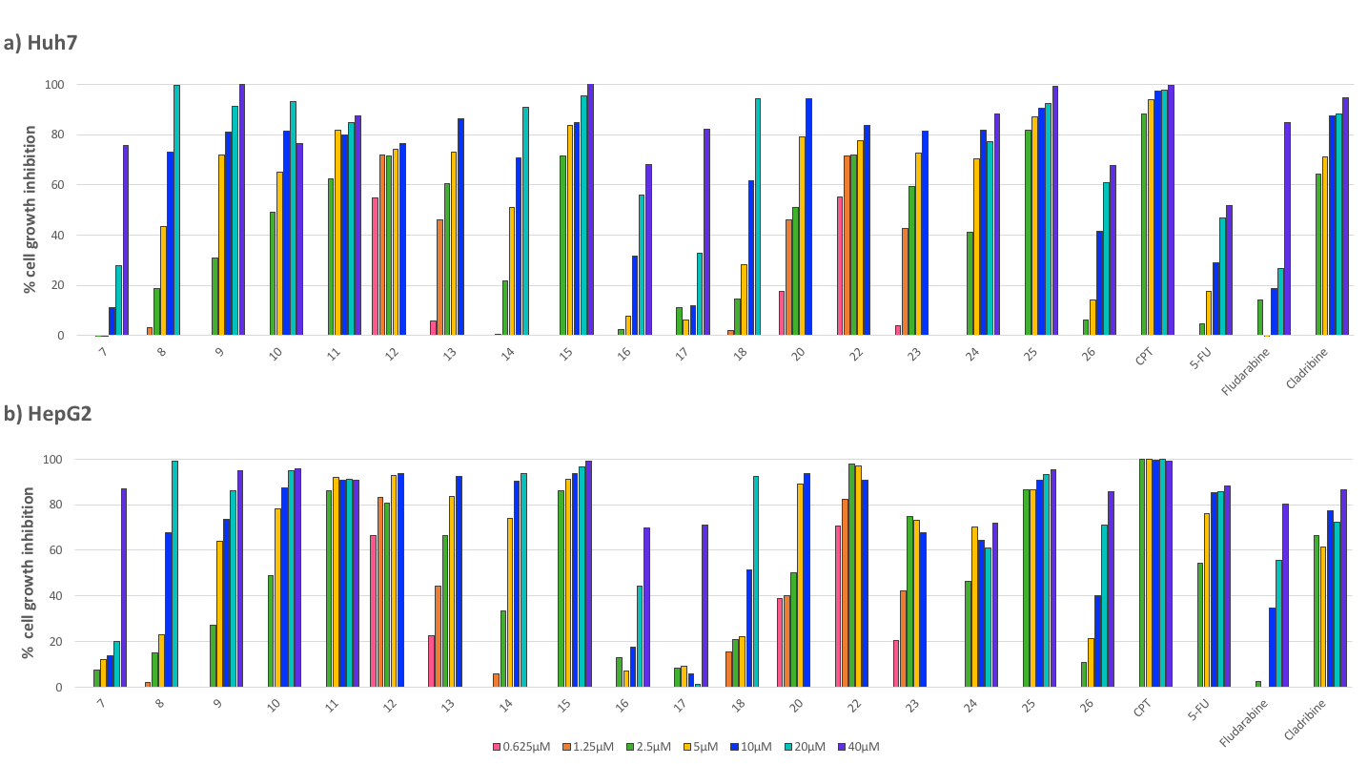
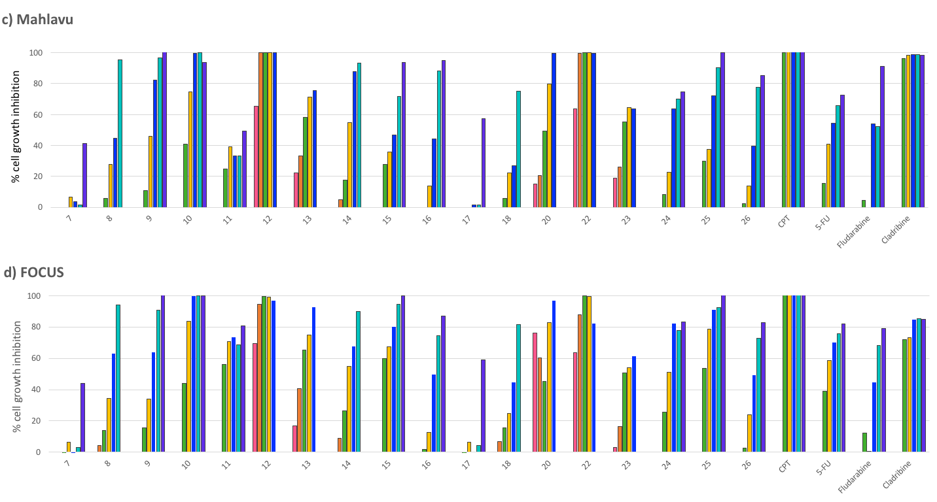
Figure 3. Percent cell death in the presence of most active compounds. Huh7, HepG2, Mahlavu and FOCUS cells were inoculated in 96-well plates. All molecules and their DMSO controls were administered to the cells in triplicate with five different concentrations: 40, 20, 10, 5, and 2.5 μM. After 72 h of incubation, SRB assays were generated, and the cell death percentages were calculated in comparison with DMSO-treated wells.

- Conclusion

We designed and synthesized twenty novel purine analogs (7-26) bearing substituted piperazine at the C-6, substituted benzyl group at the N-9 by the multistep reactions, starting from 4,6-dichloro-5-nitropyrimidine. The cytotoxic activities of the compounds were evaluated first in human liver (Huh7), breast (MCF7), colon (HCT116) and then in hepatocellular carcinoma cells (HCC): Huh7, HepG2, Mahlavu, FOCUS. Our results demonstrated that the 6-(trifluoromethylphenyl)piperazine analogs 12, 22 with IC₅₀ values less than 0.5 μM were promising molecules as cytotoxic agents on Huh7, MCF7 and HCT116 cancer cells. In order to investigate the use of potential cytotoxic agents on HCC, the bioactivity of the purine analogs was also tested in a panel of liver cancer cells. Molecule 12 and 22, that were synthesized as putative cytotoxic compounds, displayed the best anticancer bioactivities (IC₅₀= < 0.1 - 0.23 μM) against HCC cell lines (Figure 4). These results indicate that these compounds can be considered as promising lead molecules for the development of potential anticancer agents.

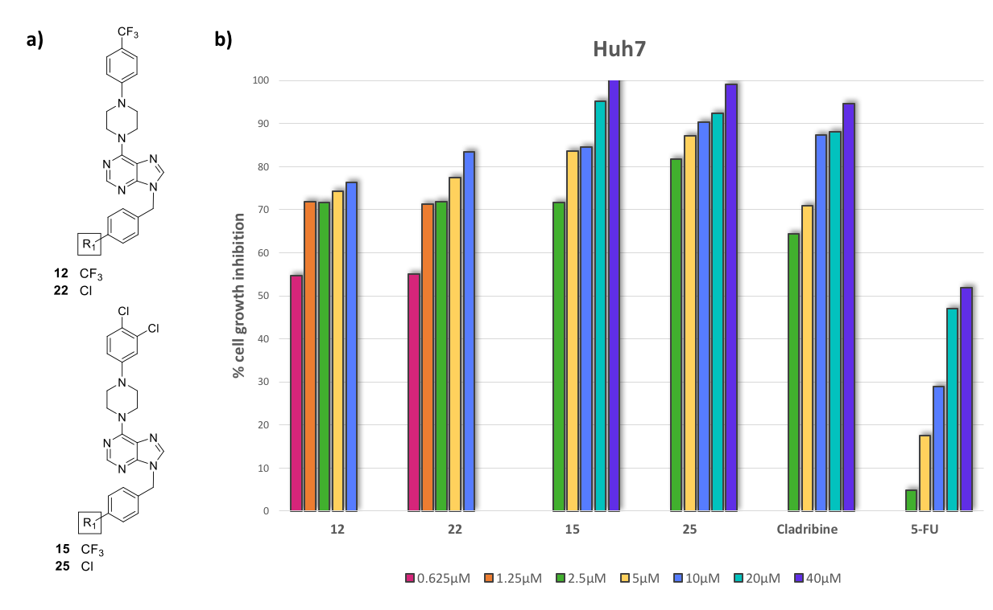
Figure 4.
a) Chemical structures of the most active purine analogs (12, 22, 15, 25)
b) Percent cell death in the presence of most active compounds (12, 22, 15, 25). Huh7 cells were inoculated in 96-well plates. All molecules and their DMSO controls were administered to the cells in triplicate with corresponding different concentrations: 0.625, 1.25, 2.5, 5, 10, 20, and 40μM. After 72 h of incubation, SRB assays were generated, and the cell death percentages were calculated in comparison with DMSO-treated wells

Acknowledgements: This work was supported by the Scientific and Technological Research Council of Turkey-TUBITAK (TBAG-109T987), the KANSIL-2016H121540 (Ministry of Development, Turkey).

- References

1. M.E. Welsch, S.A. Snyder, B.R. Stockwell, Curr. Opin. Chem. Biol. 2010, 14, 347–361.

2. I. Moriguchi, Y. Kanada, Chem. Pharm. Bull. 1977, 25, 926–935.

3. A. Brathe, G. Andresen, L.L. Gundersen, K.E. Malterud, F. Rise F, Bioorg. Med. Chem. 2002, 10, 1581–1586.

4. A. Brathe, L.L. Gundersen, K.E. Malterud, F. Rise, Arch. Pharm. Chem. Life Sci. 2005, 338, 159–166.

5. S.F. Laufer, D.M. Domeyer, T.R. Scior, W. Albrecht, D.R.J. Hauser, J. Med. Chem. 2005, 48, 710–722.

6. J.A. Montgomery, K. Hewson, J. Med. Chem. 1968, 11, 48–52.

7. G. Andersen, L.L. Gundersen, J. Nissen-Meyer, F. Rise, B. Spilsberg, Bioorg. Med. Chem. Lett. 2002, 12, 567–569.

8. J.F. Wang, L.R. Zhang, Z.J. Yang, L.H. Zhang, Bioorg. Med. Chem. 2004, 12, 1425–1429.

9. M. Hocek, P. Naus, R. Pohl, I. Votruba, P.A. Furman, P.M. Tharnish, M.J. Otto, J. Med. Chem. 2005, 48, 5869–5873.

10. R.W. Sidwell, J.H. Huffman, G.P. Khare, L.B. Allen, J.T. Witkowski, R.K. Robins, Science. 1972, 177, 705–706.

11. E. De Clercq, Biochem. Pharmacol. 1987, 36, 2567–2575.

12. E. De Clercq E, Nucleosides Nucleotides. 1998, 17, 625–634.

13. E. De Clercq, Antiviral Res. 2005, 67, 56–75.

14. B.Y. Kim, J.B. Ahn, H.W. Lee, S.K. Kang, J.H. Lee, J.S. Shin, S.K. Ahn, C.I. Hong, S.S. Yoon, Eur. J. Med. Chem. 2004, 39, 433–447.

15. G. Jin, C.C.N. Wu, R.I. Tawatao, M. Chan, D.A. Carson, H.B. Cottam, Bioorg. Med. Chem. Lett. 2006, 16, 4559–4563.

16. E.M. Peterson, J. Brownell, R. Vince, J. Med. Chem. 1992, 35, 3991–4000.

17. A. Gangjee, A. Vasudevan, S.F. Queener, J. Med. Chem. 1997, 40, 3032–3039.

18. G. Gumina, C.K. Chu, Org. Lett. 2002, 4, 1147–1149.

19. F. Bordon-Pallier, N. Jullian, P. Ferrari, A.M. Girard, M.T. Bocquel, J. Biton, N. Bouquin, J.L. Haesslein, Biochim. Biophys. Acta. 2004, 1697, 211–223.

20. P.R. Patel, C. Ramalingan, Y.T. Park, Bioorg. Med. Chem. Lett. 2007, 17, 6610–6614.

21. M. Tuncbilek, Z. Ates-Alagoz, N. Altanlar, A. Karayel, S. Ozbey, Bioorg. Med. Chem. 2009, 17, 1693–1700.

22. J.G. Kuhn, Ann Pharmacother. 2001, 35, 217–227.
23. C.M. Galmarini, J.R. Mackey, C. Dumontet, Lancet Oncol. 2002, 3, 415–424.

24. D. Sampath, V.A. Rao, W. Plunkett, Oncogene. 2003, 22, 9063–9074.
25. C.M. Galmarini, F. Popowycz, B. Joseph, Curr. Med. Chem. 2008, 15, 1072–1082.

26. G. Escherich, S. Richards, L.J. Stork, A.J. Vora, Leukemia. 2011, 25, 95–-959.

27. P.N. Munshi, M. Lubin, J.R. Bertino, Oncologist. 2014, 19, 760–765.

28. S.A. Johnson, W. Thomas, Hematol. Oncol. 2000, 18, 141–153.

29. S.A. Johnson, Expert Opin. Pharmacother. 2001, 2, 929–943.

30. W.B. Parker, J.A. 3rd Secrist, W.R. Waud, Curr. Opin. Invest. Drugs. 2004, 5, 592–596.

31. E. Lech-Maranda, A. Korycka, T. Robak, Mini-Rev Med Chem. 2006, 6, 575–581.

32. M.S. Ricci, W.X. Zong, Oncologist. 2006, 11, 342−357.

33. M. Collado, M. Serrano, Nature Rev. Cancer. 2006, 6, 472−476.

34. C. Nardella, J.G. Clohessy, A. Alimonti, P.P. Pandolfi, Nature Rev. Cancer. 2011, 11, 503–511.

35. J.L. Haesslein, N. Jullian, Curr. Topics Med. Chem. 2002, 2, 1037–1050.

36. W.F. De Azevedo, S. Leclerc, L. Meijer, L. Havlicek, M. Strnad, S.H. Kim, Eur. J. Biochem. 1997, 243, 518–526.

37. Y.T. Chang, N.S. Gray, G.R. Rosania, D.P. Sutherlin, S. Kwon, T.C. Norman, R. Sarohia, M. Leost, L. Meijer, P.G. Schultz, Chem. and Biol. 1999, 6, 361–375.

38. M.A. Biamonte, R. Van de Water, J.W. Arndt, R.H. Scannevin, D. Perret, W.C. Lee, J. Med. Chem. 2010, 53, 3–17.

39. M. Tuncbilek, E. Bilget Guven, T. Onder, R. Cetin Atalay, J. Med. Chem. 2012, 55, 3058−3065.
40. Z. Demir, E.B. Guven, S. Ozbey, C. Kazak, R.C. Atalay, M. Tuncbilek, Eur. J. Med. Chem. 2015, 89, 701–720.

41. D.L. Romero, C.E. Masse, S. Robinson, J.R. Greenwood, G. Harriman, PCT Int Appl WO 2015/048281 A l. 2015, 1–168
42. A.K. Bakkestuen, L.L. Gundersen, B.T. Utenova, J. Med. Chem. 2005, 48, 2710–2723.

