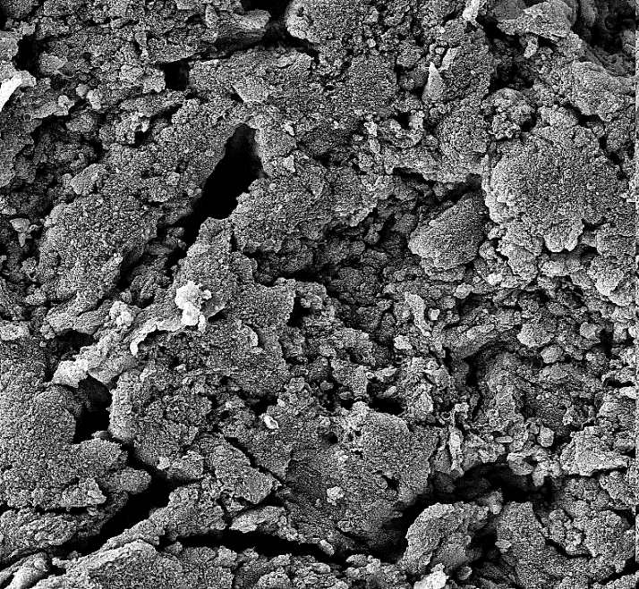
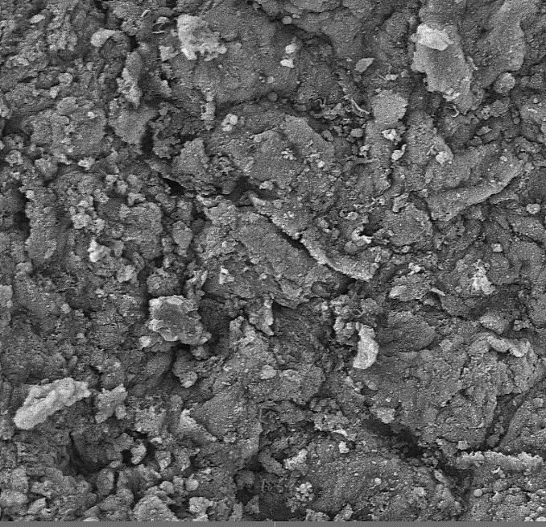
SEM photograph of (a) uncoated AAPS and (b) AV 17 coated AAPS

