Amperometric glucose biosensor based on homopolymer-chitosan double layered glucose oxidase electrode modified with zinc oxide nanoparticles

Gul Ozyilmaz*, Ali Tuncay Ozyilmaz, Esiye Irem Bayram, Ragibe Hulya Akyürekoğlu
University of Mustafa Kemal, Faculty of Arts & Sciences, Department of Chemistry 31040 Hatay/ Turkey

*Corresponding Author:
Gul Ozyilmaz
University of Mustafa Kemal,
Faculty of Arts & Sciences,
Department of Chemistry
31040 Hatay/ TURKEY
Fax: 90-326 2455867
e-mail: gozyilmaz@gmail.com

ABSTRACT
GOD was immobilized onto polypyrrole (PPy) or poly(o-anisidine) (POA) coated Pt electrode to construct glucose sensitive biosensor. Because the current value changed from polymer film properties and also from immobilization conditions, PPy and POA synthesis conditions and also enzyme immobilization parameters were optimized in detail. The optimal monomer concentration was determined as 25 and 50 mM for PPy and POA, respectively whereas scan rate was 50 mV/s for both polymer film. In case of immobilization procedure, the optimal Chi, GOD and GAL concentrations were observed as 0.5%, 2 mg/ml and 0.05% for PPY and 0.5%, 4 mg/ml and 0.075% for POA, respectively. It was revealed that ZnO-NP modification enhanced the efficiencies of both electrodes in terms of sensitivity and stability.
Keywords: Amperometric biosensor, polypyrrole, poly(o-anisidine), zincoxide nanoparticles, glucose oxidase
INTRODUCTION
Enzyme electrodes based on the glucose oxidase (GOD) have been widely applied to construct biosensors for glucose determination.¹⁻⁴ Fabrication of the enzyme containing biosensor is required immobilization of protein molecule onto/into the electrode which plays an important role in the research of glucose biosensor. There are several strategies on the immobilization techniques to get GOD biosensor such as crosslinking with glutaraldehyde,⁵⁻⁶ applying on an electrode with a gel matrix,⁷⁻¹¹ entrapment or incorporation in a polymer matrix during electropolymerization,^{3,12- 14} by covalent attachment¹⁵⁻¹⁷ or adsorbed onto electrode surface.¹⁸⁻²⁰ Chitosan is a type of natural cationic polymer, which has shown attractive characteristics such as film–forming ability, permeability, and good adhesion. Therefore, chitosan can be used as a gel matrix for enzyme immobilization through GAL or another reagent²¹⁻²³. However, the poor electrochemical conductivity of Chi reduces the performance of the enzyme-based biosensor.²⁴ To overcome this problem, several strategies were developed by adding several materials in Chi matrix such as nanoparticles^{7,23,25} ionic liquid,^{20,24} or modifying interface between electrode surface and Chi layer such as by electropolymers,²⁵ by nanoparticles,^{4,25} by Prussian Blue.²⁴ Several electropolymers were used to fabricate the glucose biosensor such as polypyrrole^{12,22,26-27} (PPy) polyaniline²⁸⁻²⁹ (PANI), poly(o-anisidine)³⁰⁻³¹ (POA), poly(N-Methylpyrrole)²¹ (PNMP) poly(o-phenylenediamine),³² polythophen³³ derivative. Recent studies reveal that the nanostructured metal oxides with reduced dimensionality have unique advantages in immobilizing enzymes and have high sensitivity due to high surface area, desirable microenvironment, and direct electron transfer between enzyme active sites and electrode. ZnO nanomaterials have been widely used for this purpose.³⁴⁻³⁶
The present study deals with the fabrication of a glucose biosensor based on redox polymers as PPy and POA. Construction of biosensor was optimized in terms of PPy and POA synthesis parameters, enzyme immobilization conditions and also the amount of ZnO nanoparticles (ZnO-NP)by measuring current response depending on glucose concentration. Enzyme electrodes were characterized by cyclic voltammograms, impedance diagrams, kinetic parameters and operational stabilities.
EXPERIMENTAL
Chemicals
Aspergillus niger origin glucose oxidase (GOD) (EC 1.1.3.4), pyrrole (Py), o-anisidine (OA), chitosan (Chi), zinc oxide nanoparticles (ZnO-NP, <100 nm), glucose anhydrous, glutaraldehyde (GAL) were purchased from Sigma. Py and OA were used after distillation and were stored in the dark until use. All other reagents were of analytical grade and used without further purification.
Preparation of enzyme electrodes
Enzyme electrodes were prepared including two steps.²¹⁻²² Firstly, homopolymer films were synthesized on Pt electrode. Secondly, GOD enzyme was immobilized onto polymer coated Pt electrodes. To this, PPy/Pt or POA/Pt electrodes were immersed in GOD contained Chi solution for 3 seconds (GOD-Chi/PPy/Pt or GOD-Chi/POA/Pt) and electrodes were dried for 2 hour open to atmosphere. Then, GOD-Chi/PPy/Pt or GOD-Chi/POA/Pt electrode was incubated in GAL solution for 10 sec for crosslinking between amine groups of enzyme and Chi to hinder GOD leakage. Modification of GOD electrode with ZnO-NP was achieved by adding nanoparticles in Chi solution by homogenizing using sonicator. After GOD supplementation, final solution was used to enzyme electrode construction as described before. Electrodes were stored at 4°C when they were not used.
Synthesis of Homopolymer films
Polymer films were achieved in a single compartment cell with three electrode configurations. The reference electrode was an Ag/AgCl (3 M KCl) electrode and the counter electrode was a platinum plate with a surface area of 0.25 cm². CHI 660b model electrochemical analyzer (serial number: A1420) was employed in electrochemical experiments. All of the potential values were referred to the Ag/AgCl (3 M KCl) electrode. PPy and POA films were synthesized onto Pt electrode with 0.25 cm² surface area by cyclic voltammetry technique in monomer containing 0.15 M sodium oxalate electrolyte solution applying.
Biosensor electrodes were optimized in terms of polymer synthesis conditions (monomer concentration and scan rate) and also enzyme immobilization conditions (Chi, GOD and GAL concentration). Current values of each electrode that was constructed at different parameters were compared using glucose solution.
Electrochemical measurements
Electrochemical experiments were performed in a single compartment cell with three electrode configurations. The reference electrode was an Ag/AgCl (3 M KCl) electrode and the counter electrode was a platinum plate with a surface area of 0.25 cm². CHI 660b model electrochemical analyzer (serial number: A1420) was employed in electrochemical experiments. All of the potential values were referred to the Ag/AgCl (3 M KCl) electrode. The biosensor response was monitored by chronoamperometrically at 0.60 V as current value that measured depending on hydrogen peroxide oxidation which was formed by GOD activity in the glucose solution. The chronoamperometric measurements were performed at room temperature in steady state conditions in potassium phosphate buffer (50 mM, pH 7.0) solution while each measurement was lasted 120 s.
Characterization of enzyme electrodes
The electrochemical characterization of enzyme electrodes in glucose solution was investigated by using cyclic voltammogram curves and also by AC impedance spectroscopy (EIS) techniques in absence and in presence of glucose. The cyclic voltammetry technique was applied to enzyme electrodes at a potential range between 0.10 and 1.00 V by 50 mV s^{–1} scan rates. To electrochemical impedance spectroscopy investigations, the Nyquist plots were recorded at 0.60 V potential in glucose free and glucose containing 0.10 M phosphate buffer electrolyte solution and in the frequency range from 10⁵ to 10⁻³ Hz using the amplitude of 4 mV.
All electrodes were compared according to net current response depending on glucose concentration at the constant potential. The net current value that was got by subtracting current value of glucose-free buffer solution from those of glucose-containing solution was represented as μA.
I_{max} and K_{M} values were calculated from Lineweaver-Burk Plot using current values depending on glucose concentrations with their optimal pH.
Operational stabilities were investigated by 20 successive using of each electrode in 5 mM glucose solution.
Results and Discussion
Optimization of PPy and POA synthesis parameters
In order to obtain the maximum current response of GOD electrodes, polymer film synthesizing parameters were optimized in terms of monomer concentration and scan rate after comprehensive preliminary studies for each polymer films. Because the pore size of polymer film is especially important for adsorption of GOD component, firstly, monomer concentrations, which were employed to obtain polymer layers on Pt electrode were changed between 10 and 100 mM; and 40 and 80 mM for PPy and POA, respectively. All other parameters such as scan rate, GOD, Chi and GAL concentrations were kept constant while enzyme electrodes were constructed. Obtaining electrodes were used to measure the current values depending on glucose concentrations and results were given as percentage of maximal current value in Fig. 1 and Fig. 2 for PPy and POA, respectively. As seen in Fig. 1, the highest current values and the most linear current curve was obtained for PPy electrode which was constructed in 25 mM pyrrole monomer.

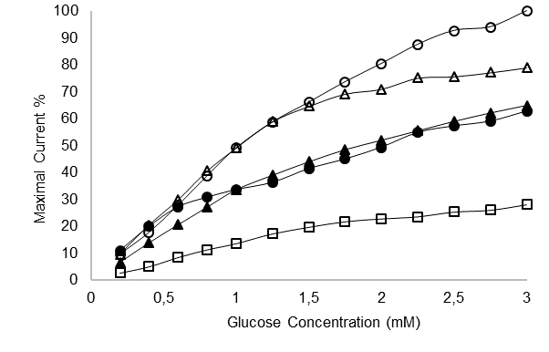

Figure 1. Current values depending on glucose concentration of GOD electrode constructed by PPy layer obtaining by different pyrrole concentrations as 10 mM (); 25 mM (); 50 mM (); 75 mM () and 100mM ()
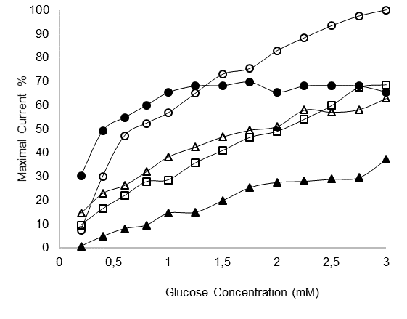
Figure 2. Current values depending on glucose concentration of GOD electrode constructed by POA layer obtaining by different o-anisidine concentrations as 40 mM (); 50 mM (); 60 mM (); 70 mM () and 80mM ()

In case of POA electrode (Fig.2), the optimal o-anisidine concentration was chosen as 50 mM due to the linearity of current curve and high current values. The change in current response depending on monomer concentration used in electrode preparation of enzyme electrodes can be explained by effect on the porosity of polymer films. At the low monomer concentration pore sizes may be too high that enzyme molecule can’t adsorb onto polymer film. And at high monomer concentrations, the polymer pores may be too small to allow the enzyme binding. The PPy and POA films formed by 25 mM for pyrrole and 50 mM for o-anisidine exhibited better current response results in the different glucose concentration solution. Therefore, all of the results in the present study were given for PPy and POA that synthesized in 25 mM pyrrole and 50 mM o-anisidine solutions, respectively.
Also, PPy and POA films were coated on the Pt electrode by applying scan rates of 20, 50 and 100 mVs⁻¹ in presence of their optimal monomer concentrations. The synthesizing of thin homopolymer films was provided with the help of proper scan number from -0.50 to 1.80 V for polypyrrole and from 0.35 to 1.50 V for poly(o-anisidine) in 0.150 M NaOX solution containing optimal monomer concentration. In order to maintain the same time in solution, 10 cycles for 20 mVs⁻¹, 26 cycles for 50 mVs⁻¹ and 50 cycles for 100 mVs⁻¹ were applied for the synthesis of the polymer films. Fig. 3 represents the current response of ezyme electrodes of which polymer layers were obtained applying different scan rate. As shown in the Fig. 3 (PPy), the current values of the electrode obtained with 20 mV/s scan rate for the low glucose concentrations were the highest, while the current values of the electrode obtained with the scan rate of 50 mV/s at high glucose concentrations were high. However, because of the more linear current response depending on glucose concentration was observed, 50 mV / s scan rate was selected as to optimal scan rate for PPy synthesis. In case of POA, enzyme electrode which was prepared applying 50 mV/s scan rate, increadibly the highest and the most linear current respond depending on glucose concentration was obtained. So, 50 mV/s scan rate was applied at the subsequent studies for PPy and POA synthesis.

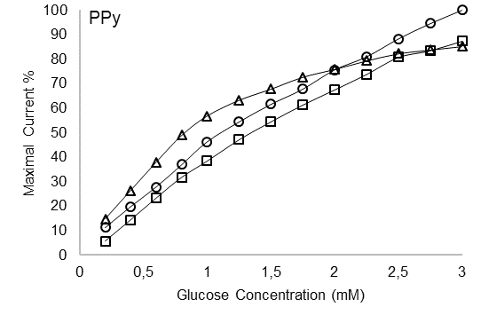
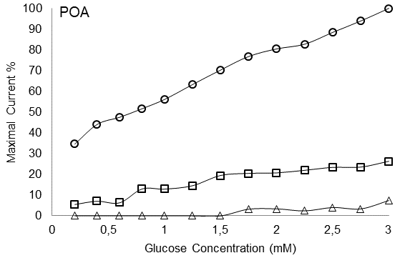
Figure 3. Variation of the current response of glucose-induced biosensors generated by PPy and POA synthesized at different scanning rates. Scan rate :20 mV/s; O: 50 mV/s; :100 mV/s

The effect of enzyme immobilization conditions such as Chi, GOD and GAL concentrations was also investigated and current responses were given for 3 mM glucose solution in the Fig. 4 A, B and C, respectively for PPY and POA.
The highest current response for both PPY and POA based electrodes were measured by enzyme electrodes constructed using 0.5% Chi solution (Fig. 4 (A)).

Figure 4. Current response of biosensors generated by PPy (o) and POA (Δ) applying different immobilization conditions as Chi (A), GOD (B) and GAL(C) concentrations.

As seen in the Fig. 4 (B) and (C), the maximal current responses were observed when enzyme electrodes were prepared using 0.05 % and 0.075% GAL solution and 2 and 4 mg/ml GOD concentration for PPy and POA based electrodes, respectively. So, enzyme immobilization parameters were chosen as 0.5 % Chi, 2 mg/ml GOD and 0.05%GAL for PPy whereas, 0.5 % Chi, 4 mg/ml GOD and 0.75%GAL for POA based electrodes at subsequent studies.

Characterization of GOD-Chi/POA/Pt and GOD-Chi/PPy/Pt electrodes prepared with
and without ZnO nanoparticles
Enzyme electrodes were modified by ZnO nanoparticles using three amounts as 0.1, 0.5 and 2 mg per ml of chitosan. As seen in Fig. 5 (A), it can be said that ZnO-NP addition in Chi solution enhanced the biosensor efficiency. The highest currents were obtained for PPy based electrode when 2mg ZnO-NP/ml was added to GOD containing Chi solution. In case of POA based electrode, when 0.1 mg ZnO-NP/ml was used the efficiency of electrode enhanced, but at higher nanoparticle using, the current values were lower than those of ZnO-NP free electrode.
Metal oxide nanoparticles were used to enhace glucose oxidase electrode in the literature

Figure 5. Current response of PPy (A) and POA (B) based biosensors that modified with ZnO nanoparticles. :NP-free; :0.1; :0.5 and : 2 mg ZnO-NP/ml Chi

Electrochemical characterization of enzyme electrodes
GOD enzyme was immobilized onto PPy and POA coated Pt electrodes via Chi thin layer and crosslinking with GAL. Optimal polymer film synthesis conditions and GOD immobilization parameters were used for electrode construction. Electrodes were also modified with ZnO-NPs. The glucose sensitivities of electrodes were investigated by cyclic voltammetry technique in glucose free and glucose containing buffer solution. In Fig. 6 (A) and (B) shows the cyclic voltammograms recorded for Pt/PPy/Chi-GOD and Pt/POA/Chi-GOD electrodes with and without ZnO-NP were obtained in glucose free and 5 mM glucose containing 0.10 M phosphate buffer electrolyte solution, respectively. In presence of glucose free 0.10 M phosphate buffer electrolyte solution, the current values of Pt/PPy/Chi-GOD and Pt/POA/Chi-GOD electrodes with and without ZnO-NP remained almost constant at around zero up to approx. + 0.70 V and then started to increase due to degradation of polymer films. Yet, oxidation current values recorded for glucose containing buffer solution were fairly higher when compared with that of glucose free buffer solution during first scan (Fig 6 A).
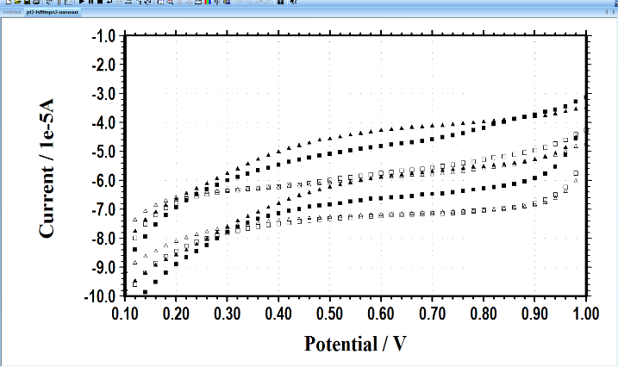
(A)

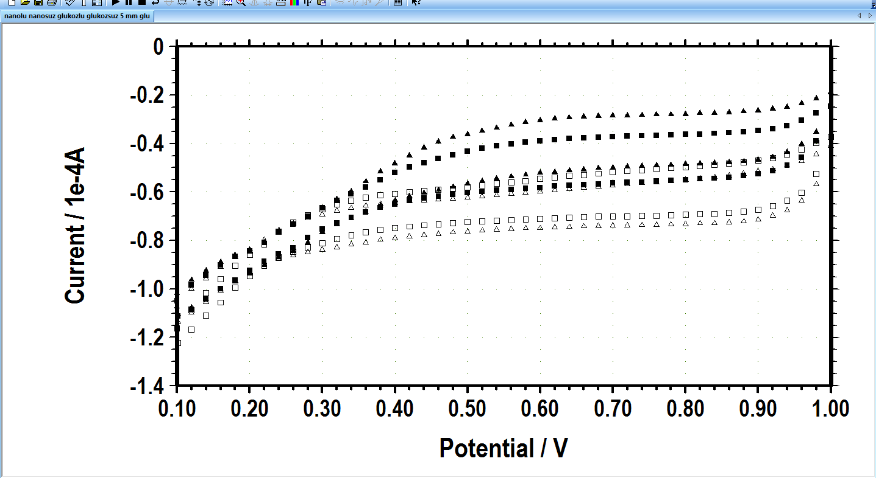
(B)

Figure 6. Cyclic voltammograms of nanoparticle free enzyme electrode in the buffer () and in the glucose solution (),Cyclic voltammograms of ZnONP containing enzyme electrodes in the buffer () and in the glucose solution () for PPy (A) and for POA (B) (5 mM glucose solution)

This case suggested that GOD enzyme on electrode surface had a sensitivity to glucose substrate. On the other hand, Pt/PPy/Chi-GOD and Pt/POA/Chi-GOD electrodes with ZnO-NP exhibited highest current values in 5 mM glucose containing buffer solution. This proved that ZnO-NP contributed to the electron transfer between metal and enzyme active center. At the same time, the oxidation current values of Pt/POA/Chi-GOD-ZnONP electrode in 5 mM glucose containing buffer solution were significantly higher when compared with those of Pt/PPy/Chi-GOD-ZnONP electrode. This situation suggested that the POA film on Pt electrode was attributed to better electron transfer rate with respect to polypyrrole film.
The other electrochemical characterization of each enzyme electrodes were carried out by EIS technique. Fig. 7 show the Nyquist diagrams recorded for Pt/PPy/Chi-GOD (A) and Pt/POA/Chi-GOD (B) electrodes with and without ZnO-NP in glucose free and 5 mM glucose containing 0.10 M phosphate buffer electrolyte solution.
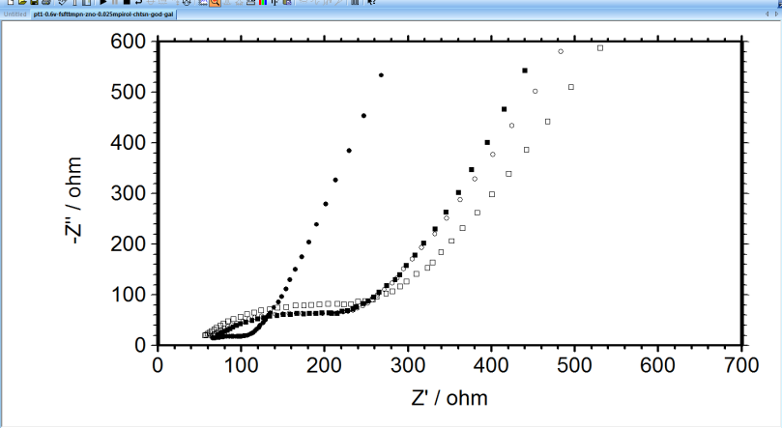
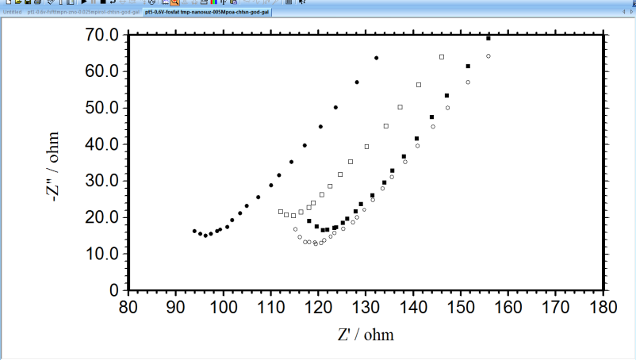
-Z" (ohm)
Z' (ohm)
-Z" (ohm)
Z' (ohm)

(A)

(B)

Figure 7. The Nyquist diagrams of Pt/PPY/Chi-GOD/GAL (A) and and Pt/POA/Chi-GOD/GAL (B) electrodes. ZnONP free in the buffer (□) and in the glucose (■), ZnONP containing in the buffer (ο) and in the glucose (•) solution.
In case of Pt/PPy/Chi-GOD and Pt/POA/Chi-GOD electrodes with and without ZnO-NP, Nyquist plots obtained at 0.60 V consisted of two depressed semicircles, which could not be well resolved, after shortly after of immersion time.
Nyquist diagrams, the first and second depressed semicircles at high and low frequencies consisted of charge transfer resistance (R_{ct}) corresponding to the anodic reaction of the substrate at the bottom of the pores and the resistances of the oxide layer (R_{o}) + polymer film (R_{f}), respectively. The first partially seen semicircle at the high frequency region is related to R_{ct} for processes occurring at the bottom of the pores of coatings.
The charge transfer reactions are known to take place at the metal/polymer interfaces. Consequently, the high R_{ct} values of coated electrodes can be explained by the build-up of protective layers and the effective barrier behaviour of films on the surface.
In Fig 7 (A), the R_{ct} value recorded for Pt/PPy/Chi-GOD-ZnONP electrode in glucose free buffer solution was highest due to forming a barrier layer such as coating, enzyme and nanoparticle on Pt surface. However, the feature of same electrode was exactly different in glucose containing buffer solution and lowest R_{ct} value. On the other hand, the magnitude of semicircle observed at high frequency region recorded for Pt/PPy/Chi-GOD electrode in glucose containing buffer solution was significantly higher when compared with that the presence of glucose free buffer solution. The lowest R_{ct} value recorded for Pt/PPy/Chi-GOD-ZnONP electrode in glucose containing buffer solution was related to the increase of the charge transfer rate between the metal and the solution. At the same time, the semicircle observed at high frequency region recorded for Pt/POA/Chi-GOD-ZnONP electrode in glucose containing buffer solution is important lowest when compared with other three semicircles in Fig 7 (B). The low R_{ct} values of Pt/PPy/Chi-GOD and Pt/POA/Chi-GOD electrodes modified ZnO-NP in glucose containing buffer solution showed that ZnO nanoparticles in glucose containing buffer solution contributed to the increase in the charge transfer rate at a metal/polymer interfaces.

Biochemical characterization of enzyme electrodes
To carry out biochemical characterization, optimal pH values, kinetic parameters and operational stabilities were investigated for each electrode. Firstly, current responses were measured at 3 mM glucose concentration at different pH values and results were given in Table 1. The highest current values were got at pH 6.0 for GOD-Chi/PPy/Pt, ZnO-GOD-Chi/PPy/Pt and GOD-Chi/POA/Pt whereas at pH 4.0 for ZnO-GOD-Chi/POA/Pt. Vmax and K_{M} values of each electrode were calculated by Lineweaver-Burk plot using current values depending on glucose concentration range between 0.1 and 10 mM get at individual optimal pH and results were given in the Table 1. As seen in Table 1, Imax values of GOD-Chi/PPy/Pt, ZnO-GOD-Chi/PPy/Pt were considerably higher than those of GOD-Chi/POA/Pt and ZnO-GOD-Chi/POA/Pt. Besides, Vmax values of enzyme electrodes prepared with ZnO nanoparticles were higher than those of their nanoparticle free counterparts. Vmax values increased as 36.18% and 47.42% in comparison with nanoparticle free electrodes for PPy and POA, respectively when ZnO nanoparticles were used at enzyme electrode preparation.

Table 1. Kinetic parameters and optimal pH values of GOD electrodes with and without ZnO-NP
 | PPy |  |  | POA
 | pH | I_{max} (µA) | K_{M} (mM) | pH | I_{max} (µA) | K_{M} (mM)
ZnO-NP-Free | 6.0 | 29.85 | 1.15 | 6.0 | 5.82 | 0.32
ZnO-NP | 6.0 | 40.65 | 1.50 | 4.0 | 8.58 | 0.42

Metaloxide nanoparticles such as TiO₂²⁹, CuGeO₃³⁷, ZrO₂³⁸, IrO₂³⁹ were used to enhance the enzymatic amperometric biosensor in the literature. Yang et al. (2004) modified by ZrO₂ nanoparticles of the amperometric glucose biosensor constructed using Chi-GOD on Pt electrode and they found Imax and Km values as 0.29 µA whereas Km values as 3.14 mM, respectively. Jhas et.al (2010)³⁹ constructed IrO₂-NP containing GOD electrode and Imax and Km values were calculated as 46 mA/m² 27 mM
Operational stabilities of electrodes were also analyzed by 20 successive using in glucose solutions. At the end of 20 cycles, retained currents as the percentage of initial activity were 92.73 % and 93.13 % for GOD-Chi/POA/Pt and ZnO-GOD-Chi/POA/Pt, respectively, while there was slight current increase was observed in the case of GOD-Chi/PPy/Pt and ZnO-GOD-Chi/PPy/Pt (Fig. 8).

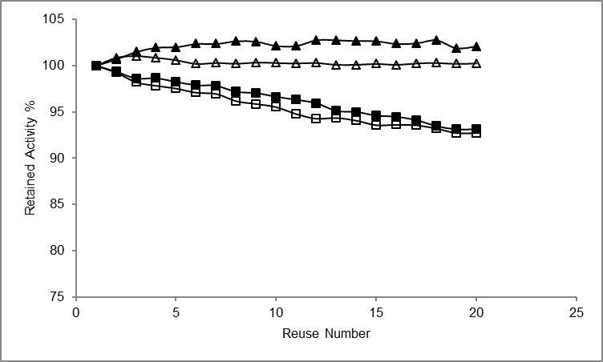
Figure 8. Operational stabilities of enzyme electrodes GOD-Chi/POA/Pt (□), ZnO-GOD-Chi/POA/Pt (■), GOD-Chi/PPy/Pt () and ZnO- GOD-Chi/PPy/Pt ()

- Conclusion
PPy and POA coated Pt electrode was successfully used to construct glucose sensitive enzyme electrode. It was found that electrode construction parameters significantly affected the current values depending on glucose construction. The current values and stabilities were higher for PPy based electrode than those of POA based electrode. Also, it was revealed that, modification of enzyme electrode by ZnO-NP contributed to the electron transfer between metal and enzyme active center.
Acknowledgements
This study was funded by Scientific Research Units of The University of Mustafa Kemal in Turkey, Project nos.9080 and 8681

References
- K. Khun, Z.H. Ibupoto, J. Lu, M.S. AlSalhi, M. Atif, A. Ansari, M. Willander, Sensors and Actuators B 2012, 173, 698-703
- A. Salimi, A. Noorbakhsh, Electrochimica Acta, 2011, 56, 6097-6105
- Y.M. Uang, T.C. Chou, Biosensors and Bioelectronics, 2003, 19, 141-147
- M. Guo, H. Fang, R. Wang, Z. Yang, X. Xu, Journal of Material Science: Mater. Med, 2011, 22, 1958-1992
- M.E. Ghica, C.M.A. Brett, Journal of Electroanalytical Chemistry, 2009, 629, 35-42
- L.V. Shkotova, N.Y. Piechniakova, O.L. Kukla, S.V. Dzyadevych, Food Chemistry, 2016, 197, 972-978
- L. Wang, X. Gao, L. Jin, Q. Wu, Z. Chen, X. Lin, Sensors and Actuators B, 2013, 176, 9-14
- Y. Hui, L. Nan, X. Jhing-Zhong, Z. Jun-Jie, Chinese Journal of Chemistry, 2005, 23, 275-279
- B. Haighi, L. Nazari, S.M. Sajjadi, Electroanalysis, 2012, 24, 2165-2175
- S. Huang, Y. Ding, Y. Liu, L. Su, R. Filosa Jr, Y. Lei, Electroanalysis, 2011, 23, 1912-1920
- R. Pauliukaite, A.M.C. Paquim, A.M.O. Brett, C.M.A. Brett, Electrochimica Acta, 2006, 52, 1-8
- G. Ozyilmaz, A.T. Ozyilmaz, F. Can, Appl. Biochem.Microbiol. 2011, 47, 217-225
- E.H. Yu, K. Sundmacher, Trans IChemE, Part B, Process Safety and Environmental Protection, 2005, 85, 489-493
- A. Eftekhari, Synthetic Metals, 2004, 145, 211-216
- K. Abu-Rabeah, R.S. Marks, Sensors and Actuators B, 2009, 136, 516-522
- F. Ekiz, F. Oğuzkaya, M. Akın, S. Timur, C. Tanyeli, L. Toppare, Journal of Materials Chemistry, 2011, 21, 12337-12343
- R.K. Shervedani, A. Hatefi-Mehrjardi, Sensors and Actuators B, 2007, 126, 415-423
- C. Guadalupe de Jesus, D. Lima, V. Santos, K. Wohnrath, C.A. Pessoa, Sensors and Actuators B, 2013, 186, 44-51
- A. Salimi, A. Noorbakhsh, Electrochimica Acta, 2011, 56, 6097-6105
- Y. Jiang, Q. Zhang, F. Li, L. Niu, Sensors and Actuators B, 2012, 161, 728-733
- G. Ozyilmaz, A.T. Ozyilmaz, R.H. Akyürekoğlu, Natural and Engineering Sciences, 2017, 2, 123-134
- G. Ozyilmaz, A.T. Ozyilmaz, S. Ağçam, Natural and Engineering Sciences, 2018, 3, 1-15
- J. Li, R. Yuan, Y. Chai, X. Che, W. Li, Bioprocess Biosys Eng, 2012, 35, 1089-1095
- Zhang Y, Liu Y, Chu Z, Shi L, Jin W, Sensors and Actuators B, 2013, 176, 978-984
- S. Chen, P. Fu, B. Yin, R. Yuan, Y. Chai, Y. Xiang, Bioprocess Biosyst Eng, 2011, 34, 711-719
- M. Raicopol, A. Prunǎ, C. Damian, L. Pilan, Nanoscale Research Letters, 2013, 8, 1-8
- D. Olea, O. Viratelle, C. Faure, Biosensors and Bioelectronics, 2008, 23, 788-794
- C. Ozdemir, F. Yeni, D. Odaci, S. Timur, Food Chemistry, 2010, 119, 380-385
- W. Tang, L. Li, X. Zeng, Talanta, 2015, 131, 417-423
- P.A. Savale, M.D. Shirsat, Appl. Biochem. Biotechnol. 2009, 159, 299-309
- D.D. Borole, U.R. Kapadi, P.P. Mahulikar, D.G. Hundiwale, Journal of Material Science, 2007, 42, 4947-4953
- S.A. Rothwell, S.J. Killoran, R.D. O’Neill, Sensors, 2010, 10, 6439-6462
- M.F. Abasiyanik, M. Senel, J Electroanal Chem, 2010, 639, 21-26
- S. Jung, S. Lim, Appl Surface Sci, 2013, 265, 24-29
- Y.T. Wang, L. Yu, J. Wang, L. Lou, W.J. Du, W.Q. Zhu, H. Peng, J.Z. Zhu, J Electroanal Chem, 2011, 661, 8-12
- X.Q. Hou, X. Ren, F.Q. Tang, D. Chen, Z.P. Wang, Chinese J Anal Chem, 2006, 34 303-306
- Y.P. Dong, L. Huang, X.F. Chu, L.Z. Pei, Russian J Electrochem, 2013, 49, 571-576
- Y. Yang, H. Yang, M. Yang, Y. Liu, G. Shen, R. Yu, Analytica Chimica Acta, 2004, 525, 213-220
- A.S. Jhas, H. Elzanowska, B. Sebastian, V. Birss, Electrochimica Acta, 2010, 55, 7683-7689

Figure Captions
Figure 1. Current values depending on glucose concentration of GOD electrode constructed by PPy layer obtaining by different pyrrole concentrations as 10 mM (); 25 mM (); 50 mM (); 75 mM () and 100mM ()
Figure 2. Current values depending on glucose concentration of GOD electrode constructed by POA layer obtaining by different o-anisidine concentrations as 40 mM (); 50 mM (); 60 mM (); 70 mM () and 80mM ()
Figure 3. Variation of the current response of glucose-induced biosensors generated by PPy and POA synthesized at different scanning rates. Scan rate :20 mV/s; O: 50 mV/s; :100 mV/s
Figure 4. Current response of biosensors generated by PPy (o) and POA (Δ) applying different immobilization conditions as Chi (A), GOD (B) and GAL(C) concentrations.
Figure 5. Current response of PPy (A) and POA (B) based biosensors that modified with ZnO nanoparticles. :NP-free; :0.1; :0.5 and : 2 mg ZnO-NP/ml Chi
Figure 6. Cyclic voltammograms of nanoparticle free enzyme electrode in the buffer () and in the glucose solution (),Cyclic voltammograms of ZnONP containing enzyme electrodes in the buffer () and in the glucose solution () for PPy (A) and for POA (B) (5 mM glucose solution)
Figure 7. The Nyquist diagrams of Pt/PPY/Chi-GOD/GAL (A) and and Pt/POA/Chi-GOD/GAL (B) electrodes. ZnONP free in the buffer (□) and in the glucose (■), ZnONP containing in the buffer (ο) and in the glucose (•) solution.
Figure 8. Operational stabilities of enzyme electrodes GOD-Chi/POA/Pt (□), ZnO-GOD-Chi/POA/Pt (■), GOD-Chi/PPy/Pt () and ZnO- GOD-Chi/PPy/Pt ()

