Supplementary Material

Supplementary data 1. Synthesis of ligands (L¹-L⁶)
Synthesis of 4-(4-fluorophenyl)-2-(furan-2-yl)-6-p-tolylpyridine [L¹]
Substituted enones synthesized by the reaction of p-fluorobenzaldehyde and p-methylacetophenone, was refluxed with pyridinium salt of 2-acetylfuran in presence of ammonium acetate for 6h. The reaction mixture was allowed to cool at room temperature. The solid product obtained was washed with cold methanol and recrystallized from ethyl acetate:hexane (1:9), in which only ligand is soluble while interference settle down at bottom. By carefully decanting solvent, only single spot ligand product was isolated. Yield: 53%, m.p.: 115-119 °C, Anal. Calc. for C₂₂H₁₆FNO (329.37): Calc. (%): C, 80.23; H, 4.90; N, 4.25. Found (%): C, 80.21; H, 4.93; N, 4.27.¹H–NMR (CDCl₃, 400 MHz): δ (ppm) 8.068–8.064 (d–poor resolved, 2H, H_{2'′,6'′}), 7.823–7.819 (d, 1H, H₃), 7.765–7.730 (complex, 3H, H_{3′′,5′′,5}), 7.590–7.584 (dd–poor resolved, 1H, H_{5′}), 7.345–7.325 (d, 2H, H_{3'′',5'''}), 7.284–7.209 (complex, 3H, H_{2′′',6'′′,4'}), 6.606–6.593 (dd, 1H, H_{3′}), 2.456 (s, 3H, –CH₃). IR (KBr, 4000–400cm⁻¹): 3032 v(C–H)ar; 1543 v(C=C); 1497 v(C=N); 1220 v(C–F); 1304 pyridine skeleton band; 740 v(C–H); 918, 818( p-substituted ring).

Synthesis of 4-(4-chlorophenyl)-2-(furan-2-yl)-6-p-tolylpyridine [L²]
It has been synthesized using the chalcone prepared from the reaction between p-chlorobenzaldehyde and p-methylacetophenone. Yield: 59%, m.p.: 110-112 °C, Anal. Calc. for C₂₂H₁₆ClNO (345.82): Calc. (%): C, 76.41; H, 4.66; N, 4.05. Found (%): C, 76.44; H, 4.67; N, 4.08. ¹H–NMR (CDCl₃, 400 MHz): δ (ppm) 8.064–8.044 (dd, 2H, H_{2'′,6'′}), 7.823–7.821 (dd, 1H, H_{5'}), 7.757 (s, 1H, H₃), 7.714–7.693 (d, 2H, H_{3′′',5'′′,}), 7.588 (s, 1H, H₅), 7.524–7.503 (d, 2H, H_{3′′,5'′}), 7.345–7.325 (d, 2H, H_{2′′′,6'′′}), 7.284–7.271 (dd, 1H, H_{4′}), 6.606-6.594 (dd, 1H, H_{3′}), 2.456 (s, 3H, –CH₃). IR (KBr, 4000–400cm⁻¹): 3063 v(C–H)ar; 1543 v(C=C); 1489 v(C=N); 1040 v(C–Cl); 1327 pyridine skeleton band; 733 v(C–H); 987, 810( p-substituted ring).

Synthesis of 4-(4-bromophenyl)-2-(furan-2-yl)-6-p-tolylpyridine [L³]
It has been synthesized using the chalcone prepared from the reaction between p-bromobenzaldehyde and p-methylacetophenone. Yield: 49%, m.p.: 129-132 °C, Anal. Calc. for C₂₂H₁₆BrNO (390.27): Calc. (%): C, 67.71; H, 4.13; N, 3.59. Found (%): C, 67.74; H, 4.17; N, 3.61. ¹H–NMR (CDCl₃, 400 MHz): δ (ppm) 8.071–8.051 (d, 2H, H_{2'′,6'′}), 7.968–7.948 (dd, 1, H_{5'}), 7.831 (s, 1H, H₃), 7.792 (s, 1H, H₅), 7.580–7.539(t, 3H, _{2''′,6''',3′′′}),7.500 (s–poor resolved, 1H, H_{5′′′}), 7.335–7.240(complex, 3H, H_{3′′,5′′,4′}), 6.607–6.597(dd, 1H, H_{3′}), 2.420 (s, 3H, –CH₃). IR (KBr, 4000–400cm⁻¹): 3044 v(C–H)ar; 1543 v(C=C); 1487 v(C=N); 1050 v(C–Br); 1373 pyridine skeleton band; 771 v(C–H); 920, 818( p-substituted ring).

Synthesis of 4-(3-fluorophenyl)-2-(furan-2-yl)-6-p-tolylpyridine [L⁴]
It has been synthesized using the chalcone prepared from the reaction between m-fluorobenzaldehyde and p-methylacetophenone. Yield: 59%, m.p.: 89-92 °C, Anal. Calc. for: C₂₂H₁₆FNO (329.37): Calc. (%): C, 80.23; H, 4.90; N, 4.25. Found (%): C, 80.24; H, 4.88; N, 4.27. ¹H–NMR (CDCl₃, 400 MHz): δ (ppm) 8.075–8.054 (d, 2H, H_{2'′,6'′}), 7.839–7.836 (d, 1H, H₃), 7.774–7.771 (d, 1H, H₅), 7.597–7.593 (d, 1H, H_{5'′′}), 7.566–7.454 (complex, 3H, H_{2′′',6'′′,4'′′}),7.350–7.330(d, 2H, H_{3′′,5′′}),7.283–7.274(d–poor resolved, 1H, H_{5′}),7.211-7.164 (t–poor resolved, 1H, H_{4′}), 6.610–6.592(dd, 1H, H_{3′}), 2.459(s, 3H, –CH₃). IR (KBr, 4000–400cm⁻¹): 3063 v(C–H)ar; 1551 v(C=C); 1489 v(C=N); 1222 v(C–F); 1381 pyridine skeleton band; 748 v(C–H); 926, 864( p-substituted ring).

Synthesis of 4-(3-chlorophenyl)-2-(furan-2-yl)-6-p-tolylpyridine [L⁵]
It has been synthesized using the chalcone prepared from the reaction between
m-chlorobenzaldehyde and p-methylacetophenone. Yield: 70%, m.p.: 78-80 °C, Anal. Calc. for C₂₂H₁₆ClNO (345.82): Calc. (%): C, 76.41; H, 4.66; N, 4.05. Found (%): C, 76.40; H, 4.68; N, 4.04. ¹H–NMR (CDCl₃, 400 MHz): δ (ppm) 8.072–8.052 (d, 2H, H_{2'′,6'′}), 7.910–7.901(t, 1H, H₃),7.820–7.817 (d, 1H, H₅), 7.756–7.753 (d, 1H, H_{2'′′}), 7.700–7.681 (d, 1H, H_{6'′′}),7.630–7.595(complex, 2H, H_{3′′′,5′′′}),7.433–7.394(t, 1H, H_{4′}), 7.348–7.329 (d, 2H, H_{3′′,5′′}), 7.248–7.275(d–poor resolved, 1H, H_{5′}), 6.609–6.597(dd, 1H, H_{3′}), 2.458(s, 3H, –CH₃).IR (KBr, 4000–400cm⁻¹): 3063 v(C–H)ar; 1551 v(C=C); 1489 v(C=N); 1225 v(C–Cl); 1381 pyridine skeleton band; 748 v(C–H); 926, 864( p-substituted ring).

Synthesis of 4-(3-bromophenyl)-2-(furan-2-yl)-6-p-tolylpyridine [L⁶]
It has been synthesized using the chalcone prepared from the reaction between m-bromobenzaldehyde and p-methylacetophenone. Yield: 38%, m.p.: 88-89 °C, Anal. Calc. for C₂₂H₁₆BrNO (390.27): Calc. (%): C, 67.71; H, 4.13; N, 3.59. Found (%): C, 67.75; H, 4.14; N, 3.58.¹H–NMR (CDCl₃, 400 MHz): δ (ppm) 8.073–8.053 (d, 2H, H_{2'′,6'′}), 7.830–7.827 (d, 1H, H₃),7.765–7.750 (dd–poor resolved, 2H, _{2'′′,6'′′}), 7.660–7.634 (complex, 1H, H_{4'}), 7.596-7.594 (dd–poor resolved, 1H, H₅), 7.480–7.464(complex, 2H, H_{3′′′,5′′′}),7.349–7.329(d, 2H, H_{3′′,5′′}),7.288–7.284 (d–poor resolved, 1H, H_{5′}), 6.610–6.597(dd, 1H, H_{3′}), 2.458(s, 3H, –CH₃).IR (KBr, 4000–400cm⁻¹): 3063 v(C–H)ar; 1543 v(C=C); 1497 v(C=N); 1369 v(C–Br); 1381 pyridine skeleton band; 733 v(C–H); 918, 813( p-substituted ring).

Supplementary data 2. Thermogram of complex–1

Supplementary data 3. LC–MS spectrum of complex–1

Supplementary data 4. Fragmentation pattern of complex–1

Supplementary data 5. MIC values of ligands [L¹-L⁶] and complexes (1-6)
Sr.  No | MIC Values (µM)
Sr.  No | Gram-positive |  | Gram-negative
Sr.  No | S. aureus | B. subtilis | S. marcescens | P. aeruginosa | E. coli
[L¹] | 230 | 325 | 225 | 225 | 180
[L²] | 255 | 375 | 250 | 270 | 225
[L³] | 295 | 500 | 275 | 310 | 240
[L⁴] | 235 | 360 | 230 | 225 | 225
[L⁵] | 295 | 400 | 260 | 310 | 270
[L⁶] | 355 | 500 | 390 | 375 | 340
(1) | 145 | 155 | 135 | 140 | 125
(2) | 140 | 160 | 150 | 135 | 140
(3) | 140 | 170 | 170 | 155 | 135
(4) | 140 | 165 | 145 | 140 | 135
(5) | 155 | 170 | 170 | 165 | 150
(6) | 185 | 195 | 180 | 155 | 160

Supplementary data 6. Data and plots of [DNA]/(ε_{a}–ε_{f}) versus [DNA] for the titration of DNA with ruthenium(III) complexes 1-6.
Complex-1
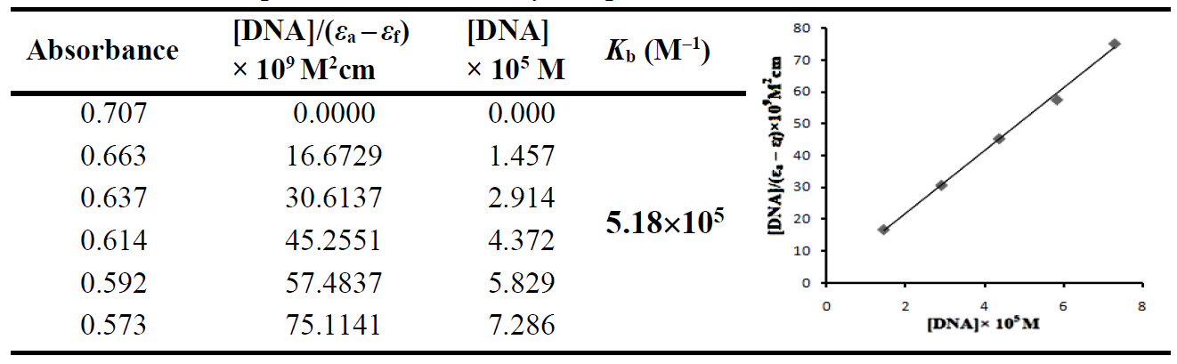
Complex-2
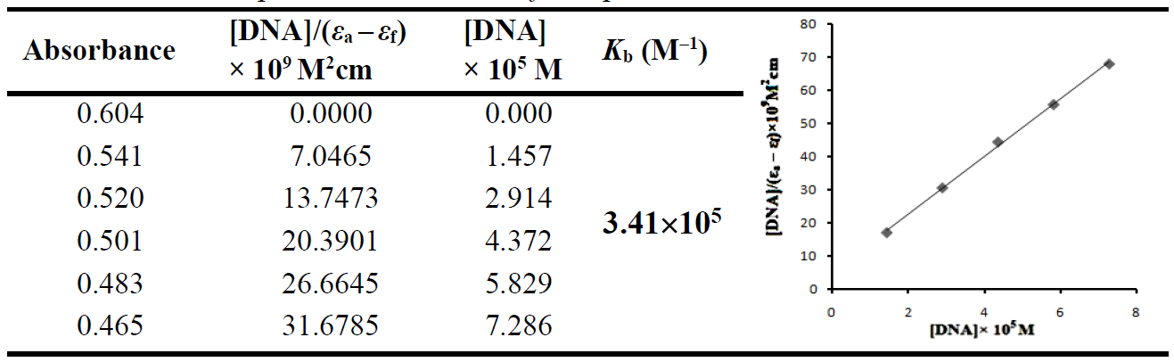
Complex-3
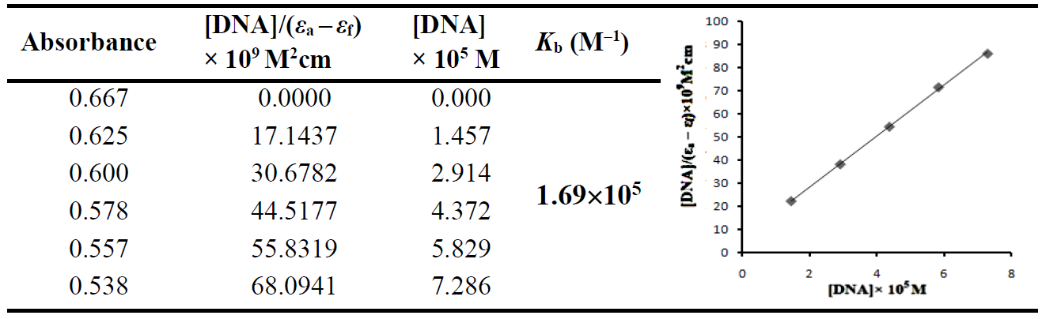

Complex-4
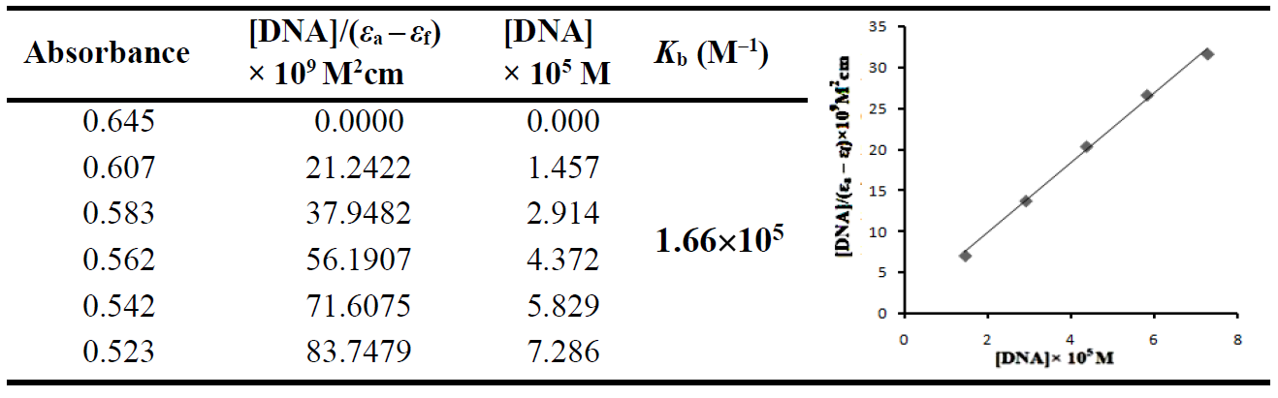
Complex-5
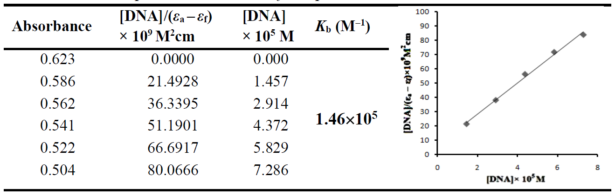
Complex-6
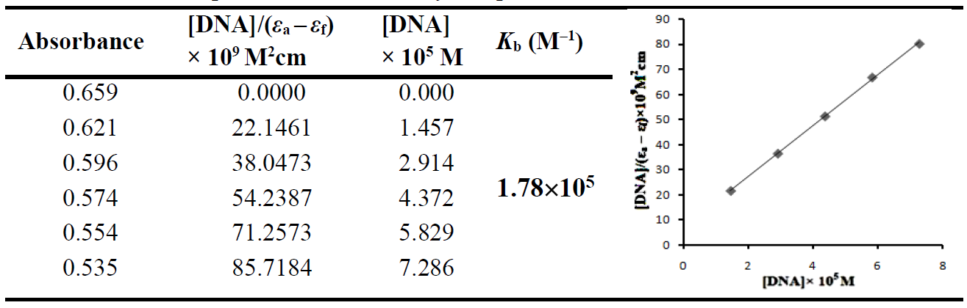

Supplementary data 7. Effect on relative viscosity of DNA under the influence of increasing amount of complexes at 37±0.1 °C in phosphate buffer (Na₂HPO₄/NaH₂PO₄, pH 7.2)

