Interactions between Ibuprofen and Silicified-MCC: Characterization, Drug Release and Modeling Approaches

Rudra Narayan Sahoo¹, Ashirbad Nanda¹, Arunima Pramanik¹, Souvik Nandi¹, Rakesh Swain¹, Sukanta Kumar Pradhan², Subrata Mallick¹*

¹School of Pharmaceutical Sciences, Siksha ‘O’ Anusandhan (Deemed to be University), Kalinganagar, Bhubaneswar- 751003, Odisha, India.
²Department of Bioinformatics, Orissa University of Agriculture and Technology, Bhubaneswar, Odisha, India.

Running Title: Docking analysis of ibuprofen with SMCC

*Correspondence to: Subrata Mallick (E-mail: profsmallick@gmail.com)
Fax: +91-674-2350642; Tel: +91-674-2350635

Abstract
Analysis of the binding interactions of ibuprofen and silicified-microcrystalline cellulose (SMCC) has been undertaken. Co-processing of ibuprofen with SMCC was carried out by solid state ball milling, and aqueous state equilibration followed by freeze drying to investigate the effect of silicified-microcrystalline cellulose on ligand. Molecular docking study revealed that ibuprofen formed complex through hydrogen bond with microcrystalline cellulose (MCC) and silicon dioxide (SiO₂); the binding energy between MCC and SiO₂, and ibuprofen and SMCC were found as -1.11 and -1.73 kcal/mol respectively. The hydrogen bond lengths were varying from 2.028 to 2.056 Å. Interaction of Si atom of SMCC molecule with Pi-Orbital of ibuprofen has shown the bond length of 4.263 Å. Significant improvement in dissolution of ibuprofen has been observed as a result of interaction. Binary and ternary interactions revealed more stabilizing interactions with ibuprofen and SMCC compared to SMCC formation.

Keywords: Co-processing; silicified microcrystalline cellulose; Docking analysis; Binary interaction; Ternary interaction.

1. INTRODUCTION
Molecular docking experiment was used to predict the binding mode interactions between the molecules.¹ The programme uses Lamarckian genetic algorithm, semiempirical free energy force field, grid box based method to allow rapid evaluation of the binding energy and pre-calculating the interaction between every atom type pair at every distance and result clustering procedures. The force field is based on a comprehensive thermodynamic model that allows incorporation of intramolecular energies into the predicted free energy of the binding.²
Rheumatoid arthritis, a systemic inflammatory disease causes pain, stiffness, and swelling of joints and, over the time, the disease has a severe, chronic and invalid progression with loss of mobility.^{3,4} Ibuprofen could be considered as drug of choice in the management and therapy of inflammation in rheumatoid arthritis.⁵ Oral bioavailability of ibuprofen is very poor due to its poor water solubility.⁶ Low oral bioavailability limits therapeutic efficacy of the drug.⁷ Dissolution rate of ibuprofen (BCS class II) in gastrointestinal fluid is the rate limiting step in its oral absorption and often results in low and erratic oral bioavailability.^{8,9} Many techniques have been reported to improve the bioavailability of poorly water-soluble drugs.¹⁰⁻¹³ Solid state amorphization can achieve improved solubility.¹⁴
Microcrystalline cellulose is used in many solid oral dosage formulations in the pharmaceutical industry. Microcrystalline cellulose has outstanding compressibility properties and is commonly used in tablets. After silicification microcrystalline cellulose can improve binding capability and drug release as a material in tablet formulations by direct compression, wet granulation, dry granulation, and extrusion/spheronization processes.¹⁵⁻¹⁷ The present work was undertaken to analyze the binding interactions between ibuprofen and silicified-microcrystalline cellulose. Chemical structure of ibuprofen, silicon dioxide and microcrystalline cellulose is shown in Figure 1. Solid state ball milling, and aqueous state equilibration and freeze drying were the co-processing techniques applied to investigate the effect of silicified-microcrystalline cellulose on ligand. Interactions were monitored by FTIR, DSC and SEM followed by in vitro drug release studies. Molecular docking analysis of binary and ternary interactions would reveal stabilizing interactions of silicone dioxide-MCC (formation of SMCC) and ibuprofen-SMCC which has not been found in extensive literature survey.
Infrared spectroscopy, a commanding technique gives a quantitative estimation of infrared intensity of absorption which is proportional to the magnitude of the change in the dipole moment of a bond during vibration.^{18,19} Drug-excipient interaction study in the solid state has been reported very recently without any co-processing (physical mixture)²⁰ using infrared spectroscopy and DSC studies.^{18,16} Infrared spectroscopy results have been supported by differential scanning calorimetry (DSC) and scanning electron microscopy (SEM) in a report of drug excipient interaction study.²¹
AutoDock 4 programme was used to predict the binding mode interactions between ibuprofen as a ligand against MCC and silicon dioxide complex (SMCC). Docking calculations was performed with the grid box of the same size [(40×40×40)] with different grid centre to find out the potential binding conformations between ibuprofen, MCC and silicon dioxide. The least binding energy scored conformations were considered as the best conformation. The detailed procedure of molecular docking (using AutoDock) was adopted from a recent study.²²

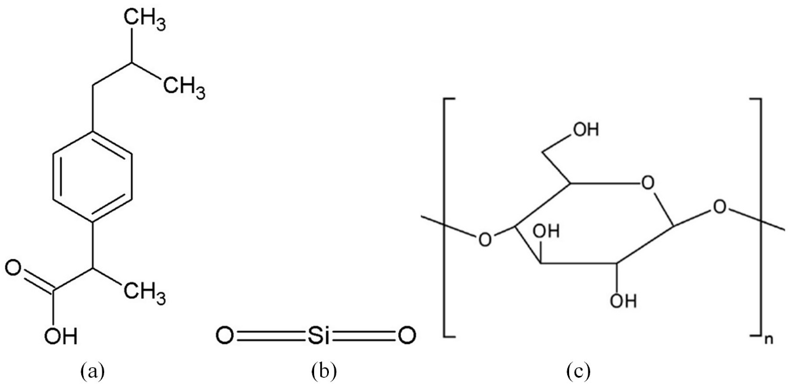

Figure 1. Chemical structure of (a) ibuprofen, (b) silicon dioxide, and (c) microcrystalline cellulose.

2. Experimental
2. 1. Materials
Ibuprofen, Colloidal Silicone Dioxide (Aerosil 200vv) was taken from Aristro Pharma as a gift sample, silicified microcrystalline cellulose were taken from Caplin Point, Chennai. All other chemical were used as analytical grade.
2. 2. Co-processing of ibuprofen and silicified microcrystalline cellulose
Ibuprofen and silicified microcrystalline cellulose were mixed for 10 minutes by blending process using mortar and spatula at laboratory ambient condition (~30 °C and 60% RH). Physical mixture of ibuprofen and silicified microcrystalline cellulose at weight ratio of 1:1 was co-processed by ball-milling in the dry state, and aqueous state kneading and freeze drying and tabulated presented in Table 1.

Table 1. Formulation of co-processing of ibuprofen with silicified microcrystalline cellulose
Formulation code | Ibu : SMCC  (by weight) | Co-processing
I₁S₁P | 1:1 | Physical mixture
I₁S₁B | 1:1 | Dry- state ball milling
I₁S₁F | 1:1 | Aqueous state kneading and freeze drying
(Ibuprofen = Ibu; Silicified microcrystline cellulose = SMCC)

2. 3. Ball milling
The physical mixture of ibuprofen and silicified microcrystalline cellulose in the solid state was placed into a the cylindrical vessel of ball mill (Swastik Electro and Scientific Work, India) and 1 h period of constant milling was done at lab ambient condition at 100 rpm (Figure 2).

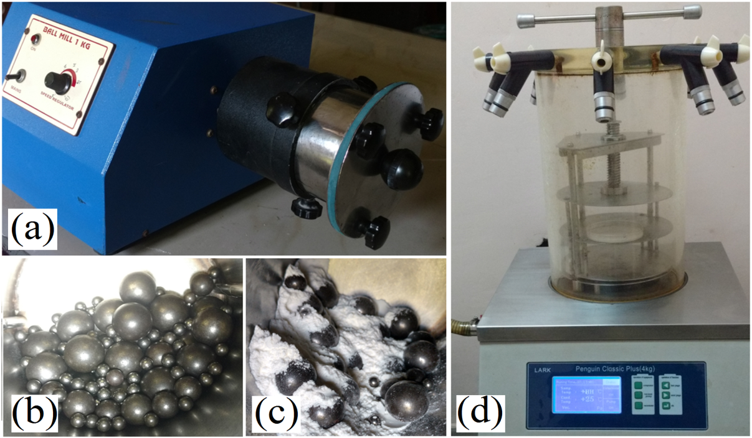

Figure 2. Co-processing of ibuprofen with SMCC: (a) Laboratory Ball mill (1kg) used for solid-state milling; (b) The balls charged for milling process; (c) Ibuprofen -SMCC physical mixture just after loading for the milling process; (d) Freeze dryer used for drying the physical mixer after aqueous state equilibration.

2. 4. Freeze – drying
Sufficient amount of distilled water was added in the physical powder mixture of ibuprofen and silicified microcrystalline cellulose to make slurry and kneaded well for a period of 30 min. The slurry then placed in the dark for a period of about 12 h at room ambient condition for equilibration. The kneaded samples were freeze dried for 12 hours for effective drying. The freeze dried samples were preserved in the desiccators till further analysis.
The ball milled and freeze dried samples were placed at ambient condition for few hours and dried in an incubator (Labotech, India) at 50 °C. The dried powder were passed through mesh 44 (opening ~350µm) and assayed for drug content determination from the absorbance measured at 222 nm (λ_{max}) in the UV visible spectrophotometer (Jasco-V630 UV spectrophotometer).
2. 5. FTIR study
The FTIR spectra of pure ibuprofen and co-processed powder samples were performed for a comparative study between co-milling and co-freeze drying interaction. All the samples were thoroughly mixed with potassium bromide in the ratio 1:100. KBr discs were prepared by compressing the powders at a pressure of 6 tons for the 10 min in a hydraulic pellet press (Technosearch Instruments, Maharashtra, India). FTIR spectrometer (FTIR-4100 type A, Jasco, Tokyo, Japan) was used for collecting all scans from 4000-400 cm⁻¹ of 80 accumulations at a resolution of 4 cm⁻¹ and scanning of 2 mm/s. Spectra manager for windows software (Jasco, Tokyo, Japan) was used for data acquisition and holding.
2. 6. Surface morphology and thermal analysis of the particle
The surface morphology and crystalline nature of the particle samples were investigated by using Scanning Electron Microscope (Instrument: JSM-6390, Jeol, Tokyo, Japan). The dried samples were coated with gold and scanned at room temperature using voltage 10 kV (Wd 19 and spot size 48). Downloaded Imagej software (https://imagej.nih.gov/ij/download.html) was used for determining particle size distribution of the powder samples. Thermal behavior of powder samples were characterized by using Differential Scanning Calorimeter (DSC, Universal V4.2E TA Instrument). Powder samples approximately 2-4 mg were weighed accurately and put into crimped aluminum pans with a pin hole in the lid. All samples were heated at a heating rate of 10° C/min in a nitrogen atmospheric condition up to 300° C.
2. 7. In-vitro dissolution release
Powdered samples containing 10 mg equivalent of ibuprofen were dispersed in 900 ml of distilled water and drug release was carried out using USP XXIV type II dissolution apparatus (Electrolab dissolution tester USP) at a temperature of 37±0.2 °C at an rpm of 100. Ibuprofen concentration was determined by UV absorbance at 222 nm. Samples were withdrawn at appropriate time intervals of 5, 10, 15, 30, 60, 90 and 120 mins, and replaced with a fresh dissolution medium. After proper rinsing of the cuvette and filtration of the sample through a 0.45 µm membrane filter, absorbance was recorded using the UV visible spectrophotometer. Standard calibration curve was used for calculating the respective concentration and the data were reported as the mean of not less than three determinations.
2. 8. Molecular docking analysis
The molecular visualizations and interaction analysis was performed using Discovery studio visualizer (Acceleris Inc.). The 3-D Structure file of ibuprofen was downloaded from Drug Bank (ID: DB01050) as PDB format. The 3-D structures of silicon dioxide and MCC were drawn by using marvin sketch ^{22,23} and saved as PDB extension files. The non-bonded H-atoms were merged, Kollman united atom type charges and solvation parameters were added. The PDBQT files of ibuprofen, MCC and silicon dioxide were prepared with the help of Auto Dock tools programme.²⁴ The ibuprofen non-steroidal anti-inflammatory drug was taken as a ligand to identify its binding affinity against the MCC and silicon dioxide complex (SMCC). In order to understand the interaction between MCC (receptor) with the ligand silicon dioxide another molecular docking experiment was carried out using these molecules. The docking complex stability was measured on the basis of binding constant and interaction energy.
3. Results and discussion
The dry-state co-milling and aqueous state co-processing could be analogous to the commonly followed process in the tablet granulation department of pharmaceutical industries. These processes are simple, effective and scalable for interaction study. Due to presence of varying amount of bound moisture in the native silicified microcrystalline cellulose the milled material became moisty in nature and needed drying. Instant character of freeze dried sample is to absorb moisture like a sponge when left at ambient condition of ∼60 % RH and 30 °C for few hours and drying in an incubator at 50 °C becomes necessary. The co-processed dried and equilibrated powder materials were passed through mesh of opening ~350 μm and assayed for actual drug content determination. Ibuprofen–silicified microcrystalline cellulose interaction study has been characterized by FTIR and the usefulness of this powerful technique has been supported by scanning electron microscopy and differential scanning calorimetry as described below. Drug release from the formulated dosage form is important and ultimately related to the bioavailability of the drug. Dissolution of ibuprofen from the co-processed material has also been described below.
3. 1. FTIR Analysis
Spectral figure and data of FTIR band assignments of ibuprofen and co-processed samples are tabulated presented in Table 2 and Figure 3 respectively. FTIR spectrum of ibuprofen has shown medium to very strong band at 3094, 2958 and 2901 cm⁻¹ assigned to CH₂ asymmetric stretching, CH₃ asymmetric stretching and CH₂.CH symmetric stretching respectively. Strong peaks in the region of 2800–3000 cm⁻¹ of ibuprofen are still present when co-milled in the dry-state as well as co-freeze-dried after aqueous state kneading and equilibration with silicified microcrystalline cellulose assigned to the characteristic symmetric and asymmetric stretching vibrations of alkyl chain. High intensity carbonyl peak at 1722 cm⁻¹ of ibuprofen became very weak after co-processing in the solid-state as well as wet-state with silicified microcrystalline cellulose.²⁵ The band at 1645 cm⁻¹ of silicified microcrystalline cellulose designated to conjugated C=O in the aldehyde on the terminal anhydro-glucose unit is also present in co-processed samples. A strong CH₂ rocking vibration band is noticed at 779 cm⁻¹ in ibuprofen and the intensity observed to be weaker and weaker after co-processing. CH₂ in plane rocking vibration (522 cm⁻¹) is identified in pure ibuprofen and became weaker when co-milled and freeze dried after co-kneading. C-O stretching at 1183, CH₂ scissoring vibration at 1462 and CH-CO deformation at 1420 cm⁻¹ contributed their occurrence strongly in ibuprofen alone and weakly in the co-processed sample. A big broad band between 3200 to 3550 cm⁻¹ attributed to the presence of the O-H stretching frequency of silanol group bonded to the inorganic structure of containing SiO₂ (SMCC), and also hydrogen bonds between adsorbed water and silanol.²⁶ This bulky broad band is not present in ibuprofen pure drug but consistently maintained in all the co-processed formulations might be due to intermolecular hydrogen bonding. The band related to the Si-O-Si (silanol) asymmetric stretching was found at 1059 cm⁻¹ with elevated intensity in SMCC and also in the co-processed materials. Another peak at 451 cm⁻¹ due to O-Si-O bending notably observed in the formulations. The small changes in the band orientation, band intensity and overlapping indicated only Van der Waals or dipole-dipole interactions between ibuprofen and silicified microcrystalline cellulose molecules.

Table 2. Spectral data of FTIR band assignments of ibuprofen and co-processed samples.
Band | Tentative assignment | Wave number (cm⁻¹)
Band | Tentative assignment | Ibuprofen | SMCC | I₁S₁B | I₁S₁F | I₁S₁P
1 | OH stretching | Absent | 3200- 3550 bb | 3200- 3550 bb | 3200- 3550 bb | 3200- 3550 bb
2 | CH₂ asym str | 3094 m | - | absent | absent | absent
3 | CH₃ asym str | 2958 vs | - | 2955 vs | 2954 vs | 2955 vs
4 | CH₂ CH sym str | 2901 s | 2901 s | 2901 s | 2901 s | 2901 s
5 | CH₂ sym str | 2868 m | - | 2868 m | 2869 m | 2868 m
6 | O-H …O valance str combination | 2729 m | - | 2730 m | 2730 m | 2728 m
7 | O-H…O valance str combination | 2630 m | - | 2629 m | 2629 m | 2629 m
8 | C=O str | 1722 vs | - | 1721 vs | 1720 vs | 1722 vs
9 | conjugated C=O stretching mode | Absent | 1645 s | 1645 m | 1645 m | 1645 m
10 | aromatic C=C str | 1507 s | - | 1508 s | 1510 s | 1507 s
11 | CH₃ asym deformation, CH₂ scissoring | 1462 s | - | 1461 s | 1461 s | 1461 s
12 | CH-CO deformation | 1420 s | - | 1420 s | 1422 s | 1420 s
13 | CH3 sym str | 1380 s | - | 1379 s | 1378 s | 1379 s
14 | OH in plane deformation | 1321 s | - | 1321 s | 1321 s | 1321 s
15 | =C-H in plane deformation | 1268 s | - | 1267 s | 1267 s | 1268 s
16 | C…C str | 1230 vs | - | 1231 vs | 1231 vs | 1231 vs
17 | C-O str | 1183 s | - | 1183 s | 1183 s | 1183 s
18 | Si-O-Si  asym str | Absent | 1059 bb | 1066 bb | 1059 bb | 1075 bb
19 | C-O-C str | 970 m | - | - | - | Absent
20 | C-H out of plane vibration | 866 s | - | 865 s | 866 s | 866 s
21 | CH₂ rocking | 779 s | - | 780 s | 780 s | 779 s
22 | CH₂ in plane rocking | 522 m | - | 521 m | 521 m | 521 m
23 | O-Si-O bending | Absent | 451 bb | 461 bb | 461 bb | 451 bb

(s- strong; bb- broad band; mbb- medium broad band; w- weak; sym-symmetrical; asym-asymmetrical; str-stretching; m- medium; vs- very strong; vw – very weak; vvw – very very weak; aa- almost absent.)

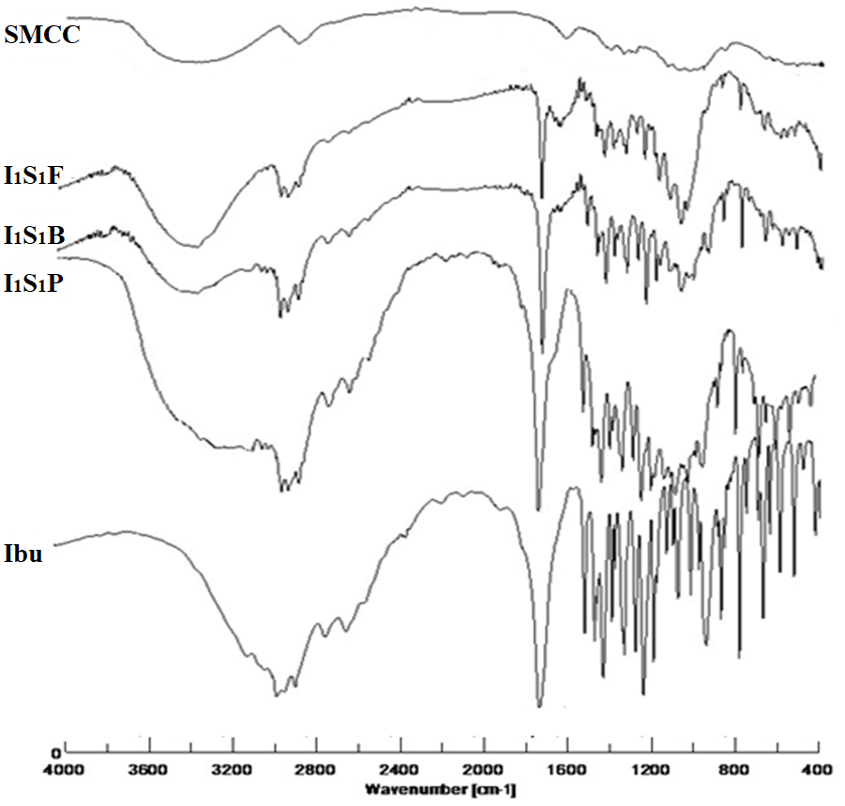

Figure 3. FTIR Spectra of Ibuprofen co-processed with SMCC

3. 2. SEM and DSC
Scanning electron microscopy is a commanding tool for examining the inhibition of crystal growth morphology. Figure 4 shows distinctive plate like geometric layers of the initial samples of pure ibuprofen indicating crystalline nature. Slightly damaged morphology of the crystal geometry of ibuprofen is seen in the physical mixture of 1: 1 ratio of I₁S₁P in presence of fine particles of SMCC. Crystal geometry of ibuprofen has been damaged appreciably after co-milling in the solid-state and co-freeze-drying after aqueous state kneading and equilibration with silicified microcrystalline cellulose. The Feret diameter and its distribution of the powder sample were evaluated opening the SEM image (Figure 5). Feret diameter is an estimate of a
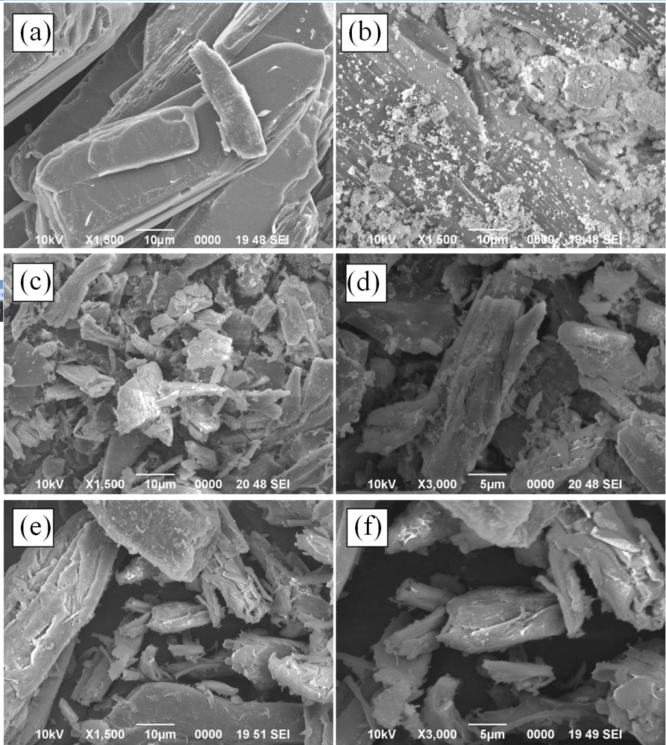

Figure 4. SEM Images (a) Ibu; (b) I₁S₁P; (c) and (d) I₁S₁B; (e) and (f) I₁S₁F.

particle size along a specified direction and can be defined as the distance between the two parallel planes restricting the particle perpendicular to that direction. In both cases (I₁S₁B and I₁S₁F) particle size has been significantly reduced. Irregular particles in agglomerated and discrete forms are prominently seen after co-processing. These noticeable changes in morphology may be due to amorphization of ibuprofen to the large extent.

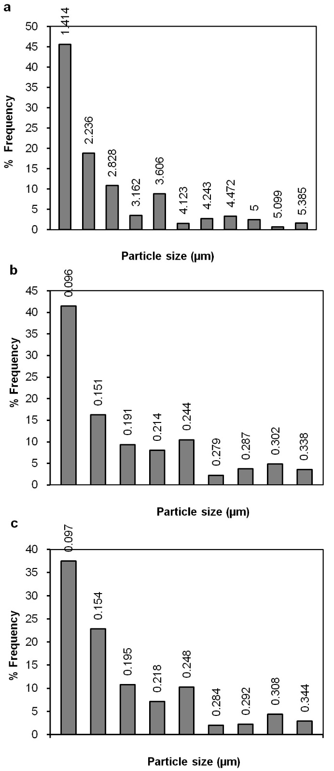

Figure 5. Feret diameter and its distribution of the powder sample estimated from SEM image: (a) Ibu, (b) I₁S₁F, (c) I₁S₁B.

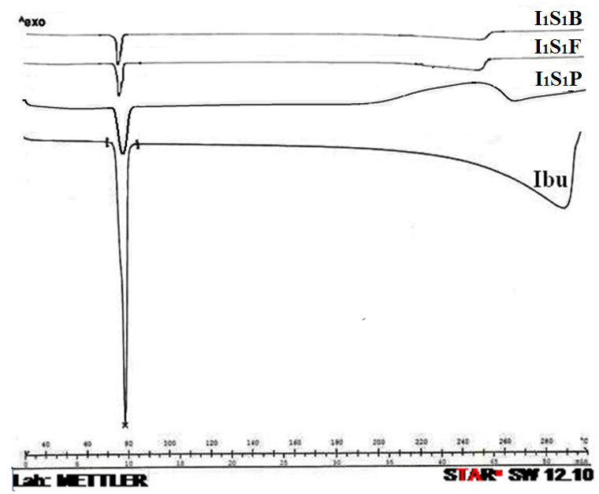

Figure 6. DSC Thermogram of ibuprofen co-processed with SMCC.

Differential scanning calorimetry is frequently used in pharmaceutical research as an analytical tool for the identification and interaction study of active drug after co-processing with other pharmaceutical compounds. It can explain the miscibility/incompatibility with its effects on thermal stability, yielding results promptly and efficiently.²⁷ Thermograms after differential scanning calorimetry of pure ibuprofen and co-processed powder samples are depicted in Figure 6. Pure ibuprofen has shown the melting endotherm at 76.66 °C which is approximately similar to the literature value.²⁸ The peak, onset and endset of melting of ibuprofen in the formulated powder samples have not been changed significantly (Table 3) but the enthalpy of melting (normalized, J/g) of ibuprofen (-322.55) decreased drastically after co-processing and that is the indication of amorphous transformation of ibuprofen in the co-processed formulations. Solid-state ball-milling sample exhibited lesser enthalpy content (-42.93) compared to freeze-dried material (-63.40). This result suggested that the extent of amorphization of ibuprofen is more in I₁S₁B rather than I₁S₁F material.

Table 3. Thermal analysis after co-processing of ibuprofen with microcrystalline cellulose

Formulation | Peak melting  (°C) | Onset  melting (°C) | End set  melting (°C) | Normalized  (J/g)
Ibu | 76.66 | 75.78 | 79.93 | -322.55
I₁S₁P | 76.56 | 73.03 | 80.43 | -72.53
I₁S₁B | 74.71 | 73.04 | 76.34 | -42.93
I₁S₁F | 75.66 | 73.03 | 77.99 | -63.40

3. 3. In-vitro drug release
Figure 7 shows cumulative percentage release of ibuprofen of the co-processed material up to 120 min. The powder materials have shown significantly improved dissolution of drug after co-processing. Comparison of two dissolution profiles is based on the determination of a model independent statistical method, the difference factor f₁ and the similarity factor f₂. Similarity or equivalence between two dissolution profiles is based on f₁ ≤ 15 and f₂ ≥ 50.²⁹⁻³⁴ Significantly improved drug dissolution of solid state milling, and aqueous state kneading and freeze drying has been understood by using f₁ and f₂ values when pair wise formulation vs pure drug was compared (f₁: 32.75, & f₂: 13.29 and f₁: 15.05, & f₂: 28.93 respectively). Crystalline ibuprofen exhibited only 52.89 % dissolution whereas, dry-state co-milling and freeze dried co-processed material has improved dissolution to a great extent (85.84 and 81.35 % respectively). Silicified microcrystalline cellulose has shown more impact in solid state milling compared to aqueous state kneading and equilibration and brought about more amorphization of ibuprofen. As a result more improved dissolution has been achieved in ball milled product.³⁵
Drug release mechanism has been predicted to develop a rational formulation utilizing mathematical models. The drug release data was analyzed by applying different kinetic models as First order, Higuchi, Korsmeyer–Peppas kinetics ^{36,37} using Origin Pro 8.0 (Originlab Corporation, US) software by non-linear regression analysis. These models are represented as follows:
First order model: $Q=100-\exp{(\left(-K_{F}*t\right)+4.605})$ (1)
Higuchi model: $Q=K_{H}× √t$ (2)
Korsmeyer-Peppas model: $Q=K_{p}×t^{n}$ (3)
Q = Cumulative percent drug release at time t
K_{F} = First order release rate constant
K_{H} = Higuchi release rate constant,
K_{P} = Parameter reflecting the structural and geometric characteristics of the delivery device, or Peppas release rate constant,
n = Power law exponent, or release exponent.
This n value indicates drug release controlled by Fick’s laws and also confirmed by the Higuchi model. Matrix controlled release has been followed (Figure 8). The kinetic parameters as per model
are presented in the Table 4. As per Peppas model, n value 0.5 is referred to Fickian release pattern. The n value of I₁S₁P, I₁S₁F and I₁S₁B was found to be 0.400, 0.408 and 0.143 respectively (less than 0.5) which indicated the diffusion controlled release mechanism. The diffusion controlled release mechanism has also been supported by the fitting of Higuchi model (R² is 0.354 - 0.973).

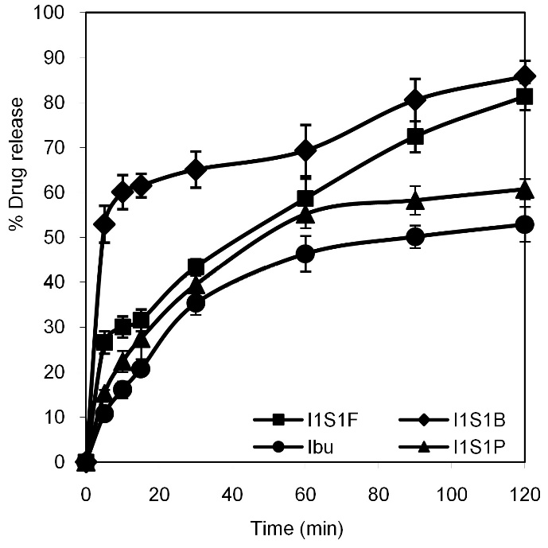

Figure 7. Cumulative percentage release profiles of ibuprofen co-processed with SMCC.

Table 4. Model fitting and kinetic parameters of drug dissolution of ibuprofen co-processed material.
Formulation | f₁ | f₂ | First order |  |  | Higuchi |  |  | Korsmeyer–Peppas
Formulation | f₁ | f₂ | K_{F}  (min⁻¹) | r² | RSS | K_{H}  (%.min^{-1/2}) | r² | RSS | n | K_{P} | r² | RSS
I₁S₁P | 6.25 | 48.96 | 0.011 | 0.789 | 727 | 6.27 | 0.956 | 150 | 0.400 | 9.544 | 0.976 | 69
I₁S₁F | 15.04 | 28.93 | 0.017 | 0.854 | 729 | 7.71 | 0.973 | 133 | 0.408 | 11.363 | 0.990 | 40
I₁S₁B | 32.75 | 13.28 | 0.07 | 0.466 | 2590 | 9.52 | 0.354 | 3131 | 0.143 | 41.497 | 0.986 | 54

RSS= Sum of (Q_{exp} - Q_{calc})^2

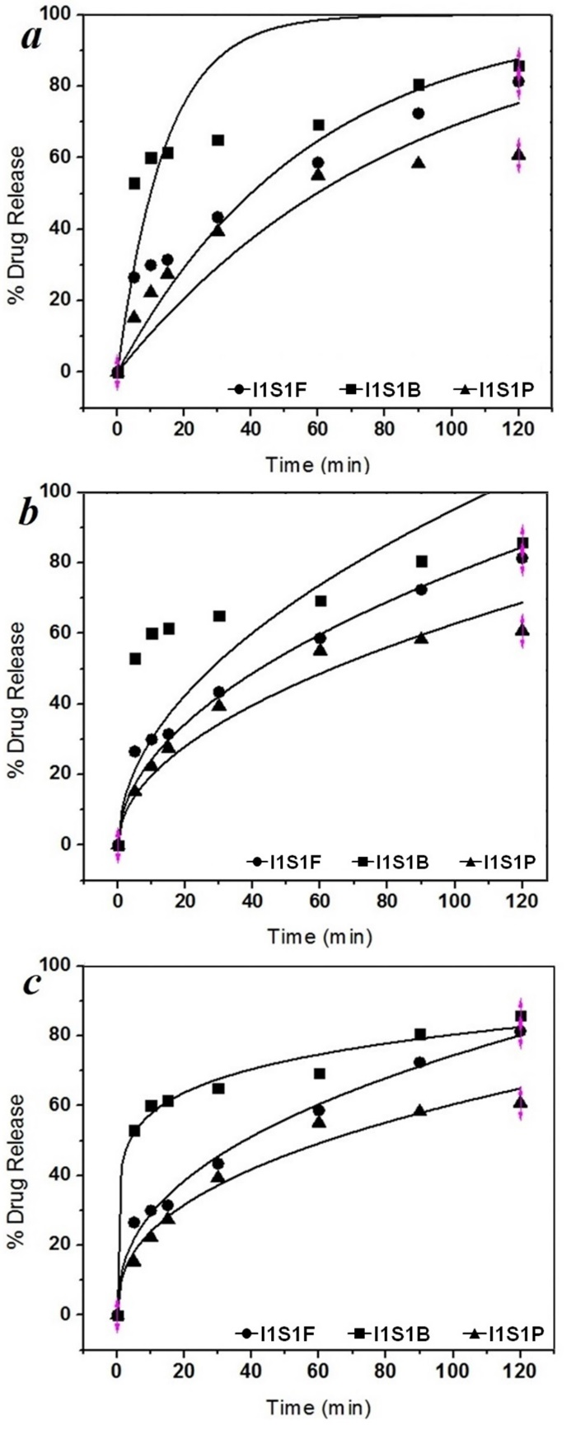

Figure 8. Kinetics of drug release applying kinetic models to plot both the experimental data (symbols) and the models (curves): (a) First order (b) Higuchi (c) Korsmeyer–Peppas.
3. 4. Molecular docking analysis of the complexes
The predicted co-ordinates of ibuprofen and silicone dioxide complex were monitored by molecular docking method Table 5 and Figure 9 respectively. The interaction between MCC-SiO₂ would be obtained from inter molecular hydrogen bonding between OH group of MCC and H atom of SiO₂. The hydrogen bond lengths are varying from 2.028 to 2.056 Å. The binding energy value was found -1.11 kcal/mol. Hydrogen bonding plays a vital role in H-bonded network systems. Hydrogen bond length between ibuprofen and SMCC are ranging from 2.028 to 2.930 Å and the most interesting other probable interaction of Si atom of SMCC molecule with Pi-Orbital of ibuprofen showing bond length of 4.263 Å. The binding energy was found to be -1.73 kcal/mol. The higher negative binding energy values indicate stable interactions than that of lower negative values, which indicate destabilizing interactions. ^{23,38}

Table 5. Molecular docking and binding parameter interactions in the co-processing of ibuprofen with silicified microcrystalline cellulose
Binding  Molecules | Binding  energy  (Kcal/mol) | Binding  atoms | Bond name | Bond length (Å)
MCC – SiO₂  (SMCC) | -1.11 | OH --- O H --- O | Hydrogen Bond  Hydrogen Bond | 2.028  2.056
SMCC - Ibuprofen | -1.73 | OH --- O  OH --- O  H --- O  Si --- Pi-orbital | Hydrogen Bond  Hydrogen Bond  Hydrogen Bond  Pi-Sulfur Bond | 2.028  2.930  2.056  4.263

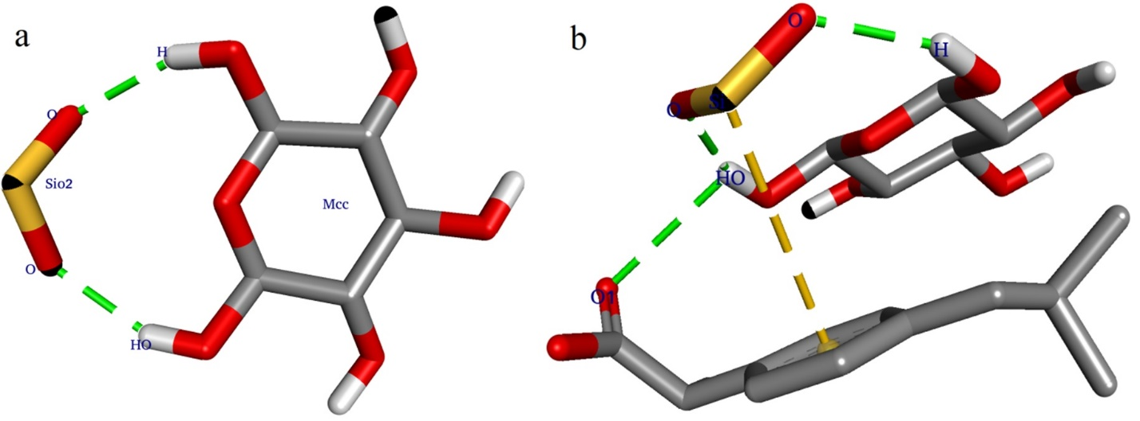

Figure 9. Molecular docking study of (a) SMCC (binary); and (b) ibuprofen-microcrystalline cellulose -silicon dioxide (ternary).

4. Conclusions
Binding interactions of ibuprofen and silicified-microcrystalline cellulose (SMCC) has been analysed. The dry-state and aqueous state co-processing of ibuprofen was performed by co-milling and co-freeze-drying after aqueous state kneading and equilibration with silicified microcrystalline cellulose in at laboratory scale to investigate the effect of silicified-microcrystalline cellulose on ligand. The changes in the band intensity, band orientation, and overlapping of FTIR indicated only the H-bond, Vander Waals and/or dipole-dipole interactions between ibuprofen and silicified microcrystalline cellulose molecules. SEM study revealed that the ibuprofen crystal morphology has been damaged appreciably after co-processing in the solid-state and wet-state with SMCC. Thermal analysis has shown significantly decreased enthalpy of melting of ibuprofen after co-processing with SMCC. Silicified microcrystalline cellulose has transformed more amorphization of ibuprofen by solid state milling compared to aqueous state kneading and freeze drying and brought about more improved dissolution of ibuprofen of ball milled product rather than freeze dried product. Matrix controlled release mechanism has been predicted utilizing mathematical kinetic models. Molecular docking study revealed the formation of ibuprofen complex through hydrogen bonding with MCC and silicon dioxide. The binding energy between MCC and SiO₂, and ibuprofen and SMCC were found as -1.11 and -1.73 kcal/mol respectively.
5. Acknowledgements
The authors are acknowledging gratefulness to the Department of Science & Technology, Ministry of Science & Technology, New Delhi, India, for providing INSPIRE fellowship to Rudra Narayan Sahoo (IF 150987). The authors are also very much grateful to Prof. Manoj Ranjan Nayak, President, Siksha O Anusandhan (Deemed to be University) for providing other facilities and encouragement.
Conflicts of interest
The authors declare that there is no conflict of interest.

6. References
- W. P. Sohtun, A. Kannan, K. Hari Krishna, D. Saravanan, M. S. Kumar, M. Velusamy, Acta Chim. Slov. 2018, 65, 621–629.
- G. M Morris, R. Huey, W. Lindstrom, M. F. Sanner, R. K. Belew, D. S. Goodsell, A. J. Olson, J. Comput. Chem. 2009, 16, 2785-2791.
- P. O. Carvalho, Q. B. Cass, S. A. Calafatti, F. J. Contesini, R. Bizaco, Braz. J. Chem. Eng. 2006, 23(03), 291–300.
- T. Chaban, V. V. Ogurtsov, V. S. Matiychuk, G. Chaban, L. Demchuk, A. Nektegayev, Acta Chim. Slov. 2019, 66, 103–111.
- Q. Wei, H. Yuanzhi, G. Zhen, L. Zhang, W. Li, Y. Xianzhen, S. Shakya, A. Maharjan, T. Yan, Z. Weifeng, Z. Jiwen, Asian J. Pharm. Sci. 2018, 4, 1-9.
- M. Mombeini, G. Saki, L. Khorsandi, N. Bavarsad, Medicina, 2018, 54(1), 1-9.
- R. Lobenberg, G. L Amidon, Eur. J. Pharm. Biopharm. 2000, 50(1), 3-12.
- R. P. Swain, B. B. Subudhi, Drug. Dev. Ind. Pharm. 2019, (Published online: 16 Feb 2019). https://doi.org/10.1080/03639045.2019.1572183
- S. Mallick, S. Pattnaik, K. Swain, P. K. De, Drug Dev. Ind. Pharm. 2007, 33, 535-541.
- S. Mallick, S. Pattnaik, K. Swain, P. K De, A. Saha, G. Ghoshal, A. Mondal, Drug Dev. Ind. Pharm. 2008, 34, 726-734.
- S. Mallick, A. Sahu, K. Pal, Acta Pol. Pharm. 2004, 61, 21-30.
- S. Bozdag-Pehlivan, B. Subasi, I. Vural, N. Unlu, Y. Capan, Acta Pol. Pharm. 2011, 68, 423-433.
- E. Vranic, A. Uzunovic, J. Basic Med. Sci. 2010, 10(3), 197-203.
- R. H. Dave, Overview of Pharmaceutical Excipients used in tablets and capsules, https://www.drugtopics.com/hospitalhealth-system-pharmacy/overview-pharmaceutical-excipients-used-tablets-and-capsules, (assessed: March 13, 2019)
- S. Lijun, L. Liping, S. Xiaoying, C. Honglang, Z. Shumin, C. Wenfeng, Z. Ruoxia, Z. Wenchang, Asian J. Pharm. Sci. 2018, 19(13), 1-10.
- R. Vasluianu, D. A. Forna, M. Zaltariov, A. Murariu, Rev. Chim. (Bucharest). 2016, 67(12), 2475-2478.
- M. S. Bhandari, S. M. Wairkar, U. S. Patil, N. R. Jadhav, Acta Chim. Slov. 2018, 65, 492–501.
- F. Dragan, I. Kacso, S. Dreve, F. Martin, G. Borodi, I. Bratu, K. Earar, Rev. Chim. (Bucharest). 2015, 66(2), 191-195.
- B. Tita, G. Furau, E. Marian, D. Tita, C. Furau, Rev. Chim. (Bucharest). 2016, 67(4), 706-710.
- A. Uzunovic, E. Vranic, Bosn. J. Basic Med. Sci. 2007, 7(3), 279-283.
- E. Marian, T. Jurca, B. Tita, P. Sfirloaga, D. Tita, N. Duteanu, Rev. Chim. (Bucharest). 2015, 66(4), 477-481.
- J. Maharana, M. C. Patra, B. C. De, B. R. Sahoo, B. K. Behera, S. De, S. K Pradhan, J. Mol. Recog. 2014, 27(5), 260-275.
- R. Mohapatra, S. Mallick, A. Nanda, R. N. Sahoo, A. Pramanik, A. Bose, D. Das, L. Pattnaik, RSC Adv. 2016, 6, 31976–31987.
- G. M. Morris, D. S. Goodsell, R. S. Halliday, R. Huey, W. E. Hart, R. K. Belew, A. J. Olson, J. Comput Chem. 1998, 19(14), 1639-1662.
- S. Mallick, S. K. Pradhan, R. Mohapatra, Int. J. Biol. Macromol. 2013, 60, 148–155.
- A. L. Balieiro, R. A. Santos, M. M. Pereira, R. T. Figueiredo, L. S. Freitas, O. L. S. de Alsina, A. S. Lima, C. M. F. Soares, Braz. J. Chem. Eng. 2016, 33(2), 361-372.
- B. Panda, A. S. Parihar, S. Mallick, Int. J. Biol. Macromol. 2014, 67, 295–302.
- S. Mallick, S. K. Pradhan, M. Chandran, M. Acharya, T. Digdarsini, R. Mohapatra, Results Pharm. Sci. 2011, 1(1), 1-10.
- S. Yıldız, E. Aytekin, B. Yavuz, S. Bozdag-Pehlivan, N. Unlu, Drug Dev. Ind. Pharm. 2016, 42(6), 1008-1017.
- B. Tubic, A. Uzunovic, S. Pilipovic, Z. Gagic, Acta Chim. Slov. 2016, 63, 193–199.
- E. Vranic, A. Uzunovic, Bosn. J. Basic Med. Sci. 2009, 9(3), 245–249.
- P. Costa, J. Manuel, S. Lobo, Eur. J. Pharm. Sci. 2001, 13, 123–133.
- A. Pramanik, R. N. Sahoo, A. Nanda, R. Mohapatra, R. Singh, S. Mallick, Curr. Eye Res. 2018, 43(6), 828-838.
- D. Vetchy, M. Vetcha1, M. R. Artina, E. Gryczova, L. Bartošikova, Medicina, 2007, 43(4), 326-330.
- S. Mallick, S. Pattnaik, K. Swain, P. K. De, Drug Dev. Ind. Pharm. 2007, 33(8), 865-873.
- S. Mallick, K. Roy, A. Saha, Acta Pol. Pharm. 2002, 59(3), 193-198.
- S. Mallick, B. K. Gupta, S. K. Ghoshal, J. Sci. Ind. Res. 1999, 58, 1010-1016.
- A. Nanda, R. N. Sahoo, A. Pramanik, R. Mohapatra, S. K. Pradhan, A. Thirumurugan, D. Das, S. Mallick, Colloids Surf. B Biointerfaces. 2018, 172, 555–564.

Figure captions
Figure 1. Chemical structure of (a) ibuprofen, (b) silicon dioxide, and (c) microcrystalline cellulose.

Figure 2. Co-processing of Ibuprofen with SMCC. (a) Laboratory Ball mill (1kg) used for solid-state milling; (b) The balls charged for milling process; (c) Ibuprofen -SMCC physical mixture just after loading for the milling process; (d) Freeze dryer used for drying the physical mixer after aqueous state equilibration.

Figure 3. FTIR Spectra of Ibuprofen co-processed with SMCC.

Figure 4. SEM Images (a) Ibu; (b) I₁S₁P; (c) and (d) I₁S₁B; (e) and (f) I₁S₁F.

Figure 5. Feret diameter and its distribution of the powder sample estimated from SEM image: (a) Ibuprofen, (b) I₁S₁F, (c) I₁S₁B.

Figure 6. DSC Thermo gram of ibuprofen co-processed with SMCC.

Figure 7. Cumulative percentage release profiles of ibuprofen co-processed with SMCC.

Figure 8. Kinetics of drug release applying kinetic models to plot both the experimental data (symbols) and the models (curves): (a) First order (b) Higuchi (c) Korsmeyer–Peppas.

Figure 9. Molecular docking study of (a) SMCC (binary); and (b) ibuprofen-microcrystalline cellulose -silicon dioxide (ternary).

