New fluorescent, thermally stable and film forming polyimines containing naphthyl rings
Farah Qureshi*, Muhammad Yar Khuhawar and Taj Muhammad Jahangir
Institute of Advanced Research Studies in Chemical Sciences, University of Sindh, Jamshoro, Sindh-Pakistan
*Corresponding author, Tel: +92-229213213, +92-3313534844
E-mail: farahqureshi94@yahoo.com
Abstract
Three new aliphatic-aromatic polymers having naphthyl rings were prepared by the polycondenstion of dialdehydes or diketone monomers with 1,5-naphthalenediamine or 1,4-phenylenediamine. The monomers were prepared by the reaction of aromatic aldehyde or ketone wirh 1,6-dibromohexane. The molecular mass of the monomers was confirmed through E.I mass spectroscopy. The structures of monomers and polymers were confirmed by CHN analysis, ¹HNMR, FT-IR and UV-Vis Spectroscopy. Fluorescence emission of monomers and polymers were recorded, all the compounds showed fluorescence property and two of the polymers (PoHOBND and PoHOAND) indicated different colors of fluorescence emissions. The surface morphology of the synthesized compounds was observed through SEM images. Thermal stability of polymers was measured by TG and DTA and all the polymers showed high thermal stability. The polymers were also tested for their antimicrobial activities against different bacterial and fungal species. Thin film forming ability of the synthesized polymers was evaluated by making their blends with PVC (poly vinyl chloride) in different w/w% ratios.
Keywords: Polyimines, fluorescence, thermal stability, thin films, morphology
1. Introduction
Schiff base polymers also called polyimines or polyazomethines (CH=N) have been the subject of interest from last several decades and prepared by the polycondensation reaction of carbonyl compounds (dialdehydes or diketones) with aliphatic or aromatic diamines.¹⁻³ The researchers are attracted towards the synthesis of new polyimines because of their advantageous properties such as liquid-crystalline,⁴ fluorescence,^{5,6} optical and electronic properties,^{7,8} high thermal stability,^{9,10} fiber forming,^{11,12} thin film forming¹³⁻¹⁵, coordination abilities with metal ions and antimicrobial activities.^{16,17} These properties make them important candidate for their application in solar cells,^{18,19} optoelectronic sensors,²⁰ photo-luminescent devices,²¹ aerospace,²² packaging materials and antifouling paints.²³ The redox activity of the Schiff base polymers was also reported, therefore they can be employed as redox indicators.²⁴ The Polymer blends are also seeking attention in technological fields from the last two decades because of their mechanical properties which can be altered according to desired application, the polymer blends comprise about 30% of the total industrial plastic products.²⁵ However aromatic polyimines are difficult to process due to their low solubility, low molecular weights and high melting points which limits their applications.²⁶ To overcome these difficulties researchers have made different attempts which are introduction of ester, ether, alkyl or alkoxy groups and chains of methylene spacers between the aromatic rings.^{27,28} In the present work three new polyimines were prepared by the polycondensation reaction of dialdehydes or diketone monomers with diamines, the polymers have flexible aliphatic spacers of n-hexane, ether linkages between the aromatic rings and one of the polymers contain alkyl group attached with the imine bond. These structural variations were made to study their effects on the solubility and other properties (thermal stability, fluorescence and thin film forming ability) of polyimines.
2. Experimental
2.1. Materials
3-hydroxybenzaldehyde (Sigma-Aldrich Corp. St. Louis, MO USA), 2-hydroxyacetophenone (Fluka, Switzerland), 2-hydroxynaphthaldehyde (Sigma-Aldrich Corp. St. Louis, MO USA), 1,6-dibromohexane (Sigma Aldrich, St. Louis USA), 1,4-phenylenediamine (Alfa-Aesar, UK), 1,5-naphthalenediamine (Toshima, Kita-ka, Tokyo, Japan), N,N-dimethylformamide (AnalaR BDH, England), dimethylsulfoxide (AnalaR BDH, England), anhydrous sodium carbonate (Sigma-Aldrich, Germany), p-toluenesulfonic acid monohydrate (Daejung Chemicals & Metals Co. Ltd. Korea), ethanol (E. Merck, Germany), potassium hydroxide (E. Merck, Gerrmany), chloroform (Merck, KGaA, Darmstadt, Germany), tetrahydrofuran (THF) (E. Merck, Germany), acetone (Sigma-Aldrich Chemie GmbH, Steinheim, Germany), poly vinyl chloride (Sigma-Aldrich Corp. St. Louis, MO USA) and distilled water from all glass were used.
2.2 Characterization
The melting point of the monomers and polymers were recorded on Gallenkamp Melting point apparatus (made in England) equipped with thermometer. The E.I mass spectra of the monomers were recorded on JEOL JMS-600 (Japan) mass spectrometer at HEJ Research Institute of Chemistry, University of Karachi, Sindh-Pakistan. The CHN analysis of two polymers (PmHOBND and PpHOAND) was performed on elemental analyser model EA1110 at Elemental Microanalysis Ltd, 1 Hameldown Road, Okehampton, Devon, EX20 1UB, United Kingdom and CHN analysis of one polymer (PoHONPD) was performed on CHNS analyzer Thermo Nicolet Flash EA 1112 Series CHNS analyzer at NCEAC, University of Sindh, Jamshoro, Sindh-Pakistan. The Proton NMR (¹HNMR) spectra of the monomers and polymers were recorded on BRUKER AVANCE-NMR 400 MHz spectrometer at HEJ Research Institute of Chemistry, University of Karachi, Sindh-Pakistan, using TMS as internal standard and deuterated dimethylsulfoxide (DMSO-d₆) as solvent. The FT-IR spectra of the monomers and polymers were recorded on Thermo Scientific™ Nicolet iS10 FT-IR Spectrometer with Attenuated total reflectance (ATR) accessory equipped with OMNIC™ Software. The UV-Visible spectra of monomers and polymers were recorded within 200-700 nm spectral range on a double beam spectrophotometer Shimadzu UV-1800 with UV Probe software at Mehran University of Engineering & Technology, Jamshoro, Sindh-Pakistan, using 1 cm quartz cuvettes and DMSO was used as solvent. The Fluorescence emission spectra of monomers and polymers were recorded on Spectrofluorophotometer RF-5301PC Series (Shimadzu, Kyoto, Japan) using 1cm quartz cuvette and DMSO as solvent. The morphologies of the compounds were observed through SEM images recorded on Scanning Electron Microscope JEOL JSM-6490 LV at Center for Pure and Applied Geology, University of Sindh, Jamshoro, Sindh-Pakistan or on JEOL JSM 5910 at Centralized Resource Laboratory (CRL), University of Peshawar, Peshawar-Pakistan, the accelerating voltage was 15 kV. The TG/DTA graphs of monomers and polymers were recorded at Centralized Resource Laboratory, University of Peshawar, Peshawar- Pakistan on Pyris Diamond Series TG/DTA (Perkin Elmer, USA) thermal analyzer in nitrogen atmosphere with flow rate of 20 ml/ min and heating rate of 20°C/min, the sample (5-10 mg) was placed on ceramic pan and heated from 50˚C to 800˚C using alumina as reference material. Thin film forming ability of the polymers were tested by making their blends with PVC (poly vinyl chloride), the polymer-PVC blends were prepared in different (10 to 50%) w/w ratios of polymer-PVC, the polymers were dissolved separately in DMSO while PVC was dissolved in THF and their mixtures in above mentioned ratios were transferred in glass Petri dishes of 2 inch diameter, then the petri dishes were placed in an oven at 60˚C for evaporating the solvent, after drying the resulting thin films were removed from the glass surface of petri dishes with the help of spatula and the film forming ability of the polymers was confirmed when the thin layers were easily separated from the glass surface without breaking. Antibacterial activities of the polymers were examined by microplate alamar blue assay using 96 well plate method, the antibacterial activities of the polymers were tested against different strains of bacteria which includes Staphylococcus aureus, Salmonella typhi, Pseudomonas aeruginosa, Bacillus subtilis and Escherichia coli using Ofloxacin as standard drug, 2 or 4 mg of the polymer was dissolved in DMSO to make concentration 50 or 200 µg/ml, for bacterial growth Mueller-Hinton Agar medium was used and the incubation period was 18 to 20 hrs. The % inhibition of bacterial species by the polymers was calculated by using reported method and formula given as equation 1.²⁹ The antifungal activities of the polymers were tested by agar tube dilution method against different fungal strains which were Candida albicans, Canadida glabrata, Aspergillus nigar, Fusarium lini, Trichphyton rubrum and Microsporum canis using standard drug Amphotericin B for Aspergillus nigar and Miconazole for other species, SDA (Sabouraud dextrose agar) media was used for fungal growth, 12 mg of polymer was dissolved in DMSO to make concentration 200 µg/ml, the incubation period was 7 days and the temperature was 27˚C, % inhibition of fungal strains by the polymers was calculated using the formula given as equation 2.

$\% inhibition=\frac{\left(ε_{ox}\right)λ_{2}Aλ_{1}-\left(ε_{ox}\right)λ_{1}Aλ_{2}}{\left(ε_{red}\right)λ_{1}A{'λ}_{2}-\left(ε_{red}\right)λ_{2}A{'λ}_{1}}×100………(1$)

$$\% Inhibition = 100 –\frac{linear growth in test (mm)}{linear growth in control (mm)}×100………(2)$$
2.3. Synthesis of monomers
Three new monomers (two dialdehydes and one diketone) were prepared by following a reported procedure.³⁰⁻³² 3-hydydroxybenzaldehyde, 2-hydroxynaphthaldehyde or 2-hydroxyacetophenone (0.2 mol) dissolved in 50 ml of DMF was added into 250 ml round bottom flask equipped with a condenser and magnetic stirrer, 0.25 mol anhydrous sodium carbonate and 0.1 mol of 1,6-dibromohexane were also added to the reaction flask. The contents were refluxed for 5 h at 150°C with continuous stirring, the resulting product was poured into 500 ml cold water and allowed to form precipitates. The precipitates were filtered and washed once with 0.1 M potassium hydroxide and then three times with distilled water, dried and recrystallized from ethanol. The structures and the reactions for the syntheses of monomers are given in Figure 1.
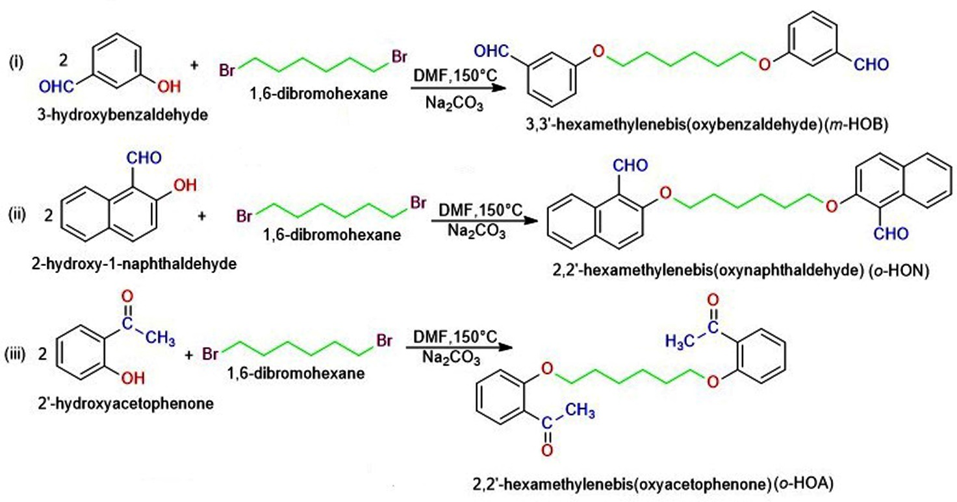
Figure 1. Synthetic reactions for the dialdehydes or diketone monomers
2.3.1. 3,3’-hexamethylenebis(oxybenzaldehyde) (m-HOB)
Yield=78%, Mp. 60˚C, C₂₀H₂₂O_{4,} FT-IR cm⁻¹ (relative intensity) 3066(w), 2944(w), 2912(w), 2866(w), 2808(w), 2719(w), 1717(m), 1694(s), 1592(m), 1486(m), 1472(m), 1450(m), 1384(m), 1323(m), 1294(w), 1258(s), 1169(s), 1148(m), 1082(w), 1021(s), 990(w), 931(w), 876(w), 864(w), 785(s), 755(s), 730(w), 682(s). ¹HNMR (DMSO-d₆), δ ppm 1.489(q), 1.762(t), 4.050(t), 7.258(m), 7.405(d), 7.486(m), 9.959. UV (DMSO), λ-max, nm (ε, L.mole⁻¹ cm⁻¹) 314(6976). E.I mass spectrum m/z (relative intensity %) M⁺ 326(33.2), 297(1.3), 221(1.5), 205(8.1), 177(5.0), 163(2.5), 149(3.0), 135(10.9), 121(31.6), 105(19.4), 83(65.5), 55(100).
2.3.2. 2,2’-hexamethylenebis(oxynaphthaldehyde) (o-HON)
Yield=85%, Mp. 180˚C, C₂₈H₂₆O_{4,} FT-IR cm⁻¹ (relative intensity) 2939(w), 2878(w), 1990(w), 1661(s), 1620(w), 1590(m), 1511(m), 1459(w), 1434(m), 1368(w), 1343(m), 1268(m), 1246(s), 1150(s), 1058(s), 1022(m), 942(w), 900(w), 866(w), 804(s), 758(s), 708(m), 645(s). ¹HNMR (DMSO-d₆), δ ppm 1.361, 1.455(d), 1.575, 1.871, 4.324(t), 7.446(t), 7.589(m), 7.925(d), 8.257(q), 9.083(d), 10.794. UV (DMSO), λ-max, nm (ε, L.mole⁻¹ cm⁻¹) 320(3043), 340(2199). E.I mass spectrum m/z (relative intensity %) M⁺ 426(52.2), 398(89.9), 397(28.3), 271(3.5), 255(19.3), 241(1.0), 227(8.2), 213(4.4), 199(3.2), 185(21.8), 171(100), 155(7.7), 83(30.6), 55(57.2).

2.3.3. 2,2’-hexamethylenebis(oxyacetophenone) (o-HOA)
Yield=81%, Mp. 80˚C, C₂₂H₂₆O_{4,} FT-IR cm⁻¹ (relative intensity) 2951(w), 2870(w), 1661(s), 1593(s), 1575(w), 1485(m), 1469(w), 1449(m), 1411(w), 1395(w), 1361(m), 1293(s), 1232(s), 1162(m), 1129(m), 1043(m), 1014(m), 865(m), 828(w), 763(s). ¹HNMR (DMSO-d₆), δ ppm 1.530(t), 1.815(t), 2.534(d), 4.099(t), 6.989(t), 7.136(d), 7.500(m), 7.557(m). UV, λ-max, nm (ε, L.mole⁻¹ cm⁻¹) 306(7076), 444(233.7). E.I mass spectrum m/z (relative intensity %) M⁺ 354(2.3), 339(19.5), 235(13.5), 219(20), 191(3.0), 177(1.5), 163(1.7), 149(23.9), 135(2.9), 119(13.9), 83(69.4), 55(100), 43(37.3).
2.4. Synthesis of polymers
Three new polymers were synthesized by following reported method³⁰⁻³² with slight modification in the procedure as under: 5mmol of monomer (m-HOB, o-HON or o-HOA) dissolved in 25 ml DMF and 5mmol of diamine (1,5-naphthalenediamine or 1,4-phenylenediamine) dissolved in 25 ml DMF were transferred in a 250 ml round bottom flask equipped with condenser and magnetic stirrer bar and 0.01 g of p-toluenesulfonic acid was also added into the flask as catalyst. The contents were refluxed for 6 to 7 hours with continuous stirring in nitrogen atmosphere. The resulting product was poured into 250 or 500 ml distilled water and allowed to settle precipitates. The product was filtered and finally dried at room temperature. The synthetic reactions for the polymers with their structures are given in Figure 2.
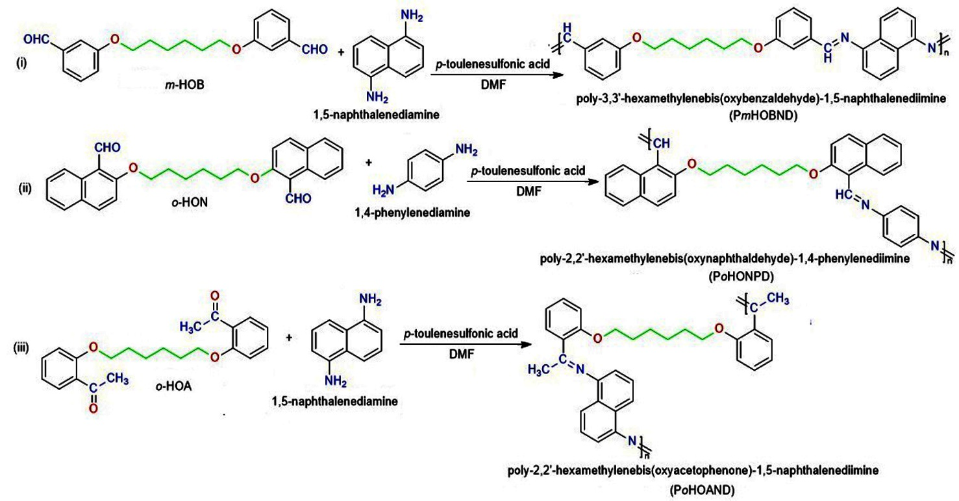
Figure 2: Synthetic reactions for the polyimines
2.4.1. poly-3,3’-hexamethylenebis(oxybenzldehyde)-1,5-naphthalenediimine (PmHOBND)
Yield = 76%, Mp. 210˚C (decomposed), CHN analysis calculated for (C₃₀H₂₈N₂O₂)_{n ,}% C=80.35, H=6.25, N=6.25, found % C=80.50, H=6.51, N=5.82. FT-IR, cm⁻¹ (rel. intensity), 2939(w), 2863(w), 1694(w), 1620(m), 1578(s), 1503(w),1485(w), 1447(m), 1404(w), 1360(w), 1360(w), 1318(w), 1248(s), 1206(s), 1174(w), 1150(m), 1024(m), 992(w), 974(w), 862(w), 778(s), 684(m). ¹HNMR (DMSO-d₆), δ ppm 1.496, 1.764, 2.721, 2.880, 4.052(m), 7.942, 9.980. UV (DMSO), λ-max nm (1% absorptivity) 287(145), 321(236.5).
2.4.2. poly-2,2’-hexamethylenebis(oxynaphthaldehye)-1,4-phenylenediimine (PoHONPD)
Yield=78%, Mp. 185-210˚C, CHN analysis calculated for (C₃₄H₃₀N₂O₂)_{n}, % C= 81.92, H=6.02, N=5.62, found % C=81.64, H=6.02, N=6.01. FT-IR, cm⁻¹ (rel. intensity) 3367(w), 2936(w), 2857(w), 1683(w), 1618(w), 1592(s), 1505(w), 1487(w), 1456(m), 1387(w), 1285(m), 1243(s), 1188(w), 1143(s), 1101(s), 1073(w), 1005(w), 887(w), 826(m), 754(s), 722(m). ¹HNMR (DMSO-d₆), δ ppm 2.722, 2.881, 7.942. UV (DMSO), λ-max nm (1% absorptivity) 265(1120), 318(940)
2.4.3. poly-2,2’-hexamethylenebis(oxyacetophenone)-1,5-naphthalenediimine (PoHOAND)
Yield=74%, Mp. 250˚C (decomposed), CHN analysis calculated for (C₃₂H₃₂N₂O₂)_{n}, % C= 80.67, H=6.72, N=5.88, found % C=79.85, H=5.14, N=5.78. FT-IR, cm⁻¹ (rel. intensity) 3339(w), 2938(w), 1594(s), 1517(w), 1485(w), 1450(s), 1407(w), 1358(w), 1293(m), 1237(m), 1164(w), 1122(w), 1033(w), 1010(w), 754(s), 681(m). ¹HNMR (DMSO-d₆), δ ppm 1.223, 1.417(m), 1.666, 1.775(t), 2.275, 4.078(t), 6.594(t), 6.736(d), 6.986(t), 7.039, 7.114(m), 7.197(m), 7.308(t), 7.509(m). UV (DMSO), λ-max nm (1% absorptivity) 307(1580), 477(500).
3. Results and Discussion
3.1. Synthesis
Three new monomers (dialdehydes or diketone) m-HOB, o-HON and o-HOA were prepared by condensation of 3-hydroxybenzaldehyde, 2-hydroxynaphthaldehyde or 2-hydroxyacetophenone with 1,6-dibromohexane. The monomers were obtained in good yield (78-85%). In the present work new meta oriented dialdehyde m-HOB was prepared while its ortho and para oriented isomers were reported in our earlier work^{30,31}. Three new polyimines (PmHOBND, PoHONPD and PoHOAND) were prepared by the polycondensation of dialdehydes or diketone monomers (m-HOB, o-HON or o-HOA) with diamines (1,5-naphthalenediamine or 1,4-phenylenediamine). The polymers have ether linkages, azomethine or imine bonds and spacers of n-hexane between the aromatic rings and the polymer derived from diketone monomer (o-HOA) contains methyl group attached with the imine (C=N) group. The polymers were also obtained in good yield (74-78%). The synthesized polymers can also be called as polyethers because all the three polymers contain ether linkages in their main chain.
3.2. Solubility
The solubility of the monomers and polymers was tested in various solvents and the results are given in Table 1. The monomers were soluble in organic solvents and insoluble in water. The polymer PmHOBND was soluble in chloroform and THF without heating while in DMSO and DMF on heating, the polymer PoHONPD was soluble in DMF and DMSO on heating and the polymer PoHOAND indicated highest solubility in all the tested solvents except water, it is soluble in chloroform, acetone, THF, DMF and DMSO without heating while in ethanol with heating. The increased solubility of the polymer PoHOAND may be due to presence of methyl side group attached with the imine bond.
Table 1. Solubility of monomers and polymers in different solvents at the concentration of 5mg/ 5ml
S.No | Compound | Solubility in different solvents
S.No | Compound | H₂O | Ethanol | Acetone | Chloroform | THF | DMF | DMSO
1 | mHOB | IS | S | S | S | S | S | S
2 | oHON | IS | PS(∆) | S(∆) | S | S | S | S
3 | oHOA | IS | S | S | S | S | S | S
4 | PmHOBND | IS | IS | SS | S | S | S(∆) | S(∆)
5 | PoHONPD | IS | SS(∆) | PS(∆) | PS | PS | S(∆) | S(∆)
6 | PoHOAND | IS | S(∆) | S | S | S | S | S
S=Soluble, S(∆)=Soluble on heating, PS=Partially Soluble, PS(∆)=Partially Soluble on heating, SS=Slightly Soluble, IS=Insoluble

3.3. E.I mass spectrum of monomers
The mass spectrum of the dialdehyde m-HOB indicated M⁺ at m/z 326 and other fragment ion peaks appeared at m/z 297, 221, 205, 177, 163, 149, 135, 121 and 105 corresponding to [M-(CHO)]⁺, [M-(C₆H₄.CHO)]⁺, [M-(O.C₆H₄.CHO)]⁺, [CHO.C₆H₄.O.(CH₂)₄]⁺, [CHO.C₆H₄.O.(CH₂)₃]⁺, [CHO.C₆H₄.O.(CH₂)₂]⁺, [CHO.C₆H₄.O.CH₂]⁺, [CHO.C₆H₄ .O]⁺ and [CHO.C₆H₄]⁺ respectively while the peaks at 83(65.5%) and 55(100%) corresponded to C₆H₁₁ and C₄H₇ (supplementary Fig. S1).
The mass spectrum of the dialdehyde o-HON indicated M⁺ at m/z 426 and the other fragment ion peaks appeared at m/z 398, 397, 271, 255, 241, 227, 213, 199, 185, 171(100%) and 155 corresponding to [M-(CHO)+1]⁺, [M-(CHO)]⁺, [M-C₁₀H₆.CHO]⁺, [CHO.C₁₀H₆.O.(CH₂)₆]⁺, [CHO.C₁₀H₆.O.(CH₂)₅]⁺, [CHO.C₁₀H₆.O.(CH₂)₄]⁺, [CHO.C₁₀H₆.O.(CH₂)₃]⁺, [CHO.C₁₀H₆.O.(CH₂)₂]⁺, [CHO.C₁₀H₆.O.CH₂]⁺, [CHO.C₁₀H₆.O]⁺ and [CHO.C₁₀H₆]⁺ respectively while the peaks at 83(30%) and 55(57.2%) were of C₆H₁₁ and C₄H₇ (Figure 3).
The mass spectrum of diketone o-HOA indicate M⁺ at m/z 354 and the other fragment ion peaks appeared at m/z 339, 235, 219, 191, 177, 163, 149, 135 and 119 were corresponding to [M-(CH₃)]⁺, [M-(C₆H₄.CO.CH₃)]⁺, [M-(O.C₆H₄.CO.CH₃)]⁺, [CH₃.CO.C₆H₄.O.(CH₂)₄]⁺, [CH₃.CO.C₆H₄.O.(CH₂)₃]⁺, [CH₃.CO.C₆H₄.O.(CH₂)₂]⁺, [CH₃.CO.C₆H₄.O.CH₂]⁺, [CH₃.CO.C₆H₄.O]⁺ and [CH₃.CO.C₆H₄]⁺ respectively while the peaks at 83(69.4), 55(100) and 43(37.3) were of C₆H₁₁, C₄H₇ and CH₃CO respectively (supplementary Fig. S2).
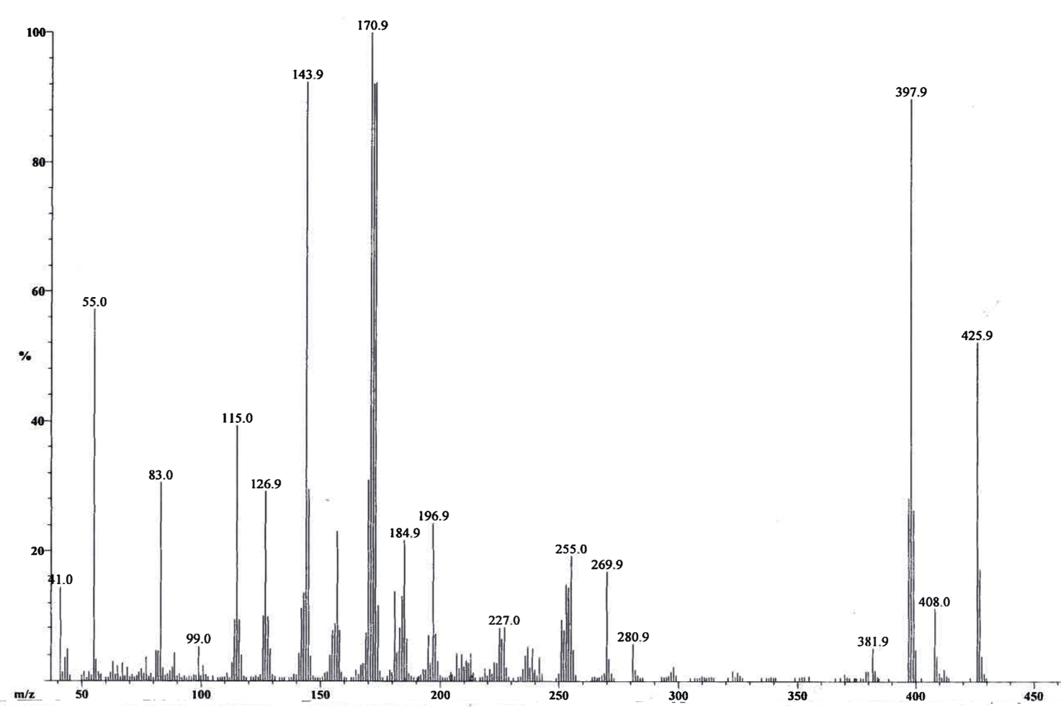
Figure 3. E.I mass spectrum of the monomer o-HON
3.4. FT-IR spectroscopy of monomers and polymers
The FT-IR spectra of dialdehydes and diketone monomers indicated two or five weak bands within 2951-2719 cm⁻¹ due to υ C-H aliphatic corresponding to n-hexane and CHO (of dialdehydes) groups, the strong band indicated within 1694-1661 cm⁻¹ due to υ C=O of aldehyde or ketone group, the band within 1595-1590 cm⁻¹ for υ C=C aromatic rings and the band within 1233-1257 cm⁻¹ for υ C-O-C of etheric bond (supplementary Fig. S3-S5), similar assignments have been reported in the literature for dicarbonyl monomers.^{33, 34}
The polymers PmHOBND and PoHONPD showed weak band at 1694 and 1683 cm⁻¹ respectively for ʋ C=O contributed from end on group, this band was present as a strong band in in their corresponding monomers which showed that carbonyl group was converted into imine group. All the three polymers (PmHOBND, PoHONPD and PoHOAND) showed strong to medium intensity band within 1594-1620 cm⁻¹ for ʋ C=N, the band within 1592-1518 cm⁻¹ due to aromatic rings of the polymers, two bands within 1237-1248 cm⁻¹ and 1024-1005 cm⁻¹ were due to ʋ C-O-C asymmetric and symmetric vibrations and number of bands within 973-681 cm⁻¹ were for C-H in plane and out of plane vibrations of aromatic rings (Figure 4) (supplementary Fig. S6 and S7). Similar assignments indicated for related polymines.^{33,35}
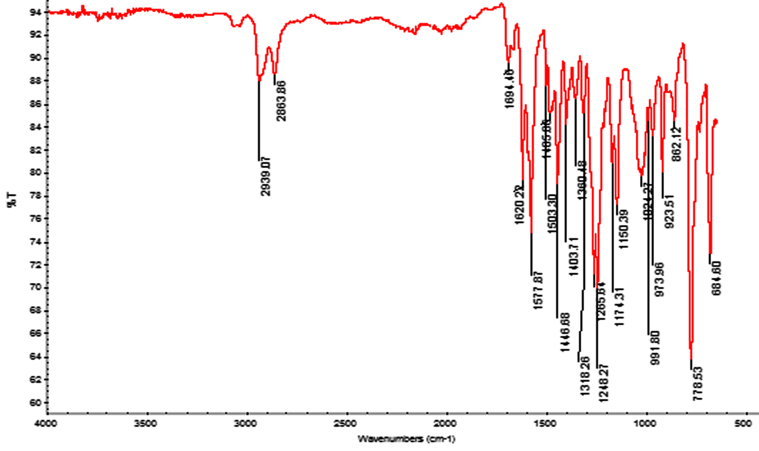
Figure 4. FT-IR spectrum of polymer PmHOBND
3.5. ¹HNMR spectroscopy of monomers and polymers
The ¹HNMR spectra of all the synthesized compounds (monomers and polymers) were recorded in DMSO-d₆ solvent. The dialdehyde monomers m-HOB and o-HON indicated CHO group signal at δ ppm 9.959 and 10.794 respectively, all the three monomers (m-HOB, o-HON and o-HOA showed signals within the range of δ ppm 6.989-8.257 due to protons of the aromatic rings (benzene or naphthalene), one triplet within δ ppm 4.050-4.324 due to etheric group (O-CH₂) protons and CH₂ aliphatic protons signals within δ ppm range of 1.361-1.871 due to n-hexane while diketone o-HOA also showed signal at δ ppm 2.534 due to CH₃ protons of acetophenone group (supplementary Fig. S8-S10). The polymers PmHOBND and PoHONPD showed singlet at δ ppm 7.942 for azomethine group proton (CH=N) while the polymer PoHOAND did not showed any proton signal at this position because it contains imine bond (C=N) instead of azomethine group. The polymer PoHOAND showed CH aromatic proton signals within δ ppm range of 6.594-7.509 while aromatic CH signals were missing in PmHOBND and PoHONPD because of their lower solubility in DMSO-d₆ (NMR solvent), the polymers PmHOBND and PoHOAND indicated triplet at δ ppm 4.052 and 4.078 due to OCH₂ group, all the three polymers showed signals within the range of δ ppm 1.417-2.880 due to CH₂ group protons of n-hexnane, PoHOAND showed singlet at δ ppm 2.275 due to CH₃ group protons (Figure 5). Similar ¹HNMR assignment have been reported for related monomers and polymers.^{35,36}
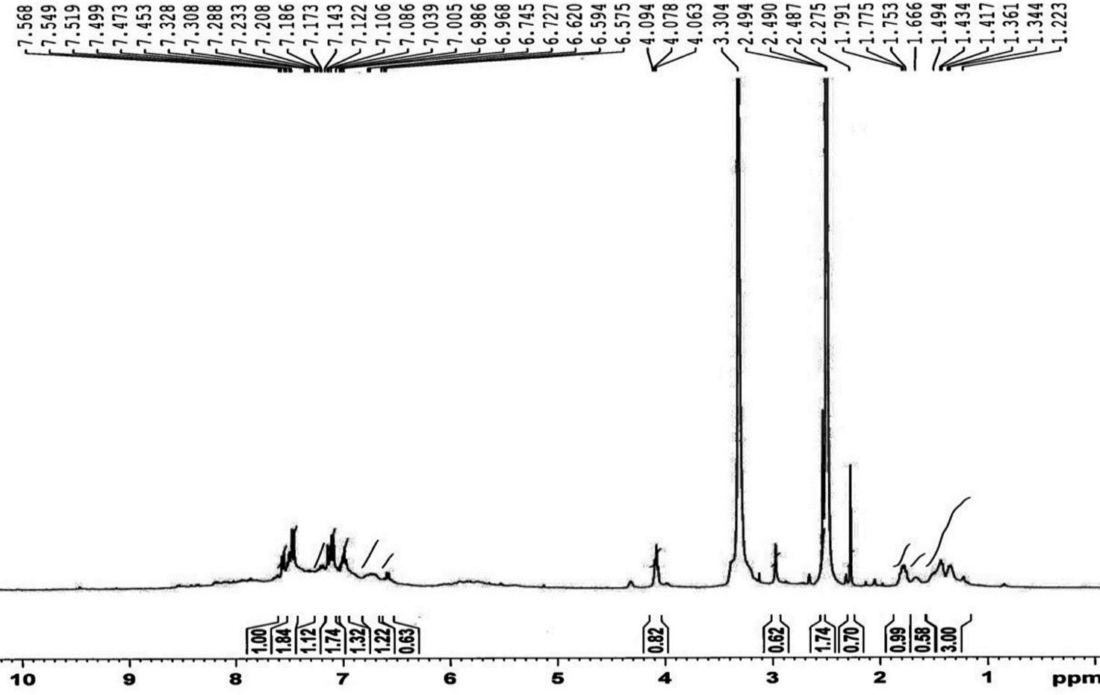
Figure 5. ¹HNMR spectrum of polymer PoHOAND
3.6. UV-Vis spectroscopy of monomers and polymers
UV-visible spectra of monomers and polymers were recorded using DMSO solvent and the results including molar absorptivity (L.mole⁻¹.cm⁻¹) of monomers and 1% absorptivity of polymers (because molecular weight of polymers was unknown) are provided in Table 2. The meta oriented monomer m-HOB showed only one band at 314 nm for π - π* transition within aromatic ring while the ortho oriented monomers o-HON and o-HOA showed two bands the first at 320 nm and 306 nm was for π - π* transition within aromatic ring and second at 340 nm and 444 nm respectively was for π - π* within conjugated aromatic ring and carbonyl (C=O) group, the appearance of second peak in ortho oriented monomers was may be due to greater influence of lone pairs of oxygen on conjugation as compared to meta oriented monomer (supplementary Fig. S11-S13) All the three polymers showed two bands, the first band appeared due to π - π* transition within aromatic ring and the second band was due to π – π* transition involving aromatic ring (phenyl or naphthyl) and conjugated azomethine (C=C-N=C) group (Figure 6) (supplementary Fig. S14-S15). Similar UV-Vis assignment for related monomers and polymers were reported.^{37,38}

Table 2. Results of spectrophotometric studies of monomers and polymers in DMSO Solvent
S. No | Compound | λ nm (ɛ 1%) | Possible transition
1 | mHOB | 314 (6976) | π – π* transition within benzaldehyde ring system
2 | PmHOBND | 287 (145) | π – π* transition within aromatic ring system
2 | PmHOBND | 321 (236.5) | π – π* transition involving naphthyl ring and conjugated C=C-N=C π-electron system
3 | oHON | 320 (3043) | π – π* transition within naphthaldehyde ring system
3 | oHON | 340 (2199) | π – π* transition involving naphthyl ring with conjugated O=C-C=C-O π-electron system and lone pair of etheric oxygen.
4 | PoHONPD | 265 (1120) | π – π* transition within aromatic ring system
4 | PoHONPD | 318 (940) | π – π* transition involving phenyl ring and conjugated C=C-N=C π-electron system
5 | oHOA | 306 (7076) | π – π* transition within acetophenone ring system
5 | oHOA | 444 (233.7) | π – π* transition involving naphthyl ring with conjugated O=C-C=C-O π-electron system and lone pair of etheric oxygen
6 | PoHOAND | 307 (1580) | π – π* transition within aromatic ring system
6 | PoHOAND | 477 (500) | π – π* transition involving phenyl ring and conjugated C=C-N=C π-electron system

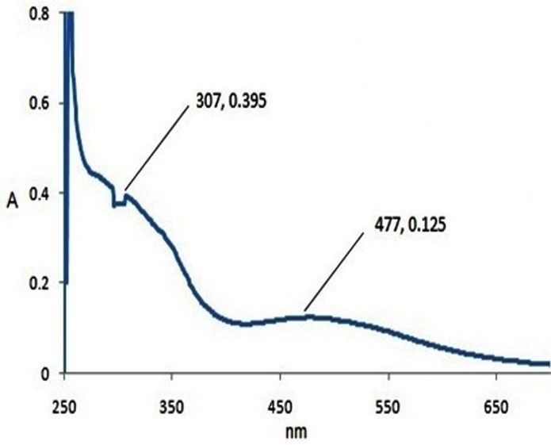
Figure 6. UV/Vis Spectrum of polymer (PoHOAND)
3.7. Fluorescence spectroscopy of monomers and polymers
All the synthesized monomers and polymers indicated fluorescence emission due to the presence of conjugated chromophoric groups in their structure (supplementary Fig. S16-S20). The emission spectra of the compounds were recorded in DMSO solvent and the results of spectrofluorometic studies are summarized in Table 3. The polymers PmHOBND and PoHOAND showed visible light emissions while the polymer PoHOBND showed emission in the UV region. The polymers PmHOBND showed violet and red light emission while PoHOAND showed violet, orange and blue-green light emission at different excitations (Figure 7).
Table 3: Spectrofluorometric determination of monomers and polymers using DMSO solvent
S. No | Compound | Concentration in µg/ml | Excitation wavelength in nm | Emission wavelength in nm (color) | Relative Intensity of emission
1 | mHOB | 25 | 314 | 350 | 121.5
2 | PmHOBND | 333.3 | 287 | 342 | 180
 |  |  |  | 402 (violet) | 1016
 |  |  |  | 681 (red) | 17.2
2 | PmHOBND | 333.3 | 321 | 386 (violet) | 152
3 | oHON | 16.6 | 320 | 354 | 258.3
3 | oHON | 16.6 | 340 | 377 | 191.4
4 | PoHONPD | 0.5 | 265 | 351 | 392
4 | PoHONPD | 0.5 | 318 | 352 | 206
5 | oHOA | 16.7 | 306 | 350 | 274.7
6 | PoHOAND | 1.6 | 307 | 344 | 101
 |  |  |  | 392 (violet) | 342
 |  |  |  | 614 (orange) | 7.98
6 | PoHOAND | 1.6 | 477 | 513 (blue-green) | 58.9
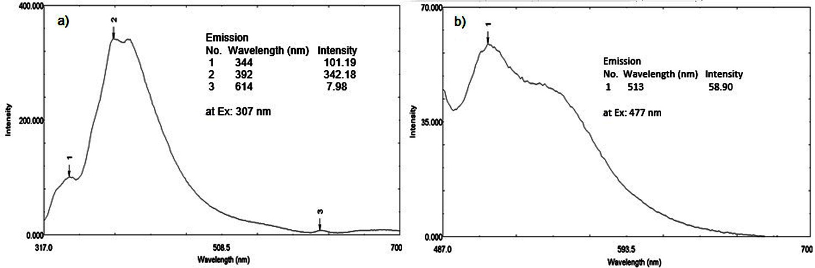
Figure 7. Fluorescence emission spectra of polymer PoHOAND at different excitation wavelengths (a) λex: 307 nm (b) λex: 477 nm)
3.8. Scanning electron microscopy of monomers and polymers
The SEM images of monomers and polymers were recorded at micron marker scale length range of 500 µm to 1 µm at different magnifications. The dialdehyde m-HOB showed crystalline morphology and looked like iron blocks while its corresponding polymer PmHOBND had sponge like morphology. The monomer o-HON had clay rock like morphology and showed non-homogeneous surface, while its corresponding polymer PoHONPD showed smooth and porous surface. However clear images of polymers PmHOBND and PoHONPD could not be recorded may be due to their amorphous nature (supplementary Fig. S21 and S22). The surface morphology of diketone monomer o-HOA was fibrous and looked like cotton wool while morphology of its corresponding polymer PoHOAND looked like cheese pieces with clearly visible pores of different sizes (Figure 8). The surface morphology of all the three polymers was different from their corresponding monomers which support their formation.
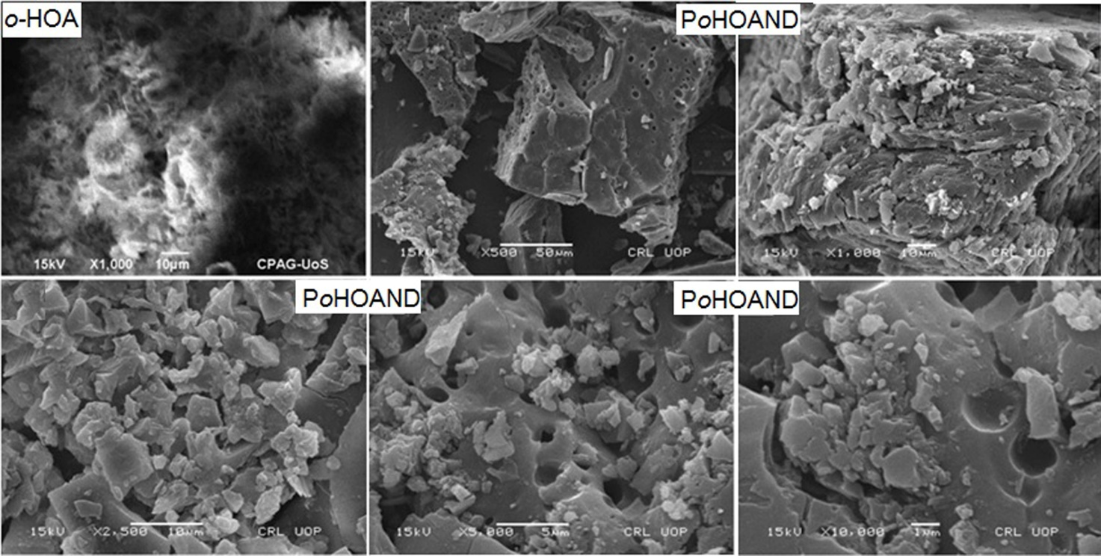
Figure 8: SEM images of monomer o-HOA and its derived polymer PoHOAND at different micron-marker scale lengths (50 um to 1um)
3.9. Thermal analysis of monomers and polymers
Thermal properties of monomers and polymers were evaluated by thermogravimetric (TG) and differential thermal analysis (DTA) and the results are summarized in Table 4. Thermal stability of the compounds was estimated from the T_{max} value (temperature indicating maximum rate of weight loss) in TG graph. TG of dialdehyde m-HOB indicated weight loss in single step of 93% within 265˚C-590˚C and T_{max} value at 394˚C, DTA showed two endotherms first at 82˚C due to melting and second at 324˚C for vaporization/decomposition followed by four exotherms due to decomposition at 263, 393, 479 and 558˚C. TG of o-HON showed three steps of weight loss, 54% weight loss within 294-413˚C, 14% loss within 414-514˚C and 19% loss within 515-611˚C, its T_{max} was observed at 354˚C, DTA indicated one endotherm at 193˚C due to melting followed by two exotherms at 362˚C and 545˚C due to decomposition. TG of diketone monomer o-HOA showed three steps of weight loss, 71% loss within 209- 377˚C, 12% loss within 378-490˚C and 9% loss indicated within 491-550˚C, its T_{max} was observed at 342˚C, DTA showed melting endotherm at 97˚C, vaporization/decomposition exotherm at 371˚C and large decomposition exotherm at 545˚C. The dialdehyde m-HOB indicated highest thermal stability among the monomers (supplementary Fig. S23-S25). TG of polymer PmHOBND indicated weight loss in three steps 8% loss was observed within 194-415˚C, 36% weight loss within 416-503˚C and 50% loss within 504-651˚C, T_{max} at 577˚C, DTA showed two exothermic curves, vaporization/decomposition exotherm at 456˚C and decomposition exotherm at 639˚C (Figure 9a). TG of PoHONPD showed three steps of weight loss, 44% weight loss was observed within 324-468˚C, 6% weight loss within 469-557˚C and 39% weight loss within 558-678˚C, T_{max} showed at 396˚C, DTA showed two volatilization/decomposition exotherms at 365˚C and 448˚C and large decomposition exotherm at 624˚C (Figure 9b). TG of PoHOAND indicated 98% weight loss within 42-727˚C in one step with T_{max} at 385˚C, DTA showed one exotherm at 676˚C due to decomposition (Figure 9c). Thermal stability of the polymers was higher than their corresponding monomers and the polymer PmHOBND showed higher thermal stability (577 ˚C) among all the synthesized compounds.
Table 4. Thermal analysis (TG/DTA) data of monomers and polymers
Compound | TG |  |  |  | DTA
Compound | Weight loss stages  I II III |  |  | Thermal stability T_{max} ˚C
Compound | Wt. loss % (temperature range ˚C) |  |  | Thermal stability T_{max} ˚C | Endo ˚C | Exo ˚C
m-HOB | 93 (265-590) | - | - | 394 | 82, 324 | 263, 393, 479, 558
o-HON | 54 (294-413) | 14 (414-514) | 19 (515-611) | 354 | 193 | 362, 545
o-HOA | 71 (209-377) | 12 (378-490) | 9 (491-550) | 342 | 97 | 371, 545
PmHOBD | 8 (194-415) | 36 (416-503) | 50 (504-651) | 577 | - | 456, 639
PoHONPD | 44 (324-468) | 6 (469-557) | 39 (558-678) | 396 | - | 54, 365, 448, 624
PoHOAND | 98 (42-727) | - | - | 385 | - | 676

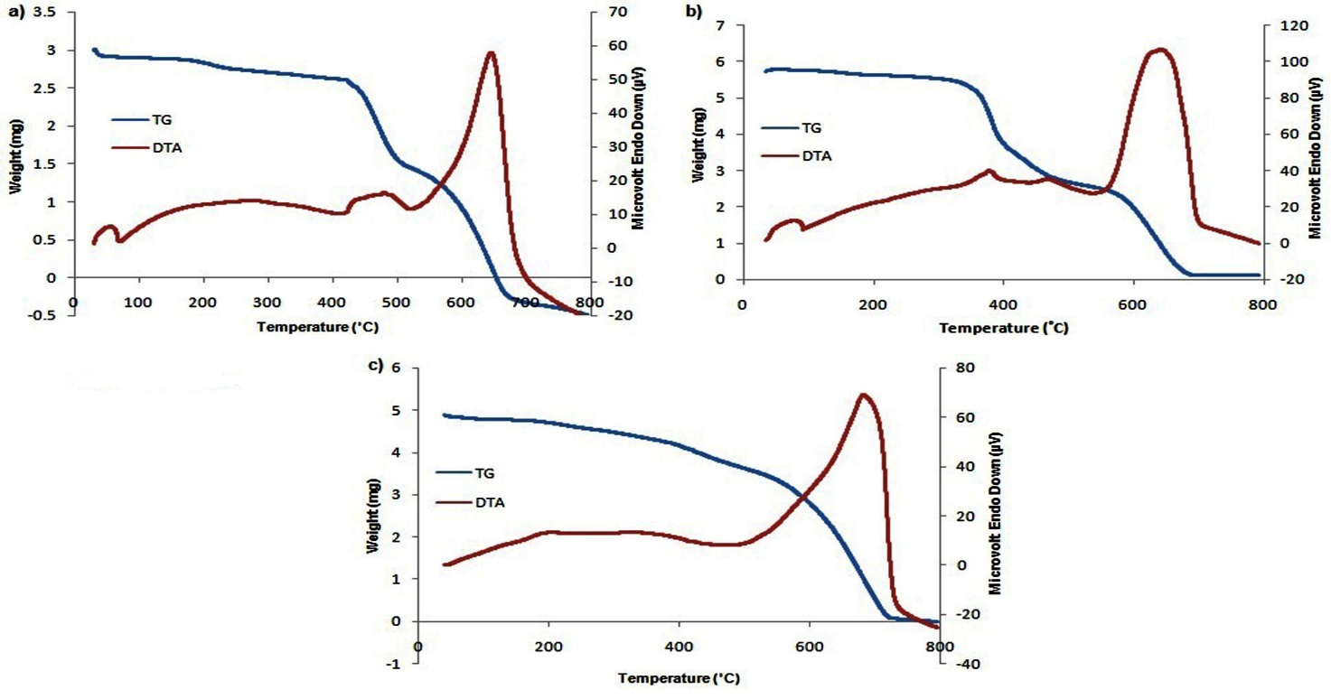
Figure 9. TG/DTA graphs of polymers (a) PmHOBND (b) PoHONPD (c) PoHOAND
3.10. Biological activities of polymers
The antimicrobial activities of the polymers were examined against different species of bacteria and fungi, however the polymers showed non-significant antimicrobial activities. The polymer PmHOBND showed 10% antibacterial activity against Staphylococcus aureus and Bacillus subtilis while only 2% inhibition against Salmonella typhi, PoHOBND showed 11% inhibition against Staphylococcus aureus, 8% inhibition against Bacillus subtilis and 7.4% inhibition against Salmonella typhi, PoHOAND indicated only 1% inhibition against Bacillus subtilis and 15.4% inhibition against Salmonella typhi. The polymers PmHOBND and PoHOBND showed 12.5% antifungal activity against Candida albicans while PoHOAND showed 10% activity against the same strain.
3.11. Thin films of Polymer-PVC blends
The polymers PmHOBND, PoHONPD and PoHOAND were tested for their thin film forming ability, the synthesized polymers could not form thin films alone therefore polymer-PVC blends in different w/w% ratios (10:90, 20:80, 30:70, 40:60 and 50:50) were prepared, among them only 50:50 w/w% blends of ortho oriented polymers PoHONPD and PoHOAND were transformed into thin layers having shiny finishing (Figure 10).
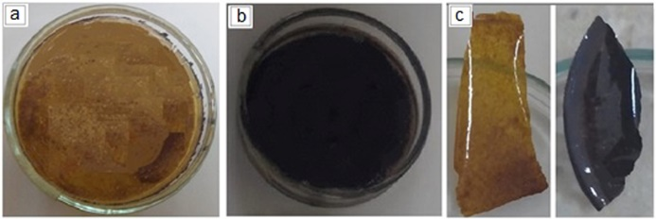
Figure 10: Images of dried homogenized polymer-PVC blends transformed into thin films (a) PoHONPD-PVC blend (b) PoHOAND-PVC blend and (d) thin films of PoHONPD-PVC and PoHOAND-PVC blend respectively
4. Conclusion:
Three new aliphatic-aromatic polyimines containing naphthyl rings in their main chain were prepared by the polycondensation reaction of newly synthesized dialdehydes and diketone monomers with diamines. The solubility of the polymers were improved significantly due to solubility enhancing arrangements made in their structures which include their aliphatic-aromatic nature, introduction of ether linkages between the aliphatic and aromatic groups and non-linear orientation (ortho and meta) of the groups attached with the aromatic ring. In addition to these structural modifications the polymer PoHOAND contain methyl side group attached at ortho position of the aromatic ring and this polymer indicates highest solubility among the synthesized polymer, it was soluble in all the organic solvent tested which include acetone, chloroform, THF, DMF and DMSO. All the synthesized compounds (monomers and polymers) were fluorescent, the polymers PmHOBND showed violet and red light emission while the polymer PoHOAND showed multi-color emissions which include violet, blue-green and orange light emission. The polymers also indicated high thermal stabilities (385-577˚C), therefore they can be applied as fluorescent and heat-resistant materials. The 50:50 w/w% polymer-PVC blends of PoHONPD and PoHOAND were transformed into thin films with shiny finishing.
References:
- K. Suematsu, K. Nakamura, and J. Takeda, Colloid Polym. Sci. 1983, 261, 493-501.
https://doi.org/10.1007/BF01419833
- S. Banerjee and C. Saxena, J Polym Sci A Polym Chem. 1996, 34, 3565-3572.
https://doi.org/10.1002/(SICI)1099-0518(199612)34:17<3565::AID-POLA11>3.0.CO;2-C
- P. Kumar Gutch, S. Banerjee, D. Gupta, and D. Jaiswal, J Polym Sci A Polym Chem. 2001, 39, 383-388.
https://doi.org/10.1002/1099-0518(20010201)39:3<383::AID-POLA1005>3.0.CO;2-3
- M. A. Hussein, M. A. Abdel-Rahman, A. M. Asiri, K. A. Alamry, and K. I. Aly, Des. Monomers Polym. 2012, 15, 431-463.
DOI: 10.1080/1385772X.2012.688325
- N. Khalid, A. Bibi, K. Akhtar, K. Mustafa, M. Khan, and N. Saeed, Polym Plast Technol Eng. 2019, 15, 419-426.
DOI: 10.1080/03602559.2018.1471719
- E. Hamciuc, M. Homocianu, C. Hamciuc, and I.-D. Carja, High Perform Polym. 2018, 30, 339-346.
https://doi.org/10.1177/0954008317697367
- M. Palewicz, A. Iwan, A. Sikora, J. Doskocz, W. Strek, D. Sek, and B. Mazurek, Acta Phys. Pol. A. 2012, 121, 439-444.
- S. Dineshkumar, A. Muthusamy, P. Chitra, and S. Anand, J ADHES SCI TECHNOL. 2015, 29, 2605-2621.
DOI: 10.1080/01694243.2015.1079455
- İ. Kaya, A. Avcı, F. Kolcu, and S. Çulhaoğlu, Des. Monomers Polym. 2014, 17, 481-490.
DOI: 10.1080/15685551.2013.867581
- H. Niu, Y. Huang, X. Bai, X. Li, and G. Zhang, Mater Chem Phys. 2004, 86, 33-37.
https://doi.org/10.1016/j.matchemphys.2004.01.023
- P. W. Wojtkowski, Macromolecules. 1987, 20, 740-748.
DOI: 10.1021/ma00170a007
- T. Borukaev, A. K. Shaov, A. Kharaev, R. C. Bazheva, L. Pashtova, A. K. Malamatov, and V. Shogenov, Fibre Chemistry. 2018, 49, 425-427.
https://doi.org/10.1007/s10692-018-9913-3
- M. Palewicz, A. Iwan, J. Doskocz, W. Strek, D. Sek, B. Kaczmarczyk, and B. Mazurek, Polym. Bull. 2011, 66, 65-76.
https://doi.org/10.1007/s00289-010-0308-8
- B. Jarząbek, B. Kaczmarczyk, J. Jurusik, M. Siwy, and J. Weszka, J. Non-Cryst. Solids. 2013, 375, 13-18.
https://doi.org/10.1016/j.jnoncrysol.2013.05.013
- M. Rusu, A. Airinei, G. G. Rusu, L. Marin, V. Cozan, P. RÂmbu, I. Caplanus, and G. I. Rusu, J MACROMOL SCI B. 2011, 50, 1285-1297.
DOI: 10.1080/00222348.2010.507444
- N. Nishat, S. Parveen, S. Dhyani, and Asma, J. Coord. Chem. 2009, 62, 1091-1099.
DOI: 10.1080/00958970802416020
- N. Nishat, S. A. Khan, S. Parveen, and R. Rasool, J. Coord. Chem. 2010, 63, 3944-3955.
DOI: 10.1080/00958972.2010.526207
- A. Iwan, B. Boharewicz, I. Tazbir, M. Malinowski, M. Filapek, T. Kłąb, B. Luszczynska, I. Glowacki, K. P. Korona, and M. Kaminska, SOL ENERGY. 2015, 117, 246-259.
https://doi.org/10.1016/j.solener.2015.03.051
- K. Gawlinska, A. Iwan, Z. Starowicz, G. Kulesza-Matlak, K. Stan-Glowinska, M. Janusz, M. Lipinski, B. Boharewicz, I. Tazbir, and A. Sikora, OPTO-ELECTRON REV. 2017, 25, 274-284.
https://doi.org/10.1016/j.opelre.2017.07.004
- C. Mallet, M. Le Borgne, M. Starck, and W. Skene, ‎Polym. Chem. 2013, 4, 250-254.
DOI: 10.1039/C2PY20703F
- M. Kamacı and İ. Kaya, J FLUORESC. 2015, 25, 1339-1349.
https://doi.org/10.1007/s10895-015-1624-z
- A. Iwan and D. Sek, Prog. Polym. Sci. 2008, 33, 289-345.
https://doi.org/10.1016/j.progpolymsci.2007.09.005
- N. Nishat, R. Rasool, S. Parveen, and S. A. Khan, J. Appl. Polym. Sci. 2011, 122, 2756-2764.
https://doi.org/10.1002/app.34100
- A. Vlad, M. Cazacu, G. Munteanu, A. Airinei, and P. Budrugeac, Eur. Polym. J. 2008, 44, 2668-2677.
https://doi.org/10.1016/j.eurpolymj.2008.05.014
- J. Runt and J. Huang, in: S. Z. D. Cheng (Ed.): Chapter 8 - Polymer blends and copolymer, Applications to polymers and plastics, Handbook of Thermal Analysis and Calorimetry. vol. 3, Elsevier Science B.V., 2002, pp. 273-294.
https://doi.org/10.1016/S1573-4374(02)80011-5
- Z. Youming, D. Xinrong, W. Liangcheng, and W. Taibao, J Incl Phenom Macrocycl Chem. 2008, 60, 313-319.
https://doi.org/10.1007/s10847-007-9379-z
- D. Nepal, S. Samal, and K. E. Geckeler, Macromolecules, 2003, 36, pp. 3800-3802.
DOI: 10.1021/ma0258410
- S. B. Park, H. Kim, W. C. Zin, and J. C. Jung, Macromolecules, 1993, 26, 1627-1632.
DOI: 10.1021/ma00059a021
- R. K. Pettit, C. A. Weber, M. J. Kean, H. Hoffmann, G. R. Pettit, R. Tan, K. S. Franks, and M. L. Horton, ANTIMICROB AGENTS CH. 2005, 49, pp. 2612-2617.
DOI: 10.1128/AAC.49.7.2612-2617.2005
- O. Catanescu, M. Grigoras, G. Colotin, A. Dobreanu, N. Hurduc, and C. I. Simionescu, Eur. Polym. J. 2001, 37, 2213-2216.
https://doi.org/10.1016/S0014-3057(01)00119-7
- F. Qureshi, M. Y. Khuhawar, T. M. Jahangir, and A. H. Channar, Acta Chim Slov. 2016, 63, 113-120.
DOI: http://dx.doi.org/10.17344/acsi.2015.1994
- F. Qureshi, M. Y. Khuhawar, and T. M. Jahangir, Acta Chim Slov. 2018, 65, 718-729.
DOI: http://dx.doi.org/10.17344/acsi.2018.4419
- S. Çulhaoğlu and İ. Kaya, 폴리머. 2015, 39, pp. 225-234. https://doi.org/10.7317/pk.2015.39.2.225
- S. Ankushrao, Y. Patil, V. Ubale, N. Maldar, and A. Ghanwat, J MACROMOL SCI A. 2017, 54, 411-417.
https://doi.org/10.1080/10601325.2017.1313155
- D. Sek, B. Jarzabek, E. Grabiec, B. Kaczmarczyk, H. Janeczek, A. Sikora, A. Hreniak, M. Palewicz, M. Lapkowski, and K. Karon, Synth. Met. 2010, 160, 2065-2076.
https://doi.org/10.1016/j.synthmet.2010.07.026
- İ. Kaya, A. Avcı, and K. Temizkan, MACROMOL RES. 2017, 25, 45-53.
https://doi.org/10.1007/s13233-017-5002-3
- P. Dutta, P. Jain, P. Sen, R. Trivedi, P. Sen, and J. Dutta, Eur. Polym. J. 2003, 39, 1007-1011.
https://doi.org/10.1016/S0014-3057(02)00328-2
- A. Hafeez, Z. Akhter, J. F. Gallagher, and H. M. Siddiqui, DES MONOMERS POLYM. 2017, 20, 74-88.
https://doi.org/10.1080/15685551.2016.1231042

