Fluorescent Membrane Probes based on Coumarin-Thiazole Scaffold

Stane Pajk^{a,b}*, Maja Garvas^{b,c} and Janez Štrancar^{b}
ª Faculty of pharmacy, University of Ljubljana, Ljubljana, Slovenia
^{b} Laboratory of biophysics, “Jožef Stefan Institute”, Ljubljana, Slovenia
^{c} Jožef Stefan International Postgraduate School, Ljubljana, Slovenia
*stane.pajk@ffa.uni-lj.si

Supplemental information

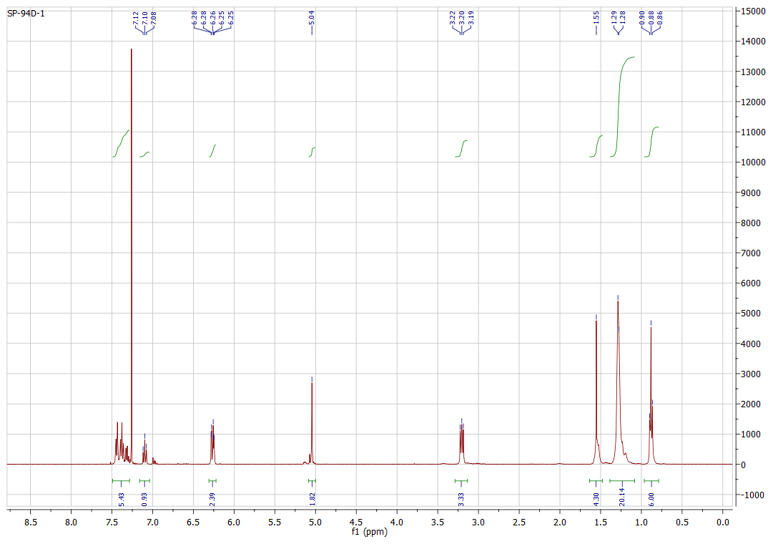
Figure S1. ¹H-NMR spectrum of compound 1 (400 MHz, CDCl₃).
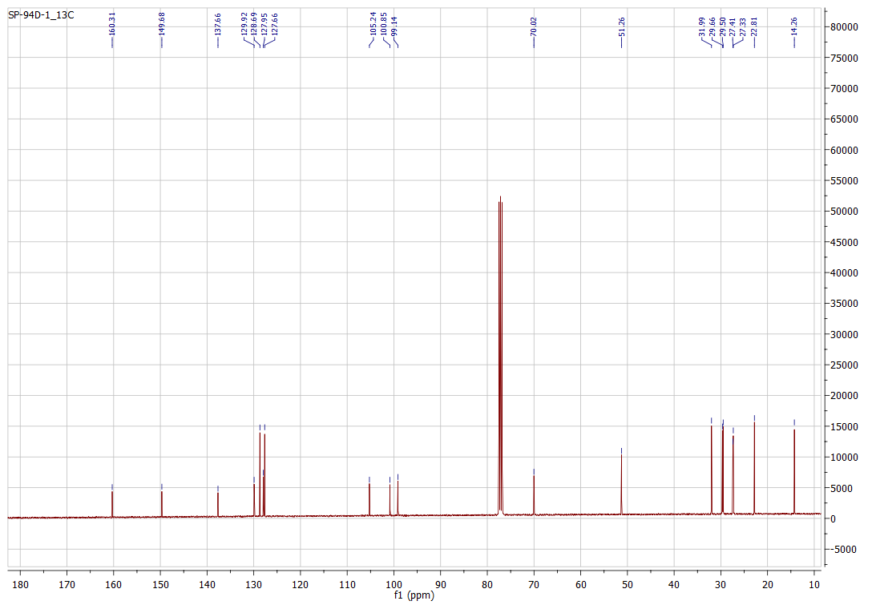
Figure S2. ¹³C-NMR spectrum of compound 1 (100 MHz, CDCl₃).
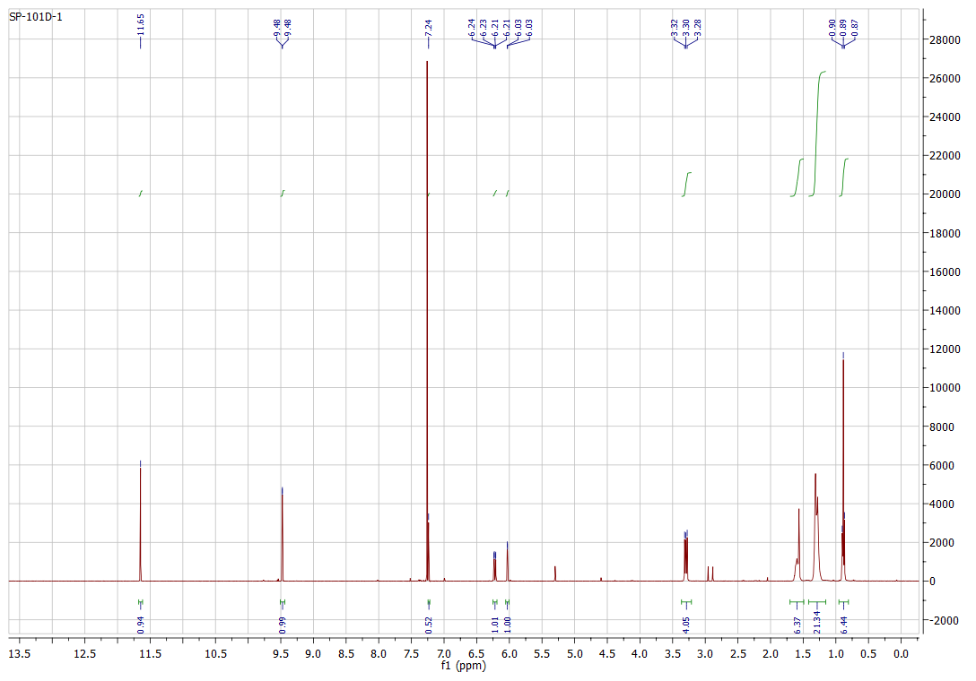
Figure S3. ¹H-NMR spectrum of compound 3 (400 MHz, CDCl₃).
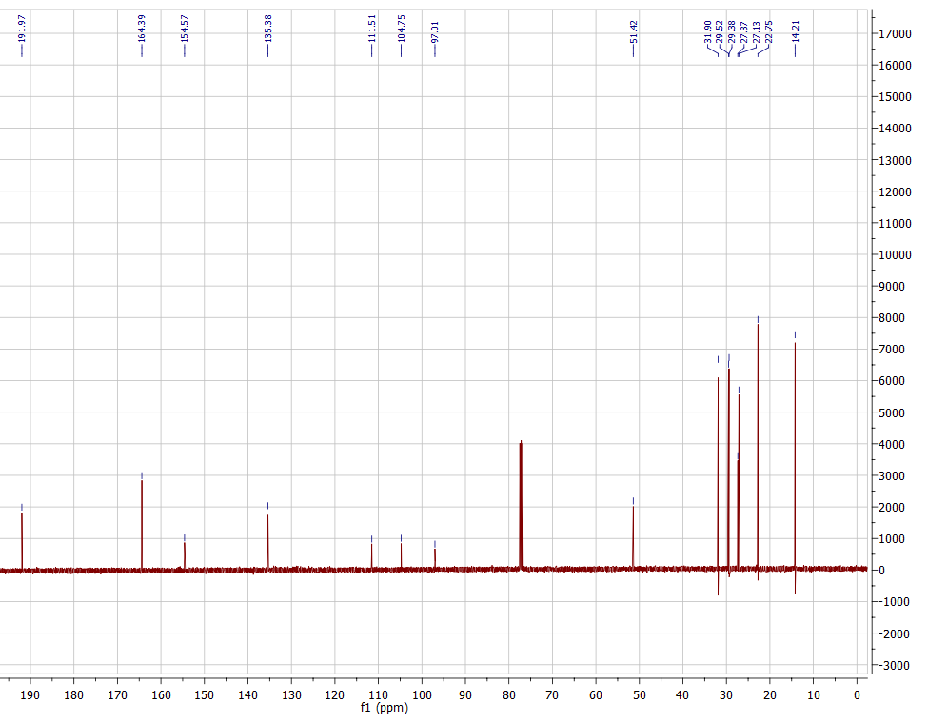
Figure S4. ¹³C-NMR spectrum of compound 3 (100 MHz, CDCl₃).
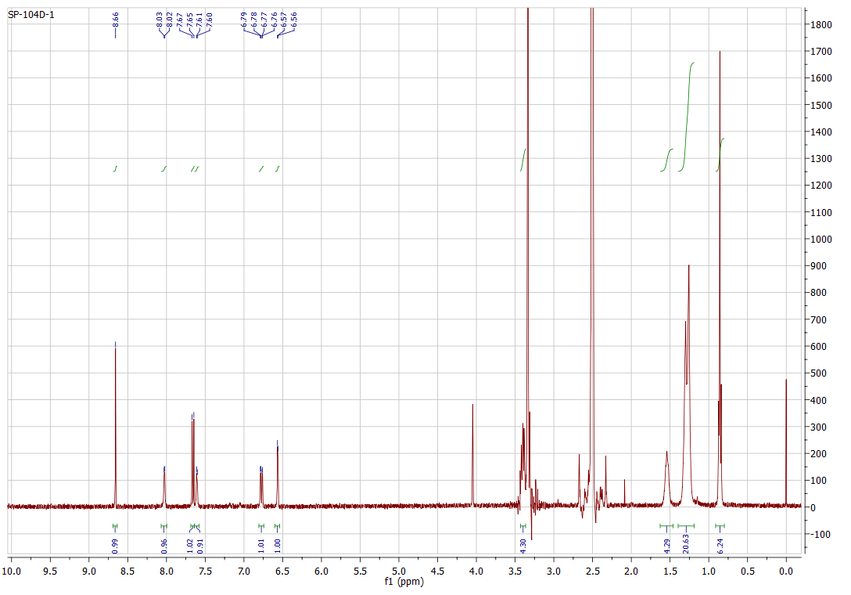
Figure S5. ¹H-NMR spectrum of compound 4 (400 MHz, DMSO-d₆).
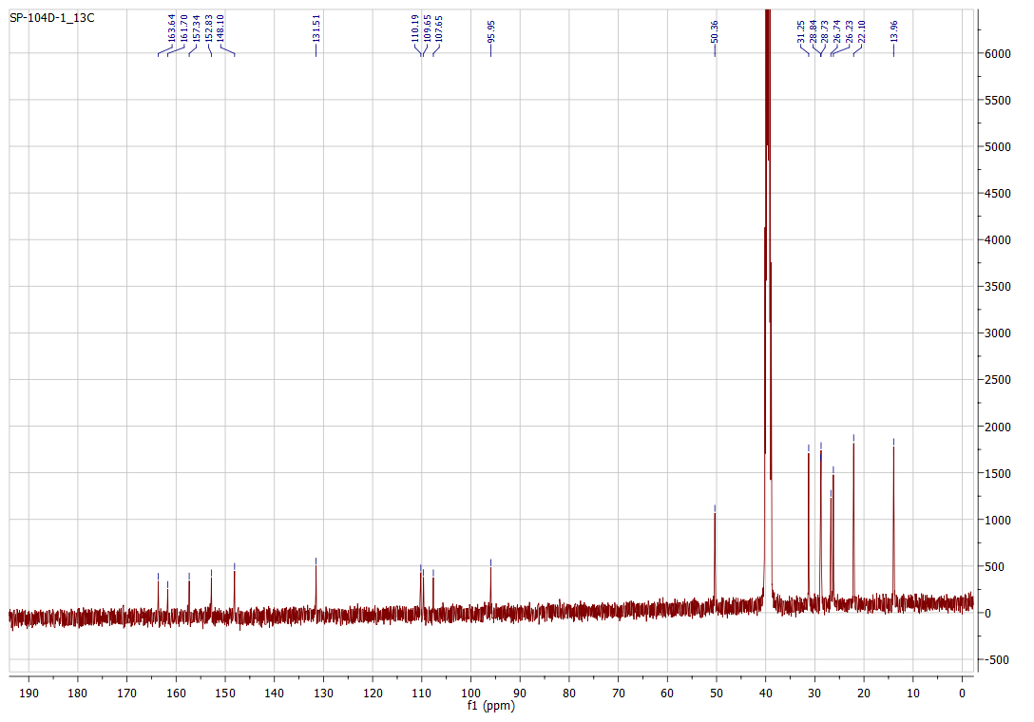
Figure S6. ¹³C-NMR spectrum of compound 4 (100 MHz, DMSO-d₆).
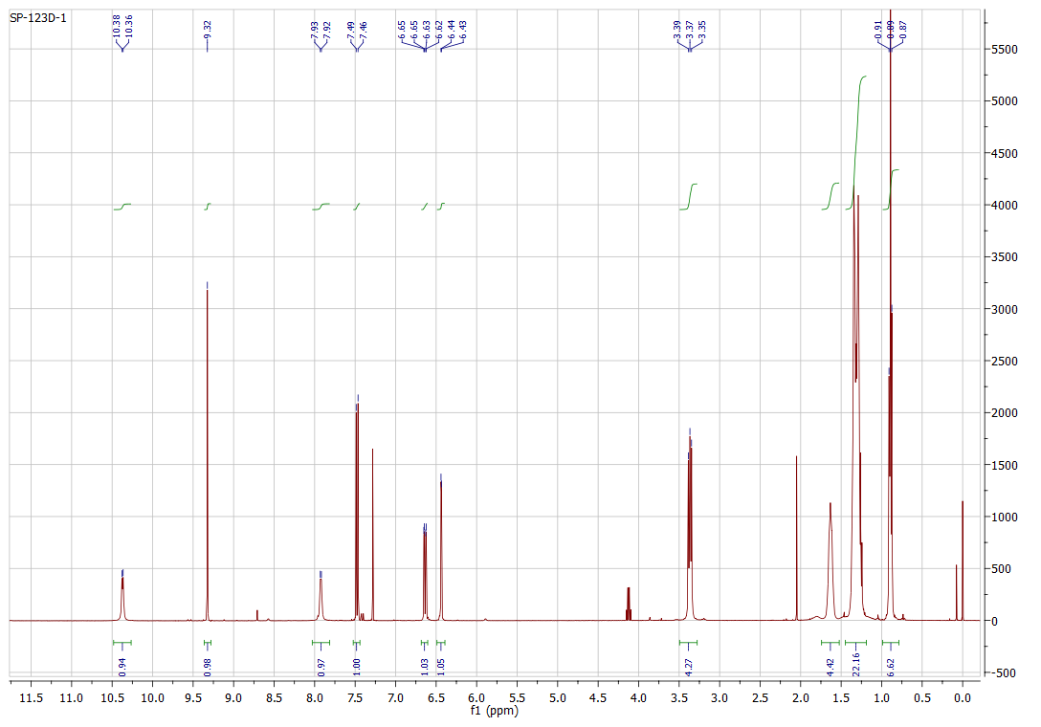
Figure S7. ¹H-NMR spectrum of compound 5 (400 MHz, CDCl₃).
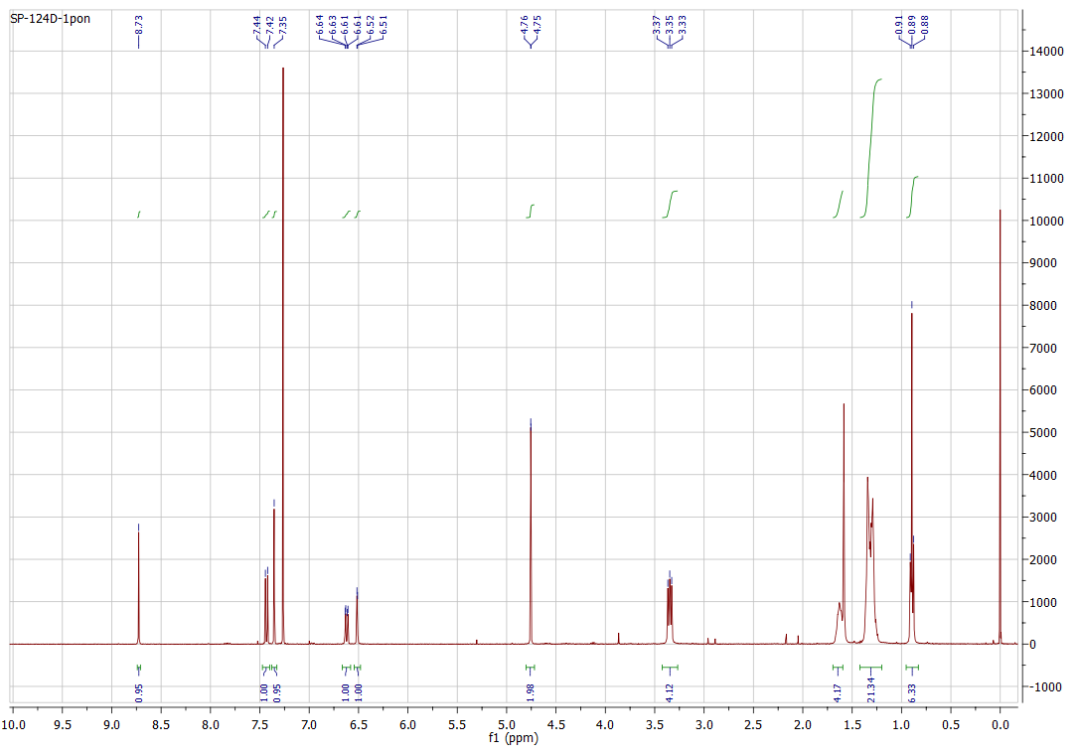
Figure S8. ¹H-NMR spectrum of compound 6 (400 MHz, CDCl₃).
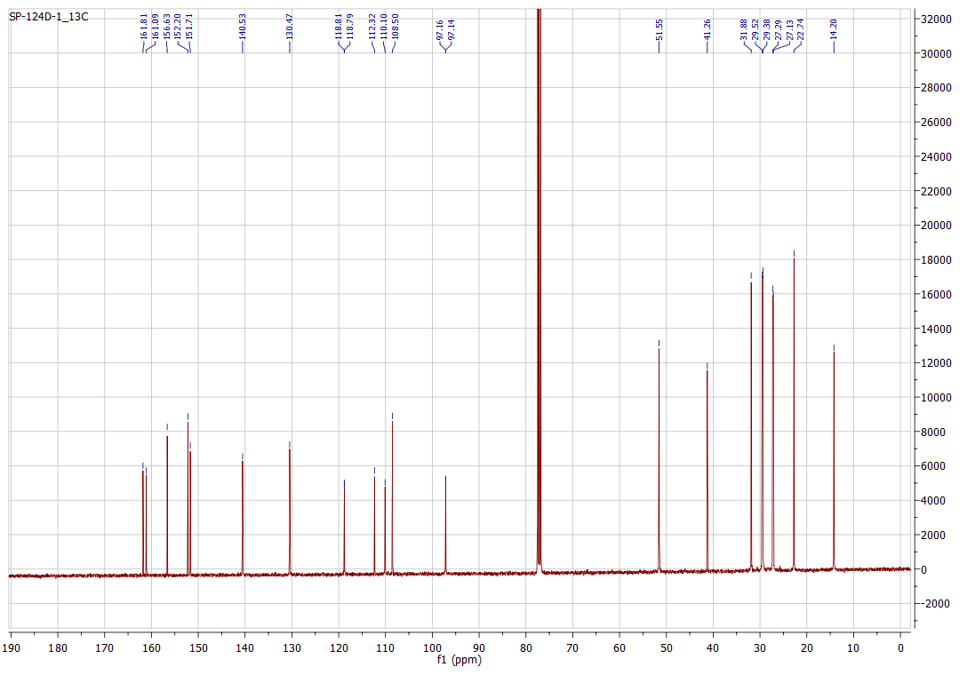
Figure S9. ¹³C-NMR spectrum of compound 6 (100 MHz, CDCl₃).
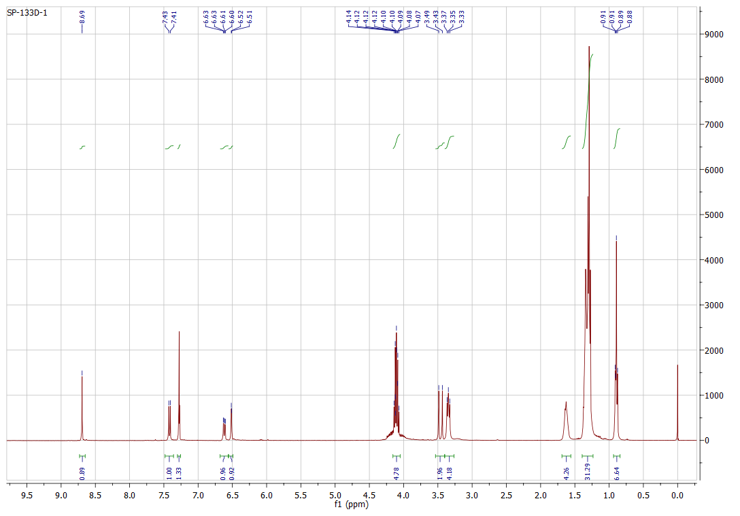
Figure S10. ¹H-NMR spectrum of compound 7 (400 MHz, CDCl₃).
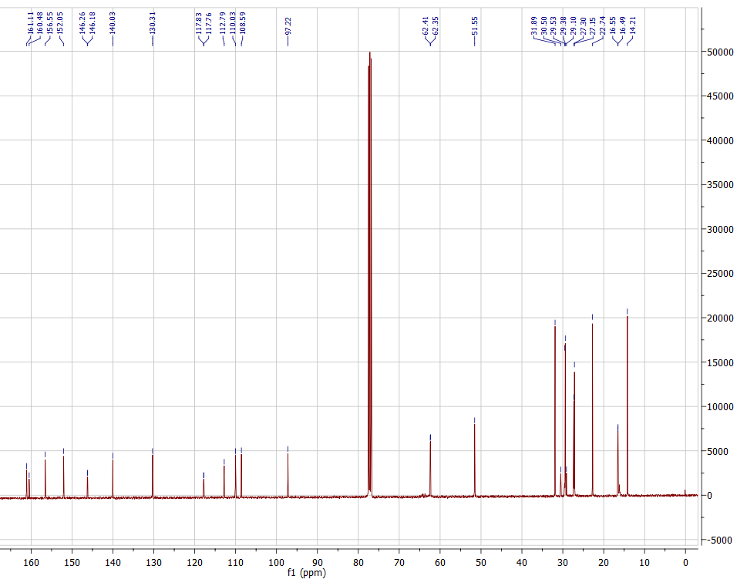
Figure S11. ¹³C-NMR spectrum of compound 7 (100 MHz, CDCl₃).
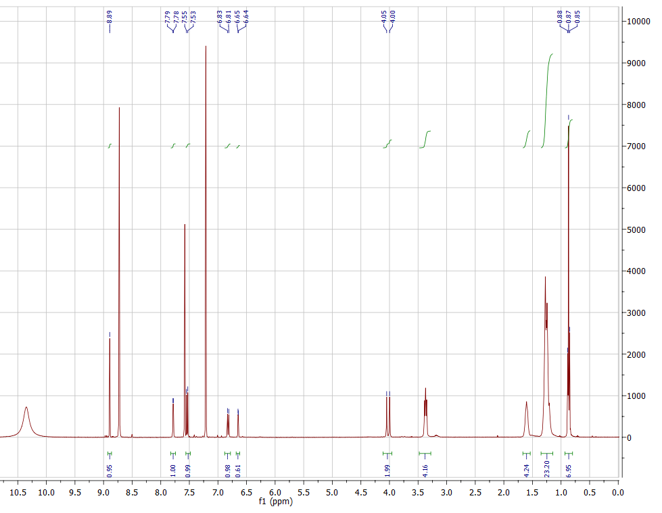
Figure S12. ¹H-NMR spectrum of compound 7 (100 MHz, Pyridine-d₅).
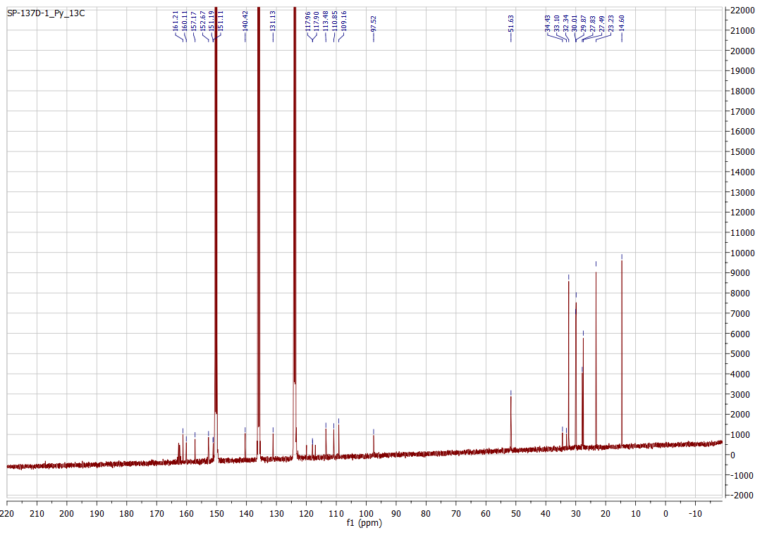
Figure S13. ¹³C-NMR spectrum of compound 8 (100 MHz, Pyridine-d₅).
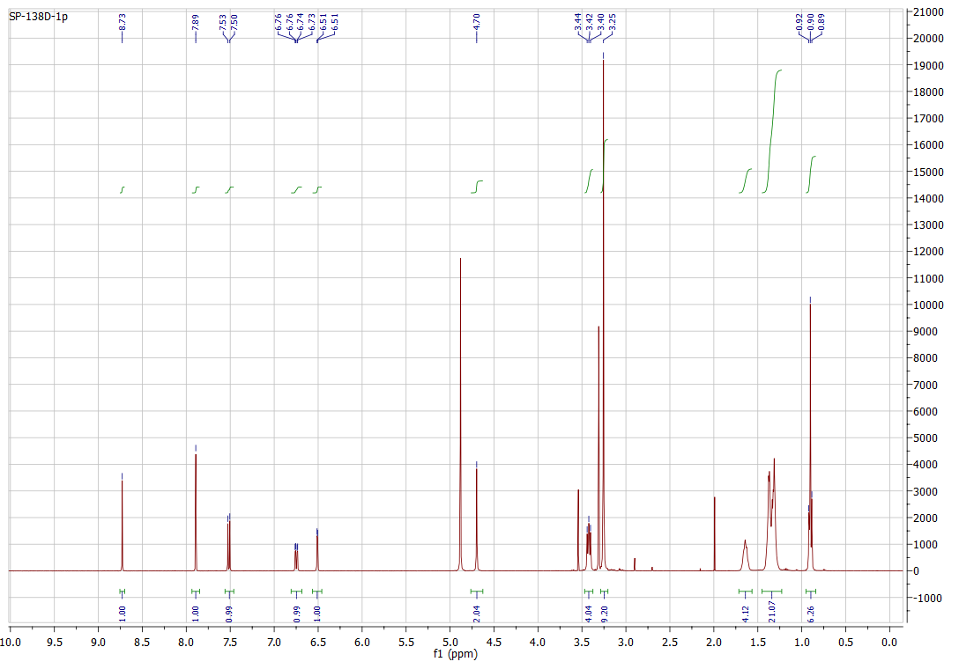
Figure S14. ¹H-NMR spectrum of compound 9 (400 MHz, MeOD).
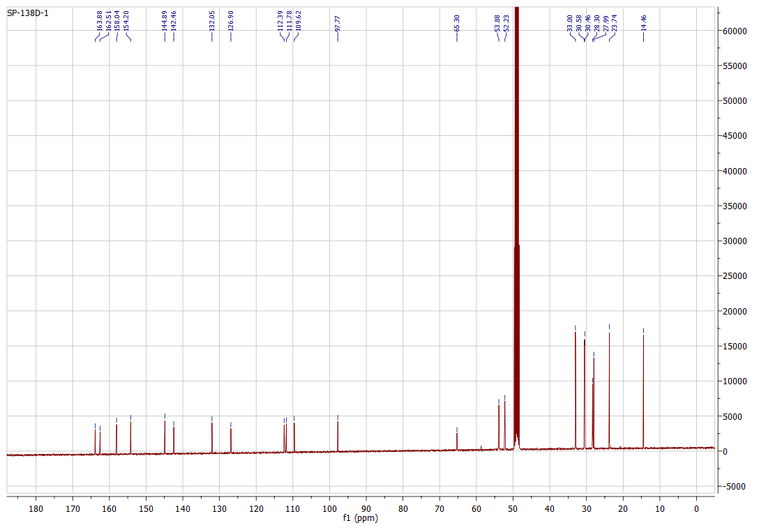
Figure S15. ¹³C-NMR spectrum of compound 9 (100 MHz, MeOD).

