Adsorptive removal of Remazol Brilliant Violet-5R dye from aqueous solutions using calcined eggshell as biosorbent

Eszter RÁPÓ^{1,2}, Katalin POSTA², Maria SUCIU³, Robert SZÉP⁴, Szende TONK¹*
¹Environmental Science Department, Sapientia Hungarian University of Transylvania, 400193 Cluj-Napoca, 8 Calea Turzii no. 4, RO (corresponding author: tonk.szende@sapientia.ro)
²Plant Protection Institute, Szent István University, Páter K. Street 1. H-2100 Gödöllő, HU
³National Institute for Research and Development of Isotopic and Molecular Technologies, Electron Microscopy Integrated Laboratory, 67-103 Donath Str., 400293, Cluj-Napoca, Romania
⁴Faculty of Economics, Sapientia Hungarian University of Transylvania, Piaţa Libertăţii no. 1, RO-530104, Miercurea-Ciuc, Romania

Abstract
As a result of industrial development water pollution has become a major issue. Providing clean water of sufficient quality and quantity is essential. According to literature, 100,000 different dyes are used worldwide in the printing, food and textile industries. Remazol Brilliant Violet-5R belongs to the group of azo dyes used in the textile industry. The purpose of this paper is to study the removal of anionic dye RBV-5R using calcined eggshell. We investigated the effect of initial dye concentration (20-100 mg/L RBV-5R), biomass amount, contact time, temperature, and pH on the adsorption process. We calculated the amounts of adsorbed material in equilibrium and the efficiency of the adsorption process. Various studies were performed on the adsorption process and the adsorbent morphology (EDX, SEM, FTIR, Raman), as well as isotherm (Langmuir, Freundlich, Temkin and Dubinin-Radushkevich), kinetic and diffusion models were used to characterize the process. Calcined eggshell was also characterized by thermogravimetric, BET surface methods. Based on the results obtained, it can be said that the calcined eggshell can be used effectively to remove the dye from the aqueous solution.

Keywords:
adsorption; calcined eggshell; Remazol Brilliant Violet-5R

INTRODUCTION
Water is the source of life, our existence, and our civilization depends to a great extent on the presence of good quality water. ¹ Today, about 232 million inhabitants in 26 countries live in water scarcity, mainly in the African and Middle Eastern countries, but also in the Netherlands, Belgium and Hungary. ^{2,3} Several cities around the world are struggling with water crisis. For instance, the population of Cape Town can use 50 liters of water per day. A similar albeit somewhat less urgent problem faces Mexico and Melbourne as well. According to an article in The New York Times, Jakarta has become so dry that the city is sinking due to the extraction of the huge amount of groundwater. In Brazil's most populous city (São Paulo), water was pumped out of sludge in 2015, since it was enough only for 20 days for the population. ^{4–6} Humanity has used materials since ancient times that are capable of staining other materials, initially working with natural colors of animal and vegetable origin. Modern industries, however, use synthetic dyes instead. Remazol Brilliant Violet-5R (RBV-5R), one of the most important dyes in the textile industry, is an organic dye that can be classified as reactive dye, as well as azo dye. Reactive dyes are typically anionic in nature, highly soluble in water, and resistant to light. ⁷ RBV-5R is often used as a starting material in the manufacturing process of polymer dyes. ⁸ In residual industrial wastewater, reactive dyes are highly toxic, characterized by a high chemical and biological oxygen demand, by high, suspended solids and strong, vivid colors. ⁹ When RBV-5R enters the aquatic environment, not least because of its Cu²⁺ content, it can be toxic to aquatic life because it prevents photosynthesis by blocking the entry of light into deeper layers.
The adsorption processes have been widely researched in the context of water pollution and several alternative biosorbents have been tested for efficacy. These biosorbents can be household or industrial wastes: orange- and banana peel ¹⁰, tea/coffee filter ^{11,12}, grape-, potato- and apple peel ¹³, dead and dried mushrooms ^{14,15}, sawdust ¹⁶, bentonite ^{17–19}, clay. ²⁰
Eggshells from household waste can also be used as an adsorbent. The eggshell is a porous, uneven, granular structure with high surface area. It contains approximately 17,000 pores. 95-97% of the eggshell is made up of calcium carbonate (CaCO₃), calcite crystals and fewer organic materials such as proteins, fats and sugars. ^{21,22} Eggshell as an adsorbent can be used to remove many organic and inorganic substances: heavy metals ^{23,24}, phenols ²⁵, cyanide ²⁶, drug residues ²⁷, dyes. ^{28–30}
The aim of this study is to investigate the removal of Remazol Brilliant Violet-5R dye from aqueous solutions using calcined chicken (Gallus Gallus domesticus) eggshell household waste as biosorbent. This study covers a niche by focusing more specifically on the elemental analysis of the biosorbent material before and after adsorption (with EDX, Raman and FTIR analyses), calculating the biosorbents' bioconcentration factor and studying the morphological changes of the adsorbent using SEM images. Calcined eggshell was also characterized by thermogravimetric, BET surface methods.

Materials and methods
Adsorbate
The analytical grade dye, Remazol Brilliant Violet-5R, selected for the purposes of the adsorption experiments in the present study, was purchased from DyeStar Singapore Pte. Ltd. It was used without any purification.
The dye stock solution of 2 g/L was prepared by dissolving the dye powder with deionized (MilliQ) water. During adsorption studies, stock solution was diluted to the needed concentration (20, 40, 60, 80, 100 mg/L).
Adsorbent
Chicken eggshell (Gallus Gallus domesticus) samples were collected from kitchen waste. In order to remove pollutants and impurity from its surface, they were repeatedly washed with tap water and ultrapure MilliQ deionized water. After drying (Memmert UN75PLUS dried at 85ºC) the chicken eggshell was crushed and shieved to 160 µm particle size. Finally, it was calcined at 1000ºC for 4 hours.
CaCO₃ CaO + CO₂
Batch adsorption and studies of initial parameters’ change
The biosorption of azo-dye RBV-5R on the surface of calcined eggshell was carried out in 250 mL Erlenmeyer flasks using 100 mL dye in aqueous solution.
During batch equilibrium experiments, the concentration of the dye was measured by Agilent Cary 60 UV-VIS spectrophotometer at λ_{max}=553 nm. The concentration was calculated by using calibration curve quantitative measuring technique. Results listed below are the means and standard deviations from 9 different measurements.
To achieve maximum adsorption capacity and efficiency, various initial parameters (such as initial dye concentration, biomass weight, aqueous solution pH and temperature) affecting the RBV-5R dye removal process on calcined eggshell were studied and optimized.
The effect of initial dye concentration on adsorption with calcined eggshell (160 µm particle size) was studied using constantly rotating (700 rpm) 1.5 g calcined eggshell in a 100 mL aqueous solution of RBV-5R azo-dye between 20-100 mg/L concentrations at 20ºC without pH adjustment (pH=6).
To examine the effect of calcined eggshells weight, 100 mL volumes of 20 mg/L concentration RBV-5R dye (pH=6) was constantly (700 rpm) mixed with 0.5-1-1.5-2 g eggshell (160 µm particle size) at 20ºC.
Due to the fact that dye adsorption is pH dependent, the effect of pH was also studied between pH=2-11 by mixing 20 mg/L dye solution at 700 rpm with 1.5 g calcined eggshell (160 µm particle size) at 20ºC. In each case 1M HCl and NaOH was used as pH adjuster.
IKA C-MAG HS7 digital magnetic sharers were used to investigate the effect of temperature (20, 30, 40ºC) on the adsorption process, where constant parameters were: c=20 mg/L, particle size= 160 µm, biomass weight= 1.5 g, 700 rpm agitation speed, pH=6.
Analytical methods
For the characterization of calcined eggshell, thermal analysis was carried out using a DTA-TG differential heat analyzer, Model: STA 449 F5 Jupiter, Manufacturer: Netzsch GmbH, Germany, with graphite furnace, with a possibility of analysis of up to 1600°C. The heat treatment temperature of the samples was 1200°C at a heating rate of 10 K/min under a nitrogen atmosphere.
Total surface area (S_{t}), pore volume (V_{p}) and pore radius (R_{m}) were obtained from N₂ adsorption–desorption isotherms (measured at –196°C), using the BET model for S_{t} determination, and Dollimore – Heal method for V_{p} and R_{m}. The isotherms were recorded using Sorptomatic 1990 apparatus (Thermo Electron Corporation). For prior determination, the samples were degassed at 150°C in vacuum (around 1Pa) for 3 hours, in order to remove the physically adsorbed impurities from the surface. No pressure variation was observed at the end of the 1hour samples degassing process.
The powdered calcined eggshell surface was studied by scanning electron microscopy (JEOL (USA) JSM 5510 LV SEM) at various magnifications before and after adsorption. During the test, eggshell particle sizes of 160 μm were used (control, 2 g/L RBV-5R solution). To improve the quality of the images and to increase the electrical conductivity of the surface, the surface of the samples was covered with a thin layer (10nm) of 1.33 × 10-6 mBar vacuum.
Scanning Jeol JEM 5510 JV and Oxford Instruments EDS Analysis System Inca 300 (UK) were used to examine the elemental composition of the calcined eggshell on the control and the dye adsorbed samples (2 g/L RBV-5R). The distribution of the elements was studied by mathematical calculations, computing the enrichment factors. The value obtained gives the percentage of elements in the dye-„contaminated” sample relative to the control sample.
$\text{δ=}\frac{{\text{R}}_{\text{sample}}\text{-}{\text{R}}_{\text{contro}\text{l}}}{{\text{R}}_{\text{contro}\text{l}}}\text{ ∙100}$
Where: 𝛿- enrichment factor, ${\text{R}}_{\text{sample}}$- the EDX results for eggshells in the 2 g/L solution, ${\text{R}}_{\text{control}}$- the amount of elements in the control eggshell obtained during EDX measurement.
FTIR spectroscopy was used to identify the functional groups of calcined eggshells before and after RBV-5R dye adsorption, which was performed by JASCO 615FTIR at 500-4000 cm⁻¹ wavelength.
HORIBA JobinYvon LabRAM HR Raman Spectrophotometer, with a 532 nm wavelength green laser (with a laser point diameter of 1.5 μm, an optic lattice of 1800 lines/mm, and 100x objective) was used to study the material assays of calcined eggshell (powdered form), RBV-5R dye
Results and discussion
Thermogravimetry
Materials can change their physical and chemical properties due to heat, and thermal analyses can be used to test these properties. During the process, the eggshell biosorbent properties were investigated as a function of elapsed time or temperature variation. The most important ingredient of eggshell is calcite with a known decomposition temperature of 900°C. ³¹ But at this temperature we found gray/black residues in the sample. Figure 1 made with Proteus software shows the TG-thermogravimetric curve and the DTA differential thermal analysis curve (which gives the heat flow at the temperature).
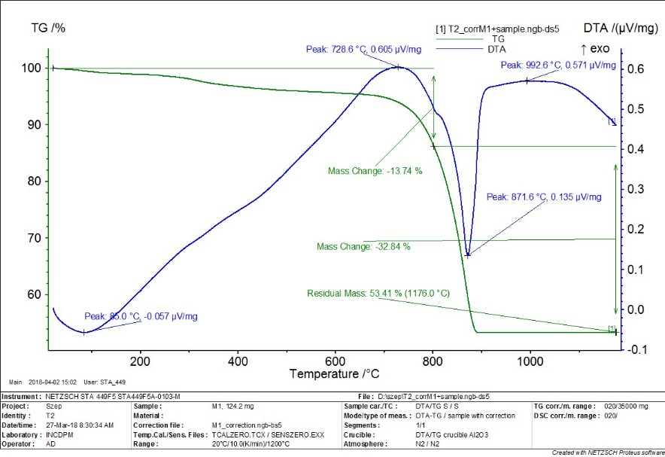
Figure 1. Thermogravimetric measurements (Created with NETZSCH Proteus software): TG - Thermogravimetry, DTA - Differential Thermoanalytics

Based on the TG curve (green curve), there are two main mass losses owing to temperature, below 800ºC and in the range 800-900ºC. In the first case, mass loss can be explained with the disappearance of adsorbed water molecules and organic compounds. In the second case, the main weight loss corresponds to 32.84% by weight when the CaCO₃ phase is transformed into a CaO phase.
Since the mass of the sample remained constant after 900°C, we can assume that the transformation is complete. ^{32,33}
According to the DTA curve, decomposition occurs at 728.6ºC, which is the maximum temperature at which exothermic phenomenon or decomposition occurs.

BET surface
Based on the values obtained in the BET surface and Dollimore–Heal method, listed in Table 1, it can be observed that after the adsorption the surface area (S_{t}) of the calcined eggshell decreased, thus dye molecules had become incorporated into the pores. Moreover, we can see that the pore volume (V_{p}) also decreased after dye adsorption.

Table 1. Eggshell surface area and pore volume
Sample | S_{t} (m²/g) | Vp (cm³/g)
Control calcined eggshell | 3.0 | 0.015
Dye adsorbed calcined eggshell | 1.7 | 0.012

The size distribution of the pore bars of the two samples is shown in Figure 2. Figure 2.1 shows the multimodal mesoporous and macroporous structure of untreated calcined eggshell having three main ranges for the pore radius: 21-20 Å, 110 Å and 280 Å. The first two are located in the mesoporous region and the last one is in the small macroporous region.
As for the sample after the adsorption, due to the small value of the surface, the pore size analysis is not very accurate, but there are two types of pores with radius of about 30 Å and 90 Å. For values above 150°C, the pore radius cannot be calculated due to the nitrogen condensation between the material particles.
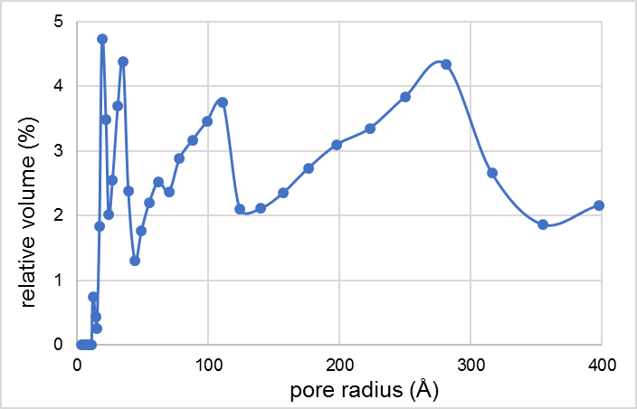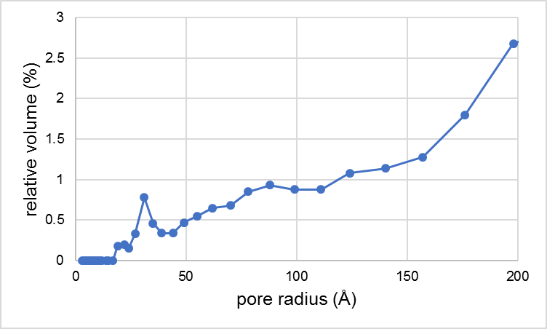
2.
1.
Figure 2. Pore size distribution (1) control (2) dye adsorbed calcined eggshell

Effect of the initial RBV-5R dye concentration
Five different studies (C_{i} = 20-100 mg/L) were made for the adsorption process at a constant 700 rpm at room temperature, 1.5 g of biomass (1000°C calcined eggshell) without adjusting the pH of the aqueous medium. The equilibrium values ​​obtained at the end of the adsorption were used to calculate the efficiency of the biosorption and the maximum amount of material in equilibrium. Figure 3 graphically illustrates the calculated values. Here we can observe that the efficiency achieved is in all cases greater than 90%. Compared to our previous study (untreated eggshell adsorption), no clear trend was observed regarding the increase in concentration. But for subsequent comparison, studies were performed on the 20 mg/L solution.

Figure 3. Effect of the initial RBV-5R dye concentration, standard deviations calculated from measurements from nine parallel results
(C_{i}=20-100 mg/L, 1,5 g biomass, 160 µm, 700 rpm, pH=6,0±0,2, T=20±ºC)

Effect of the amount of biosorbent
The amount of biomass is an important factor in the adsorption process. In theory, the higher the amount of adsorbent present in the aqueous medium, the more binding sites are available to the dye molecules. Nonetheless, after a while, the binding dye molecules are depleted in the solution. In our research we investigated the adsorption parameters of four different initial amounts of calcined eggshells (0.5; 1; 1.5; 2 g).
We studied the dye’s adsorption on untreated eggshell, it can be observed in Figure 4 that the increase as the amount of calcined eggshell increases, the removal efficiency increases, but the quantity in equilibrium exhibits a decreasing tendency. Based on the results, the highest efficiency was obtained (E% = 96.83) for 1.5 g of calcined eggshell.

Figure 4. Effect of the initial biomass weight, standard deviations calculated from measurements from nine parallel results
(C_{i}=20 mg/L, 160 µm, 700 rpm, pH=7,0±0,2, T=20±1ºC)

Effect of the pH of an aqueous medium
The pH of the aqueous medium can influence the biosorption of the dyes: changes in sorbent properties, adsorption mechanism, dissociation of the dye molecules, and the chemical structure of the dye. Changing the pH may cause surface charge as well. Reactive dyes and thus RBV-5R dressing dyes are anionic in nature. This property implies that the dye may be adsorbed in acidic medium with greater efficiency. The pH of the prepared 20 mg/L dye solutions was adjusted using 1N NaOH and 1N HCl solutions. In practice, adding HCl to the aqueous solution protonates the surface of the biosorbent in the solution (acidic medium), so that the anionic dye is willing to bound to the surface of the adsorbent. In the basic medium, by adding NaOH, there is a repulsive force between the dye and the adsorbent, so that the surface of the calcined eggshell is deprotonated; therefore, the adsorption is less efficient.
The calcined eggshell used in our research contains CaO, which is alkaline, highly influencing the pH of the aqueous medium. At the end of the adsorption experiments, the solutions were filtered and the pH of the filtrate was checked. All solutions showed a pH of around 11. Figure 5 shows the results in equilibrium, the constant values of quantity in equilibrium and efficiency were the consequence of the similar pH.

Figure 5. Effect of the pH of an aqueous medium, standard deviations calculated from measurements from nine parallel results
(C_{i}=20 mg/L, 1,5 g, 160µm, 700 rpm, pH=2-11, T=20±1ºC)

Effect of solution temperature
In our research, the adsorption properties of the calcined eggshell were studied by changing the temperatures (20, 30, 40ºC) of the dye solution.
Figure depicts the effect of temperature dependence on the efficiency and the quantity in equilibrium. It can be observed that the efficiency and the quantity in equilibrium decreases with the increase in the temperature of the aqueous medium. Similar results were obtained in our previous study for untreated eggshells, but with lower efficiency (20ºC: 94.39, 30ºC: 92.36, 40ºC: 89.65). This was anticipated because the molecules’ thermal movement increases with the increase of temperature, and thus adsorption decreases.

Figure 6. Effect of the temperature, standard deviations calculated from measurements from nine parallel results (C_{i}=20 mg/L, 1,5 g, 160µm, 700 rpm, pH=6,0±0,2, T=20-40±1ºC)

Thermodynamics
In our research we investigated the effect of temperature (239K, 303K, 313K) on the adsorption process. Based on the results obtained, ln(q_{e}/C_{e}) was plotted against 1/T, and the thermodynamic parameters were determined on the basis of the equation of the obtained straight line.
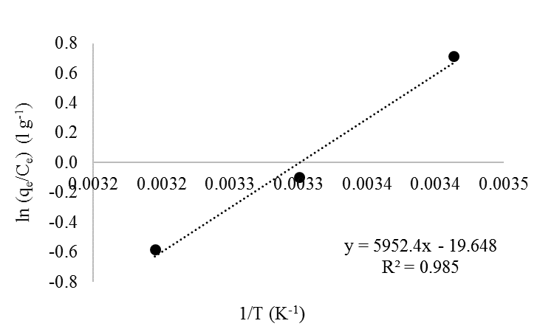
Figure 7. Thermodynamics of biosorption of RBV-5R dye

Table 2 shows the thermodynamic parameters calculated on the basis of equation, namely enthalpy, entropy and free energy of Gibbs. In line with the results of our untreated eggshell experiments, ΔH, enthalpy is less than 84 KJ/mole but positive. According to literature data, it can be concluded that adsorption is an endothermic process and physical adsorption (ΔH < 84 KJ/mole physical adsorption; ΔH 84- 420 KJ/mol of chemical adsorption), and the positive value of ΔS entropy indicates the randomness of the adsorption process. Gibbs' free energy is reduced by the effect of temperature. The lower the temperature, the higher the spontaneity of the process, so it is inversely proportional. ^{34–37}
In summary, based on thermodynamic data, it can be said that biosorption is a spontaneous and endothermic process. Physical adsorption occurs between the dye molecules and the surface of the calcined eggshell.
Table 2. Calculated thermodynamic parameters
ΔS | ΔH | ΔG
ΔS | ΔH | 293 K | 303 K | 313 K
0.163 | 49.649 | 1.786 | 0.153 | -1.481

Adsorption isotherm models
In order to characterize the adsorption process, the four most frequently used isotherm models (Langmuir, Freundlich, Temkin, Dubinin-Radushkevich) were used. In each case, the linear regression coefficients and characteristic parameters were calculated based on equations received from linearized forms (Table 3). The calculated parameters lead us to state that adsorption is physical in nature. Weak Van der Waals bonds are formed between the biosorbent and the dye, because the B-Temkin constant is less than 20 kJ/mol and the E-energy is less than 8 kJ/mol. Since the correlation coefficient of the Langmuir isotherm is the highest in our experimental conditions, the Langmuir isotherm model describes the process, assuming that the adsorption is reversible, monolayer. The surface of the adsorbent, in this case calcined eggshell, has a homogeneous, uniform strength with a constant number of binding centers that incorporate only one molecule into a binding site.

Table 3. Parameters of isotherm models
Langmuir |  |  | Freundlich |  |  | Dubinin-Radushkevich |  |  | Temkin
K_{L} | q_{max} | R² | n | K_{f} | R² | β | E | R² | A_{T} | B | R²
(l/mg) | (mg/g) | R² | n | (mg^{(1−1/n)}l^{1/n}/g) | R² | (mol² kJ²) | (kJ/mol) | R² | (l/g) | (J/mol) | R²
0.133 | 16.949 | 0.924 | 1.388 | 2.31 | 0.678 | 2×10⁻⁷ | 1.58 | 0.833 | 2.4 | 3×10⁻⁵ | 0.282

Adsorption kinetic and diffusion models
Kinetic and diffusion models can be used to study the adsorption mechanisms between biosorbent, calcined egg shells, and adsorbents, RBV-5R. The correlation coefficient of pseudo-first order and pseudo-second order kinetic models was determined by the linear regression method. The calculated parameters for each model are shown in Table 4. Since the calculations show that the linear regression coefficient is higher for the pseudo-second order kinetic model, in addition to our experimental conditions, the adsorption process is described more precisely by the pseudo-second order kinetic model developed by Ho and McKay.

Table 4. Parameters of kinetic models
RBV-5R |  | Pseudo I. |  |  | Pseudo II.
C | q_{e} (exp) | k₁ | q_{e} (calc) | R² | k₂ | q_{e} (calc) | R²
(mg/L) | (mg/g) | (1/min) | (mg/g) | R² | (g/mg×min) | (mg/g) | R²
20 | 1.290 | 0.534 | 1.43 | 0.839 | 6.842 | 1.946 | 0.9999
40 | 2.450 | 0.019 | 1.67 | 0.459 | 0.553 | 3.678 | 0.9997
60 | 3.710 | 0.014 | 2.12 | 0.521 | 0.174 | 5.571 | 0.9997
80 | 5.710 | 0.052 | 1.07 | 0.453 | 0.246 | 7.806 | 0.9999
100 | 6.470 | 0.022 | 1.64 | 0.519 | 0.133 | 9.728 | 0.9999

The intraparticular particle diffusion rate or the liquid film diffusion rate can control the biosorption of the RBV-5R clothing dye on the surface of the calcined eggshell.
Table 5 summarizes the calculated parameters for each diffusion model (intraparticular, liquid film), namely the linear regression coefficients, intersects, velocity values, and particle diffusion coefficient (D) The pore diffusion coefficients range from 6.60 × 10⁻⁹ to 9.09 × 10⁻⁸ cm²/s by varying the concentration. It can also be observed that none of the incisions pass through the origin of any diffusion model. It can be concluded that during the binding of the dye on the surface of the eggshell, the intra-particle section is not rate-determining, nor does the liquid film diffusion affect the adsorption process. ^{34–37}
In summary, the speed of the process is only determined by biosorption.

Table 5. Parameters of diffusion models
RBV-5R |  | Intra-particle diffusion |  |  | Liquid film diffusion
C (mg/l) | D (cm²/s) | k_{ip} (mg/g∙min^{1/2}) | Intersect | R²_{ip} | k_{fd} (1/min) | Intersect | R²_{fd}
20 | 9.09×10⁻⁸ | 0.060 | 1.088 | 0.746 | 0.399 | -2.08 | 0.841
40 | 1.39×10⁻⁸ | 0.012 | 2.287 | 0.218 | 0.018 | -2.86 | 0.666
60 | 6.60×10⁻⁹ | 0.028 | 3.326 | 0.334 | 0.001 | -2.59 | 0.508
80 | 1.31×10⁻⁸ | 0.151 | 3.776 | 0.375 | 0.059 | -2.31 | 0.819
100 | 8.86×10⁻⁹ | 0.169 | 4.579 | 0.418 | 0.019 | -2.19 | 0.506

Scanning electron microscopy
The morphological properties and texture of the surface of the calcined eggshell used during the adsorption were studied by scanning electron microscopy, both for the control and the dye adsorbed eggshells. Figure 8 shows the captured images at 5.000x and 15.000x magnifications. In the figures (Figures 8.1 and 8.3), the porous structure of the calcined eggshell is observed between the irregular shaped structures. Moreover, on the surface some small crystals of about 300 nm can be found. Following the adsorption (Figures 8.2 and 8.4), this porous and irregular structure disappears, with the molecules of the dye filling the "gaps".

2.
1.
4.
3.
Figure 8. SEM (1, 3) control and (2, 4) 2 g/L RBV-5R dye adsorbed calcined eggshell

Energy dispersive spectroscopy, enrichment factors
To determine the elemental composition of calcined eggshell (control and dye adsorbed), energy-dispersive X-ray spectroscopy was performed where the dye-adsorbed biomass was in a 2 g/L solution. The table below shows (Table 6) that there were two main elements in the control sample, Ca and O – since calcined eggshells composition is CaO – and in small percentage N, Mg, C, and Pb. Gold was also present, but is not listed in the table because of its small value (it was attached to the specimen in vacuum to increase conductivity). After adsorption, the amount of C and the amount of N increased by more than 500%, which is typically derived from the dye, being an azo dye.

Table 6. Results of EDX analyses
Elements | Wt(%) calcined eggshell | Wt(%)calcined eggshell + RBV-5R | Enrichment factor (%)
C | 3.33 | 9.89 | 197.49
N | 0.32 | 2.09 | 554.17
O | 35.97 | 36.04 | 0.19
Mg | 0.76 | 0.67 | -11.84
Ca | 59.63 | 51.29 | -13.99

Fourier Transformation Infrared Spectroscopy
Functional groups of calcined eggshell before and after adsorption were determined using Fourier transformations infrared spectroscopy in a wavelength range of 500 and 4000 cm⁻¹ (Figure 9). Typical peaks of calcite and CaO are found at 874, 1442, 1795 cm⁻¹ wavelengths, 713 and 1050 cm⁻¹ typically exhibit peaks of R-SO₂, functional groups on 2923 and 2853 cm⁻¹ represent CH. ^{21,38–40}

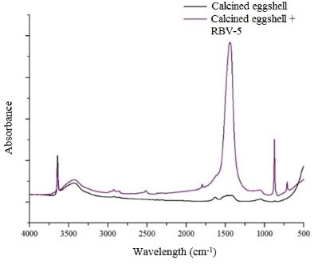
Figure 9. FTIR spectrum for control and 2 g/L RBV-5R dye adsorbed calcined eggshell

Raman Spectroscopy
Raman spectroscopic measurements were performed in the Litosphere Fluidum Research Laboratory of the Eötvös Loránd University, Faculty of Science. Figure illustrates the spectra obtained in the Raman Shift interval between 100 and 1500 cm⁻¹. The figure from top to bottom includes the calcined eggshell, RBV-5R dye adsorbed biomass and RBV-5R fabric dye spectra.
Spectrums of the control and the dye adsorbed calcined eggshells contained peaks of calcite described in literature ^{41,42} at 150-154, 712-711, 1087-1086 cm⁻¹. Peaks at 281-274 and 3618 cm⁻¹ represent Ca(OH)₂. We also observe the characteristic peaks of the dye on the dye-adsorbed biomass sample: 582, 1261-1262, 1307-1306, 1437-1435 cm⁻¹. Newly emerging peaks may be suitable for aliphatic C-S, N = N bonds. ⁴³
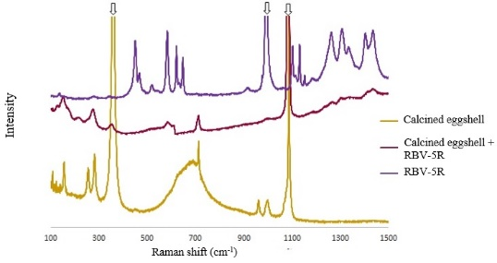
Figure 10. Raman spectrum for control, 2 g/L RBV-5R dye adsorbed calcined eggshell and RBV-5R dye

Bioconcentration factor
Based on the equilibrium concentrations, the bioconcentration factor (BCF) was determined. It indicates how many times the calcined eggshell can accumulate the concentration of RBV-5R. BCF was calculated based on the concentration of the aqueous solution in equilibrium and the concentration of paint on the surface of the calcined eggshell. According to the work of Milinki ⁴⁴, biosorbents can be grouped according to their bioconcentration value as: BCF > 3 large, 1.5 < BCF < 3 medium, BCF < 1.5 small tendency. Five different concentrations (20-100 mg/L) were determined for the BCF (Figure 11). The highest BCF value was obtained for the 100 mg/L solution where BCF = 33.48. It can be observed that the change in the BCF value shows a tendency similar to the efficiency of removing the initial dye concentration. Since the BCF has exceeded the value 3 for all concentrations, the calcined eggshell biomass has a high bioaccumulation tendency.

Figure 11. Bioconcentration factor
(C_{i}=20-100 mg/L, 1,5 g adsorbent, 160 µm, 700 rpm, pH=6,0±0,2, T=20±1ºC)

Conclusion
This study proves that calcined eggshells and eggshells embedded in alginate are suitable for removing RBV-5R dye from sewage. We have shown that the decomposition of the eggshell occurs at 728.6ºC. The total surface area of ​​the eggshell decreased after the adsorption.
Changing the initial parameters leads to the following conclusions:
- by changing the initial dye concentration results show an efficiency higher than 90% in each case;
- as the amount of biomass increases, the amount of bound dye decreases; the highest efficiency is reached at 1.5 g (96.8%);
- in our case, the pH of the aqueous solution did not influence the potency of the binding because the sorbent used in it provided a strong alkaline pH (pH = 11); in each case the efficiency was higher than 95%;
- the increase in the temperature of the aqueous solution reduces the efficiency of adsorption, the process is spontaneous, endothermic.
Mathematical modeling of equilibrium data leads to the following conclusions:
- in addition to our experimental conditions, the adsorption processes are most accurately described by the Langmuir isotherm;
- pseudo-second order kinetic model characterizes the adsorption process;
- the results of the diffusion models prove that neither the intraparticular model nor the liquid film influences the rate of the adsorption process; only the adsorption is decisive;
- thermodynamic measurements further confirm the physical nature of adsorption, the spontaneity of the process, because as the temperature increases, the amount of adsorption decreased.
SEM images of calcined eggshell powder confirm that the dye molecules fill the porous structure. EDX measurements confirm the adsorption resulting in increased C and N and decreased Ca and Mg. Based on the peaks of control and dye adsorbed samples of FTIR and Raman spectra, functional groups and bonds specific to each component can be found.

Acknowledgements
This work was funded by the Sapientia Hungariae Foundations’ Collegium Talentum scholarship program. Research would not have been possible without support from the Research and Instrument Core Facility (RICF) of the Faculty of Science of the Eötvös University, Budapest (Dr. Csaba Szabó, László Aradi).

References
[1] P. Juuti, T. Katko, H. Vuorinen, ‘Environmental History of Water - Global view on community water supply and sanitation’, 2007.
[2] C. Pregun, C. Juhász, ‘Vízminőségvédelem’, Debreceni Egyetem Agrár- És Gazdálkodástudományok Centruma (AGTC) Mezőgazdaság-, Élelmiszertudományi És Környezetgazdálkodási Kar Víz- És Környezetgazdálkodási Intézet.
[3] Török S., ‘Vízellátás és szennyvízkezelés|Digitális Tankönyvtár’, Szent István Egyetem, 2011.
[4] Day Zero, http://coct.co/water-dashboard/, accessed April 2, 2018.
[5] M. Kimmelman, N. Y. Times 2017.
[6] Why Cape Town Is Running Out of Water, and Who’s Next, https://news.nationalgeographic.com/2018/02/cape-town-running-out-of-water-drought-taps-shutoff-other-cities/, accessed March 30, 2018.
[7] S. K. Chinta, S. Vijaykumar, I.J.E.M.S. 2013, 4, 308.
[8] O. S. Bello, T. T. Siang, M. A. Ahmad, Asia-Pac. J. Chem. Eng. 2012, 7, 378.
[9] H. Zollinger, ‘Color Chemistry: Syntheses, Properties, and Applications of Organic Dyes and Pigments’, John Wiley & Sons, 2003.
[10] G. Annadural, R. S. Juang, D. J. Lee, Water Sci. Technol. J. Int. Assoc. Water Pollut. Res. 2003, 47, 185.
[11] M. Hirata, N. Kawasaki, T. Nakamura, K. Matsumoto, M. Kabayama, T. Tamura, S. Tanada, J. Colloid Interface Sci. 2002, 254, 17, DOI: 10.1006/jcis.2002.8570.
[12] M. T. Uddin, M. A. Islam, S. Mahmud, M. Rukanuzzaman, J. Hazard. Mater. 2009, 164, 53, DOI: 10.1016/j.jhazmat.2008.07.131.
[13] F. Kaymak-Ertekin, A. Gedik, LWT - Food Sci. Technol. 2004, 37, 429, DOI: 10.1016/j.lwt.2003.10.012.
[14] C. Majdik, S. Burca, A. Maicaneanu, M. Stanca, S. Tonk, P. Mezey, Rev. Roum. Chim. 2010, 55, 871.
[15] B. Nagy, A. Măicăneanu, C. Indolean, C. Mânzatu, L. Silaghi-Dumitrescu, C. Majdik, J. Taiwan Inst. Chem. Eng. 2014, 45, 921, DOI: 10.1016/j.jtice.2013.08.013.
[16] B. Nagy, A. Maicaneanu, C. Indolean, S. Burca, L. Silaghi-Dumitrescu, C. Majdik, Acta Chim. Slov. 2013, 60, 263.
[17] R. Fabryanty, C. Valencia, F. E. Soetaredjo, J. N. Putro, S. P. Santoso, A. Kurniawan, Y.-H. Ju, S. Ismadji, J. Environ. Chem. Eng. 2017, 5, 5677, DOI: 10.1016/j.jece.2017.10.057.
[18] N. Georgieva, Z. Yaneva, D. Dermendzhieva, Water Sci. Technol. 2017, 76, 1065, DOI: 10.2166/wst.2017.283.
[19] Z. Huang, Y. Li, W. Chen, J. Shi, N. Zhang, X. Wang, Z. Li, L. Gao, Y. Zhang, Mater. Chem. Phys. 2017, 202, 266, DOI: 10.1016/j.matchemphys.2017.09.028.
[20] A. Kausar, M. Iqbal, A. Javed, K. Aftab, Z.-H. Nazli, H. N. Bhatti, S. Nouren, J. Mol. Liq. 2018, 256, 395, DOI: 10.1016/j.molliq.2018.02.034.
[21] R. Slimani, I. El Ouahabi, F. Abidi, M. El Haddad, A. Regti, M. R. Laamari, S. E. Antri, S. Lazar, J. Taiwan Inst. Chem. Eng. 2014, 45, 1578, DOI: 10.1016/j.jtice.2013.10.009.
[22] P. S. Guru, S. Dash, Adv. Colloid Interface Sci. 2014, 209, 49, DOI: 10.1016/j.cis.2013.12.013.
[23] J. V. Flores-Cano, R. Leyva-Ramos, J. Mendoza-Barron, R. M. Guerrero-Coronado, A. Aragón-Piña, G. J. Labrada-Delgado, Appl. Surf. Sci. 2013, 276, 682, DOI: 10.1016/j.apsusc.2013.03.153.
[24] S. Tonk, C. Majdik, S. Robert, M. Suciu, E. Rápó, B. Nagy, A. Gabriela Niculae, Rev. Chim. -Buchar.- Orig. Ed.- 2017, 68, 1951.
[25] L. Giraldo, J. C. Moreno-Piraján, J. Anal. Appl. Pyrolysis 2014, 106, 41, DOI: 10.1016/j.jaap.2013.12.007.
[26] O. A. A. Eletta, O. A. Ajayi, O. O. Ogunleye, I. C. Akpan, J. Environ. Chem. Eng. 2016, 4, 1367, DOI: 10.1016/j.jece.2016.01.020.
[27] J. Li, D. H. L. Ng, R. Ma, M. Zuo, P. Song, Chem. Eng. Res. Des. 2017, 126, 123, DOI: 10.1016/j.cherd.2017.07.005.
[28] N. Pramanpol, N. Nitayapat, Kasetsart J. - Nat. Sci. 2006, 40, 192.
[29] A. Mittal, M. Teotia, R. K. Soni, J. Mittal, J. Mol. Liq. 2016, 223, 376, DOI: 10.1016/j.molliq.2016.08.065.
[30] E. Rápó, R. Szép, Á. Keresztesi, M. Suciu, S. Tonk, Acta Chim. Slov. 2018, 65, 709, DOI: 10.17344/acsi.2018.4401.
[31] R. Mohadi, K. Anggraini, F. Riyanti, A. Lesbani, Sriwij. J. Environ. 2016, 1, 32, DOI: 10.22135/sje.2016.1.2.32-35.
[32] H. J. Park, S. W. Jeong, J. K. Yang, B. G. Kim, S. M. Lee, J. Environ. Sci. 2007, 19, 1436, DOI: 10.1016/S1001-0742(07)60234-4.
[33] T. Witoon, Ceram. Int. 2011, 37, 3291, DOI: 10.1016/j.ceramint.2011.05.125.
[34] O. S. Bello, M. A. Ahmad, Chem. Ecol. 2011, 27, 481, DOI: 10.1080/02757540.2011.600696.
[35] H. Patel, Fresenius Environ. Bull. 2011, 20.
[36] P. C. N. Ejikeme, E. M. Ejikeme, G. N. Okonkwo, Int. J. Tech. Res. Appl. 2014, 2, 96.
[37] Subramani S.E., Thinakaran N., Process Saf. Environ. Prot. 2017, 106, 1, DOI: 10.1016/j.psep.2016.11.024.
[38] B. P. Vinayan, Z. Zhao-Karger, T. Diemant, V. S. Kiran Chakravadhanula, N. I. Schwarzburger, M. Ali Cambaz, R. Jürgen Behm, C. Kübel, M. Fichtner, Nanoscale 2016, 8, 3296, DOI: 10.1039/C5NR04383B.
[39] G. A. C. Ribeiro, D. S. A. Silva, C. C. dos Santos, A. P. Vieira, C. W. B. Bezerra, A. A. Tanaka, S. A. A. Santana, G. A. C. Ribeiro, D. S. A. Silva, C. C. dos Santos, A. P. Vieira, C. W. B. Bezerra, A. A. Tanaka, S. A. A. Santana, Polímeros 2017, 27, 16, DOI: 10.1590/0104-1428.2386.
[40] A. V. Borhade, A. S. Kale, Appl. Water Sci. 2017, 1, DOI: 10.1007/s13201-017-0558-9.
[41] S. K. Sharma, Spectrochim. Acta. A. Mol. Biomol. Spectrosc. 2007, 68, 1008, DOI: 10.1016/j.saa.2007.06.047.
[42] D. B. Thomas, M. E. Hauber, D. Hanley, G. I. N. Waterhouse, S. Fraser, K. C. Gordon, J. Exp. Biol. 2015, 218, 2670, DOI: 10.1242/jeb.124917.
[43] Raman Spectroscopy for Analysis and Monitoring, http://www.horiba.com/fileadmin/uploads/Scientific/Documents/Raman/bands.pdf.
[44] Ecotoxicology and Enviromental Protection|Digitális Tankönyvtár, http://www.tankonyvtar.hu/hu/tartalom/tamop412A/2011-0038_28_milinki_en/ix01.html, accessed November 26, 2017.

