Supporting information

DFT/TDDFT investigation on the electronic structure and spectroscopic properties of cis-dioxomolybdenum (VI) complexes
Imane Seghir, Nadia Nebbache*, Yazid Meftah, Salah Eddine Hachani and Samira Maou
Laboratory of Applied chemistry LCA, University of Biskra, B.P. 145, RP. 07000 Biskra, Algeria
*Corresponding author: E-mail: nadianebbache1@gmail.com ; nadia_nebbache@yahoo.fr
Telephone/Fax: (+213) 33 54 33 18

- Experimental structure of complex 1
CIF file of structure Complex 1(Crystallographic data for the structure analysis have been deposited with the CambridgeCrystallographic Data Center, CCDC No. 1499777https://www.ccdc.cam.ac.uk)
Mo 4.69600000 8.51520000 2.55510000
O 4.41660000 10.18040000 3.46910000
O 4.32010000 7.33170000 3.73950000
O 4.41440000 7.34370000 0.94870000
O 5.76740000 14.46790000 4.91830000
O 2.32300000 8.51920000 2.40790000
O 6.37690000 8.55610000 2.47620000
N 4.28430000 9.81800000 0.78090000
N 4.02800000 9.15110000 -0.42710000
C 3.97040000 6.92800000 -1.34260000
C 4.15210000 7.86310000 -0.23720000
C 4.69050000 11.46660000 3.16660000
C 5.17390000 14.16710000 2.61390000
C 5.05180000 12.32820000 4.18970000
C 4.57610000 11.94290000 1.84410000
C 4.29890000 11.09820000 0.73360000
C 3.74480000 5.58400000 -1.08440000
C 3.48780000 4.67860000 -2.10340000
C 4.78040000 13.32320000 1.62900000
C 3.75410000 6.43830000 -3.68820000
C 5.33400000 13.67480000 3.89730000
C 3.47530000 5.12890000 -3.40280000
C 3.99540000 7.35610000 -2.67620000
H 5.32350000 15.09370000 2.41470000
H 5.10530000 12.00490000 5.09230000
H 4.12260000 11.54340000 -0.09850000
H 3.76790000 5.27010000 -0.17780000
H 3.31040000 3.75730000 -1.90020000
H 4.64050000 13.65070000 0.73760000
H 3.78080000 6.73970000 -4.59930000
H 3.28620000 4.51290000 -4.11490000
H 4.17970000 8.27720000 -2.87610000
H 1.86910000 7.79320000 1.97330000
H 1.81840000 9.24530000 2.78170000
H 5.87290000 14.09580000 5.79700000

Optimized structure of complexe 1:
Mo 0.18703965 -1.37871500 -0.25221907
O 2.02627858 -0.95593110 0.33448779
O 0.01596096 -2.98645046 0.30780208
O -1.74464744 -0.87801879 -0.09519645
O 6.44636581 0.68469933 -0.03172961
O -0.02193175 -1.03324465 2.20309129
O 0.39229220 -1.44473699 -1.93280388
N 0.01818390 0.85271980 -0.01223398
N -1.26672513 1.35251682 0.03793603
C -3.56626057 0.65101507 -0.01999807
C -2.11710425 0.38571031 -0.02732666
C 2.84306614 0.07669763 0.14143835
C 4.65713307 2.19497642 -0.13854984
C 4.21368693 -0.16920582 0.13123197
C 2.36757518 1.39661114 0.00127651
C 0.96922316 1.71710155 0.01355217
C -4.46321207 -0.41093103 -0.10068592
C -5.82815687 -0.16724536 -0.09606560
C 3.30670903 2.43418064 -0.12497660
C -5.40889153 2.19538709 0.07003031
C 5.11059695 0.87715067 -0.01214321
C -6.30273715 1.13371163 -0.01034114
C -4.04574754 1.95795610 0.06465021
H 5.38130949 2.99186855 -0.24549452
H 4.54974538 -1.19516730 0.23833026
H 0.67585576 2.76529755 0.04089069
H -4.07973240 -1.42062302 -0.16936723
H -6.52332855 -0.99663724 -0.16085738
H 2.94474263 3.45225698 -0.22350996
H -5.77830340 3.21258480 0.13584149
H -7.37061801 1.32275657 -0.00728433
H -3.33799072 2.77460612 0.12540484
H -0.45088002 -1.84870475 2.48664505
H 0.89082132 -1.06566330 2.51046658
H 6.65267223 -0.25243644 0.04445648

- Calculated structure of Mo complexes
Optimized structure of Complex 2
Mo 0.15527809 -1.28018770 -0.44106354
O 1.99655585 -0.89225382 0.16306817
O 0.00456100 -2.93247549 -0.02281147
O -1.77914870 -0.81441459 -0.22239299
O 6.39758016 0.81801326 -0.09947569
O 0.34379485 -1.19647312 -2.12282052
N -0.03131924 0.91980095 -0.00444182
N -1.32012158 1.40047863 0.10159155
C -3.61367777 0.68395237 0.00404498
C -2.16232808 0.43472452 -0.04027510
C 2.80191583 0.16139372 0.05373131
C 4.59372318 2.31398710 -0.05629869
C 4.17453183 -0.06903640 0.00899213
C 2.31305928 1.48372498 0.03454063
C 0.91205978 1.78799371 0.08815415
C -4.50174866 -0.37567923 -0.16110126
C -5.86872667 -0.14691177 -0.12217482
C 3.24139745 2.53764943 -0.00898539
C -5.46920896 2.19608773 0.24680104
C 5.06039407 0.99472335 -0.05041755
C -6.35417345 1.13672880 0.08196432
C -4.10409612 1.97359929 0.20768416
H 5.30950506 3.12434446 -0.09969420
H 4.52096338 -1.09704820 0.02238495
H 0.60949878 2.82678307 0.21022120
H -4.10985890 -1.37159261 -0.32182100
H -6.55698126 -0.97428717 -0.25297335
H 2.86922012 3.55679808 -0.01429399
H -5.84712983 3.19986908 0.40518788
H -7.42363617 1.31415752 0.11172212
H -3.40318364 2.78876181 0.33322311
H 6.61314814 -0.12009690 -0.10784469
C 0.00064126 -1.17534674 1.61044723
H -0.93652142 -1.58930014 1.91910376
H 0.05844105 -0.15294566 1.92069776
O 1.06851966 -1.91572780 2.20741617
H 0.83745968 -2.13840961 3.11219472

Table S1. Selected theoretical geometric parameters at CAM-B3LYP/LANL2DZ/6-311G* level of complex 2.
 | Theo |  | Theo
Bond length (A°) |  | Angle length  (°)
Mo(1)-O(3) | 1.716 | O(2)-Mo(1)-O(4) | 178.73
Mo(1)-O(7) | 1.716 | O(3)-Mo(1)-N(8) | 174.31
Mo(1)-O(6) | 2.060 | O(6)-Mo(1)-O(7) | 179.69
Mo(1)-O(4) | 1.959 | O(3)-Mo(1)-O(7) | 89.42
Mo(1)-O(2) | 1.92 | O(4)-Mo(1)-N(8) | 81.42
Mo(1)-N(8) | 1.972 | O(3)-Mo(1)-O(4) | 93.35
N(8)-N(9) | 1.387 | O(2)-Mo(1)-O(3) | 87.84
N(9)-C(11) | 1.289 | O(2)-Mo(1)-N(8) | 97.38
N(8)-C(16) | 1.285 | O(4)-Mo(1)-O(6) | 88.86
O(4)-C(11) | 1.442 | O(4)-Mo(1)-O(7) | 91.38
O(2)-C(12) | 1.439 | O(7)-Mo(1)-N(8) | 81.42
C(12)-C(15) | 1.415 | O(2)-Mo(1)-O(7) | 89.03
C(15)-C(16) | 1.404 | O(3)-Mo(1)-O(6) | 90.86
C(10)-C(11) | 1.540 | O(6)-Mo(1)-N(8) | 91.25

- Frontier molecular orbitals ( FMO) of Mo complexes

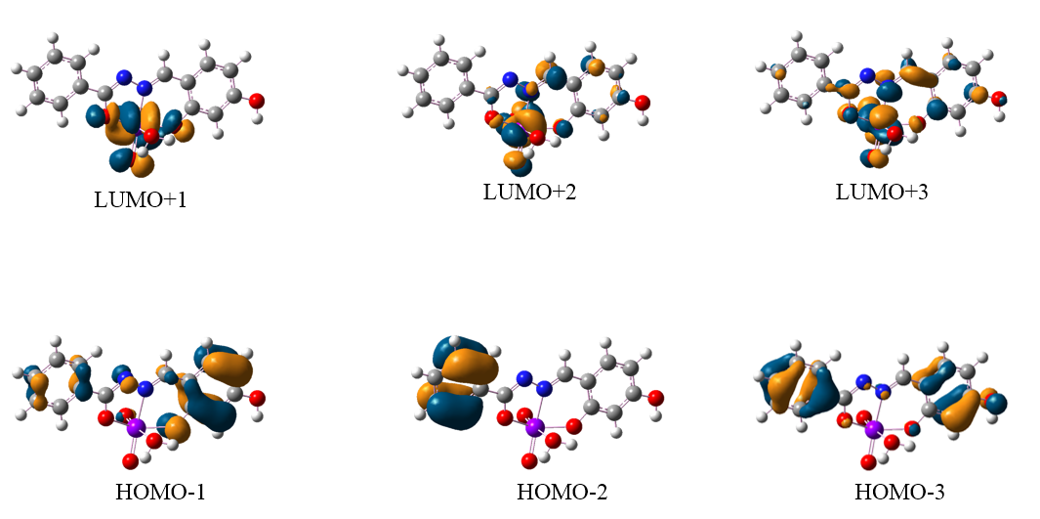
Figure S1. FMO of complex 1

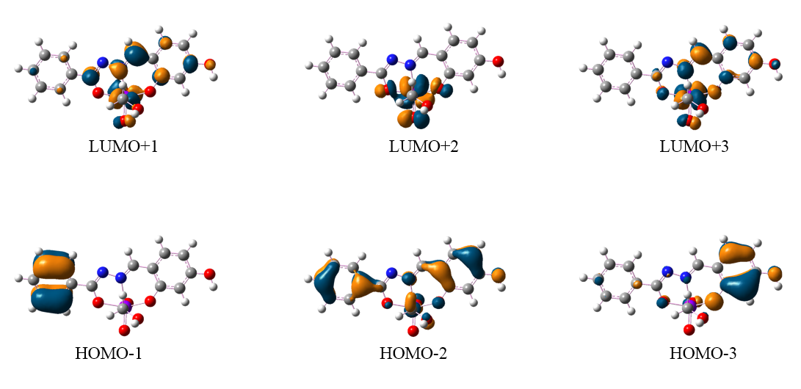
Figure S2. FMO of complex 2

- Detailed reference of Gaussian program
Gaussian 09, Revision A.02, M. J. Frisch, G. W. Trucks, H. B. Schlegel, G. E. Scuseria, M. A. Robb, J. R. Cheeseman, G. Scalmani, V. Barone, G. A. Petersson, H. Nakatsuji, X. Li, M. Caricato, A. Marenich, J. Bloino, B. G. Janesko, R. Gomperts, B. Mennucci, H. P. Hratchian, J. V. Ortiz, A. F. Izmaylov, J. L. Sonnenberg, D. Williams-Young, F. Ding, F. Lipparini, F. Egidi, J. Goings, B. Peng, A. Petrone, T. Henderson, D. Ranasinghe, V. G. Zakrzewski, J. Gao, N. Rega, G. Zheng, W. Liang, M. Hada, M. Ehara, K. Toyota, R. Fukuda, J. Hasegawa, M. Ishida, T. Nakajima, Y. Honda, O. Kitao, H. Nakai, T. Vreven, K. Throssell, J. A. Montgomery, Jr., J. E. Peralta, F. Ogliaro, M. Bearpark, J. J. Heyd, E. Brothers, K. N. Kudin, V. N. Staroverov, T. Keith, R. Kobayashi, J. Normand, K. Raghavachari, A. Rendell, J. C. Burant, S. S. Iyengar, J. Tomasi, M. Cossi, J. M. Millam, M. Klene, C. Adamo, R. Cammi, J. W. Ochterski, R. L. Martin, K. Morokuma, O. Farkas, J. B. Foresman, and D. J. Fox, Gaussian, Inc., Wallingford CT, 2016.

