Subcritical water for recovery of polyphenols from comfrey root and biological activities of extracts
Jelena Vladicª, Natasa Nasticª, Tatjana Stanojkovic^{b}, Zeljko Zizak^{b}, Jelena Cakarevicª, Ljiljana Popovicª, Senka Vidovicª

ªFaculty of Technology, University of Novi Sad, Bulevar cara Lazara 1, 21000 Novi Sad, Serbia
^{b}Institute of Oncology and Radiology of Serbia, Pasterova 14, 11000 Belgrade, Serbia

Abstract
In the present study, subcritical water was used for extraction of bioactive compounds of Symphytum officinale root. Temperature (120–200 °C), extraction time (10–30 min) and HCl concentration in extraction solvent (0–1.5%) were investigated as independent variables in order to obtain the optimal conditions for extraction and to maximize the yield of total phenols, flavonoids and antioxidant activity of obtained extracts. The application of optimal conditions (200 °C, 25.6 min and 0.0075%) provided extracts rich in total phenols and flavonoids and high antioxidant activity. Results also demonstrated that subcritical water extraction showed significant advantages for recovery of comfrey root bioactive compounds comparing to maceration and ultrasound-assisted extraction techniques. In addition, subcritical water extracts of S. officinale root are the promising sources of compounds with antioxidant, ACE inhibition, and antiproliferative properties and could potentially be used for production of new pharmacologically-active formulations.
Keywords: Symphytum officinale root; Subcritical water extraction; Antioxidant activity; ACE inhibition activity; Antiproliferative activity
1. Introduction
Comfrey (Symphytum officinale L.), a member of the genus Boraginacae, is a well-known medicinal plant with large hairy leaves and small purple bell-shaped flowers, found predominantly in moist habitats especially beside river. Native in Europe and Asia, the plant has a striking record of medicinal use. The root and leaf have been used externally to treat a wide variety of ailments as well as internally as a decoction for oral and pharyngeal gargle or as a part of dietary supplements.¹ Comfrey root is used by both traditional and modern herbalists for closing up joint inflammations, musculoskeletal injuries, inflamed breasts and wounds.²⁻⁴ Its pharmacological properties and clinical efficacy are ascribed mainly to allantoin, rosmarinic acid, mucopolysaccharides, triterpenoids and tannins.⁵ Allantoin is responsible for the stimulation of cell proliferation. It protects tissues and accelerates the healing process, with abundant growth of healthy granulation tissue in slowly healing suppurative wounds. The root of comfrey is also a good source of bioactive compounds including antioxidant polyphenols, A, B and C vitamins, steroidal saponins, proteins, inulin, calcium, potassium, copper, sulfur and selenium.⁶
The increasing interest in the bioactive compounds of a natural origin with a high antioxidant capacity has resulted in increased attention for the applying of different extraction techniques and their optimization. In the past two decades, their health effects such as the treatment and prevention of cancer, cardiovascular, chronic and neurodegenerative diseases are well supported by scientific researchers who are challenged to find the most efficient extraction and purification method, as well as to do the full characterization of obtained bioactive compounds from natural matrices.
Extraction of bioactive compounds from comfrey root has been investigated in the last few years focusing mainly on conventional solid/liquid extraction.^{7,8} Conventional extraction techniques, however, are quite laborious, time- and solvent-consuming.⁹ They present low efficiency, insufficient selectivity, and use of toxic solvents. The issues encountered for conventional methods can be overcome by application of environmental-friendly extraction techniques, such as ultrasound-assisted extraction (UAE) and subcritical water extraction (SWE).
Among these technologies, UAE has been demonstrated as an advisable tool to recover polyphenols from plant materials, due to its cheapness and maintenance cost.¹⁰ Report by Wang et al. indicates that UAE reduces processing time, accelerates heat and mass transfer and requires a simple and easy to operate apparatus which helps in easy extraction of thermolabile compounds, without any degradation.¹¹ The enhancement of extraction process by ultrasounds is attributed to the cavitation phenomenon and its consequent thermal and mechanical effects which can result in disruption of the cell walls, reduction of the particle size and enhanced mass transfer across cell membrane caused by the collapse of the numerous tiny bubbles.
From the literature review, subcritical water extraction, as a potential alternative to conventional extraction techniques, has been successfully applied to extract target compounds from various matrices mainly due to its safety and compatibility with consecutive applications, environmental concerns and solvent recovery operations. SWE is based on the use of water at temperatures ranging from boiling point to the critical temperature and pressures high enough to keep the water in a liquid state throughout the extraction process. The change of the dielectric constant of water with temperature results in the possibility of tuning its polarity, for high-selectivity extractions.¹²
The aim of this study was to optimize SWE of polyphenol antioxidants from S. officinale root. Response surface methodology and Box-Behnken experimental design were employed to investigate the effect of three process parameters (temperature, time and amount of added acidifier) on the extraction of targeted compounds. Their effect on total phenols and total flavonoids content, as well as on antioxidant activity, was evaluated. Investigated responses were compared in extracts obtained by conventional and novel extraction techniques (UAE, SWE). In addition, ACE inhibition and antiproliferative activities of extracts obtained by using contemporary SWE and UAE, and classical maceration extraction of S. officinale root were determined.

2. Materials and methods
2.1. Chemicals and reagents
1,1-Diphenyl-2-picryl-hydrazyl-hydrate was purchased from Sigma-Aldrich (Sternheim, Germany). Folin–Ciocalteu reagent and gallic acid were purchased from Merck (Germany). All other reagents used were either analytical or HPLC grade.
2.2. Plant sample
All analysis was performed by using commercial dry S. officinale root supplied by a producer of medicinal plants (Chamomilla, Banatski Karlovac, Vojvodina, Serbia).
2.3. Preparation of extracts
2.3.1. Maceration
Conventional solid-liquid extraction was performed with two different extraction solvents: methanol and ethanol solution (50%, w/w). All the extractions were performed by macerating 5.0 g of dry sample with 50 mL of extraction solvent at room temperature (25 °C) for 48 h in a shaker with temperature control (KS 4000i, IKA, Germany) at 150 rpm. After extraction, obtained extracts were filtrated through filter paper. Extracts were collected into glass vials and stored at 4 °C prior analysis.
2.3.2. Ultrasound-assisted extraction
Ultrasound-assisted extraction was performed in sonication water bath (EUP540A, Euinstruments, France). The bath consisted of a rectangular container with frequency fixed at 40 kHz. The samples of dried powdered S. officinale root (5 g) were placed in a flask (250 mL) and mixed with 50 mL of selected solvent (methanol and 50% ethanol (w/w)). The sonication was performed at temperature of 30 °C and ultrasonic power of 60 W/L for 40 min. Flasks with condensers were always positioned in the same distance from the transducer in order to provide constant ultrasonic power. After extraction, extracts were filtered through filter paper under vacuum, collected into glass vials and stored in a dark place at 4 °C prior analysis.
2.3.3. Subcritical water extraction
Subcritical water extraction (SWE) was carried out in a batch-type high-pressure extractor (Parr Instrument Company, USA) using the same experimental process previously described by Zeković et al.¹³ For each run, the extraction cell was filled with 5 g of dried ground S. officinale root and 50 mL of double-distilled water. All SFE extractions were performed at 30 bar with different combinations of temperature (120-200 ˚C), extraction time (10-30 min) and concentration of HCl (0-1.5%). Obtained extracts were filtrated through filter paper under vacuum, collected into glass vials and stored in a dark place at 4 °C prior analysis.
2.4. Analyses of extracts
2.4.1. Determination of total phenols content and flavonoids content
The total phenolics (TP) content in obtained S. officinale extracts was determined spectrophotometrically using standard Folin–Ciocalteu procedure.¹⁴ Absorbances of the samples were measured at 750 nm (6300 Spectrophotometer, Jenway, UK). The results are expressed as g of gallic acid equivalents (GAE) per 100 g dry weight (DW).
The total flavonoids (TF) content in S. officinale extracts was determined using aluminium chloride colorimetric assay, as reported by Markham.¹⁵ The absorbance for all tested extracts was measured at 510 nm. The content of total flavonoids was expressed as g of catechin equivalents (CE) per 100 g DW.
2.4.2. Determination of antioxidant activity-DPPH assay
Free radical scavenging activities of S. officinale subcritical water extracts were evaluated following the procedure previously reported by Espín et al.¹⁶ Antioxidant activity were expressed as IC₅₀ value, defined as the inhibition concentration of the sample required to inhibit 50% of radical scavenging capacity (mg/mL).
2.4.3. Analysis of angiotensin-I-converting enzyme inhibition activity
Angiotensin-I-converting enzyme (ACE) inhibitory activity was measured following the assay described by Yoshie-Stark et al.¹⁷ The IC₅₀ value of samples was defined as the inhibition concentration of the sample (in μg/mL) required to inhibit 50% of ACE activity.
2.4.4. Cell lines - treatment
Malignantly cell lines used in this assay (human cervix adenocarcinoma HeLa, breast carcinoma MDA-MB-453, human myelogenous leukemia K562 and human fetal lung fibroblasts MRC-5 cells) were obtained from the American Type Culture Collection (Manassas, VA, USA). All cancer cells were kept in the RPMI-1640 medium supplemented with 10% heat-inactivated (56°C) fetal bovine serum (FBS), l-glutamine (3 mmol/L), streptomycin (100 mg/mL), penicillin (100 IU/mL) and 25 mM HEPES, and adjusted to pH 7.2 by bicarbonate solution. Upon reaching confluence, cells were cultured in an atmosphere of 5% CO₂ and 95% relative humidity at 37 °C. 200 mg/ml of Stock solutions of compounds were prepared in dimethylsulfoxide (DMSO), and afterwards diluted in RPMI-1640 medium. HeLa cells (2000 cells per well), MDA-MB-453 cells (3000 cells per well), and MRC-5 cells (5000 cells per well) were distributed in sterile 96-well microtiter plates, and were cultured for 20 h. Thereafter, the cells were treated with investigated extracts of various concentrations. The concentrations tested were in the range of 0.0625 to 2 mg/mL. In control wells, only nutrient medium was added to the cells. The investigated extracts were added to a suspension of K562 cells (5000 cells per well) 2 h after cell seeding, in the same final concentrations. The cultures were incubated for 72 h at 37°C in a humidified incubator with 5% CO₂.
Determination of cell survival (MTT test)
The influence of S. officinale extracts on the viability of malignantly transformed cell lines was determined by MTT (microculture tetrazolium test) following the procedure described by Mosmann¹⁸ with slight modification by Ohno and Abe,¹⁹ 72 hours after the investigated extract was added. Briefly, 20 μL of MTT solution (5 mg/mL in phosphate buffered saline (PBS)) was added to each well and plates were incubated for a further 4 h at 37 °C in 5% CO₂ humidified atmosphere. After incubation, the MTT formazan crystals were dissolved by adding 100 μl of 10% SDS to each well. The number of viable cells was measured by detecting absorbance in an ELISA microplate reader at a wavelength of 570 nm 24 h later. The cell survival (%) was calculated as absorbance of treated cells divided with absorbance of control cells and multiplied with 100. Cell growth inhibitions were expressed as IC₅₀ values, defined as the concentrations of sample required to inhibit 50% of cell survival. All experiments were done in triplicate.
2.5. Design of experiments and statistical analysis
Response surface methodology was employed to study the effect of independent variables temperature (X1, 120–200 °C), extraction time (X2, 10–30 min) and HCl concentration (X3, 0–1.5%) on the total phenols content, total flavonoids content and antioxidant activity parameters as responses. The Box-Behnken experimental design (BBD) was selected to propose the model for the investigated responses. The experimental design consisted of fifteen trials in random order, including three replicates at the central point. Table 1 shows the three independent variables encoded to three levels (-1, 0 and 1).
A second-order polynomial model (Eq. (3)) was fitted to results in order to correlate the relationship of each factor to the response:²⁰
Y = β₀ +∑ β_{i}X_{i} + ∑b_{ii}X_{ii}² + ∑b_{ij}X_{i}X_{j} (1)
where Y represents the response variable, Xi, Xii and XiXj represent the linear, quadratic, and interactive terms of the coded independent variables, respectively, and β0, βi, βii, and βij are the regression coefficients for intercept, linearity, quadratic, and interaction intercept terms, respectively. Analysis of variance (ANOVA) was carried out to identify the adequacy of the developed model with the significance levels of 0.05 (significant) and 0.10 (moderately significant). The coefficient of multiple determination (R²), coefficient of variance (CV) and p-values for the model and lack of fit coefficient were obtained from analysis of variance. The statistical software Design-Expert v.7 Trial (Stat-Ease, Minneapolis, Minnesota, USA) was employed for the all computation and graphics in this study.

3. Results and discussion
3.1. Statistical analysis and model fitting
In this study, a Box-Behnken design was carried out to optimize the procedure for the extraction of phenolic compounds using SWE. The investigated response values (TP and TF content, and antioxidant activity) for different combination of SWE parameters (extraction temperature, extraction time and HCl concentration) are presented in Table 2.
The experimental results of SWE were fitted to a second-order polynomial model (Eq. (3)). Multiple regression coefficients for linear, interaction and quadratic terms were achieved using method of least square (MLS) (Table 3).
Analysis of variance (ANOVA) was employed to check adequacy of the applied models and the results are summarized in Table 4. Statistical analysis suggested that the experimental values correlate well with the models. Good model fitness has been confirmed by highly significant p-values (p < 0.05) for all models. For all three investigated responses, mathematical models proved to be statistically acceptable due to insignificant lack of fit (p > 0.05). Validity of the models has been also confirmed by significant regression (p < 0.05). Furthermore, considering particularly high determination coefficients (R² > 0.90) for the TP content, TF content, and IC₅₀ values (0.965, 0.974 and 0.957, respectively), applied second-order polynomial model is well adjusted to the experimental results. Considering the obtained values, these data were used for creation of response surface 3D plots for each experimental model.
3.2. Influence of independent variables on the investigated dependent variables
Total phenolic content observed in S. officinale root extracts obtained under different SWE conditions ranged from 1.11 to 6.87 g GAE/100 g DW. The highest TP content was observed at temperature of 200 °C, extraction time of 30 min and HCl concentration of 0.75%, while the lowest TP content was obtained at temperature of 120 °C and extraction time of 20 min without added acid modifier (Table 2). All SWE extracts obtained at 200 °C had significantly higher TP content comparing to extracts obtained at 120 and 160 °C. According to ANOVA analysis, the linear temperature terms had an important influence (p < 0.05), while other effects were not statistically important (Table 4). Based on the sum of squares, the importance of the independent variables on TP content was insignificant, as well as their interactions. Determination of regression coefficients using the least squares method provided the predictive model equation for TP extraction depicted in the Table 5.
The combined effect of the extraction parameters on the TP content of S. officinale root extracts obtained by SWE is presented in Figure 1a. The TP content increased linearly with temperature, while the extraction time did not influence this investigated response. The HCl concentration effect on phenols extraction of obtained extracts was rather insignificant. Similar findings for SWE of phenolic compounds were previously reported for other plant species.^{13,21} In subcritical water extraction, temperature is one of the most prominent operational parameter that affect the efficiency and selectivity of the process. Water at high temperatures breaks bonds between phenolics and cell wall releasing them more efficiently.²² Elevated temperatures enhance also the diffusion rate and desorption kinetics, resulting in a decrease in its viscosity and surface tension.¹² A decrease in solvent surface tension allows better pore filling, thus permitting analytes to be better solubilised.
Concerning the total flavonoids content, predictive second-order polynomial model equation, which is able to describe influence of SWE parameters on investigated response, is presented on Table 5. The linear terms of temperature and HCl concentration exhibited highly significant influence on TF content, while linear influence of extraction time was insignificant. Extraction temperature expressed the most significant positive effect on TF meaning that TF will significantly increase with increasing the temperature, which is in accordance with experimental results obtained for TP content. Linear term of HCl concentration exhibited negative influence on TF content, which imply that comfrey root flavonoids were better extracted if reduced acidifier concentration in extraction solvent were applied. Also, the interaction term between temperature and HCl concentration interaction affected TP content negatively. This means that elevated temperature and increased HCl concentration caused reduction in TF content, probably due to thermal degradation of flavonoid compounds on these severe extraction conditions. Quadratic term of extraction time exhibited significant positive influence on TF content. This suggested that an increase of extraction time increased the TF content of S. officinale extract. The response surface plots describing influences of SWE parameters on TF content of S. officinale root extracts are shown in Figure 1b. TF content of extracts ranged from 0.97 to 3.04 g CE/100 g DW. The highest TF value was measured in the samples obtained at a temperature of 200 °C and extraction time of 20 min, but with the absence of HCl. Extracts obtained at 120 °C, for 20 min, without using acid modifier, exhibited the lowest TF content.

(a)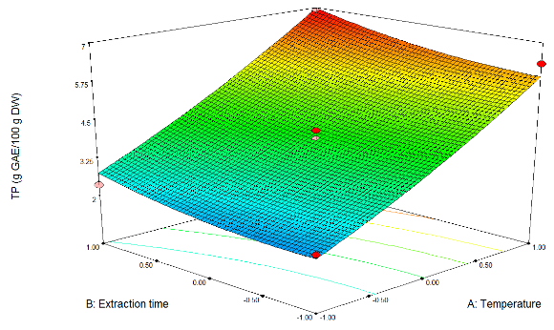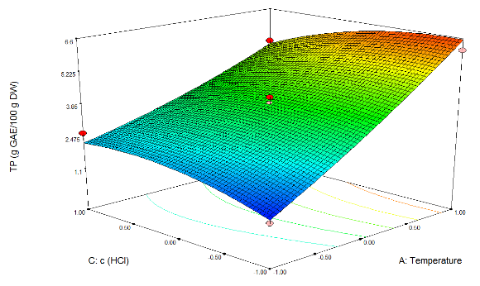 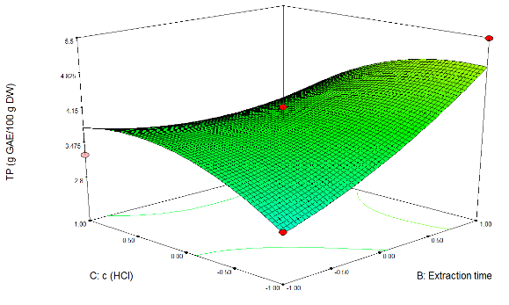
(b)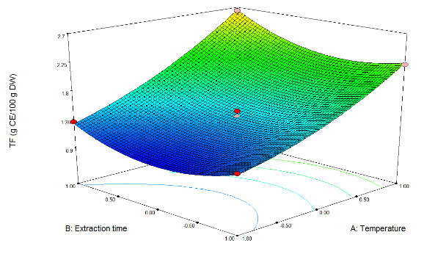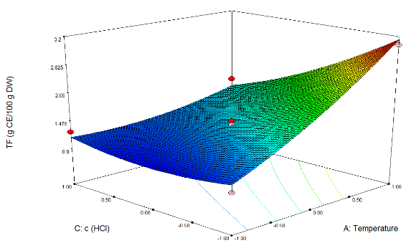
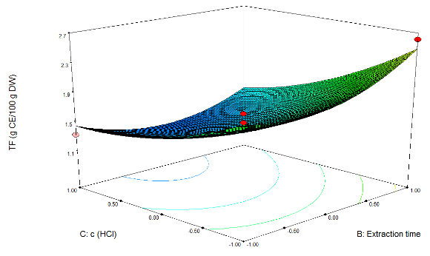
(c)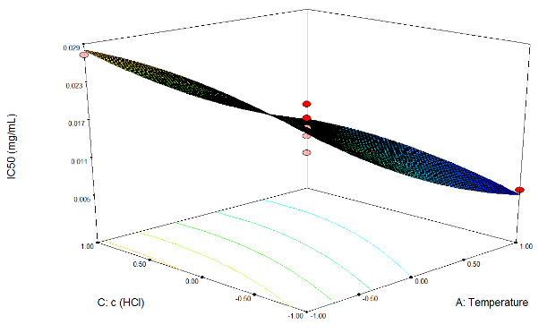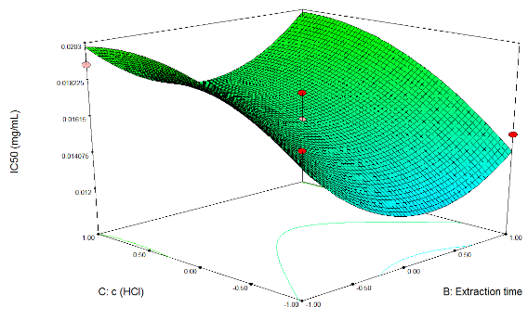
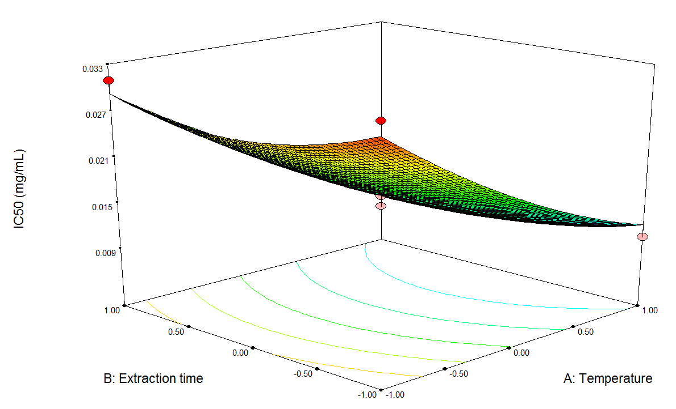
Figure 1. Response surface of TP content (a), TF content (b) and IC₅₀ value (c) as simultaneous function of temperature, extraction time and HCl concentration
Experimentally obtained values of antioxidant activity observed in S. officinale root extracts obtained by SWE are presented in Tables 2 and 4. The antioxidant activity of comfrey root extracts is not affected by extraction time, while the temperature and HCl concentration had a significant influence on this property, as it was the case with TF content. Linear terms of temperature displayed highly significant negative influence on investigated response (IC₅₀ value). On the other hand, HCl concentration exhibited significant positive influence on IC₅₀ value, which means that pure, or slightly acidified water should be used as extraction solvent. The final equation which could predict the behaviour of the investigated response is shown in Table 5. Depending on the extraction parameters antioxidant activity of extracts varied from 0.0059 to 0.0329 mg/mL. The highest antioxidant activity was measured in the extracts obtained at a temperature of 200 °C and extraction time of 20 min without using HCl modifier. On the other hand, extracts obtained at 120 °C for 10 min using 0.75% HCl as extraction solvent, showed the lowest antioxidant activity. Antioxidant activity significantly increased with the increase in extraction temperatures from 120 to 200 ºC being in accordance with the content of polyphenols and flavonoids. These findings were in agreement with previously published studies on using SWE for the isolation of natural antioxidants where antioxidant activity increased with temperature up to 200 ºC in SWE of deodorized thyme.²³ He et al.²⁴ also examined the effects of temperature on the antioxidant activity of pomegranate seed residues extracts. The highest antioxidant activities were seen when extraction was performed at temperature between 180 and 240 ºC. The high antioxidant activity of extracts acquired at such relatively high temperature may have been related to the formation of new bioactive compounds during the extraction process via Maillard reactions.²³ Visual representation of extraction parameters influence on antioxidant activity in comfrey root extracts is given in Figure 1c. Moreover, moderate correlation between IC_{50,} TP and TF can be noticed, proving that polyphenols were the most important compounds responsible for antioxidant activity of S. officinale root.
Regarding all these aspects, the efficiency of extraction of phenolic compounds and antioxidative activity of SWE extracts depend on temperature directly. Extraction time had a negligible effect on all three investigated variables, while HCl concentration affected TF content and antioxidant activity. Other authors that dealt with subcritical water extraction came to similar conclusion.^{21,} ^{25, 26} However, in order to gain complete information about extraction parameters effect on investigated responses during SWE of S. officinale root, further studies including chemical characterization of the extracts and the identification of responsible bioactive compounds are required.
3.3. Optimization of process parameters
Optimization of SWE process was the primary subject of this work, which allowed setting process parameters that maximized the value of all investigated responses. Optimized extraction conditions for maximized yields of TP, TF, and minimized IC₅₀ value, i.e. maximized antioxidant activity are presented in Table 6. By applying the response surface methodology and the multiple response optimization in the experimental domain investigated, the optimal process parameters of all three responses simultaneously of S. officinale root were determined to be as follows: temperature of 200 °C, extraction time of 25.6 min and 0.0075% HCl concentration in extraction solvent. Predicted values of investigated responses on these conditions were 7.26 g GAE/100 g DW, 3.40 g CE/100 g DW and 0.0058 μg/mL, for TP, TF and IC₅₀, respectively. Determination of optimal conditions and predicted values was based on desirability function, D = 1. The results showed that there was no significant difference observed between the predicted values and experimental ones, indicating that the model was adequate for reflecting the expected optimization. In addition, the extract obtained under optimal conditions was used for further analysis.
3.4. Comparison of extraction techniques
Currently, literature data concerning S. officinale root extracts is very limited. In the present study, subcritical water extracts of S. officinale root obtained under optimal conditions (200 °C, 25.6 min, and 0.0075% HCl) were compared to those obtained by conventional extraction and ultrasound-assisted extraction, where ethanol (50%) and methanol were used as extraction solvents (Table 7).
SWE was found to be much more efficient for extraction of TP and TF from S. officinale root in comparison to maceration and UAE. Lower TP and TF contents were observed by Alkan et al.²⁷ in methanolic and aqueous extracts of comfrey root obtained by Soxhlet extraction and decoction method. Furthermore, antioxidant activity obtained by SWE was significantly higher comparing to that obtained by maceration and UAE with ethanol and methanol. Moderately high antioxidant activity of S. officinale ethanolic extract (0.0397 mg/mL) was reported by Alkan et al.²⁷ According to the results from Table 7, addition of methanol showed the lowest recovering capacity for bioactive compounds from comfrey root. Addition of ethanol to the water improved her capabilities to extract these bioactive compounds. But, by application of increased pressure and temperature, and transformation of water into the subcritical state, these capabilities were much more improved. These observations are related to dielectric constant of extraction solvent. In subcritical conditions, as the temperature of water is increased, the polarity of water decreases. That allows dissolving compounds of intermediate or low polarity. The dielectric constant of water decreases with the temperature (e.g., from ε = 80 at ambient temperature to ε = 27 at 250 °C) and becomes close to that of methanol (ε = 33.6 at 25 °C) and ethanol (ε = 24.5 at 25 °C).²⁸
In addition, SWE process only needed 25.6 min to reach significantly higher values of investigated responses, while extraction time for maceration was 48 h and for UAE 40 min. This might be due to the dissolving properties of subcritical water, thus providing a much faster mass transfer. Given the advantages of used solvent, including its safety, selectivity and low cost, functionality, good yields of target compounds and reduced energy consumption, make this technique favorable for potential industrial applications.
3.5. ACE inhibition activity
Angiotensin-I-converting enzyme (ACE) is a glycosylated zinc dipeptidyl-carboxypeptidase whose main function is to regulate arterial blood pressure by converting angiotensin I to angiotensin II, a potent vasoconstrictor.²⁹ Thus, inhibition of ACE has been considered as important in the chronic treatment of various cardiovascular diseases. A series of synthetic ACE inhibitors, which have been clinically used as antihypertensive drugs, cause some adverse side effects in humans.³⁰ Last years of the twentieth century were marked with increased worldwide interest in herbal medicine and the development of new drugs based on naturally occurring biologically active compounds.
Within this context, in the present study the extracts obtained by maceration, UAE, and SWE extract obtained under optimal conditions (temperature of 200 ºC, extraction time of 25.6 min and HCl concentration of 0.0075%) were assayed for their ACE inhibitory activity. The results of the ACE inhibition activity of S. officinale extracts are depicted in Table 8.
All samples exhibited ACE inhibition. The subcritical water extract of comfrey root showed the highest ACE inhibitory with the IC₅₀ being 0.18 μg/mL. The lowest inhibitory activity was recorded for methanol extracts obtained by maceration (5.24 μg/mL). Ethanol fractions showed higher ACE inhibition activities than did methanol fractions. This is the first report with ACE inhibition evaluation from this plant. Previous studies on the ACE inhibition of some other plant extracts obtained by different extraction techniques indicated their strong activity.^{31, 32} According to Wagner et al.,³³ the in vitro activity of some flavonoids was due to the formation of chelate complexes within the active centre of ACE. This chelate complex could be formed between a heterocyclic oxygen and a phenolic hydroxyl group in its vicinity. In studies reported by other authors, phenolic acids inhibited ACE via interaction with the zinc ion and this interaction was stabilized by other interactions with amino acids in the active site of ACE.³¹ Early works with S. officinale root extract indicated presence of some phenolic compounds such as rosmarinic acid, chlorogenic acid, caffeic acid, rutin, kaempferol, apigenin, quercetin.^{7, 8} Some of these compounds such as caffeic acid,³¹ rutin,³⁴ quercetin,³⁵ apigenin and kaempferol,³⁶ were evaluated for their potency for ACE inhibition. The screening results of several plant methanolic extracts showed a low ACE inhibition activity of the isolated chlorogenic acid.³² Thus, based on the reported previous and present studies, it is feasible to suppose that the ACE inhibition activity of S. officinale root extracts may be due to its rich content of phenolic compounds. However, further research is needed to provide structural information of the ACE-inhibitory compounds from S. officinale root.
In addition, the present findings indicated the efficiency and potential use of subcritical water extracts for the development of antihypertensive functional foods and nutraceuticals formulation that would be economical and a natural alternative therapy to commercial synthetic drugs.
3.6. Antiproliferative activity
Research for new anticancer drugs with improved pharmacological profiles is a very active domain. Natural products represent an important source of new drugs. A number of studies have demonstrated the anticancerogenic effects of bioactive compounds isolated from various plants.
In the current research, the influence of the extraction techniques on antiproliferative activity of comfrey root extracts was evaluated. MTT assay was used in the analysis of subcritical water extract obtained at optimal conditions and extracts obtained by maceration and UAE. Antiproliferative effects of extracts were determined for three human cancer cell lines: the human cervix carcinoma (HeLa), breast cancer cell line (MDA-MB-453) and chronic myelogenous leukemia cell line (K562), as well as toward normal human lung fibroblast (MRC-5). Calculated activities of the tested extracts are summarized in Table 9.
Regarding antiproliferative effects, subcritical water extract of S. officinale root was the most toxic of all extracts screened (Table 9). The viability of cell lines was minimally affected by the extract obtained by maceration. The extract prepared by the SWE was the most active against K562 cell line (IC₅₀=0.209 mg/mL). Moderate IC₅₀ values could be explained by the presence or synergistic activities of polyphenolic compounds in the extracts since the number of studies have suggested that anticarcinogenic activity is closely associated with this group of secondary metabolites.^{37, 38} Qualitative phytochemical screening of S. officinale root have identified the presence of allantoin, rosmarinic acid, ellagic acid, caffeic acid, rutin, tannin, which are believed to contribute to the antiproliferative activity.^{7, 8, 27} Antiproliferative activity of plant extracts is also closely related to the extraction technique and the operational parameters applied during the process. Namely, subcritical water has much better selectivity in comparison to methanol and ethanol, being able to simultaneously extract different chemical classes. Therefore, by selecting the appropriate extraction parameters of subcritical water extraction, it is possible to influence the antiproliferative activity of extracts.

4. Conclusions
The results of the present study demonstrate that subcritical water extracts of S. officinale root are the promising sources of compounds with antioxidant, ACE inhibition and antiproliferative properties. Applied second-order polynomial model provided adequate mathematical description of SWE of investigated responses: TP, TF and antioxidant activity. Optimization of extraction conditions, in order to provide maximum yields for the observed responses, was successfully performed. Numerical optimization determined the optimum extraction conditions to be temperature of 200 °C, extraction time of 26.5 min and HCl concentration of 0.0075%. Predicted values of investigated responses on these conditions were 7.26 g GAE/100 g DW, 3.40 g CE/100 g DW and 0.0058 μg/mL, for TP, TF and IC₅₀, respectively. Extraction temperature had notable influence on each investigated response, followed by effect of HCl concentration in extraction solvent. When compared to other extraction techniques, SWE indicated better bioactivity. According to the results, subcritical water extracts of S. officinale root can find application in the development and production of new safe, pharmacologically-active formulations. Taking into consideration the efficiency, functionality, and safety of the SWE process, present investigation also demonstrates the potency of subcritical water application in food and pharmaceutical technology.

References
1. F. Stickel, H. K. Seitz, Public Health Nutr. 2000, 3, 501-508.
2. M. Kucera, J. Kálal, Z. Polesna, Adv. Ther. 2000, 17, 204-211.
3. J. A. Duke, Chemicals and their biological activities, in: Symphytum officinale L. (Boraginaceae)-Comfrey, Phytochemical Database, USDA–ARS-NGRL, Beltsville Agricultural Research Center, Beltsville, MD, USA, 2002.
4. H.G. Predel, B. Giannetti, R. Koll, M. Bulitta, C. Staiger, Phytomed. 2005, 12, 707-714.
5. R. Andres, R. Brenneisen, J. T. Clerc, Planta Med. 1989, 55, 643-644.
6. B. Grabias, L. Swiatek, Pharm. Pharmacol. Lett. 1998, 8, 81-84.
7. G. Paun, E. Neagu, S. C. Litescu, P. Rotinberg, G. L. Radu, J. Serb. Chem. Soc. 2012, 77.
8. V. L. Savić, S. R. Savić, V. D. Nikolić, L. B. Nikolić, S.J. Najman, J. S. Lazarević, A. S. Đorđević, Hem. Ind. 2015, 69, 1-8.
9. I. Ignat, I. Volf, V. I. Popa, Food Chem. 2011, 126, 1821-1835.
10. H. F. Zhang, X. H. Yang, L. D. Zhao, Y. Wang, Innov. Food Sci. & Emer. Technol. 2009, 10, 54-60.
11. J. Wang, Y. M. Zhao, Y. T. Tian, C. L. Yan, C. Y. Guo, Scientific World Journal, 2013.
12. M. Herrero, A. Cifuentes, E. Ibañez, Food Chem. 2006, 98, 136-148.
13. Z. Zeković, S. Vidović, J. Vladić, R. Radosavljević, A. Cvejin, M.A. Elgndi, B. Pavlić, J. Supercrit. Fluid. 2014, 95, 560-566.
14. M. P. Kähkönen, A.I. Hopia, H.J. Vuorela, J.P. Rauha, K. Pihlaja, T.S. Kujala M. Heinonen, J. Agric. Food Chem. 1999, 47, 3954-3962.
15. K. R. Markham, in: Harborne, J.B., Dey, P.M. (Eds.), Methods in Plant Biochemistry, Academic Press, London, 1989, pp. 193–237
16. J. C. Espín, C. Soler-Rivas, H.J. Wichers, J. Agric. Food Chem. 2000, 48, 648-656.
17. Y. Yoshie-Stark, Y. Wada, A. Wäsche, Food Chem. 2008, 107, 32-39.
18. T. Mosmann, J. Immunol. Methods. 1983, 65, 55-63.
19. M. Ohno, T. Abe, J. Immunol. Methods. 1991, 145, 199-203.
20. M. A. Bezerra, R.E. Santelli, E.P. Oliveira, L.S. Villar, L.A. Escaleira, Talanta. 2008, 76, 965-977.
21. A. Tomšik, B. Pavlić, J. Vladić, M. Cindrić, P. Jovanov, M. Sakač, A. Mandić, S. Vidović, J. Supercrit. Fluid. 2017, 128, 79-88.
22. R.K. Toor, G.P. Savage, Food Chem. 2006, 94, 90-97.
23. J. R. Vergara-Salinas, J. Pérez-Jiménez, J. L. Torres, E. Agosin, J. R. Pérez-Correa, J. Agric. Food Chem. 2012, 60, 10920-10929.
24. L. He, X. Zhang, H. Xu, C. Xu, F. Yuan, Ž. Knez, Z. Novak, Y. Gao, Food Bioprod. Process. 2012, 90, 215-223.
25. J. Vladić, O. Canli, B. Pavlić, Z. Zeković, S. Vidović, M. Kaplan, J. Supercrit. Fluid. 2017, 120, 86-94.
26. A. Naffati, J. Vladić, B. Pavlić, R. Radosavljević, A. Gavarić, S. Vidović, J. Supercrit. Fluid. 2017, 121, 1-9.
27. F. U. Alkan, C. Anlas, O. Ustuner, T. Bakırel, A. B. Sari, Asian J. Plant Sci. Res. 2014, 4, 62-68.
28. M. Uematsu, E. U. Frank, J. Phys. Chem. Ref. Data. 1980, 9, 1291-1306.
29. G. H. Li, G. W. Le, Y. H. Shi, S. Shrestha, Nutr. Res. 2004, 24, 469-486.
30. L. Paiva, E. Lima, A.I. Neto, J. Baptista, J. Funct. Foods. 2016, 26, 65-76.
31. N. Al Shukor, J. Van Camp, G.B. Gonzales, D. Staljanssens, K. Struijs, M.J. Zotti, K. Raes, G. Smagghe, J. Agric. Food Chem. 2013, 61, 11832-11839.
32. M. A. Lacaille-Dubois, U. Franck, H. Wagner, Phytomed. 2001, 8, 47-52.
33. H. Wagner, G. Elbl, H. Lotter, M. Guinea, Pharm. Pharmacol. Lett. 1991, 1, 15-18.
34. H. M. Shaw, J. L. Wu, M. S. Wang, J. Funct. Foods. 2017, 35, 68-73.
35. H. Wagner, ACS Symposium Series. 1998, 691, 46-61.
36. L. Guerrero, J. Castillo, M. Quiñones, S. Garcia-Vallvé, L. Arola, G. Pujadas, B. Muguerza, PLOS one. 2012, 7, e49493.
37. S. Vuorela, K. Kreander, M. Karonen, R. Nieminen, M. Hämäläinen, A. Galkin, L. Laitinen, J.P. Salminen, E. Moilanen, K. Pihlaja, H. Vuorela, J. Agric. Food Chem. 2005, 53, 5922-5931.
38. K. A. Lee, K. T. Kim, P. S. Chang, H. D. Paik. J. Ginseng Res. 2014, 38, 289-292.

Table 1. Box-Behnken experimental design with natural and coded levels of SWE parameters
Independent variable | Factor levels
Independent variable | (-1) | (0) | (1)
Temperature (˚C) | 120 | 160 | 200
Extraction time (min) | 10 | 20 | 30
Concentration HCl (%) | 0 | 0.75 | 1.5

Table 2. Natural values of independent variables for Box-Behnken design and experimentally observed responses (TP, TF, IC₅₀) in obtained extracts
Run order | Independent variables |  |  |  | Investigated responses
Run order | T (°C) | t (min) | c HCl (%) |  | TP  (g GAE/100 g) | TF  (g CE/100 g) | IC₅₀  (mg/mL)
1 | 160 | 10 | 1.5 |  | 3.24 | 1.33 | 0.0191
2 | 120 | 20 | 0 |  | 1.11 | 0.97 | 0.0203
3 | 120 | 10 | 0.75 |  | 2.16 | 1.23 | 0.0329
4 | 160 | 20 | 0.75 |  | 3.90 | 1.39 | 0.0160
5 | 160 | 20 | 0.75 |  | 3.91 | 1.49 | 0.0175
6 | 200 | 10 | 0.75 |  | 6.34 | 2.23 | 0.0105
7 | 200 | 30 | 0.75 |  | 6.87 | 2.64 | 0.0103
8 | 160 | 20 | 0.75 |  | 4.19 | 1.41 | 0.0147
9 | 200 | 20 | 0 |  | 6.13 | 3.04 | 0.0059
10 | 200 | 20 | 1.5 |  | 5.14 | 1.67 | 0.0125
11 | 160 | 30 | 0 |  | 5.49 | 2.62 | 0.0152
12 | 160 | 10 | 0 |  | 2.87 | 2.17 | 0.0171
13 | 120 | 20 | 1.5 |  | 2.65 | 1.26 | 0.0273
14 | 160 | 30 | 1.5 |  | 3.44 | 1.34 | 0.0192
15 | 120 | 30 | 0.75 |  | 2.37 | 1.32 | 0.0310

Table 3. Estimated coefficients of second-order polynomial models for investigated responses
Regression coefficient | Response
Regression coefficient | TP | TF | IC₅₀
Intercept  β₀ | +3.99696 | +1.43103 | +0.016078
Linear
β₁ | +2.02431* | +0.60021* | -9.04385 ˣ 10^{-3*}
β₂ | +0.44419 | +0.12192 | -4.92939 ˣ10⁻⁴
β₃ | -0.13947 | -0.39902* | +2.44993 ˣ 10^{-3*}
Interaction
β₁₂ | +0.082186 | +0.080163 | +4.22203 ˣ10⁻⁴
β₁₃ | -0.63150 | -0.41380* | -9.44828 ˣ 10⁻⁵
β₂₃ | -0.60841 | -0.10725 | +5.20550 ˣ10⁻⁴
Quadratic
β₁₁ | +0.21706 | +0.14668 | +1.96614 ˣ 10⁻³
β₂₂ | +0.22050 | +0.27633* | +3.11321 ˣ 10⁻³
β₃₃ | -0.45832 | +0.15653 | -1.53053 ˣ 10⁻³
R^{2a} | 0.9654 | 0.9738 | 0.9569
^{*Significant at 0.05 level}
a Coefficient of multiple determination

Table 4. Analysis of variance (ANOVA) of the fitted second-order polynomial model for TP content, TF content and IC₅₀ value
 | Sum of squares | DF | Mean Square | F-value | p-value
TP content
Model | 38.84 | 9 | 4.32 | 15.51 | 0.0038
T | 32.78 | 1 | 32.78 | 117.84 | 0.0001
t | 1.58 | 1 | 1.58 | 5.67 | 0.0630
c | 0.16 | 1 | 0.16 | 0.56 | 0.4882
T x t | 0.027 | 1 | 0.027 | 0.097 | 0.7679
T x c | 1.60 | 1 | 1.60 | 5.73 | 0.0620
t x c | 1.48 | 1 | 1.48 | 5.32 | 0.0692
T² | 0.17 | 1 | 0.17 | 0.63 | 0.4649
t² | 0.18 | 1 | 0.18 | 0.65 | 0.4583
c² | 0.78 | 1 | 0.78 | 2.79 | 0.1558
Residual | 1.39 | 5 | 0.28
Lack of Fit | 1.34 | 3 | 0.45 | 16.28 | 0.0584
Pure Error | 0.055 | 2 | 0.027
Cor Total | 40.23 | 14
TF content
Model | 5.43 | 9 | 0.60 | 20.65 | 0.0019
T | 2.88 | 1 | 2.88 | 98.63 | 0.002
t | 0.12 | 1 | 0.12 | 4.07 | 0.0997
c | 1.27 | 1 | 1.27 | 43.59 | 0.0012
T x t | 0.026 | 1 | 0.026 | 0.88 | 0.3914
T x c | 0.68 | 1 | 0.68 | 23.44 | 0.0047
t x c | 0.046 | 1 | 0.046 | 1.57 | 0.2650
T² | 0.079 | 1 | 0.079 | 2.72 | 0.1601
t² | 0.28 | 1 | 0.28 | 9.65 | 0.0267
c² | 0.090 | 1 | 0.090 | 3.10 | 0.1388
Residual | 0.15 | 5 | 0.029
Lack of Fit | 0.14 | 3 | 0.047 | 15.83 | 0.0600
Pure Error | 5.905 ˣ 10⁻³ | 2 | 2.952 ˣ 10⁻³
Cor Total | 5.58 | 14
IC₅₀ value
Model | 7.664 ˣ 10⁻⁴ | 9 | 8.515 ˣ 10⁻⁵ | 12.30 | 0.0065
T | 6.543 ˣ 10⁻⁴ | 1 | 6.543 ˣ 10⁻⁴ | 94.49 | 0.0002
t | 1.944 ˣ 10⁻⁶ | 1 | 1.944 ˣ 10⁻⁶ | 0.28 | 0.6189
c | 4.802 ˣ 10⁻⁵ | 1 | 4.802 ˣ 10⁻⁵ | 6.93 | 0.0463
T x t | 7.130 ˣ 10⁻⁷ | 1 | 7.130 ˣ 10⁻⁷ | 0.10 | 0.7613
T x c | 3.571 ˣ 10⁻⁸ | 1 | 3.571 ˣ 10⁻⁸ | 5.157 ˣ 10⁻³ | 0.9455
t x c | 1.084 ˣ 10⁻⁶ | 1 | 1.084 ˣ 10⁻⁶ | 0.16 | 0.7087
T² | 1.427 ˣ 10⁻⁵ | 1 | 1.427 ˣ 10⁻⁵ | 2.06 | 0.2106
t² | 3.579 ˣ 10⁻⁵ | 1 | 3.579 ˣ 10⁻⁵ | 5.17 | 0.0721
c² | 8.649 ˣ 10⁻⁶ | 1 | 8.649 ˣ 10⁻⁶ | 1.25 | 0.3145
Residual | 3.462 ˣ 10⁻⁵ | 5 | 6.925 ˣ 10⁻⁶
Lack of Fit | 3.053 ˣ 10⁻⁵ | 3 | 1.018 ˣ 10⁻⁵ | 4.97 | 0.1721
Pure Error | 4.097 ˣ 10⁻⁵ | 2 | 2.049 ˣ 10⁻⁶
Cor Total | 8.010 ˣ 10⁻⁴ | 14

Table 5. Model equations which are able to predict response values within investigated experimental domain
Response | Second-order polynomial equation
TP content | TP = 3.9969 + 2.0243 X₁
TF content | TF = 1.43103 + 0.60021 X₁ – 0.39902 X₃ – 0.41380 X₁ X₃ + 0.27633 X₂²
IC₅₀ value | IC₅₀ = 0.0161 – 9.04385 ˣ 10⁻³ X₁ + 2.44993ˣ 10⁻³ X₃

Table 6. Optimized extraction conditions for maximized yields of TP and TF and minimized IC₅₀ value
 |  | Investigated variable
 |  | TP | TF | IC₅₀
Optimal extraction condition | Temperature | 200 | 197.60 | 200
Optimal extraction condition | Extraction time | 29.2 | 29.9 | 21.1
Optimal extraction condition | c (HCl) | 0.3375 | 0.075 | 0.0225
 | Optimal value | 7.50 | 3.52 | 0.00527

Table 7. Total phenolic, total flavonoid contents and antioxidant activity of comfrey root extracts
Extraction |  | TP (g GAE/100 g DW) | TF (g CE/100 g DW) | IC₅₀ (mg/mL)
Maceration | Ethanol (50%) | 2.16 | 1.57 | 0.0739
Maceration | Methanol | 0.32 | 0.27 | 0.3618
UAE | Ethanol (50%) | 1.26 | 1.00 | 0.1041
UAE | Methanol | 0.18 | 0.16 | 0.6020
SWE |  | 7.26 | 3.40 | 0.0058

Table 8. ACE inhibition activity of comfrey root extracts
Extraction |  | IC₅₀ (μg/mL)
Maceration | Ethanol (50%) | 1.27
Maceration | Methanol | 5.24
UAE | Ethanol (50%) | 1.53
UAE | Methanol | 2.59
SWE |  | 0.18

Table 9. Antiproliferative activity of comfrey root extracts
Extraction |  | IC₅₀ (mg/mL)
 |  | HeLa | MDA-MB-453 | K562 | MRC-5
Maceration | Ethanol (50%) | >2 | >2 | >2 | >2
Maceration | Methanol | >2 | >2 | >2 | >2
UAE | Ethanol (50%) | 0.719±0.028 | >2 | 0.578±0.054 | >2
UAE | Methanol | >2 | >2 | >2 | >2
SWE |  | 0.337±0.005 | 0.319±0.028 | 0.209±0.027 | 0.483±0.005
Values are expressed as average ± standard deviation

Bulevar cara Lazara 1, 21000 Novi Sad, Serbia; Tel.: +381 21 485 3731, Email: senka.curcin@yahoo.com

