Crystal structure, Hirshfeld surface analysis and biological activities of Trans-di-pyridine-bis (3-acetyl-4-hydroxy-coumarin) cobalt (II)
Linda Bejaoui¹, Jan Rohlíček², Michal Dusek², Ismail Amel ³, Monia El Bour³ and Rached Ben Hassen^{1,*}
¹Laboratoire des Matériaux et de l'Environnement pour le Développement Durable, LR18ES10
, Université de Tunis El Manar, 9, Avenue Dr. Zoheir Safi, 1006 Tunis, Tunisie.
²Institute of Physics AS CR, v.v.i., Na Slovance 2, 182 21 Prague 8, Czech Republic.
³National Institute of Marine Sciences and Technologies (INSTM), Salammbô, Tunisia.
*Corresponding author’s email: rached.benhassen@issbat.utm.tn

Abstract
The novel cobalt (II) complex 'Trans-di-pyridine-bis (3-acetyl-4-hydroxy-2H-chromen-2-one) cobalt (II)' was synthesized in ethanol. The coordination sphere of the cobalt cation was elucidated using single crystal X-ray diffraction investigations and spectroscopic techniques (FT-IR, UV-Visible and Fluorescence). Hirshfeld surface analysis indicates that hydrogen bond interactions, such as C—H ··· O hydrogen bonding between the oxygen of lactone group and the pyridine appear as a primary interactions between the complex’s molecules. The presence of π-π staking was evident by the shape index and curvature. Analysis of 2D fingerprint plots confirm that inter­molecular H ··· H, C ··· H and H ··· O interactions are well dominated and are in complement to the Hirshfeld surface. The metal-ligand coordination strongly influences the fluorescence intensity (the fluorescence quenching) and the offset of the emission wavelength. The metal complex was monitored for antimicrobial activity using the disk diffusion method and showed significant activity compared to the coumarin ligand.
Keywords: coumarin, Cobalt Complex, fluorescence quenching, Hirshfeld surfaces, antimicrobial activity.
- Introduction
In recent decades, the new coumarin derivatives have received a lot of attention because of their important biological activities.¹ Coumarins exhibit biochemical and physical properties. So, they are used as improver’s agents in cosmetics products,² fluorescent probes,³ and indicators for biological research and as medicaments,⁴ for the treatment of various clinical conditions.⁵ Research has also demonstrated the selective cytotoxicity of coumarins for tumor cells as well as their influence on the regulation of immune response, cell growth and differentiation.^{6, 7} The physical, pharmacological and therapeutic properties of coumarins are adjusted by the substitution of a heterocyclic moiety as a substituent or as a fused component in the coumarin skeleton.⁸
The investigations on the development of metal complexes based drugs have become an interesting subject for bioinorganic chemists.⁹ They are used as therapeutic agents for the treatment of different diseases.^{10, 11} The scientific research in this field has proven that the binding of a drug to a metal enriches its activity. In some cases, the complex has an even more interesting activity than the parent compound.¹² In particular, several metal-coumarin complexes have also been prepared and some show a biological activity superior to that of coumarin itself.^{13, 14}
New studies are based on the investment of protocols for the synthesis of new coumarin derivatives prepared from 3-acetyl-4-hydroxycoumarin, in the form of complexes,¹⁵ chalcones,^{16,17} aminocoumarines,¹⁸ Schiff bases,^{19, 20} and their complexes.^{12, 20} We always try to highlight them through structural studies, physical properties and biological evaluation. In this context, we continue our studies on the synthesis of new Co (II) complexes from ‘3-acetyl-4-hydroxycoumarin’ and we successes to prepare trans-di-pyridine-bis (3-acetyl-4-hydroxy-2H-chromen-2-one) cobalt (II), a new complex which is characterized by spectroscopic techniques such as FT-IR, UV-Visible and Fluorescence. Its three-dimensional structure is determined by single-crystal X-ray diffraction. Characterization and quantification of its intermolecular interactions are performed by Hirshfeld surface analysis. This new complex was evaluated by its antioxidant and antimicrobial activities.
- Experimental
- Synthesis and crystallization
Hot ethanolic solution of ligand ‘3-acetyl-4-hydroxycoumarin’ (0.5 mmol, 0.102 g) was added to previously heated aqueous solution of cobalt (II) acetate tetrahydrate of formula Co(C₂H₃O₂)₂.4H₂O (0.25 mmol, 0.062 g). The mixture was heated for a few minutes, and then the pyridine (0.5 mmol) was added to the solution. The reaction was refluxed at 70° C for 1 hour and then cooled to room temperature (Scheme 1). On cooling, a purple powder was settled down and the precipitate was filtered off, washed several times with ethanol with a yield of 59%. The successive recrystallization from ethanol produces transparent purple-colour crystals of shape and size suitable for single-crystal X-ray diffraction with a decomposition temperature T_{decomp}> 643K. Scheme 1: Synthesis of the new ‘trans-di-pyridine-bis (3-acetyl-4-hydroxy-2H-chromen-2-one) cobalt (II) complex’.
- Analyses and Instrumentation
The IR spectra of ligand and its metal complex were recorded on on a Bruker FT-IR spectrophotometer ‘Tensor 27 by KBr pellet technique in the range 4000-400 cm⁻¹. The electronic absorption spectra were recorded on double beam UVD-3500 UV–Vis spectrometer in ethanol and dimethylsulfoxide (DMSO) in the region 200-900 nm. The fluorescence study of the complex was recorded on a SHIMADZU RF-5301PC spectrophotometer. Solutions of different concentrations (C1 = 10⁻⁴ M, C2 = 1.6 10 ⁻⁵ M, C3 = 0.26 10 ⁻⁵ M, C4 = 0.52 10 ⁻⁶ M) were prepared in DMSO and the experiment was carried out at room temperature.
- Refinement
The single crystal X-ray diffraction data were collected on a Gemini Atlas CCD diffractometer with monochromatic graphite Mo K radiation and measured at 120K temperature. CrysAlis PRO (Rigaku Oxford Diffraction, 2015) was used for data reduction and correction of uptake. The crystal data, the data collection and the details of the structure are summarized in Table 1. The structure was solved by the direct method using Superflip software,²¹ and was refined by least-squares calculations on F2 with Jana2006.²² All hydrogen atoms present in the structure model were discernible in difference Fourier maps and could be refined to reasonable geometry. H atoms bonded to C were kept in ideal positions with C—H bond equals to 0.96 Å. In both cases U_{iso} (H) was set to 1.2 times of U_{eq}. All non-hydrogen atoms were refined using harmonic refinement. The X-ray crystallographic analysis reveals that the title complex crystallizes in a monoclinic crystal system in the centrosymmetric space group C2/c.The final reliability factors and the details of the refinements are displayed in Table 1. The molecular and packing diagrams of new complex were generated using the software DIAMOND Version 3.²³ The ORTEP of the molecule with thermal ellipsoids was generated.²⁴
- Results and discussion
- Infrared spectra
The comparison of the infrared absorption spectrum of the complex (fig. 1) with that of the ligand shows the absence of frequency of the stretching vibration ν (OH) which appears around 3435.7 cm⁻¹ in the spectrum of the uncoordinated coumarin ligand. This indicates that the carbonyl groups of the ligand were deprotonated during coordination with the cobalt (II) cations. The band around 1613.13 cm⁻¹ is less intense and less wide compared to the analogous band in the coumarin ligand spectrum , this band corresponds to the lactone-carbonyl fragment which is a superposition of two stretching bands of the conjugated C=C and C=O. A decrease in the frequency of the stretch band of the C=O acetyl group is observed with respect to the starting coumarin ligand which may be due to the engagement of this group in the coordination sphere of cobalt (II) cation. The low frequency region shows the appearance of new low intensity bands in the spectrum of the cobalt complex at frequencies 473.16 cm⁻¹ and 430.84 cm⁻¹, attributed to the vibration of the bonds Co-O-(coumarin) and Co-N-(pyridine).
Figure 1. Comparison of the two IR spectra of the complex and ligand.
- UV-Visible Spectra
The UV-Vis spectra of the cobalt (II) complex are recorded at different concentrations in DMSO in figure 2 a. For high concentrations, these spectra display a large absorption band between 440 nm and 610 nm with maxima at 509 nm, this corresponds to the electronic transition d → d *. The position of the maximum is compatible with the octahedral configurations of cobalt (II) complexes.²⁵We also observe that the progressive decrease in the concentration of the complex is accompanied by a hypsochromic displacement in the low wavelength range of the absorption bands located between 270 nm and 350 nm, which are attributed to the π → π * electronic transition of coumarin as well as hypochromic effect on the intensity of absorption.
In fig.2 (b) are presented the electron absorption spectra of the complex in different solvents with different polarities ((DMSO) and ethanol) in order to examine the influence of the surrounding environment on the spectroscopic properties of the complex .The absorption spectrum of the complex in DMSO solvent shows a redshift of the absorption maximum of the π → π * transition with λ_{max} = 314 nm compared to the spectrum recorded in ethanol (λ_{max} = 302 nm) and a hyperchromic effect. This is manifested by the dipole interaction between the complex molecules and the surrounding molecules of the polar solvent, which causes a decrease of the energy difference of the HOMO-LUMO of electronic transition π → π * and consequently an increase of the wavelength.
This result is evident when comparing the spectra of the complex studied in ethanol and DMSO.
Figure 2. (a) Absorption spectra of complex recorded in DMSO at different concentrations C2 = 10⁻⁴ M, C3 = 1.6 10⁻⁵ M, C4 = 0.26 10⁻⁵ M, C5 = 0.52 10⁻⁶ M. The inset shows the spectrum at C1 = 0.6 10⁻³ M. (b) UV-Visible spectra of complex Co (II) at different solvents (EtOH and DMSO) at 1.6 10 ⁻⁵ M concentration.
- Fluorescence spectra
The analysis of the fluorescence spectrum of the complex in DMSO at a concentration of 10⁻⁵ M shows that the excitation peak of its possible fluorescent center is almost identical to its corresponding absorption band (recorded under the same conditions) and that the emission spectrum is approximately an inverted image of the absorption spectrum with a slight red shift (fig. 3). The wavelength interval between the peak position of the absorption spectrum and the peak of the fluorescence spectrum of the same electron transition π → π* is called the Stokes shift. Indeed, the probability that an electron returns to a particular vibrational energy level in the ground state is similar to the probability that this electron is in the ground state before excitation. That is, the same electronic transitions are the most favourable for absorption and emission. This concept is known as the mirror image rule.
Figure 3. The absorption and emission spectra of the complex in DMSO at concentration C = 10⁻⁵ M.
The analysis of the emission spectra of the complex at different concentrations (fig. 4) in the DMSO for a 330 nm excitation corresponding to the π → π * transition shows a broad band of fluorescence in the blue-green region with a maximum emission at about 416 nm. The increase in the concentration of the complex solution resulted in a significant decrease in the intensity of photoluminescence and a hypochromic shift towards the low wavelengths. This decrease is due to the solvation phenomenon, to the interaction between the solvent and the solute, as well as to the coordination effect of the cobalt (II) ions. This effect has been observed in other cobalt (II) complexes.¹⁵ This phenomenon is known as fluorescence quenching. The comparison of the fluorescence spectra of the coordinated complex and uncoordinated coumarin (fig. 4), recorded in the same solvent (DMSO) at concentration of 1.6 10 ⁻⁴ M and an excitation at 303 nm, revealed a significant decrease in emission intensity and a slight hypsochromic shift of the complex. Indeed, there seems to be a transfer of intramolecular photoinduced electrons (PeT) from coumarin to the cobalt (II) cation. The photoluminescence properties of the cobalt complex result mainly from the coumarin ligand. During excitation, an electron transfer takes place from the coumarin fluorophore excited at the LUMO energy level of the cobalt (II) complex, which leads to the quenching of the fluorescence. The decrease in the fluorescence intensity also indicates that the Co (II) ions have a quality of fluorescent quenching. The results of our study are consistent with works reports of Singh et al., 2012.²⁶
Figure 4. Fluorescence spectra of the complex (recorded in DMSO at λ_{ex} = 330 nm) at different concentrations C1 = 10⁻⁴ M, C2 = 1.6 10⁻⁵ M, C3 = 0.26 10⁻⁵ M, C4 = 0.52 10⁻⁶ M. The inset shows the spectra of complex and ligand (in DMSO at λ_{ex} = 303 nm) at C1=1.6 10 ⁻⁴ M.
- Structural study
The cobalt (II) atom exhibits an axially elongated octahedral CoN₂O₄ coordination geometry. In the asymmetric unit of the crystal structure (fig.5), the Co (II) cation is coordinated by two O atoms (O₁, O₂) and two N atoms (N₁, N₂). The octahedral environment of cobalt (II) consists of 3-acetyl-4-hydroxy-2H-chromen-2-one in equatorial sites in Trans configuration and two pyridine molecules occupying the axial sites. The Co-O and Co-N distances as well as the O-Co-O, O-Co-N and N-Co-N angles are considered as the expected values of a cobalt (II) complex coordinated by four oxygen’s in the equatorial plane and two nitrogen’s in axial position, compared to the other crystalline structures of the literature.²⁷
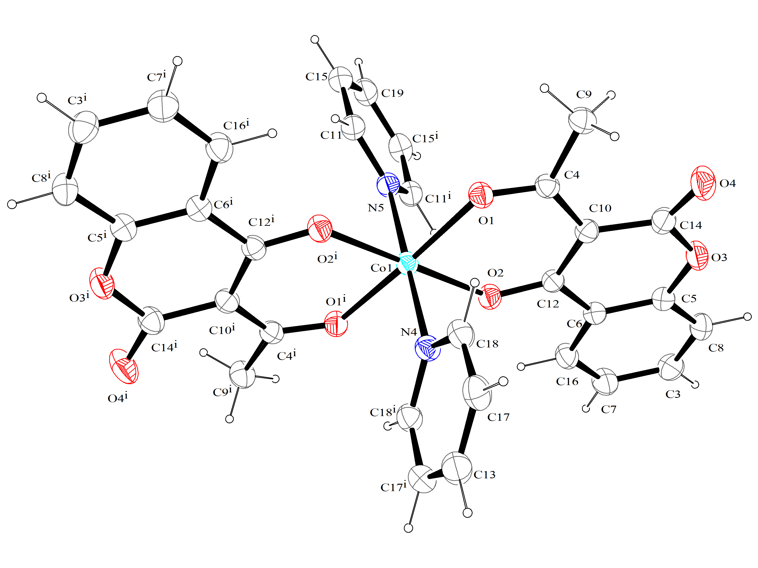
Figure 5. A perspective view of complex showing the atom-labelling scheme and displacement ellipsoids at the 50% probability level, symmetry code: (i) –x, y, 1/2-z.
The angle between the equatorial plane (Co₁ O₁ O₂) and the coumarin ligand (O₁ O₂ C₁₂) is 2.67 ° which is weaker if compared with the previously published compounds.¹⁵ In addition, the angle between the two planes of pyridine in the axial position, plane 1 (C₁₅ C₁₁ N₅ C_{11i} C_{15i} C₁₉) and plane 2 (C₁₈N₄C_{18i} C₁₇C₁₃C_{17i}) with symmetry code: (i) (-x, -y, -z) is 53.81 °. In the packing of crystal lattice, all the complex molecules are connected by an extensive network of hydrogen bonds (Table 2) and by interactions of type C-H ••• π and π-π. In fact, the inter­molecular bond between the coumarin lactone group and the pyridine C₁₅-H_{1c15} ••• O₄, C₁₈-H_{1c18} ••• O₄ and C₁₉-H_{1c19} ••• O₃ creates a network of inter­actions of type C—H ••• π which can be seen in the packing diagram where the complexes are connected in chains parallel to the axis [001] (fig.6).
Figure 6. Crystal packing of complex showing the formation of a chain along [001], showing the intermolecular C-H ••• O hydrogen bonds as thin green lines. Hydrogen atoms not involved in hydrogen bonding has been omitted for the sake of clarity.
These hydrogen bonds also connect the complexes in parallel layers to the a direction. In the plane (110), we can also find these layers, which are weakly connected by offset π-π interactions between coumarin ligands (fig.7).The benzene ring and the coumarinic lactone ring are in contact with the neighbouring molecule via π-forces at the symmetry code (-1 / 2-x, 1/2-y, 1-z) with intercentroid separations of 3.9533 (9) A ° (Cg3 ••• Cg6i) and 3.6177 (10) A ° (Cg6 ••• Cg6i) (table 3).
Figure 7. Crystal packing of complex showing a weak offset π–π stacking interactions between coumarin ligands in (110) plane. The green dotted line represents π–π stacking interactions. Hydrogen atoms have been omitted for clarity.
- Hirshfeld surface analysis
The Hirshfeld surfaces were used for exploring intermolecular interactions in the studied crystal. ^{28, 29} The molecular Hirshfeld surfaces calculations were performed using the crystal explorer 3.1 program,³⁰ which accepts a structure input file in the CIF format. The Hirshfeld surfaces of the title compound are illustrated in Fig.8. This figure is showing surfaces that have been mapped over d_{norm} (normalized contact distance) (fig.8 (1)), shape index (fig.8 (2)), curvedness (fig.8 (3)) and d_{e} (distance from a point on the surface to the nearest nucleus outside the surface) (fig.5 (4)). The Hirshfeld surfaces of cobalt (II) complex were generated using a standard (high) surface resolution with 3D dnorm surfaces mapped to a range (-0.1829-1.0550). The d_{norm} mapping indicates that strong hydrogen bond interactions, such as C—H ··· O hydrogen bonding between the oxygen of the lactone group and the pyridine appear as a primary interaction between the complex’s molecules, seen as a bright red zone in the Hirshfeld surfaces (fig.8 (1)).
The size and shape of the Hirshfeld surface allow the qualitative and quantitative study and visualization of inter­molecular close contacts in molecular crystals. The shape index and the curvature were used to identify packaging modes (planar stacking arrangements). In fact, the presence of stack π…π is evident as a flat region down on both sides of the molecules and is clearly visible on the curve surface. The pattern of the red and blue triangles on the area of the shape index surface (fig. 8 (2)) is characteristic of the π...π stack. The blue triangles exhibit the convex regions due to the carbon atoms of the molecule inside the surface, while the red triangles represent the concave regions because of the carbon atoms of the stacked molecule π above.^{31, 32} The C—H ... π contact in the crystal shows a bright-orange spots on the d_{e} surface (fig. 8 (4)),²⁹ directly above the center of the C=C bonds and generates a distinct pattern of a pair of wings in the two-dimensional fingerprint plot (fig.9), it will become obvious that this is a characteristic feature of all C—H ... π interactions.
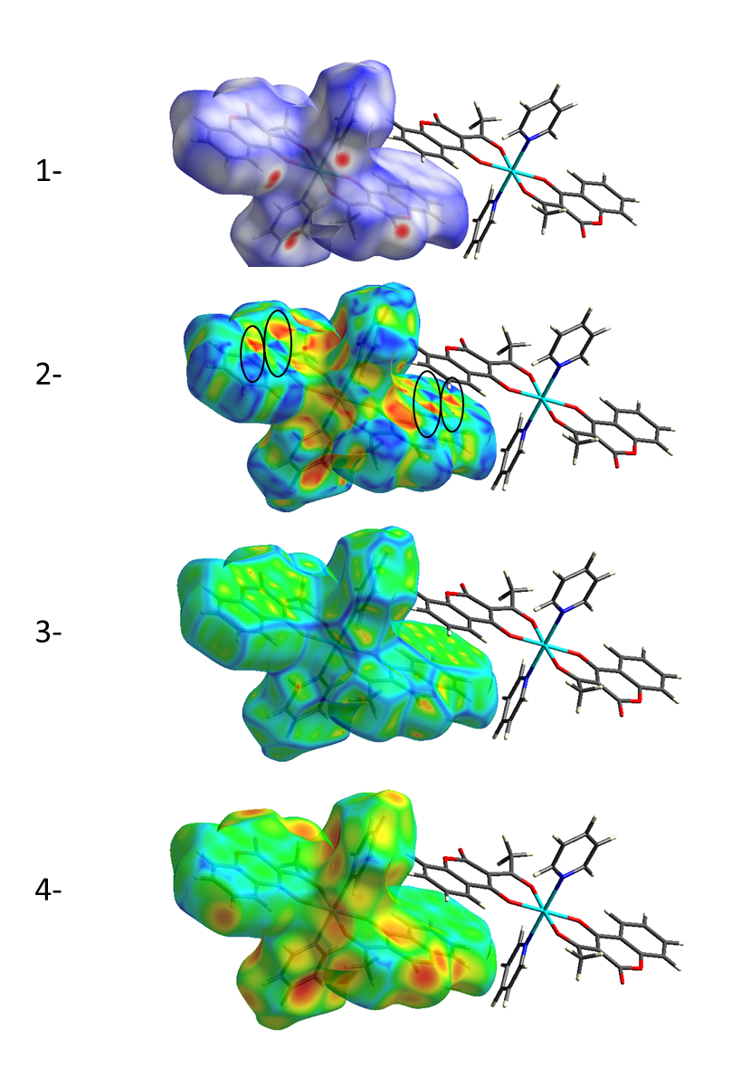
Figure 8. Hirshfeld surfaces of complex: (1) 3D d_{norm} surface, (2) surface index, (3) curvedness, (4) d_{e}.
The 2D fingerprint plots are deconstructed to highlight particular atom pair contacts. This allows the separation of the contributions of different types of overlapping inter­action in the complete fingerprint. The analysis of 2D fingerprint plots for the title compound (fig.9) confirm that inter­molecular H ··· H, C ··· H and H ··· O inter­actions are well dominated and are in complement to the Hirshfeld surface. The first main inter­action of type H ··· H were represented by the largest region in the fingerprint plot with contribution 38.2%. A second main inter­action of type C ··· H is due to hydrogen bonds C₈ ··· H_{1c17}—C₁₇, and appears at the top left of the plot in the form of the characteristic wings with a contribution of 30.6%, these can also be identified by C—H ··· π type inter­actions. This deduction is compatible with the qualitative d_{e} surface analysis. A third principal inter­action of type H ··· O is manifested in the molecular structure by the C₁₅—H_{1c15} ··· O₄, C₁₈—H_{1c18} ··· O₄ and C₁₉—H_{1c19} ··· O₃ hydrogen bonds between axial pyridine and coumarin plane. This type of interaction is presented as two sharp points pointing to the lower left of the plot which contributes 22.6% of the total. The interactions C ... C exist in the 2D plot with a low contribution of 5.9%. This contact corresponds to the parallel π ... π stacks between the coumarin cycles. It’s compatible with the surfaces of the shape index and the curvature.
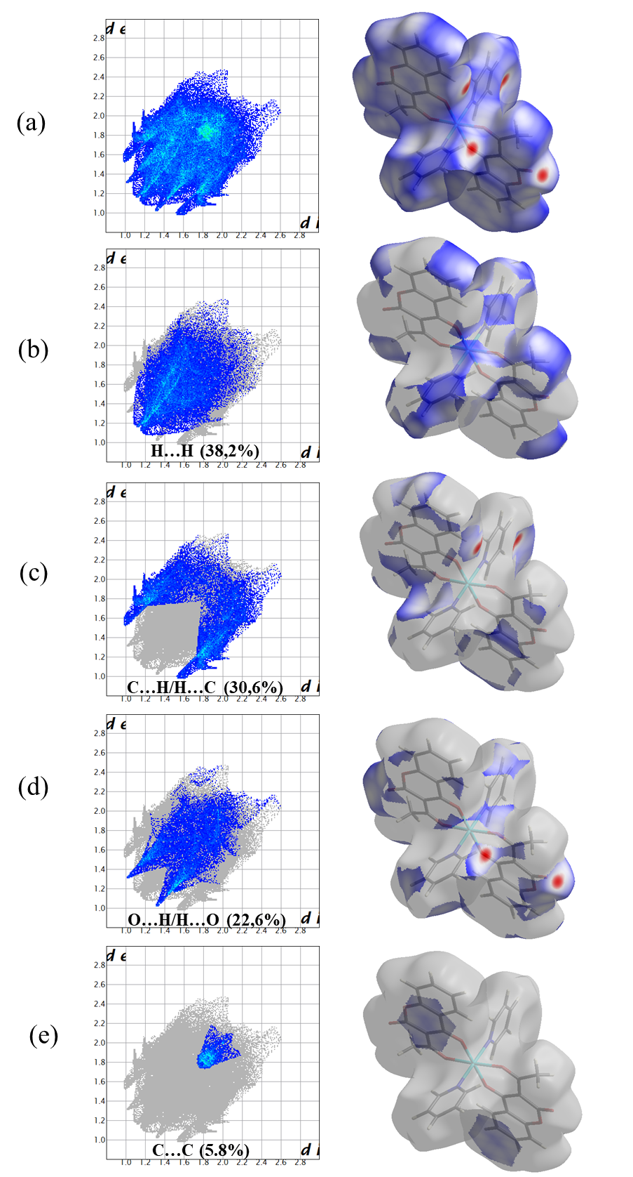
Figure 9. Two-dimensional fingerprint plots of the complex showing percentages of contacts contributing to the total Hirshfeld surface area of the molecule: (a) all interactions, and delineated into (b) H⋯H, (c) C⋯H/H⋯C, (d) O⋯H/H⋯O and (e) C⋯C interactions.
- Antiradical activity
The antiradical activity of the extracts is determined by the method of reduction of the free radical of DPPH (1, 1, diphenyl-2-picrylhydrazyl).³³ The DPPH radical is a stable organic free radical with an adsorption band at 515-518 nm. The free radical scavenging mechanism is the transfer of the hydrogen atom from the test compound to DPPH, which is transformed into a stable molecule DPPHH.³⁴ The ability to reduce the DPPH radicals was determined by the decrease in its absorbance at 515 nm induced by antioxidants. The IC50 (scavenging concentration 50%) allowing calculate the extract concentration needed to trap 50% of the DPPH radicals. It is determined graphically by linear regression. The graph was plotted with percent scavenging effects (% IDPPH) according to concentration (μmol /L) (fig.10). The metal complex showed good activities as a radical scavenger with IC50 = 0.0195μmol / L. A lower IC50 value indicates greater antioxidant activity, compared to ascorbic acid (vitamin C) as a reference that has an IC50 value of 21μmol / L,³⁵ it is considered a good free radical trapper. In addition, it possesses significant antioxidant activity relative to its coumarin ligand,¹⁵ and other similar cobalt (II) complexes. It is difficult to draw general conclusions about antioxidant structure-activity relationships with the limited number of antioxidant molecules. It may be suggested that metal ions significantly change the chemical properties of coumarin ligand. The complexation with the transition metal Co was carried out via the carboxylate and phenol groups of the two ligands of coumarin in equatorial positions, this can improve the anti-radical activity.³⁶

Figure 10. DPPH inhibition percentage curves of the coumarin complex.
- Antimicrobial activity
The antibacterial test was carried out by using standard paper disc method according to Ismail et al. 2010,³⁷ with slight modification. Briefly, 2 mg of each crude extract dissolved in 1 ml of sterile dimethyl-sulfoxide (DMSO) was applied to sterile filter paper discs (6 mm). Then, discs were placed on tryptic soy agar (TSA, BIO RAD) plates, which were inoculated with 18h cultured of the tested pathogen (10⁶ bacteria/ml) in tryptic soy broth (TSB, BIO RAD). As negative control, a disc loaded with DMSO was simultaneously prepared. Plates were incubated overnight at 30°C. After 24h incubation, inhibition diameter was measured in mm. All assays were carried out in triplicate.
Bacterial type strains (8 strains) used for the antimicrobial activity evaluation of chemical compounds were: Escherichia coli ATCC 25922 (E.coli), Pseudomonas fluorescens (AH2) (Danish Institute for Fisheries Research, Denmark), Pseudomonas aeruginosa ATCC 27853 (P.aerugi), Salmonella typhimurium C52 (S.typhy) (Laboratoire Hydrobiologie Marine et Continentale, Université de Montpellier II, France), Staphylococcus aureus ATCC 25923 (S.aureus), Vibrio anguillarum ATCC 12964T (V.angui), Vibrio alginolyticus ATCC 17749T (V.algino) and the yeast Candida albicans ATCC 10231 (C.albi).
The antimicrobial activities of ligand and complex were screened against six Gram-negative bacteria: E. coli, P. aerugi, S.typhy, V.algino, AH2 and V.angui and a Gram-positive bacterium: Staphylococcus aureus and against a fungus, ie C. albicans, to evaluate their potential as an antimicrobial agent.
The antimicrobial activities of the complex and its coumarin ligand under test against different strains of bacteria are shown in Table 4 and Figure 11. The most sensitive microorganisms to the Co complex were E. coli, V. algino and V.angui (gram negative) with inhibition diameters of 11.66 mm, 13.33 mm and 12 mm, respectively. This complex also showed low activity against P. aerugi, S.typhy, AH2, C. albi and S. aureus. In contrast, the coumarin ligand '3-acetyl-4-hydroxycoumarin' exhibits a broad anti-bacterial activity against all strains tested but was more active against E. coli, P. aerugi, S.typhy, AH2, C. albi and S. aureus with inhibition diameters of 11.33 mm, 11 mm, 11.66 mm, 12.66 mm, 11.33 mm, 11 mm. This relatively high antibacterial activity of uncoordinated coumarin may be due to its flat molecular structure that contributes to penetration across the membrane or bacterial cell wall.³⁸ It is clear that the zones of inhibition may be larger or weak for metal chelates than for the coumarin ligand for certain microorganisms. In addition, the antibacterial actions of coumarin ligand can be significantly improved upon chelation with cobalt (II) ions.³⁹ In particular cases, the increase in antimicrobial activity is due to the faster diffusion of metal complexes as a whole across the cell membrane or to the combined activity of the metal and the ligand.⁴⁰

Figure 11. Antibacterial activity spectrum of the complex.
The minimum inhibitory concentration (MIC) was determined by the micro-dilution method according to the standard reference method for bacteria.⁴¹ Various concentrations of metal complex solutions (62.5 μg / ml, 125 μg / mL, 250 μg / ml, 500 μg / ml, 1 mg / ml) were obtained by dissolving the compound in DMSO (2%) and then diluted to give serial two-fold dilutions. These solutions were added to each medium in the 96-well plates. The bacterial suspensions are added at the rate of 180 μl in suspension of 10⁶ bacteria / ml to each well. The purpose of this method was to determine the exact concentration of the compound under study which will have an inhibitory effect on growth selected microorganisms. This concentration was considered as minimal inhibition concentration (MIC). The MIC values were determined against E. coli, V. algino, V. angui bacteria which have an inhibition diameter greater than 10 mm. As a negative control, DMSO did not affect the growth of bacterial strains at the concentrations used in this study. Values of MIC of complex are shown in Table 5. It should be noted that the cobalt (II) complex exhibited a good MIC result against Gram negative bacteria.
- Conclusion
In this paper, a novel Co (II) complex 'trans-di-pyridine-bis (3-acetyl-4-hydroxy-2H-chromen-2-one) cobalt (II)' was synthesized and characterized by different spectroscopic techniques. The bonding of ligand to metal ion is confirmed by spectral studies (UV-Vis, IR, and Fluorescence). The IR spectral analysis shows a decrease in the frequency of the stretch band of the C=O acetyl group with respect to the starting coumarin which may be due to the donor-acceptor interaction of this group with the cobalt (II) cation. The UV-Vis spectral studies suggested an octahedral geometry for the Co (II) complex. The metal-ligand coordination results a decrease in the fluorescence intensity (the fluorescence quenching) and an offset of the emission wavelength. The crystal structure of the Co complex was studied by single crystal X-ray diffraction; the cobalt (II) atom exhibits an axially elongated octahedral CoN₂O₄ coordination geometry. In the packing of crystal lattice, all the complex molecules are connected by an extensive network of hydrogen bonds and by interactions of type C-H ••• π and π-π. The molecular Hirshfeld surface and 2D fingerprint plots were used for quantitative mapping out of molecular interactions, revealing that close contacts are dominated by H ••• H, C ••• C and C ••• H interactions, these relatively weak contacts have clear signatures in the fingerprint plots. The new coumarin complex reveal potentially important antioxidant activity against free radicals DPPH compared to the coumarin derivative ligand and vitamin C. The antimicrobial studies suggested that the coumarin derivative ligand is biologically active and its metal complex exhibits significantly enhanced antimicrobial activity against some microbial strains in comparison to the free ligand. Thus, this new cobalt (II) complex can be used further in the pharmaceutical industry, as an antioxidant and antimicrobial agent, after testing its toxicity to humans.
- Supplementary Material
CCDC reference number 1891314 for the cobalt complex contains the supplementary crystallographic data for this paper. These data can be obtained free of charge at www.ccdc.cam.ac.uk, or from Cambridge Crystallographic Data Center, 12, Union Road, Cambridge CB2 1EZ, UK; Fax: +44 1223 336 033; e-mail: deposit@ccdc.cam.ac.uk.
Acknowledgements
Financial support from the Ministry of Higher Education and Scientific Research of Tunisia is gratefully acknowledged. The authors gratefully also acknowledge the ICDD for financial support (Grant number: 09-04) and Senior scientist Dr. Michal Dusek is acknowledged for his contribution to the X-ray diffraction data collection at the Department of structure analysis, Institute of Physics, Prague, Czech Republic.
References
1. D. Egan, R. O’kennedy, E. Moran, D. Cox, E. Prosser, R. D. Thornes, Drug Metab. Rev. 1990, 22, 503–529.
2. H. Xiongfeng, L. Lvye, X. Qun, J. Rohrer, Thermo Fisher Scientific Application Note. 2016, pp. 1128.
3. L. Hongqi, C. Li, C. Zhen, Adv. Chem. Sensors. 2012, pp. 121–150.
4. E. Guardado Yordi, M.J. Matos, A. Pérez-Martínez , C.Tornes, L. Santana, E. Molina Pérez, E. Uriarte, Food Funct. 2017, 8, 2958–2966.
5. P. K. Jain, H. Joshi, J. Appl. Pharm. Sci. 2012, 2, 236–240.
6. Y. Bansal, P. Sethi, G. Bansal, Med. Chem. Res. 2013, 22, 3049–3060.
7. D. R. Vianna, L. Hamerski, F. Figueiró, A. Bernardi, L.C. Visentin, Eur. J. Med. Chem. 2012, 57, 268–274.
8. K. Rohini, P.S. Srikumar, J. Biofertilizers Biopestic. 2014, 5, 5–7.
9. I. P. Kostova, I. I. Manolov, I. N. Nicolova, N. D. Danchev, Farmaco. 2001, 56, 707–713.
10. I. Sheikhshoaie, A. Badiei, M. Ghazizadeh, Der Chem. Sin. 2012, 3, 24–28.
11. A. S. Munde, V. A. Shelke, S. M. Jadhav, A. S. Kirdan, S. R. Vaidya, S. G. Shankarwar , T. K. Chondhekar, Adv. Appl. Sci. Res. 2012, 3, 175–182.
12. I. Ketata, T. Bouzaiene, T. Ben Ayed, R. Ben Hassen, Mediterr.J.Chem. 2014, 3, 767–779.
13. A. Karaliota, O. Kretsi, C. Tzougraki, J. Inorg. Biochem. 2001, 84, 33–37.
14. G. Kokotos, V. Theodorou, C. Tzougraki, D. L. D. Deforce, E. G. Van Den Eeckhout, Bioorganic Med. Chem. Lett. 1997, 7, 2165–2168.
15. L. Bejaoui, J. Rohlicek, R. Ben Hassen, J. Mol. Struct. 2018, 1173, 574 –582.
16. A. Ghouili, R. Ben Hassen, Acta Crystallogr. Sect. E Struct. Reports Online. 2011, 67, 6 –13.
17. A. Ghouili, M. Dusek, V. Petricek, T. Ben Ayed, R. Ben Hassen, J. Phys. Chem. Solids. 2014, 75, 188–193.
18. A. Brahmia, T. Ben Ayed, R. Ben Hassen, Acta Crystallogr. Sect. E Struct. Reports Online. 2013, 69, 1296.
19. J. Rohlíček, I. Ketata, T. Ben Ayed, R. Ben Hassen, J. Mol. Struct. 2013, 1051, 280–284.
20. I. Ketata, L. Mechi, T. Ben Ayed, M. Dusek, V. Petricek, R. Ben Hassen, Open J. Inorg. Chem. 2012, 2, 33–39.
21. L. Palatinus, G. Chapuis, J. Appl. Crystallogr. 2007, 40, 786–790.
22. V. Petricek, M. Dusek, L. Palatinus, Jana. The crystallographic computing system, Institute of Physics. Praha, Czech Republic, 2006.
23. K. Brandenburg, H. Putz, “DIAMOND Version 3”, Crystal Impact GbR, Postfach 1251, D-53002 Bonn, Germany, 2005.
24. L.J. Farrugia, J.Appl.Cryst. 2012, 45, 849-854.
25. A. Bernalte-Garcia, F.J. Garcia-Barros, F.J. Higes-Rolando, F. Luna-Giles, Bioinorg. Chem. Appl. 2004, 2, 307–316.
26. K. Singh, Y. Kumar, P. Puri, G. Singh, Bioinorg. Chem. Appl. 2012, 2012, 1–9.
27. R. Kirchmaier, E. Altinand, A. Lentz, Z. Krist. 2004, 219, 29–30.
28. M. A. Spackman, D. Jayatilaka, Cryst Eng Comm. 2009, 11, 19–32.
29. J. J. McKinnon, M. A. Spackman, A. S. Mitchell, Acta Crystallogr. Sect. B. 2004, 60, 627–668.
30. S. K. Wolff, D. J. Grimwood, J. J. McKinnon, D. Jayatilaka, M. A. Spackman, Crystal Explorer 3.1, University of Western Australia, Perth, Australia, 2012.
31. Y. H. Luo, G. G. Wu, S. L. Mao, B. W. Sun, Inorganica Chim. Acta. 2013, 397, 1–9.
32. I. Bennour, M. Haukka, F. Teixidor, C. Viñas, A. Kabadou, J. Organomet. Chem. 2017, 846, 74–80.
33. W. Brand-Williams, M. E. Cuvelier, C. Berset, Food Sci. Technol. 1995, 28, 25–30.
34. P. Molyneux, Songklanakarin J. Sci. Technol. 2004, 26, 211–219.
35. Y. C. F. Ladoh, S. D. Dibong, M. A. Nyegue, T. R. P. Djembissi, N. B. Lenta, M. E. Mpondo, J. Yinyang, J. D. Wansi, J. Appl. Biosci. 2014, 84, 7636–7643.
36. M. Rajeshirke, R. Shah, P. Yadav, N. V. Purohit, Der Pharmacia Sinica. 2012, 3, 239–248.
37. A. Ismail, L. Ktari, A. Boudabbous, M. El Bour, Inst. Natn. Scien. Tech. Mer. 2010, 37, 127-132.
38. O. Kayser, H. Kolodziej, Z. Naturforsch. 1999, 54c, 169-174.
39. N. K. Singh, M. S. Agrawal, R. C. Aggarwal, Synth. React. Inorg. Met. Chem. 1985, 15, 75–92.
40. N. Fahmi, R. V. Singh, Transit. Met. Chem. 1994, 19, 12–16.
41. V. Duraipandiyan, S. Ignacimuthu, J. Ethnopharmacol. 2009, 123, 494–498.

Table 1: Crystallographic details and structure refinement of complex
Crystal data
Chemical formula | C₃₂H₂₄CoN₂O₈
M_{r} | 623.46
Crystal system, space group | Monoclinic, C2/c
Temperature (K) | 120
a, b, c (Å) | 16.1109 (3), 14.4864 (3), 11.4281 (3)
ꞵ (°) | 98.3873 (18)
V (Å³) | 2638.67 (10)
Z | 4
Radiation type | Cu Kα
μ (mm⁻¹) | 5.62
Crystal size (mm) | 0.16 × 0.06 × 0.05
Data collection
Diffractometer | SuperNova, Dual, Cu at zero, AtlasS2  diffractometer
Absorption correction | analytical
T_{min}, T_{max} | 0.637, 0.828
No. of measured, independent and  observed [I> 3σ (I)] reflections | 20921, 2679, 2509
R_{int} | 0.028
(sin θ/θ)_{max} (Å⁻¹) | 0.624
Refinement
R[F²> 2σ(F²)], wR(F²), S | 0.026, 0.083, 1.15
No. of reflections | 2679
No. of parameters | 197
H-atom treatment | H-atom parameters constrained
Δ_{max}, Δ_{min} (e Å⁻³) | 0.29, -0.21
CCDC number | 1891314

Table 2: Hydrogen-bond geometry (Å, º) for complex
D—H···A | D—H | H···A | D···A | D—H···A
C₁₅—H_{1c15}···O_{4ii} | 0.96 | 2.67 | 3.3905 (19) | 132.34
C₁₈—H_{1c18}···O_{4iii} | 0.96 | 2.44 | 3.1600 (15) | 132.04
C₁₉—H_{1c19}···O_{3ii} | 0.96 | 2.66 | 3.2105 (14) | 116.53

Symmetries codes: (ii) x+1/2, y+1/2, z; (iii) -x-1/2, -y+1/2, -z.
Table 3: Details of the intercentroid distances (Å) of complex
Cg3 and Cg6 are centroids of the O3/C5-C14 and C3/C7-C8 rings, respectively.
Cg3 ··· Cg6i | 3.9533 (9)
Cg6 ··· Cg6i | 3.6177(10)

Symmetry code: (i) -1/2-x, 1/2-y, 1-z.
Table 4: Antimicrobial activities of the synthesized Coumarin ligand and complex
Microorganisms | E. coli | P.aerugi | S.typhy | V.algino | AH2 | C.albi | V.angui | S.aureus
Compound  (2 mg/ml) | INHIBITION ZONES (mm)
Coumarin ligand | 11.33 | 11 | 11.66 | 11 | 11.33 | 12.66 | 10.33 | 11
Complex | 11.66 | 8 | 9.33 | 13.33 | 8.33 | 8.66 | 12 | 8.66
Control (DMSO) | 0 | 0 | 0 | 0 | 0 | 0 | 0 | 0
All data are the averages of the measurements in triplicate
Table 5: Minimum Inhibitory Concentration assay of metal complex against bacterial pathogens
Microorganisms | E. coli | V.algino | V.angui
MIC (mg/ml)
Complex | 0.250 | 0.125 | 0.125
Control(DMSO) | 0 | 0 | 0

