Electronic Supplementary Material
Synthesis, Antifungal Evaluation and Molecular Docking Studies of Some Tetrazole Derivatives
Mohammad Hosein Afsarian¹, Mojtaba Farjam^{*2, 3}, Elham Zarenezhad ²*, Somayeh Behrouz ⁴ Mohammad Navid Soltani Rad ⁴
¹ Department of Medical Mycology & Parasitology, School of Medicine, Fasa University of Medical Sciences, Fasa, Iran
² Noncommunicable Diseases Research Center, School of Medicine, Fasa University of Medical Sciences, Fasa, Iran
³ Department of Medical pharmacology, school of medicine, Fasa University of medical sciences, Fasa, Iran
⁴ Medicinal Chemistry Research Laboratory, Department of Chemistry, Shiraz University of Technology, Shiraz, Iran

 Elham Zarenezhad
E-mail: El.Zarenezhad@gmail.com
Email: El.Zarenezhad.fums@gmail.com

((1H-tetrazol-5-yl)methyl)-2-methyl-1H-benzo [d] imidazole (2a)

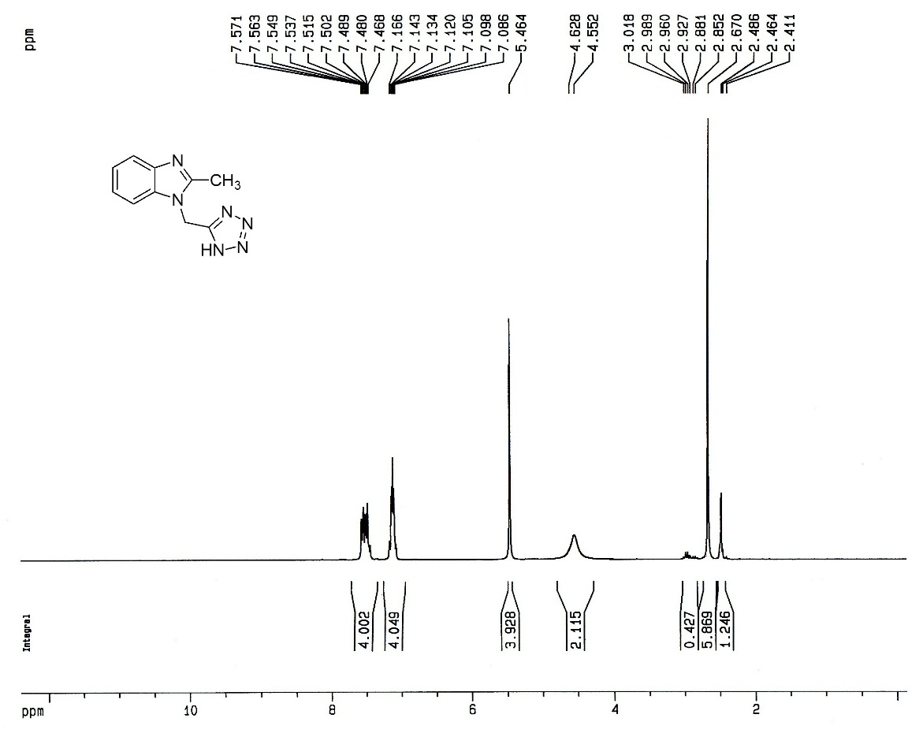

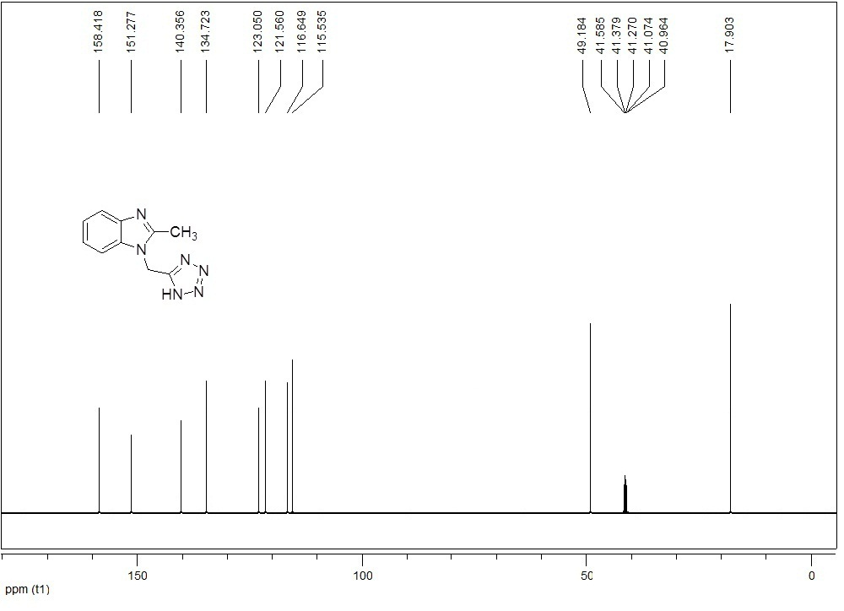

((1H-tetrazol-5-yl)methyl)-1H-benzo[d]imidazole (2b)

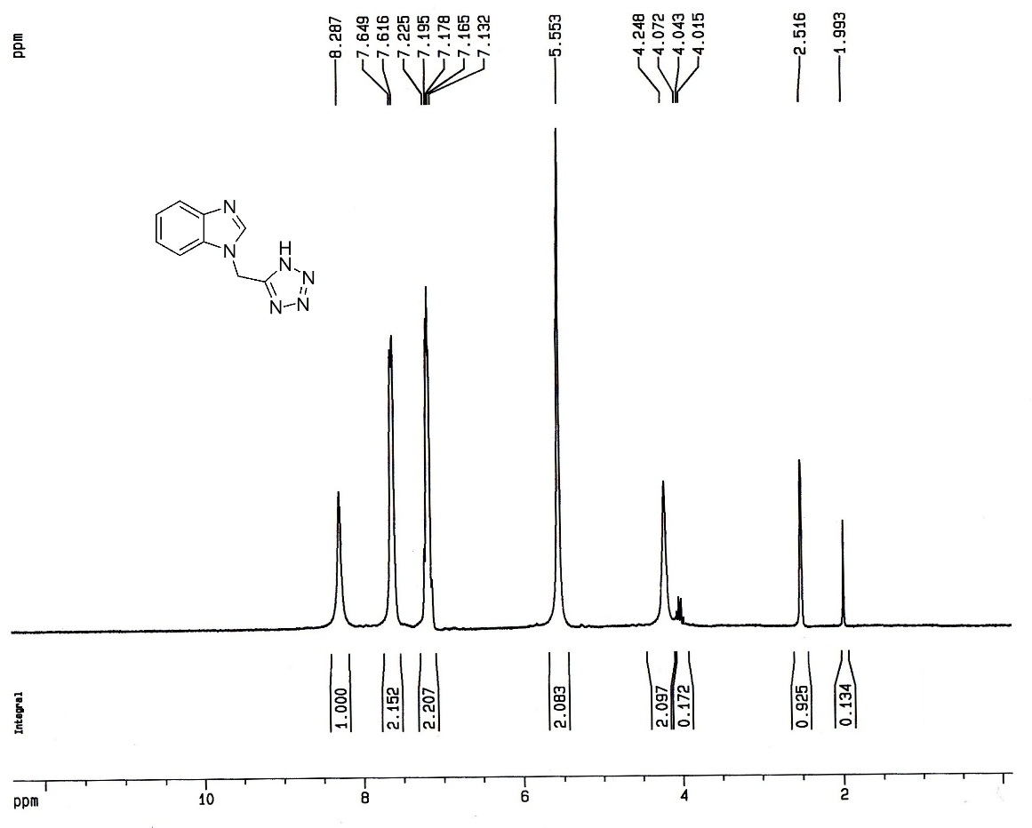

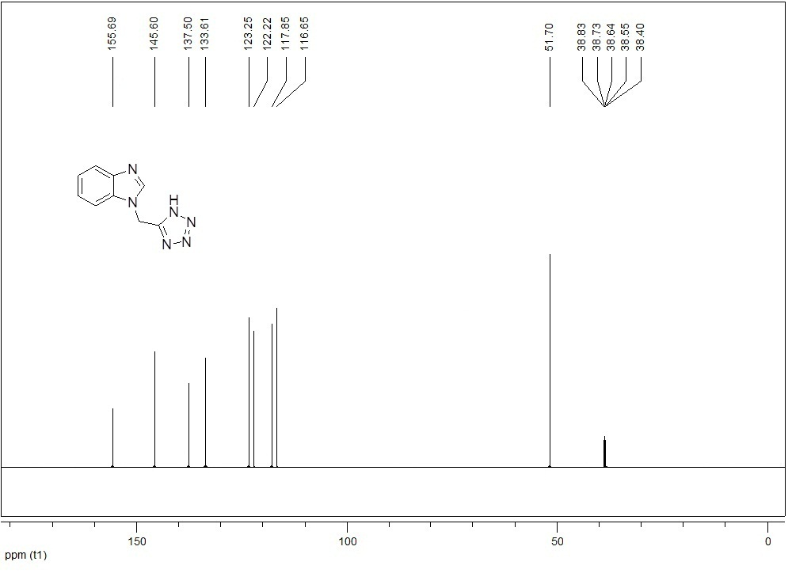

((2-methyl-4-nitro-1H-imidazol-1-yl)methyl)-1H-tetrazole (2c)

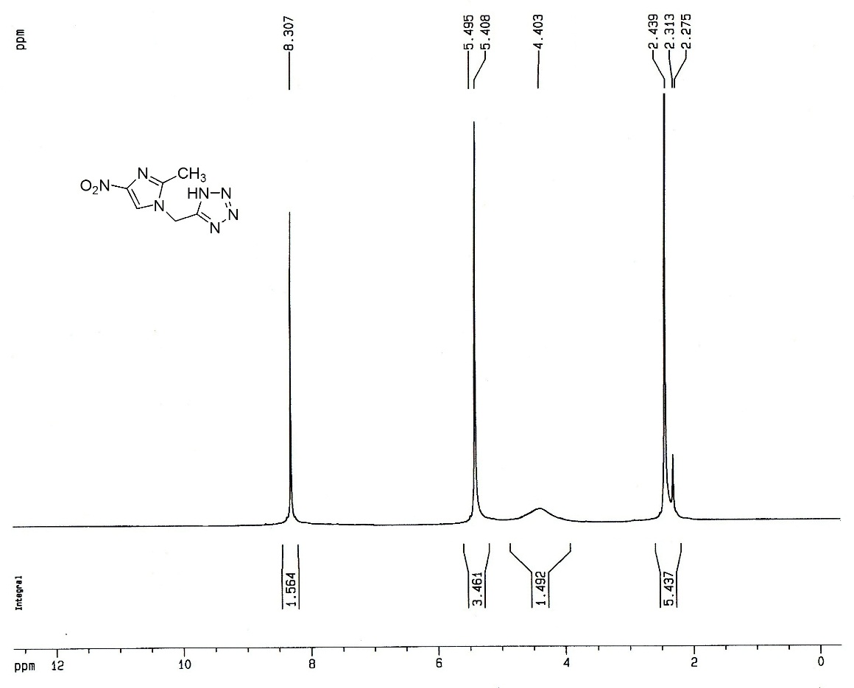

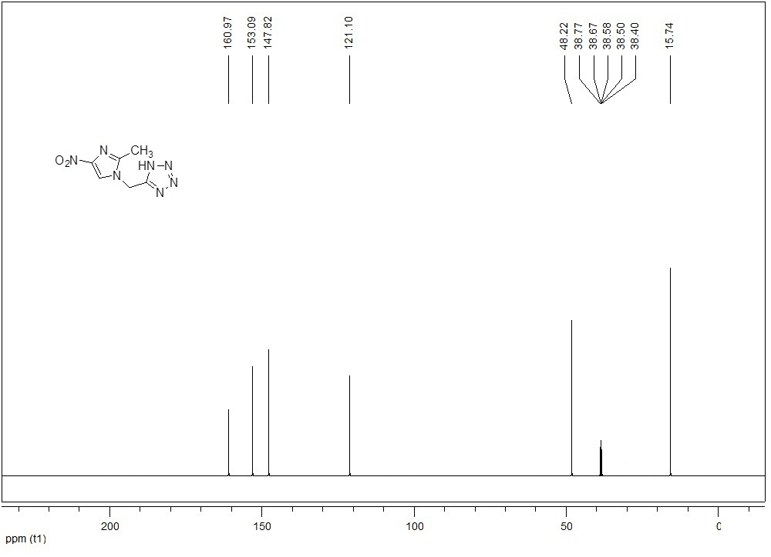
((2-phenyl-1H-imidazol-1-yl)methyl)-1H-tetrazole (2d)

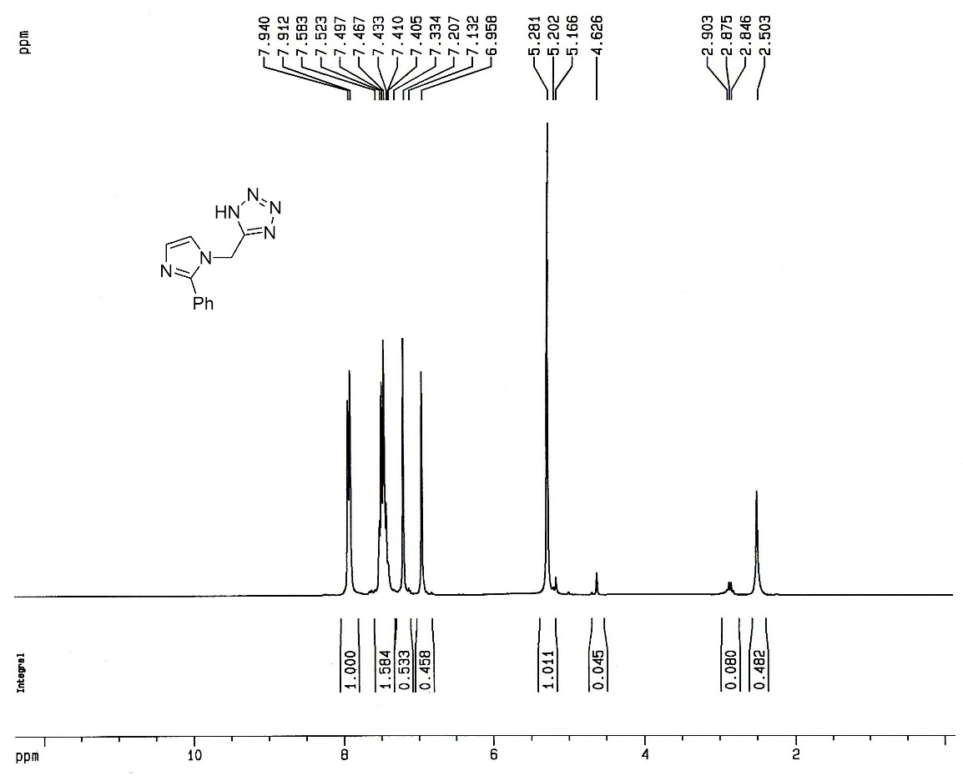

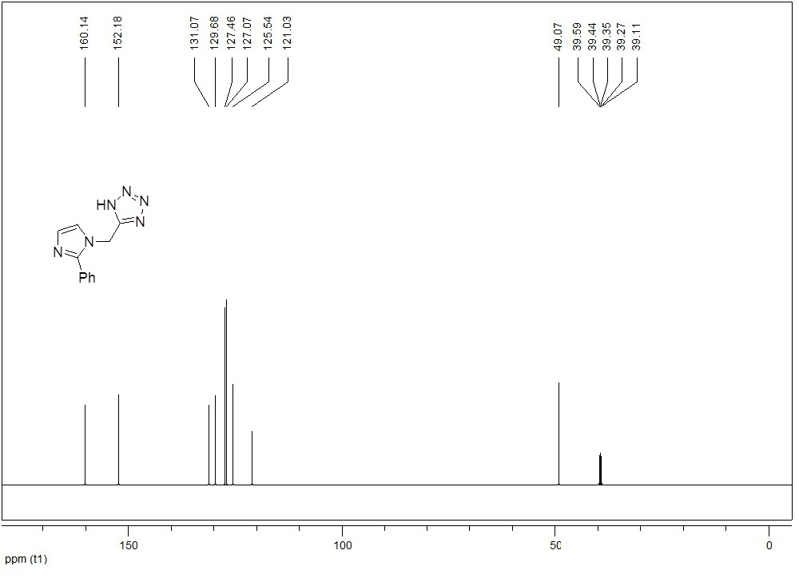

((1H-tetrazol-5-yl)methyl)-1,3-dimethyl-1H-purine-2,6(3H,7H)-dione(2e)
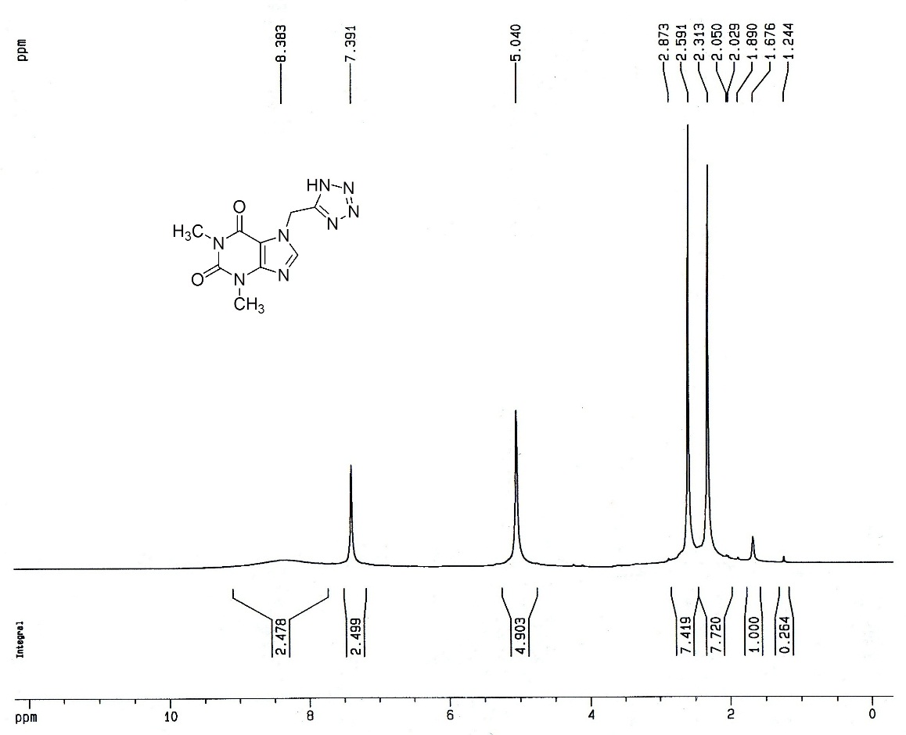

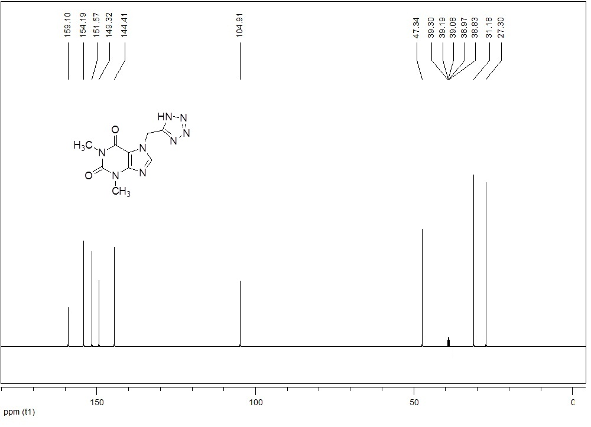

((1H-tetrazol-5-yl)methyl)pyrimidine-2,4(1H,3H)-dione (2f)

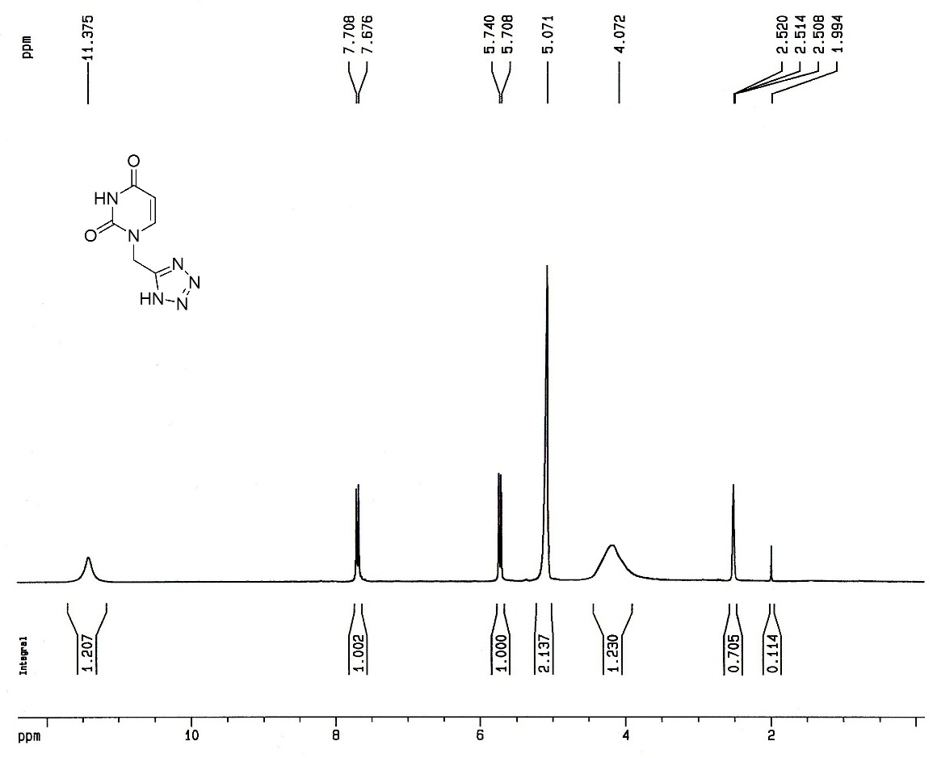

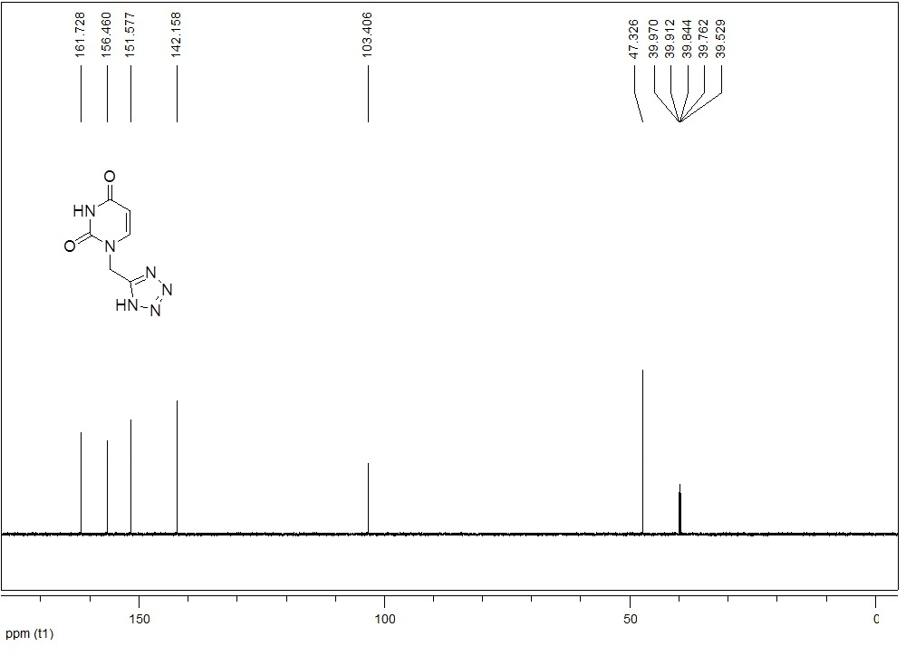

((1H-tetrazol-5-yl)methyl)-9H-purin-6-amine (2g)

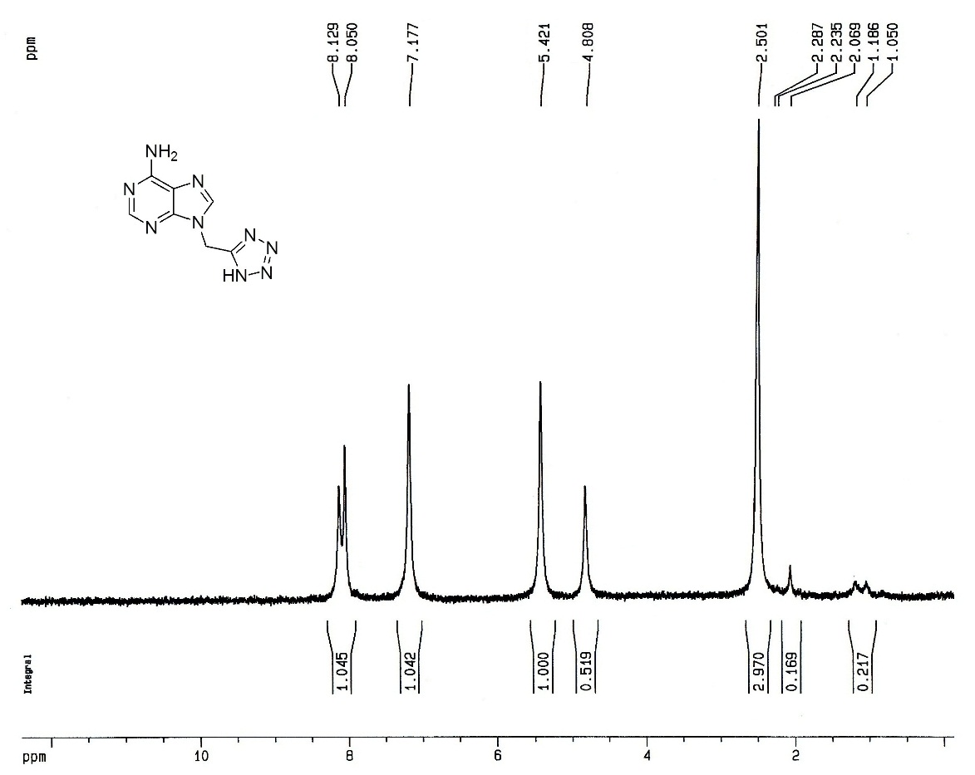

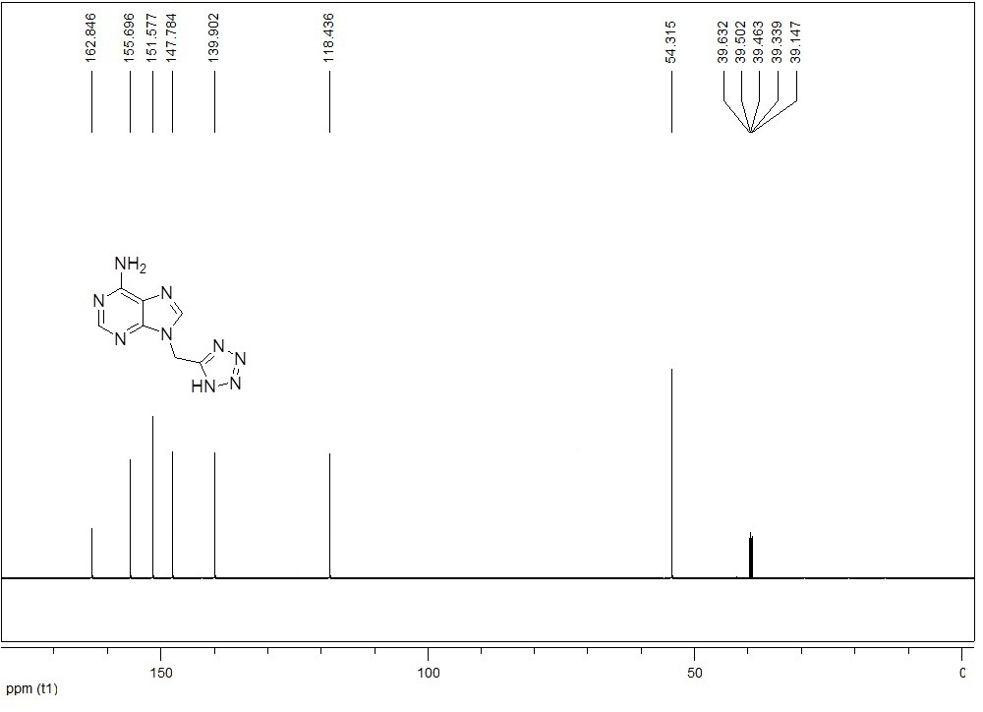

((1H-tetrazol-5-yl)methyl)isoindoline-1,3-dione (2h)

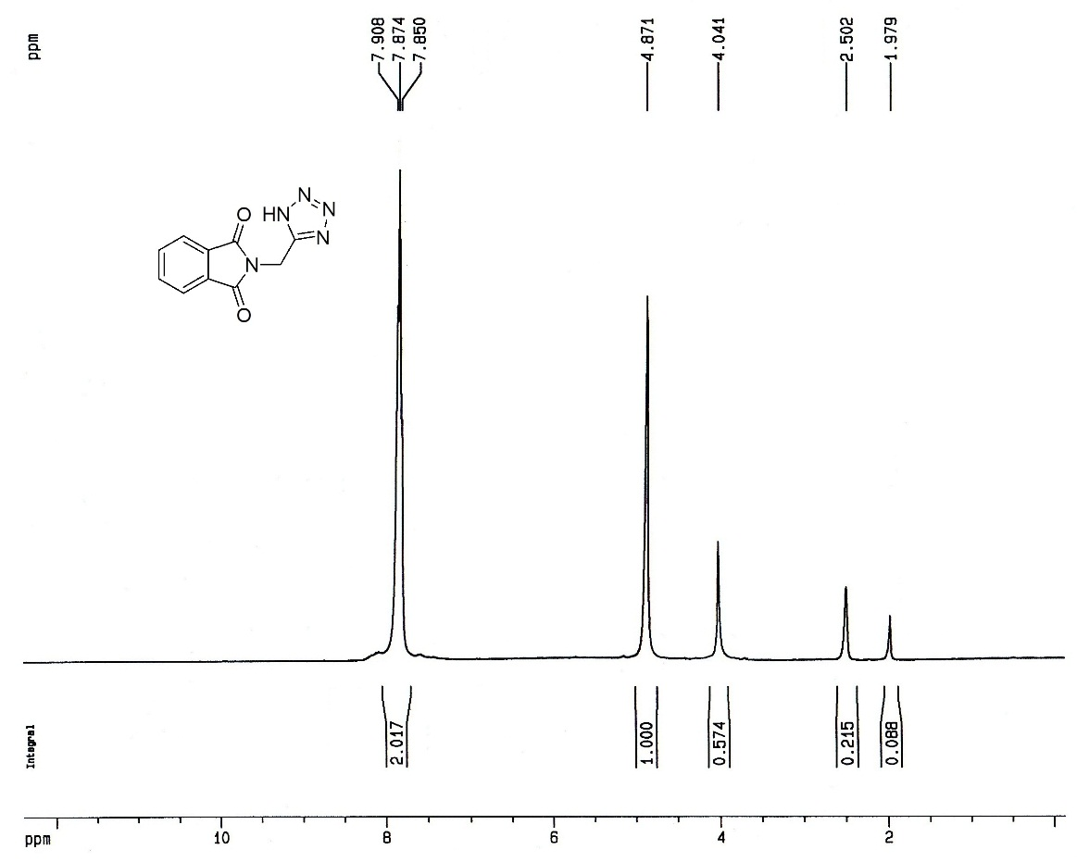

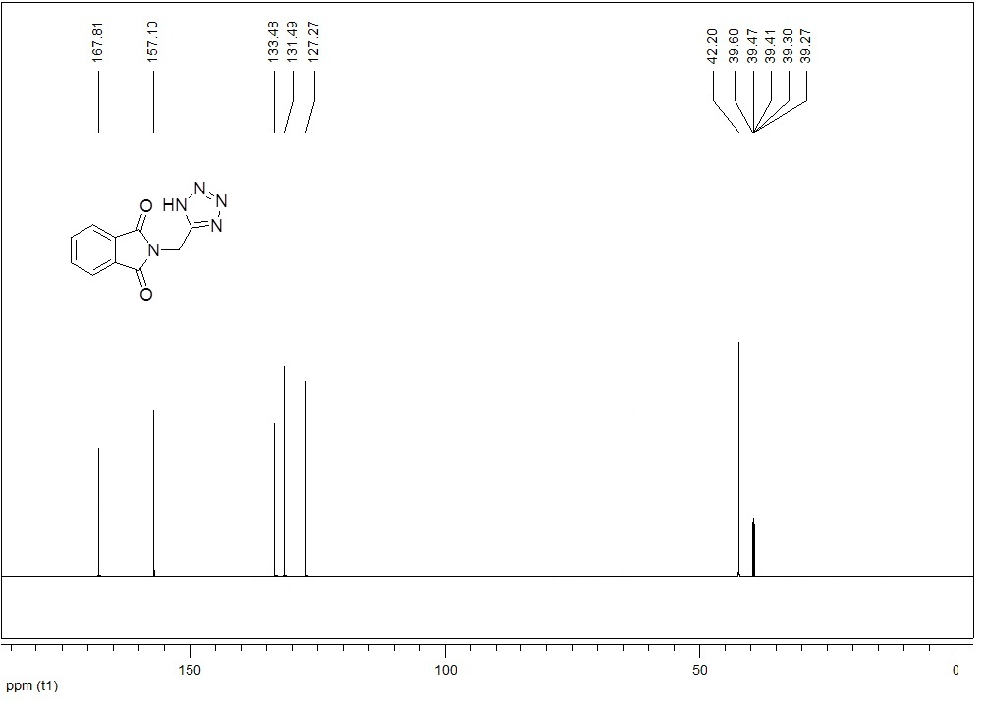
((1H-tetrazol-5-yl)methyl) benzo[d]isothiazol-3(2H)-one 1,1-dioxide (2i)

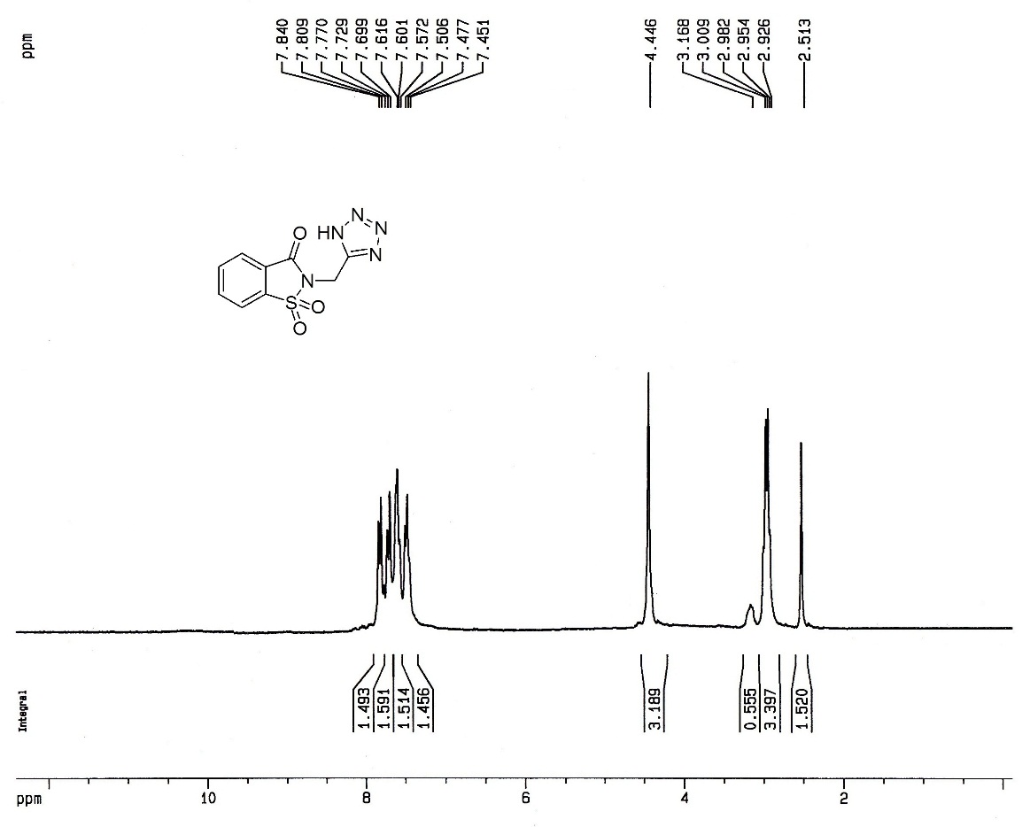
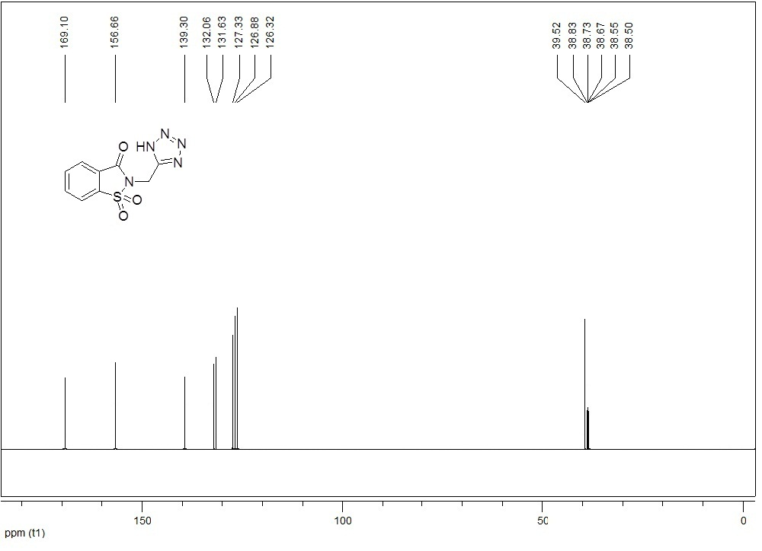

(2-(2-methyl-4-nitro-1H-imidazol-1-yl)ethyl)-1H-tetrazole (2j)

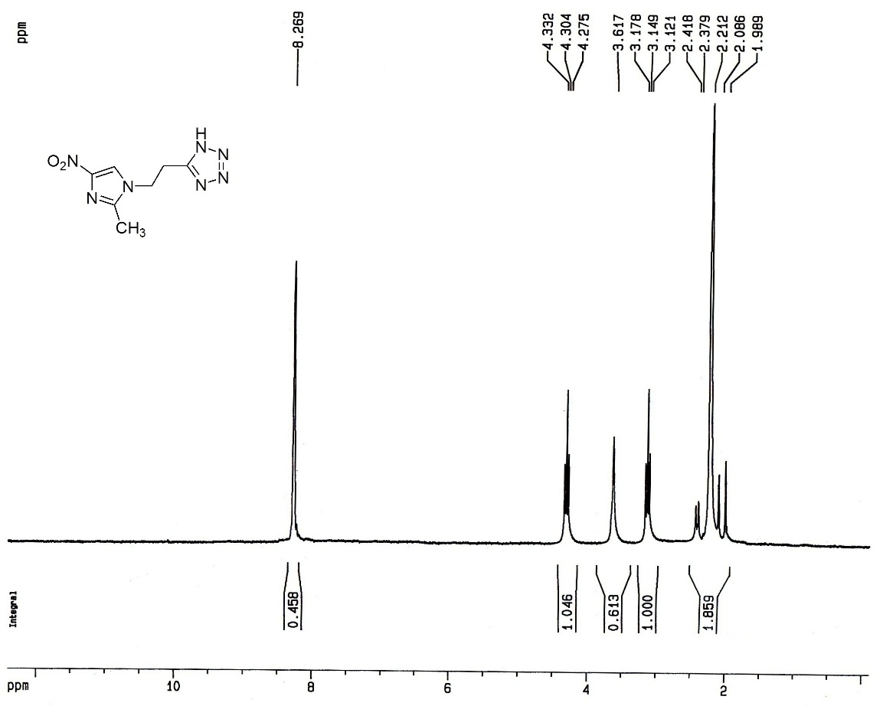

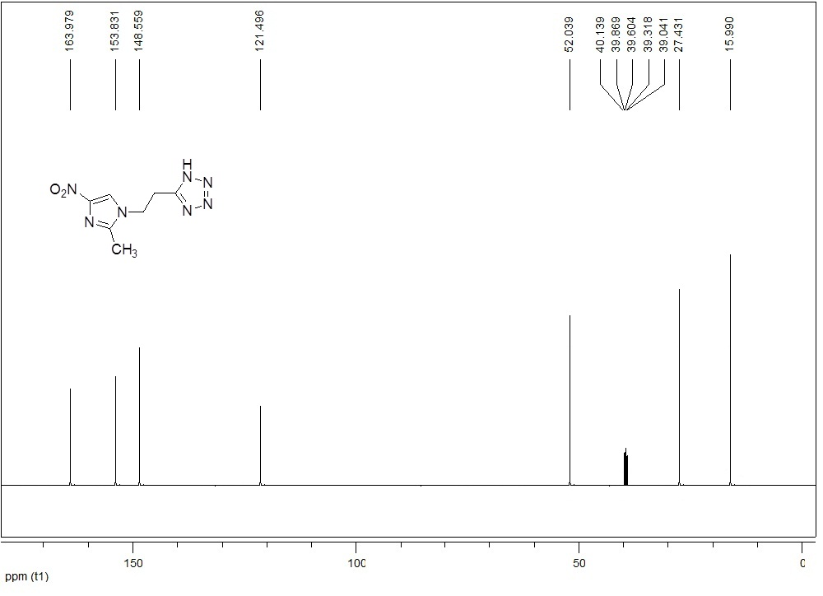

5-(2-(2-phenyl-1H-imidazol-1-yl)ethyl)-1H-tetrazole (2k)

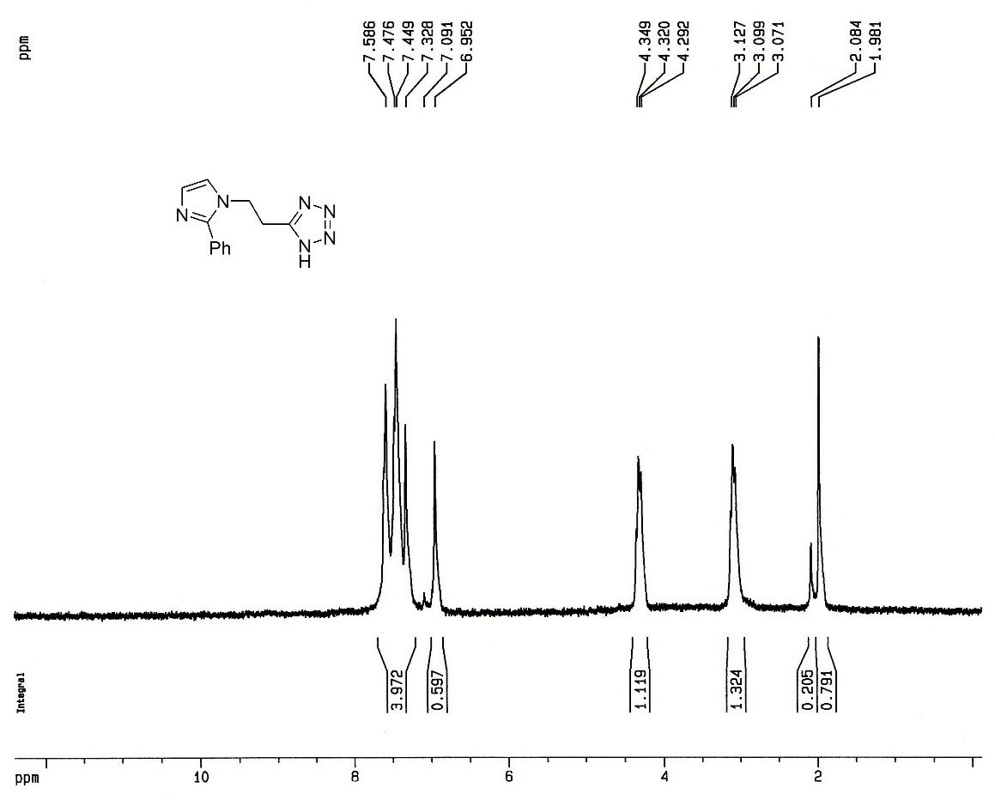

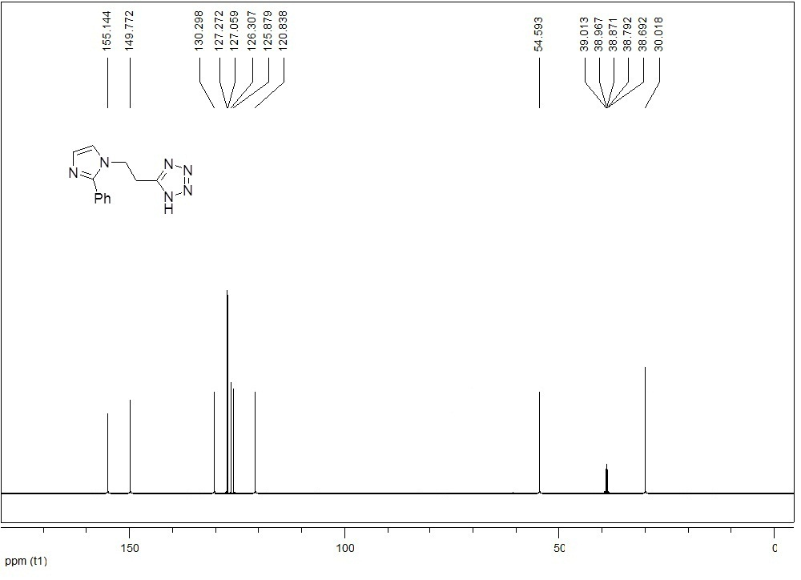

(2-(1H-tetrazol-5-yl)ethyl)-1H-benzo[d]imidazole (2l)

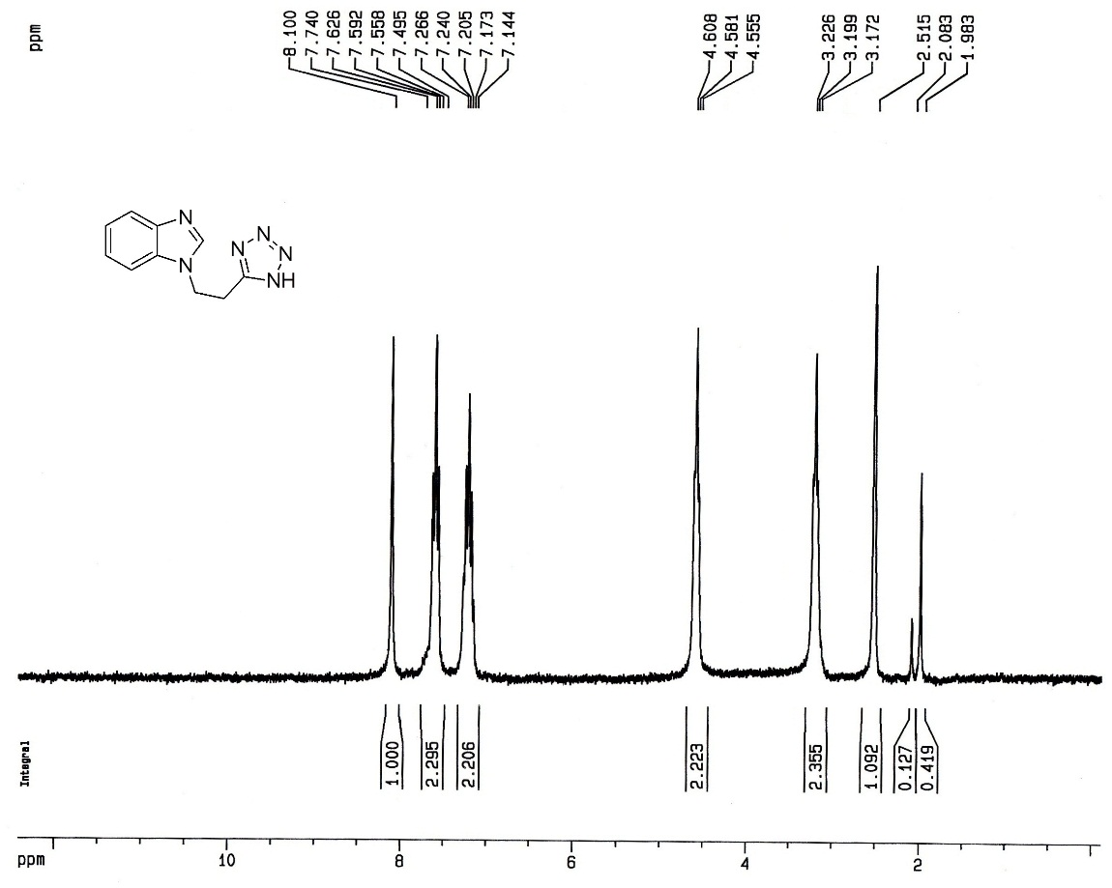

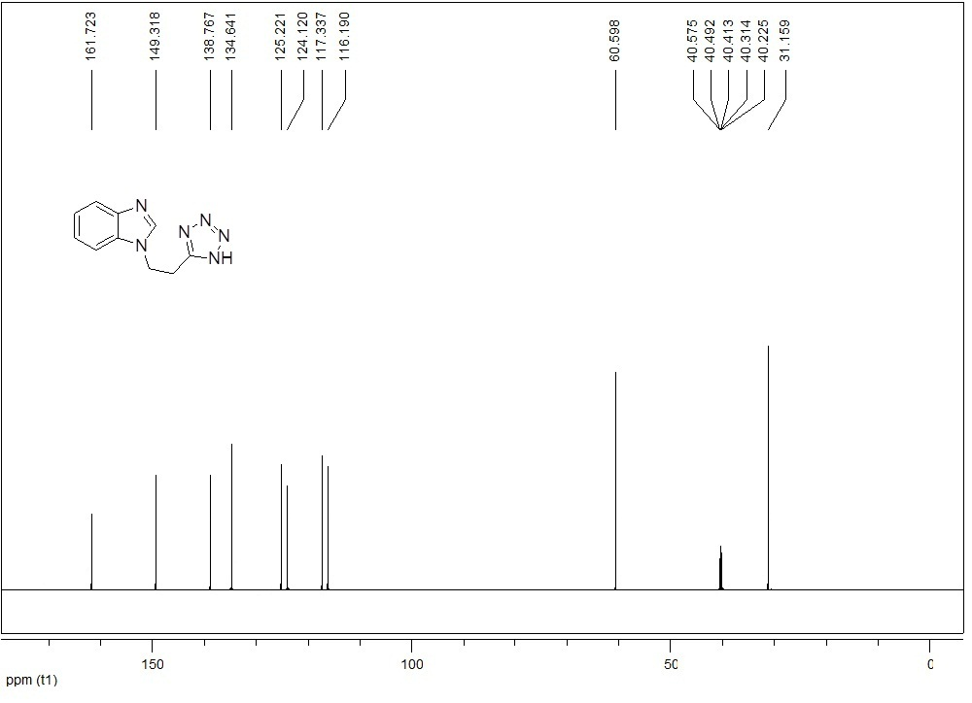

2-(2-(1H-tetrazol-5-yl)ethyl)isoindoline-1,3-dione (2m)

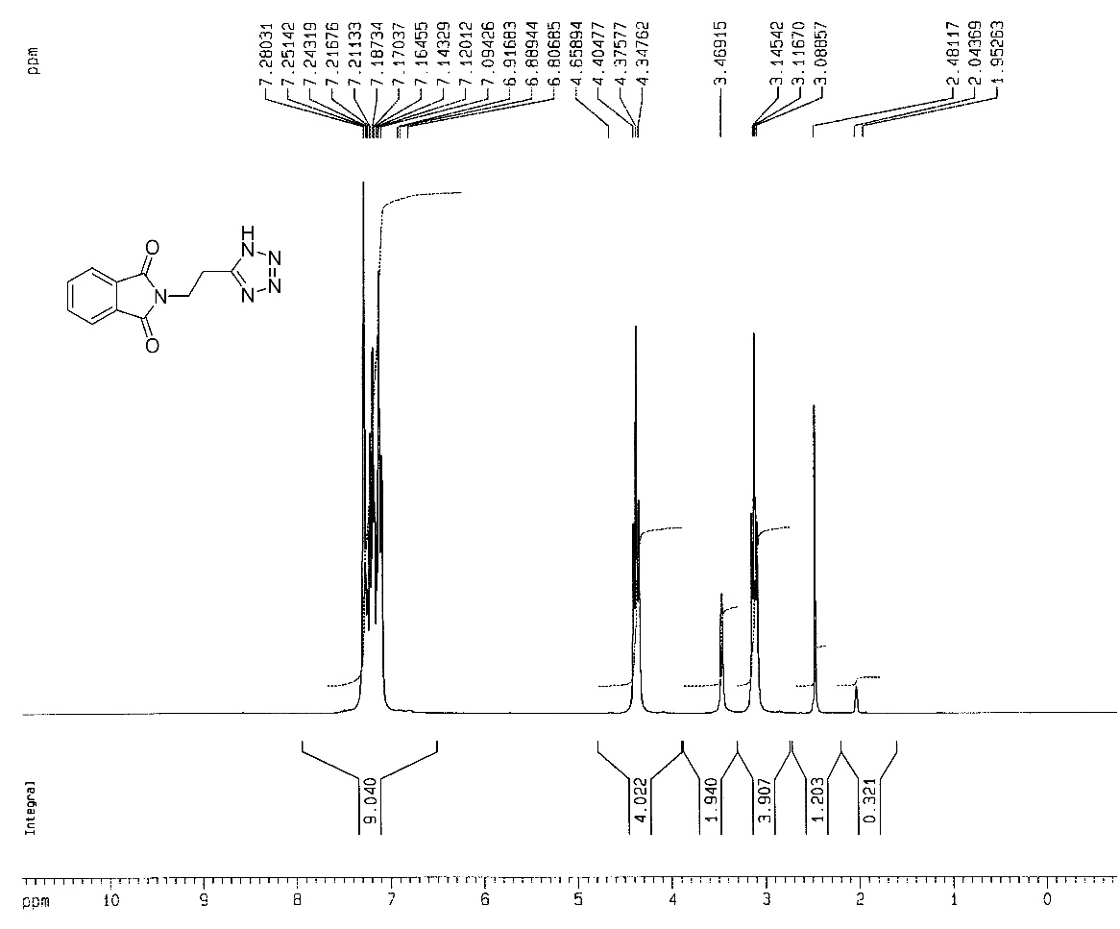

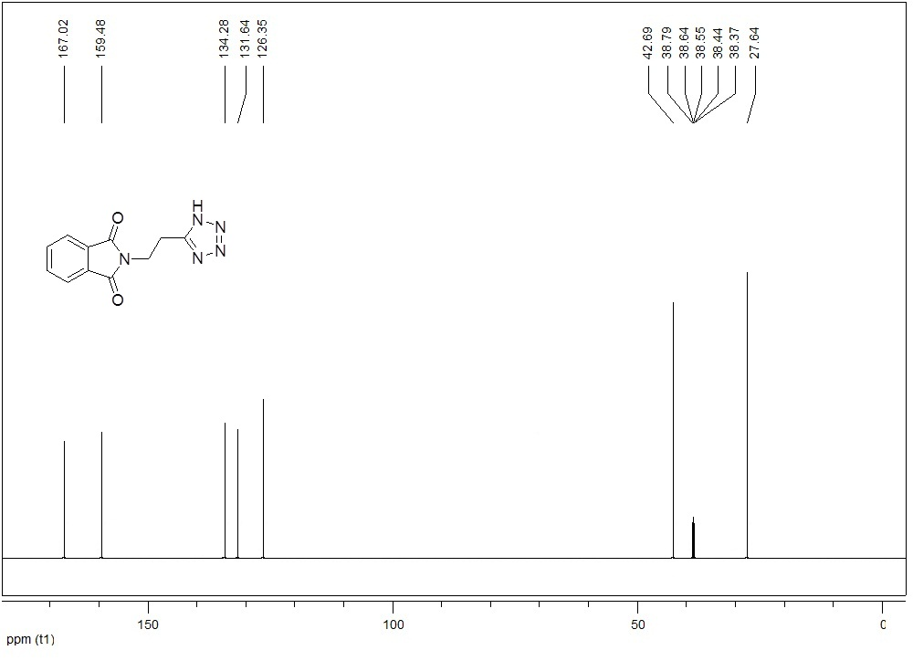
1-(2-(1H-tetrazol-5-yl)ethyl)-4-phenylpiperazine (2n)

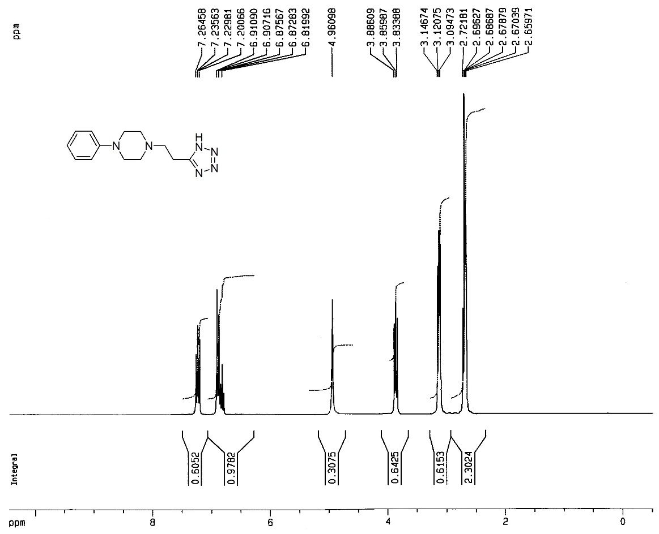
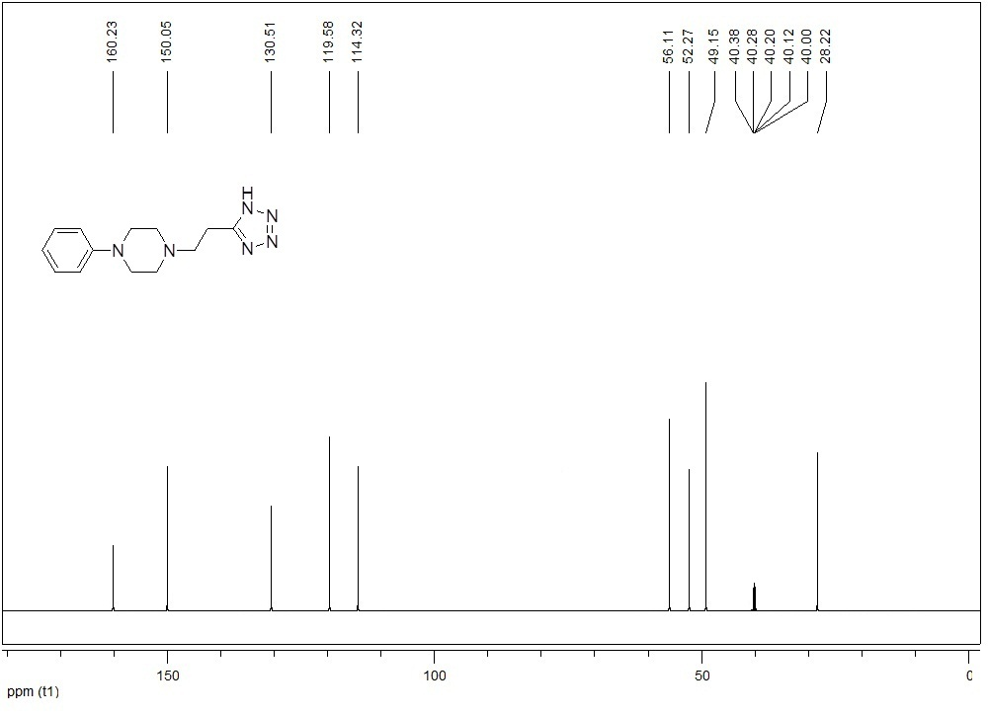

7-(2-(1H-tetrazol-5-yl)ethyl)-1,3-dimethyl-1H-purine-2,6(3H,7H)-dione (2o)
