EDITOR
- Line 18 of original manuscript: “weight however” was changed to “weight, however”
- Line 51 of original manuscript “In combination, it comprises” was changed to “In combination with other elements, it comprises”
- Line 54: “form inorganic” was changed to “form of inorganic”
- Line 83 of original manuscript: “body weight)” was changed to “body weight”
- Line 93 of original manuscript: “especially in a view” was changed to “especially in view”.
- Suggestion, lines 94–97 of original manuscript: Add some more chemical point of view. ACSi is a general chemistry journal.
Answer: “This review was written with the aim to provide the adequate background information on fluoride, which would assist in understanding its role and effects in humans. In addition, some of the fluoride controversies related to human health were revisited.” was changed to “The aim of this paper was two-fold: first to provide adequate background information on fluoride, which would assist in understanding its role and effects on humans, and, second, to present some of analytical problems associated with determination of fluoride at low levels as present in human and environmental samples. In addition, some of the fluoride controversies related to the intake of fluoride by humans and its impact on health were discussed.”
- Lines 132–133 of original manuscript: Dodati več kemijsko/analitskega pogleda na določanje in analitiko F.
Answer: Section 2.3. was left as it was because it deals with possible indicators for monitoring exposure to fluoride and not analytics. As however suggested by reviewer C, The placement of the chapters was changed. After a review of fluoride action and its impacts on human health we placed Analytical section. This section was quite extended as well as some issues related to determination of fluoride with hyphenated techniques were highlighted.
- Lines 132-133 of original manuscript: “or by stopping the drug altogether.” was changed to “or by stopping the administration of the drug altogether.”
- Line 254 of original manuscript “and remain 50% is” was changed to “and the remaining 50% is”
- Line 258 of original manuscript “Estimated was that less,” was changed to “It was estimated that”
- Line 258 of original manuscript “also by World Health” was changed to “also by the World Health”
- Line 258 of original manuscript “can be find” was changed to “can be found”
- Line 293 of original manuscript “Urine is regarded as a most suitable” was changed to “Urine is regarded as the most suitable”
- Line 476 of the original manuscript “These results suggested, that there” was changed to “These results suggested that there”
- Line 504 of the original manuscript: The text was modified and corrected (see answers to Reviewer D)
- Line 568 of the original manuscript: “required form or fluorine” was changed to “required form”
- Line 568 of the original manuscript: “fluoride ion selective electrode” was changed to “fluoride ion selective electrode (ISE)”
- Line 647 of the original manuscript: “however noted that that” was changed to “however noted that”
- Section “10. CONCLUSIONS” was renamed to “10. CONCLUSIONS – ENOUGH OR TOO MUCH FLUORIDE?” Section “11. OUR RESEARCH AND FUTURE DIRECTIONS” was introduced as the last section of the manuscript. In that section, we present our most recent activities and perspectives for future fluorine research. This section is not copied at this place, but it is highlighted in the version of the manuscript with highlighted changes.
- Author biographies were added before references.
- Slovenian abstract was added after references.

Lines 19–21 of the original manuscript: “In this review, the role and the effects of fluoride on human health are enlightened and some of the fluoride controversies are revisited.” were changed to “Some of the fluoride controversies are discussed and future research directions suggested.”
Lines 93–97 of the original manuscript: “Fluoride remains a subject of debate, time and time again, especially in a view of the current knowledge on its possible adverse effects. This review was written with the aim to provide adequate background information on fluoride, which would assist in understanding its role and effects in humans. In addition, some of the fluoride controversies related to human health were revisited.” were changed to “Fluoride remains a subject of debate, time and time again, especially in view of the current knowledge on its possible adverse effects. The aim of this paper was two-fold: first to provide adequate background information on fluoride, which would assist in understanding its role and effects on humans, and, second, to present some of the analytical problems associated with the determination of fluoride at low levels as present in human and environmental samples. In addition, some of the fluoride controversies related to the intake of fluoride by humans and its impact on health were discussed.”

Reviewer A
Comment 1, line 58 of the original manuscript: “Please be consistent with the way of referencing. Use reference number after the dots or before but not mix them.”
Answer: The references in the manuscript are consistently put after the dot with certain exceptions to this rule. For example, references given in line 58. The first two references are given to illustrate usual ranges of water soluble fluorides and the next two to illustrate usual ranges of total fluorine present in soil.
Comment 2, line 162 of the original manuscript: “for a 70-kg person)” was changed to “for a 70 kg person)”.
Comment 3, lines 198–199 of the original manuscript: “were suggested, e.g. decreased total fertility rate in both females and males⁷⁰, diabetes⁷¹, greater impairment of thyroid function⁷²,…” was changed to “were suggested, e.g., decreased total fertility rate in both females and males⁷², diabetes⁷³ and greater impairment of thyroid function⁷⁴.”.
Comment 4, line 254 of the original manuscript: “This 50 : 50 distribution” was changed to “This 50:50 distribution”.
Comment 5, line 295 of the original manuscript: “units”
Answer: A ratio between the excretion and the intake of fluoride is given which does not have units.
Comment 6, line 301 of the original manuscript: “units”
Answer: A ratio between parotid saliva to plasma fluoride concentrations is given which does not have units.
Comment 7, line 301 of the original manuscript: “units”
Answer: A ratio between submandibular saliva to plasma fluoride concentrations is given which does not have units.
Comment 8, line 387 of the original manuscript: “older date (from 2007 and before).²¹” was changed to “before 2007.²³”.
Comment 9, line 414 of the original manuscript: “may not contain more than 1.5 mg/L.” was changed to “may not contain more than 1.5 mg/l.”
In addition:
- line 452 of the original manuscript: “1.28 mg/L” was changed to “1.28 mg/l”
- lines 453–454 of the original manuscript: “from 0.02 to 1.28 mg/L” was changed to “from 0.02 to 1.28 mg/l”
- line 454 of the original manuscript: “High concentrations, 1.77 and 1.66 mg/L” was changed to “High concentrations, 1.77 and 1.66 mg/l”
Comment 10, lines 417–421 of the original manuscript:: Please, revise entire section “The controversy is illustrated by the fact that, while the US Centers for Disease Control and Prevention (CDC) claimed that water fluoridation is one of the ten great public health achievements in the US during the 20th century¹⁸¹ ,– 69% of the population receives fluoridated drinking water¹⁸² – water fluoridation is banned in most of Europe¹⁷⁴.”
Answer: This sentence was copied (with the exception of the references, which were updated), from our earlier chapter, which was language edited by a native English speaker. Therefore we left it in the original form.
Comment 11, footnote b to Table 2 of the original manuscript: “The highest content was not considered (115 µg/100 g of F in french fries, McDonald's)”
Answer: The commercial was retained because this is how the product was labelled in the original database.
Comment 12, line 532 of the original manuscript: “usually contain” was changed to “usually contains”.
Comment 13, Line 548 of original manuscript: “there is low⎕quality evidence”
It seems that there was a problem when converting word file to pdf file. Therefore “there is low-quality evidence” was changed to “there is low quality evidence”
Comment 14, line 595 of original manuscript: “Please develop the chapter to be more adequate for a chemical journal. In our days mass spectrometry hyphenated with many
other techniques (ionization techniques) are used for chemical compounds identification and
quantification”
Answer: The analytical section was developed to be more adequate for a chemical journal. A new subsection listing the forms of fluoride in fluorine containing compounds was introduced. Analytical methods for determination of fluoride were described in more details. An explanation why chromatography, plasma based methods and mass spectrometry are not well suited for determination of fluoride was added. As to marking changes made to this section in the manuscript we would like to explain, that we were not successful in highlighting them completely because of references are inserted as endnotes. However in general it is evident what changes were made. We are sorry for this inconvenience.

Reviewer B
Reviewer comment, l. 50–51 of the original manuscript: l.50 - Fluorine is chemically most reactive of all the elements and cannot be found in nature in the free state, with extremely rare exceptions . [NB – F. Kraus found recently that in very rare type of fluorite natural crystals (antozonite), fluorine gas (F2) could be trapped within the sample. But this topic is far from the main purpose of the paper and so adding a reference is not required. Schmedt auf der Günne J., Mangstl M., Kraus F., Occurrence of difluorine F2 in nature–in situ proof and quantification by NMR spectroscopy, Angew. Chem. Int. Ed. Engl., 51 (31) (2012) pp. 7847–7849.]
Answer: The reviewer indicated that this topic is not important from the perspective of the present paper. However we consider it as important from the perspective of the fluorine community as well as more general public. Therefore the sentence “Fluorine is chemically most reactive of all the elements and does not occur naturally in the free state.” was modified to “Fluorine is chemically most reactive of all the elements and is never or rarely encountered in nature as elemental fluorine. Two extremely rare exceptions where fluorine as gas could be trapped within the crystal of antozonite¹ and villiaumite² were recently reported.”. Two new references were inserted as Ref. 1 (J. Schmedt auf der Günne, M. Mangstl, F. Kraus, Angew. Chem. Int. Ed. 2012, 51, 7847–7849.) and Ref. 2 (V. R. Celinski, M. Ditter, F. Kraus, F. Fujara, J. Schmedt auf der Günne, Chem. Eur. J. 2016, 22, 18388–18393.). In accordance, the references’ numbers and list of references were updated.

Reviewer comment, l. 113 of original manuscript: Sentence “Thus to exert its maximum effect topical, rather than systemic use of fluoride is recommended.” was changed to “Thus, topical use of fluoride is recommended, rather than systemic.”
Reviewer comment, l. 157 of original manuscript: Sentence “Acute high oral exposure to fluoride may lead to nausea” was changed to “Acute high oral exposure to fluoride may lead to (with increased seriousness of observed symptoms) nausea,”.
Reviewer comment, l. 431 of the original manuscript: Some details should be added concerning the effect of low-quality tea in Southern China (see for instance the recent book on Fluorine [ Fluorine, a Paradoxical Element, Alain Tressaud, Vol. 5 of Progress in Fluorine Science series, Elsevier 2019].
Answer: A comment on the intake of fluoride with brick tea in Southern China has been made in the section “Fluoride intake in adults. Two new references were inserted (252. Z. Fan, Y. Gao, W. Wang, H. Gong, M. Guo, S. Zhao, X. Liu, B. Yu, D. Sun, J. Epidemiol. 2016, 26, 57–63 and 253. A. Tressaud, Fluorine, a Paradoxical Element, Progress in Fluorine Science, Vol. 5, Elsevier, Amsterdam, Netherlands, 2019.) The references and list of references were updated. ”. In addition, possible intake of fluoride with tea and food in adults was graphically illustrated in Figure 7. Changes made to the text are highlighted.

Reviewer comment: May be too many “exerts”.
Answer: The word “exerts” was used in the manuscript four times (lines 105, 112, 185 and 202. Line 113 was in accordance to the comment above rewritten and use of word “exerts” omitted. Lines 112–113 of original manuscript: “Thus to exert its maximum effect topical, rather than systemic use of fluoride is recommended.” was changed to “Thus, topical use of fluoride is recommended, rather than systemic.”.

Reviewer C
General remark: reconsider of placing Chapter 8 (analytical methods) before Chapter 6 (daily intake). On such way the explanation about analytical variability will be explained in advance before going to certain numbers given in Tables 1 and 2 that can, without explanation, rise many questions.
Answer: A suggested, Chapter 8 was placed in front of Chapter 6. In addition, Chapter 7 (Sources of oral exposure to fluoride) was placed in front of Chapter 6 (Daily intake of fluoride). In accordance with the new placement we also renumbered sections and references.
Remark 1, Page 2, lines 27, 35, 36: font size is 11 instead of 12,
Answer: Corrected.
Remark 2, Page 3, line 67: position of reference and dot (.).The same observed also in lines: 187, 199, 632, 687, 689, 699, ... . The whole paper should be checked.
Answer: This remark is very much similar to Remark 1 of Reviewer A. The references are presented in certain cases in this way to refer the reader to a specific reference and not a number of references citing also other information not related to the topic.
Remark 3, Page 5, line 144: non specific should be changed to nonspecific
Answer: Corrected.
Remark 4, Page 13, Table 1:
- parameter γgamma(F–)water is not explained
Answer: parameter γ(F–)_{water} was explained in the Caption to the Table 2.
- why some results do not include also SD?
Answer to comment, line 354: “Estimates for the total fluoride intakes for children from food and toothpaste, by water fluoridation status and the age groups together with their standard deviations (SDs) generated based on the papers reported in the last decade are presented in Table 1.” was changed to “Estimates for the total fluoride intakes for children from food and toothpaste, by water fluoridation status and the age groups as reported in the last decade are presented in Table 2.”
- how Total (SD) is determined: explain for both Total and SD?
Answer to comment on Table 1: The text was changed from “Estimates for the total fluoride intakes for children from food and toothpaste, by water fluoridation status and the age groups together with their standard deviations (SDs) generated based on the papers reported in the last decade are presented in Table 1.” to “Estimates for the total fluoride intakes for children from food and toothpaste, by water fluoridation status and the age groups as reported in the last decade are presented in Table 2.”.
Remark 5, Page 18, Table 2: parameters nproducts and wF are not explained
Answer: w_{F} was explained in the caption to Table 1 and n_{products} was explained in a footnote to the same table.
Remark 6: Page 20, line 548: “low- quality evidence” should be rephrased
Answer: “there is low-quality evidence” was changed to “there is low quality evidence”.
Remark 7: Page 21, line 563 and page 23, line 626: wrong style set for Chapters 8 and 9
Answer: Titles “Fluorin(d)e analytical methods” and “Adequate intake of fluoride” were put in upper case to “FLUORIN(D)E ANALYTICAL METHODS” and “ADEQUATE INTAKE OF FLUORIDE”.

Reviewer D
Comment 1: The List of Acronyms could be moved to the end of the manuscript (all the acronyms are already explained in the text (when they first appear).
Answer: The list of Acronyms was compressed and moved to the end of the text.
Comment 2: Figure or schematic presentation of fluoride intake in human body could be useful in terms of understanding of the F »flow«, the tissues that are more exposed to the F intake etc…(section 4.)
Answer: Section “ABSORPTION, METABOLISM, DISTRIBUTION AND EXCRETION OF FLUORIDE” is now “summarized” by a schematic representation of “fluoride flow” through the body after ingestion, which is presented in Fig. 2 All subsequent figures were adequately renumbered.

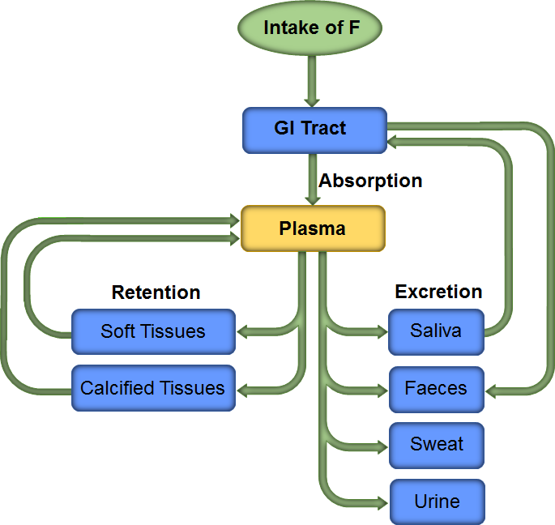
Figure 2: General features of fluoride metabolism

Comment 3: Figure (or graph) presenting amount of F in various types of food could be interesting (selected data from Table 2).
Answer: A histogram visualizing contents of fluorine in different food items was added. The average content of F in infant foods and drinks (UK Database) was recalculated by considering results obtained using tap water containing 0.05–0.13 mg F–/l for preparation of products requiring water for preparation. The changes made to the manuscript are as follows:
Table 2, last line column 6: “19 (25)” was changed to “15 (21)”.
Table 2, last line column 7: “1–170” was changed to “1–120”.
Lines 501–514: the paragraphs “The presented data compiled from the original databases (Table 2) show a wide variation in fluorine contents within and between individual food groups. Because of extremely high contents of F in raisins, french fries and cream substitute (Table 2, footnotes a, b and c), these items were excluded from the compiled table.
In general, the data are not normally distributed (see SDs) and the range of fluorine contents is from less than 0.1 up to 1054.2 µg/100 g. The average content of F in all food groups is 2-fold higher in USDA Database than in UK Database, this is 49 µg/100 g as compared to 24.5 µg/100 g. The content of fluorine in food is generally low (bellow 50 µg/100 g). There are some exceptions: (1) processed food (breakfast cereals, sweets, snacks, sauces) and beverages can contain considerable amounts of fluorine if fluoridated water is used during the process or for their preparation; (2) tea can accumulate high contents of fluorine in the leaves which is released during the infusion; and (3) fish and shellfish might contain high fluorine content, if analyzed samples, due to mechanical deboning, contain bones and exoskeleton remains, where fluoride is accumulated from the sea.”.
were changed to:
“The presented data compiled from the original databases (Table 1) show a wide variation in fluorine contents within and between individual food groups (see SDs and ranges). The average content of F of all food groups is 2.7-fold higher in the USDA Database than in the UK Database, this is 47 µg/100 g as opposed to 17 µg/100 g. The average content of F in the USDA Database remains 1.9-fold higher than in the UK Database even if tea is taken aside. This can be explained by different levels of fluoride in water used for the preparation of the products requiring water; results obtained using tap water containing 0.71 mg F–/l are reported in the USDA Database and results reported using tap water containing 0.05–0.13 mg F–/l were selected from the UK Database. The fluorine contents in individual food groups were, for easier visualization presented also in Figure 4.

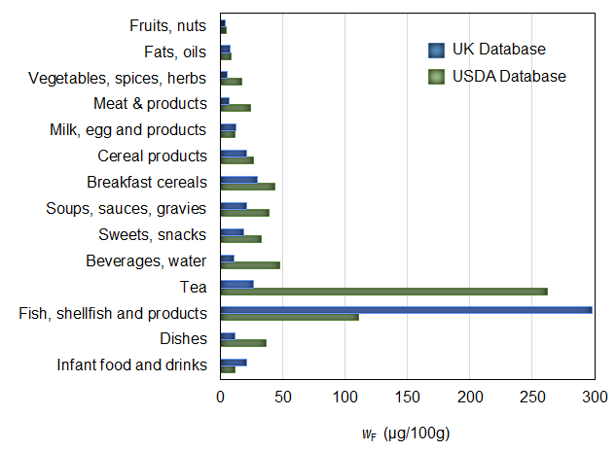
Figure 4: The average contents of fluorine in different food groups on a fresh weight basis listed in the USDA National Fluoride Database²¹⁸ and the UK Fluoride Database^{219,220} analyzed as ready-to-eat items

The content of fluorine in food is generally below 50 µg/100 g (Figure 4 and Table 1). Exceptions to this include: (1) processed food (breakfast cereals, sweets, snacks, sauces) and beverages which can contain considerable amounts of fluorine if fluoridated water is used during the production process or for their preparation; (2) tea, which can during infusion release high amounts of fluoride accumulated in the leaves; and (3) fish and shellfish which might contain high fluorine contents, if analyzed samples, due to mechanical deboning, contain bones and exoskeleton remains, where fluoride is accumulated from the sea.”

In addition two more figures were inserted into the manuscript, which illustrate the daily intake of fluoride in children and adults.

Figure 6 illustrating daily intake of fluoride in children was inserted after line 365 of the original manuscript. The following text (and figure) were added:
“The average total daily intakes of fluoride in children were estimated using data listed in Table 2 and illustrated in Figure 6.”

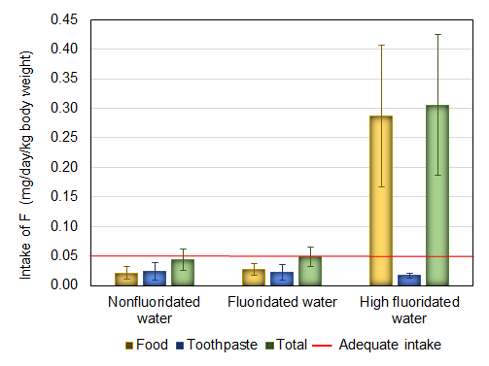
Figure 6: Estimated average total daily intake of fluoride in children from food and toothpaste in areas with nonfluoridated, fluoridated and high fluoridated water”

The changes made to the text in the following six lines are highlighted in yellow.

Figure 7 illustrating daily intake of fluoride in adults was inserted after line 625 of the original manuscript. The following text (and figure) were added:
“The average total daily intake of fluoride estimated in our study conducted in Slovenia, where water is nonfluoridated and fluoride content is generally low was 0.73–2.50 mg (average 1.50 mg) (equivalent to 0.010–0.036 (average 0.021) mg/kg body weight for a 70 kg man). This study is of importance because it is one of the rare studies conducted in adults using duplicate diet technique.¹⁴⁹
There are exceptions however showing higher fluoride intakes than those listed. Tea can significantly contribute to the total daily intake of fluoride. The content of F– in tea as determined in our recent study ranged between 0.32 and 3.55 mg/l (average 1.42 mg/l).¹⁶³ Figure 7 illustrates average daily intakes of fluoride in adults from food and daily consumption of 1 l of tea. Water with F– concentration of 1 mg/l was considered for preparing tea infusions in fluoridated areas.

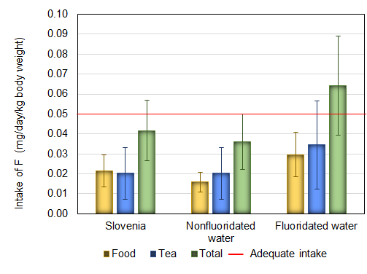
Figure 7: Estimated average total daily intake of fluoride in adults from food and tea in Slovenia and areas with nonfluoridated and fluoridated water

As illustrated in Figure 7, the consumption of tea can significantly contribute to the daily intake of fluoride; the AI for fluoride can be easily exceeded with consumption of higher quantities (≈1 l) of low quality tea. The presented intakes can be however also extremely higher in fluoride endemic areas13^{,14} or in southern China, where brick tea-type fluorosis has even become an urgent public health problem252,253.
Two new references (252 and 253) were inserted and listed in reference list; see also answers to comments of Reviewer B.

Comment 4: Graphical abstract is nice, informative and summarize the manuscript. I suggest that it is included in the manuscript as a figure. It could be placed in the section 10. Conclusions.
Answer: Graphical abstract was inserted as Figure 1 in Section Introduction because it adequately summarizes the content of the Introduction.
“The adequate intake of fluoride in relation to its beneficial/adverse effects and the main sources of fluoride for humans are graphically depicted in Figure 1.

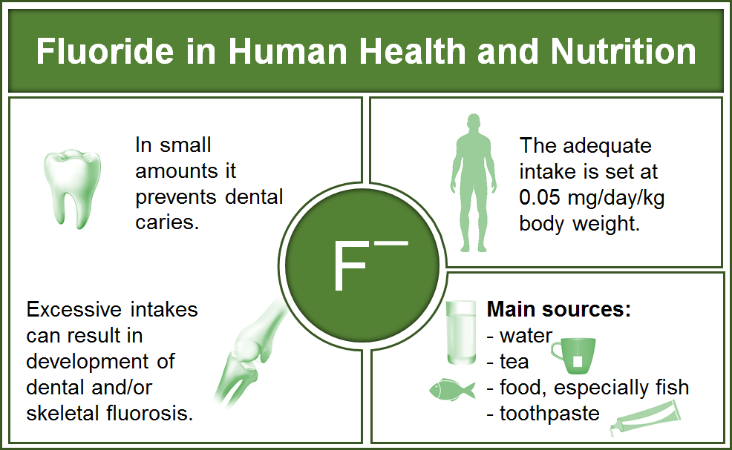

Figure 1: The adequate intake of fluoride in relation to its beneficial/adverse effects and the main sources of fluoride for humans”

OTHER REMARKS
- Line 90 of original manuscript: “especially in children28,29, should be considered.” was changed to “especially in children, should be considered.28,²⁹”
- Line 143 of original manuscript: “Fluoride related effects are many and can be classified as adverse.” was changed to “There are many fluoride related adverse effects.”
- Line 467 of original manuscript: “The WHO, based on earlier documents¹³⁶⁻¹³⁸, set in 2010 the guideline” was changed to “The WHO, based on earlier documents (from 1984, 1993 and 2004)^{77,175,176}, set in 2010 the guideline”
- Line 435 of original manuscript: “about 0.30 to 8.8 mg/l” was changed to “about 0.3 to 8.8 mg/l”
- Line 445 of original manuscript: “ranged” was changed to “varied”
- Line 514 of original manuscript: “the level of fluorine” was changed to “the determined level of fluorine”
- Line 527 of original manuscript: “the oral total intake” was changed to “the total oral intake”
- Line 543–544 of original manuscript: paragraphs were merged into one paragraph because they are both related to fluoridated salt
- Line 343 of original manuscript: “food consumed²⁰.” was changed to “food consumed.²⁰”
- Line 363 of original manuscript: “fluoride in different food items” was changed to “fluoride in different food items and water”
- Line 382 of original manuscript “These fluoride intakes extremely exceed” was changed to “These intakes extremely exceed”
- Lines 388–389 of original manuscript: “mg (average 1.1 mg)” was changed to “mg (average 1.11 mg)”
- Lines 390–391 of original manuscript: “being 0.9–3.8 (average 2.1)” was changed to “being 0.91–3.78 (average 2.07)”
- References 25 and 142 of the original manuscript were duplicated so the later reference was cited as a cross reference
- Line 638 of original manuscript: “intake with water” was changed to “intake from water”
- Lines 664–665 of original manuscript: “Among different food items, tea, beverages, processed food, fish and shellfish products might also contain considerable contents of fluorine.” was changed to “Among different food items processed food, fish and shellfish products might contain considerable contents of fluorine.”
- Lines 672–674 of original manuscript: “Other adverse effects related to the toxicity of fluoride for cells of different tissues include, among others, neurodevelopmental disorders, neurotoxicity, decreased total fertility rate, diabetes resulting from the toxicity of fluoride for cells of different tissues.” were changed to “Other adverse effects related to the toxicity of fluoride for cells of different tissues include, among others, neurodevelopmental disorders, neurotoxicity, decreased total fertility rate and diabetes.”
- Lines 675–676 of original manuscript: “A review of the recent studies showed that the average intake of fluoride from the diet and the toothpaste in children” was changed to “A review of the recent studies showed that the average total daily intake of fluoride with diet and toothpaste in children”
- Line 694 of original manuscript: “appears to be narrow” was changed to “appears to be so narrow”
- References 48 and 128 of the original manuscript were duplicated so the later reference was cited as a cross reference
- References 75 and 136 of the original manuscript were duplicated so the later reference was cited as a cross reference
- As suggested by Reviewer C, section “5. BIOMARKERS OF FLUORIDE EXPOSURE” followed by section “6. FLUORIN(D)E ANALYTICAL METHODS”. When inserting Figures, we also changed places of two subsequent sections to make continuation of the paper more logic. Section 6 is followed by sections “7. SOURCES OF ORAL EXPOSURE TO FLUORIDE” and “8. DAILY INTAKE OF FLUORIDE”.
- Table 2: The average intakes and their SDs of fluoride were calculated based on the presented data and listed in the table
- Additional acronyms listed in the analytical methods section were added into the list of acronyms: AAS, Atomic Absorption Spectrometry; CZE, Capillary Zone Electrophoresis; ¹⁹F-NMR, ¹⁹F-Nuclear Magnetic Resonance; HR-CS, High-Resolution Continuum Source; ICP–OES, Inductively Coupled Plasma Optical Emission Spectrometry; ICP–MS, Inductively Coupled Plasma Mass Spectrometry; ICP−MS−MS, Inductively Coupled Plasma Quadrupole Mass Spectrometry; LIBS, Laser-Induced Breakdown Spectroscopy; MAS, Molecular Absorption Spectrometry; NAA, Neutron Activation Analysis; NIR, Near Infrared Spectroscopy;

