Supporting information

Two acylated isoscutellarein glucosides with anti-inflammatory and antioxidant activities isolated from endemic Stachys subnuda Montbret & Aucher Ex Benth.

Ali Sen ª*, Fatih Göger ^{b}, Ahmet Dogan ^{c}, Leyla Bitisª

ª Department of Pharmacognosy, Faculty of Pharmacy, Marmara University, İstanbul, Turkey,
^{b} Department of Pharmacognosy, Faculty of Pharmacy, Anadolu University, Eskişehir, Turkey
^{c} Department of Pharmaceutical Botany, Faculty of Pharmacy, Marmara University, İstanbul, Turkey

*Corresponding author: Ali Sen, Ph.D.; Marmara University, Faculty of Pharmacy, Department of Pharmacognosy, Tibbiye Cad. No.49 34668, İstanbul, Turkey; Phone: +90 535 938 78 94; Fax: +90 216 345 29 52; e-mail: ali.sen@marmara.edu.tr; alisenfb@hotmail.com

Two acylated isoscutellarein glucosides with anti-inflammatory and antioxidant activities isolated from endemic Stachys subnuda Montbret & Aucher Ex Benth.

Abstract
In this study, we report anti-inflammatory and antioxidant activities of two acylated isoscutellarein glucosides isolated from ethyl acetate extract of Stachys subnuda aerial part. 4′-O-methylisoscutellarein-7-O-2′′-O-(6′′′-O-acetyl-β-D-allopyranosyl)-β-D-glucopyranoside (1) and isoscutellarein-7-O-2′′-O-(6′′′-O-acetyl-β-D-allopyranosyl)-β-D-glucopyranoside (2) were isolated as major compounds from ethyl acetate extract (EAE). Also, 2 hydroxycinnamic acid derivatives, and 5 isoscutellarein glucoside derivatives in the EAE were identified using LC-MS/MS. Compound 1 with IC₅₀ values of 2.35 ve 1.98 μg/mL and compound 2 with IC₅₀ values 13.94 ve 12.76 μg/mL showed fairly strong antioxidant activity against DPPH and ABTS radicals, respectively. Compound 1 and 2 inhibited 5-lipoxygenase (5-LOX) activity with an approximate IC₅₀ values of 47.23 and 41.60 μg/mL. The results demonstrated that isolated compounds have significant anti-inflammatory and antioxidant potential. Acylated flavonoid glycosides have been first reported for Stachys subnuda. Also, the activities of their have been investigated for the first time in this study.

Keywords: Stachys subnuda, acylated flavonoids, anti-inflammatory activity, antioxidant activity, LC-MS/MS

List of Supplementary Material
Figure 1. ¹H-NMR (500 MHz, CD₃OD) spectrum of Compound 1 ………………….. 4
Figure 2. ¹³C-NMR (APT) (125 MHz, CD₃OD) spectrum of Compound 1 ………….. 5
Figure 3. ¹H-NMR (500 MHz, CD₃OD) spectrum of Compound 2 ………………….. 5
Figure 4. ¹³C-NMR (APT) (125 MHz, CD₃OD) spectrum of Compound 2 ………….. 5
Spectral data for Compound 1 ………………………………………………................ 6
Spectral data for Compound 2 ……………………………………………………….... 6
References ……………………………………………………………………………... 7

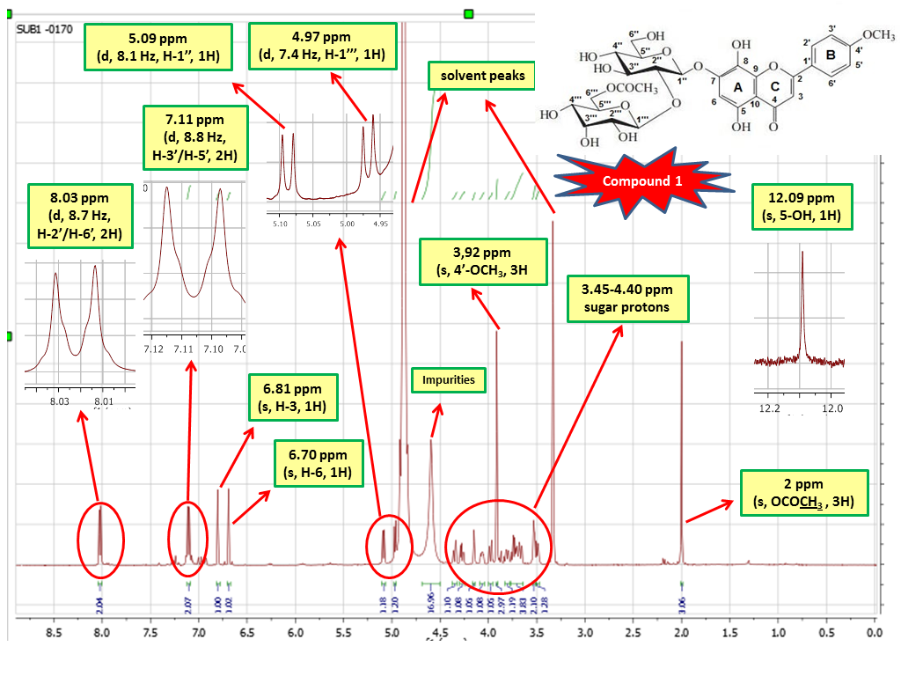
Figure 1. ¹H-NMR (500 MHz, CD₃OD) spectrum of Compound 1
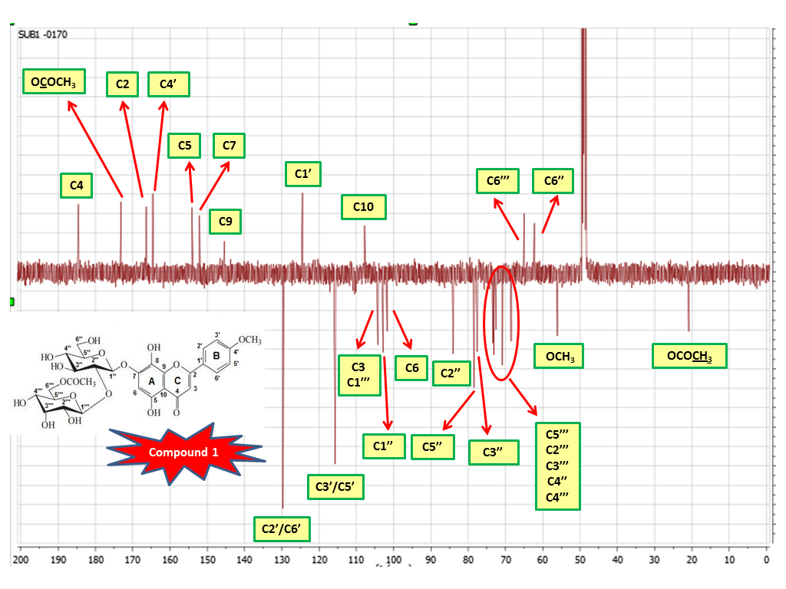
Figure 2. ¹³C-NMR (APT) (125 MHz, CD₃OD) spectrum of Compound 1

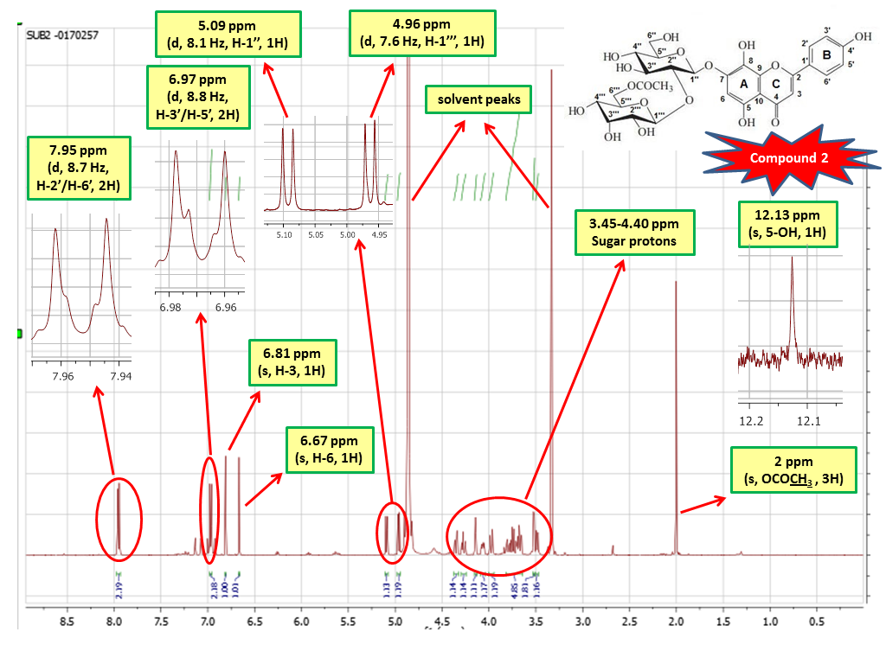
Figure 3. ¹H-NMR (500 MHz, CD₃OD) spectrum of Compound 2
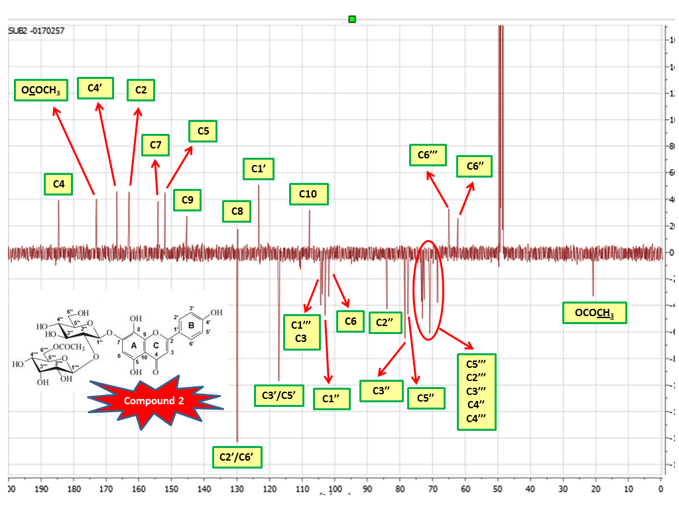
Figure 4. ¹³C-NMR (APT) (125 MHz, CD₃OD) spectrum of Compound 2

Spectral data for Compound 1
4´-O-methylisoscutellarein-7-O-2´´-O-(6´´´-O-acetyl-β-D-allopyranosyl)-β-D-glucopyranosid (1): Pale yellow, amorphous powder [1,2]. ¹H NMR (500 MHz, CD₃OD, δ, ppm, J/Hz): 6.81 (s, 1H, H-3), 6.70 (s, 1H, H-6), 8.03 (d, J= 8.7 Hz, 2H, H-2', H-6'), 7.11 (d, J= 8.8 Hz, 2H, H-3', H-5'), 3.92 (s, 3H, OCH₃), 12.09 (s, 1H, OH), 5.09 (d, J=8.1 Hz, 1H, glucose H-1´´), 4.97 (d, J=7.4 Hz, 1H, allose H-1´´´), 2 (s, 3H, OCOCH₃), 3.45-4.40 (glucose and allose protons). ¹³C NMR (125 MHz, CD₃OD, δ, ppm): Aglycone; 166.31 (C-2), 104.31 (C-3), 184.53 (C-4), 154.10 (C-5), 101.79 (C-6), 152.06 (C-7), 129.67 (C-8), 145.36 (C-9), 107.76 (C-10), 124.49 (C-1′), 129.67 (C-2′/6′), 115.65 (C-3′/5′), 164.60 (C-4′), 56.16 (4'-OCH₃), Glucose; 102.87 (C-1′′), 84.02 (C-2′′), 75.55 (C-3′′), 70.81 (C-4′′), 78.48 (C-5′′), 62.29 (C-6′′), Allose; 104.23 (C-1′′′), 73.09 (C-2′′′), 72.62 (C-3′′′), 68.49 (C-4′′′), 73.42 (C-5′′′), 65.06 (C-6′′′), 173.10 (COCH₃), 20.86 (COCH₃). ESI-MS: 665 ([M–H]⁻).
Spectral data for Compound 2
Isoscutellarein-7-O-2′′-O-(6′′′-O-acetyl-β-D-allopyranosyl)-β-D-glucopyranoside (2): Pale yellow, amorphous powder [1,2]. ¹H NMR (500 MHz, CD₃OD, δ, ppm, J/Hz): 6.81 (s, 1H, H-3), 6.67 (s, 1H, H-6), 7.95 (d, J= 8.8 Hz, 2H, H-2', H-6'), 6.97 (d, J= 8.8 Hz, 2H, H-3', H-5'), 12.13 (s, 1H, OH), 5.09 (d, J=8.1 Hz, 1H, glucose H-1´´), 4.96 (d, J=7.6 Hz, 1H, allose H-1´´´), 2 (s, 3H, OCOCH₃), 3.45-4.40 (glucose and allose protons). ¹³C NMR (125 MHz, CD₃OD, δ, ppm): Aglycone; 162.99 (C-2), 103.78 (C-3), 184.52 (C-4), 152.02 (C-5), 101.78 (C-6), 154.11 (C-7), 129.76 (C-8), 145.36 (C-9), 107.75 (C-10), 123.22 (C-1′), 129.84 (C-2′/6′), 117.05 (C-3′/5′), 166.72 (C-4′), Glucose; 102.95 (C-1′′), 84.01 (C-2′′), 78.49 (C-3′′), 70.82 (C-4′′), 77.58 (C-5′′), 62.30 (C-6′′), Allose; 104.21 (C-1′′′), 73.09 (C-2′′′), 72.59 (C-3′′′), 68.50 (C-4′′′), 73.43 (C-5′′′), 65.03 (C-6′′′), 173.0 (COCH₃), 20.82 (COCH₃). ESI-MS: 651 ([M–H]⁻).
References

[1] D.C. Albach, R.J. Grayer, S.R. Jensen, F. Ozgokce, N.C. Veitch, Acylated flavone glycosides from Veronica, Phytochemistry 64 (2003) 1295-1301.
[2] I. Saracoglu, Ş. Harput, Y. Ogihara, Acylated Flavone Glycosides from Veronica pectinata var. glandulosa and V. persica, Turk J. Chem. 28 (2004) 751-759.

